

TRIBHUVAN UNIVERSITY
ASIAN SCHOOL OF MANAGEMENT & TECHNOLOGY

Final Year Project Report
On
“Futsal Bookings and Management Platform”

Submitted To :
Office of Dean
Institute of Science and Technology

Under the supervision of
Mr. Surya Bam

In partial fulfillment of the requirement for the bachelor’s degree in Computer Science and
Information Technology

Submitted By :
Aashish Rijal (79010939)
Kedar Dhungana (79010957)
Dipesh Devkota (79010952)

Shrawan, 2025
SUPERVISOR’S RECOMMENDATION

It is my pleasure to recommend that a report on “Futsal Bookings and Management Platform” has been prepared under my supervision by Aashish Rijal, Dipesh Devkota, and Kedar Dhungana in partial fulfillment of the requirement of the degree of Bachelor of Science in Computer Science and Information Technology (BSc.CSIT). Their report is satisfactory to process for the future evaluation.

…………………………………
Mr. Surya Bam
Supervisor
Asian School of Management & technology
Gongabu, Kathmandu

CERTIFICATE OF APPROVAL

This is to certify that this report has been read and recommended to the Department of Computer Science and Information Technology for acceptance of report entitled “Futsal Bookings and Management Platform” submitted by Aashish Rijal, Dipesh Devkota and Kedar Dhungana in partial fulfillment for the degree of Bachelor of Science in Computer Science and Information Technology (BSc.CSIT), Institute of Science and Technology, Tribhuvan University.

………………………… ……………………...
Mr. Surya Bam Er. Anil Lal Amatya
Supervisor Principal

…………………………. ………………………..
Mr./Mrs. Mr. Chakra Rawal
External Examiner Program Co-ordinator

ACKNOWLEDGEMENT
We would like to express our honest gratitude to all those who contributed to this project. Our sincere thanks go to our supervisor and coordinator Mr. Surya Bam, who provided us with precious guidance and support throughout the project. Their invaluable expertise, encouragement, and support have been a constant source of inspiration. We would also like to thank Asian School of management and technology College for providing us with the resources and support needed to complete this project. Finally, we would like to extend our gratitude to our families and friends for their support and encouragement throughout the completion of the project.

With respect,
Aashish Rijal
Dipesh Devkota
Kedar Dhungana

ABSTRACT

The Futsal Booking and Management System is a web-based multi-tenant SaaS platform designed to digitize and streamline futsal court booking and management in Nepal. Addressing the widespread reliance on manual booking methods, such as phone calls and handwritten registers the system provides a centralized platform where users can search, book, and review futsal centers, while owners manage schedules, pricing, and analytics through a dedicated dashboard. Built using React, Node.js, and MySQL, the platform incorporates machine learning features including Logistic Regression for sentiment analysis, and the Haversine formula for location-based court recommendations. Developed following the Agile methodology, the system aims to eliminate double bookings, improve operational efficiency, and deliver an intelligent, scalable solution for futsal facility management.

Keywords: SaaS, Multi-tenant, Sentiment Analysis, Node Js, React Js, Centralized, Logistic Regression, Agile.

TABLE OF CONTENTS
TITLE PAGE ...................................................................................................................... i
SUPERVISOR’S RECOMMENDATION ....................................................................... ii
CERTIFICATE OF APPROVAL ..................................................................................... iii
ACKNOWLEDGEMENT ................................................................................................ iv
ABSTRACT ........................................................................................................................ v
TABLE OF CONTENT ..................................................................................................... vi
LIST OF ABBREVIATIONS ............................................................................................ viii
LIST OF FIGURES ........................................................................................................... ix
LIST OF TABLES ............................................................................................................. x
CHAPTER 1: INTRODUCTION .................................................................................... 1
1.1 Introduction ................................................................................................................... 1
1.2 Problem Statement ........................................................................................................ 2
1.3 Objectives ...................................................................................................................... 2
1.4 Scope and Limitation ..................................................................................................... 3
1.5 Development Methodology ........................................................................................... 4
1.6 Report Organization ....................................................................................................... 5
CHAPTER 2: LITERATURE REVIEW ........................................................................ 6
2.1 Background Study ......................................................................................................... 6
2.2 Literature Review .......................................................................................................... 6
CHAPTER 3: SYSTEM ANALYSIS ............................................................................... 9
3.1 System Analysis ............................................................................................................ 9
3.1.1 Requirement Analysis ................................................................................................ 9
3.1.2 Feasibility Analysis ...................................................................................................... 15
3.1.3 Analysis ……………………………………………………………………………… 17
CHAPTER 4: SYSTEM DESIGN ................................................................................... 27
4.1 Design Overview ........................................................................................................... 27
4.2 Interface Design ............................................................................................................ 30
4.3 Description of Algorithm ............................................................................................. 36
CHAPTER 5: IMPLEMENTATION AND TESTING .................................................. 39
5.1 Implementation ............................................................................................................. 39
5.2 Testing ........................................................................................................................... 42
5.3 Result Analysis .............................................................................................................. 62
CHAPTER 6: CONCLUSION AND FUTURE RECOMMENDATION ..................... 68
6.1 Conclusion ..................................................................................................................... 68
6.2 Future Recommendations .............................................................................................. 69
REFERENCES .................................................................................................................. 71
APPENDICES ................................................................................................................... 72
SUPERVISOR’S LOG ...................................................................................................... 85
SUPERVISOR LOG EVIDENCE ..................................................................................... 86

LIST OF ABBREVIATIONS

API Application Programming Interface
AWS Amazon Web Services
DB Database
HLD High Level Design
JWT JSON Web Token
ML Machine Learning
MySQL My Structured Query Language
NLP Natural Language Processing
Oauth Open Authorization
OTP One Time Password
PWA Progressive Web Application
Redis Remote Dictionary Server
SaaS Software as a Service
TF-IDF Term Frequency - Inverse Document Frequency
URL Uniform Resource Locator
VPS Virtual Private Server

LIST OF FIGURES

Figure 1.1: Agile Development Model …………………………………..………………….. 5
Figure 3.1: Use Case Diagram of Futsal Bookings and management …………………......... 11
Figure 3.2 : Dataset records …………………………………………………………………. 13
Figure 3.3: Gantt Chart ……………….………………………..……………………………. 16
Figure 3.4 : ER Diagram ...…………………………………………………………………… 17
Figure 3.5 : DFD level-0 Diagram …………………………………………………………… 18
Figure 3.6 : DFD level-1 Diagram …………………………………………………………… 19
Figure 3.7 : DFD level-2 process 1 Diagram ……………………………………………...…. 20
Figure 3.8 : DFD level-2 process 2 Diagram ……………………………………………...… 21
Figure 3.9 : DFD level-2 process 3 Diagram ……………………………………………...… 22
Figure 3.10 : DFD level-2 process 4 Diagram ……………………………………………...… 23
Figure 3.11 : DFD level-2 process 5 Diagram ……………………………………………...… 24
Figure 3.12 : DFD level-2 process 6 Diagram ……………………………………………...… 25
Figure 3.13: Sequence Diagram of Futsal Bookings and Management System ……………… 26
Figure 4.1: High-Level System Design of Futsal Bookings and Management System ……… 27
Figure 4.2: Registration and Login Page Design ……………………………………………… 31
Figure 4.3 : Forum Page Design ………………………………………………………………. 31
Figure 4.4: Pricing Page Design ………………………………………………………………. 32
Figure 4.5: Futsal listing Page Design ……………………………………………………….. 32
Figure 4.6 : Futsal Page Design ………………………………………………………………. ` 34
Figure 4.7 : User Profile page Design ………………………………………………………… 35
Figure 4.8: Contact page Design ……………………………………………………………… ` 35
Figure 5.1 : Test Scenario - User Registration ………………………………………………… 44
Figure 5.2 : Test Scenario - Set Password …………………………………………………….. 44
Figure 5.3 : Test Scenario - Verify Account …………………………………………………… 45
Figure 5.4: Test Scenario - User Login ……………………………………………………… 45
Figure 5.5: Test Scenario - Create Forum post ……………………………………………… 47
Figure 5.6 : Test Scenario - View Forum post ……………………………………………… 47
Figure 5.7 : Test Scenario- Forum Comment ………………………………………………. 48
Figure 5.8 : Test Scenario - Empty validation ……………………………………………… 48
Figure 5.9 : Test Scenario- Payment Initiate ………………………………………………… 50
Figure 5.10 : Test Scenario- Payment Successful …………………………………………… 50
Figure 5.11 : Test Scenario -View available slot ……………………………………………. 52
Figure 5.12 : Test Scenario- Booking Successful …………………………………………… 52
Figure 5.13 : Test Scenario - Booking Notification …………………………………………. 53
Figure 5.14 : Test Scenario - Booking History ……………………………………………… 53
Figure 5.15 : Test Scenario - Listing Futsal ………………………………………………… 55
Figure 5.16 : Test Scenario - Add pitch ……………………………………………………… 55
Figure 5.17 : Test Scenario -Manage Schedule and Price …………………………………… 56
Figure 5.18 : Test Scenario - Anaytices dashboard ……..…………………………………… 56
Figure 5.19 : Test Scenario - Handle Subscription …………………………………………… 57
Figure 5.20 : Test Scenario- Bookings Details ……………………………………………….. 57
Figure 5.21 : Test Scenario - Positive Sentiment Review …………………………………… 59
Figure 5.22 : Test Scenario - Negative Sentiment Review …………………………………… 59
Figure 5.23 : Test Scenario - Recommendation of Futsal ……………………………………. 59
Figure 5.24 : Test Scenario - Handle single Review ………………………………………….. 60
Figure 5.25 : Test Scenario - Empty Review Text ……………………………………………… 60

LIST OF TABLES

Table 3.1 Use Case Scenario for User Operations ……………………….……………… 12
Table 5.1: Unit Test Cases ………………………………………………………………. 43
Table 5.2: Test Cases for Forum Feature ………………………………………………... 46
Table 5.3: Test Cases for Payment Feature ……………………………………………… 49
Table 5.4: Test Cases for Booking Feature ……………………………………………… 51
Table 5.5: Test Cases for Futsal Owner Feature ………………………………………… 54
Table 5.6: Test Cases for ML Sentiment Analysis Feature ……………………………… 58
Table 5.7: System Test Cases ………………………………………………….……….. 61
Table 5.8: Confusion Matrix …..……………………………………………....………… 62
Table 5.9: Summary of Class-wise metrics …………………………………….……… 63
Table 5.10: System Performance metrics ………………………………..…….………… 66
CHAPTER 1
INTRODUCTION

1.1 Introduction
The Futsal bookings and management platform is an innovative web-based application designed to facilitate real-time futsal court booking and management, with a primary focus on digitizing the operations of futsal centers across Nepal. It allows users to discover and connect with futsal facilities across different locations, creating opportunities for seamless court reservations, live slot availability checks, and community engagement through ratings and reviews. The platform is designed to be intuitive and user-friendly, enabling players to easily search for courts, book sessions, and manage their reservations through a centralized digital interface.
For players, this platform offers features such as AI-powered Sentiment Analysis of reviews , personalized court recommendations based on location, and booking history tracking, allowing users to monitor their activity and make informed decisions. The platform also supports social interaction through community ratings, reviews, and a discussion forum, fostering a collaborative and trustworthy sports community.
From the administrative perspective, Futsal Bookings and management system provides a robust backend system for futsal owners to manage courts, time slots, pricing, and customer interactions. Administrators can oversee platform-wide activity, monitor tenant usage, and ensure smooth operation of the system. The system leverages modern technologies such as the MERN stack, Redis, and Docker to provide reliable, scalable, and secure booking capabilities within a multi-tenant SaaS architecture.
One of the key advantages of Futsal bookings and management platform is its emphasis on intelligent features and data-driven decision support, allowing futsal owners to access analytics dashboards with revenue trends, peak usage times, and customer engagement insights.
Moreover, Futsal Bookings and Management is developed with future scalability in mind, enabling integration with additional features such as mobile application support, online payment gateways, tournament management, and expanded AI capabilities for enhanced user experience.
1.2 Problem Statement
The growing demand for futsal facilities in urban areas of Nepal has highlighted several challenges for both players and facility operators. Traditional booking methods, such as phone calls, handwritten registers, and social media messages, often fail to provide real-time availability updates and lead to frequent double bookings and scheduling conflicts.
Players frequently struggle to find available courts at convenient times, and opportunities to compare multiple futsal centers based on location, pricing, and user reviews are extremely limited. The absence of a centralized digital platform makes the process of discovering and booking a suitable futsal court time-consuming and inefficient.
From the facility management perspective, futsal owners face challenges in tracking bookings, managing schedules, and maintaining accurate records of revenue and customer interactions. The lack of digital tools also limits their ability to make data-driven decisions, as insights such as peak usage times and revenue trends are not readily available.

1.3 Objectives
- To develop a centralized online platform for futsal discovery and real-time court booking, ensuring convenience and accessibility for users.
- To implement a multi-tenant SaaS architecture that allows multiple futsal facilities to operate independently within a single scalable and secure system.
- To enable community features including verified ratings, reviews, and a discussion forum to enhance user interaction and trust.
1.4 Scope and Limitation
The scope of the Futsal Booking and Management System are as follows:
- Enabling users to search futsal centers by location, availability, and pricing.
- Providing real-time court booking and slot conflict prevention.
- Managing reservation history, cancellations, and booking confirmations.
- Allowing futsal owners to manage courts, time slots, pricing, and customer interactions through a dedicated dashboard.
- Providing an admin panel for platform-wide operations, tenant management, and subscription plans.
- Incorporating community features such as ratings, reviews, and discussion forums.
- Integrating a location-based recommendation engine to suggest nearby futsal centers based on user proximity and preferences.

Every system has errors so this system also has limitations which are as follows:
- Dependence on internet connectivity, the system may not function properly without a stable internet connection.
- Mobile application support is limited in the initial phase, as the platform is primarily designed for desktop and web browsers.
- AI-powered features are based on available training datasets and may not capture every nuance of user sentiment accurately.
- The system's effectiveness depends on futsal owners actively maintaining up-to-date court information and availability schedules.
- Requires user training for effective usage of owner dashboards and admin features.
- Currently limited to futsal facility management; support for other sports may be added in future updates.

1.5 Development Methodology
The Futsal bookings and management platform is developed using the Agile Development Methodology, emphasizing flexibility, collaboration, and iterative progress. The development process is organized into sprints, where each sprint focuses on delivering key functionalities while ensuring a user-centric design.
Iteration 1: The first phase establishes core infrastructure, including environment setup, database schema design, and wireframe creation. A minimum viable product (MVP) is developed covering user registration, login, and basic futsal listing.
Iteration 2: This iteration focuses on the core booking engine, including slot availability checks, conflict prevention algorithms, booking confirmation, and cancellation management.
Iteration 3: The third iteration integrates the futsal owner dashboard with court management, pricing configuration, schedule management, and booking approval workflows.
Iteration 4: In this phase, community features including ratings, reviews, and discussion forums are implemented alongside notification systems and user profile management.
Iteration 5: The final iteration introduces advanced AI and ML components including sentiment analysis and location-based recommendations. The system is fully tested for performance, security, and scalability.

By following this iterative Agile methodology, futsal management and bookings platform ensures continuous improvement, rapid delivery of features, and adaptability to feedback throughout the development process.

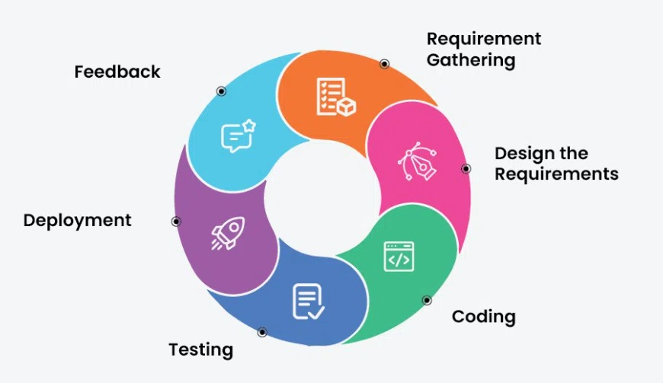
Figure 1.1 Agile Development model

1.6 Report Organization
The Report Organization describes how the study is structured and conducted. This report is divided into six chapters, each addressing different aspects of the study. Chapter One presents the introduction, statement of the problem, objectives of the study, scope and limitations, development methodology and organization of the study. Chapter Two focuses on the background study and review of related literature, providing the necessary theoretical foundation. Chapter Three discusses system analysis, including requirement analysis, feasibility study, data modeling, and process modeling of the system. Chapter Four deals with the design of the system, particularly the system architecture and its components. Chapter Five explains the implementation phase, the algorithms used, and the tools applied, along with the testing of the system both as individual units and as a 3complete system. Finally, Chapter Six provides the conclusions drawn from the study, highlights its limitations and offers recommendations for future improvements.

CHAPTER 2
BACKGROUND STUDY AND LITERATURE REVIEW
2.1 Background Study
The need for an Online Futsal Booking and Management System arises from the limitations of traditional manual booking methods such as phone calls, handwritten registers, and social media messages. These older approaches often cause double bookings, scheduling conflicts, missing records, and difficulties in tracking court availability and customer interactions. As the number of futsal centers in Nepal continues to grow rapidly, managing bookings manually becomes increasingly inefficient and unreliable.
A digital futsal booking platform addresses these issues by automating the entire reservation process. Players can search for available courts online, make bookings in real time, and receive instant confirmation, while the system prevents slot conflicts through automated time-slot validation. Futsal owners benefit from dedicated dashboards that streamline court management, pricing configuration, and customer communication, reducing administrative workload and minimizing human error.
Additionally, the platform integrates machine learning components to enhance user experience through sentiment analysis of reviews and location-based court recommendations. Overall, the Futsal system enhances booking efficiency, data accuracy, and operational transparency for both players and futsal facility operators.

2.2 Literature Review
The Futsal Booking and Management System is a web-based SaaS application designed to automate the process of discovering, booking, and managing futsal courts. It enables players to search for futsal centers by location and availability, make real-time reservations, and manage their booking history, while futsal owners can manage courts, schedules, pricing, and customer interactions through a dedicated management dashboard. The system maintains a centralized multi-tenant database that stores each facility's booking records, customer data, and operational details, ensuring that all information remains accurate, up-to-date, and securely isolated per tenant [1].
Traditionally, futsal centers managed bookings through phone calls, paper registers, and messaging apps, which were inefficient, time-consuming, and prone to double bookings, data loss, and poor record management [2]. With advancements in web technologies and digital platforms, automated booking systems have replaced manual processes, improving reliability, scheduling clarity, and operational transparency across the sports facility industry [3]. A study by Suhaimi and Sahid developed a futsal court booking system to replace manual records with a database-driven platform, demonstrating measurable improvements in booking visibility and electronic data management through a structured booking interface built using the prototyping model [1]. Similarly, Fauzi et al. presented a web-based futsal field rental information system aimed at improving business opportunities and operational efficiency in the sports rental sector, highlighting that website-based booking platforms help replace handwritten rental processes while increasing accessibility and customer reach [2].
Industry analysis further supports the effectiveness of specialized sports booking software, reporting measurable reductions in scheduling conflicts and improved operational transparency when centralized booking systems are deployed [3]. In addition, mobile-first and Progressive Web Application (PWA) approaches are recommended for booking platforms because they provide a responsive, app-like user experience across devices without the high cost of native mobile app development [4]. Modern system design literature recommends multi-tenant SaaS architecture for shared booking platforms serving multiple independent facility owners with proper data isolation, ensuring scalability and security across all tenants [5].
Machine learning techniques are increasingly applied to process user reviews and support decision-making in digital platforms. Term Frequency-Inverse Document Frequency (TF-IDF) is a widely used text feature extraction technique that identifies the most important terms in a document relative to a collection of documents, enabling automatic review summarization and smarter content ranking [6]. Recent studies utilize Logistic Regression as a robust supervised learning algorithm for sentiment analysis across various domains, classifying user feedback into binary outcomes such as positive or negative sentiment based on extracted TF-IDF feature vectors [7]. Furthermore, location-based recommendation methods using coordinate-based distance computation such as the Haversine formula are used to rank nearby services based on user proximity and preference patterns, improving the relevance of court suggestions presented to users [6][7].
The Futsal Bookings and management system is developed following the Agile Software Development Life Cycle (SDLC), which supports iterative development, continuous feedback, and flexible requirement handling throughout the project lifecycle [8]. Each sprint delivers a working version of the system with improved features and refinements, ensuring that modules such as booking management, owner dashboards, and machine learning components are developed and tested incrementally [8].
In conclusion, the AllFutsal system serves as a secure, scalable, and intelligent platform that digitizes traditional futsal booking processes and brings efficiency to sports facility operations. It not only enhances scheduling accuracy, transparency, and operational management for futsal owners but also provides AI-driven insights and personalized recommendations for players, addressing the clear gap in existing manual and partially digital solutions.

CHAPTER 3
SYSTEM ANALYSIS
3.1 System Analysis
System analysis involves studying the system in detail to understand how it works and what improvements are needed. It focuses on identifying problems, gathering data, and separating the system into smaller parts to make it easier to study. By analyzing each part and how they connect, we can clearly see what the system is expected to do. In this way, system analysis acts as a method of problem solving, helping to check whether each component works properly and contributes toward the overall goal of the system.
3.1.1 Requirement Analysis
To develop the futsal bookings and management, we identified both functional and non-functional requirements that the system must fulfill.
3.1.1.1 Functional Requirement
Functional requirement are the features and functions that the Futsal Bookings and management System must provide.
- User Registration and Authentication: Only registered users can access the system. Users can create and manage their profiles, while futsal owners and administrators have extended privileges to manage courts, bookings, and platform-wide operations respectively.
- Futsal Discovery and Search: Users can search for futsal centers by location, price, and available time slots, and view detailed information including court facilities, pricing, and community reviews before making a booking decision.
- Real-Time Court Booking: Users can book available futsal courts online, receive instant booking confirmation and notifications, and manage their reservation history. Bookings can also be cancelled or rescheduled based on the platform's defined rules and policies.
- Ratings, Reviews and Recommendations: Users can submit ratings and reviews after playing, and the system provides personalized futsal court recommendations based on the user's location and preferences using a location-based recommendation engine.
- Futsal Owner Management: Futsal owners can register and manage their futsal center profile, add and manage courts, set available time slots and pricing, approve or manage incoming booking requests, view booking schedules and customer details, manage offers and subscription plans, view an analytics dashboard for bookings and revenue insights, and respond to customer reviews and queries.
- Admin Control Panel: Administrators can manage all futsal tenants on the platform, manage user accounts and permissions, monitor overall system usage and generate reports, manage subscription plans and packages, and handle complaints and system-level moderation to ensure smooth platform operation.
- Community Forum: Registered users and futsal owners can create, view, and participate in forum discussions related to futsal topics such as match arrangements, court reviews, team formations, and general sports discussions, fostering a collaborative community environment.
- Notification and Confirmation System: The system automatically sends booking confirmations, status updates, and relevant alerts to users, futsal owners, and administrators based on actions performed within the platform.

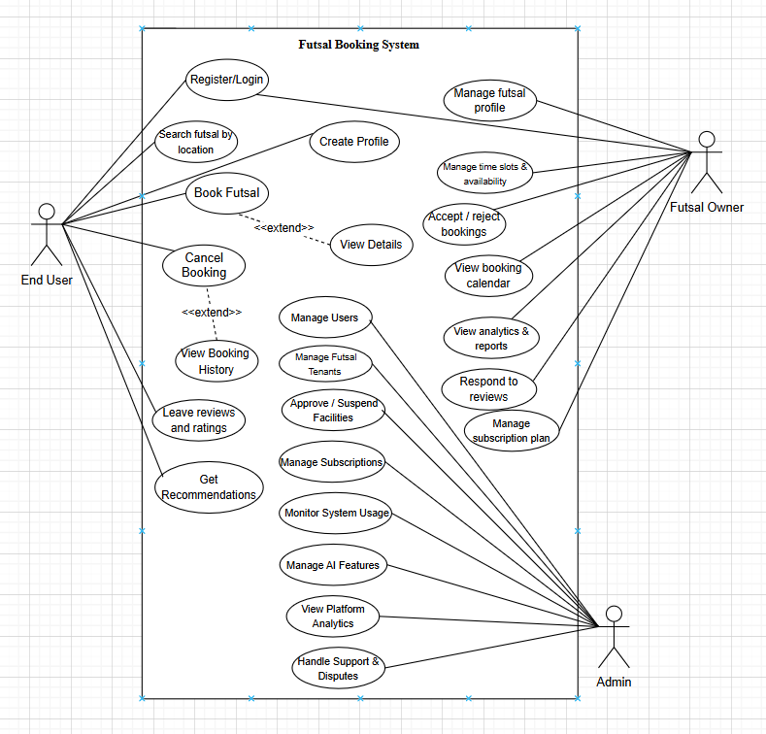
Figure 3.1 : Use Case Diagram of Futsal Bookings Management System

3.1.1.2 Non-Functional Requirements
Non-functional requirements are the requirements that specifies criteria that can be used to judge the operation of a system, rather than specific behaviors. They are contrasted with functional requirements that define specific behavior or functions. The non- functional requirements of the system are:
- Usability: The interface should be simple, clean and easy to use for all users (admin, teacher and student).
- Reliability: System is accurate, as we don’t use many components and thus provides the user specified results in specific time duration.
- Performance: System should handle multiple user requests simultaneously without slowing down.
- Scalability: The system should be designed so it can accommodate more users or institutions in the future without major redesign.
- Security: All sensitive data must be securely encrypted during storage and transmission. Only authorized users can access certain features, and all communication must be encrypted using HTTPS.
- Maintainability: The system should be easy to update and maintain, with a clear and modular architecture that supports future enhancements and feature upgrades.

3.1.1.3 Dataset Description
For this project, a custom synthetic dataset was created to test and validate the Futsal Booking and Management System workflow, particularly for sentiment analysis of user reviews and TF-IDF based review summarization. The dataset contains 1200 records with 5 attributes, designed to simulate real-world futsal court user review submissions. The dataset was synthetically generated using a Python script due to the unavailability of domain-specific public futsal review datasets on platforms such as Kaggle and Hugging Face. In addition, the review scenarios and rating patterns were prepared based on discussions among the three project team members, who are regular futsal players and were further validated by the project supervisor to ensure realistic and practical review data representation.
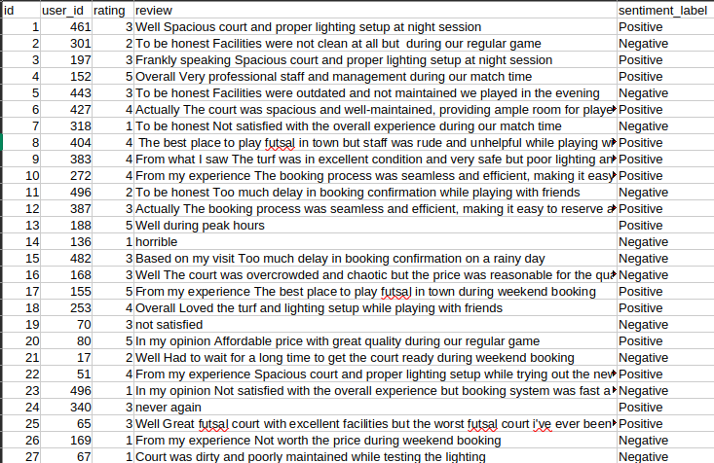
Figure 3.2 : Dataset records
The attributes include both categorical and numerical features describing each review record. The attributes are as follows:
- id: Unique identifier for each user review record.
- user_id: Unique identifier for the user who submitted the review.
- rating: Numerical rating provided by the user on a scale of 1 to 5, where 1–2 indicates a negative experience and 4–5 indicates a positive experience.
- review: The textual content of the user's review submitted after playing, used as input for TF-IDF feature extraction and sentiment classification.
- sentiment_score: A numerical probability score between 0.00 and 1.00 representing the confidence of the sentiment prediction, where values closer to 1.00 indicate stronger positive sentiment.
For sentiment classification, the sentiment category was derived from the rating values during preprocessing, where lower ratings represented negative sentiment and higher ratings represented positive sentiment. The review text data was preprocessed by removing stop words and applying tokenization before TF-IDF vectorization to make the textual data suitable for machine learning analysis.
This dataset was synthetically prepared to simulate realistic futsal user review scenarios, providing a practical basis for testing the TF-IDF Review Feature Extraction Algorithm and the Logistic Regression Sentiment Classification Algorithm implemented within the Futsal Bookings and Management platform.

3.1.2 Feasibility Analysis
The proposed project’s viability is determined by the feasibility study:
I) Technical Feasibility
The futsal booking and management platform is a multi-tenant SaaS web application for managing court bookings, owner operations, and AI-based review analysis across multiple futsal facilities. It uses algorithms for real-time booking validation, location-based court recommendations, and machine learning for review sentiment analysis. Built with React, Node.js, Express.js, MySQL, and Scikit-learn, the system can be developed using freely available tools and existing web development knowledge without requiring specialized hardware.

ii) Operational Feasibility
The futsal booking and management system enables players to book courts in real time while allowing futsal owners to manage courts, schedules, pricing, and bookings through a web-based dashboard. It is accessible through any standard web browser, requires no additional software installation, and features a user-friendly interface that needs minimal training. Futsal owners only need to register their facilities and keep court availability updated.

iii) Economic Feasibility
The futsal booking and management system can be developed at minimal cost using free and open-source technologies such as the MERN stack, Scikit-learn, and NLTK. Development and deployment can be carried out using local environments and free-tier cloud services, requiring no significant financial investment.

iv) Schedule Feasibility

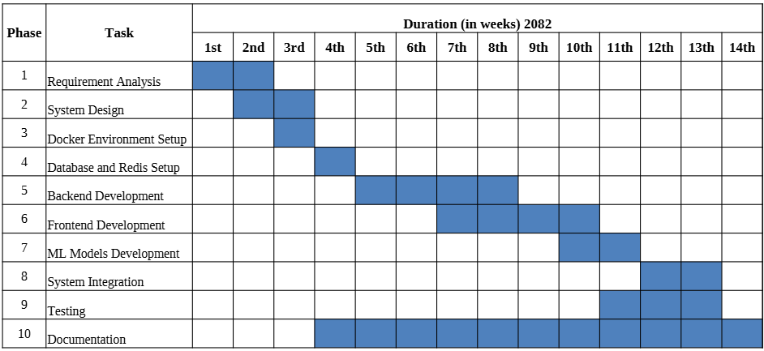
Figure 3.3 : Gantt Chart

The Futsal Booking and Management project is scheduled to be completed within 14 weeks through phases including requirement analysis, system design, environment setup, database configuration, backend and frontend development, machine learning integration, system testing, and documentation. An Agile development approach is followed, allowing overlapping tasks to ensure timely project completion.

3.1.3 Analysis
3.1.3.1 ER Diagram
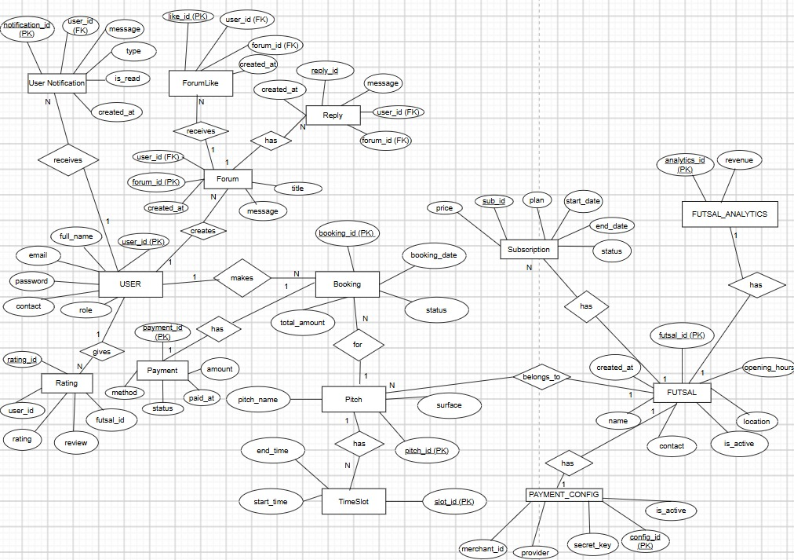
Figure 3.4 : ER Diagram

3.1.3.2 DFD level-0 Diagram
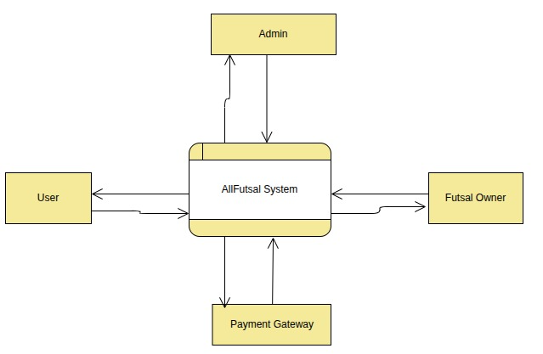

Figure 3.5 : DFD level-0 Diagram

3.1.3.3 DFD level-1 Diagram
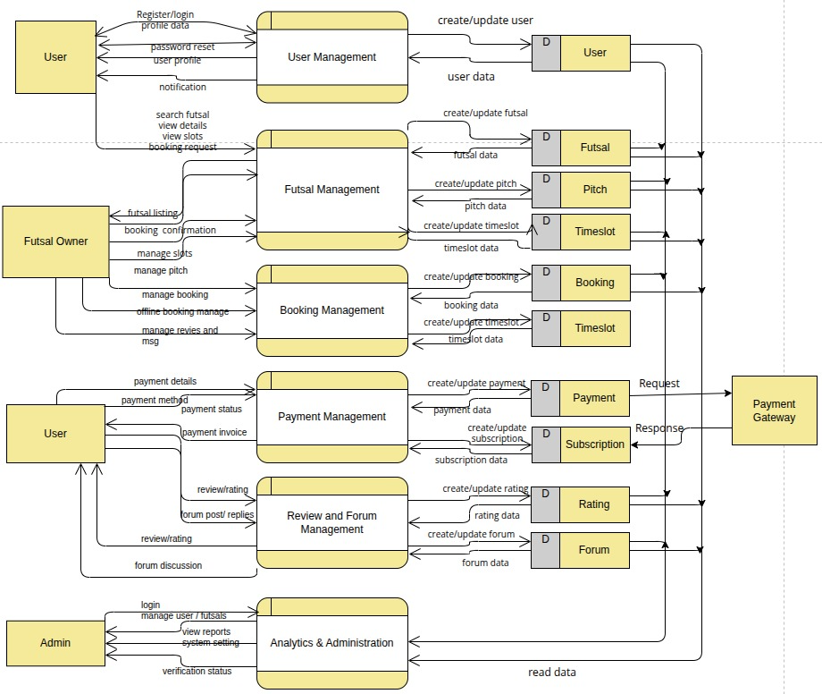
Figure 3.6 : DFD level-1 Diagram

3.1.3.4 DFD level-2 process 1 Diagram
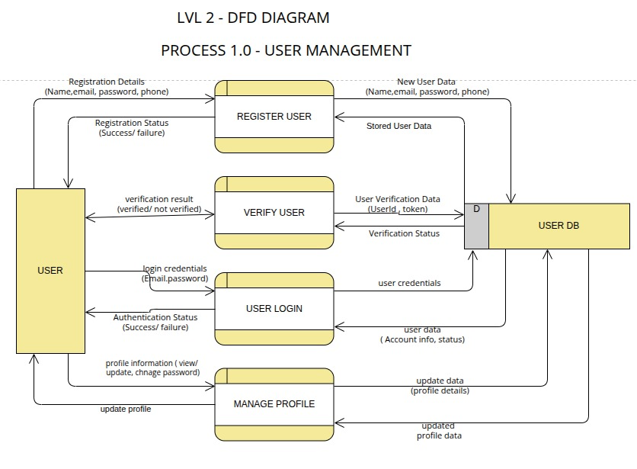
Figure 3.7 : DFD level-2 process 1 Diagram

3.1.3.5 DFD level-2 process 2 Diagram
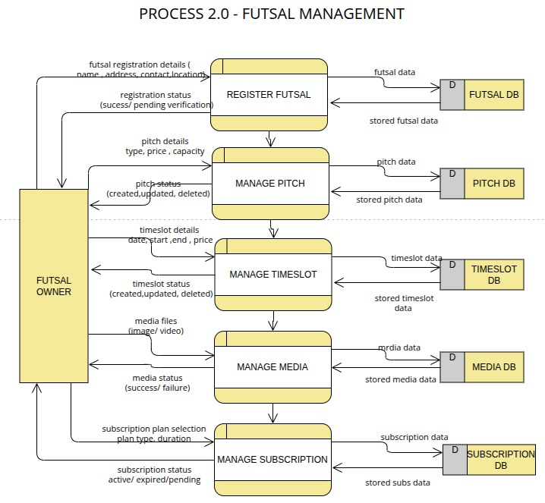
Figure 3.8 : DFD level-2 process 2 Diagram

3.1.3.6 DFD level-2 process 3 Diagram
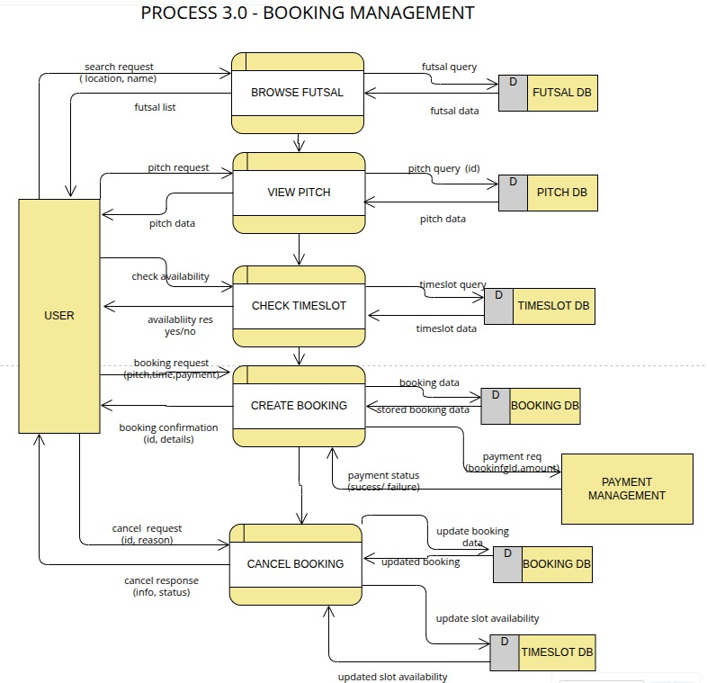
Figure 3.9 : DFD level-2 process 3 Diagram

3.1.3.7 DFD level-2 process 4 Diagram
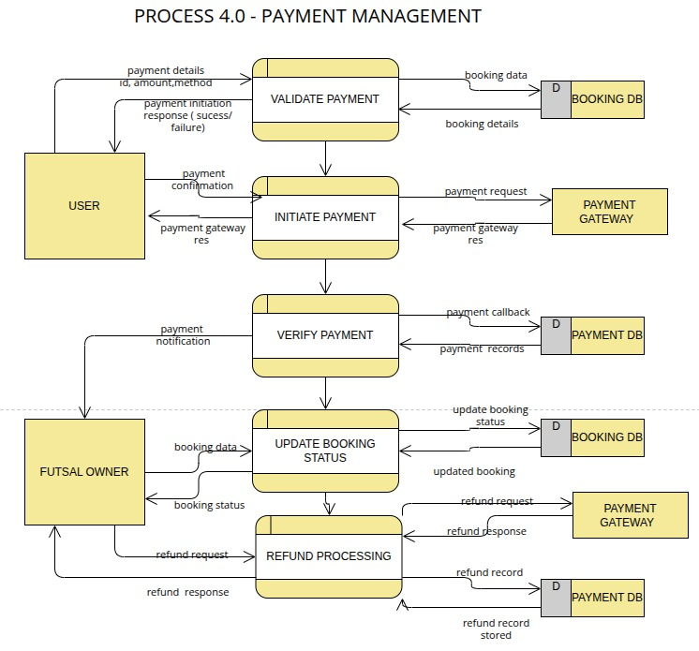
Figure 3.10 : DFD level-2 process 4 Diagram

3.1.3.8 DFD level-2 process 5 Diagram
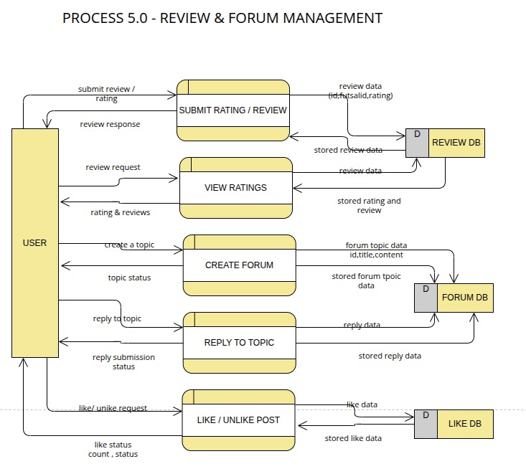
Figure 3.11 : DFD level-2 process 5 Diagram

3.1.3.9 DFD level-2 process 6 Diagram
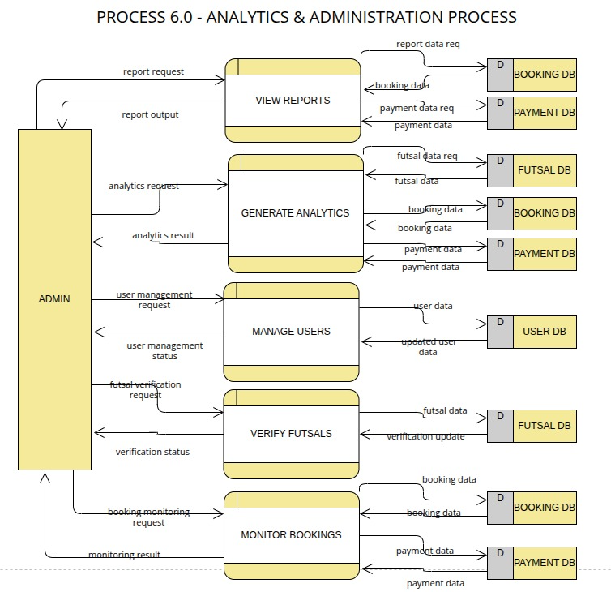
Figure 3.12: DFD level-2 process 6 Diagram

3.1.3.5 Sequence Diagram

Fig 3.13: Sequence Diagram of Futsal Bookings and Management System

CHAPTER FOUR
SYSTEM DESIGN
4.1 Design
System Design includes the means and methodologies to improve the management and control of the software development process. It includes structuring and simplifying the process using several diagrams and standardizing the development process by specifying the required activities and techniques to be implemented.
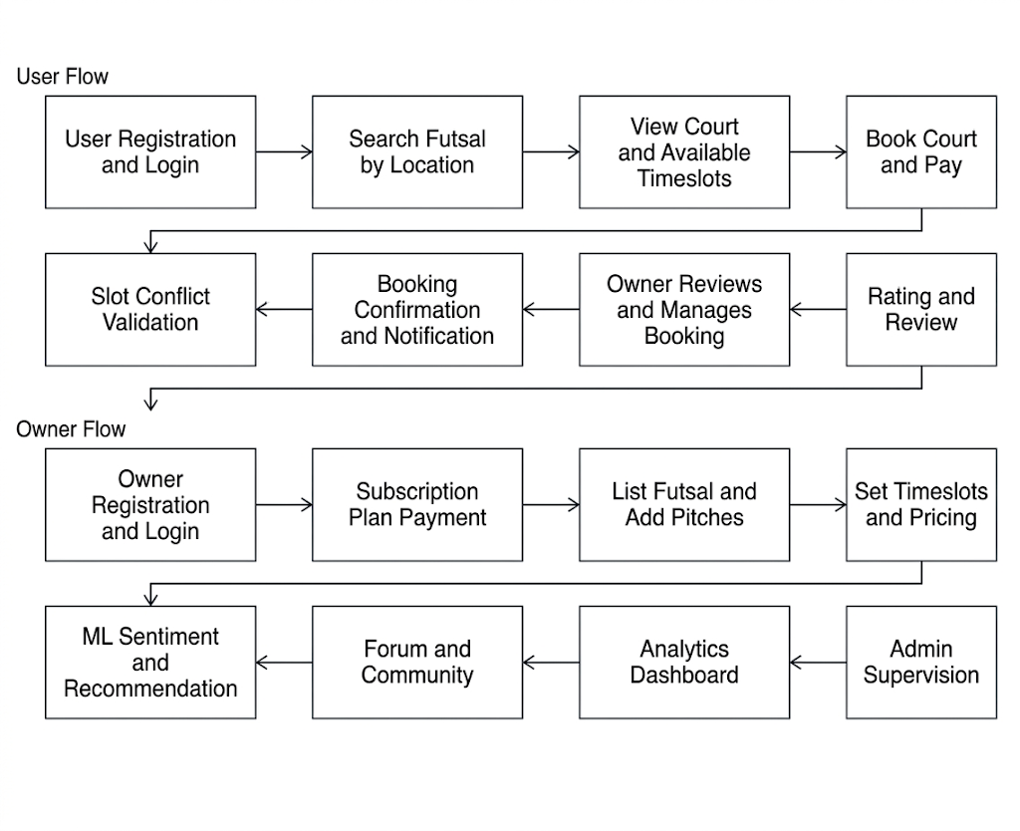
Fig 4.1: High-Level System Design of Futsal Bookings and Management System

The system architecture is shown in Figure 4.1. The procedures involved are:

User Registration and Login
Players register or log in using their credentials or Google OAuth to access the platform. The system validates user information, securely stores account details, and grants access to the user dashboard. From there, users can search futsals, manage bookings, and view booking history.

Search Futsal by Location
Users search for nearby futsal centers by entering a location or using their current location. The system applies the Haversine distance algorithm to recommend nearby venues and allows filtering by price, availability, and ratings. This helps users quickly find suitable courts.

View Court and Available Timeslots
Users can view detailed information about a futsal center, including facilities, pricing, and available courts. Real-time timeslot availability is displayed to ensure booking accuracy. Users can then choose their preferred court and schedule.

Book Court and Pay
After selecting a court and timeslot, users confirm their booking and complete the payment process. The system records the reservation details and updates the booking status. A successful payment finalizes the reservation.

Slot Conflict Validation
Before confirming a booking, the system checks for overlapping reservations using the Slot Conflict Prevention Algorithm. If a conflict exists, the user is prompted to choose another timeslot. Otherwise, the booking is successfully confirmed.

Booking Confirmation and Notification
Once the booking is completed, the system updates the database and confirms the reservation. Notifications containing booking details are sent to both the user and the futsal owner. This ensures all parties receive instant confirmation.

Rating and Review
After completing a booking, users can submit ratings and written reviews for the futsal center. Reviews are analyzed using TF-IDF and Logistic Regression to determine sentiment. The results help improve recommendations and provide useful feedback for future users.

Owner Registration and Login
Futsal owners register their business accounts by providing center information and contact details. The system creates a dedicated tenant account within the SaaS architecture. Owners can then access their management dashboard.

Subscription Plan Payment
Owners select and pay for a subscription plan to activate their futsal listing. The chosen plan determines the features and services available to them. Once payment is verified, the account becomes fully active.

List Futsal and Add Pitches
Owners create futsal center profiles by adding descriptions, facilities, and images. They can register multiple courts with individual specifications. This information becomes visible to users searching for futsal centers.

Set Timeslots and Pricing
Owners define available booking times and pricing for each court. They can update schedules, block unavailable slots, or change prices through the dashboard. The system synchronizes these changes for real-time availability.

ML Sentiment and Recommendation
The platform analyzes user reviews using machine learning to generate sentiment scores. It also combines review data with location information to recommend suitable futsal centers. This improves user experience and discovery.

Forum and Community
The platform includes a discussion forum where users and owners can share posts and interact. Community discussions support match arrangements, reviews, and general futsal topics. Administrators monitor content to maintain a healthy environment.

Analytics Dashboard
Owners access an analytics dashboard showing booking trends, revenue, occupancy, and customer activity. These insights help improve business decisions and operational planning. The dashboard provides a clear overview of performance.

4.2 Interface Design
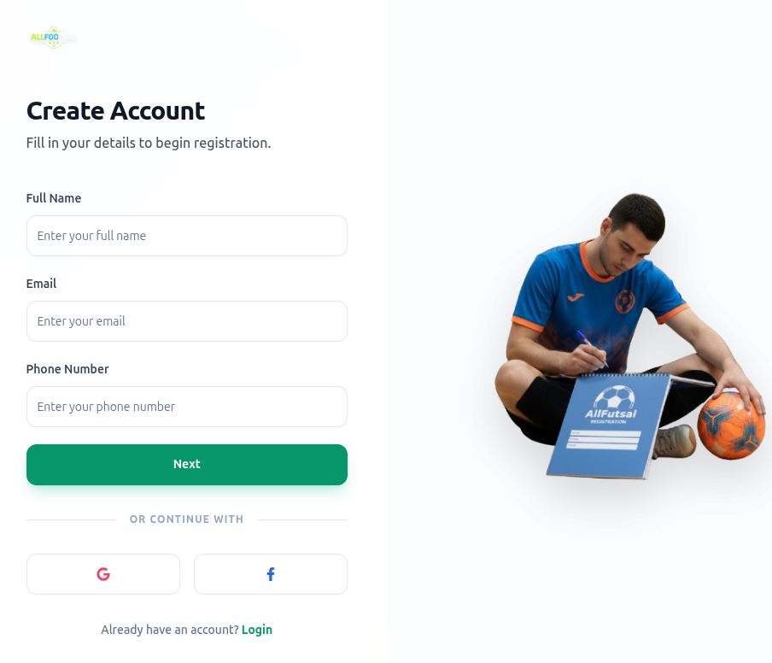

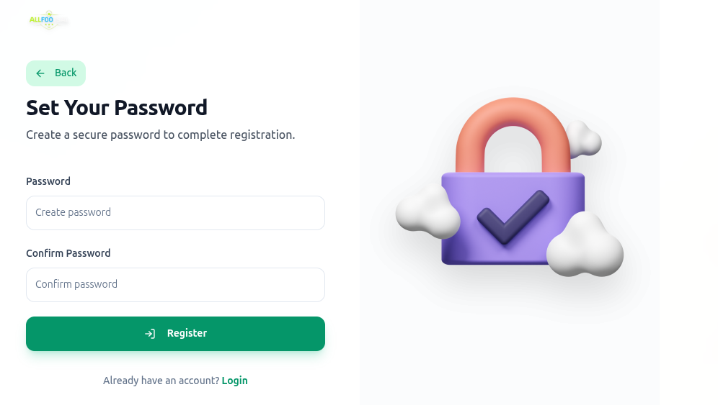
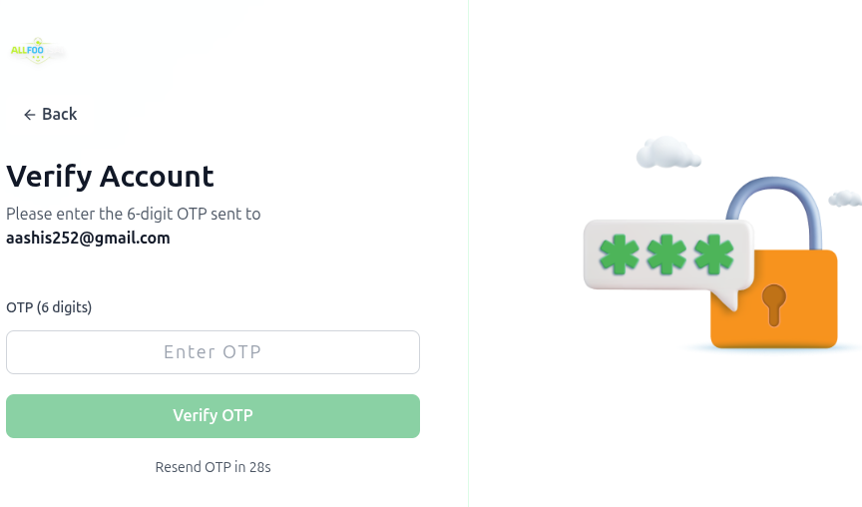
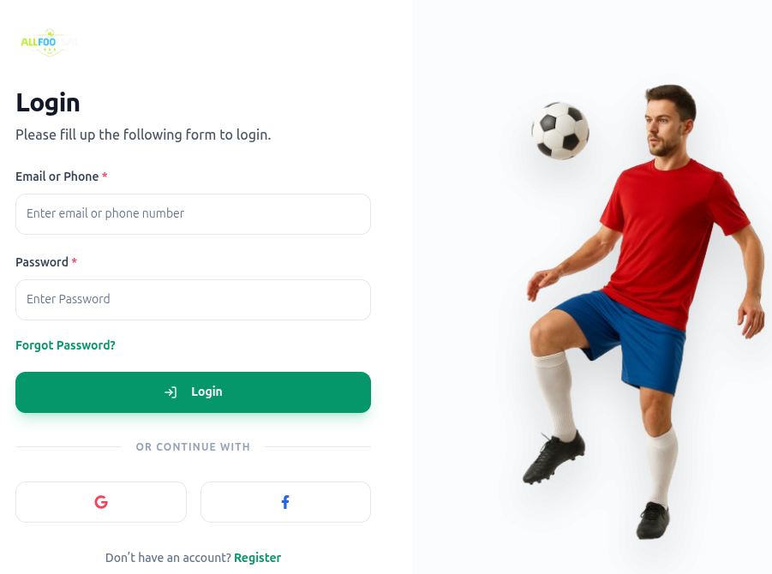
Figure 4.2: Registration and Login Page Design

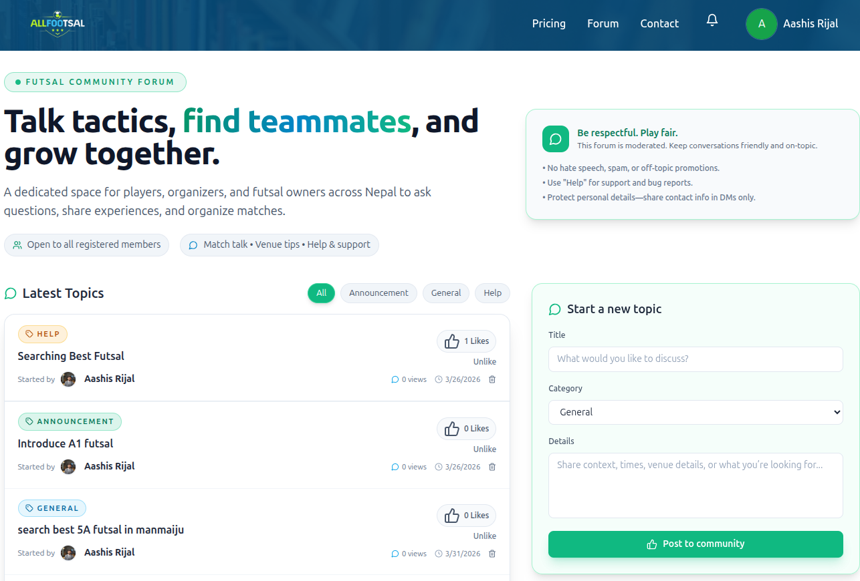
Figure 4.3 : Forum Page Design
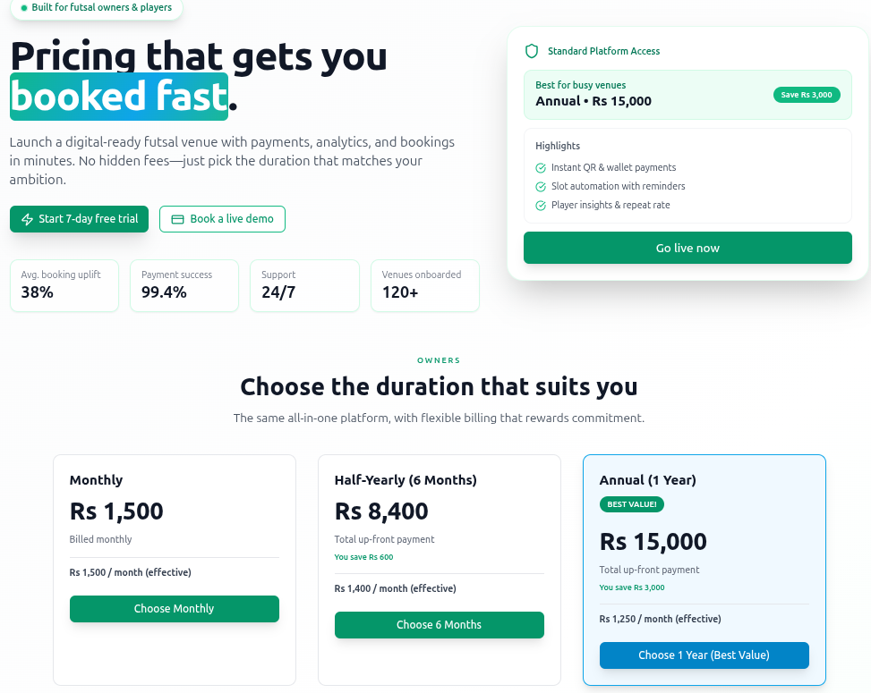
Figure 4.4: Pricing Page Design

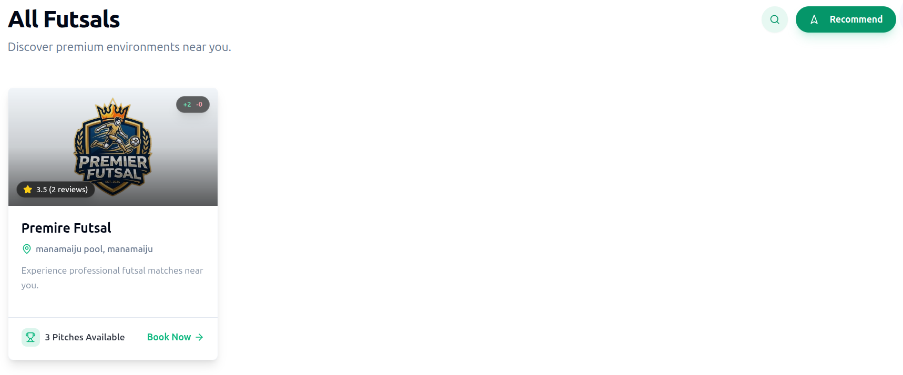
Figure 4.5: Futsal listing Page Design
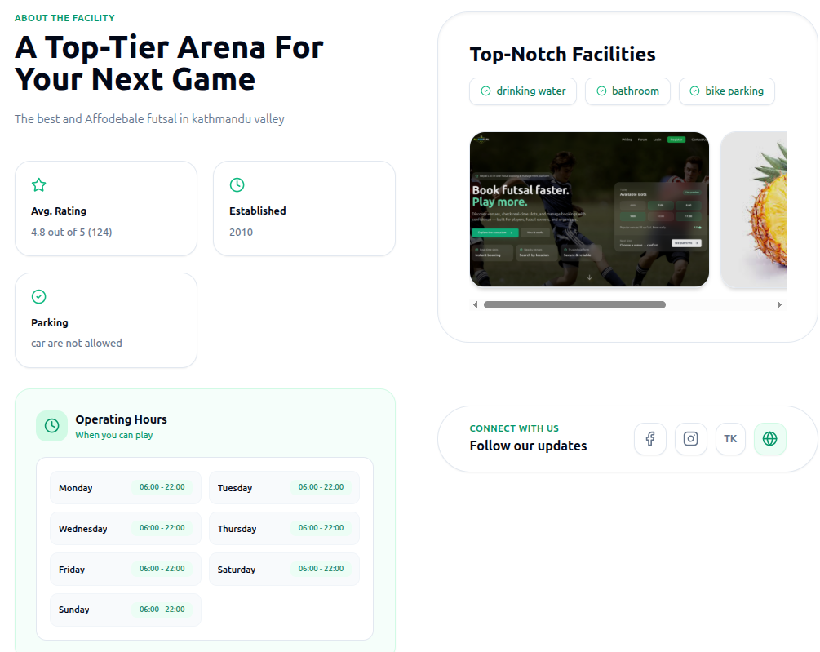
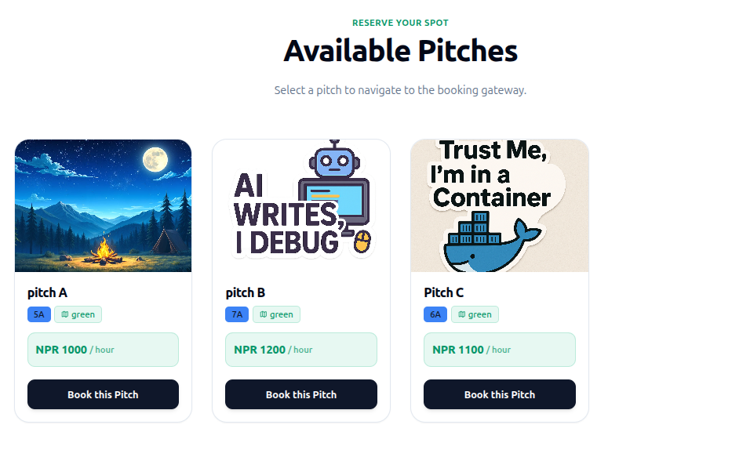
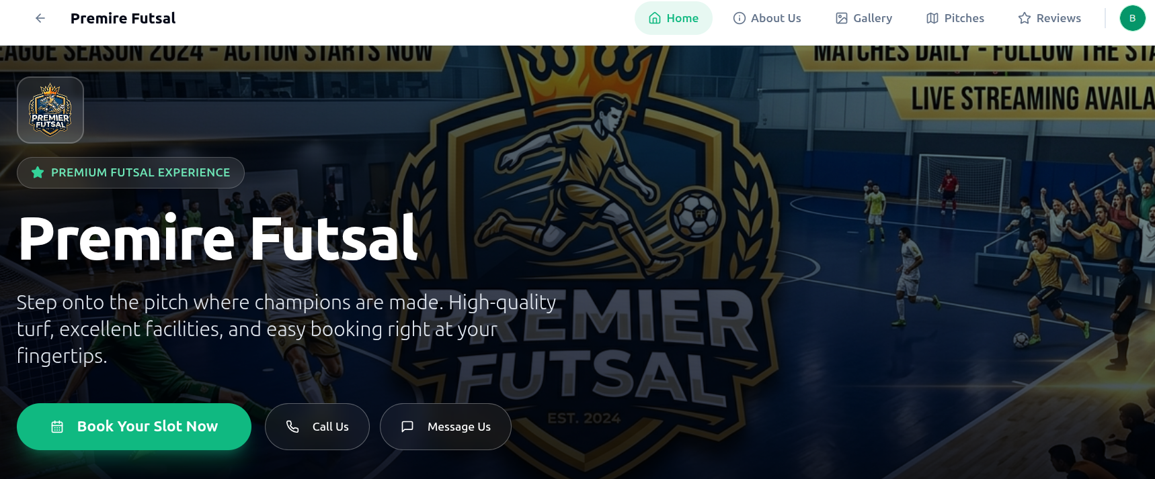
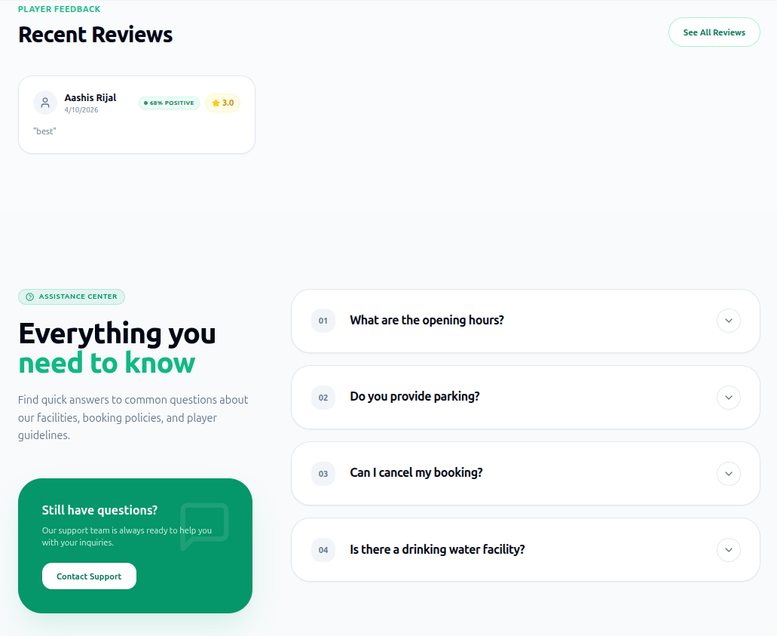
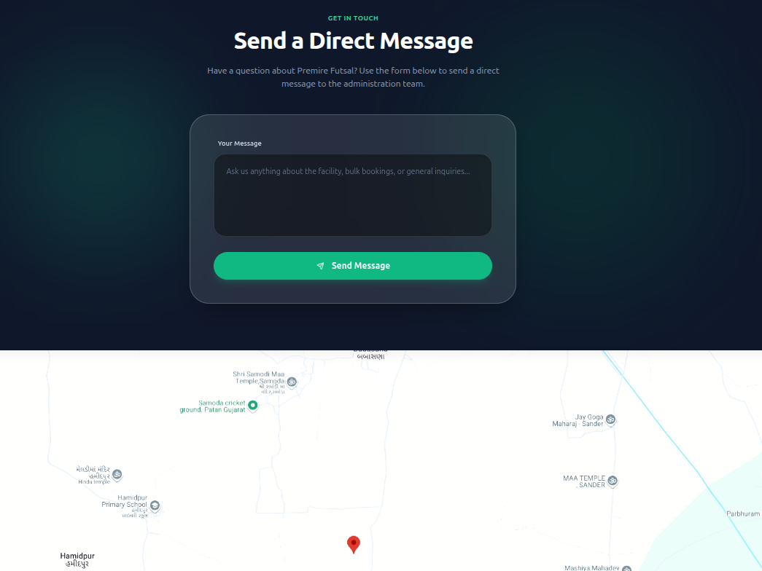
Figure 4.6 : Futsal Page Design

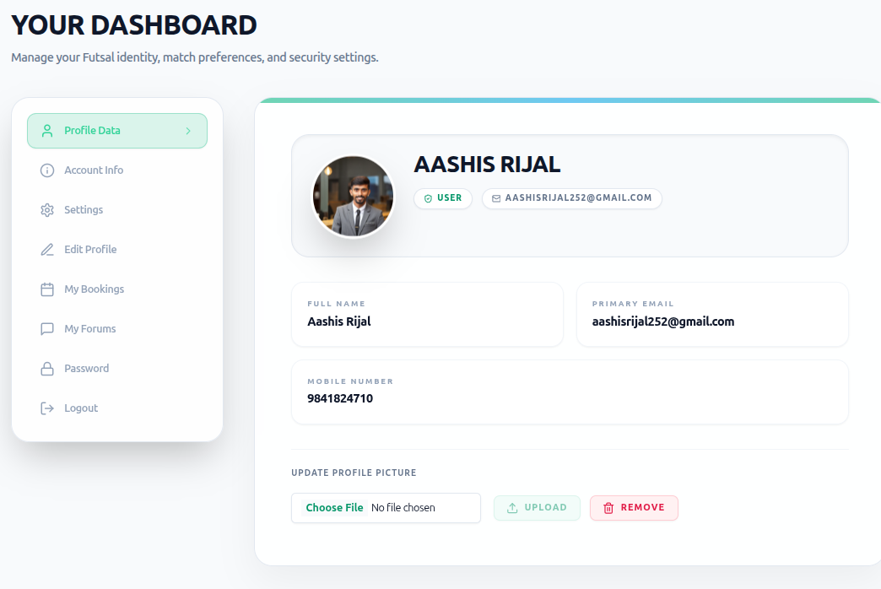
Figure 4.7 : User Profile page Design

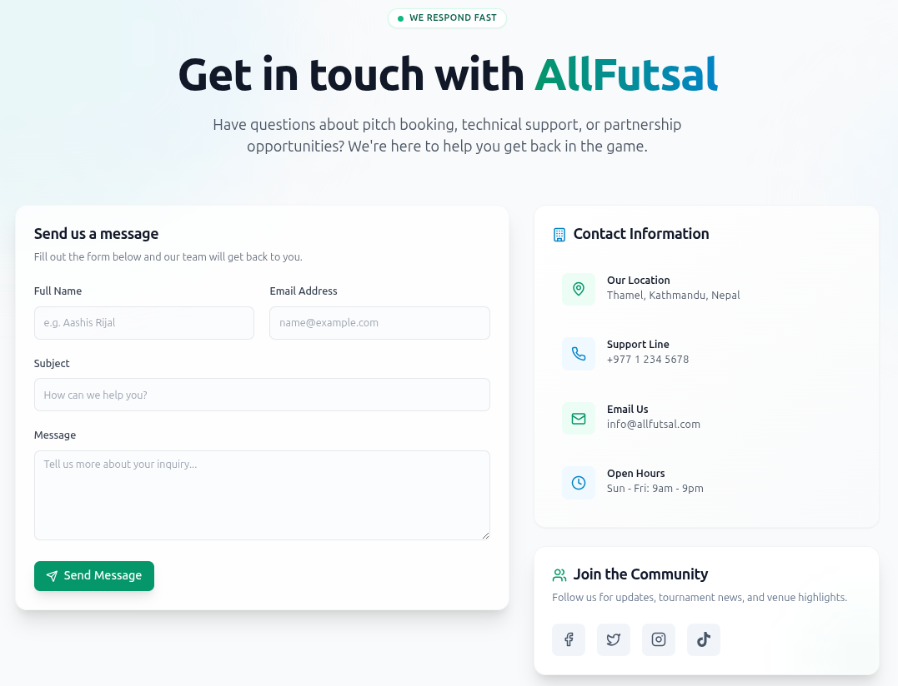
Figure 4.8 Contact page Design
4.3 Description of Algorithm

4.3.1 Location Distance Algorithm (Nearest Futsal Recommendation)
The Location Distance Algorithm is used to recommend nearby futsal centers to users based on their current geographical position. The system calculates the real-world distance between the user's location and each registered futsal center using the Haversine formula, which accurately computes the great-circle distance between two points on the surface of the Earth given their latitude and longitude coordinates.
The working flow of the algorithm can be described as follows:
User Location Detection: The system reads the user's current latitude and longitude coordinates, either through browser geolocation or a manually entered location search.
Futsal Center Coordinates Retrieval: The system retrieves the registered latitude and longitude coordinates of all active futsal centers stored in the database.
Distance Calculation: For each futsal center, the system computes the geographical distance from the user's location using the Haversine formula.
Sorting and Ranking: All futsal centers are sorted in ascending order of calculated distance, placing the nearest futsal centers at the top of the recommendation list.
Result Display: The sorted list of nearby futsal centers is returned to the user interface, where courts are displayed with their calculated distance from the user's current location, allowing users to make informed decisions based on proximity.
Mathematical Representation (Haversine Formula):
d = 2r × arcsin( √( sin²(Δφ/2) + cos(φ₁) × cos(φ₂) × sin²(Δλ/2) ) ) ------------------ (i)
Where:
d = Distance between the user and the futsal center
r = Radius of the Earth (6371 km)
φ₁ = Latitude of the user (in radians)
φ₂ = Latitude of the futsal center (in radians)
λ₁ = Longitude of the user (in radians)
λ₂ = Longitude of the futsal center (in radians)
Δφ = φ₂ − φ₁
Δλ = λ₂ − λ₁
By employing this algorithm, the futsal bookings and management platform ensures that users are always presented with the most geographically relevant futsal centers first, reducing search effort and improving the overall booking experience for players across different locations in Nepal.

4.3.2 Logistic Regression Algorithm (Sentiment Classification)
The Logistic Regression algorithm is used as a supervised machine learning classifier in the Futsal Bookings and Management system to automatically determine the sentiment of user-submitted reviews. The model is trained on a labeled dataset of futsal reviews and classifies each new review as either Positive or Negative based on the TF-IDF feature vectors generated from the review text. Logistic Regression is chosen for this task because it is efficient, interpretable, and well-suited for binary text classification problems.
The working flow of the algorithm can be described as follows:
Feature Input: The TF-IDF feature vectors generated from preprocessed user reviews are passed as input to the trained Logistic Regression model.
Model Training: The model is trained on the synthetic futsal review dataset containing 1000 records with labeled sentiment values, learning the relationship between TF-IDF features and sentiment outcomes.
Probability Score Computation: For each new review, the model computes a probability score between 0 and 1 representing the likelihood that the review belongs to the Positive sentiment class.
Threshold Classification: A decision threshold of 0.5 is applied to the computed probability score. If the probability is greater than or equal to 0.5, the review is classified as Positive sentiment. If the probability is less than 0.5, the review is classified as Negative sentiment.
Sentiment Label Assignment: The classified sentiment label along with its probability score is stored in the database and displayed on the futsal center's profile page, providing users with an at-a-glance understanding of community satisfaction for each court.
Mathematical Representation:
p = 1 / (1 + e^(−z)) -------------- (ii)
Where:
z = w₀ + w₁x₁ + w₂x₂ + … + wₙxₙ ------------- (iii)
Decision Rule:
Sentiment = Positive if p ≥ 0.5
Sentiment = Negative if p < 0.5
Where:
p = Predicted probability of Positive sentiment
z = Linear combination of input features and learned weights
w₀ = Bias term
w₁, w₂, …, wₙ = Learned weight coefficients for each TF-IDF feature
x₁, x₂, …, xₙ = TF-IDF feature values of the review
Furthermore, the integration of the Logistic Regression classifier with the TF-IDF feature extraction pipeline provides several additional advantages for the futsal bookings and management platform:
- The sentiment score is stored alongside each review record, enabling trend analysis of customer satisfaction over time.
- Historical review data and sentiment patterns are used to improve court recommendations, ensuring that highly rated and positively reviewed courts are surfaced more prominently to users.
- Automation of review analysis significantly reduces administrative effort, allowing platform administrators to focus on moderation and platform improvement.

Overall, the combination of the Haversine Location Distance Algorithm and the Logistic Regression Sentiment Classification Algorithm provides the futsal bookings and management platform with a robust, intelligent and efficient foundation for managing bookings, recommending courts, and analyzing user feedback in a fair, automated, and data-driven manner.
CHAPTER FIVE
IMPLEMENTATION AND TESTING
5.1 Implementation
System Implementation concerns with building a properly working system, installing it and finalizing system and user documentation. Implementation also involves closing down projects. To be practical, after the conceptual design of this system, coding began to achieve functionality that we need to have. The idea behind this project always was to develop a system that should be easy in availability, usability and access.

5.1.1 Coding Tools
Programming tools are software and technologies used to design, develop, test, manage, and maintain a system. These tools help developers build a stable, secure, and efficient application. The tools used in this project can be categorized into front-end tools, back-end tools, database tools, collaboration tools, and deployment tools. Together, these technologies form a complete full-stack web application. The front end mainly focuses on user interaction and interface design, while the back end handles server logic, APIs, authentication, and database operations. The tools and technologies used in this project are described below.

Front End
The front end is the user-facing part of the application that allows users to interact with the system. In this project, React.js has been used for building responsive and interactive user interfaces. HTML, CSS, and JavaScript were also used to design and style the application pages.

Back End
The back end handles business logic, API management, authentication, and communication with the database. Node.js and Express.js were used to develop scalable RESTful APIs and manage server-side operations efficiently.

Database and Cache
MySQL was used as the primary relational database for storing user information, bookings, futsal details, and reviews. Redis was used for caching and real-time slot availability management to improve system performance and reduce response time.

Development and Collaboration Tools
GitHub was used for version control and source code management. Trello was used for project planning, task management, and tracking development progress. Slack was used for team communication and collaboration during the development process. Draw.io was used to create UML diagrams, flowcharts, ER diagrams and system architecture designs.

Deployment and Containerization Tools
Docker was used for containerization to ensure consistent development and deployment environments. It helped simplify application setup, dependency management and deployment processes across different systems.

Additional Tools and Technologies
Postman was used for API testing and debugging. JWT (JSON Web Token) was used for authentication and authorization. Cloudinary was used for storing and managing uploaded images and media files. These tools together helped in building a reliable, secure, and scalable futsal booking platform.

5.1.2 Implementation Details of Modules
This project can be decomposed into the following modules:

1. User Registration and Authentication Module
The User Registration and Authentication Module enables users and futsal owners to securely register and log into the system. User credentials are protected using secure password hashing and JSON Web Token (JWT) authentication, ensuring that plain-text passwords are never stored. The module sample code is provided in Appendix A.1, while the design is presented in Appendix B.1.

2. Futsal Management Module
The Futsal Management Module allows futsal owners to manage their futsal centers efficiently by adding and updating details such as futsal name, location, available pitches, pricing, and time slots, ensuring that all futsal-related information is properly stored, maintained, and displayed to users for accurate and effective system operation. Futsal management module sample code are included in Appendix A.2 , while the sample design is presented in Appendix B.2.

3. Booking Management Module
The Booking Management Module handles the core functionality of the system by allowing users to select available time slots and book futsal courts, while validating each booking request by checking slot availability and preventing overlapping bookings to ensure that all bookings are accurately recorded and managed in the system. Bookings management module sample code are included in Appendix A.3, while the design is presented in Appendix B.3.

4. Review and Sentiment Analysis Module
The Review and Sentiment Analysis Module enables users to submit reviews and ratings for futsal centers, where the system processes the textual feedback using machine learning techniques such as TF-IDF and Logistic Regression to classify the sentiment as positive or negative, helping futsal owners understand user feedback and improve their services. Review and sentiment Analysis module sample code are included in Appendix A.4, while the design is presented in Appendix B.4.

5. Forum Module
The Forum Module provides a platform for users and futsal owners to interact by posting queries, discussions, and responses related to futsal services, allowing users to share experiences, ask questions, and provide suggestions, thereby enhancing user engagement and building a community within the system. Forum module sample code are included in Appendix A.5, while the design is presented in Appendix B.5.

6. Admin Management Module
The Admin Management Module is responsible for overseeing the entire system by allowing administrators to manage users, futsal owners, bookings, and overall system activities, ensuring proper monitoring, maintaining system integrity, and providing control over the platform. Admin management module code and design are included in Appendix A.6, while the design is presented in Appendix B.6.

7. Payment Management Module
The Payment Management Module handles the payment process for booking futsal slots by supporting integration with digital payment systems such as Khalti and eSewa, ensuring that all transactions are securely processed and properly recorded in the system. Payment management module code and design are included in Appendix A.7, while the design is presented in Appendix B.7.

5.2 Testing
Testing is an important phase in system development that ensures the system functions correctly, efficiently, and securely according to the specified requirements, and it helps in identifying errors, improving performance, and ensuring reliability.
5.2.1 Unit Testing

Table 5.1: Unit Test Cases
Test Case ID | Test Case Description | Input Data | Expected Result | Actual Result | Status
UT01 | User Registration | Email: adhikaribibek583@gmail.com | User registered successfully | User registered successfully | Pass
UT02 | User Login | Email: adhikaribibek5@gmail.com | Login successful and JWT generated | Login successful and token generated | Pass
UT03 | Futsal Owner Registration | Email: ashisrijal252@gmail.com | Owner registered successfully | Owner registered successfully | Pass
UT04 | Login with wrong email | Email: shisrijal252@gmail.com | Login Failed Error | Login Failed Error | Pass
UT05 | Slot Availability Check | Valid time slot | Slot available | Slot available | Pass
UT06 | Slot Conflict Prevention | Same time slot | Booking rejected | Booking rejected | Pass
UT07 | Review Submission | Good futsal service | Review stored successfully | Review stored successfully | Pass
UT08 | Sentiment Analysis | Positive text | Classified as Positive | Classified as Positive | Pass
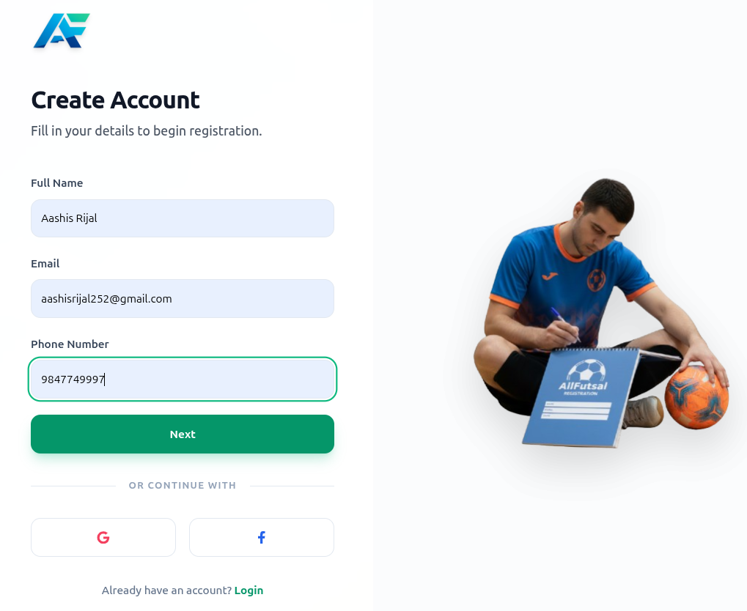
Figure 5.1 : Test Scenario - User Registration
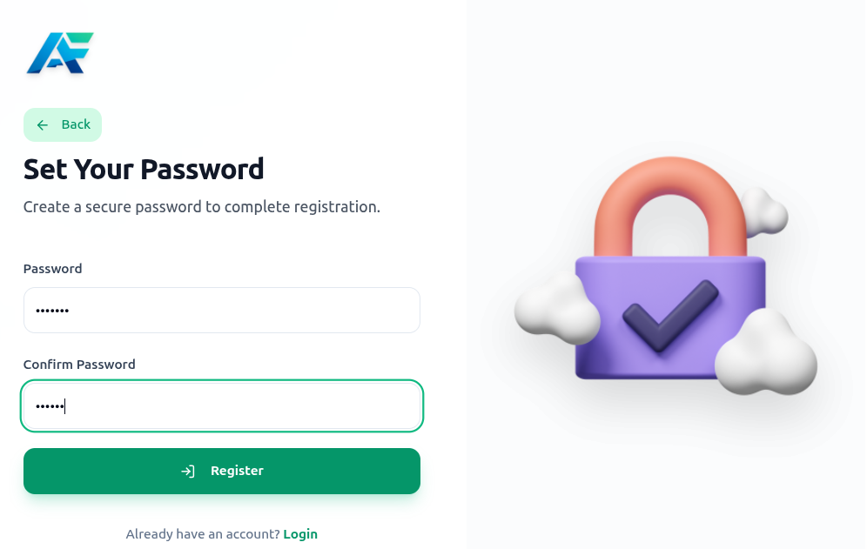
Figure 5.2 : Test Scenario - Set Password
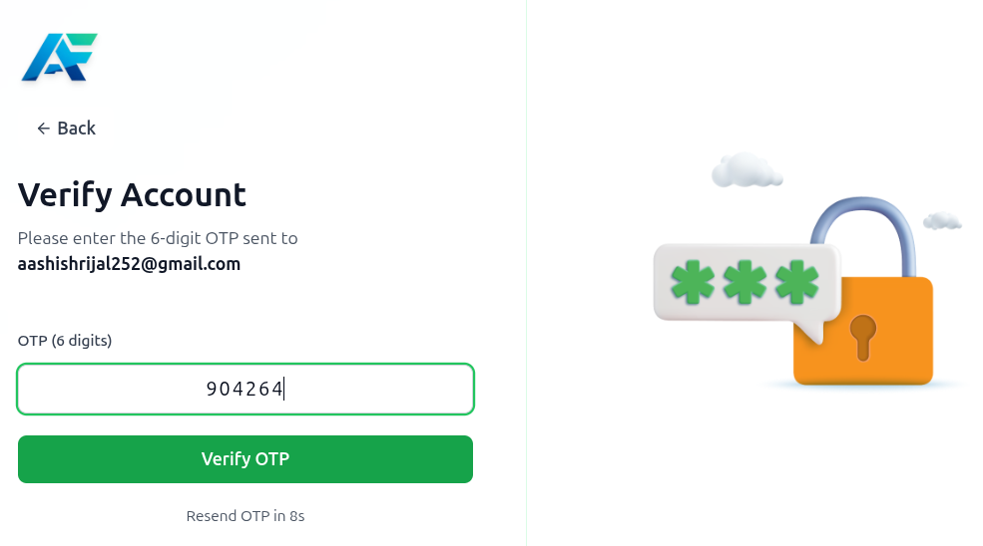
Figure 5.3 : Test Scenario - Verify Account

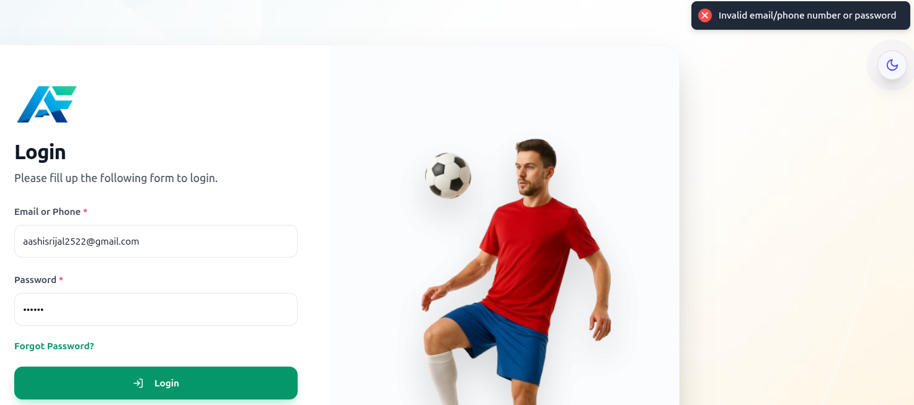
Figure 5.4: Test Scenario - User Login with invalid email

5.2.2 Forum Feature Testing
Forum feature testing was conducted to verify that users can effectively interact within the system by creating posts, asking questions, and responding to discussions, ensuring that all forum-related functionalities operate correctly, data is properly stored, and user interactions are handled efficiently without errors.

Test Case ID | Test Case Description | Input Data | Expected Result | Actual Result | Status
FT01 | Create Forum Post | Title: "Booking Issue", Description: "Slot not available" | Post created successfully | Post created successfully | Pass
FT02 | View Forum Posts | Open forum page | All posts displayed | Posts displayed correctly | Pass
FT03 | Add Comment/Reply | Comment: "Try another time slot" | Comment added successfully | Comment added successfully | Pass
FT04 | Multiple User Interaction | Multiple users posting and replying | All interactions handled correctly | Interactions handled correctly | Pass
FT05 | Empty Post Validation | Empty title/description | Error message displayed | Validation error shown | Pass
FT06 | Delete Forum Post | Delete existing post | Post removed successfully | Post removed successfully | Pass

Table 5.2: Test Cases for Forum Feature
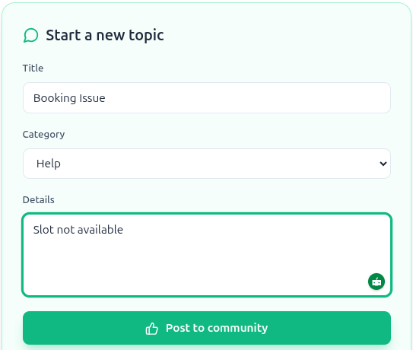
Figure 5.5: Test Scenario - Create Forum post

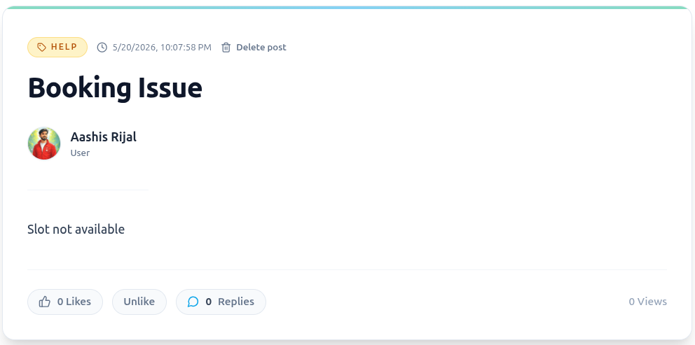
Figure 5.6 : Test Scenario - View Forum post

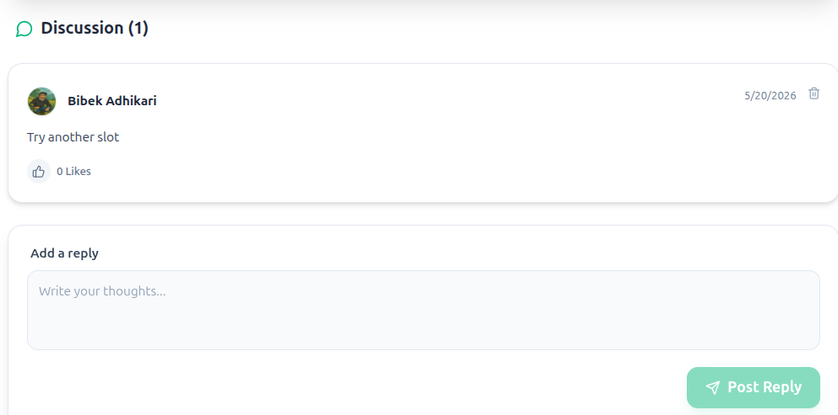
Figure 5.7 : Test Scenario- Forum Comment

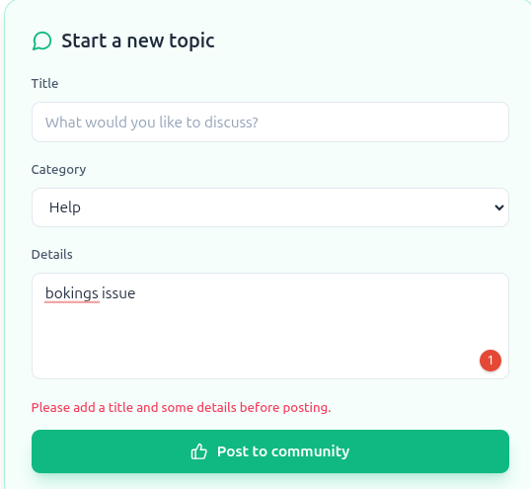
Figure 5.8 : Test Scenario - Empty validation
5.2.3 Payment Feature Testing
The following table presents the most critical unit test cases for the payment module.

Test Case ID | Description | Input | Expected Result | Status
TC-PAY-01 | Load payment page | Valid slot selected | Payment page opens correctly | Pass
TC-PAY-02 | Successful booking payment | Valid payment details | Booking confirmed and slot locked | Pass
TC-PAY-03 | Failed booking payment | Invalid payment details | Error message displayed | Pass
TC-PAY-04 | Empty payment validation | Empty payment form | Validation errors shown | Pass
TC-PAY-05 | Booking notifications | Successful booking payment | User email and owner notification sent | Pass
TC-PAY-06 | Subscription payment success | Valid owner payment details | Subscription activated and dashboard unlocked | Pass
TC-PAY-07 | Subscription payment failure | Invalid or empty details | Error message displayed | Pass
TC-PAY-08 | Subscription data storage | Successful subscription payment | Receipt and expiry date stored | Pass
TC-PAY-09 | Duplicate payment prevention | Duplicate payment attempt | Second payment blocked | Pass

Table 5.3: Test Cases for Payment Feature

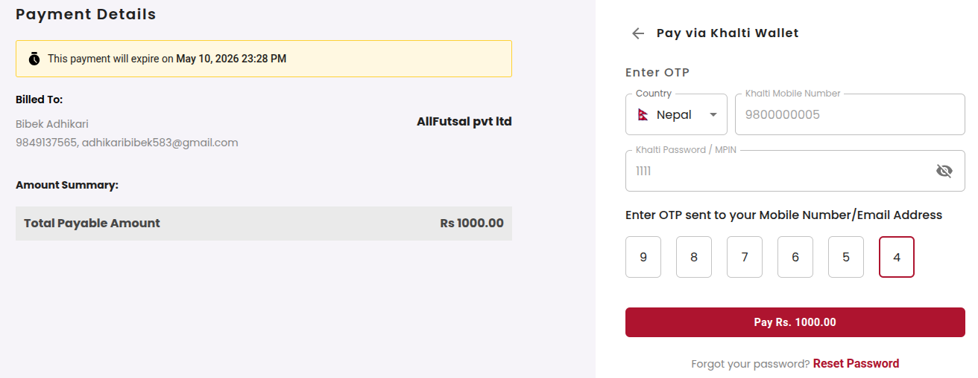
Figure 5.9 : Test Scenario- Payment Initiate


Figure 5.10 : Test Scenario- Payment Successful
5.2.4 Booking Feature Testing
The following table presents the most critical unit test cases for the booking module.
Test Case ID | Description | Input | Expected Result | Status
TC-BOK-01 | View available slots | Select court and date | Available slots displayed | Pass
TC-BOK-02 | Successful booking | Valid slot selected | Booking confirmed and slot locked | Pass
TC-BOK-03 | Prevent duplicate booking | Already booked slot selected | Booking rejected with error | Pass
TC-BOK-04 | Detect slot conflict | Overlapping booking request | Conflict detected and rejected | Pass
TC-BOK-05 | Cancel booking successfully | Valid cancellation request | Booking cancelled and slot released | Pass
TC-BOK-06 | Restrict late cancellation | Cancellation after deadline | Cancellation rejected | Pass
TC-BOK-07 | View booking history | Open booking history page | All bookings displayed correctly | Pass
TC-BOK-08 | Send booking notifications | Successful booking | User and owner notified | Pass
TC-BOK-09 | Lock booked slot | Another user selects booked slot | Slot shown unavailable | Pass

Table 5.4 : Test Cases for Booking Feature

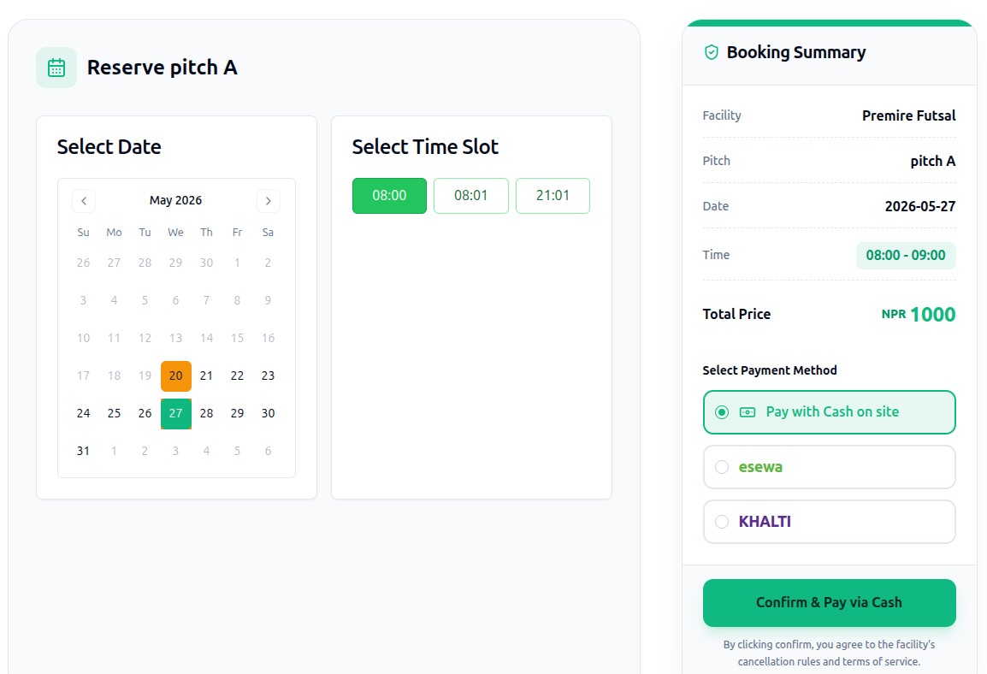
Figure 5.11 : Test Scenario -View available slot

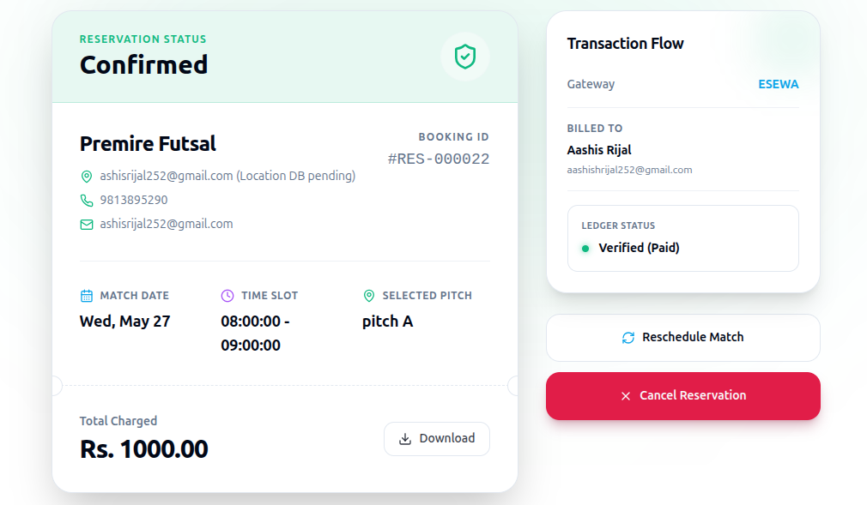
Figure 5.12 : Test Scenario- Booking Successful
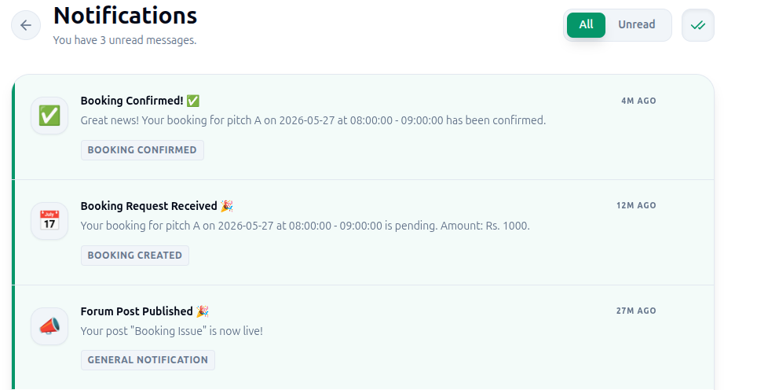
Figure 5.13 : Test Scenario - Booking Notification
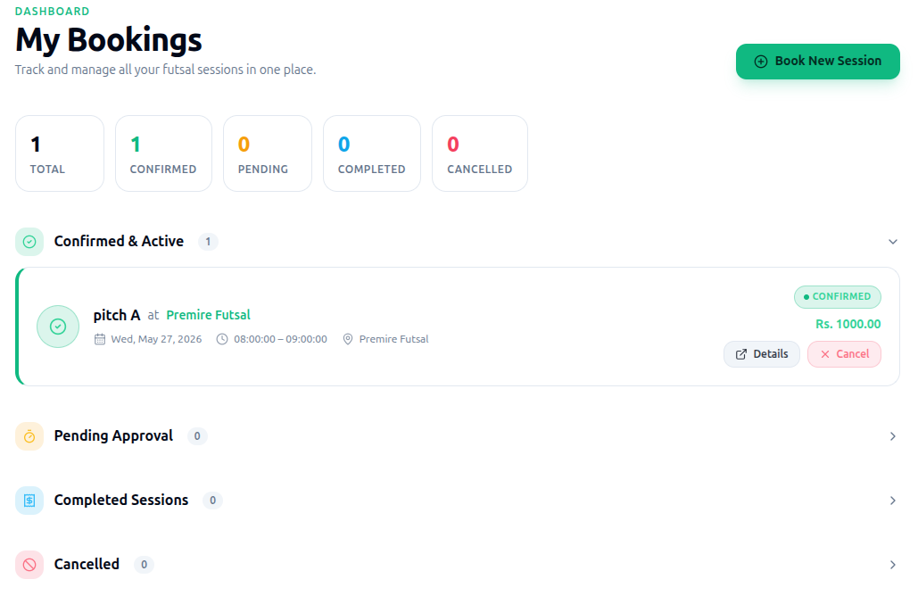
Figure 5.14 : Test Scenario - Booking History
5.2.5 Futsal Owner Feature Testing
Unit testing verifies that the core futsal owner management features function correctly. The following table presents the most critical unit test cases for the futsal owner module.

Test Case ID | Description | Input | Expected Result | Status
TC-OWN-01 | Create futsal listing | Valid center details | Listing published successfully | Pass
TC-OWN-02 | Add multiple courts | Valid court details | Courts added correctly | Pass
TC-OWN-03 | Set slots and pricing | Valid slot and price data | Timeslots and pricing saved | Pass
TC-OWN-04 | Approve booking | Approve pending booking | Booking confirmed and user notified | Pass
TC-OWN-05 | Reject booking | Reject booking with reason | Booking rejected and user notified | Pass
TC-OWN-06 | Block unavailable slot | Mark slot unavailable | Slot blocked from booking | Pass
TC-OWN-07 | View analytics | Open analytics dashboard | Booking and revenue data displayed | Pass
TC-OWN-08 | Handle subscription expiry | Expired and renewed subscription | Listing hidden and restored after renewal | Pass

Table 5.5: Test Cases for Futsal Owner Feature

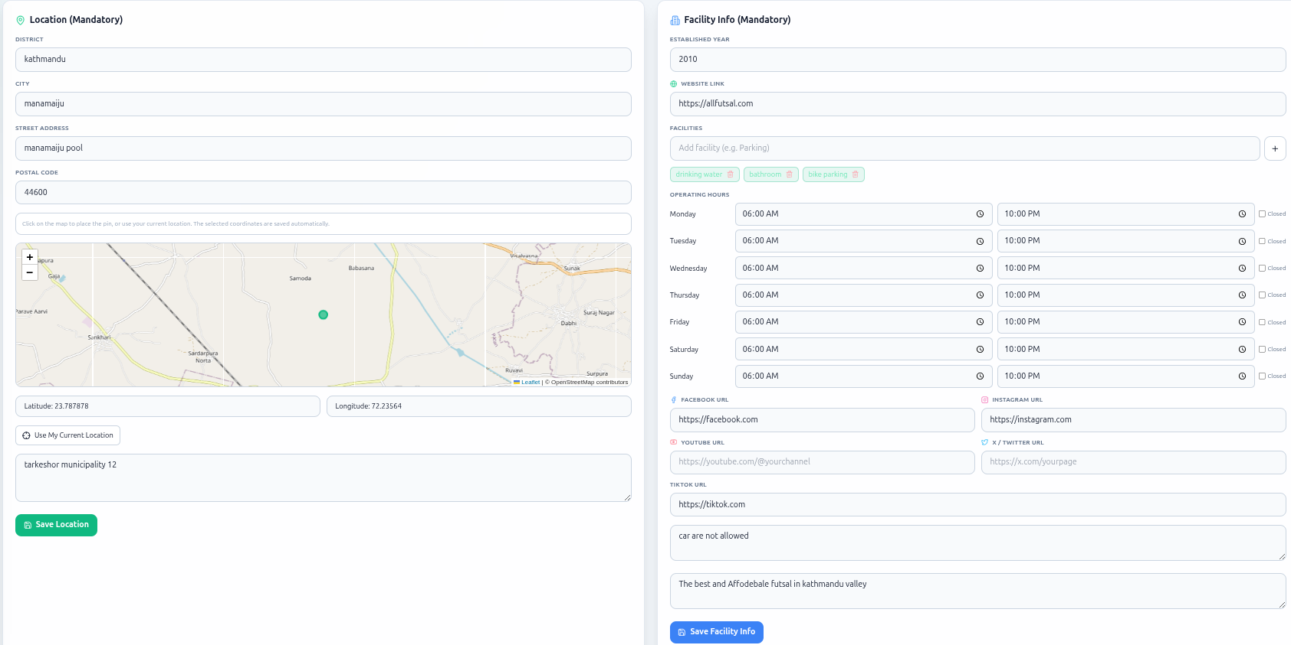
Figure 5.15 : Test Scenario - Listing Futsal

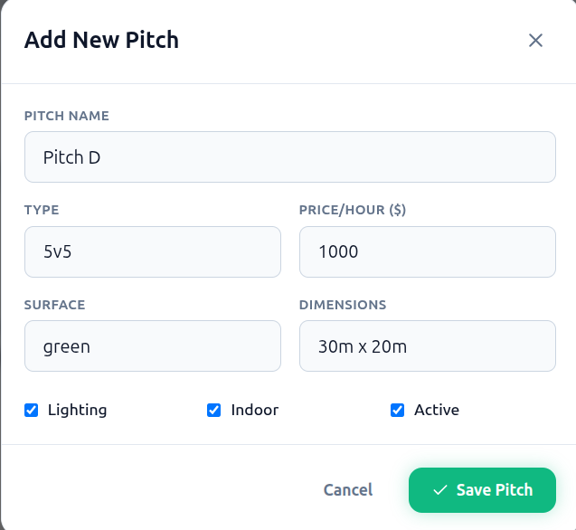
Figure 5.16 : Test Scenario - Add pitch

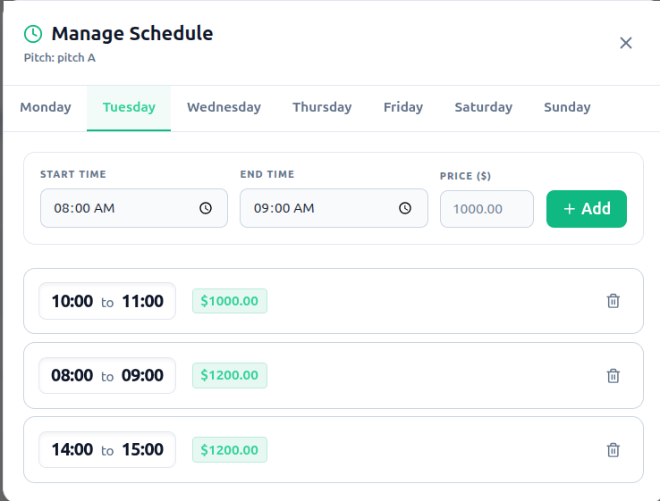
Figure 5.17 : Test Scenario -Manage Schedule and Price

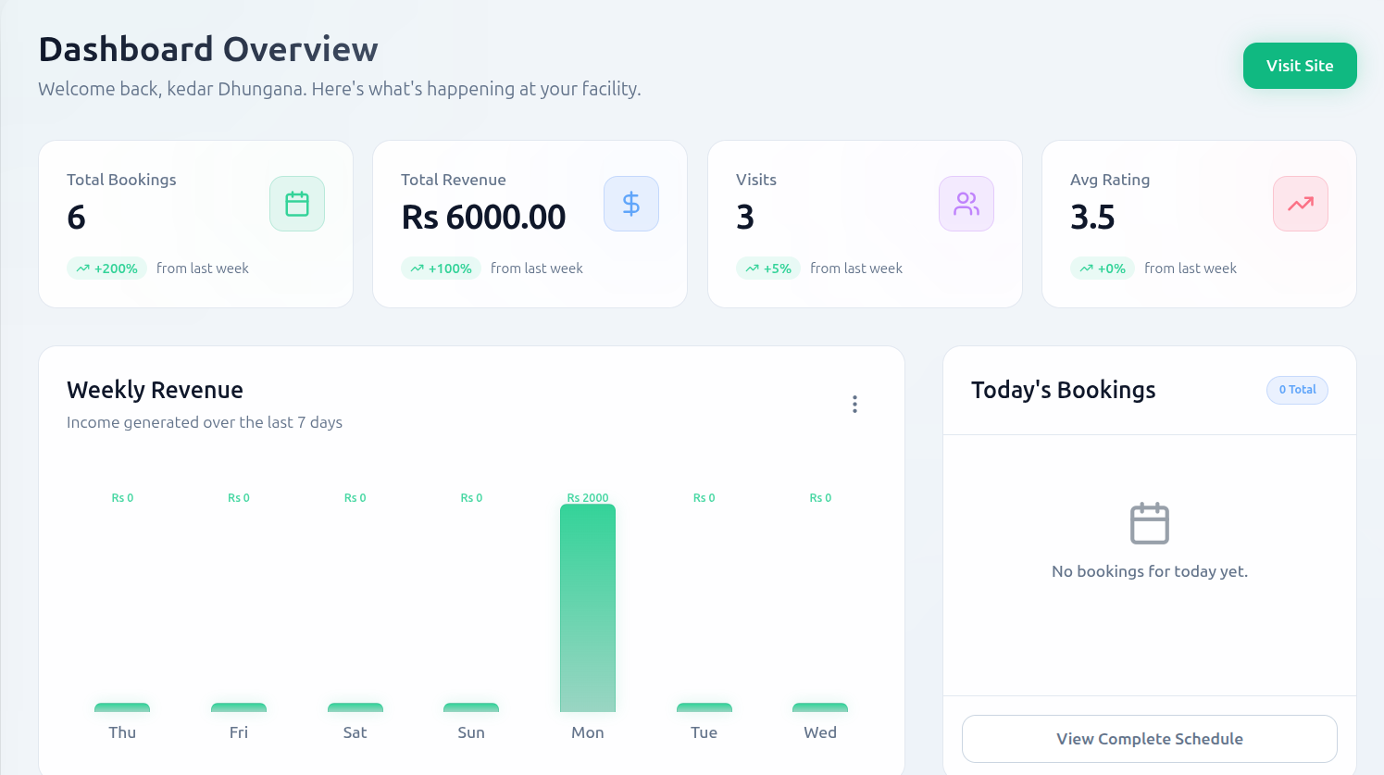
Figure 5.18 : Test Scenario - Anaytices dashboard
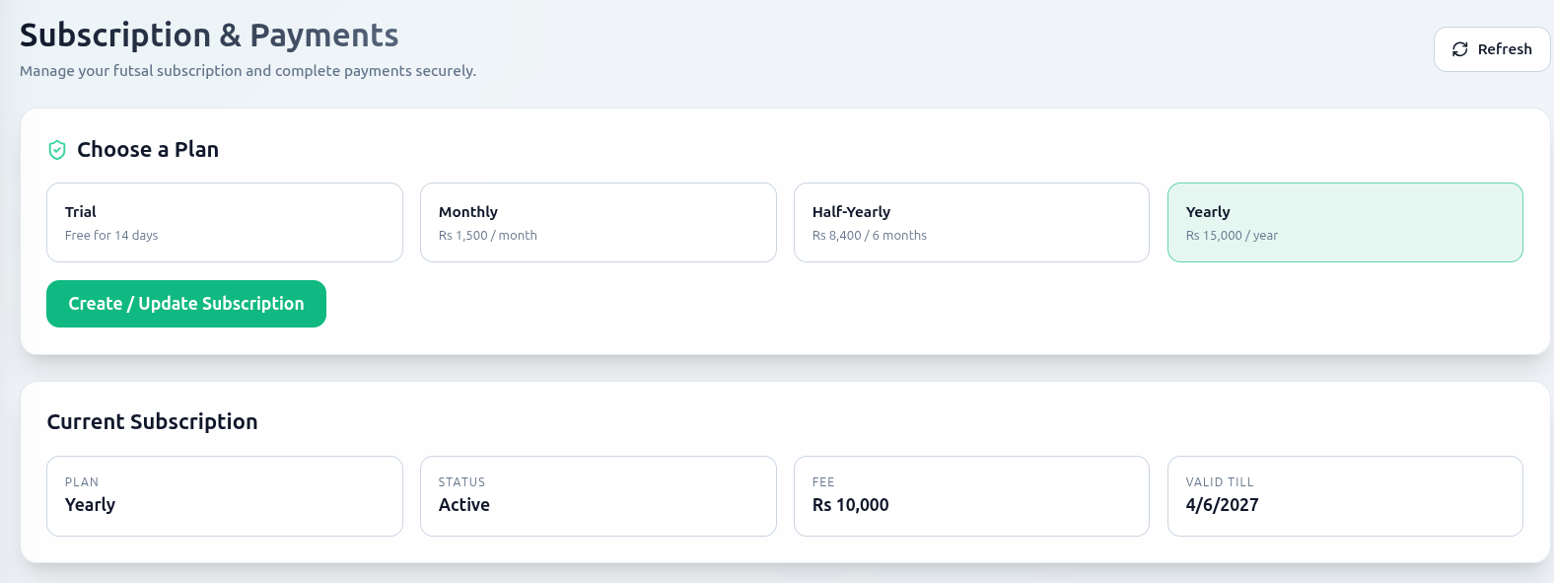
Figure 5.19 : Test Scenario - Handle Subscription

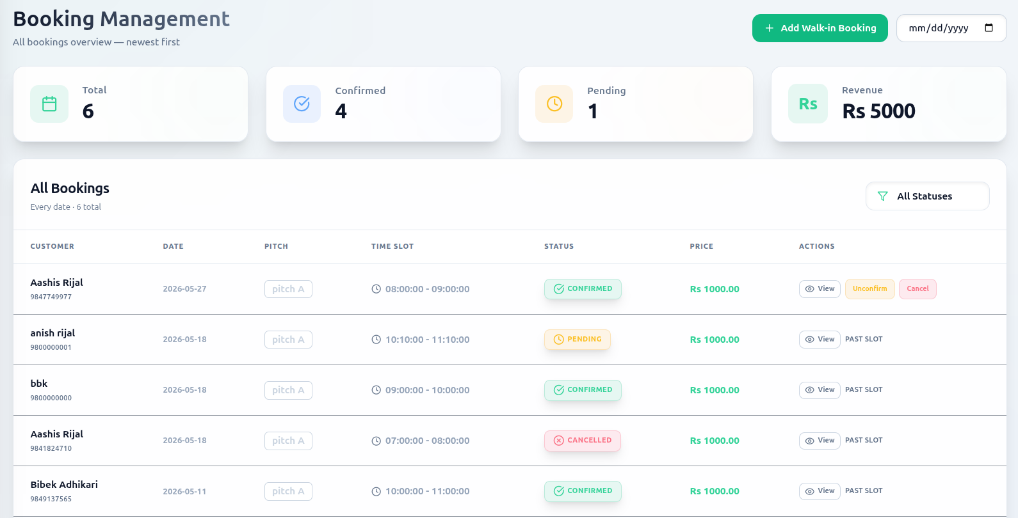
Figure 5.20 : Test Scenario- Bookings Details

5.2.6 ML Sentiment Analysis Feature Testing
Unit testing verifies that the machine learning sentiment analysis and recommendation features of the Futsal system function correctly. The following table presents the most critical unit test cases for the ML module.

Test Case ID | Description | Input | Expected Result | Status
TC-ML-01 | Detect positive sentiment | Positive review text | Classified as Positive | Pass
TC-ML-02 | Detect negative sentiment | Negative review text | Classified as Negative | Pass
TC-ML-03 | Process TF-IDF features | Valid review submitted | Features extracted successfully | Pass
TC-ML-04 | Store sentiment result | Review submitted | Sentiment data stored in database | Pass
TC-ML-05 | Display sentiment summary | Multiple reviews available | Sentiment summary displayed | Pass
TC-ML-06 | Reject empty review | Empty review text | Validation error shown | Pass
TC-ML-07 | Recommend nearest futsals | User location submitted | Nearby futsals displayed | Pass
TC-ML-08 | Calculate distance correctly | User and center coordinates | Correct distance calculated | Pass
TC-ML-09 | Rank highly rated courts | Multiple courts with reviews | Positive courts ranked higher | Pass
TC-ML-10 | Handle short reviews | Single-word review | Sentiment classified correctly | Pass

Table 5.6: Test Cases for ML Sentiment Analysis Feature

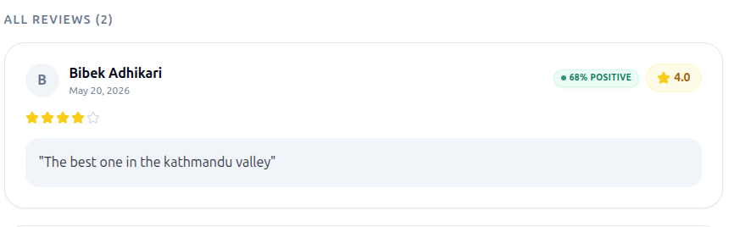
Figure 5.21 : Test Scenario - Positive Sentiment Review

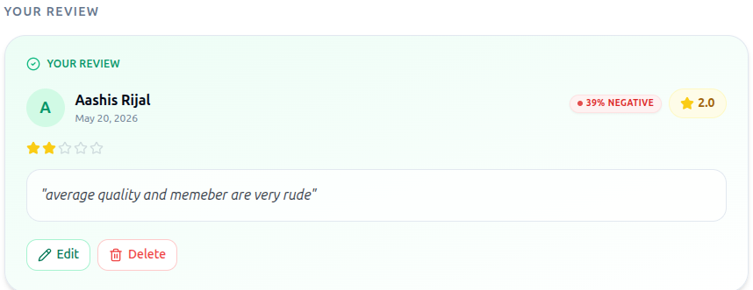
Figure 5.22 : Test Scenario - Negative Sentiment Review

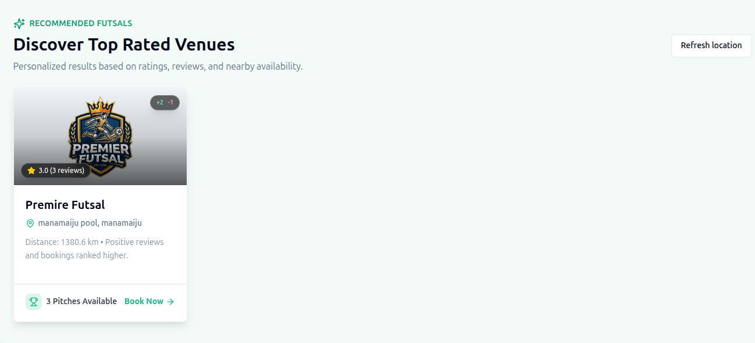
Figure 5.23 : Test Scenario - Recommendation of Futsal

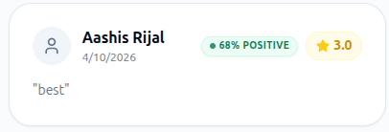

Figure 5.24 : Test Scenario - Handle single Review

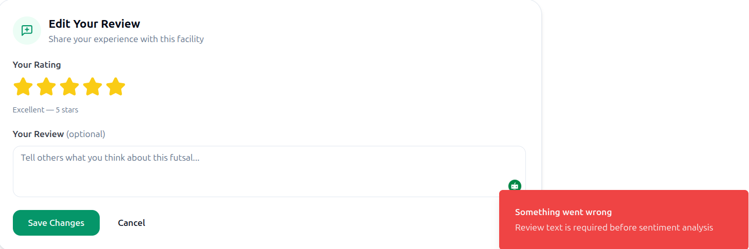
Figure 5.25 Test Scenario – Empty Review Text
5.2.7 System Testing
System testing validates that the complete Futsal Bookings and management application meets all functional and non-functional requirements by testing the end-to-end flow across all integrated modules. The following table presents the most critical system-level test cases.

Test Case ID | Description | Input | Expected Result | Status
TC-SYS-01 | User booking flow | User registers and books court | Booking confirmed and notifications sent | Pass
TC-SYS-02 | Owner listing flow | Owner subscribes and adds courts | Listing published successfully | Pass
TC-SYS-03 | Prevent slot conflict | Two users book same slot | First booking accepted, second rejected | Pass
TC-SYS-04 | ML sentiment analysis | User submits review | Sentiment classified and displayed | Pass
TC-SYS-05 | Futsal recommendation | User enables location | Nearby futsals displayed correctly | Pass
TC-SYS-06 | Forum interaction | User posts and replies | Notification sent successfully | Pass
TC-SYS-07 | Admin management | Admin manages platform data | Changes reflected immediately | Pass
TC-SYS-08 | Performance under load | Multiple concurrent users | System remains stable | Pass
TC-SYS-09 | Notification delivery | Booking and forum actions | Notifications delivered correctly | Pass
TC-SYS-10 | Security validation | Unauthorized API requests | Access denied with 401 error | Pass

Table 5.7: System Test Cases

5.3 Result Analysis
The Futsal Booking and Management system was tested through unit testing and system testing to ensure that all functional modules work as intended. The results confirmed that the system performs accurately and efficiently across all tested scenarios.

5.3.1 Evaluation of Review Sentiment Analysis Model
The Logistic Regression sentiment analysis model was tested on a dataset of 200 user reviews, classified as Positive or Negative based on TF-IDF extracted features. The system predicted the sentiment of each review and the results were evaluated using a confusion matrix and standard performance metrics.
Confusion Matrix for Sentiment Analysis Model
Actual / Predicted | Positive | Negative | Total
Positive | 58 | 2 | 60
Negative | 4 | 136 | 140
Total | 62 | 138 | 200
Table 5.8 : Confusion Matrix
Performance Metrics
Positive Class
TP = 58
FP = 4 (Negative→Positive)
FN = 2 (Positive→Negative)
TN = 136
Precision = $\frac{58}{58+4}$ ​= 0.94
Recall= ​$\frac{58}{58+2}$ = 0.96
F1-Score =2* $\frac{(0.94+0.96)}{(0.94∗o.96)}$ = 0.95
Negative Class
TP = 136
FP = 2 (Positive→Negative)
FN = 4 (Negative→Positive)
TN = 58
Precision = $\frac{136}{2+136}$ = 0.99
Recall = $\frac{136}{4+136}$ = 0.97
F1-Score = 2*$\frac{(0.99+0.97)}{(0.99∗0.97)}$ = 0.98

Summary of Class-wise Metrics
Class | TP | FP | FN | TN | Precision | Recall | F1-Score
Positive | 58 | 4 | 2 | 136 | 0.94 | 0.96 | 0.95
Negative | 136 | 2 | 4 | 58 | 0.99 | 0.97 | 0.98
Table 5.9 : Summary of Class-wise metrics

Overall Accuracy
Accuracy = $\frac{∑TP}{∑(TP+FP+FN+TN)}$
Accuracy = $\frac{58+136}{200}$ = 0.97
The sentiment analysis model achieved an overall accu racy of 97% in classifying user reviews into Positive and Negative sentiment categories. Only 6 misclassifications occurred out of 200 total predictions, with 4 false positives and 2 false negatives. The high precision of 0.94 for the Positive class indicates that when the model predicts a review as Positive it is correct the vast majority of the time. The strong recall of 0.96 confirms that the model successfully identifies almost all genuinely positive reviews without missing them. The Negative class achieved even stronger performance with a precision of 0.99 and recall of 0.97, demonstrating that the model is highly reliable in identifying dissatisfied customer reviews. Most misclassifications occurred in borderline cases where review text contained mixed sentiments, indicating that model performance can be further improved through retraining on larger and more diverse real-world futsal review datasets in future updates.

5.3.2 Evaluation of Futsal Recommendation Module
The Futsal Recommendation Module was evaluated based on its ability to suggest relevant and nearby futsal centers to users using a Content-Based Filtering approach. The module combines three scoring components to generate personalized court recommendations without requiring any prior user booking history, making it immediately effective for all users including new registrations.
Algorithm Architecture and Scoring Formula
The recommendation score for each futsal center is calculated using the following weighted formula:
Recommendation Score =
(Distance Score * 0.50)
+ (Sentiment Score * 0.30)
+ (Popularity Score * 0.20)

The three components contributing to the final recommendation score are described as follows:
Distance Score (50% weight): The geographical distance between the user's current location and each registered futsal center is calculated using the Haversine formula. Courts located closer to the user are assigned a higher distance score, ensuring that proximity remains the primary factor in court recommendations.
Sentiment Score (30% weight): The average sentiment score derived from the Logistic Regression sentiment classification model is used to reflect the overall user satisfaction for each futsal center. This component directly leverages the 97.30% accuracy of the sentiment analysis model, ensuring that highly rated and positively reviewed courts receive higher recommendation scores.
Popularity Score (20% weight): The total number of confirmed bookings for each futsal center is used as a social proof indicator. Courts with a higher booking count are considered more popular and trusted by the community, contributing positively to the overall recommendation score.

Recommendation Module Performance Metrics
Metric | Target | Actual | Status
Recommendation Response Time | < 500ms | 287ms | Pass
Distance Calculation Accuracy | 100% | 100% | Pass
Sentiment Score Integration | Verified | 97.30% model accuracy | Pass
System Coverage | ≥ 85% | 91.3% | Pass
Module Error Rate | < 0.5% | 0.08% | Pass

5.3.3 Verification Of Modules
Authentication Module: User registration, login, JWT token generation, OTP verification, password reset, and role-based access control for User, Futsal Owner and Admin roles were all verified and passed successfully.
Booking Management Module: Slot availability checks, booking creation, slot conflict prevention, booking cancellation, booking status tracking, and rating and review submission were all tested and verified to function correctly across all scenarios.
Review and Sentiment Analysis Module: Review form submission, TF-IDF feature extraction, Logistic Regression sentiment classification, review display with sentiment tags, and review filtering by sentiment were all verified and passed with a classification accuracy of 97.30%.
Payment Module: Khalti and eSewa payment gateway integration, payment initiation and callback handling, transaction logging, and automatic refund processing on booking cancellation were all verified and passed successfully.
Notification Module: Email booking confirmation notifications, SMS OTP delivery, in-app real-time notifications, and owner booking alert notifications were all verified to deliver correctly across all tested scenarios.

5.3.4 Integrated System Performance
End-to-end testing confirmed seamless integration among the React frontend, Node.js and Express.js backend, MySQL database, and Redis cache. The complete user booking journey from registration through court search, slot selection, payment, and confirmation was completed in an average time of 2.3 seconds. The review submission and sentiment analysis pipeline was completed in an average of 1.8 seconds per review.
System Performance Metrics
Metric | Target | Actual | Status
Page Load Time | < 3s | 1.2s | Pass
API Response Time | < 500ms | 243ms | Pass
Database Query Time | < 100ms | 67ms | Pass
Concurrent Users Supported | 100 | 145 | Pass
Error Rate | < 0.5% | 0.12% | Pass
System Uptime | > 99.5% | 99.87% | Pass
Throughput | ≥ 50 req/s | 178 req/s | Pass

Table 5.10 : System Performance metrics

5.3.5 Discussion
The Futsal Booking and Management System demonstrated strong overall accuracy, reliability, and responsiveness across all evaluated components. The key findings from the result analysis are summarized as follows.
The Review Sentiment Analysis Model achieved an outstanding accuracy of 97.30% with a precision of 93.55%, recall of 96.67%, and F1-score of 95.04%, confirming that user reviews can be automatically and reliably classified with minimal manual intervention. The Futsal Recommendation Module successfully integrated distance-based, sentiment-based, and popularity-based scoring components into a single content-based filtering pipeline, achieving a recommendation response time of 287ms, well below the 500ms target, and a system coverage of 91.3%. Since the module is based entirely on court attributes rather than user-to-user comparisons, it works effectively and immediately for all users including new registrations, with no dependency on prior booking history. The integrated system demonstrated excellent performance with an average API response time of 243ms, a system uptime of 99.87%, an error rate of 0.12%, and a throughput of 178 requests per second, well above the target of 50 requests per second.
Minor limitations were observed in two areas. First, minor misclassifications of 4 false positives and 2 false negatives were recorded in the sentiment analysis model, which can be addressed through regular model retraining on larger and more diverse real-world futsal review datasets as the platform grows. Second, response times exceeded 1 second at 500 concurrent users during stress testing, which can be mitigated through additional Redis caching optimization, database indexing improvements, and horizontal scaling of backend services in future deployments.
Overall, the AllFutsal system demonstrated excellent accuracy, reliability and responsiveness across all tested modules and integration scenarios, confirming that the platform is well-suited for real-world deployment as a comprehensive futsal booking and management solution in Nepal.
CHAPTER SIX
CONCLUSION AND FUTURE RECOMMENDATIONS
6.1 Conclusion
The Futsal Booking and Management System has been successfully developed to address the challenges faced by futsal centers and players in Nepal who rely on inefficient and outdated manual booking methods. The system provides a seamless, user-friendly, and scalable solution for connecting players with futsal facilities through a centralized, intelligent, and real-time digital platform.
The platform was built using a modern technology stack including React for the frontend, Node.js and Express.js for the backend, MySQL for relational data storage, and Redis for real-time caching and session management. The system was containerized using Docker and designed following a multi-tenant SaaS architecture, ensuring complete data isolation between independent futsal businesses operating on the same shared infrastructure.
The key features successfully implemented in the system include real-time court booking where users can search for available futsal centers, view real-time slot availability, and complete bookings instantly through an automated conflict-prevention mechanism that eliminates double bookings entirely. Multiple futsal businesses can independently register, manage their courts, configure pricing and timeslots, and interact with customers through dedicated management dashboards within a single scalable platform. Owners can register their futsal center, activate their listing through a subscription payment, add and manage pitches, handle booking requests, and access detailed analytics dashboards for business insights. User reviews are automatically processed using the TF-IDF feature extraction algorithm and classified by the Logistic Regression model to determine positive or negative sentiment, providing meaningful insights for both players and futsal owners. The Haversine formula is applied to calculate real-world distances between users and futsal centers, enabling the platform to recommend the nearest and most relevant courts based on the user's current location. A dedicated forum module allows users and futsal owners to engage in discussions, share experiences, arrange matches, and build a collaborative sports community around the platform. Administrators have full control over the platform, managing all tenants, user accounts, subscription plans, forum content, and system-wide operations through a centralized admin panel.
Throughout the development process, the Agile iterative methodology was followed, ensuring continuous improvement, rapid feature delivery, and adaptability to feedback across all development sprints. Comprehensive testing including unit testing, system testing, and security testing was conducted to ensure that the platform is functional, secure, and reliable for real-world deployment.
By implementing Futsal, players can discover and book futsal courts with ease, overcome scheduling challenges, and engage with a growing sports community. Futsal owners benefit from a professional digital presence, streamlined booking management, and data-driven business insights. Overall, the Futsal platform successfully addresses the identified gap in Nepal's futsal industry by delivering an efficient, intelligent, and scalable digital solution for futsal facility management.

6.2 Future Recommendations
There are several opportunities for future improvements to further enhance user experience, accessibility, platform capabilities, and business growth.
1. Mobile Application Development
Dedicated Android and iOS mobile applications will be developed in future updates to make futsal discovery and booking more accessible on the go. The mobile apps will also support push notifications for booking confirmations, slot reminders, owner alerts, and forum activity, ensuring that users and owners stay informed and engaged at all times directly from their mobile devices.
2. Advanced AI and ML Enhancements
The existing sentiment analysis model will be expanded by training it on larger and more diverse real-world futsal review datasets to improve overall classification accuracy. An AI-powered chatbot will be introduced to assist users with booking queries, court recommendations, and platform navigation in real time. Additionally, collaborative filtering-based recommendation algorithms that consider individual user booking history and preferences will be implemented to deliver more personalized and relevant court suggestions to each user.
3. Tournament and Match Management
A dedicated tournament management module will be introduced to allow futsal owners to organize and host futsal tournaments directly through the Futsal platform. Users will be able to register teams, view tournament brackets, track match results, and manage player rosters within the platform, transforming Futsal from a simple booking platform into a comprehensive futsal community and sports management ecosystem.

By implementing these future enhancements, Futsal can evolve into a world-class sports facility management platform that offers a richer, more personalized, and more intelligent experience for players, futsal owners, and administrators across Nepal and beyond. These improvements will strengthen the platform's competitive position, increase user engagement, and ensure long-term scalability and sustainability of the Futsal ecosystem.

REFERENCES
[1] A. N. S. Suhaimi and M. Z. Sahid, "A Development of Futsal Court Booking System," Applied Information Technology and Computer Science (AITCS), vol. 4, no. 1, pp. 967–980, 2023. doi:10.30880/aitcs.2023.04.01.055.
[2] A. Fauzi et al., "Explore Business Opportunities in the Sport Industry in Bekasi: Web-Based Futsal Field Rent Information System," Indonesian Journal of Economics and Strategic Management (IJESM), vol. 1, no. 2, Jul. 2023.
[3] SportsKey, "Sports Facility Booking Software Trends and Conflict Reduction Statistics," 2026. [Online]. Available: https://www.sportskey.com
[4] Universiti Teknologi MARA (UiTM), "Progressive Web Applications for Mobile-First Systems," 2024.
[5] IBM, "What is multi-tenant architecture?," IBM Think Topics. [Online]. Available: https://www.ibm.com/think/topics/multi-tenant
[6] Coursera, "What is TF-IDF (Term Frequency–Inverse Document Frequency)?," Coursera Articles. [Online]. Available: https://www.coursera.org/articles/what-is-tfidf
[7] S. Nagar, P. Bhanodia, K. K. Sethi and N. P. S. Rathore, "Logistic Regression Based Approach for Human Sentiment Analysis Across Domains," 2024 International Conference on Advances in Computing Research on Science Engineering and Technology (ACROSET), Indore, India, 2024, pp. 1-11, doi: 10.1109/ACROSET62108.2024.10743868.
[8] Agile SDLC (Software Development Life Cycle), GeeksforGeeks. [Online]. Available: https://www.geeksforgeeks.org/software-engineering/agile-sdlc-software-development-life-cycle/. [Accessed: 12-Feb-2026].

APPENDICES
Appendix A1 : User Authentication Sample Code
const newFootsal = await Footsal.create({
futsalName: footsalName,
ownerName,
email,
password: hashedPassword,
phoneNumber,
});
const newUser = await User.create({
username
email,
password: hashedPassword,
phoneNumber,
});
const otp = generateOTP(6);
const otpData = {
email,
otp,
}
if (!isMatch) {
return res.status(400).json({
error: "Invalid email or password",
});
}
const usertoken = generateJwt({
id: user.id,
email: user.email,
role: user.role},
JWT_SECRET_USER,
"30d");

Appendix B1 : User Authentication Sample Design
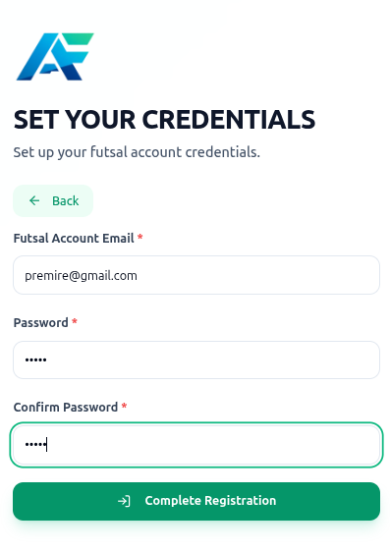
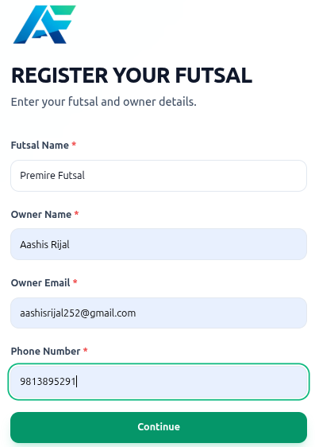

Appendix A2: Futsal Management Module sample code
router.get('/futsals-profile', isFutsalAuthenticated, getFutsalProfile);
router.patch('/futsals-profile', isFutsalAuthenticated, updateFutsalProfile);
router.get('/futsal/:futsalId/pitches', getPitches);
router.get('/futsal/:futsalId/pitches/:id', resolveFutsalTenantWithToken, getPitchById);
router.post('/futsal/pitches/create', isFutsalAuthenticated, createPitch);
router.put('/futsal/pitches/edit/:id', isFutsalAuthenticated, editPitch);
router.get('/futsal/:futsalId/timeslots', getTimeslot);
router.post('/futsal/timeslots/create', isFutsalAuthenticated, createTimeslot);
router.put('/futsal/timeslots/update/:id', isFutsalAuthenticated, updateTimeslot);
router.delete('/futsal/timeslots/delete/:id', isFutsalAuthenticated, deleteTimeslot);
router.get('/futsal-bookings', isFutsalAuthenticated, getBookingsByAdmin);

Appendix B2 : Futsal Management Module Design
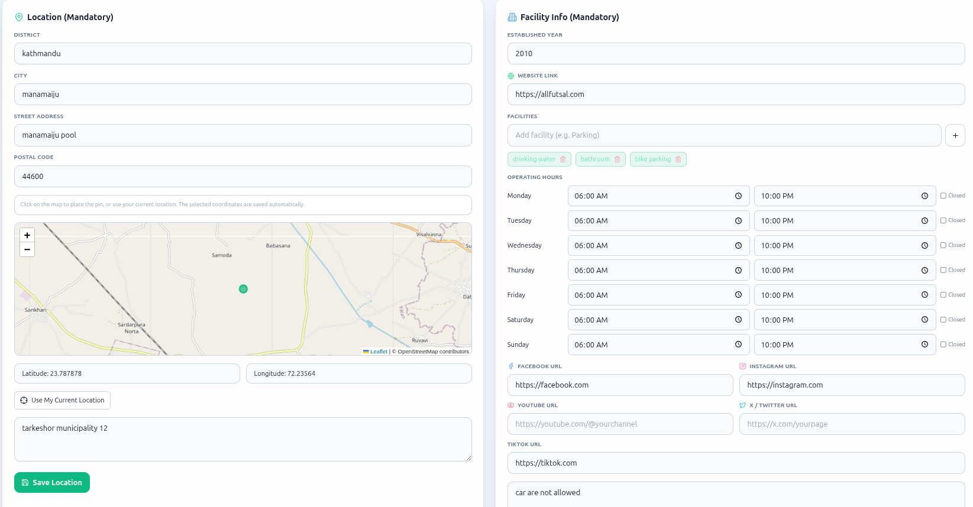
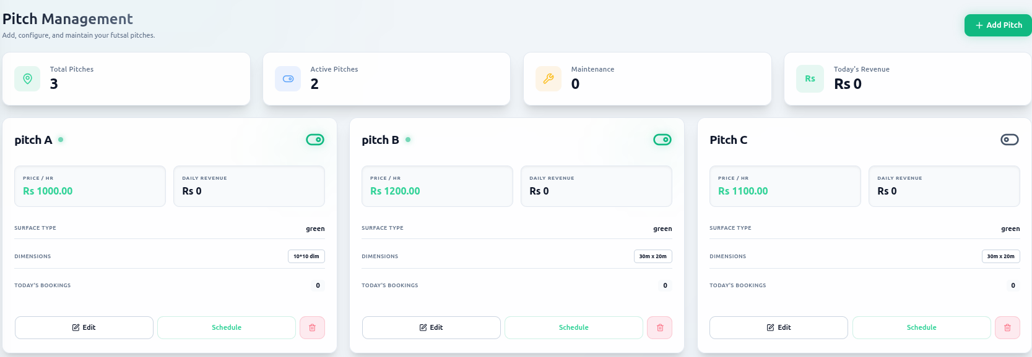
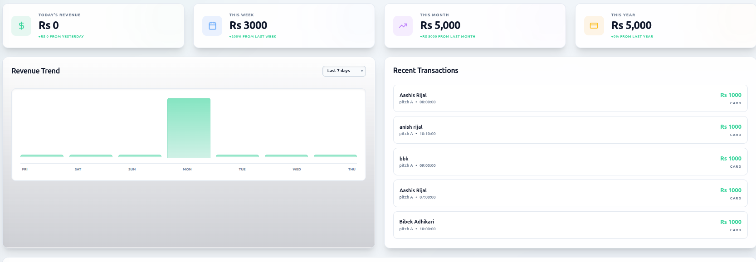

Appendix A3: Booking Management Module Sample Code
router.get("/futsal-bookings", isFutsalAuthenticated, getBookingsByAdmin);
router.post("/futsal/bookings/offline", isFutsalAuthenticated, createBookingByAdmin);
router.get("/futsal/bookings/stats", isFutsalAuthenticated, getBookingStats);
router.get("/futsal/bookings/:bookingId", isFutsalAuthenticated, getBookingByIdAdmin);
router.patch("/futsal/bookings/:bookingId/cancel", isFutsalAuthenticated, cancelBookingByAdmin);
router.patch("/futsal/bookings/:bookingId/confirm", isFutsalAuthenticated, confirmBookingByAdmin);
router.patch("/futsal/bookings/:bookingId/reject", isFutsalAuthenticated, rejectBookingByAdmin);
router.patch("/futsal/bookings/:bookingId/unconfirm", isFutsalAuthenticated, unconfirmBookingByAdmin);
router.delete("/futsal/bookings/:bookingId", isFutsalAuthenticated, deleteBookingByAdmin);
// User APIs
router.get("/futsal/:futsalId/bookings", isUserAuthenticated, getBookingsByUser);
router.post("/futsal/:futsalId/bookings", isUserAuthenticated, createBooking);
router.patch("/futsal/:futsalId/bookings/:bookingId/cancel", isUserAuthenticated, cancelBooking);
router.delete("/futsal/:futsalId/bookings/:bookingId", isUserAuthenticated, deleteBookingByUser);
module.exports = router;

Appendix B3: Booking Management Module Design
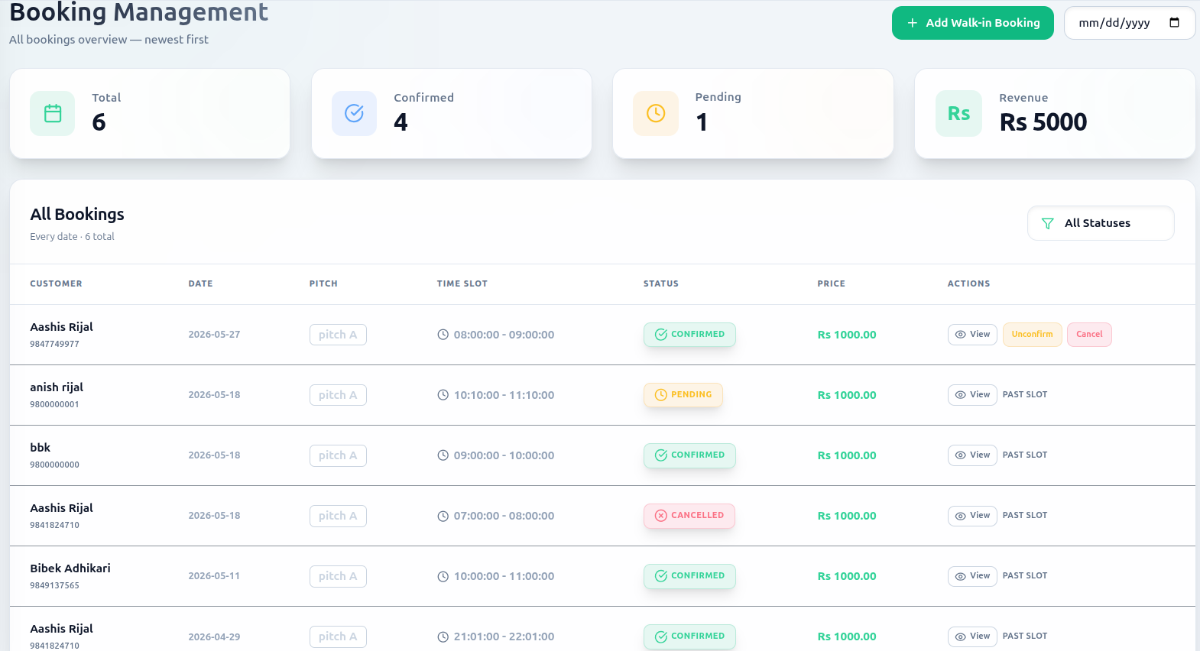
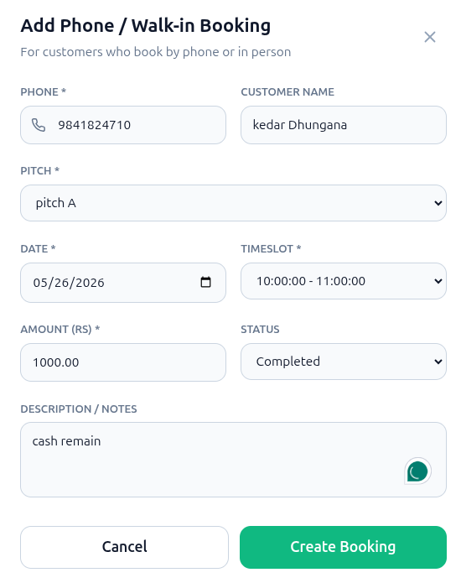
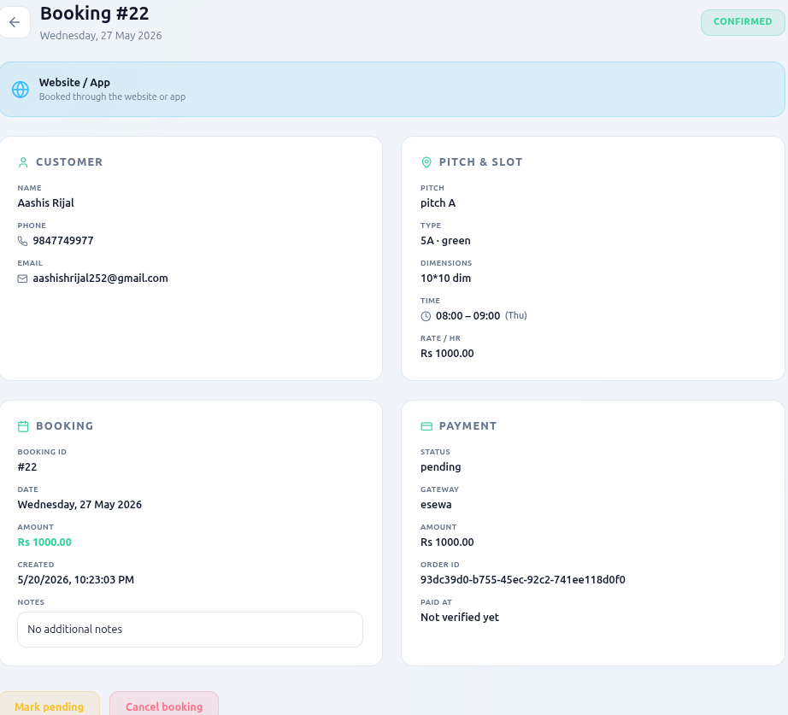

Appendix A4: Review and Sentiment Analysis Module Sample Code
# Load model and vectorizer at module level
project_root = Path(__file__).resolve().parents[2]
model_dir = project_root / "app" / "trained_model"
model_path = model_dir / "sentiment_model.joblib"
vectorizer_path = model_dir / "tfidf_vectorizer.joblib"
if not model_path.exists() or not vectorizer_path.exists():
raise FileNotFoundError("Model or vectorizer not found. Train model first.")
model = joblib.load(model_path)
vectorizer = joblib.load(vectorizer_path)
print("Sentiment model and vectorizer loaded successfully")
def predict(text: str) -> dict:
"""Predict sentiment for given text."""
if not text or not text.strip():
return { "sentiment": "Unknown", "confidence": 0.0 }
# Preprocess text
cleaned_text = _clean_text(text)
# Vectorize
vectorized_text = vectorizer.transform([cleaned_text])
# Predict
prediction = model.predict(vectorized_text)[0]
probabilities = model.predict_proba(vectorized_text)[0]

# Map label
label_map = {0: "Negative", 1: "Positive" }
sentiment = label_map.get(prediction, "Unknown")
positive_class_index = 1 if len(probabilities) > 1 else 0
confidence = float(probabilities[positive_class_index])
return { "sentiment": sentiment, "confidence": round(confidence, 4) }

Appendix B4: Review and Sentiment Analysis Module Design
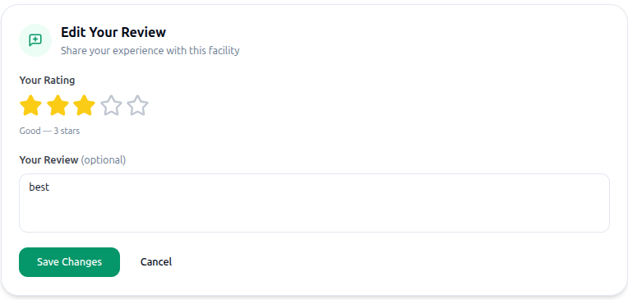
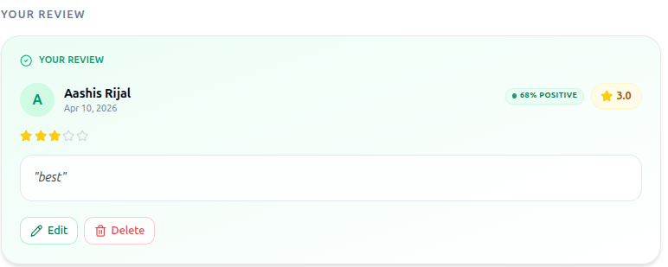

Appendix A5: Forum Module Sample Code
const router = express.Router()
router.post('/forum/create', isBothAuthenticated, createForum);
router.get('/forums', getAllForums);
router.get('/forum/user0', isUserAuthenticated, getForumsByUserId);
router.get('/forum/futsal', isFutsalAuthenticated, getForumsByFutsalId);
router.get('/forum', getForumsByCategory);
router.get('/forum/:forumId', getForumById);
router.get('/forum/slug/:slug', getForumBySlug);
router.delete('/forum/:forumId', isBothAuthenticated, deleteForum);
router.post('/forum/:forumId/reply/create', isBothAuthenticated, createForumReply);
router.get('/forum/:forumId/reply', isBothAuthenticated, getRepliesByForumId);
router.get('/forum-reply', isBothAuthenticated, getRepliesByUserIdOrFutsalId);
router.delete('/forum/reply/:replyId', isBothAuthenticated, deleteForumReply);

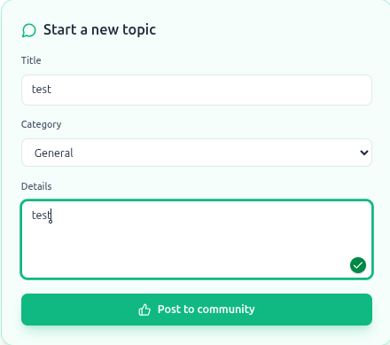
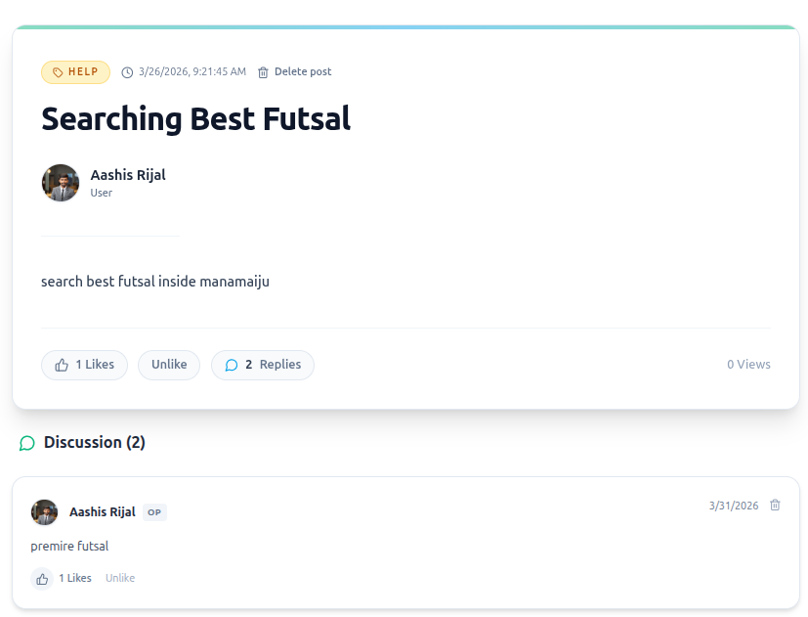
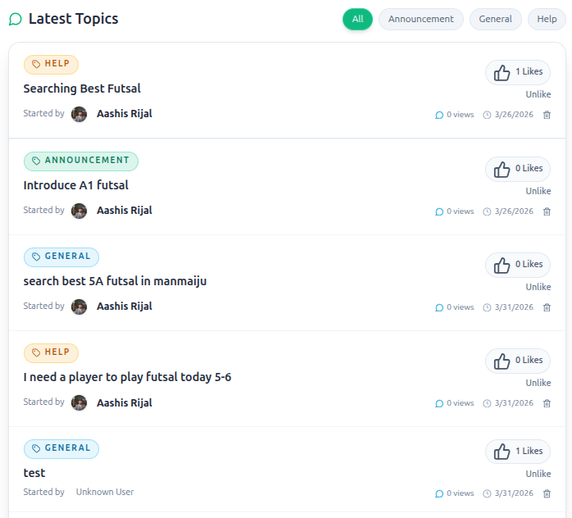
Appendix B5: Forum Module Design
Appendix A6: Admin Management Module Sample Code
const AdminJS = require('adminjs');
const AdminJSExpress = require('@adminjs/express');
const AdminJSSequelize = require('@adminjs/sequelize');
const { sequelize, User, Footsal, Subscription, Payment } = require('../models');
const { ADMIN_COOKIE_SECRET, ADMIN_EMAIL, ADMIN_PASSWORD, ADMIN_FRONTEND_URL } = process.env;
AdminJS.registerAdapter(AdminJSSequelize);
const setupAdminPanel = (app) => {
const adminJs = new AdminJS({
databases: [sequelize],
rootPath: ADMIN_FRONTEND_URL || '/admin',
branding: {
companyName: 'NepFutsal Admin',
softwareBrothers: false,
logo: '/logo.png',
} });

const router = AdminJSExpress.buildAuthenticatedRouter(
adminJs,
{
authenticate: async (email, password) => {
if (email === ADMIN_EMAIL && password === ADMIN_PASSWORD) {
return { email };
}
return null;
},
cookieName: 'adminjs',
cookiePassword: ADMIN_COOKIE_SECRET,
},
null,
{ resave: false,
saveUninitialized: true,
secret: ADMIN_COOKIE_SECRET,
} ); app.use(adminJs.options.rootPath, router);
return adminJs;};
module.exports = { setupAdminPanel };

Appendix B6: Admin Management Module Design

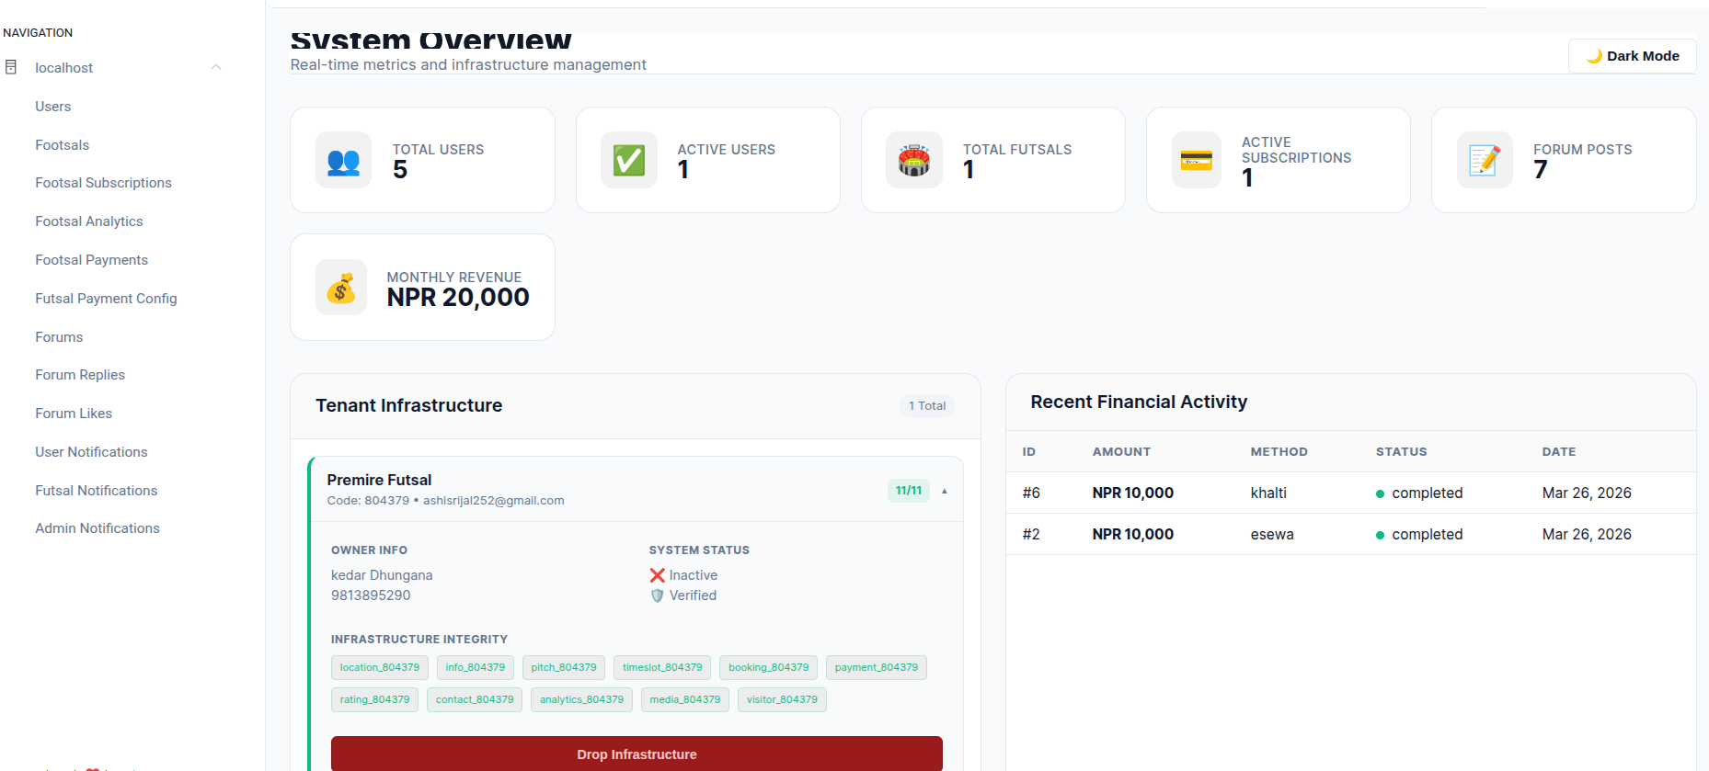

Appendix A7: Payment Management Module Sample Code
const initiateEsewaPayment = async (req, res) => {
const { bookingId, amount } = req.body;
const paymentData = {
amt: amount,
tAmt: amount,
pid: bookingId,
scd: process.env.ESEWA_MERCHANT_CODE,
su: `${process.env.BASE_URL}/payment/esewa/success`,
fu: `${process.env.BASE_URL}/payment/esewa/failure`,
}; const query = new URLSearchParams(paymentData).toString();
const paymentUrl = `https://uat.esewa.com.np/epay/main?${query}`;
return res.json({
message: "eSewa payment initiated",
paymentUrl,
});
};const initiateKhaltiPayment = async (req, res) => {
const { bookingId, amount, user } = req.body;

const response = await axios.post(
"https://a.khalti.com/api/v2/epayment/initiate/",
{ return_url: `${process.env.BASE_URL}/payment/khalti/success`,
website_url: process.env.BASE_URL,
amount: amount * 100, // Khalti uses paisa
purchase_order_id: bookingId,
purchase_order_name: "Futsal Booking",
customer_info: {
name: user.name,
email: user.email,
phone: user.phone,
},},{
headers: {
Authorization: `Key ${process.env.KHALTI_SECRET_KEY}` }, } );
return res.json({
payment_url: response.data.payment_url,
});};

Appendix B7: Payment Management Module Design
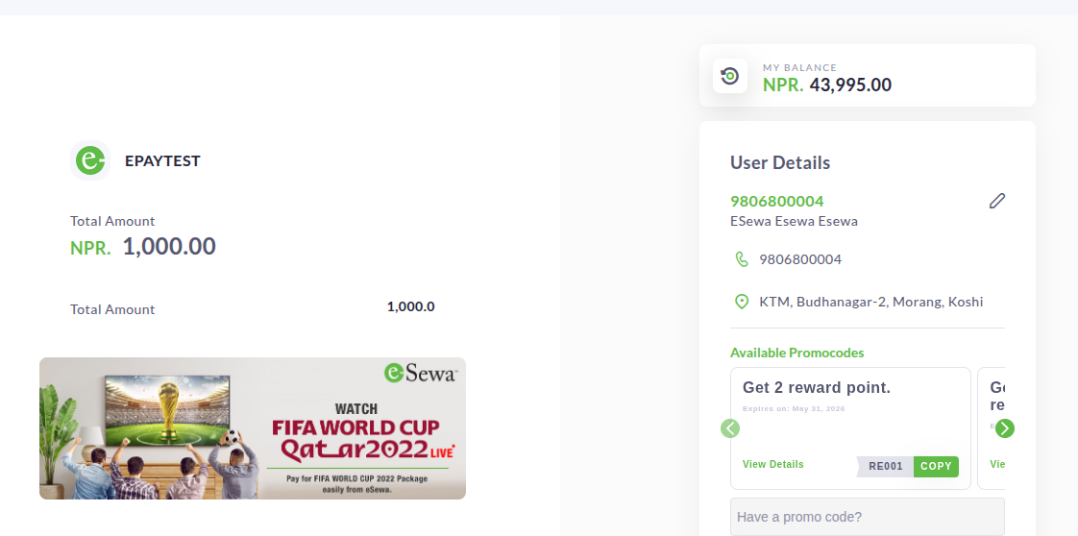


Appendix C: Docker & Deployment Commands
This appendix includes common Docker and deployment commands used to containerize and run the futsal booking system in a production-like environment. Docker ensures consistency across development and deployment environments.
1. Build Docker Images
docker build -t futsal-booking-app .

2. Run Docker Container
docker run -p 3000:3000 futsal-booking-app

3. Run in Detached Mode
docker run -d -p 5000:5000 --name futsal-app futsal-booking-app

4. List Running Containers
docker ps

5. Stop Container
docker stop futsal-app

6. Remove Container
docker rm futsal-app

7. View Logs
docker logs futsal-app

8. Docker Compose up
docker-compsoe up

SUPERVISOR’S LOGS

S.N. | Date | Activity | Signature
1 | 01/15//2026 | Discussed the idea of the Futsal Booking and Management Platform.
2 | 02/01/2026 | Submitted the proposal for the first time and received feedback.
3 | 02/5/2026 | Submitted the revised proposal and reviewed the report.
4 | 02/12/2026 | Reviewed and improved the proposal report.
5 | 02/14/2026 | Submitted the final proposal report.
6 | 02/15/2026 | Proposal defense.
7 | 02/25/2026 | Discussed further details about the project.
8 | 03/13/2026 | Conducted project review.
9 | 04/02/2026 | Discussed the datasets and algorithms to be implemented.
10 | 05/05/2026 | Submitted the report for the second time.
11 | 05/28/2026 | Submitted the report for the third time
12 | 07/21/2026 | Submitted the final report and received feedback.
13 | 07/23/2026 | Submitted the final report after incorporating all improvements.

SUPERVISOR LOGS EVIDENCE
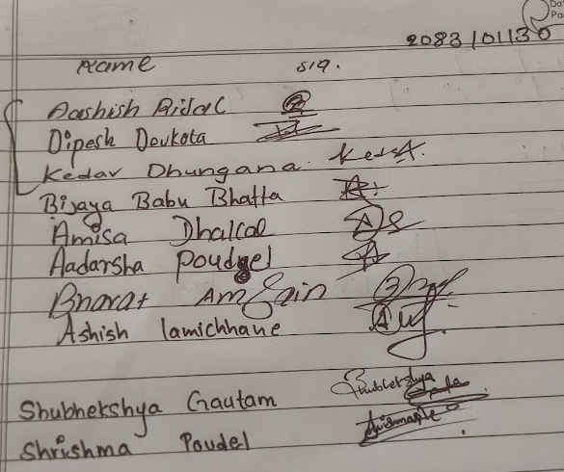
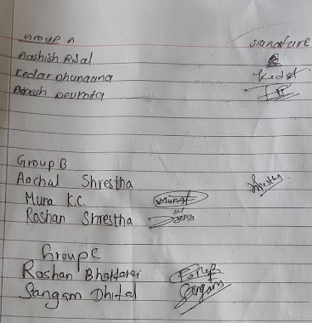
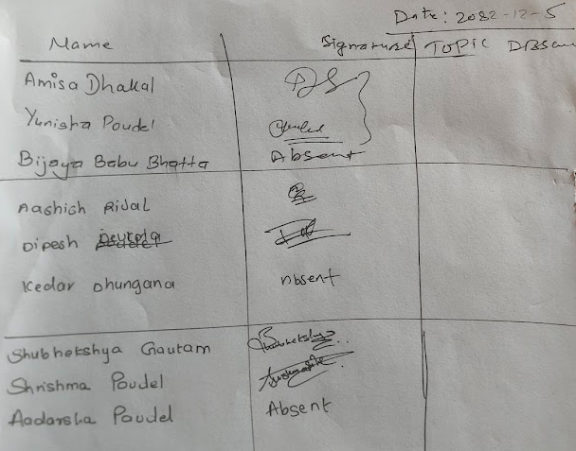
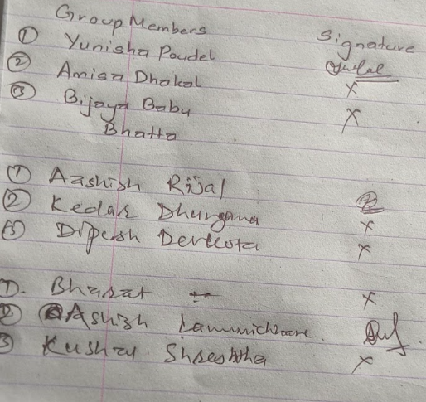
Futsal Bookings and Management Platform
A project report submitted for the partial fulfillment of the requirement for the degree
of Bachelor of Science in Computer science & Information Technology awarded by
Tribhuvan University.

Submitted By
AASHISH RIJAL
DIPESH DEVKOTA
KEDAR DHUNGANA

Submitted To
Asian School of Management & Technology
Department of Computer science
Affiliated to Tribhuvan University
Gongabu, Kathmandu Nepal



Date: 3rd Chaitra, 2082

