
TRIBHUVAN UNIVERSITY

ASIAN SCHOOL OF MANAGEMENT AND TECHNOLOGY
GONGABU, KATHMANDU

Project Proposal
on
AllFutsal: Online Futsal Booking and Management System with Machine Learning Integration using Multi-Tenant SaaS Architecture
Under the Supervision of Mr. Surya Bam

SUBMITTED BY:
Aashish Rijal (79010939)
Kedar Dhungana (79010957)
Dipesh Devkota (79010952)

SUBMITTED TO:
CENTRAL DEPARTMENT OF COMPUTER SCIENCE AND INFORMATION TECHNOLOGY

February 7, 2026
TABLE OF CONTENTS

1. Introduction …………………………………………………………….. 3

2. Problem Statement …………………………………………………….. 4

3. Objectives ………………………………………………………………. 5

4. Methodology …………………………………………………………… 6
4.1 Requirement Identification ……………………………………. 7
4.1.1 Literature Review ……………………………………… 8
4.1.2 Requirement Analysis …………………………………. 9
4.2 Feasibility Study ………………………………………………. 10
4.2.1 Technical Feasibility ………………………………….. 11
4.2.2 Operational Feasibility ………………………………… 12
4.2.3 Economic Feasibility …………………………………… 13
4.2.4 Schedule Feasibility ……………………………………. 14
4.3 High Level Design of System ………………………………….. 15
4.3.0 Flow chart ……………………. ……………………….. 16
4.3.1 Proposed System Methodology ………………………….. 17 4.3.2 Machine Learning Methodology …….. ………………… 17 4.3.3 System Flow & Working Mechanism …………………. 18
4.3.4 Core Algorithms Description …………………………. 18 5. Expected Outcome …………………………………………………….. 19 6. References ……………………………………………………………… 20

1. Introduction
The rapid growth of sports facilities in Nepal, particularly futsal centers, has created a strong demand for efficient digital booking and management systems. However, many futsal facilities still rely on manual booking methods such as phone calls, messaging apps, and paper records, which often lead to double bookings, inconsistent record keeping, and inefficient communication. These limitations highlight the need for a centralized and automated digital solution for sports facility management.
To address these challenges, AllFutsal is proposed as a smart Online Futsal Booking and Management System developed as a multi-tenant SaaS platform, where multiple futsal businesses operate independently within a shared infrastructure while maintaining data isolation [2]. The platform connects players and futsal owners through a centralized web application that supports real-time booking, facility management, subscription handling, analytics dashboards, and structured communication.
The system integrates modern web technologies together with machine learning features to enhance user experience and decision support. Review understanding is improved using natural language processing techniques such as sentiment analysis and TF-IDF–based text processing for review summarization [1][4]. In addition, a location-based suggestion approach is used to suggest futsal courts based on proximity and user preference patterns [3]. The platform is designed to be secure, scalable, containerized using Docker, and performance-optimized with Redis caching, while remaining mobile-responsive and API-driven. Overall, the project demonstrates the practical application of SaaS architecture and machine learning techniques in modern sports facility management.

2. Problem Statement
In recent years, the demand for futsal facilities in urban areas has increased significantly, but the management and booking systems used by many futsal centers are still outdated and manual. Many futsal courts continue to manage bookings through phone calls, paper registers, and messaging apps. These manual methods often cause problems such as double bookings, incorrect records, poor coordination, and lack of real-time availability information.
The current futsal booking and management environment faces several major issues:
- Lack of Centralized Discovery: There is no single platform where players can easily find and compare multiple futsal courts.
- Inefficient Booking and Availability Management: Booking is manual and not real-time, which causes conflicts and double bookings.
- Limited Feedback and Engagement Mechanisms: Most systems do not support proper ratings, reviews, or community interaction.
- Suboptimal Business Intelligence for Owners : Owners do not get proper reports on bookings, revenue, and usage trends.
- Absence of Automated Customer Support : Customer queries are handled manually, which is slow and inconsistent.
- Neglect Advanced Technologies : Modern AI and ML features like recommendations, review summaries, and chatbots are not used.

Therefore, there is a clear need for a centralized, secure, and intelligent online futsal booking and management system that supports multiple futsal businesses under a scalable multi-tenant SaaS architecture. The proposed AllFutsal platform is designed to address these problems by providing a modern digital solution that improves booking efficiency, management capability, and overall user experience.

3. Objectives

The key objectives of the proposed AllFutsal - Online Futsal Booking & Management System are:
- Develop Online Booking Platform: Build a centralized web system for futsal discovery and real-time court booking.
- Multi-Tenant SaaS Architecture: Support multiple futsal facilities independently within one scalable platform.
- Community Features: Enable verified ratings, reviews, and a discussion forum.
- AI & ML Integration: Implement recommendation, Sentimental Analysis of user Reviews.

Overall, the objective is to build a practical and production-oriented system that demonstrates modern web technologies, intelligent automation, and scalable system design.

4. Methodology
We selected the Prototyping Model for our project because it supports iterative development and continuous improvement. In this approach, an initial working prototype with basic features is developed first to visualize the final system. Feedback is then collected from users and the project supervisor to identify issues and required improvements. Based on this feedback, the prototype is refined through multiple iterations by adding new features and enhancing functionality and user interface. This process provides flexibility, reduces risk, and helps ensure that the final system meets user needs and project requirements.
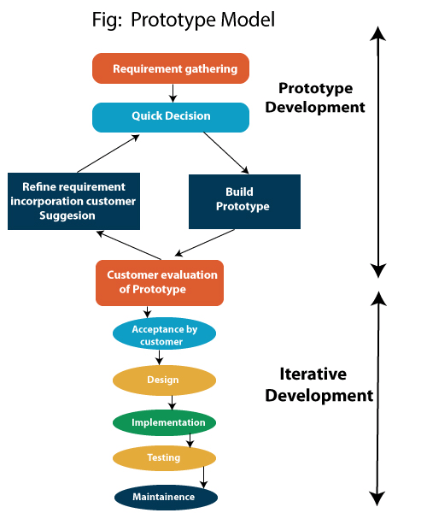
Fig 1 : Prototyping Model [9]
4.1 Requirement Identification
4.1.1 Literature Review
The development of the AllFutsal system is based on prior research in three main areas: digital sports facility management, multi-tenant SaaS architecture, and machine learning techniques for user engagement and decision support.
Recent academic research shows a growing shift from manual futsal court booking toward web-based digital systems. Many futsal centers still use manual booking methods such as log books and phone reservations, which increase the risk of data loss and make schedule management difficult. A study by Suhaimi and Sahid developed a futsal court booking system to replace manual records with a database-driven platform. Their system improved booking visibility, scheduling clarity, and electronic data management through a structured booking interface built using the prototyping model [6].
Similarly, Fauzi et al. presented a web-based futsal field rental information system aimed at improving business opportunities and operational efficiency in the sports rental sector. Their research highlights that website-based booking platforms help replace hand-written and manual rental processes while increasing accessibility and customer reach [5].
Industry analysis also supports the effectiveness of specialized sports booking software, reporting measurable reductions in scheduling conflicts and improved operational transparency when centralized booking systems are used [7]. In addition, mobile-first and Progressive Web Application approaches are recommended for booking platforms because they provide responsive, app-like user experience across devices without the high cost of native mobile app development [8].
Modern system design literature further recommends multi-tenant SaaS architecture for shared booking platforms serving multiple independent facility owners with proper data isolation [2]. Machine learning techniques such as sentiment analysis and text feature extraction (e.g., TF-IDF) are increasingly applied to process user reviews automatically [1][4], while location-based recommendation methods are used to rank nearby services based on user proximity and preference patterns [3].
These studies and industry practices collectively demonstrate the effectiveness of digital, database-driven, and intelligent booking systems, while also showing that integrated, multi-tenant, ML-enhanced futsal management platforms remain limited which motivates the development of the AllFutsal system.

4.1.2 Requirement Analysis
In requirement analysis, the primary goal is to identify and define both the functional and non-functional requirements of the system. Functional requirements for a futsal management & Booking system include features like user operation, search and filter, booking, Rating & Review, Suboptimal. Non-functional requirements focus on Multi-tenant data isolation, Mobile responsiveness, API-based design, system performance, ensuring that the system can handle a growing number of users and transactions. This analysis helps ensure that the system meets the needs of the futsal and its customers while maintaining efficiency and effectiveness.

a) Functional Requirements
- User Registration & Login: Support secure login using OTP and Google Oauth.
- Futsal Search & Filtering: Allow users to find futsals by location and features.
- Real-Time Slot Availability: Show live court slot status to users.
- Booking & Cancellation: Enable online booking and controlled cancellation.
- Rating & Review System: Allow users to give ratings and written feedback.
- Admin Dashboards: Provide management panels for futsal owners.
- Subscription Management: Handle futsal plans and expiry tracking.
- Email Notifications: Send automatic booking and update alerts.
- Forum Module: Support discussion between players and management.
- ML Recommendation: Suggest futsals based on location and preferences.
- NLP Review Summarization: Generate short summaries from reviews.

b) Non-functional Requirement
    - Secure Authentication: The system must ensure secure login using encryption and token-based authentication.
- Scalable Architecture: The platform should handle increasing users and futsal tenants without performance loss.
- Multi-Tenant Data Isolation: Each futsal’s data must remain logically separated and protected.
- Fast Response Time: System operations and API responses should be delivered with minimal delay.
- Mobile Responsiveness: The user interface must work properly across mobile and tablet devices.
- API-Based Design: Backend services should be exposed through structured APIs for future integrations.

4.2 Feasibility Study

4.2.1 Technical Feasibility
The AllFutsal system is technically feasible because it is based on widely used and well-supported technologies for modern web and data-driven applications. The platform can be developed using React for the frontend and Node.js with Express.js and MySQL for the backend, which are proven for building scalable, secure, and multi-tenant SaaS systems. Redis can be integrated for caching, session handling, and fast real-time slot availability checks to improve performance, while Docker can be used to containerize services for consistent development, testing, and deployment across environments. Required features such as JWT authentication, Google OAuth, OTP verification, Email notifications, and cloud file storage are supported through reliable third-party APIs, making integration practical. The machine learning components, including review sentiment analysis, review summarization can be implemented using Python ML/NLP libraries with datasets from Kaggle and real user reviews. Since all required frameworks, tools, and infrastructure are readily available and compatible with the team’s technical skills, the project is technically achievable within the given resources.

4.2.2 Operational Feasibility
The system is designed to mimic existing manual workflows but digitize them, reducing the learning curve for futsal owners. Since most owners and players already use smartphones, the operational adoption barrier is low. The system automates tedious tasks (recording bookings, calculating totals), thereby streamlining operations rather than complicating them.

4.2.3 Economic Feasibility
As a SaaS product, the development cost involves primarily developer time and hosting fees (cloud servers like AWS or affordable VPS). The revenue model (subscription-based for tenants) ensures sustainability. For this academic project, open-source tools and free-tier hosting services will be used, making the development cost negligible.

4.2.4 Schedule Feasibility
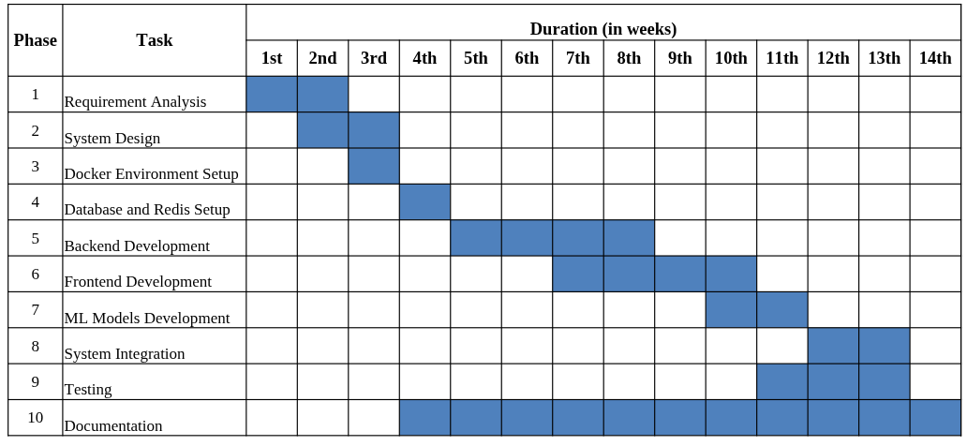
Fig : Gantt chart
4.3 High Level Design of System
4.3.0 Flow Chart
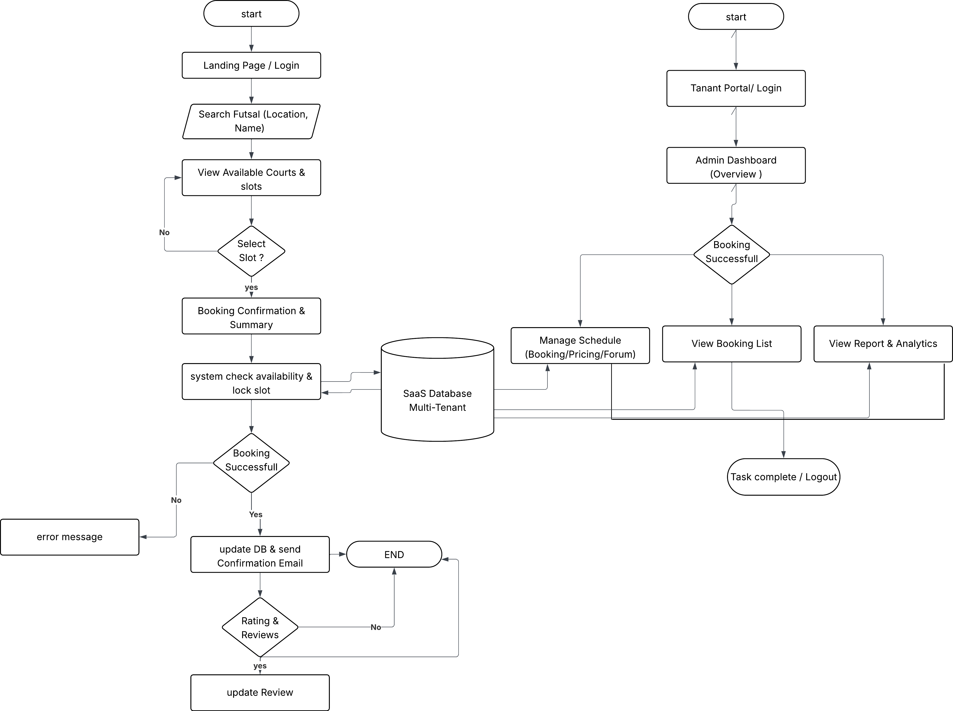
Fig : Flow Chart of System

4.3.1 Proposed System Methodology
The system follows a Multi-tenant SaaS Architecture using a Siloed Data Model within a shared database to ensure data isolation. The backend is built on a Modular Micro-service inspired structure where ML services are decoupled from the core booking logic.

4.3.2 Machine Learning Methodology
The machine learning components within the AllFutsal system are developed and trained entirely within the scope of this project, without reliance on externally pretrained large language models or transformer architectures. This approach ensures domain specificity, data privacy, and full control over model behavior and performance.

4.3.1.1 Sentimental Analysis Model
A supervised machine learning model will be developed to classify futsal reviews into positive, neutral, and negative sentiment categories. The model will be trained from scratch using labeled review data and standard NLP preprocessing techniques. The methodology includes the following steps:
Dataset Collection: Review data will be collected from a Kaggle dataset and supplemented with real user futsal reviews for testing and validation.
Data Labeling: Each review will be assigned a sentiment label (positive, neutral, negative). The Kaggle dataset already contains labels, and additional user reviews will be labeled manually where required.
Text Preprocessing: Reviews will be cleaned before training by removing special characters, stop words, and duplicates, along with tokenization and lowercasing to improve model accuracy.
Feature Extraction: Cleaned text will be converted into numerical form using TF-IDF vectorization so that machine learning models can process it.
Model Training: Classification algorithms such as Naive Bayes or Logistic Regression will be trained on the processed dataset for sentiment prediction.
Train/Test Split: The dataset will be divided into training and testing sets (for example 80% training and 20% testing) to properly evaluate model performance.
Evaluation: The model will be evaluated using metrics such as accuracy, precision, recall, and F1-score.
System Integration: The trained model will be deployed as an API service and connected to the AllFutsal system to analyze and score new reviews automatically.

4.3.3 Use Case Diagram
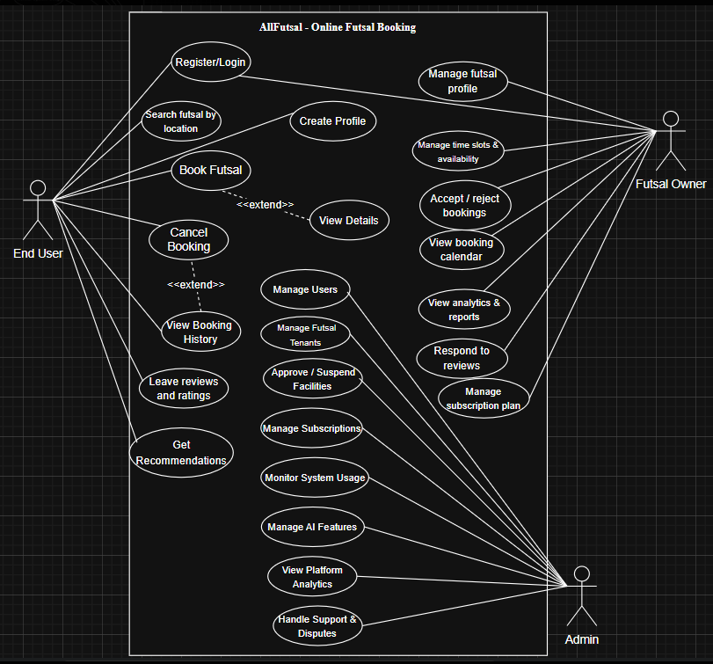
Fig 2 : Use Case Diagram
4.3.4 ER Diagram

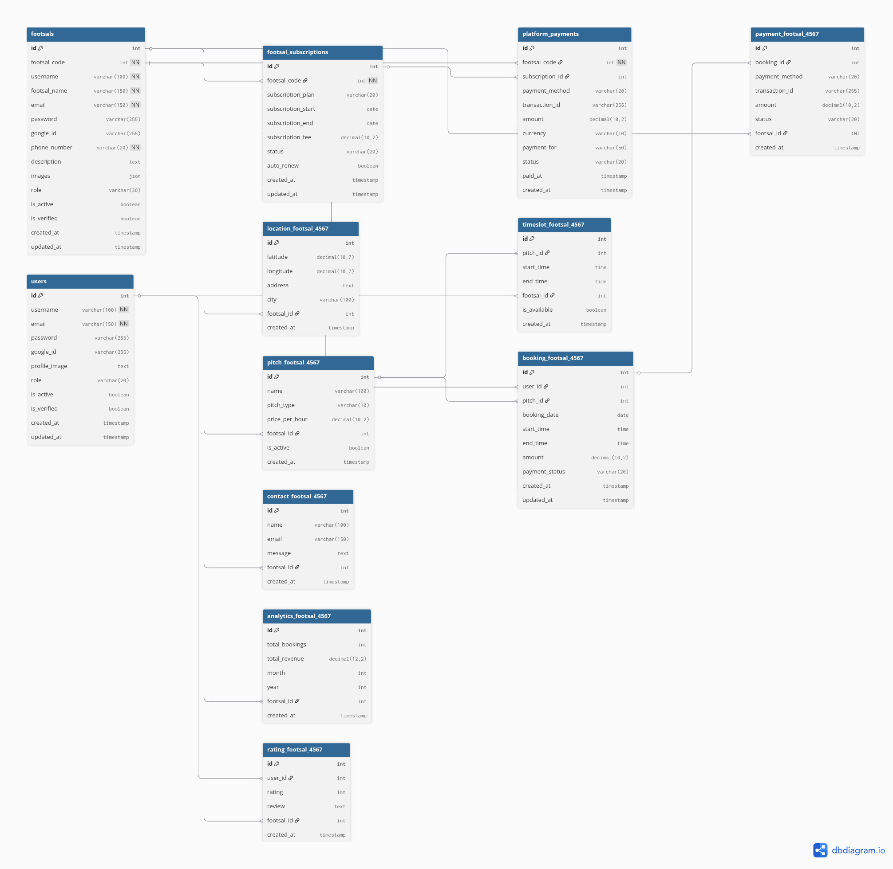
Fig : ER diagram
4.3.5 Core Algorithms Description
The AllFutsal system uses several core algorithms to ensure correct booking, smart recommendations, sentimental analysis of reviews and summarization. The main algorithms are described below.

Slot Conflict preventation Algorithms
This algorithm prevents double booking of the same futsal court and time slot.
Logic:
        - User selects futsal, date, and time slot
        - System checks database for existing booking
        - If slot is free ( temporarily lock slot )
        - Booking is confirmed ( slot marked as reserved )
        - If already booked ( system rejects request )
Result: No two users can book the same slot at the same time.

Review Sentiment & Summarization Algorithm
This algorithm analyzes user reviews and generates short insights.
Logic:
        - Collect futsal reviews
        - Clean and preprocess text
        - Convert text to TF-IDF vectors
        - Apply trained sentiment classifier
        - Label reviews as positive, neutral, or negative
        - Extract key sentences for summary
Result: Users quickly understand overall feedback.

Location Based suggestion
This algorithm suggest a futsal to users based on their nearest location.
Logic:
        - Take user location coordinates
        - calculate distance to each futsal
        - Apply weighted scoring formula
        - rank footsal by score
        - return top futsal
Result : User see nearby footsal first.

5. Expected Outcome
Upon completion, the AllFutsal project will provide a fully functional Software as a Service (SaaS) platform capable of hosting multiple independent futsal businesses while ensuring complete data isolation. The system will feature an intelligent booking engine that prevents scheduling conflicts, manages peak hours efficiently, and handles cancellations automatically. Futsal owners will have access to analytical dashboards that provide insights into peak usage times, revenue trends, and customer engagement, supporting data-driven decision-making. From the user’s perspective, the platform will offer an AI-enhanced experience, including a recommendtion system that suggests futsal courts based on user location, as well as a review summarization feature that condenses user feedback into meaningful insights. Additionally, the project will deliver comprehensive code documentation and a detailed final report describing the system architecture, implemented algorithms, and overall methodology, ensuring the solution is well-documented and maintainable.
6. References
[1] Coursera, “What is TF-IDF (Term Frequency–Inverse Document Frequency)?,” Coursera Articles. [Online]. Available: https://www.coursera.org/articles/what-is-tfidf
[2] IBM, “What is multi-tenant architecture?,” IBM Think Topics. [Online]. Available: https://www.ibm.com/think/topics/multi-tenant
[3] Towards Data Science, “Location-Based Recommendations,” Towards Data Science. [Online]. Available: https://towardsdatascience.com/location-based-recommendations-bb70af7b1538/
[4] IBM, “What is sentiment analysis?,” IBM Think Topics. [Online]. Available: https://www.ibm.com/think/topics/sentiment-analysis
[5] A. Fauzi et al., “Explore Business Opportunities in the Sport Industry in Bekasi: Web-Based Futsal Field Rent Information System,” Indonesian Journal of Economics and Strategic Management (IJESM), vol. 1, no. 2, Jul. 2023. [Online]. Available: https://journal.drafpublisher.com
[6] A. N. S. Suhaimi and M. Z. Sahid, “A Development of Futsal Court Booking System,” Applied Information Technology and Computer Science (AITCS), vol. 4, no. 1, pp. 967–980, 2023. doi: 10.30880/aitcs.2023.04.01.055.
[7] SportsKey, “Sports Facility Booking Software Trends and Conflict Reduction Statistics,” 2026. [Online]. Available: https://www.sportskey.com
[8] Universiti Teknologi MARA (UiTM), “Progressive Web Applications for Mobile-First Systems,” 2024.
[9] I. Sommerville, Software Engineering, 10th ed. Pearson, 2016.

