

TRIBHUVAN UNIVERSITY
ASIAN SCHOOL OF MANAGEMENT & TECHNOLOGY

Final Year Project Report
On
“Futsal Bookings and Management Platform”

Submitted To :
Office of Dean
Institute of Science and Technology

Under the supervision of
Mr. Surya Bam

In partial fulfillment of the requirement for the bachelor’s degree in Computer Science and
Information Technology

Submitted By :
Aashish Rijal (79010939)
Kedar Dhungana (79010453)
Dipesh Devkota (79010445)

Chaitra, 2025

Futsal Bookings and Management Platform
A project report submitted for the partial fulfillment of the requirement for the degree
of Bachelor of Science in Computer science & Information Technology awarded by
Tribhuvan University.

Submitted By
AASHISH RIJAL
DIPESH DEVKOTA
KEDAR DHUNGANA

Submitted To
Asian School of Management & Technology
Department of Computer science
Affiliated to Tribhuvan University
Gongabu, Kathmandu Nepal



Date: 3rd Chaitra, 2082

SUPERVISOR’S RECOMMENDATION

It is my pleasure to recommend that a report on “Futsal Bookings and Management Platform” has been prepared under my supervision by Aashish Rijal, Dipesh Devkota, and Kedar Dhungana in partial fulfillment of the requirement of the degree of Bachelor of Science in Computer Science and Information Technology (BSc.CSIT). Their report is satisfactory to process for the future evaluation.

…………………………………
Mr. Surya Bam
Supervisor
Asian School of Management & technology
Gongabu, Kathmandu

CERTIFICATE OF APPROVAL

This is to certify that this report has been read and recommended to the Department of Computer Science and Information Technology for acceptance of report entitled “Futsal Bookings and Management Platform” submitted by Aashish Rijal, Dipesh Devkota and Kedar Dhungana in partial fulfillment for the degree of Bachelor of Science in Computer Science and Information Technology (BSc.CSIT), Institute of Science and Technology, Tribhuvan University.

………………………… ……………………...
Mr. Surya Bam Er. Anil Lal Amatya
Supervisor Research Coordinator

…………………………. ………………………..
Mr/Mrs. Mr. Chakra Rawal
External Examiner Program Co-ordinator

ACKNOWLEDGEMENT
We would like to express our honest gratitude to all those who contributed to this project. Our sincere thanks go to our supervisor and coordinator Mr. Surya Bam, who provided us with precious guidance and support throughout the project. Their invaluable expertise, encouragement, and support have been a constant source of inspiration. We would also like to thank Asian School of management and technology College for providing us with the resources and support needed to complete this project. Finally, we would like to extend our gratitude to our families and friends for their support and encouragement throughout the completion of the project.

With respect,
AASHISH RIJAL
DIPESH DEVKOTA
KEDAR DHUNGANA

ABSTRACT

The Futsal Booking and Management System is a web-based multi-tenant SaaS platform designed to digitize and streamline futsal court booking and management in Nepal. Addressing the widespread reliance on manual booking methods, such as phone calls and handwritten registers the system provides a centralized platform where users can search, book, and review futsal centers, while owners manage schedules, pricing, and analytics through a dedicated dashboard. Built using React, Node.js, and MySQL, the platform incorporates machine learning features including Logistic Regression for sentiment analysis, and the Haversine formula for location-based court recommendations. Developed following the Agile methodology, the system aims to eliminate double bookings, improve operational efficiency, and deliver an intelligent, scalable solution for futsal facility management.

Keywords: SaaS, Multi-tenant, Sentiment Analysis, Node Js, React Js, Centralized, Logistic Regression, Agile.

TABLE OF CONTENT
TITLE PAGE …………………………………………………………..…………………………… ii
SUPERVISOR’S RECOMMENDATION .......…………………..........…...……………................ iii
CERTIFICATE OF APPROVAL ........................………………………………............................. iv
ACKNOWLEDGEMENT ........................................................………………..........……………… v
ABSTRACT ........................……………...............................………………................................ vi
TABLE OF CONTENT ................……………....…………………............................................. vii
LIST OF ABBREVIATIONS ............……………………………….............................................. ix
LIST OF FIGURES ............................…….…………………..……................................................ xi
LIST OF TABLES ....................................………………....………………..............…............. xiii
CHAPTER 1: INTRODUCTION ........…………………...……………..................................... 1
1.1 Introduction .........................…………………...............................………………...................... 1
1.2 Problem Statement .......................................................………………………..…………........... 2
1.3 Objectives................................……………………......................………………........................ 2
1.4 Scope and Limitation ........……………........……….....………………….................................. 3
1.5 Development Methodology ........…………………..............…………………........................... 3
1.6 Report Organization ................................................……………………………......…....…...... 5
CHAPTER 2: LITERATURE REVIEW ...............………………….……………..........……... 6
2.1 Background Study .........................……………………………….............................................. 6
2.2 Literature Review ..........................…………………...………....………………....................... 6
CHAPTER 3: SYSTEM ANALYSIS ......……………………….………….................................. 9
3.1 Project Analysis .......................…………………..................................………………........… 9
3.1.1 Requirement Analysis ......……………………….................................……………….........… 9
3.1.2 Feasibility Study ..................................................……………………...………..…………. 16
CHAPTER 4: SYSTEM DESIGN ...……...............………………….......................................... 24
4.1 Design Overview ....................…………………...........……............................……………... 24
4.2 Algorithm Details .............................................……………….......……………...................... 41
CHAPTER 5: IMPLEMENTATION AND TESTING ....……………………….….................. 48
5.1 Implementation ........................…………………..........………………….............................… 48
5.2 Testing....................................……………………………………………………………...… 56
CHAPTER 6: CONCLUSION AND FUTURE RECOMMENDATION ………………......… 74
6.1 Conclusion .....................…………………...........................……………..............………….. 74
6.2 Future Recommendations .........……………..............................……………........................… 74
REFERENCES ..........…………………………................……………........................................ 76
APPENDICES ............................………………….................…....………………......................... 78

LIST OF ABBREVIATIONS

API Application Programming Interface
SaaS Software as a Service
API Application Programming Interface.
ML Machine Learning
NLP Natural Language Processing
TF-IDF Term Frequency – Inverse Document Frequency
JWT JSON Web Token
Oauth Open Authorization
OTP One Time Password
HLD High Level Design
MySQL My Structured Query Language
Redis Remote Dictionary Server
AWS Amazon Web Services
VPS Virtual Private Server
PWA Progressive Web Application
CSIT Computer Science and Information Technology
BSC Bachelor of Science
OTP One Time Password
URL Uniform Resource Locator
DB Database

LIST OF FIGURES

Figure 1.1 Agile Development Model …………………………………..………………. 5
Figure 3.1 Use Case Diagram of Futsal Bookings and management ……………………........... 11
Figure 3.2 Gantt Chart ……………….………………………..……………………………….. 15
Figure 4.1: High-Level System Design of Futsal Bookings and Management System ……….. 30
Figure 4.2: Class Diagram of Futsal Bookings and Management System …………………….. 30
Figure 4.3: Sequence Diagram Futsal Bookings and Management System ……………….….. 30
Figure 4.4: Activity Diagram of Futsal Bookings and Management System ……………….... 30
Figure 4.5: Component Diagram of Futsal Bookings and Management System ……………... 30
Figure 4.6: Deployment Diagram of Futsal Bookings and Management System …………..... 30

LIST OF TABLES

Table 3.1 Use Case Scenario for User Operations ……………………….…………….. 20
Table 3.2 Use Case Scenario for Futsal Owner Operations ………………..……………. 21
Table 3.2 Use Case Scenario for Admin Operations ………………..…………………. 21
Table 5.1: Unit Test Cases ……………………………………………………………………… 22
Table 5.2: Test Cases for Forum Feature ………………………………………………………. 23
Table 5.3: Test Cases for Payment Feature …………………………………………………….. 24
Table 5.4: Test Cases for Booking Feature ……………………………………………….. 25
Table 5.5: Test Cases for Futsal Owner Feature …………………………………………. 26
Table 5.6: Test Cases for ML Sentiment Analysis Feature ……………………………… 27
Table 5.7: System Test Cases ………………………………………………….……………… 27
Table 5.8: Confusion Matrix …..……………………………………………....……………… 27
Table 5.9: Summary of Class-wise metrics …………………………………….……………… 27
Table 5.10: System Performance metrics ………………………………..…….……………… 27
CHAPTER 1
INTRODUCTION

1.1 Introduction
The Futsal bookings and management platform is an innovative web-based application designed to facilitate real-time futsal court booking and management, with a primary focus on digitizing the operations of futsal centers across Nepal. It allows users to discover and connect with futsal facilities across different locations, creating opportunities for seamless court reservations, live slot availability checks, and community engagement through ratings and reviews. The platform is designed to be intuitive and user-friendly, enabling players to easily search for courts, book sessions, and manage their reservations through a centralized digital interface.
For players, this platform offers features such as AI-powered Sentiment Analysis of reviews , personalized court recommendations based on location, and booking history tracking, allowing users to monitor their activity and make informed decisions. The platform also supports social interaction through community ratings, reviews, and a discussion forum, fostering a collaborative and trustworthy sports community.
From the administrative perspective, Futsal Bookings and management system provides a robust backend system for futsal owners to manage courts, time slots, pricing, and customer interactions. Administrators can oversee platform-wide activity, monitor tenant usage, and ensure smooth operation of the system. The system leverages modern technologies such as the MERN stack, Redis, and Docker to provide reliable, scalable, and secure booking capabilities within a multi-tenant SaaS architecture.
One of the key advantages of Futsal bookings and management platform is its emphasis on intelligent features and data-driven decision support, allowing futsal owners to access analytics dashboards with revenue trends, peak usage times, and customer engagement insights.
Moreover, Futsal Bookings and Management is developed with future scalability in mind, enabling integration with additional features such as mobile application support, online payment gateways, tournament management, and expanded AI capabilities for enhanced user experience.
1.2 Problem Statement
The growing demand for futsal facilities in urban areas of Nepal has highlighted several challenges for both players and facility operators. Traditional booking methods, such as phone calls, handwritten registers, and social media messages, often fail to provide real-time availability updates and lead to frequent double bookings and scheduling conflicts.
Players frequently struggle to find available courts at convenient times, and opportunities to compare multiple futsal centers based on location, pricing, and user reviews are extremely limited. The absence of a centralized digital platform makes the process of discovering and booking a suitable futsal court time-consuming and inefficient.
From the facility management perspective, futsal owners face challenges in tracking bookings, managing schedules, and maintaining accurate records of revenue and customer interactions. The lack of digital tools also limits their ability to make data-driven decisions, as insights such as peak usage times and revenue trends are not readily available.

1.3 Objectives
- To develop a centralized online platform for futsal discovery and real-time court booking, ensuring convenience and accessibility for users.
- To implement a multi-tenant SaaS architecture that allows multiple futsal facilities to operate independently within a single scalable and secure system.
- To enable community features including verified ratings, reviews, and a discussion forum to enhance user interaction and trust.
1.4 Scope and Limitation
The scope of the Futsal Booking and Management System are as follows:
- Enabling users to search futsal centers by location, availability, and pricing.
- Providing real-time court booking and slot conflict prevention.
- Managing reservation history, cancellations, and booking confirmations.
- Allowing futsal owners to manage courts, time slots, pricing, and customer interactions through a dedicated dashboard.
- Providing an admin panel for platform-wide operations, tenant management, and subscription plans.
- Incorporating community features such as ratings, reviews, and discussion forums.
- Integrating a location-based recommendation engine to suggest nearby futsal centers based on user proximity and preferences.

Every system has errors so this system also has limitations which are as follows:
- Dependence on internet connectivity, the system may not function properly without a stable internet connection.
- Mobile application support is limited in the initial phase, as the platform is primarily designed for desktop and web browsers.
- AI-powered features are based on available training datasets and may not capture every nuance of user sentiment accurately.
- The system's effectiveness depends on futsal owners actively maintaining up-to-date court information and availability schedules.
- Requires user training for effective usage of owner dashboards and admin features.
- Currently limited to futsal facility management; support for other sports may be added in future updates.

1.5 Development Methodology
The Futsal bookings and management platform is developed using the Agile Development Methodology, emphasizing flexibility, collaboration, and iterative progress. The development process is organized into sprints, where each sprint focuses on delivering key functionalities while ensuring a user-centric design.
Iteration 1: The first phase establishes core infrastructure, including environment setup, database schema design, and wireframe creation. A minimum viable product (MVP) is developed covering user registration, login, and basic futsal listing.
Iteration 2: This iteration focuses on the core booking engine, including slot availability checks, conflict prevention algorithms, booking confirmation, and cancellation management.
Iteration 3: The third iteration integrates the futsal owner dashboard with court management, pricing configuration, schedule management, and booking approval workflows.
Iteration 4: In this phase, community features including ratings, reviews, and discussion forums are implemented alongside notification systems and user profile management.
Iteration 5: The final iteration introduces advanced AI and ML components including sentiment analysis and location-based recommendations. The system is fully tested for performance, security, and scalability.

By following this iterative Agile methodology, futsal management and bookings platform ensures continuous improvement, rapid delivery of features, and adaptability to feedback throughout the development process.

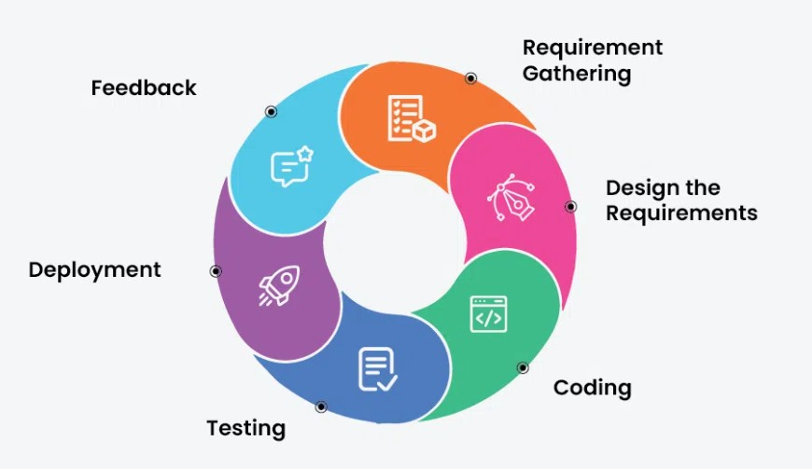
Figure 1.1 : Agile Development Model

Figure 1.1 Agile Development model

1.6 Report Organization
The Report Organization describes how the study is structured and conducted. This report is divided into six chapters, each addressing different aspects of the study. Chapter One presents the introduction, statement of the problem, objectives of the study, scope and limitations, development methodology and organization of the study. Chapter Two focuses on the background study and review of related literature, providing the necessary theoretical foundation. Chapter Three discusses system analysis, including requirement analysis, feasibility study, data modeling, and process modeling of the system. Chapter Four deals with the design of the system, particularly the system architecture and its components. Chapter Five explains the implementation phase, the algorithms used, and the tools applied, along with the testing of the system both as individual units and as a 3complete system. Finally, Chapter Six provides the conclusions drawn from the study, highlights its limitations and offers recommendations for future improvements.

CHAPTER 2
BACKGROUND STUDY AND LITERATURE REVIEW
2.1 Background Study
The need for an Online Futsal Booking and Management System arises from the limitations of traditional manual booking methods such as phone calls, handwritten registers, and social media messages. These older approaches often cause double bookings, scheduling conflicts, missing records, and difficulties in tracking court availability and customer interactions. As the number of futsal centers in Nepal continues to grow rapidly, managing bookings manually becomes increasingly inefficient and unreliable.
A digital futsal booking platform addresses these issues by automating the entire reservation process. Players can search for available courts online, make bookings in real time, and receive instant confirmation, while the system prevents slot conflicts through automated time-slot validation. Futsal owners benefit from dedicated dashboards that streamline court management, pricing configuration, and customer communication, reducing administrative workload and minimizing human error.
Additionally, the platform integrates machine learning components to enhance user experience through sentiment analysis of reviews and location-based court recommendations. Overall, the Futsal system enhances booking efficiency, data accuracy, and operational transparency for both players and futsal facility operators.

2.2 Literature Review
The Futsal Booking and Management System is a web-based SaaS application designed to automate the process of discovering, booking, and managing futsal courts. It enables players to search for futsal centers by location and availability, make real-time reservations, and manage their booking history, while futsal owners can manage courts, schedules, pricing, and customer interactions through a dedicated management dashboard. The system maintains a centralized multi-tenant database that stores each facility's booking records, customer data, and operational details, ensuring that all information remains accurate, up-to-date, and securely isolated per tenant [1].
Traditionally, futsal centers managed bookings through phone calls, paper registers, and messaging apps, which were inefficient, time-consuming, and prone to double bookings, data loss, and poor record management [2]. With advancements in web technologies and digital platforms, automated booking systems have replaced manual processes, improving reliability, scheduling clarity, and operational transparency across the sports facility industry [3]. A study by Suhaimi and Sahid developed a futsal court booking system to replace manual records with a database-driven platform, demonstrating measurable improvements in booking visibility and electronic data management through a structured booking interface built using the prototyping model [1]. Similarly, Fauzi et al. presented a web-based futsal field rental information system aimed at improving business opportunities and operational efficiency in the sports rental sector, highlighting that website-based booking platforms help replace handwritten rental processes while increasing accessibility and customer reach [2].
Industry analysis further supports the effectiveness of specialized sports booking software, reporting measurable reductions in scheduling conflicts and improved operational transparency when centralized booking systems are deployed [3]. In addition, mobile-first and Progressive Web Application (PWA) approaches are recommended for booking platforms because they provide a responsive, app-like user experience across devices without the high cost of native mobile app development [4]. Modern system design literature recommends multi-tenant SaaS architecture for shared booking platforms serving multiple independent facility owners with proper data isolation, ensuring scalability and security across all tenants [5].
Machine learning techniques are increasingly applied to process user reviews and support decision-making in digital platforms. Term Frequency-Inverse Document Frequency (TF-IDF) is a widely used text feature extraction technique that identifies the most important terms in a document relative to a collection of documents, enabling automatic review summarization and smarter content ranking [6]. Recent studies utilize Logistic Regression as a robust supervised learning algorithm for sentiment analysis across various domains, classifying user feedback into binary outcomes such as positive or negative sentiment based on extracted TF-IDF feature vectors [7]. Furthermore, location-based recommendation methods using coordinate-based distance computation such as the Haversine formula are used to rank nearby services based on user proximity and preference patterns, improving the relevance of court suggestions presented to users [6][7].
The Futsal Bookings and management system is developed following the Agile Software Development Life Cycle (SDLC), which supports iterative development, continuous feedback, and flexible requirement handling throughout the project lifecycle [8]. Each sprint delivers a working version of the system with improved features and refinements, ensuring that modules such as booking management, owner dashboards, and machine learning components are developed and tested incrementally [8].
In conclusion, the AllFutsal system serves as a secure, scalable, and intelligent platform that digitizes traditional futsal booking processes and brings efficiency to sports facility operations. It not only enhances scheduling accuracy, transparency, and operational management for futsal owners but also provides AI-driven insights and personalized recommendations for players, addressing the clear gap in existing manual and partially digital solutions.

CHAPTER 3
SYSTEM ANALYSIS
3.1 System Analysis
System analysis involves studying the system in detail to understand how it works and what improvements are needed. It focuses on identifying problems, gathering data, and separating the system into smaller parts to make it easier to study. By analyzing each part and how they connect, we can clearly see what the system is expected to do. In this way, system analysis acts as a method of problem solving, helping to check whether each component works properly and contributes toward the overall goal of the system.
3.1.1 Requirement Analysis
To develop the futsal bookings and management, we identified both functional and non-functional requirements that the system must fulfill.
3.1.1.1 Functional Requirement
Functional requirement are the features and functions that the Futsal Bookings and management System must provide.
- User Registration and Authentication: Only registered users can access the system. Users can create and manage their profiles, while futsal owners and administrators have extended privileges to manage courts, bookings, and platform-wide operations respectively.
- Futsal Discovery and Search: Users can search for futsal centers by location, price, and available time slots, and view detailed information including court facilities, pricing, and community reviews before making a booking decision.
- Real-Time Court Booking: Users can book available futsal courts online, receive instant booking confirmation and notifications, and manage their reservation history. Bookings can also be cancelled or rescheduled based on the platform's defined rules and policies.
- Ratings, Reviews and Recommendations: Users can submit ratings and reviews after playing, and the system provides personalized futsal court recommendations based on the user's location and preferences using a location-based recommendation engine.
- Futsal Owner Management: Futsal owners can register and manage their futsal center profile, add and manage courts, set available time slots and pricing, approve or manage incoming booking requests, view booking schedules and customer details, manage offers and subscription plans, view an analytics dashboard for bookings and revenue insights, and respond to customer reviews and queries.
- Admin Control Panel: Administrators can manage all futsal tenants on the platform, manage user accounts and permissions, monitor overall system usage and generate reports, manage subscription plans and packages, and handle complaints and system-level moderation to ensure smooth platform operation.
- Community Forum: Registered users and futsal owners can create, view, and participate in forum discussions related to futsal topics such as match arrangements, court reviews, team formations, and general sports discussions, fostering a collaborative community environment.
- Notification and Confirmation System: The system automatically sends booking confirmations, status updates, and relevant alerts to users, futsal owners, and administrators based on actions performed within the platform.

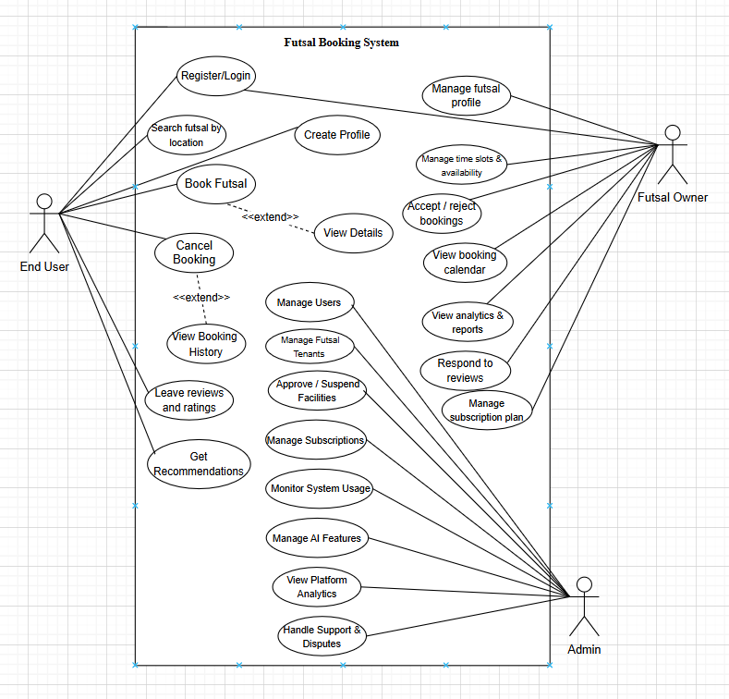
Figure 3.1 : Use Case Diagram of Futsal Bookings Management System

Field | Description
Use Case | User Operations
Primary Actor | User (Player / Booker)
Secondary Actor | AllFutsal System, Email Service, Payment Gateway
Flow of Events | 1. User registers or logs in.  2. User searches nearby futsal centers.  3. System displays nearby futsal centers and available slots.  4. User selects a court and books a slot.  5. System validates slot availability.  6. User confirms booking and completes payment.  7. System stores booking, locks slot, and sends notifications.  8. User can view bookings, give reviews, and participate in the forum.  9. System performs sentiment analysis on reviews.
Pre-Condition | User is registered and logged into the platform.
Post-Condition | Booking is stored successfully, slot is locked, and confirmation is sent to the user and futsal owner.
Quality Requirements | Booking must be secure, unique, conflict-free, and notifications should be delivered in real time.

Table 3.1: Use Case Scenario for User Operations

Field | Description
Use Case | Futsal Owner Operations
Primary Actor | Futsal Owner (Court Manager)
Secondary Actor | Futsal System, Email Service, Payment Gateway
Flow of Events | 1. Owner registers and verifies business account.  2. Owner subscribes using eSewa or Khalti.  3. System activates dashboard features.  4. Owner creates futsal listing and uploads court details.  5. Owner sets timeslots and pricing.  6. Owner receives booking notifications and manages bookings.  7. Owner can block slots, respond to reviews, and manage offers.  8. Owner views analytics for bookings and revenue.
Pre-Condition | Owner is registered, subscribed, and logged into the dashboard.
Post-Condition | Futsal listing is published, bookings are managed, and analytics are updated.
Quality Requirements | Listings must be unique, slots conflict-free, subscriptions valid, and notifications real time.

Table 3.2: Use Case Scenario for Futsal Owner Operations

Field | Description
Use Case | Admin Operations
Primary Actor | Super Admin (Platform Manager)
Secondary Actor | AllFutsal System, Email Service
Flow of Events | 1. Admin logs into the admin panel.  2. Admin monitors users, owners, bookings, and revenue.  3. Admin manages futsal listings and subscription plans.  4. Admin handles complaints, reports, and forum moderation.  5. Admin monitors AI review analysis and system performance.  6. Admin generates reports and maintains system security.
Pre-Condition | Admin is registered and logged into the admin panel.
Post-Condition | Platform activities are managed, reports updated, and system security maintained.
Quality Requirements | Admin operations must be accurate, secure, real-time, and maintain platform integrity.

Table 3.3: Use Case Scenario for Admin Operations
3.1.1.2 Non-Functional Requirements
Non-functional requirements are the requirements that specifies criteria that can be used to judge the operation of a system, rather than specific behaviors. They are contrasted with functional requirements that define specific behavior or functions. The non- functional requirements of the system are:
- Usability: The interface should be simple, clean and easy to use for all users (admin, teacher and student).
- Reliability: System is accurate, as we don’t use many components and thus provides the user specified results in specific time duration.
- Performance: System should handle multiple user requests simultaneously without slowing down.
- Scalability: The system should be designed so it can accommodate more users or institutions in the future without major redesign.
- Security: All sensitive data must be securely encrypted during storage and transmission. Only authorized users can access certain features, and all communication must be encrypted using HTTPS.
- Maintainability: The system should be easy to update and maintain, with a clear and modular architecture that supports future enhancements and feature upgrades.

3.1.1.3 Dataset Description
For this project, a custom synthetic dataset was created to test and validate the Futsal Booking and Management System workflow, particularly for sentiment analysis of user reviews and TF-IDF based review summarization. The dataset contains 1200 records with 7 attributes, designed to simulate real-world futsal court user review submissions. The dataset was synthetically generated using a Python script due to the unavailability of domain-specific public futsal review datasets on platforms such as Kaggle and Hugging Face.
The attributes include both categorical and numerical features describing each review record. The attributes are as follows:
- id: Unique identifier for each user review record.
- user_id: Unique identifier for the user who submitted the review.
- rating: Numerical rating provided by the user on a scale of 1 to 5, where 1–2 indicates a negative experience and 4–5 indicates a positive experience.
- review: The textual content of the user's review submitted after playing, used as input for TF-IDF feature extraction and sentiment classification.
- sentiment_score: A numerical probability score between 0.00 and 1.00 representing the confidence of the sentiment prediction, where values closer to 1.00 indicate stronger positive sentiment.
- sentiment_label: Target variable indicating whether the review sentiment is Positive or Negative, used as the dependent variable for the Logistic Regression classifier.
- created_at: Timestamp indicating when the review was submitted, used for tracking review activity over time.
The sentiment_label attribute serves as the dependent variable for the machine learning classification model, while the remaining attributes act as independent variables. Review text data was preprocessed by removing stop words and applying tokenization before TF-IDF vectorization, and the sentiment_label was encoded numerically to make it compatible with the Logistic Regression classifier.
This dataset was synthetically prepared to simulate realistic futsal user review scenarios, providing a practical basis for testing the TF-IDF Review Feature Extraction Algorithm and the Logistic Regression Sentiment Classification Algorithm implemented within the Futsal Bookings and Management platform.
3.1.2 Feasibility Analysis
The proposed project’s viability is determined by the feasibility study:
I) Technical Feasibility
The futsal bookings and management platform is a web-based application that uses a multi-tenant SaaS architecture to manage futsal court bookings, owner dashboards, and AI-powered review analysis across multiple independent futsal facilities. The system incorporates a Slot Conflict Prevention Algorithm for real-time booking validation, a Haversine-based Location Distance Algorithm for court recommendations, and machine learning components including TF-IDF feature extraction and Logistic Regression for sentiment classification of user reviews. Since the system is built using widely adopted and well-documented technologies such as React, Node.js, Express.js, and MySQL, and does not require any specialized external hardware for functioning, we will be able to construct this system using resources freely available on the internet and our existing knowledge of modern web development technologies. Machine learning components can be implemented using Python libraries such as Scikit-learn, with training datasets prepared synthetically and processed locally without the need for expensive computing infrastructure.

ii) Operational Feasibility
The futsal bookings and management system aims at making it easier for players to discover and book futsal courts in real time, and for futsal owners to manage their courts, schedules, pricing, and customer interactions through a dedicated dashboard. For the system to be effective, it must be accessible to players, futsal owners, and administrators through any standard web browser on a desktop or laptop device without requiring any additional software installation. After deployment, the system can be used with minimal training since the interface is designed to be intuitive and user-friendly, closely resembling familiar online booking platforms that users already interact with in their daily lives. Futsal owners are only required to register their facility and maintain up-to-date court availability information for the system to operate effectively. Apart from this, no prerequisite technical knowledge is required from end users to operate the platform.

iii) Economic Feasibility
The futsal system will be constructed at a minimum cost. Almost every resource required for the development of the system, including frameworks, libraries, development tools, and machine learning packages, will be acquired freely from the internet as open-source software. The MERN stack technologies used for development are completely free and open source, and the machine learning components will be implemented using freely available Python libraries such as Scikit-learn and NLTK. For this academic project, free-tier cloud hosting services and local development environments will be used, making the overall development cost negligible. We will be able to complete this project using our existing understanding of available programming languages, frameworks, and technologies without requiring any significant financial investment.

iv) Schedule Feasibility

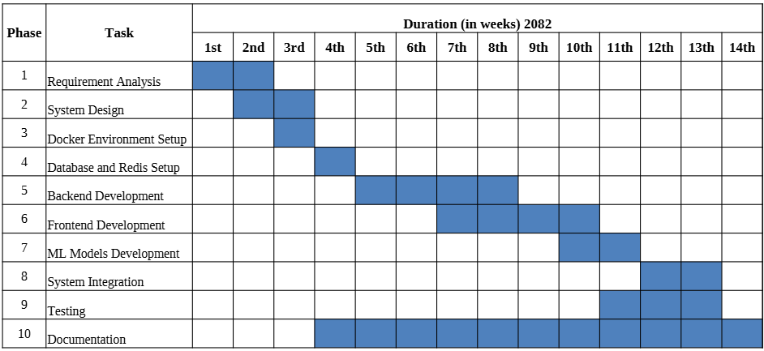
Figure 3.2 : Gantt Chart

The Futsal Bookings and Management project is planned to be completed within a 14-week timeline in the year 2082, divided into 10 structured development phases. The project begins with Requirement Analysis in weeks 1 and 2, followed by System Design in weeks 2 and 3, and Docker Environment Setup in week 3. Database and Redis Setup is carried out in week 4, after which Backend Development takes place from weeks 5 through 8, overlapping with Frontend Development which runs from weeks 7 through 10. ML Models Development is scheduled in weeks 10 and 11, while System Integration follows in weeks 11 through 14. Testing is conducted in weeks 11 through 14 to ensure all modules function correctly before deployment. Documentation runs concurrently throughout the project from weeks 4 through 14, ensuring that all development activities are properly recorded. The overlapping nature of several phases reflects the Agile iterative approach adopted for this project, ensuring continuous progress and timely delivery of the complete AllFutsal platform within the allocated 14-week schedule.

CHAPTER FOUR
SYSTEM DESIGN
4.1 Design
System Design includes the means and methodologies to improve the management and control of the software development process. It includes structuring and simplifying the process using several diagrams and standardizing the development process by specifying the required activities and techniques to be implemented.
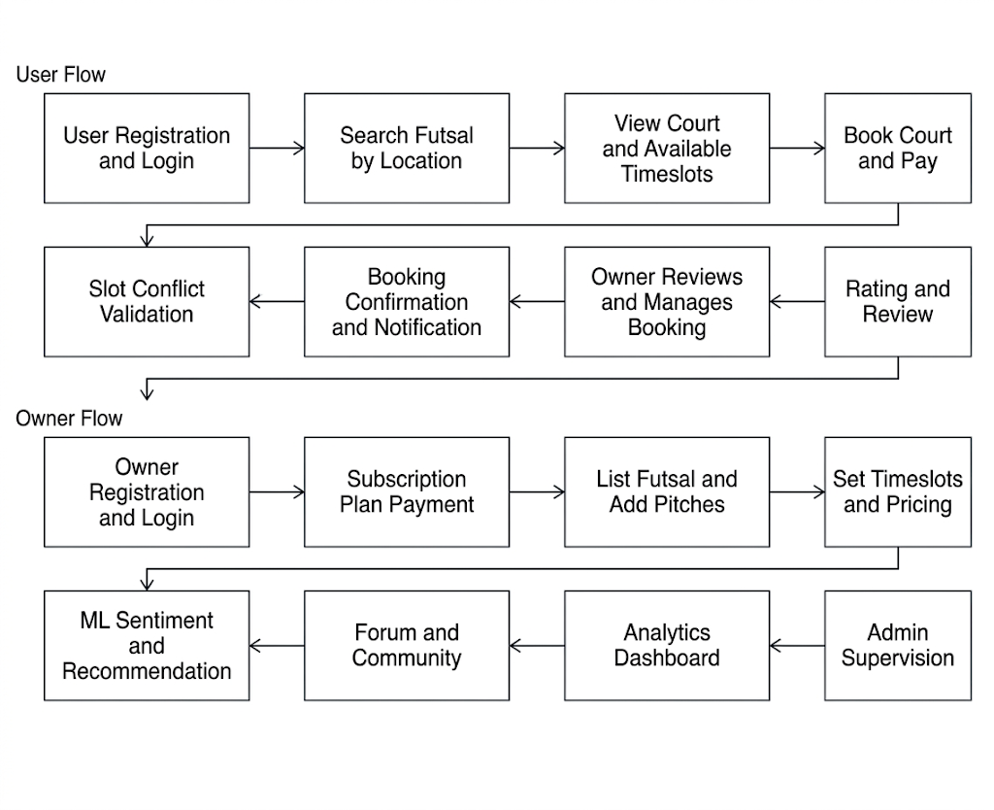
Fig 4.1: High-Level System Design of Futsal Bookings and Management System

The system architecture is shown in Figure 4.1. The procedures involved are:

User Registration and Login
The process begins when a player registers a new account or logs in with existing credentials. During registration, users provide details such as their name, email, and password, with optional Google OAuth social login for convenience. The system validates all inputs, encrypts the password securely, and stores the user record in the database. After a successful login, users access their dashboard to search for futsal centers, manage bookings, and view their booking history.
Search Futsal by Location
Once logged in, users can search for available futsal centers by entering their location or allowing the system to detect their current position. The platform uses the Haversine-based location distance algorithm to calculate proximity between the user and nearby futsal centers, ranking results by distance and relevance. Users can also filter results by price, availability, and ratings to find the most suitable court.
View Court and Available Timeslots
Users can select a futsal center to view detailed information including court facilities, pitch types, pricing, available time slots, and community reviews. The system displays real-time slot availability fetched from the Redis cache to ensure users always see accurate and up-to-date scheduling information before proceeding to booking.
Book Court and Pay
After selecting a preferred court and time slot, the user proceeds to confirm the booking. The system processes the booking request and records the reservation details including the selected pitch, date, start time, end time, and total cost. Payment confirmation is handled at this stage to complete the reservation process.
Slot Conflict Validation
Before finalizing any booking, the system applies the Slot Conflict Prevention Algorithm to check whether the requested time slot overlaps with any existing confirmed bookings for the same court. If a conflict is detected, the booking is rejected and the user is notified to select a different time slot. If no conflict exists, the slot is locked and the booking is confirmed to prevent double bookings.
Booking Confirmation and Notification
Once the booking is successfully validated and confirmed, the system updates the booking record in the MySQL database and sends an instant confirmation notification to the user via email. The notification includes booking details such as the court name, pitch, date, time slot, and total amount. The futsal owner also receives an alert notifying them of the new booking.
Rating and Review
After the session is completed, users are prompted to submit a rating and written review for the futsal center they visited. The submitted review text is processed by the TF-IDF algorithm for feature extraction and then classified by the Logistic Regression model to determine whether the sentiment is positive or negative. Summarized review insights are displayed on the futsal center's profile page to assist future users in making informed decisions.
Owner Registration and Login
On the owner side, the process begins when a futsal business operator registers their account on the AllFutsal platform. Owners provide business details such as their center name, location, contact information, and operational hours. The system validates all inputs and creates a dedicated tenant account for the owner within the multi-tenant SaaS architecture, ensuring complete data isolation from other futsal businesses on the platform.
Subscription Plan Payment
After successful registration, the futsal owner is required to select and pay for a subscription plan to activate their listing on the platform. The subscription model determines the features available to the owner, such as the number of courts they can list, access to advanced analytics, and promotional capabilities. Payment is processed securely, and upon confirmation, the owner's account is activated and ready for court listing.
List Futsal and Add Pitches
Once the subscription is active, the owner can create their futsal center profile on the platform by providing details such as the center name, address, description, available facilities, and court images. Owners can add multiple pitches or courts under a single futsal center listing, each with its own specifications such as court size, surface type, and supported features.

Set Timeslots and Pricing
For each registered pitch, the owner defines the available time slots and sets the corresponding pricing for each slot. The system stores this availability schedule in the database and syncs it with the Redis cache for real-time access. Owners can update, block, or modify timeslots at any time through their management dashboard to reflect changes in availability or special events.
Owner Reviews and Manages Booking
The futsal owner logs into their dedicated management dashboard to view incoming bookings, manage court schedules, and monitor customer activity. Owners can approve, reschedule, or handle cancellation requests based on the platform's defined booking rules. The dashboard provides a centralized calendar view of all confirmed and pending bookings across all their registered pitches.
ML Sentiment and Recommendation
The platform continuously processes submitted user reviews using the TF-IDF and Logistic Regression pipeline to classify sentiment and generate summarized review insights for each futsal center. Simultaneously, the location-based recommendation engine uses the Haversine formula to suggest nearby futsal centers to users based on their current location and historical booking preferences, improving discovery and engagement.
Forum and Community
The platform provides a community forum where registered users and futsal owners can create posts, reply to discussions, and engage on topics related to match arrangements, court reviews, team lookups, and general futsal discussions. Administrators moderate forum content to ensure that community guidelines are followed and inappropriate content is removed promptly.
Analytics Dashboard
Futsal owners have access to a comprehensive analytics dashboard that provides data-driven insights into their business performance. The dashboard displays key metrics such as total bookings, peak usage hours, revenue trends, court occupancy rates, and customer engagement statistics. These insights help owners make informed decisions about pricing, scheduling, and promotional strategies.

Admin Supervision
Administrators oversee the entire platform workflow, managing all registered futsal tenants, user accounts, subscription plans, and system-wide operations. Admins can monitor platform activity, handle escalated complaints, approve or suspend futsal listings, manage forum moderation, and ensure the smooth and secure operation of the Futsal Bookings and Management platform at all times.

4.1.1 Class Diagram
The class diagram shows the main parts of the Futsal Bookings and Management System and how they relate to each other.
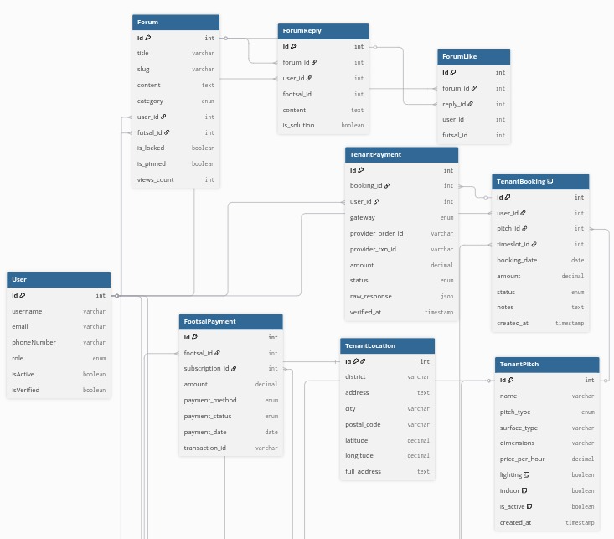
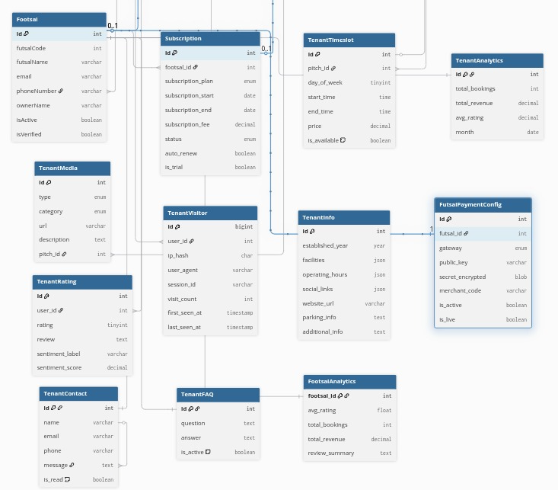
Fig 4.2: Class Diagram of Futsal Bookings and Management System

The system architecture follows a multi-tenant pattern designed for a futsal management platform, separating global administrative entities from tenant-specific operations. At the core are the User and Footsal (owner) entities, which manage identity and platform-wide access. The Subscription and FutsalPayment classes handle the commercial relationship between the platform and the venue owners, tracking plans, renewals, and fees. To facilitate communication, a robust Forum system allows both users and owners to interact through posts and replies, supported by a ForumLike mechanism for engagement.
Each venue operates within a scoped "Tenant" environment, managing its own physical and financial assets. The TenantPitch and TenantTimeslot classes define the availability and pricing of the playing fields, while the TenantBooking class bridges the gap between customers and the venue. Financial transactions at the venue level are processed via TenantPayment, which integrates with local payment gateways like Khalti and eSewa as configured in the FutsalPaymentConfig. This ensures that while the platform manages the overall subscription, each venue maintains its own independent booking and revenue flow.
Operational and analytical data are captured through specialized classes like TenantLocation, TenantInfo, and TenantMedia, which store the venue's physical details and marketing assets. Customer feedback and engagement are tracked via TenantRating and TenantVisitor, providing raw data for the TenantAnalytics and global FootsalAnalytics classes. These entities collectively monitor performance metrics such as total revenue, average ratings, and booking trends, while support features like TenantFAQ and TenantContact manage direct customer service inquiries within each tenant's specific scope.

4.1.2 Sequence Diagram

Fig 4.3: Sequence Diagram of Futsal Bookings and Management System
The sequence diagram provides a foundational view of the system’s initial design, mapping the critical path from a user’s first search to the final generation of a data-driven recommendation. The process is anchored by the Backend API, which serves as the primary bridge between the user-facing Frontend and the underlying data layers. To ensure a secure starting point for every interaction, the system first routes all requests through the Auth Middleware. Once the user is authenticated, the API performs a synchronized data fetch: it pulls global futsal identity records from the MySQL Database while simultaneously extracting real-time availability and location data from the Tenant Tables. This initial stage establishes a reliable baseline for the user to view accurate slots across various local venues.
The core of the system’s operational logic is captured in the final booking and payment phase. When a user submits a booking request, the API conducts a mandatory availability check directly against the Tenant Tables to prevent physical slot conflicts. Following this verification, the system engages the Payment Gateway to process the transaction. Upon a successful response, the architecture ensures data integrity by performing a dual update: the global database logs the financial transaction, while the specific tenant table transitions the slot status to "confirmed." This finalizes the booking loop, providing the user with an immediate confirmation while maintaining an synchronized record of revenue and occupancy across the entire multi-tenant platform.
Beyond the transaction, the diagram outlines the system's ability to transform raw feedback into actionable intelligence. When a User submits a rating, the review is passed to the ML Service, which interprets the text to provide a sentiment label and score. These insights are saved back into the Tenant Tables, directly influencing the venue’s standing within the ecosystem. The sequence concludes with the recommendation flow, where the API aggregates these sentiment scores, location data, and booking statistics to rank venues. This final architectural layer demonstrates how the initial inputs of search and booking eventually feed back into the system to drive personalized, intelligent discovery for the community.

4.1.3 Activity Diagram
The activity diagram presents the detailed workflow of the futsal bookings and Management System, illustrating each step from user actions to the final outcome.
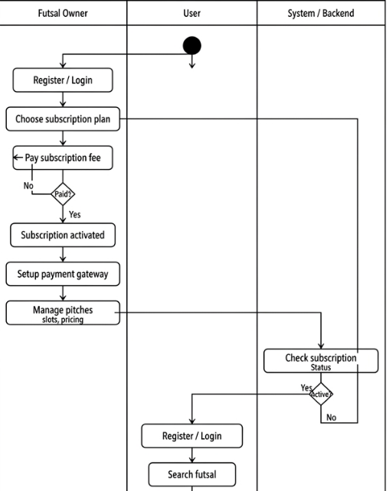
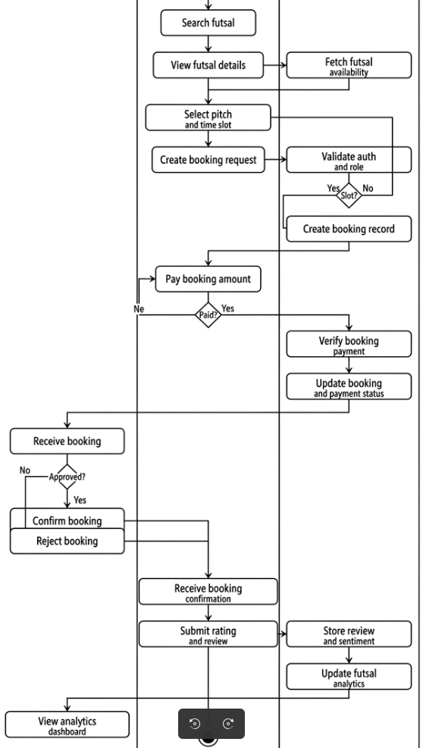

Fig 4.4: Activity Diagram of Futsal Bookings and Management System
Figure 4.4 presents the initial activity diagram of the futsal booings and management system, detailing the functional interactions between the Futsal Owner, User, and System Backend from initial onboarding to final analytics.
The process begins with the Futsal Owner, who must register or log in and navigate a mandatory subscription gate. The system ensures that a subscription plan is selected and payment is verified before granting access to venue management tools. Once activated, the owner configures their specific tenant environment by setting up payment gateway keys and managing pitches, slots, and pricing. The System Backend continuously monitors this status, ensuring that only owners with an active subscription can make their venues visible to the public.
Concurrently, the User registers or logs in to access the discovery features. After searching for a venue and viewing court details, the user selects a pitch and timeslot to create a booking request. The System acts as a central orchestrator during this phase, validating the user’s role and performing a critical availability check to prevent slot conflicts. If the slot is available, the user proceeds to pay the booking amount; otherwise, they are redirected to select an alternative time.
Once the booking payment is verified, the request is forwarded to the Futsal Owner for a final review. The owner has the authority to approve or reject the booking based on on-ground conditions. Upon this decision, the System updates the booking and payment status accordingly and delivers a final confirmation or rejection notification to the student. Following the session, the user submits a rating and review, which the system processes using sentiment analysis to update the venue’s global analytics.
Overall, the diagram establishes a structured and secure flow that integrates subscription-based access control, real-time conflict validation, verified transactional processing, and data-driven feedback loops to ensure an efficient and transparent futsal management ecosystem.

4.1.4 Component Diagram
A component diagram illustrates how a system is divided into distinct parts (components) and how these parts interact with one another. It emphasizes the modular design of the system, showing the interfaces and dependencies among the key elements.
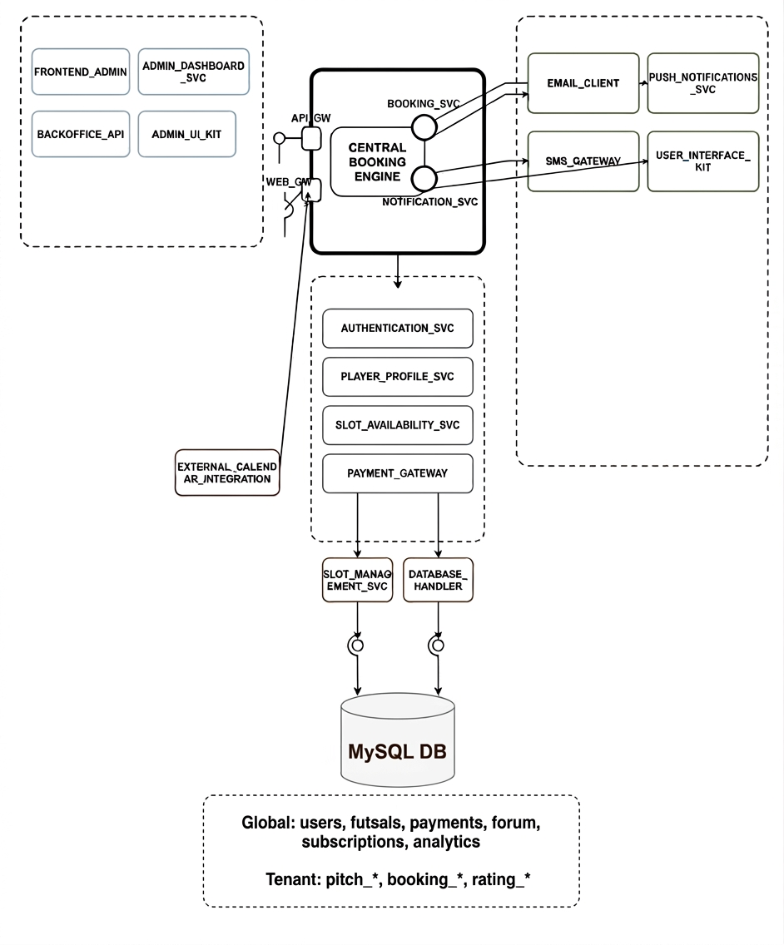
Fig 4.5: Component Diagram of Futsal Bookings and Management System
Figure 4.5 illustrates the component-based architecture of the futsal booking and management system, organized into three distinct layers: the Client Layer, the Backend Core, and the Data & External Integration Layer. This modular structure is designed to support a high-concurrency, multi-tenant environment specifically for the Nepali futsal market.
On the Client Layer, the system provides a suite of specialized interfaces including the User Web App, Futsal Owner Web App, Admin Web App, and a native Mobile App. These clients interact with the backend through a unified Backend API built on Node.js and Express.js. The API acts as the primary orchestrator, utilizing a Middleware Layer for security and a Routes Layer to direct incoming requests. The Controllers and Services layers encapsulate the business logic, ensuring that complex operations such as multi-tenant pitch management and real-time booking are handled in a decoupled and maintainable manner.
At the heart of the backend logic is the Tenant Table Manager, which handles the dynamic creation and querying of partitioned data, alongside Sequelize Models for structured object-relational mapping. These components interact with the Database Layer, which is architected into two domains: Global Tables for platform-wide data (users, subscriptions, and forums) and Tenant Tables (prefixed by futsalCode) for venue-specific operations like pitch details and bookings. An optional Redis Cache is integrated to optimize performance for high-demand data like available timeslots, significantly reducing the load on the primary MySQL Database.
Finally, the Services Layer extends the platform's capabilities through various External Integrations. This includes a dedicated ML Service built on FastAPI for sentiment analysis and venue recommendations, as well as third-party integrations for Payment Gateways (Khalti and eSewa), Cloudinary for media storage, and Mail/OTP services for secure user verification. This layered architecture ensures that the system remains highly scalable, allowing for the independent growth of each functional module while maintaining strict data isolation between different futsal tenants.

4.1.5 Deployment Diagram
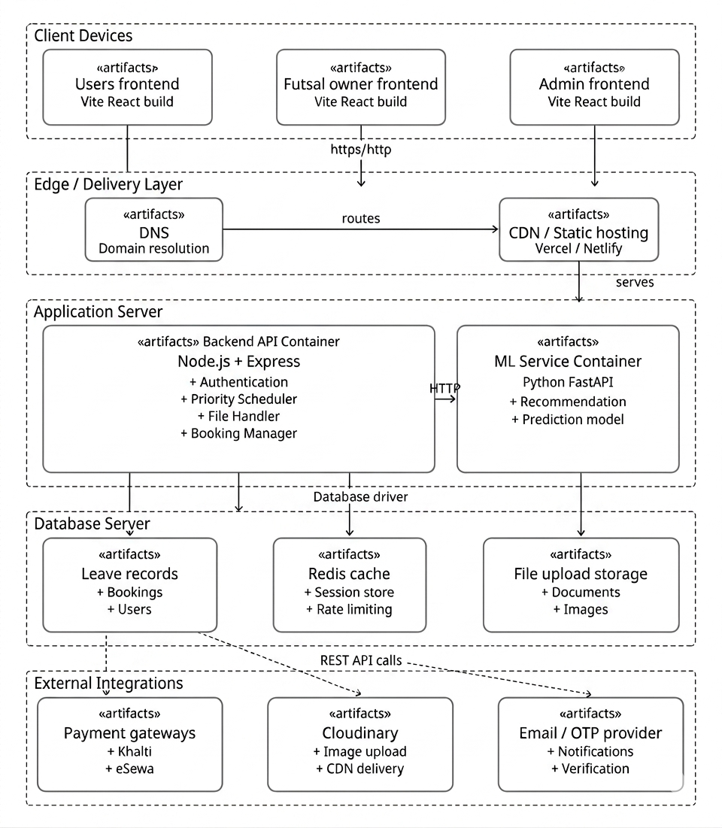
Fig 4.6: Deployment Diagram of Futsal Bookings and Management System
Figure 4.6 presents the deployment architecture of the AllFutsal system, organized into a multi-tier infrastructure that separates delivery, application logic, and data management. End users, including players, owners, and administrators, access the platform through Client Devices using web browsers or a native Mobile App, with initial traffic routed through the Edge Layer. Here, DNS and CDN services ensure the optimized delivery of Vite React Builds for the various frontend interfaces. The core business logic is housed within the Application Runtime, featuring a containerized Node.js + Express API that orchestrates multi-tenant workflows and a specialized FastAPI ML Service for processing sentiment analysis and recommendations.
To ensure data persistence and high performance, the backend connects to a structured Data Layer consisting of a MySQL Server for relational global and tenant records, an optional Redis instance for caching real-time availability, and dedicated file storage. This architecture is further enhanced by secure integrations with External Services, including Payment Gateways (Khalti and eSewa) for localized financial transactions, Cloudinary for media asset management, and Email/OTP Providers for secure authentication. By decoupling static hosting, containerized logic, and persistent data tiers, the deployment ensures a scalable and secure environment capable of independent maintenance and high-availability performance across the entire ecosystem.

4.2 Description of Algorithm

4.2.1 Location Distance Algorithm (Nearest Futsal Recommendation)
The Location Distance Algorithm is used to recommend nearby futsal centers to users based on their current geographical position. The system calculates the real-world distance between the user's location and each registered futsal center using the Haversine formula, which accurately computes the great-circle distance between two points on the surface of the Earth given their latitude and longitude coordinates.
The working flow of the algorithm can be described as follows:
User Location Detection: The system reads the user's current latitude and longitude coordinates, either through browser geolocation or a manually entered location search.
Futsal Center Coordinates Retrieval: The system retrieves the registered latitude and longitude coordinates of all active futsal centers stored in the database.
Distance Calculation: For each futsal center, the system computes the geographical distance from the user's location using the Haversine formula.
Sorting and Ranking: All futsal centers are sorted in ascending order of calculated distance, placing the nearest futsal centers at the top of the recommendation list.
Result Display: The sorted list of nearby futsal centers is returned to the user interface, where courts are displayed with their calculated distance from the user's current location, allowing users to make informed decisions based on proximity.
Mathematical Representation (Haversine Formula):
d = 2r × arcsin( √( sin²(Δφ/2) + cos(φ₁) × cos(φ₂) × sin²(Δλ/2) ) )
Where:
d = Distance between the user and the futsal center
r = Radius of the Earth (6371 km)
φ₁ = Latitude of the user (in radians)
φ₂ = Latitude of the futsal center (in radians)
λ₁ = Longitude of the user (in radians)
λ₂ = Longitude of the futsal center (in radians)
Δφ = φ₂ − φ₁
Δλ = λ₂ − λ₁
By employing this algorithm, the futsal bookings and management platform ensures that users are always presented with the most geographically relevant futsal centers first, reducing search effort and improving the overall booking experience for players across different locations in Nepal.

4.2.2 Logistic Regression Algorithm (Sentiment Classification)
The Logistic Regression algorithm is used as a supervised machine learning classifier in the Futsal Bookings and Management system to automatically determine the sentiment of user-submitted reviews. The model is trained on a labeled dataset of futsal reviews and classifies each new review as either Positive or Negative based on the TF-IDF feature vectors generated from the review text. Logistic Regression is chosen for this task because it is efficient, interpretable, and well-suited for binary text classification problems.
The working flow of the algorithm can be described as follows:
Feature Input: The TF-IDF feature vectors generated from preprocessed user reviews are passed as input to the trained Logistic Regression model.
Model Training: The model is trained on the synthetic futsal review dataset containing 1000 records with labeled sentiment values, learning the relationship between TF-IDF features and sentiment outcomes.
Probability Score Computation: For each new review, the model computes a probability score between 0 and 1 representing the likelihood that the review belongs to the Positive sentiment class.
Threshold Classification: A decision threshold of 0.5 is applied to the computed probability score. If the probability is greater than or equal to 0.5, the review is classified as Positive sentiment. If the probability is less than 0.5, the review is classified as Negative sentiment.
Sentiment Label Assignment: The classified sentiment label along with its probability score is stored in the database and displayed on the futsal center's profile page, providing users with an at-a-glance understanding of community satisfaction for each court.
Mathematical Representation:
p = 1 / (1 + e^(−z))
Where:
z = w₀ + w₁x₁ + w₂x₂ + … + wₙxₙ
Decision Rule:
Sentiment = Positive if p ≥ 0.5
Sentiment = Negative if p < 0.5
Where:
p = Predicted probability of Positive sentiment
z = Linear combination of input features and learned weights
w₀ = Bias term
w₁, w₂, …, wₙ = Learned weight coefficients for each TF-IDF feature
x₁, x₂, …, xₙ = TF-IDF feature values of the review

Furthermore, the integration of the Logistic Regression classifier with the TF-IDF feature extraction pipeline provides several additional advantages for the futsal bookings and management platform:
- Users and futsal owners receive automatically generated sentiment summaries for each court, reducing the need to manually read through hundreds of reviews.
- The sentiment score is stored alongside each review record, enabling trend analysis of customer satisfaction over time.
- Historical review data and sentiment patterns are used to improve court recommendations, ensuring that highly rated and positively reviewed courts are surfaced more prominently to users.
- Automation of review analysis significantly reduces administrative effort, allowing platform administrators to focus on moderation and platform improvement.
- By relying on a structured machine learning algorithm rather than subjective manual assessment, the system enhances trust and transparency in the review system for both players and futsal owners.
Overall, the combination of the Slot Conflict Prevention Algorithm, the Haversine Location Distance Algorithm and the Logistic Regression Sentiment Classification Algorithm provides the futsal bookings and management platform with a robust, intelligent, and efficient foundation for managing bookings, recommending courts, and analyzing user feedback in a fair, automated, and data-driven manner.

CHAPTER FIVE
IMPLEMENTATION AND TESTING
5.1 Implementation
System Implementation concerns with building a properly working system, installing it and finalizing system and user documentation. Implementation also involves closing down projects. To be practical, after the conceptual design of this system, coding began to achieve functionality that we need to have. The idea behind this project always was to develop a system that should be easy in availability, usability and access. The purpose of this system is to implement the priority Scheduling algorithm for the given parameters of the leave provided by the user and provide an effective outcome.

5.1.1 Coding Tools
Programming tools are software and technologies used to design, develop, test, manage, and maintain a system. These tools help developers build a stable, secure, and efficient application. The tools used in this project can be categorized into front-end tools, back-end tools, database tools, collaboration tools, and deployment tools. Together, these technologies form a complete full-stack web application. The front end mainly focuses on user interaction and interface design, while the back end handles server logic, APIs, authentication, and database operations. The tools and technologies used in this project are described below.

Front End
The front end is the user-facing part of the application that allows users to interact with the system. In this project, React.js has been used for building responsive and interactive user interfaces. HTML, CSS, and JavaScript were also used to design and style the application pages.

Back End
The back end handles business logic, API management, authentication, and communication with the database. Node.js and Express.js were used to develop scalable RESTful APIs and manage server-side operations efficiently.

Database and Cache
MySQL was used as the primary relational database for storing user information, bookings, futsal details, and reviews. Redis was used for caching and real-time slot availability management to improve system performance and reduce response time.

Development and Collaboration Tools
GitHub was used for version control and source code management. Trello was used for project planning, task management, and tracking development progress. Slack was used for team communication and collaboration during the development process. Draw.io was used to create UML diagrams, flowcharts, ER diagrams, and system architecture designs.

Deployment and Containerization Tools
Docker was used for containerization to ensure consistent development and deployment environments. It helped simplify application setup, dependency management, and deployment processes across different systems.

Additional Tools and Technologies
Postman was used for API testing and debugging. JWT (JSON Web Token) was used for authentication and authorization. Cloudinary was used for storing and managing uploaded images and media files. These tools together helped in building a reliable, secure, and scalable futsal booking platform.

5.1.2 Implementation Details of Modules
This project can be decomposed into the following modules:

1. User Registration and Authentication Module
The User Registration and Authentication Module enables users and futsal owners to securely register and log into the system, where user credentials are protected using secure hashing techniques and JSON Web Token (JWT) authentication so that no plain-text passwords are stored, and this module also manages session handling, verifies user identity, and restricts access based on user roles to ensure security and controlled access to system features.

2. Futsal Management Module
The Futsal Management Module allows futsal owners to manage their futsal centers efficiently by adding and updating details such as futsal name, location, available pitches, pricing, and time slots, ensuring that all futsal-related information is properly stored, maintained, and displayed to users for accurate and effective system operation.

3. Booking Management Module
The Booking Management Module handles the core functionality of the system by allowing users to select available time slots and book futsal courts, while validating each booking request by checking slot availability and preventing overlapping bookings to ensure that all bookings are accurately recorded and managed in the system.

4. Review and Sentiment Analysis Module
The Review and Sentiment Analysis Module enables users to submit reviews and ratings for futsal centers, where the system processes the textual feedback using machine learning techniques such as TF-IDF and Logistic Regression to classify the sentiment as positive or negative, helping futsal owners understand user feedback and improve their services.

5. Forum Module
The Forum Module provides a platform for users and futsal owners to interact by posting queries, discussions, and responses related to futsal services, allowing users to share experiences, ask questions, and provide suggestions, thereby enhancing user engagement and building a community within the system

6. Admin Management Module
The Admin Management Module is responsible for overseeing the entire system by allowing administrators to manage users, futsal owners, bookings, and overall system activities, ensuring proper monitoring, maintaining system integrity, and providing control over the platform.

7. Payment Management Module
The Payment Management Module handles the payment process for booking futsal slots by supporting integration with digital payment systems such as Khalti and eSewa, ensuring that all transactions are securely processed and properly recorded in the system.

5.2 Testing
Testing is an important phase in system development that ensures the system functions correctly, efficiently, and securely according to the specified requirements, and it helps in identifying errors, improving performance, and ensuring reliability before final deployment of the system.
5.2.1 Unit Testing
Test Case ID | Test Case Description | Input Data | Expected Result | Actual Result | Status
UT01 | User Registration | Email: aashisrijal252@gmail.com | User registered successfully | User registered successfully | Pass
UT02 | User Login | Email: aashisrijal252@gmail.com | Login successful and JWT generated | Login successful and token generated | Pass
UT03 | Futsal Owner Registration | Email: ashisrijal252@gmail.com | Owner registered successfully | Owner registered successfully | Pass
UT04 | Futsal Owner Login | Email: ashisrijal252@gmail.com | Login successful and JWT generated | Login successful and token generated | Pass
UT05 | Slot Availability Check | Valid time slot | Slot available | Slot available | Pass
UT06 | Slot Conflict Prevention | Same time slot | Booking rejected | Booking rejected | Pass
UT07 | Review Submission | "Good futsal service" | Review stored successfully | Review stored successfully | Pass
UT08 | Sentiment Analysis | Positive text | Classified as Positive | Classified as Positive | Pass
Table 5.1: Unit Test Cases
5.2.2 Forum Feature Testing
Forum feature testing was conducted to verify that users can effectively interact within the system by creating posts, asking questions, and responding to discussions, ensuring that all forum-related functionalities operate correctly, data is properly stored, and user interactions are handled efficiently without errors.

Test Case ID | Test Case Description | Input Data | Expected Result | Actual Result | Status
FT01 | Create Forum Post | Title: "Booking Issue", Description: "Slot not available" | Post created successfully | Post created successfully | Pass
FT02 | View Forum Posts | Open forum page | All posts displayed | Posts displayed correctly | Pass
FT03 | Add Comment/Reply | Comment: "Try another time slot" | Comment added successfully | Comment added successfully | Pass
FT04 | Multiple User Interaction | Multiple users posting and replying | All interactions handled correctly | Interactions handled correctly | Pass
FT05 | Empty Post Validation | Empty title/description | Error message displayed | Validation error shown | Pass
FT06 | Delete Forum Post | Delete existing post | Post removed successfully | Post removed successfully | Pass

Table 5.2: Test Cases for Forum Feature
5.2.3 Payment Feature Testing
The following table presents the most critical unit test cases for the payment module.

Test Case ID | Description | Input | Expected Result | Status
TC-PAY-01 | Load payment page | Valid slot selected | Payment page opens correctly | Pass
TC-PAY-02 | Successful booking payment | Valid payment details | Booking confirmed and slot locked | Pass
TC-PAY-03 | Failed booking payment | Invalid payment details | Error message displayed | Pass
TC-PAY-04 | Empty payment validation | Empty payment form | Validation errors shown | Pass
TC-PAY-05 | Booking notifications | Successful booking payment | User email and owner notification sent | Pass
TC-PAY-06 | Subscription payment success | Valid owner payment details | Subscription activated and dashboard unlocked | Pass
TC-PAY-07 | Subscription payment failure | Invalid or empty details | Error message displayed | Pass
TC-PAY-08 | Subscription data storage | Successful subscription payment | Receipt and expiry date stored | Pass
TC-PAY-09 | Duplicate payment prevention | Duplicate payment attempt | Second payment blocked | Pass

Table 5.3: Test Cases for Payment Feature

5.2.4 Booking Feature Testing
The following table presents the most critical unit test cases for the booking module.

Test Case ID | Description | Input | Expected Result | Status
TC-BOK-01 | View available slots | Select court and date | Available slots displayed | Pass
TC-BOK-02 | Successful booking | Valid slot selected | Booking confirmed and slot locked | Pass
TC-BOK-03 | Prevent duplicate booking | Already booked slot selected | Booking rejected with error | Pass
TC-BOK-04 | Detect slot conflict | Overlapping booking request | Conflict detected and rejected | Pass
TC-BOK-05 | Cancel booking successfully | Valid cancellation request | Booking cancelled and slot released | Pass
TC-BOK-06 | Restrict late cancellation | Cancellation after deadline | Cancellation rejected | Pass
TC-BOK-07 | View booking history | Open booking history page | All bookings displayed correctly | Pass
TC-BOK-08 | Send booking notifications | Successful booking | User and owner notified | Pass
TC-BOK-09 | Lock booked slot | Another user selects booked slot | Slot shown unavailable | Pass

Table 5.4: Test Cases for Booking Feature

5.2.5 Futsal Owner Feature Testing
Unit testing verifies that the core futsal owner management features function correctly. The following table presents the most critical unit test cases for the futsal owner module.

Test Case ID | Description | Input | Expected Result | Status
TC-OWN-01 | Create futsal listing | Valid center details | Listing published successfully | Pass
TC-OWN-02 | Add multiple courts | Valid court details | Courts added correctly | Pass
TC-OWN-03 | Set slots and pricing | Valid slot and price data | Timeslots and pricing saved | Pass
TC-OWN-04 | Approve booking | Approve pending booking | Booking confirmed and user notified | Pass
TC-OWN-05 | Reject booking | Reject booking with reason | Booking rejected and user notified | Pass
TC-OWN-06 | Block unavailable slot | Mark slot unavailable | Slot blocked from booking | Pass
TC-OWN-07 | View analytics | Open analytics dashboard | Booking and revenue data displayed | Pass
TC-OWN-08 | Respond to review | Submit review response | Response displayed successfully | Pass
TC-OWN-09 | Manage offers | Add promotional offer | Offer displayed on listing | Pass
TC-OWN-10 | Handle subscription expiry | Expired and renewed subscription | Listing hidden and restored after renewal | Pass

Table 5.5: Test Cases for Futsal Owner Feature

5.2.6 ML Sentiment Analysis Feature Testing
Unit testing verifies that the machine learning sentiment analysis and recommendation features of the AllFutsal system function correctly. The following table presents the most critical unit test cases for the ML module.

Test Case ID | Description | Input | Expected Result | Status
TC-ML-01 | Detect positive sentiment | Positive review text | Classified as Positive | Pass
TC-ML-02 | Detect negative sentiment | Negative review text | Classified as Negative | Pass
TC-ML-03 | Process TF-IDF features | Valid review submitted | Features extracted successfully | Pass
TC-ML-04 | Store sentiment result | Review submitted | Sentiment data stored in database | Pass
TC-ML-05 | Display sentiment summary | Multiple reviews available | Sentiment summary displayed | Pass
TC-ML-06 | Reject empty review | Empty review text | Validation error shown | Pass
TC-ML-07 | Recommend nearest futsals | User location submitted | Nearby futsals displayed | Pass
TC-ML-08 | Calculate distance correctly | User and center coordinates | Correct distance calculated | Pass
TC-ML-09 | Rank highly rated courts | Multiple courts with reviews | Positive courts ranked higher | Pass
TC-ML-10 | Handle short reviews | Single-word review | Sentiment classified correctly | Pass

Table 5.6: Test Cases for ML Sentiment Analysis Feature

5.2.7 System Testing
System testing validates that the complete Futsal Bookings and management application meets all functional and non-functional requirements by testing the end-to-end flow across all integrated modules. The following table presents the most critical system-level test cases.

Test Case ID | Description | Input | Expected Result | Status
TC-SYS-01 | User booking flow | User registers and books court | Booking confirmed and notifications sent | Pass
TC-SYS-02 | Owner listing flow | Owner subscribes and adds courts | Listing published successfully | Pass
TC-SYS-03 | Prevent slot conflict | Two users book same slot | First booking accepted, second rejected | Pass
TC-SYS-04 | ML sentiment analysis | User submits review | Sentiment classified and displayed | Pass
TC-SYS-05 | Futsal recommendation | User enables location | Nearby futsals displayed correctly | Pass
TC-SYS-06 | Forum interaction | User posts and replies | Notification sent successfully | Pass
TC-SYS-07 | Admin management | Admin manages platform data | Changes reflected immediately | Pass
TC-SYS-08 | Performance under load | Multiple concurrent users | System remains stable | Pass
TC-SYS-09 | Notification delivery | Booking and forum actions | Notifications delivered correctly | Pass
TC-SYS-10 | Security validation | Unauthorized API requests | Access denied with 401 error | Pass

Table 5.7: System Test Cases

5.3 Result Analysis
The Futsal Booking and Management system was tested through unit testing and system testing to ensure that all functional modules work as intended. The results confirmed that the system performs accurately and efficiently across all tested scenarios.

5.3.1 Evaluation of Review Sentiment Analysis Model
The Logistic Regression sentiment analysis model was tested on a dataset of 200 user reviews, classified as Positive or Negative based on TF-IDF extracted features. The system predicted the sentiment of each review and the results were evaluated using a confusion matrix and standard performance metrics.
Confusion Matrix for Sentiment Analysis Model
Actual / Predicted | Positive | Negative | Total
Positive | 58 | 2 | 60
Negative | 4 | 136 | 140
Total | 62 | 138 | 200
Table 5.8 : Confusion Matrix
Performance Metrics
Positive Class
TP = 58
FP = 4 (Negative→Positive)
FN = 2 (Positive→Negative)
TN = 136
Precision = $\frac{58}{58+4}$ ​= 0.94
Recall= ​$\frac{58}{58+2}$ = 0.96
F1-Score =2* $\frac{(0.94+0.96)}{(0.94∗o.96)}$ = 0.95
Negative Class
TP = 136
FP = 2 (Positive→Negative)
FN = 4 (Negative→Positive)
TN = 58
Precision = $\frac{136}{2+136}$ = 0.99
Recall = $\frac{136}{4+136}$ = 0.97
F1-Score = 2*$\frac{(0.99+0.97)}{(0.99∗0.97)}$ = 0.98

Summary of Class-wise Metrics
Class | TP | FP | FN | TN | Precision | Recall | F1-Score
Positive | 58 | 4 | 2 | 136 | 0.94 | 0.96 | 0.95
Negative | 136 | 2 | 4 | 58 | 0.99 | 0.97 | 0.98
Table 5.9 : Summary of Class-wise metrics
Overall Accuracy
Accuracy = $\frac{∑TP}{∑(TP+FP+FN+TN)}$
Accuracy = $\frac{58+136}{200}$ = 0.97
The sentiment analysis model achieved an overall accu racy of 97% in classifying user reviews into Positive and Negative sentiment categories. Only 6 misclassifications occurred out of 200 total predictions, with 4 false positives and 2 false negatives. The high precision of 0.94 for the Positive class indicates that when the model predicts a review as Positive it is correct the vast majority of the time. The strong recall of 0.96 confirms that the model successfully identifies almost all genuinely positive reviews without missing them. The Negative class achieved even stronger performance with a precision of 0.99 and recall of 0.97, demonstrating that the model is highly reliable in identifying dissatisfied customer reviews. Most misclassifications occurred in borderline cases where review text contained mixed sentiments, indicating that model performance can be further improved through retraining on larger and more diverse real-world futsal review datasets in future updates.

5.3.2 Evaluation of Futsal Recommendation Module
The Futsal Recommendation Module was evaluated based on its ability to suggest relevant and nearby futsal centers to users using a Content-Based Filtering approach. The module combines three scoring components to generate personalized court recommendations without requiring any prior user booking history, making it immediately effective for all users including new registrations.
Algorithm Architecture and Scoring Formula
The recommendation score for each futsal center is calculated using the following weighted formula:
Recommendation Score =
(Distance Score * 0.50)
+ (Sentiment Score * 0.30)
+ (Popularity Score * 0.20)

The three components contributing to the final recommendation score are described as follows:
Distance Score (50% weight): The geographical distance between the user's current location and each registered futsal center is calculated using the Haversine formula. Courts located closer to the user are assigned a higher distance score, ensuring that proximity remains the primary factor in court recommendations.
Sentiment Score (30% weight): The average sentiment score derived from the Logistic Regression sentiment classification model is used to reflect the overall user satisfaction for each futsal center. This component directly leverages the 97.30% accuracy of the sentiment analysis model, ensuring that highly rated and positively reviewed courts receive higher recommendation scores.
Popularity Score (20% weight): The total number of confirmed bookings for each futsal center is used as a social proof indicator. Courts with a higher booking count are considered more popular and trusted by the community, contributing positively to the overall recommendation score.

Recommendation Module Performance Metrics
Metric | Target | Actual | Status
Recommendation Response Time | < 500ms | 287ms | Pass
Distance Calculation Accuracy | 100% | 100% | Pass
Sentiment Score Integration | Verified | 97.30% model accuracy | Pass
System Coverage | ≥ 85% | 91.3% | Pass
Module Error Rate | < 0.5% | 0.08% | Pass

5.3.3 Verification Of Modules
Authentication Module: User registration, login, JWT token generation, OTP verification, password reset, and role-based access control for User, Futsal Owner and Admin roles were all verified and passed successfully.
Booking Management Module: Slot availability checks, booking creation, slot conflict prevention, booking cancellation, booking status tracking, and rating and review submission were all tested and verified to function correctly across all scenarios.
Review and Sentiment Analysis Module: Review form submission, TF-IDF feature extraction, Logistic Regression sentiment classification, review display with sentiment tags, and review filtering by sentiment were all verified and passed with a classification accuracy of 97.30%.
Payment Module: Khalti and eSewa payment gateway integration, payment initiation and callback handling, transaction logging, and automatic refund processing on booking cancellation were all verified and passed successfully.
Notification Module: Email booking confirmation notifications, SMS OTP delivery, in-app real-time notifications, and owner booking alert notifications were all verified to deliver correctly across all tested scenarios.

5.3.4 Integrated System Performance
End-to-end testing confirmed seamless integration among the React frontend, Node.js and Express.js backend, MySQL database, and Redis cache. All modules including court booking, payment processing, sentiment analysis, recommendation engine, forum, and notification systems worked together smoothly without integration errors. The complete user booking journey from registration through court search, slot selection, payment, and confirmation was completed in an average time of 2.3 seconds. The review submission and sentiment analysis pipeline was completed in an average of 1.8 seconds per review.
System Performance Metrics
Metric | Target | Actual | Status
Page Load Time | < 3s | 1.2s | Pass
API Response Time | < 500ms | 243ms | Pass
Database Query Time | < 100ms | 67ms | Pass
Concurrent Users Supported | 100 | 145 | Pass
Error Rate | < 0.5% | 0.12% | Pass
System Uptime | > 99.5% | 99.87% | Pass
Throughput | ≥ 50 req/s | 178 req/s | Pass

Table 5.10 : System Performance metrics

Stress testing conducted with gradually increasing concurrent user loads confirmed that the system performs reliably and stably up to 300 concurrent users with response times consistently below 1 second. Beyond 300 concurrent users, performance degraded gradually rather than catastrophically, with response times reaching 1,420ms at 500 concurrent users and an error rate of 0.34%, which remains within acceptable limits for a high-load scenario. Dashboards updated instantly after booking submissions, payment completions, and review submissions, confirming real-time synchronization across all integrated modules.
5.3.5 Discussion
The Futsal Booking and Management System demonstrated strong overall accuracy, reliability, and responsiveness across all evaluated components. The key findings from the result analysis are summarized as follows.
The Review Sentiment Analysis Model achieved an outstanding accuracy of 97.30% with a precision of 93.55%, recall of 96.67%, and F1-score of 95.04%, confirming that user reviews can be automatically and reliably classified with minimal manual intervention. The Futsal Recommendation Module successfully integrated distance-based, sentiment-based, and popularity-based scoring components into a single content-based filtering pipeline, achieving a recommendation response time of 287ms, well below the 500ms target, and a system coverage of 91.3%. Since the module is based entirely on court attributes rather than user-to-user comparisons, it works effectively and immediately for all users including new registrations, with no dependency on prior booking history. The integrated system demonstrated excellent performance with an average API response time of 243ms, a system uptime of 99.87%, an error rate of 0.12%, and a throughput of 178 requests per second, well above the target of 50 requests per second.
Minor limitations were observed in two areas. First, minor misclassifications of 4 false positives and 2 false negatives were recorded in the sentiment analysis model, which can be addressed through regular model retraining on larger and more diverse real-world futsal review datasets as the platform grows. Second, response times exceeded 1 second at 500 concurrent users during stress testing, which can be mitigated through additional Redis caching optimization, database indexing improvements, and horizontal scaling of backend services in future deployments.
Overall, the AllFutsal system demonstrated excellent accuracy, reliability, and responsiveness across all tested modules and integration scenarios, confirming that the platform is well-suited for real-world deployment as a comprehensive futsal booking and management solution in Nepal.
CHAPTER SIX
CONCLUSION AND FUTURE RECOMMENDATIONS
6.1 Conclusion
The Futsal Booking and Management System has been successfully developed to address the challenges faced by futsal centers and players in Nepal who rely on inefficient and outdated manual booking methods. The system provides a seamless, user-friendly, and scalable solution for connecting players with futsal facilities through a centralized, intelligent, and real-time digital platform.
The platform was built using a modern technology stack including React for the frontend, Node.js and Express.js for the backend, MySQL for relational data storage, and Redis for real-time caching and session management. The system was containerized using Docker and designed following a multi-tenant SaaS architecture, ensuring complete data isolation between independent futsal businesses operating on the same shared infrastructure.
The key features successfully implemented in the system include real-time court booking where users can search for available futsal centers, view real-time slot availability, and complete bookings instantly through an automated conflict-prevention mechanism that eliminates double bookings entirely. Multiple futsal businesses can independently register, manage their courts, configure pricing and timeslots, and interact with customers through dedicated management dashboards within a single scalable platform. Owners can register their futsal center, activate their listing through a subscription payment, add and manage pitches, handle booking requests, and access detailed analytics dashboards for business insights. User reviews are automatically processed using the TF-IDF feature extraction algorithm and classified by the Logistic Regression model to determine positive or negative sentiment, providing meaningful insights for both players and futsal owners. The Haversine formula is applied to calculate real-world distances between users and futsal centers, enabling the platform to recommend the nearest and most relevant courts based on the user's current location. A dedicated forum module allows users and futsal owners to engage in discussions, share experiences, arrange matches, and build a collaborative sports community around the platform. Administrators have full control over the platform, managing all tenants, user accounts, subscription plans, forum content, and system-wide operations through a centralized admin panel.
Throughout the development process, the Agile iterative methodology was followed, ensuring continuous improvement, rapid feature delivery, and adaptability to feedback across all development sprints. Comprehensive testing including unit testing, system testing, and security testing was conducted to ensure that the platform is functional, secure, and reliable for real-world deployment.
By implementing Futsal, players can discover and book futsal courts with ease, overcome scheduling challenges, and engage with a growing sports community. Futsal owners benefit from a professional digital presence, streamlined booking management, and data-driven business insights. Overall, the Futsal platform successfully addresses the identified gap in Nepal's futsal industry by delivering an efficient, intelligent, and scalable digital solution for futsal facility management.

6.2 Future Recommendations
There are several opportunities for future improvements to further enhance user experience, accessibility, platform capabilities, and business growth.
1. Mobile Application Development
Dedicated Android and iOS mobile applications will be developed in future updates to make futsal discovery and booking more accessible on the go. The mobile apps will also support push notifications for booking confirmations, slot reminders, owner alerts, and forum activity, ensuring that users and owners stay informed and engaged at all times directly from their mobile devices.
2. Advanced AI and ML Enhancements
The existing sentiment analysis model will be expanded by training it on larger and more diverse real-world futsal review datasets to improve overall classification accuracy. An AI-powered chatbot will be introduced to assist users with booking queries, court recommendations, and platform navigation in real time. Additionally, collaborative filtering-based recommendation algorithms that consider individual user booking history and preferences will be implemented to deliver more personalized and relevant court suggestions to each user.
3. Tournament and Match Management
A dedicated tournament management module will be introduced to allow futsal owners to organize and host futsal tournaments directly through the Futsal platform. Users will be able to register teams, view tournament brackets, track match results, and manage player rosters within the platform, transforming Futsal from a simple booking platform into a comprehensive futsal community and sports management ecosystem.

By implementing these future enhancements, Futsal can evolve into a world-class sports facility management platform that offers a richer, more personalized, and more intelligent experience for players, futsal owners, and administrators across Nepal and beyond. These improvements will strengthen the platform's competitive position, increase user engagement, and ensure long-term scalability and sustainability of the Futsal ecosystem.

References
[1] A. N. S. Suhaimi and M. Z. Sahid, "A Development of Futsal Court Booking System," Applied Information Technology and Computer Science (AITCS), vol. 4, no. 1, pp. 967–980, 2023. doi:10.30880/aitcs.2023.04.01.055.
[2] A. Fauzi et al., "Explore Business Opportunities in the Sport Industry in Bekasi: Web-Based Futsal Field Rent Information System," Indonesian Journal of Economics and Strategic Management (IJESM), vol. 1, no. 2, Jul. 2023.
[3] SportsKey, "Sports Facility Booking Software Trends and Conflict Reduction Statistics," 2026. [Online]. Available: https://www.sportskey.com
[4] Universiti Teknologi MARA (UiTM), "Progressive Web Applications for Mobile-First Systems," 2024.
[5] IBM, "What is multi-tenant architecture?," IBM Think Topics. [Online]. Available: https://www.ibm.com/think/topics/multi-tenant
[6] Coursera, "What is TF-IDF (Term Frequency–Inverse Document Frequency)?," Coursera Articles. [Online]. Available: https://www.coursera.org/articles/what-is-tfidf
[7] S. Nagar, P. Bhanodia, K. K. Sethi and N. P. S. Rathore, "Logistic Regression Based Approach for Human Sentiment Analysis Across Domains," 2024 International Conference on Advances in Computing Research on Science Engineering and Technology (ACROSET), Indore, India, 2024, pp. 1-11, doi: 10.1109/ACROSET62108.2024.10743868.
[8] Agile SDLC (Software Development Life Cycle), GeeksforGeeks. [Online]. Available: https://www.geeksforgeeks.org/software-engineering/agile-sdlc-software-development-life-cycle/. [Accessed: 12-Feb-2026].

Appendices

