**Lab Assignment #1**

1. WAP to implement Bisection Method.

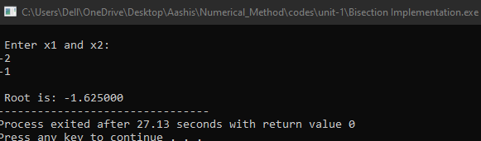

1. Write a program to implement Secant Method.

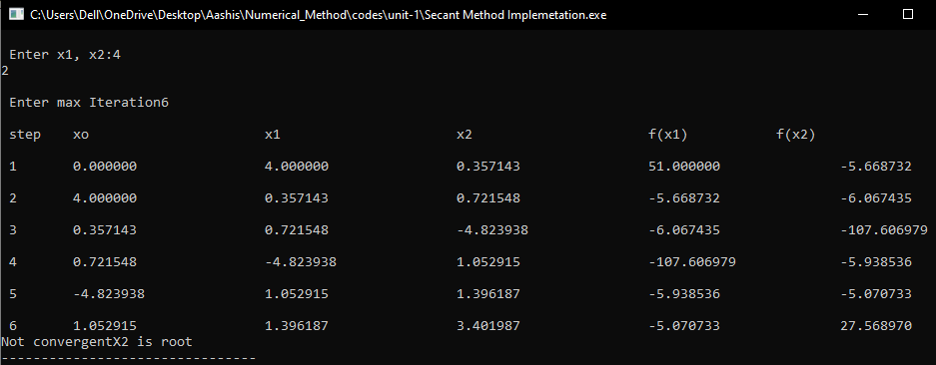

1. WAP to implement Newton Raphson method.

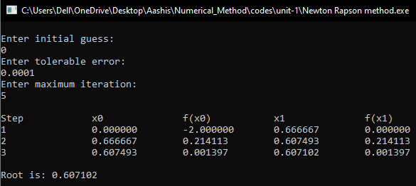

1. WAP to implement fixed point iteration method.

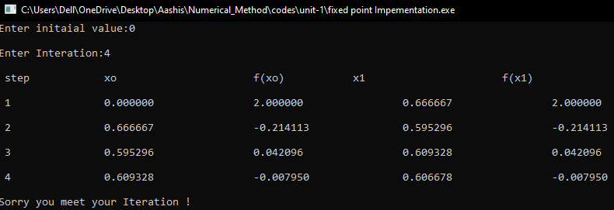

1. WAP to implement synthetic division.

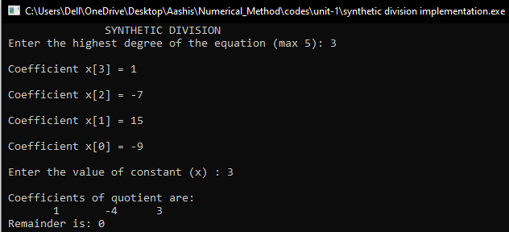

1. WAP to implement Horner’s method.

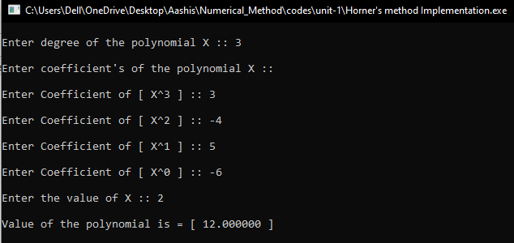

**Lab Assignment #2**

1. WAP to implement Lagrange’s interpolation.

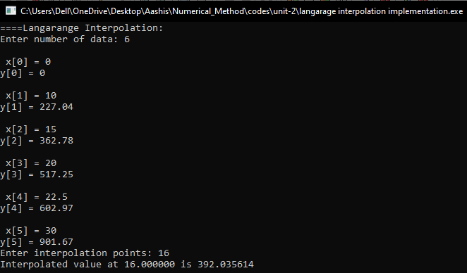

1. Write a program to implement Newton’s divided difference interpolation.

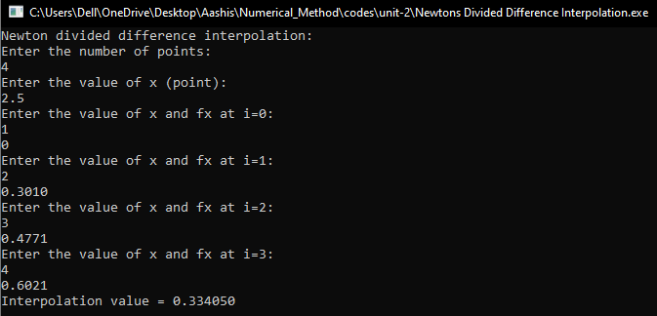

1. WAP to implement Newton’s forward difference formula.

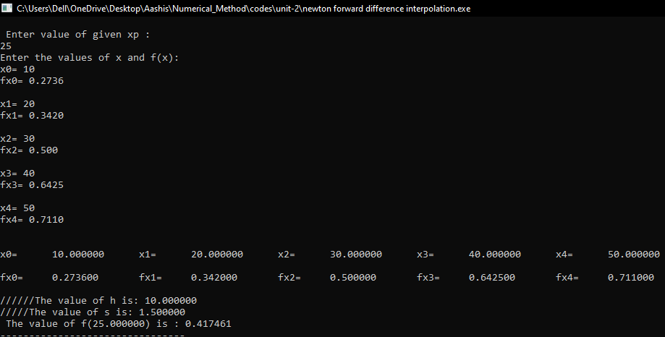

1. WAP to implement Newton’s backward difference formula.

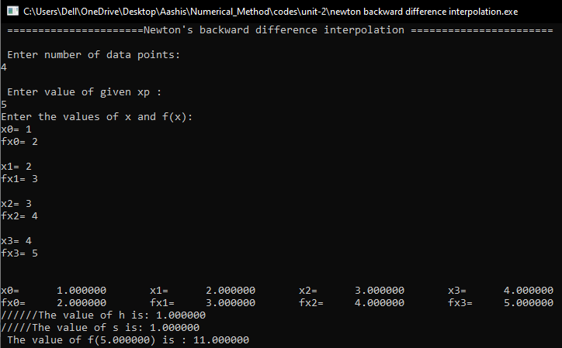

1. WAP to implement least square approximation.
2. Linear least square method.

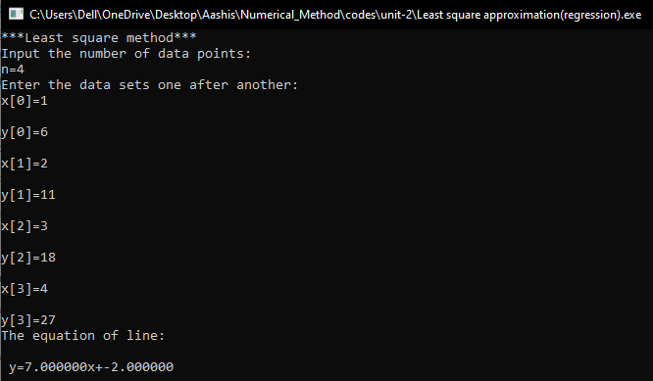

Polynomial regression.

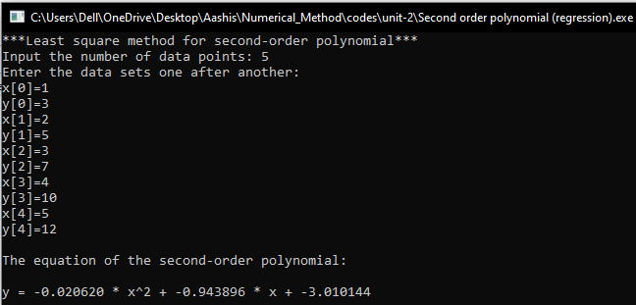

1. Exponential regression.

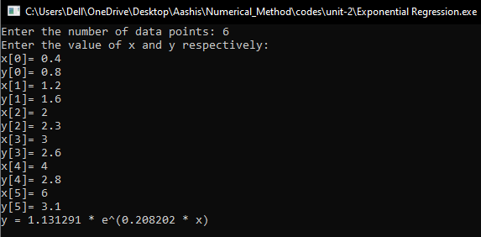

1. WAP to implement maxima and minima of tabulated function.

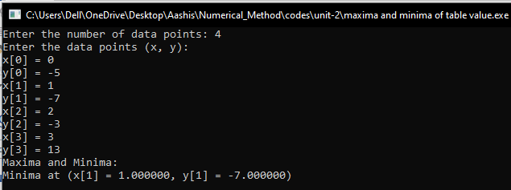

**Lab Assignment #3**

1. Write a program to calculate the derivative using forward difference

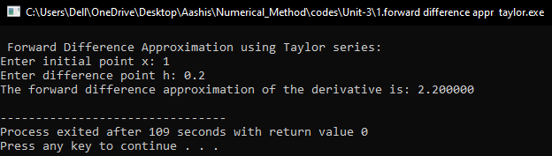

1. Write a program to calculate the derivative using backward difference

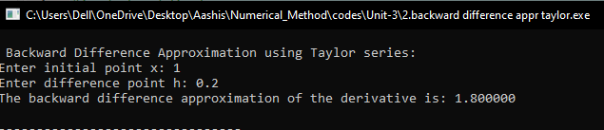

1. Write a program to calculate the derivative using central difference formula.

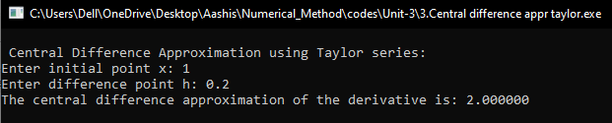

1. Write a program to calculate the derivative using forward divided difference

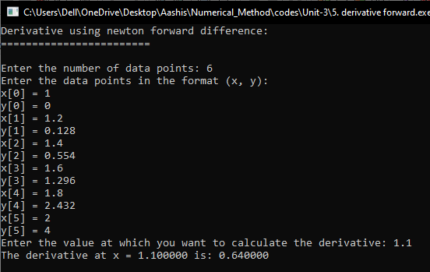

1. program to calculate the derivative using backward divided difference

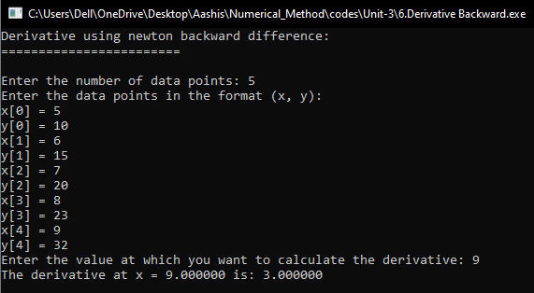

1. Write a program to implement trapezoidal rule.

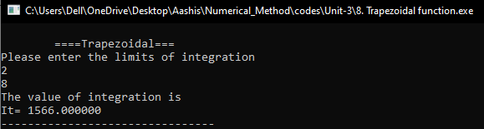

1. Write a program to implement composite trapezoidal rule.

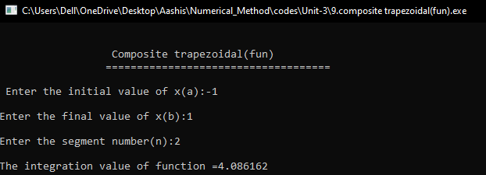

1. Write a program to implement Simpson’s 1/3 rule .

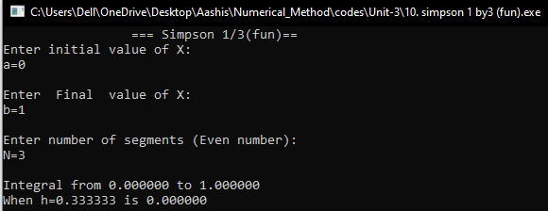

1. Write a program to implement composite Simpson’s 1/3 rule

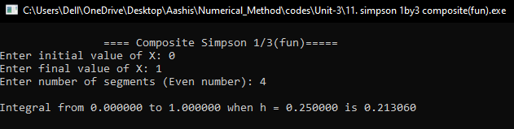

1. Write a program to implement Simpson’s 3/8 rule.

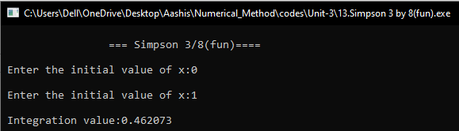

1. Write a program to implement composite Simpson’s 3/8 rule.

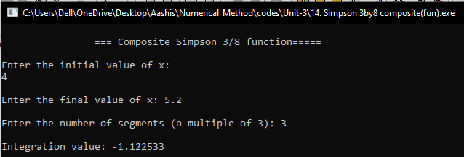

**Lab Assignment #4**

1. Write a Program to implement Gauss Elimination Method.

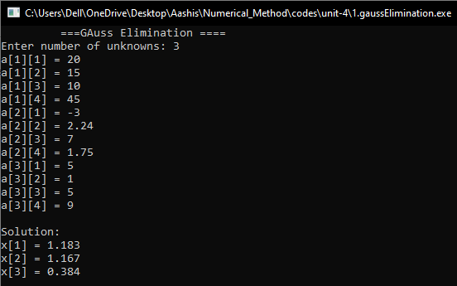

1. Write a Program to implement Gauss Elimination with pivoting.

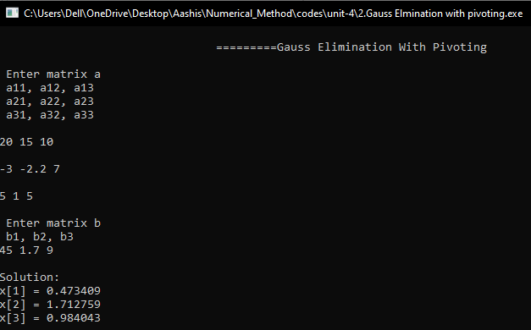

1. Write a Program to implement Gauss Jordan Method.

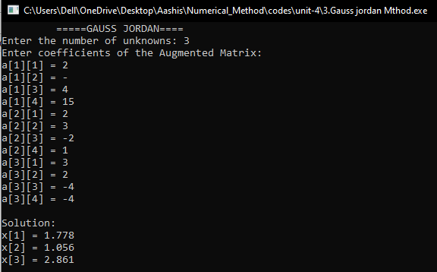

1. Write a Program to implement matrix inversion with Gauss-Jordan method.

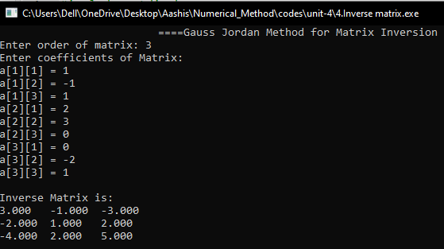

1. Write a Program to implement Do-Little LU Decomposition.

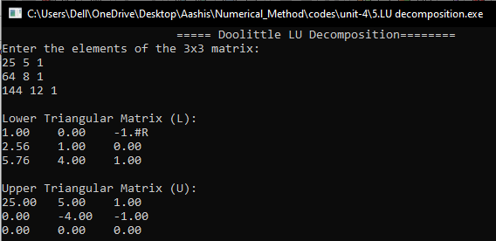

1. Write a Program to implement Cholesky Method.

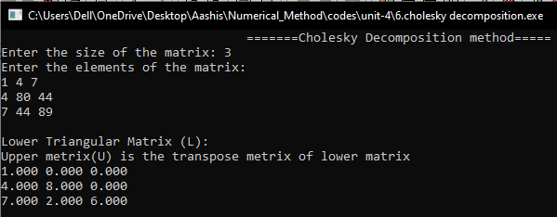

1. Write a Program to implement Jacobi iteration method.

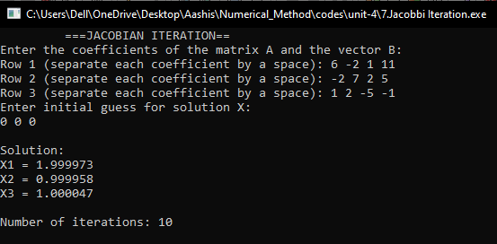

1. Write a Program to implement Gauss Seidal Method.

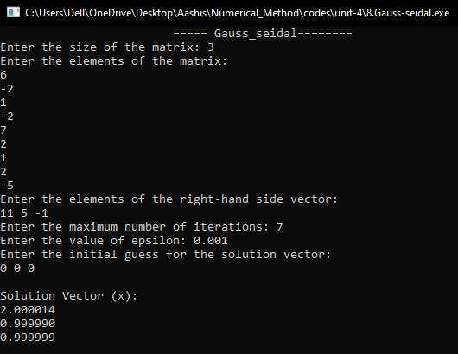

**Lab Assignment #5**

1. Write a Program to solve ODE by Using Taylors series method.

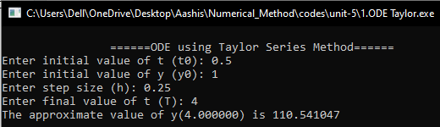

1. Write a Program to solve ODE by Using Picard’s method.

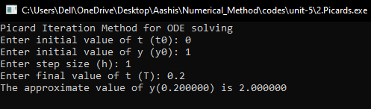

1. Write a Program to solve ODE by Using Eulers’s method.

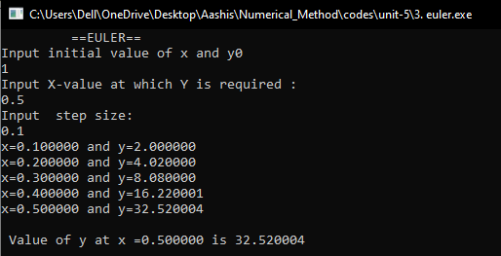

1. Write a Program to solve ODE by Using Heun’s method.

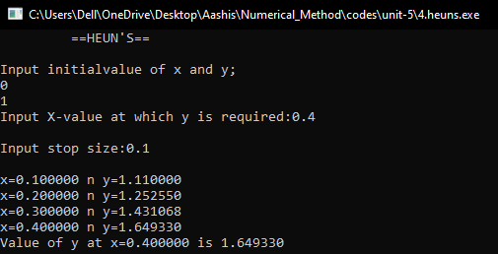

1. Write a Program to solve ODE by Using Runge-Kutta method.

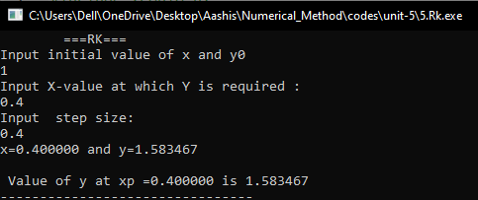

1. Write a program to solve boundary value problem using shooting method.

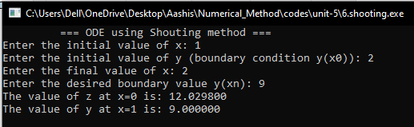

1. Write a program to Elliptic PDE.

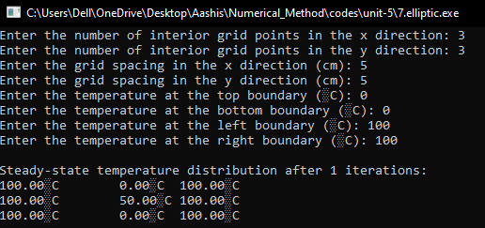

1. Write a program to solve poisson’s equation.

