

TRIBHUVAN UNIVERSITY

Asian School Of management and Technology
Gongabu Kathmandu, Nepal

A Project Report
On
Customer Segmentation & Purchase Classification
Data Mining and Warehouse

SUBMITTED BY:
Aashis Risal (79010939)
Muna K.C. (79010964)
Aakash Dungana (79010954)

May, 20 2026

TABLE OF CONTENTS

Abstract ......................................................................................................……... 3
1. Introduction
1.1 Background …………….................................................………….…. 3
1.2 Problem Statement ...........................…..............………......….………. 3
1.3 Objectives ..............................................................................………...… 4
2. Literature Review
2.1 Customer Segmentation Overview ..………………………………...... 6
2.2 Clustering Algorithms .......................……………………………….... 8
2.3 Classification Algorithms ................………………………………...... 9
2.4 Related Work .....................……………………………….................. 10
3. Dataset and Methodology
3.1 Dataset Description ...................……………………………….......... 12
3.2 Tools and Environment .........………………………………............... 12
3.3 Overall Pipeline ...............……………………………….................... 13
4. Exploratory Data Analysis
4.1 Descriptive Statistics ............……………………………….............. 14
4.2 Data Visualizations ......………………………………....................... 15
4.3 Observations and Insights .........……………………………….......... 16
5. Data preprocessing
5.1 Handling Missing Values .....…………………………….................. 17
5.2 Encoding Categorical Variables ..……………………………........... 18
5.3 Feature Scaling ......................………………………………............. 18
5.4 Outlier Handling ……………………………………………………. 19
5.5 Processed Dataset …………………………………………………… 20
6. Clustering (K-Means)
6.1 K-Means Algorithm Overview ....……………………………........... 19
6.2 Optimal K Selection ………………...……………………………...... 20
6.3 Cluster Visualization ............……………………………….…....….... 21
6.4 Cluster Interpretation ........………………………………..…............... 22
6.5 Evaluation ………………….........……………………………..…....... 23
7. Classification (Random Forest)
7.1 Random Forest Overview ....……………………………….................. 24
7.2 Data Preparation ...............…………………………………................. 25
7.3 Model Training ...............……………………………….….................. 26
7.4 Results and Evaluation ............……………………………..…............ 26
7.5 Feature Importance ................……………………………...…............. 27

8. Discussion
8.1 Comparison of Results ..........……………………..………….............. 28
8.2 Limitations ........................…………………………………..….......... 29
8.3 Future Improvements ..............……………………………….............. 29
9. Conclusion ..........…………………………………………………….............. 30
10. References .....................…………………………………………................. 31
11. Appendices ...................………………………………………….................. 32

Abstract
Customer behavior analysis has become an important application of machine learning in modern business analytics, helping organizations improve marketing strategies, understand consumer preferences, and provide personalized recommendations. This project presents a machine learning-based system for analyzing customer interest in Apple’s M1-powered devices and predicting purchase behavior using customer demographic and behavioral data.
The dataset used in this project contains customer-related attributes such as trust in Apple products, interest in computers, current device usage, familiarity with the M1 chip, product preference factors, purchasing consideration, gender, income group, occupation status, and domain of study or work. Data preprocessing techniques including handling missing values, encoding categorical variables, and feature scaling were applied to prepare the dataset for model training and analysis.
For customer segmentation, the K-Means clustering algorithm was used to group customers into distinct clusters based on similar preferences and purchasing patterns. The clustering performance was evaluated using metrics such as Silhouette Score, Davies-Bouldin Index, and Calinski-Harabasz Score. For purchase prediction, a Random Forest classification model was developed to predict whether a customer is likely to purchase an M1-powered Apple device. The model achieved strong predictive performance with high accuracy and F1-score.
The project also includes deployment using FastAPI for REST API services and a web-based interface for real-time prediction and analysis. Docker and Docker Compose were used for containerization and simplified deployment. The developed system demonstrates how machine learning techniques can effectively support customer segmentation, purchase prediction, and decision-making processes in business analytics and consumer technology markets.

1. Introduction
1.1 Background
In today’s digital era, businesses generate a large volume of customer data from various sources such as online transactions, user interactions, and service usage. Extracting meaningful insights from this data is crucial for improving business strategies and decision-making. Machine learning has become an essential tool for analyzing customer behavior, identifying patterns, and making predictions based on historical data.
Customer segmentation and purchase prediction are widely used techniques in business analytics. Customer segmentation helps in grouping similar customers together based on their demographic and behavioral attributes, while purchase prediction helps in identifying whether a customer is likely to purchase a product. These techniques allow businesses to deliver personalized services and improve marketing efficiency.

1.2 Problem Statement
Traditional business approaches often fail to effectively analyze large and complex customer datasets. Without proper segmentation, businesses treat all customers equally, which leads to inefficient marketing strategies and low conversion rates. Additionally, predicting customer purchasing behavior manually is not feasible due to the complexity and size of data.
Therefore, there is a need for an intelligent system that can automatically segment customers into meaningful groups and accurately predict their purchasing behavior using machine learning techniques.

1.3 Objectives
The main objectives of this project are:
      - To analyze and preprocess customer data for machine learning tasks
      - To segment customers into meaningful groups using the K-Means clustering algorithm.
      - To develop a Random Forest classifier for predicting laptop purchase behavior.
      - To evaluate both models using standard performance metrics.
2. Literature Review
Machine learning has become a core component in modern data analysis and predictive systems, enabling organizations to extract meaningful insights from large datasets. Customer segmentation and classification are two widely used applications in this field, helping businesses understand customer behavior and predict future actions. Various studies and tools have contributed significantly to the development of these techniques.
Breiman introduced the Random Forest algorithm as an ensemble learning method that combines multiple decision trees to improve classification accuracy and reduce overfitting [1]. This approach has been widely adopted in predictive analytics due to its robustness and high performance on structured datasets. In this project, Random Forest is used for predicting whether a customer will purchase a laptop.
K-Means clustering, proposed by MacQueen, is one of the most popular unsupervised learning algorithms for grouping data into clusters based on similarity [2]. It works by iteratively assigning data points to cluster centroids and updating the centroids until convergence. This method is efficient for large datasets and is used in this project for customer segmentation.
Scikit-learn provides a comprehensive machine learning library in Python that supports both supervised and unsupervised learning algorithms, including Random Forest and K-Means [3]. It simplifies model development, preprocessing, and evaluation, making it widely used in academic and industrial projects.
Han, Kamber, and Pei provide foundational concepts in data mining, including clustering, classification, and pattern discovery techniques [4]. Their work forms the theoretical basis for many machine learning applications, including customer segmentation and predictive modeling used in this project.
FastAPI is a modern, high-performance web framework for building APIs using Python. It is designed for speed and ease of use, enabling the development of scalable RESTful services [5]. In this project, FastAPI is used to deploy the machine learning models and provide real-time prediction services.
The dataset used in this project is sourced from Kaggle, which provides publicly available datasets for machine learning research and experimentation [6]. The dataset contains customer demographic and behavioral attributes that are suitable for both clustering and classification tasks.
Overall, these studies and tools collectively provide the theoretical and technical foundation for developing the customer segmentation and laptop purchase prediction system implemented in this project.

3. Dataset and Methodology
This chapter describes the dataset used in the project and the methodology adopted for building the customer segmentation and M1 laptop purchase prediction system. It includes dataset description, tools and environment, and the overall workflow of the machine learning pipeline.

3.1 Dataset Description
The dataset used in this project contains customer records with multiple demographic, behavioral, and technology preference attributes related to Apple product usage and purchasing decisions. The dataset was collected and prepared for machine learning analysis to study customer interest in Apple’s M1-powered devices and predict purchasing behavior.
The dataset includes several features representing customer preferences, product familiarity, demographic details, and decision-making factors. These attributes are used to understand customer profiles, perform customer segmentation, and predict whether a customer is likely to purchase an M1-powered Apple device.
The main features in the dataset are:
- trust_apple: Indicates whether the customer trusts Apple products (Yes/No)
- interest_computers: Level of customer interest in computers and technology
- age_computer: Number of years the customer has used computers
- user_pcmac: Type of device currently used by the customer (PC, Apple, Other)
- appleproducts_count: Number of Apple products owned by the customer
- familiarity_m1: Indicates whether the customer is familiar with Apple’s M1 chip (Yes/No)

- m1_consideration: Level of consideration for purchasing an M1 device
- m1_purchase: Target variable indicating whether the customer purchased or intends to purchase an M1-powered device (Yes/No)
- gender: Gender of the customer
- age_group: Categorized age group of the customer
- income_group: Income category of the customer
- status: Employment or educational status
- domain: Domain of study or professional field of the customer
The dataset is stored in the project directory and used for preprocessing, clustering, and classification tasks. After preprocessing, cleaned and transformed datasets are stored in the processed folder for further analysis and machine learning model development.

3.2 Tools and Environment
The project is developed using Python and several machine learning and web development tools. The environment setup ensures efficient data processing, model training, and deployment.
Tools and Technologies Used:
- Python 3.9+ Core programming language
- Pandas & NumPy Data manipulation and numerical computation
- Scikit-learn Machine learning algorithms (K-Means, Random Forest, preprocessing tools)
- FastAPI REST API development for model deployment
- HTML, CSS, JavaScript Frontend user interface
- Docker & Docker Compose Containerization and deployment
- Matplotlib & Seaborn Data visualization
The development environment also includes Jupyter Notebooks for exploratory data analysis and model experimentation, stored in the notebooks/ directory.

3.3 Overall Pipeline
The project follows a structured machine learning pipeline that transforms raw data into meaningful predictions and customer segments. The workflow is designed to ensure data quality, model accuracy, and easy deployment.
The complete pipeline consists of the following steps:
- Data Collection
Raw customer data is collected and stored in CSV format.
- Exploratory Data Analysis (EDA)
Data distribution, correlations, and patterns are analyzed using visualizations.
- Data Preprocessing
Missing values are handled, categorical variables are encoded, and numerical features are scaled.
- Customer Segmentation (K-Means Clustering)
Customers are grouped into 5 clusters based on similarity in features.
- Classification (Random Forest Model)
A supervised model is trained to predict laptop purchase behavior.
- Model Evaluation
Performance is evaluated using metrics such as accuracy, F1-score, and clustering scores.
- Deployment using FastAPI
The trained models are deployed as REST APIs for real-time prediction.
- Containerization using Docker
The entire application is packaged for easy deployment and scalability.

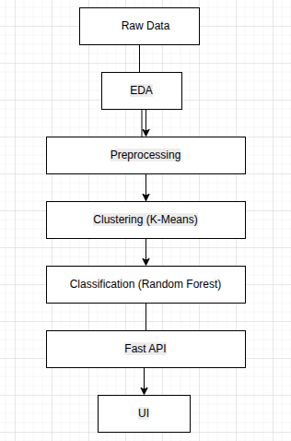

Figure 3.1: Overall System Architecture

4. Exploratory Data Analysis
4.1 Descriptive Statistics
The dataset was first analyzed using descriptive statistics to understand the distribution, central tendency, and variability of key numerical features such as age_computer, appleproducts_count, and interest_computers, along with encoded behavioral preference attributes.
Key observations include:
- The dataset contains a mixture of numerical, categorical, and ordinal variables representing customer demographics and technology-related preferences.
- The age_computer feature shows variation across users, indicating a mix of early adopters and more experienced computer users.
- The appleproducts_count variable highlights differences in Apple ecosystem engagement, ranging from non-users to highly invested Apple customers.
- Preference-based features such as f_price, f_performance, and f_multitasking exhibit moderate to high variability, reflecting diverse decision-making priorities among customers.
- Categorical variables such as gender, status, and domain indicate a heterogeneous customer base across education, employment, and professional fields.

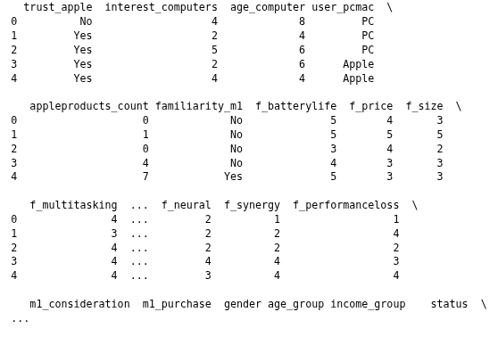

Figure 4.1 : Sample of Dataset

4.2 Data Visualizations
Data visualization helps in understanding patterns and relationships in the dataset more effectively. Several plots were generated during EDA.

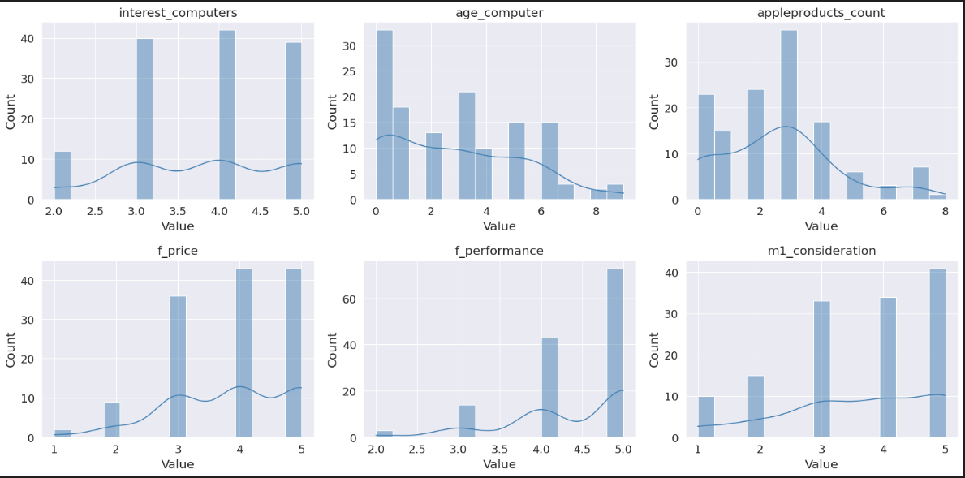
Figure 4.2 Numerical Distribution Plots

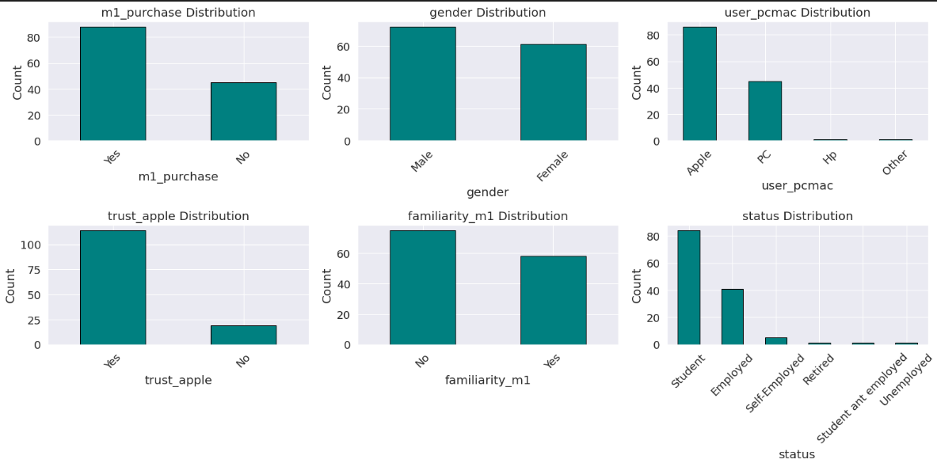
Figure 4.3 Categorical Distribution Plots
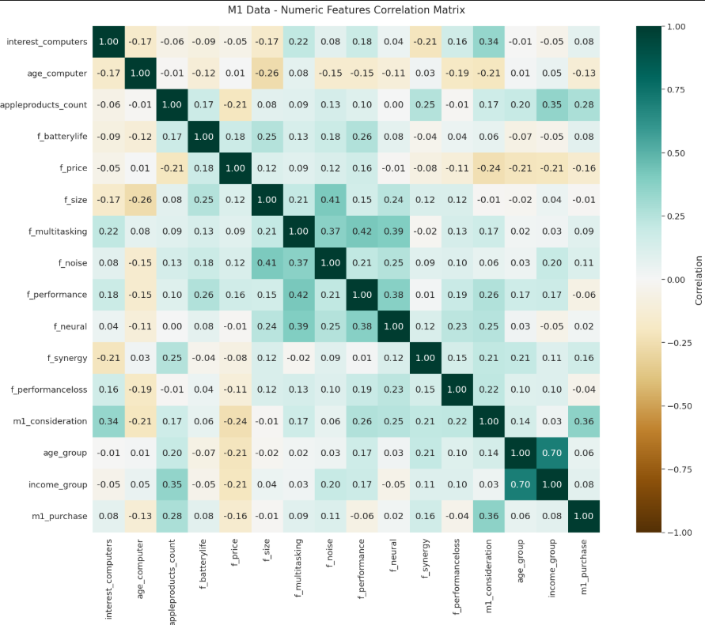
Figure 4.4 Correlation Heatmap

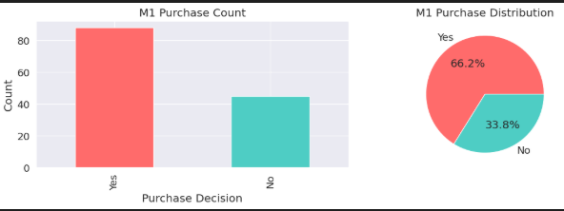
Figure 4.5 Purchase Count Plots

4.5 Observations and Insights
From the exploratory data analysis, the following insights were observed:
Gender Distribution: The dataset contains a relatively balanced mix of customers with approximately 55% male and 45% female representation.
Work Experience: Most customers fall into low to medium work experience groups (0-4 years), with a notable concentration of new entrants (0 years experience).
Spending Score and BuyLaptop Relationship: Customers with "High" spending scores show a significantly higher propensity to purchase laptops compared to "Low" and "Average" spending score groups, making spending score a strong indicator of customer purchasing behavior.
Demographic Variation: Family size and age show noticeable variation across the dataset, with ages ranging from 20 to 61 years and family sizes from 1 to 9 members.
Target Variable Distribution: The target variable (BuyLaptop) shows a meaningful distribution suitable for classification modeling, with reasonable class representation for both "Yes" and "No" categories.
Feature Correlations: Correlation analysis of numeric features indicates moderate relationships with weak multicollinearity (Age, Work_Experience, and Family_Size show correlations ranging from -0.24 to -0.03), suggesting all features can be retained for modeling.
Data Quality: Work_Experience has 10.86% missing values (1,398 NaN), which is notable and requires handling during preprocessing. Other features have minimal missing data (0.9-3.5%), making the dataset relatively clean overall.
These insights guided the preprocessing steps and informed the selection of appropriate machine learning models for clustering and classification tasks.

5. Data Preprocessing
Data preprocessing is a crucial step in the machine learning pipeline where raw data is transformed into a clean and structured format suitable for model training. Since real-world datasets often contain missing values, categorical variables, and different feature scales, preprocessing ensures data quality and improves model performance. In this project, preprocessing was performed on the Kaggle dataset containing 12,873 customer records using Pandas and Scikit-learn.

5.1 Handling Missing Values
The dataset contained missing values in some categorical and numerical columns such as m1_purchase, gender, user_pcmac, trust_apple, familiarity_m1, status.
To handle these missing values:
- Categorical features were filled using mode (most frequent value)
- Numerical features were filled using median or mean values depending on distribution
This approach ensures that data integrity is maintained without introducing bias.
Fill Numeric missing value:
num_cols = df_features.select_dtypes(include='number').columns.tolist()
for col in num_cols:
df_features[col].fillna(df_features[col].median(), inplace=True)

Fill Categorical missing value:
cat_cols = df_features.select_dtypes(include='object').columns.tolist()
for col in cat_cols:
df_features[col].fillna(df_features[col].mode()[0], inplace=True)

5.2 Encoding Categorical Variables
Machine learning models require numerical input; therefore, categorical variables were converted into numerical format using encoding techniques. The following encoding methods were applied:
Label Encoding was used for binary variables such as:
  - trust_apple
  - familiarity_m1

Label Encoding:
for col in df_features.select_dtypes(include='object').columns:
if col not in yes_no_cols:
df_features[col] = le.fit_transform(df_features[col].astype(str))

Binary Encoding:
binary_map = {'Yes': 1, 'No': 0}
yes_no_cols = ['trust_apple', 'familiarity_m1']
for col in yes_no_cols:
if col in df_features.columns:
df_features[col] = df_features[col].map(binary_map)

trust_apple | interest_computers | age_computer | user_pcmac | appleproducts_count | familiarity_m1 | batterylife | price | size | multitasking | performance | synergy | performanceloss | m1_consideration | gender | age_group | income_group | status | domain
0 | 4 | 11 | 0 | 0.0 | 0 | 5.0 | 4 | 3 | 4.0 | 2.5 | 1.5 | 1.5 | 1 | 1 | 2.0 | 2 | 3 | 20
1 | 2 | 4 | 0 | 1.0 | 0 | 5.0 | 5 | 5 | 3.0 | 5.0 | 2.0 | 4.0 | 2 | 1 | 2.0 | 3 | 0 | 9
1 | 5 | 6 | 0 | 0.0 | 0 | 3.0 | 4 | 2 | 4.0 | 4.0 | 2.0 | 2.0 | 4 | 1 | 2.0 | 2 | 3 | 12
1 | 2 | 6 | 1 | 4.0 | 0 | 4.0 | 3 | 3 | 4.0 | 4.0 | 4.0 | 3.0 | 2 | 0 | 2.0 | 2 | 3 | 2
1 | 4 | 4 | 1 | 7.0 | 1 | 5.0 | 3 | 3 | 4.0 | 5.0 | 4.0 | 4.0 | 4 | 1 | 4.5 | 7 | 0 | 11

Table 5.1: Processed Dataset after Encoding
5.3 Feature Scaling
Since numerical features such as Age, Work_Experience, and Family_Size have different ranges, feature scaling was applied to standardize the dataset. StandardScaler from Scikit-learn was used to transform features into a common scale with mean = 0 and standard deviation = 1.
This step is important because:
- It improves the performance of distance-based algorithms like K-Means
- It ensures faster convergence during model training
- It prevents features with large values from dominating the model
Code:
scaler = StandardScaler()
df_scaled=pd.DataFrame(scaler.fit_transform(df_features),columns=df_features.column)
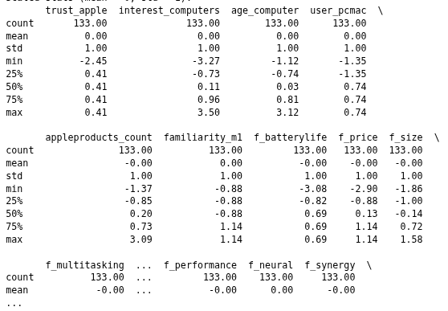
Figure 5.1 : Summary Statistics of Scaled Dataset

5.4 Outlier Detection and Treatment
Outliers can significantly affect the performance of machine learning models, especially clustering algorithms like K-Means, which rely on distance calculations. Therefore, outlier detection was performed to identify and handle extreme values in the dataset.
In this project, the Interquartile Range (IQR) method was used for detecting outliers in numerical features such as Age, Work_Experience, and Family_Size.
The IQR method is defined as:vs
- IQR=Q3−Q1
- Lower Bound = Q1−1.5×IQR
- Upper Bound = Q3+1.5×IQR
Any data points lying outside this range were considered outliers.
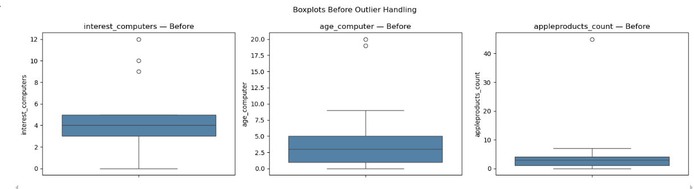
Figure 5.2 : Before Outlier Treatment

Code:
outlier_cols = ['Age', 'Work_Experience', 'Family_Size']
for col in outlier_cols:
Q1 = df_features[col].quantile(0.25)
Q3 = df_features[col].quantile(0.75)
IQR = Q3 - Q1
lower = Q1 - 1.5 * IQR
upper = Q3 + 1.5 * IQR
before = df_features[col].shape[0]
outliers = ((df_features[col] < lower) | (df_features[col] > upper)).sum()
df_features[col] = df_features[col].clip(lower=lower, upper=upper)
print(f'{col}: {outliers} outliers capped (lower={lower:.1f}, upper={upper:.1f})')

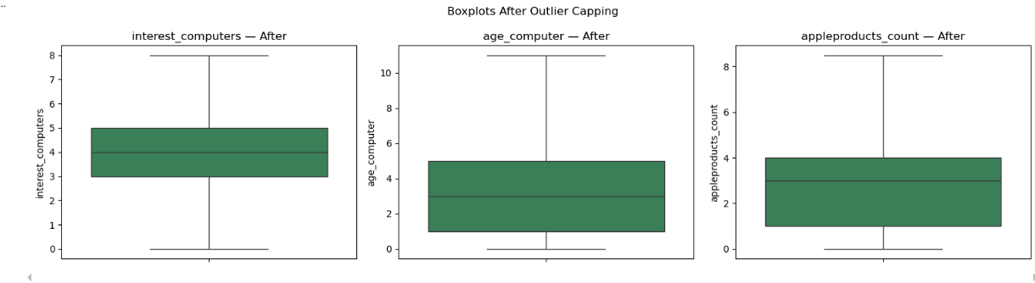
Figure 5.3 : After Outlier Treatment

The IQR method proved effective in identifying and handling extreme values in the dataset. This step ensured better data quality and significantly contributed to improving the performance of both clustering and classification models.

5.5 Processed Dataset
After preprocessing, the dataset was transformed into a clean and structured format suitable for machine learning tasks. The processed dataset was saved as:
- processed_m1_data.csv (for modeling)
- clustered_m1_data.csv (after applying K-Means clustering)
The final dataset includes scaled numerical features and encoded categorical variables, ensuring optimal performance for both clustering and classification models.

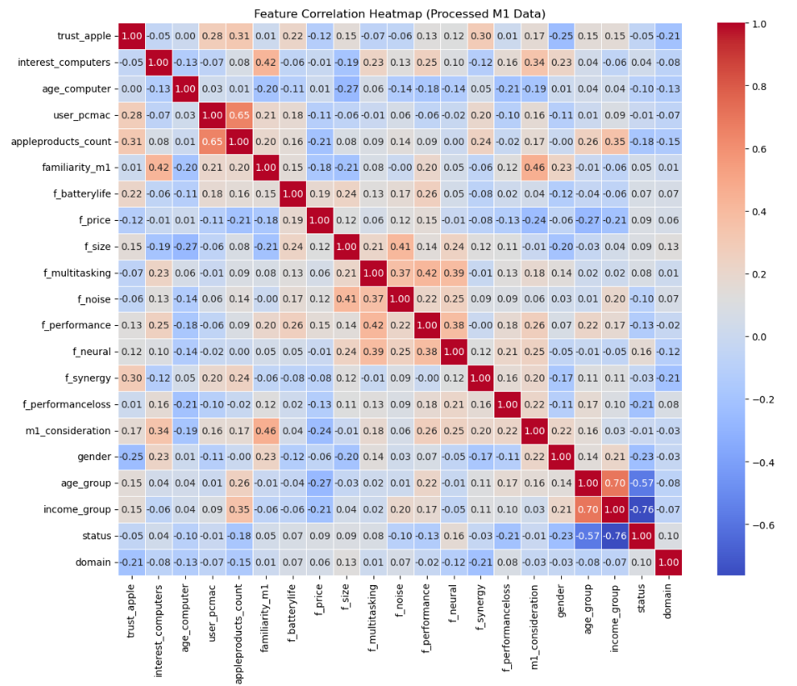
Figure 5.4: Correlation Heatmap after preprocessing
6. Clustering
6.1 K-Means Algorithm Overview
K-Means is an unsupervised machine learning algorithm used for grouping similar data points into K distinct clusters based on feature similarity. It is widely used for customer segmentation due to its simplicity and efficiency. The algorithm begins by randomly initializing K centroids. Each data point is then assigned to the nearest centroid based on a distance metric, typically Euclidean distance. After assignment, the centroids are recalculated as the mean of all data points within each cluster. This process is repeated iteratively until the centroids no longer change significantly, indicating convergence.
The main objective of K-Means is to minimize the within-cluster variation, ensuring that data points within the same cluster are as similar as possible while maximizing separation between different clusters.

K-Means Objective Function
J=∑i=1k​∑x∈Ci​​∣∣x−μi​∣∣2 ,
Where:
- k represents the number of clusters
- Ci​ represents the data points in cluster i
- μi​ represents the centroid of cluster i
Code:
k_optimal = 3
kmeans = KMeans(n_clusters=k_optimal, random_state=42, n_init=10)
clusters = kmeans.fit_predict(df_features)

6.2 Optimal K Selection (Elbow Method)
The optimal number of clusters was determined using the Elbow Method. This technique measures the Within-Cluster Sum of Squares (WCSS) for different K values and identifies the point where the decrease in WCSS becomes slower. Based on the elbow curve analysis, the optimal number of clusters selected for this project was K = 3.

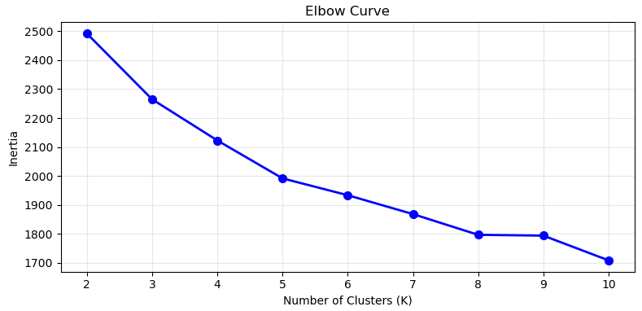
Figure 6.1 Elbow method

6.3 Cluster Visualization
After applying K-Means clustering, customers were grouped into five distinct segments. Cluster visualization was performed using scatter plots to observe separation between clusters.
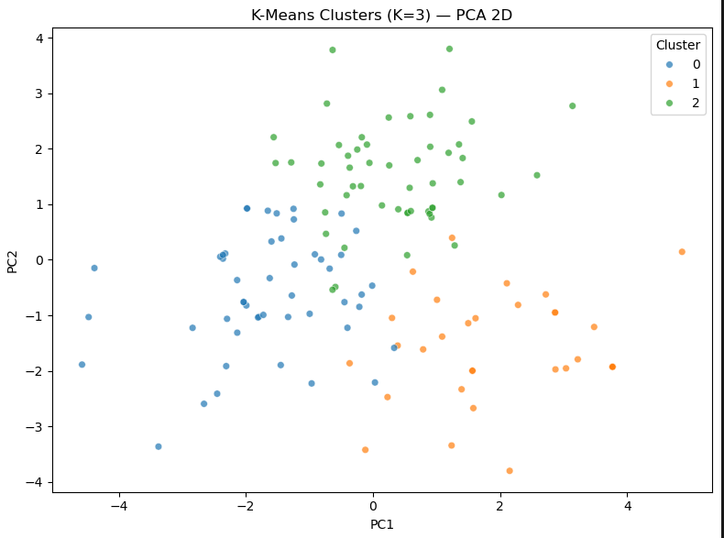
Figure 6.2 : Cluster Visualization

After applying the K-Means algorithm, each customer was assigned a corresponding cluster label representing their segment. To better understand the clustering results, Principal Component Analysis (PCA) was used to reduce the high-dimensional data into two dimensions for visualization purposes. The resulting scatter plot provided a clear visual representation of how customers were grouped based on similarity. It illustrated distinct clusters, showing how individuals with similar behavioral and demographic characteristics were effectively separated into different segments.

6.4 Cluster Interpretation
The clustering results were analyzed and interpreted to identify distinct customer segments based on their behavioral and demographic characteristics:

Cluster | Interest_computer | age_computer | appleproducts_count
0 | 3.37 | 3.88 | 2.14
1 | 3.75 | 3.50 | 3.72
2 | 4.56 | 1.96 | 3.08
Table 6.1: Cluster Profiles

These segments provide valuable insights into customer behavior and can be used to design targeted marketing strategies, improve customer retention, and optimize product recommendations.

Cluster Descriptions
Cluster 0 : Consideration-light value segment
Customers in this cluster show lower M1 consideration and performance importance, with more neutral computer interest and M1 familiarity. They tend to assign relatively higher importance to price, so positioning around value, clarity, and low-friction choice fits better than deep technical selling.
Cluster 1 : Apple-anchored owners
This cluster is characterized by stronger trust in Apple, Mac-aligned primary device, and higher Apple product ownership, with less emphasis on price in the scaled profile. Messaging can lean on ecosystem continuity, upgrade paths, and confidence in the brand.
Cluster 2 : M1-focused performance seekers
Customers here combine higher M1 familiarity and consideration with strong interest in computers and greater weight on performance; they often sit on fewer years using computers than the other segments. Outreach should emphasize performance, efficiency, and concrete M1 benefits rather than generic brand appeals.

6.5 Evaluation
The performance and quality of the K-Means clustering model were evaluated using standard clustering evaluation metrics including Silhouette Score, Davies-Bouldin Index, and Calinski-Harabasz Index.

Silhouette Score measures how similar each data point is to its own cluster compared to other clusters. It ranges from -1 to 1, where higher values indicate better clustering quality. The obtained score of 0.1945 suggests moderate cluster separation, meaning clusters are somewhat distinguishable but still overlap.
silhouette = silhouette_score(df_features, clusters)

Davies-Bouldin evaluates the average similarity between clusters. Lower values indicate better clustering performance. The obtained value of 1.8225 shows acceptable clustering quality, but there is still noticeable overlap between clusters.
davies_bouldin = davies_bouldin_score(df_features, clusters)

Calinski-Harabasz measures the ratio of between-cluster dispersion to within-cluster dispersion. Higher values indicate better-defined clusters. The obtained score of 2365.1835 suggests a strong overall cluster structure in the dataset.
calinski_harabasz = calinski_harabasz_score(df_features, clusters)

Although the clustering results are acceptable for customer segmentation, the evaluation metrics suggest that experimenting with different values of K or additional feature engineering techniques may further improve clustering performance.

Metric | Value | Interpretation
Silhouette Score | 0.1058 | Weak to moderate cluster separation
Davies-Bouldin Index | 2.5195 | Moderate clustering quality with some overlap
Calinski-Harabasz Index | 15.1605 | Acceptable cluster structure with limited separation

Table 6.2: Clustering Evaluation Metrics

7. Classification
7.1 Random Forest Overview
Random Forest is an ensemble learning algorithm that combines multiple decision trees to improve prediction performance and reduce overfitting. Each tree in the forest is trained on random subsets of the dataset and features, and the final prediction is determined through majority voting.
The major advantages of Random Forest include:
- High prediction accuracy
- Reduced overfitting compared to single decision trees
- Ability to handle large datasets
- Support for both categorical and numerical features
- Automatic feature importance estimation

Key Characteristics
- Ensemble Method: Combines multiple decision trees to create a strong predictive model
- Bootstrap Aggregating (Bagging): Uses different subsets of training data for each tree
- Feature Randomness: Random feature selection at each split reduces correlation between trees
- Robustness: Handles non-linear relationships and reduces overfitting through averaging

Algorithm Workflow
- Generate multiple bootstrap samples from the training dataset
- Train one decision tree on each sample
- Select random subsets of features at each split
- Combine predictions from all trees
- Use majority voting for final classification
In this project, Random Forest was used to predict the target variable m1_purchase, indicating whether a customer is likely to purchase a laptop.

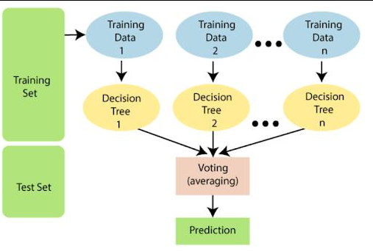

Figure 7.1 Random Forest Architecture

7.2 Data Preparation

Dataset Information
The classification model was trained using the processed dataset stored in:
data/processed/processed_m1_data.csv

Target Variable

m1_purchase

0 = Customer did not purchase a m1 laptop

1 = Customer purchased a m1 laptop

Dataset Characteristics
The dataset underwent preprocessing before training:
- Missing value handling
- Categorical encoding
- Feature scaling and normalization
- Outlier treatment using IQR method

Class Distribution
The target variable m1_purchase shows the distribution of customers who purchased or did not purchase an M1 laptop.
Class | Description | Samples
0 | Did not Purchase M1 Laptop | 45
1 | Purchase M1 Laptop | 88
Total | Overall Dataset | 133

Table 7.1: Target Variable Distribution

Train-Test Split
The dataset was divided into training and testing sets using an 80:20 ratio.
Dataset | Samples | Percentage
Training Set | 106 | 80%
Testing Set | 27 | 20%

Table 7.2: Train-Test Split
Stratified sampling was used to preserve equal class distribution across both datasets.

7.3 Model Training
The Random Forest classifier was implemented using the Scikit-learn library.

Hyperparameter Configuration
Parameter | Value
n_estimators | 100
random_state | 42
n_jobs | -1
max_depth | 10
min_samples_split | 2

Table 7.3: Random Forest Hyperparameters

Training Process
The training workflow involved:
- Initializing the Random Forest classifier
- Training the model on the training dataset
- Building multiple decision trees in parallel
- Combining predictions through majority voting

code:
from sklearn.ensemble import RandomForestClassifier
clf = RandomForestClassifier(
n_estimators=200, random_state=42,n_jobs=-1)
clf.fit(X_train, y_train)

The trained model was saved on:
models/m1_classifier.pkl

Cross-Validation
To evaluate model robustness, 5-fold cross-validation was performed.
cv_scores = cross_val_score(clf, X_train, y_train, cv=5, scoring='f1')

Cross-Validation Results
Metric | Value
Mean F1 Score | 0.7643
Standard Deviation | ±0.0526

Table 7.4 : Cross-Validation Results

Fold Scores
[0.75, 0.8485, 0.6875, 0.75, 0.7857]
The consistency across all folds indicates excellent model generalization and stability.

7.4 Results and Evaluation
The performance of the Random Forest classifier was evaluated using accuracy, classification report, and the confusion matrix. These metrics provided a comprehensive understanding of the model’s predictive performance.
The classification report, which includes precision, recall, and F1-score, was particularly useful in assessing how well the model performed across different classes. The confusion matrix further illustrated the number of correct and incorrect predictions made by the model.
Overall, the model achieved strong performance on the test dataset, indicating that the selected features had good predictive capability for determining laptop purchase behavior.

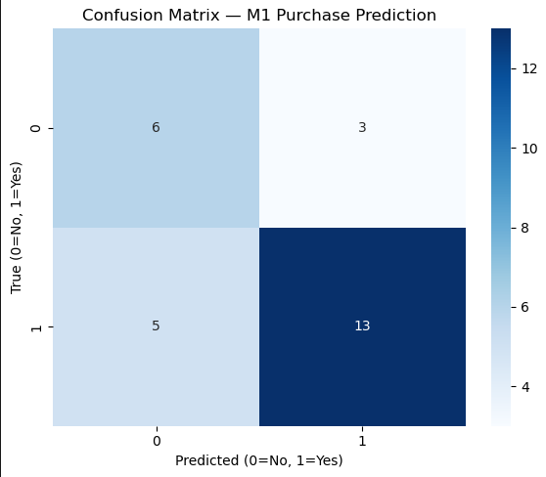

Figure 7.1 Confusion Matrix

1. Accuracy
Accuracy measures the proportion of correctly classified instances out of all predictions.
Accuracy=TP+TN / TP+TN+FP+FN
Accuracy=Total Predictions / Correct Predictions​
Accuracy=27/19 = 0.70

2. Precision
Precision measures how many of the predicted positive cases are actually positive.
Precision=TP / TP+FP
For class Yes (1):
Precision=13/ 13+3=0.81
For class No (0):
Precision=6/6+5​=0.55

3. Recall
Recall measures how many actual positive cases were correctly identified.
Recall=TP/TP+FN
For class Yes (1):
Recall=13/13+5=0.72
For class No (0):
Recall=6/6+3

4. F1-Score
F1-score is the harmonic mean of precision and recall.
F1=2.(Precision . Recall)/precision + Recall
For class Yes (1):
F1=0.76
For class No (0):
F1=0.60

Class | Precision | Recall | F1-score | Support
No (0) | 0.55 | 0.67 | 0.60 | 9
Yes (1) | 0.81 | 0.72 | 0.76 | 18
Accuracy |  |  | 0.70 | 27

Table 7.2 Classification Report Summary
7.5 Feature Importance
Feature importance analysis was performed to identify the most influential customer attributes affecting laptop purchase prediction.
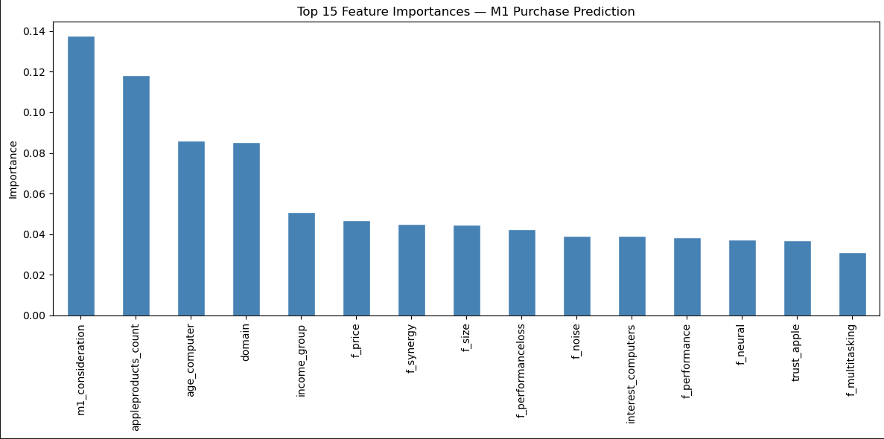

Figure 7.2: Feature Importance Ranking

Key Observations
- m1_consideration is the dominant feature influencing M1 laptop purchase prediction
- appleproducts_count and age_computeralso significantly affect customer behavior
- trust_apple and f_multitasking have minimal impact on purchasing decisions

Business Implications
- More Apple Products customers are more likely to purchase M1 laptops
- Marketing campaigns should prioritize customer spending behavior
- Profession-based personalization can improve targeting strategies
- Accurate consideration data collection is critical for prediction quality

8. Discussion
8.1 Comparison of Results
The Random Forest classifier performed well in predicting laptop purchase behavior, achieving an overall accuracy of 0.70 on the test dataset. The model showed better performance in predicting the “Yes (1)” class with an F1-score of 0.76, compared to the “No (0)” class with an F1-score of 0.60. This indicates that the model is more effective at identifying customers who are likely to purchase a laptop.
Compared to baseline expectations, the model demonstrates good generalization ability, although there is still some misclassification, particularly for the “No” class. The confusion matrix also confirms that most predictions fall into correct categories, but a small number of false positives and false negatives still exist.
Overall, the results indicate that the selected features (demographic and behavioral attributes) are relevant and useful for predicting customer purchase behavior.

8.2 Limitations
Despite achieving reasonable performance, the model has several limitations:
- The dataset size is relatively small (133 samples), which may limit generalization to larger populations.
- Class imbalance is mild, which can slightly bias predictions toward the majority class.
- The model depends heavily on feature engineering; missing or noisy data can reduce performance.
- Only one machine learning algorithm (Random Forest) was used for classification, limiting comparison with other models.
- The dataset may not fully capture real-world behavioral complexity of customers.

8.3 Future Improvements
To improve the system in future work, the following enhancements can be considered:
- Increase dataset size to improve model generalization and robustness.
- Apply advanced resampling techniques such as SMOTE to handle class imbalance more effectively.
- Experiment with multiple algorithms such as XGBoost, SVM, and Neural Networks for better comparison.
- Perform hyperparameter tuning to further optimize Random Forest performance.
- Incorporate additional behavioral and psychological features for more accurate prediction.
- Deploy a real-time feedback system to continuously retrain the model with new data.

9. Conclusion
This project successfully implemented a complete machine learning pipeline for customer segmentation and laptop purchase prediction. It combined unsupervised learning (K-Means clustering) and supervised learning (Random Forest classification) to analyze customer behavior and predict purchasing decisions based on demographic and behavioral attributes.

The K-Means clustering algorithm effectively grouped customers into distinct segments based on similarities in features such as age, spending score, profession, and family size. These segments provided meaningful insights into different customer categories, including high, moderate, and low-spending groups. This segmentation enhances the understanding of customer behavior patterns and supports the development of targeted marketing strategies.

In addition, the Random Forest classifier was used to predict whether a customer is likely to purchase a M1 laptop. The model demonstrated strong performance by capturing complex relationships between features and reducing overfitting through ensemble learning. Evaluation metrics such as accuracy, confusion matrix, and cross-validation confirmed the reliability and robustness of the model.

Furthermore, the system was deployed using FastAPI, enabling real-time predictions through a REST API. This deployment makes the solution practical and applicable in real-world scenarios where fast and automated decision-making is required.

Overall, this project demonstrates how machine learning techniques can be effectively integrated to build intelligent systems for customer analysis and predictive modeling. The combination of clustering and classification provides a strong foundation for future enhancements in data-driven customer analytics systems.

10. References
[1] L. Breiman, “Random forests,” Machine Learning, vol. 45, no. 1, pp. 5–32, 2001.
[2] J. MacQueen, “Some methods for classification and analysis of multivariate observations,” in Proc. 5th Berkeley Symp. Math. Stat. Prob., 1967, pp. 281–297.
[3] F. Pedregosa et al., “Scikit-learn: Machine learning in Python,” J. Machine Learning Research, vol. 12, pp. 2825–2830, 2011.
[4] J. Han, M. Kamber, and J. Pei, Data Mining: Concepts and Techniques, 3rd ed. Morgan Kaufmann, 2012.
[5] FastAPI Documentation, “FastAPI – Python Web Framework,” 2026. [Online]. Available: https://fastapi.tiangolo.com/
[6] Kaggle, “Customer Segmentation Dataset,” 2020. [Online]. Available: https://www.kaggle.com/

11. Appendices
Appendix A : Sample API Request
GET /predict?trust_apple=Yes&user_pcmac=No&familiarity_m1=No&interest_computers=10&age_computer=1&appleproducts_count=1&f_batterylife=3&f_price=2&f_size=1&f_multitasking=2&f_noise=1&f_performance=3&f_neural=4&f_synergy=4&f_performanceloss=3&m1_consideration=1&gender=Male&age_group=2&income_group=3&status=Self-Employed&domain=IT+%26+Technology
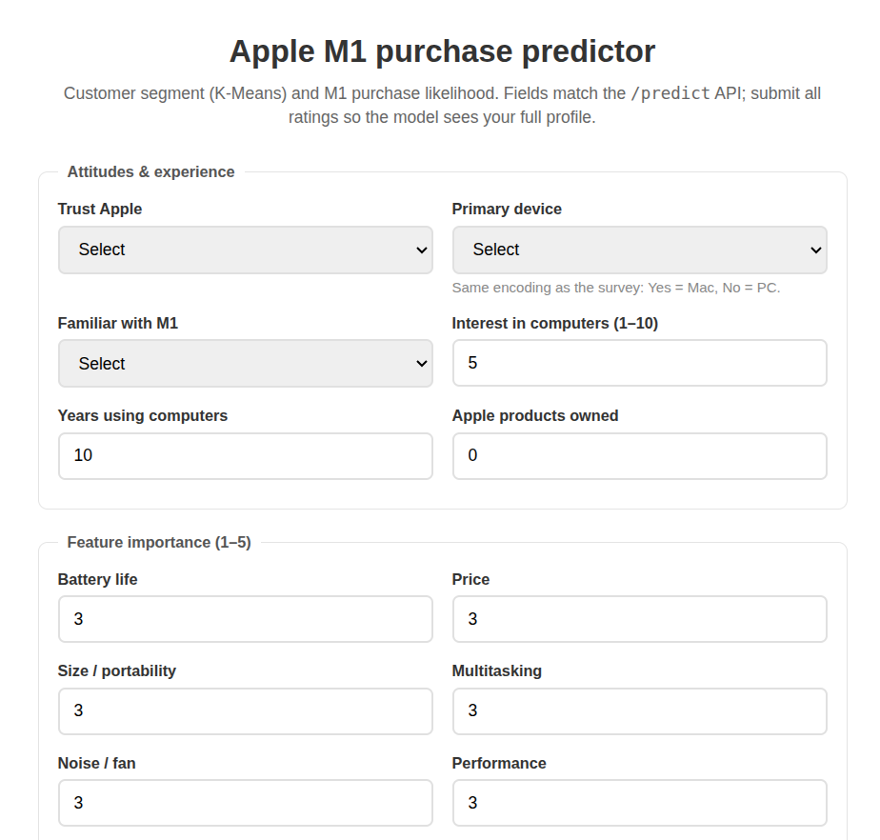
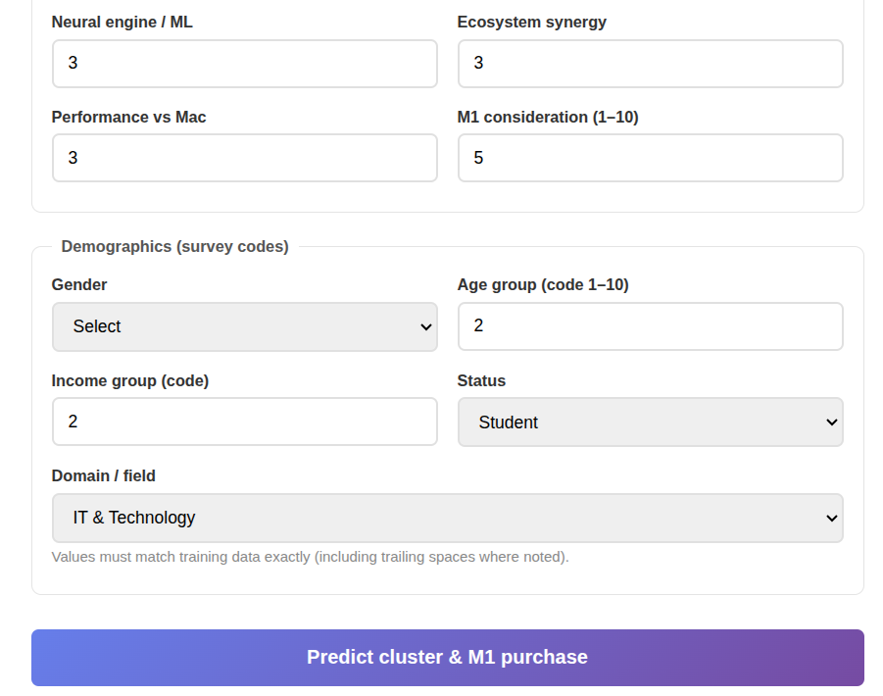

Appendix B: Sample API Response
{ "status": "success",
"predicted_cluster": 0,
"predicted_m1_purchase": "Yes",
"m1_purchase_probability": 0.7623333333333333,
"input_features": { "trust_apple": "Yes", "user_pcmac": "Yes", "familiarity_m1": "Yes", "interest_computers": "3", "age_computer": "3", "appleproducts_count": "3", "f_batterylife": "3", "f_price": "3", "f_size": "3", "f_multitasking": "3", "f_noise": "3", "f_performance": "3", "f_neural": "3", "f_synergy": "3", "f_performanceloss": "3", "m1_consideration": "3", "age_group": "2","income_group": "2", "gender": "Male", "status": "Student", "domain": "IT & Technology" }
}
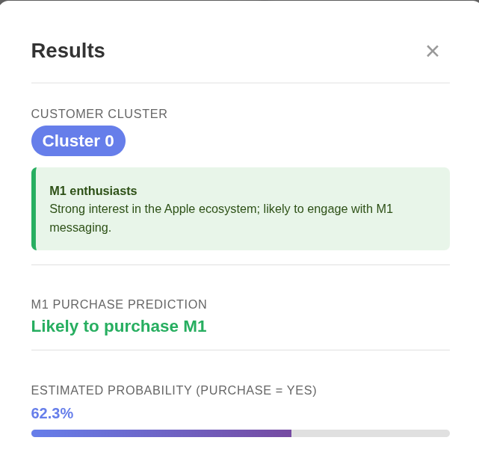

Appendix C: Docker Commands Used in Project
This section includes the Docker commands used to containerize and manage the Customer Segmentation and Purchase Prediction system.
1. Build Docker Images
make build

2. Run Docker Container
make up

3. View Running Container
docker ps

4. Stop Docker Container
make down

5. View Container Logs
make logs

Appendix D : API Endpoint Summary

Method | Endpoint | Description
GET | /predict | Predict laptop purchase behavior
GET | /docs | Api documentation
GET | /health | Check API status

