Smart Logistics Chatbot using Generative AI (Retrieval-Augmented Generation Based System)
Course Name: Generative AI
Institution Name: Medicaps University – Datagami Skill Based Course
Submitted By:
Sr No | Student Name | Enrollment Number
1 | AKSHAT BAJAJ | EN22CS301088
2 | AJAY PAL SINGH THAKUR | EN22CS301077
3 | AKSHITA FARKYA | EN22CS301099
4 | AASHITA CHAVHAN | EN22CS301018
5 | AKANKSHA PARIHAR | EN22CS301079
6 | AAKRATI JAIN | EN22CS301013

Abstract
The rapid advancement of Generative Artificial Intelligence has revolutionized the way organizations analyze and interact with large volumes of unstructured data. In the logistics and supply chain domain, companies manage extensive documentation including shipment records, inventory reports, demand forecasts, traffic updates, and delay logs. Extracting meaningful insights manually from such documents is time-consuming and inefficient. The Smart Logistics Chatbot addresses this challenge by implementing a Retrieval-Augmented Generation (RAG) architecture that integrates semantic search with a Large Language Model (LLM).
The system processes logistics PDF documents, converts textual data into vector embeddings using sentence-transformer models, stores embeddings in a FAISS vector database, and retrieves relevant information based on user queries. The retrieved context is then passed to the Google Gemini model to generate accurate, context-aware responses. The project demonstrates the practical implementation of Generative AI in enterprise-level applications, highlighting improvements in operational efficiency, decision-making speed, and data accessibility.

1. Introduction
The logistics industry is a backbone of global commerce, responsible for transportation, inventory management, warehouse operations, and last-mile delivery services. With increasing digitalization, logistics companies generate massive amounts of operational data daily. Traditional systems rely on structured databases and manual search mechanisms, which often fail to efficiently handle unstructured document-based information.
Generative AI has emerged as a transformative technology capable of understanding natural language and generating human-like responses. However, standalone Large Language Models may produce inaccurate or hallucinated answers when lacking domain-specific knowledge. To overcome this limitation, Retrieval-Augmented Generation combines vector search with generative models to ensure factual grounding.
This project aims to develop an intelligent logistics chatbot that leverages RAG architecture to provide reliable and context-based responses directly from logistics documentation.

2. Literature Review
Research in Natural Language Processing (NLP) has significantly evolved with the introduction of Transformer-based architectures such as BERT, GPT, and Gemini. These models use self-attention mechanisms to understand contextual relationships within text.
Recent studies highlight the limitations of pure generative models in enterprise settings, especially when accuracy and factual consistency are critical. Retrieval-Augmented Generation (Lewis et al., 2020) proposed combining external knowledge retrieval with text generation to improve reliability.
FAISS (Facebook AI Similarity Search) has been widely adopted for efficient similarity search in high-dimensional vector spaces. HuggingFace Sentence Transformers provide pre-trained models for generating semantic embeddings. The integration of these technologies has shown promising results in document-based question-answering systems.

3. Problem Statement
Logistics organizations handle large volumes of documentation containing shipment status, temperature records, humidity logs, asset utilization percentages, and delay reasons. Extracting relevant insights from these documents manually is time-consuming, prone to errors, and inefficient.
There is a need for an intelligent system that can automatically process logistics documents, understand user queries, retrieve relevant information, and generate accurate answers in real-time. The absence of such a system limits operational efficiency and slows decision-making processes.

4. Project Objectives
• Design and implement a Retrieval-Augmented Generation architecture.
• Convert unstructured logistics documents into vector embeddings.
• Enable semantic similarity search using FAISS.
• Integrate Google Gemini LLM for accurate answer generation.
• Develop a user-friendly interface using Streamlit.
• Evaluate system performance and accuracy.

5. System Architecture
The architecture consists of multiple layers including document ingestion, preprocessing, embedding generation, vector storage, retrieval mechanism, and response generation. The ingestion layer loads PDF documents using PyPDFLoader. The preprocessing layer splits text into manageable chunks using RecursiveCharacterTextSplitter.
Each text chunk is converted into a numerical vector representation using a sentence-transformer embedding model. These embeddings are stored in a FAISS vector database, enabling efficient similarity search.
When a user submits a query, it is converted into an embedding and compared against stored vectors. The top relevant chunks are retrieved and passed as context to the Gemini model, which generates a final, context-aware response.

6. Methodology
Step 1: Data Collection – Logistics PDF document acquisition.
Step 2: Data Preprocessing – Cleaning and chunking text data.
Step 3: Embedding Generation – Creating semantic vector representations.
Step 4: Vector Indexing – Storing embeddings in FAISS database.
Step 5: Query Processing – Converting user query into embedding.
Step 6: Context Retrieval – Fetching top similar chunks.
Step 7: Response Generation – Passing context to Gemini LLM.
Step 8: Deployment – Hosting application using Streamlit and Ngrok.

7. Implementation Details
The system was implemented using Python programming language. LangChain was used to manage document loading and pipeline orchestration. HuggingFace embeddings enabled semantic text representation. FAISS provided fast similarity search capabilities. Google Gemini API was integrated to generate intelligent responses. Streamlit was used to build an interactive web interface for end users.

8. Results and Analysis
The system successfully answered domain-specific queries such as shipment status, logistics delay reasons, asset utilization percentage, and demand forecast insights. RAG architecture significantly reduced hallucinated responses compared to standalone LLM usage.
The response time remained efficient due to FAISS similarity search optimization. The system demonstrated scalability for handling multiple document chunks.

9. Advantages
• Accurate and context-aware responses.
• Efficient semantic search.
• Improved operational decision-making.
• Scalable and modular architecture.

10. Limitations
• Dependent on API availability.
• Performance depends on embedding quality.
• Requires computational resources for vector indexing.

11. Future Scope & Enhancements
• Integration with real-time tracking systems.
• Multi-language support.
• Deployment on enterprise cloud infrastructure.
• Addition of analytics dashboard.
• Integration with IoT-based logistics monitoring.

12. Conclusion
The Smart Logistics Chatbot demonstrates the transformative potential of Generative AI in enterprise applications. By combining semantic search with large language models, the system ensures accurate and context-grounded responses. The project provided hands-on exposure to embeddings, vector databases, LLM integration, and AI-based deployment strategies.

13. References
• Lewis et al., Retrieval-Augmented Generation (2020).
• FAISS Research Paper – Facebook AI Research.
• HuggingFace Sentence Transformers Documentation.
• Google Gemini API Documentation.
• LangChain Official Documentation.

Visualizations and System Diagrams
Figure 1: Shipment Status Distribution
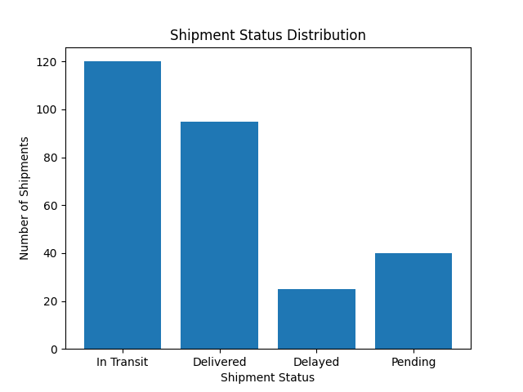
Figure 2: Monthly Asset Utilization Trend
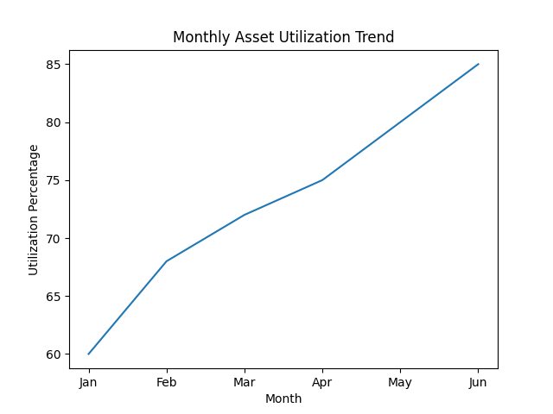
Figure 3: Average Waiting Time Analysis
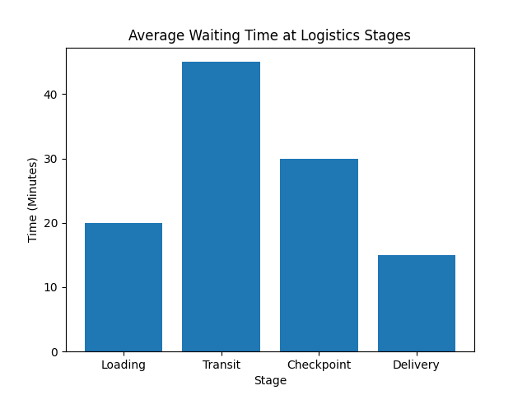
Figure 4: RAG Architecture Workflow Diagram
