Task 5.1: Nmap Scanning

Ping Scan
Command: nmap -sn scanme.nmap.org
Explanation: This command checks whether the target host is active without scanning any ports. It is used to verify if the system is reachable.

TCP SYN Scan
Command: sudo nmap -sS -T4 -p 22,80,443 scanme.nmap.org
Explanation: This command performs a TCP SYN scan on selected ports. It is a stealthy scan used to identify open ports without completing the full TCP connection.

Service Version Detection
Command: nmap -sV -T4 -p 80 scanme.nmap.org
Explanation: This command detects the service running on port 80 and attempts to identify its version.

OS Detection
Command: sudo nmap -O -T4 scanme.nmap.org
Explanation: This command attempts to detect the operating system of the target based on network responses.

NSE Script Scan
Command: nmap -sC -T4 -p 80 scanme.nmap.org
Explanation: This command runs default NSE scripts on port 80 to gather additional information and check for possible vulnerabilities.

Screenshots:
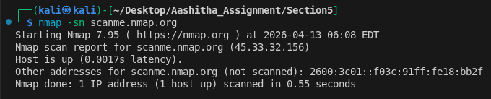
Basic ping scan

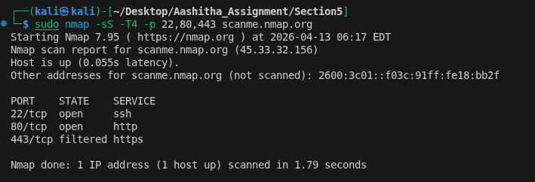
TCP SYN Scan
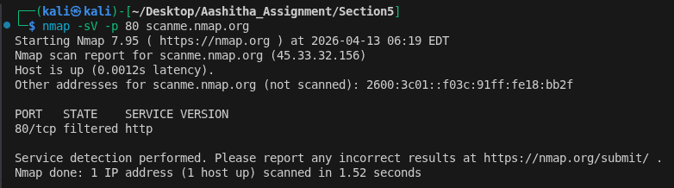
Service Detection Scan

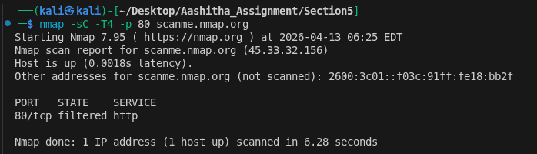
OS Detection Scan

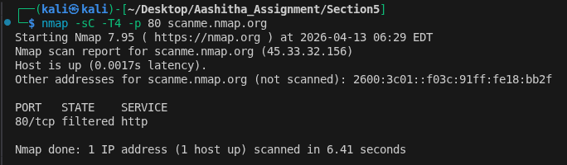
NSE Script Scan

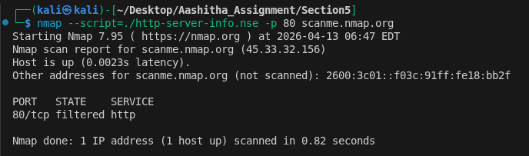
Http-server-info.nse output

