Intelligent RPA Value &
Automation Opportunity Analytics

Internship Project Report

Date: September 24, 2026
Dataset: Enterprise RPA Automation Projects (50,000 rows)
Tool: Streamlit Interactive Dashboard (app.py)

Submitted by: Aashi Tiwari
B.Tech – Computer Science & Engineering
Bharati Vidyapeeth (Deemed to be University), Pune

Table of Contents
- 1. Executive Summary
- 2. Problem Statement
- 3. Dataset Description
- 4. Data Cleaning & Preparation Methodology
- 5. KPI Definitions
- 6. Analysis Methodology
- 7. Automation Performance Findings
- 8. Key Observations & Insights
- 9. Hypothesis Analysis
- 10. Project Output & Dashboard
- 11. Value Driver Findings
- 12. Opportunity Analysis Methodology & Findings
- 13. Actionable Recommendations
- 14. Limitations
- 15. Conclusion
- Appendix A: Column Reference
- Appendix B: Technology Stack

1. Executive Summary
This report presents the findings of an analytics project analysing 50,000 enterprise Robotic Process Automation (RPA) projects. The Streamlit dashboard built as part of this project transforms raw automation data into actionable business intelligence across four analytical dimensions: executive KPIs, performance analysis, value driver identification, and investment opportunity prioritisation.
Key findings from the full dataset:
- The portfolio of 50,000 projects achieved an average ROI (Savings/Budget) of 174.5%, generating $15.90B in total annual savings against a total investment of $9.11B.
- A total of 3.06B hrs in employee labour hours were saved annually across the portfolio.
- Completion rate stands at 55.4% (27,681 of 50,000 projects).
- AI-enabled projects (55.1% of the portfolio) show marginally higher average ROI (175.2%) compared to non-AI projects (173.7%), indicating AI enablement alone is not a dominant ROI differentiator at the portfolio level.
- Regulatory Reporting, Supply Chain Optimization, and Customer Onboarding rank as the top three automation types by median ROI.
- Construction & Engineering, Hospitality & Travel, and Professional Services & Consulting lead industry Opportunity Scores.
- Process Automation and Contract Analysis are flagged as high-investment, below-median-ROI automation types warranting re-evaluation.

2. Problem Statement
Organisations invest significant capital in RPA and intelligent automation, yet frequently lack a structured analytical framework to answer key business questions:
- Which automation types and industries deliver the highest return on investment?
- What project characteristics (AI, cloud, scale) are associated with superior outcomes?
- Which areas of the automation portfolio represent high investment with relatively low returns?
- Where should future automation investment be prioritised?
This project addresses these questions by building an interactive analytics dashboard over a dataset of 50,000 enterprise automation projects spanning 26 industries, 30 departments, 56 countries, and 11 years (2015–2025).

3. Dataset Description
The dataset consists of 50,000 enterprise RPA and intelligent automation projects sourced from the Kaggle Enterprise RPA Automation Projects Dataset. It covers a wide range of automation types, industry sectors, geographies, and project outcomes.

Dataset Summary Statistics
Property | Value
Total rows | 50,000
Columns | 18
Date range | 2015 – 2025
Automation types | 25
Industries | 26
Departments | 30
Countries | 56
Implementation partners | 38
Missing completion_date | 29.9% (Active projects only)
ROI range | 15.0% – 500.0%
Budget range | $10.0K – $9.56M
Annual savings range | $2.4K – $22.38M
Employee hours saved range | 96 – 624,697

Important note on the ROI column: roi_percent is calculated as (annual_savings_usd / budget_usd) × 100. This is a savings-to-investment ratio, not the conventional net-return ROI formula. Values are capped at 500% in the dataset. All dashboard labels and this report use the label 'ROI (Savings/Budget %)' to avoid misinterpretation.

4. Data Cleaning & Preparation Methodology
The raw CSV file required minimal cleaning. The following steps were applied inside the load_data() function in app.py, using @st.cache_data to avoid reloading on every user interaction.
Issue | Action Taken
start_date and completion_date stored as strings | Parsed with pd.to_datetime(errors='coerce')
completion_date missing for ~30% of rows | Left as NaT; exclusively Active projects — no imputation applied
Numeric columns stored as strings in some environments | Coerced with pd.to_numeric(errors='coerce')
No negative numeric values | No action required
No duplicate project_id values | No action required
No encoding issues or corrupted strings | No action required
ROI capped at 500% | Retained as-is; median (not mean) used for group comparisons

Derived Columns
Column | Formula | Notes
project_duration_days | (completion_date - start_date).dt.days | NaN for Active/Planned without completion_date
start_year | start_date.dt.year | Used for year-over-year trend chart
net_savings_usd | annual_savings_usd - budget_usd | Can be negative; indicates project cost exceeds savings
ai_flag | ai_enabled == 'Yes' | Boolean for groupby arithmetic
cloud_flag | cloud_deployment == 'Yes' | Boolean for groupby arithmetic

5. KPI Definitions
KPI | Definition | Full-Dataset Value
Total Projects | COUNT of all projects in filtered view | 50,000
Avg ROI (Savings/Budget %) | (annual_savings_usd / budget_usd) × 100, averaged | 174.5%
Total Budget Invested | SUM of budget_usd | $9.11B
Total Annual Savings | SUM of annual_savings_usd | $15.90B
Total Employee Hours Saved | SUM of employee_hours_saved | 3.06B hrs
Completion Rate | COUNT(Completed) / COUNT(all) × 100 | 55.4%
AI Adoption Rate | COUNT(ai_enabled='Yes') / COUNT(all) × 100 | 55.1%
Cloud Adoption Rate | COUNT(cloud_deployment='Yes') / COUNT(all) × 100 | 64.8%
Opportunity Score | Composite percentile rank (see Section 9) | 0–100 per group
Net Savings | annual_savings_usd - budget_usd | Varies; can be negative

6. Analysis Methodology

Dashboard Architecture
The application (app.py) is a single-file Streamlit dashboard with four analytical tabs. A global sidebar provides multi-select filters for industry, department, automation type, country, project status, AI enablement, and cloud deployment. All four tabs respond dynamically to these filters.

Visualisation Approach
All charts use Plotly Express or Plotly Graph Objects for interactivity. Median (not mean) is used for ROI group comparisons to reduce distortion from the 500% cap. Scatter plots sample up to 5,000 points for browser performance while all aggregated KPIs use the full filtered dataset.

Statistical Approach
No machine learning or predictive modelling is used. All analysis is descriptive and aggregative. Group comparisons use median and mean aggregations. The Opportunity Score is a rule-based percentile-rank composite (detailed in Section 9).

7. Automation Performance Findings

Portfolio Overview
Across all 50,000 projects: 27,681 are Completed (55.4%), 14,936 are Active, and 7,383 are Planned. The average project takes approximately 360 days (median: 349 days) to complete, based on the 27,681 projects with valid duration data.

ROI by Automation Type (Top 10 by Median ROI)
Rank | Automation Type | Median ROI (Savings/Budget %)
1 | Regulatory Reporting | 153.7%
2 | Supply Chain Optimization | 152.9%
3 | Customer Onboarding | 151.7%
4 | Compliance Monitoring | 151.5%
5 | Inventory Management | 151.4%
6 | Lead Generation | 151.1%
7 | Data Validation | 150.6%
8 | Quality Control | 150.3%
9 | HR Onboarding | 150.2%
10 | Financial Reconciliation | 150.1%

Total Annual Savings by Industry (Top 10)
Rank | Industry | Total Annual Savings (USD)
1 | Education | $774.61M
2 | Aerospace & Defense | $733.27M
3 | Chemical & Materials | $680.87M
4 | Banking & Financial Services | $676.06M
5 | Hospitality & Travel | $672.37M
6 | Mining & Metals | $658.37M
7 | Insurance | $651.18M
8 | Professional Services & Consulting | $642.04M
9 | Construction & Engineering | $629.25M
10 | Agriculture & Food Processing | $629.19M

Budget vs Savings Relationship
The scatter plot of budget vs annual savings (with a break-even reference line) shows that the overwhelming majority of projects generate savings exceeding their budget. Total portfolio savings of $15.90B against total investment of $9.11B represents a portfolio-level savings-to-budget ratio of 1.75x.

8. Key Observations & Insights

Observation 1 — Strong overall financial value
The 50,000-project portfolio generated approximately $15.90B in annual savings against $9.11B in total investment, representing a portfolio-level savings-to-budget ratio of approximately 1.75×.
Insight: Enterprise automation can generate substantial measurable financial value, but performance varies considerably across automation types and industries.

Observation 2 — ROI varies across automation types
Regulatory Reporting, Supply Chain Optimization, and Customer Onboarding recorded the highest median ROI among the automation types analyzed.
Insight: Automation value is not uniform across use cases. Selecting the right automation process is an important factor when prioritizing future initiatives.

Observation 3 — AI enablement shows only a marginal ROI difference
AI-enabled projects recorded an average ROI of 175.22%, compared with 173.72% for non-AI projects — a difference of only 1.50 percentage points.
Insight: AI enablement alone does not appear to be a dominant ROI differentiator at the portfolio level. Project design, automation type, and implementation quality may have greater influence.

Observation 4 — Cloud deployment does not show a strong ROI advantage
Cloud-deployed projects recorded an average ROI of 174.20%, compared with 175.19% for non-cloud projects.
Insight: Cloud adoption by itself does not guarantee higher financial returns. Deployment architecture should therefore be selected according to operational and technical requirements rather than ROI expectations alone.

Observation 5 — Some high-investment areas underperform
Process Automation and Contract Analysis were flagged as High Investment / Low Return areas because they combine above-median investment with below-33rd-percentile median ROI.
Insight: These areas warrant deeper review of project scope, implementation approach and automation design before additional investment is committed.

9. Hypothesis Analysis

The following hypotheses were formulated to investigate whether commonly expected technology and investment characteristics are associated with stronger automation outcomes.
H1: AI-enabled automation projects achieve higher ROI than non-AI projects.
Result: Partially supported at a descriptive level.
AI-enabled projects have an average ROI of 175.22%, compared with 173.72% for non-AI projects. The difference is only 1.50 percentage points, indicating that the relationship is relatively small at the overall portfolio level.
Business implication: AI should not be treated as a standalone guarantee of higher ROI.

H2: Cloud-deployed automation projects achieve higher ROI than non-cloud projects.
Result: Not supported by the observed portfolio averages.
Cloud projects have an average ROI of 174.20%, while non-cloud projects have 175.19%.
Business implication: Cloud deployment should be evaluated based on operational, scalability and architectural requirements rather than assuming it will improve ROI.

H3: Higher automation investment consistently produces higher returns.
Result: Not supported.
The analysis identifies areas with relatively high investment but comparatively low median ROI, including Process Automation and Contract Analysis.
Business implication: Increasing investment alone does not guarantee proportional returns. Automation selection and implementation quality should be considered when allocating future resources.

10. Project Output & Dashboard
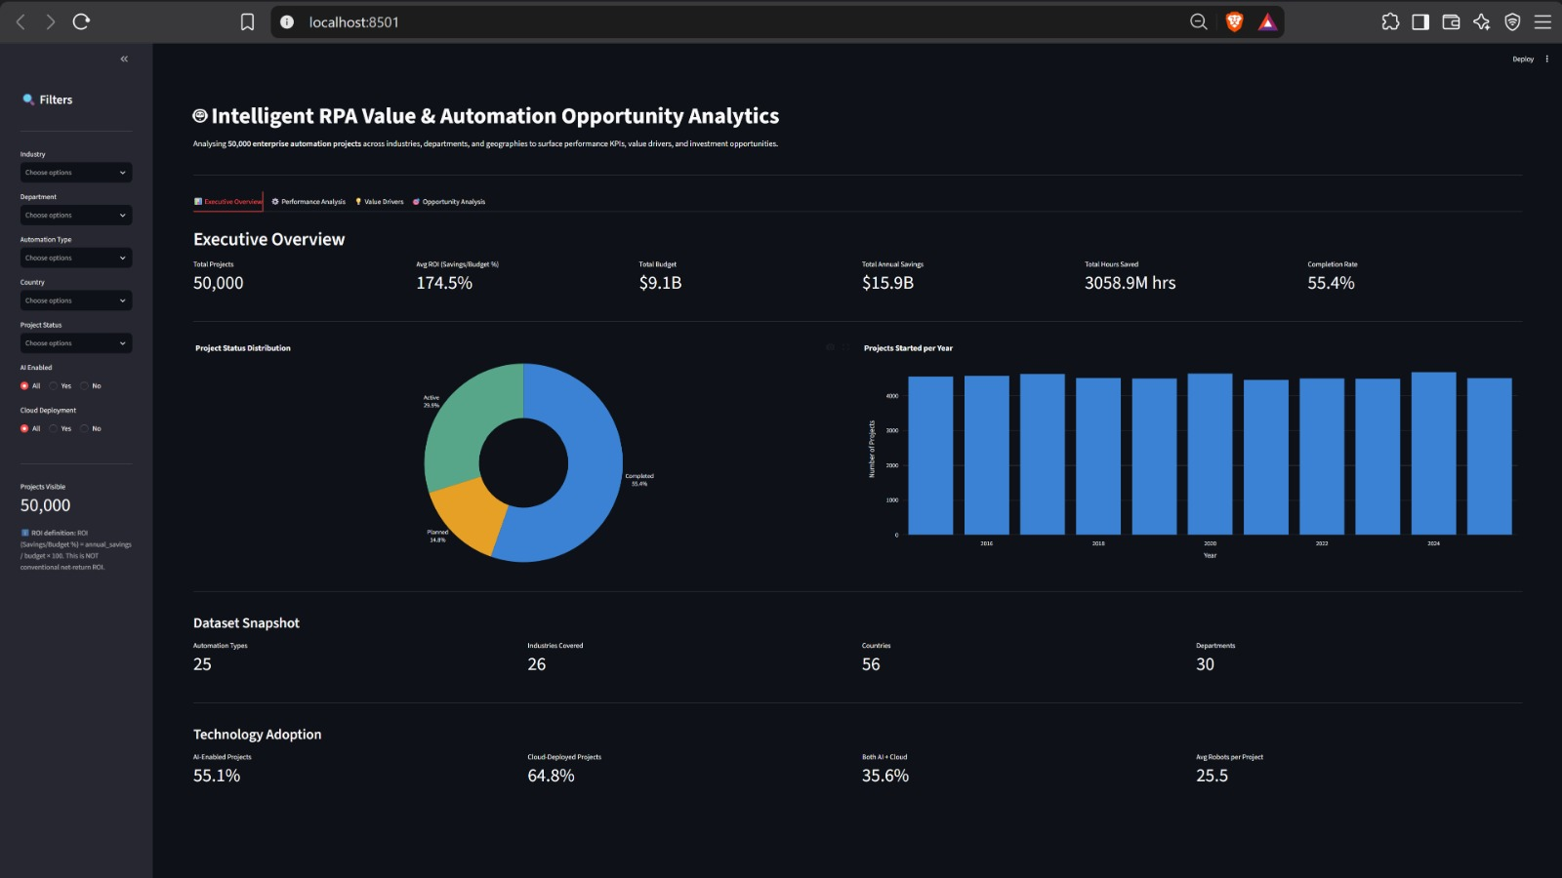
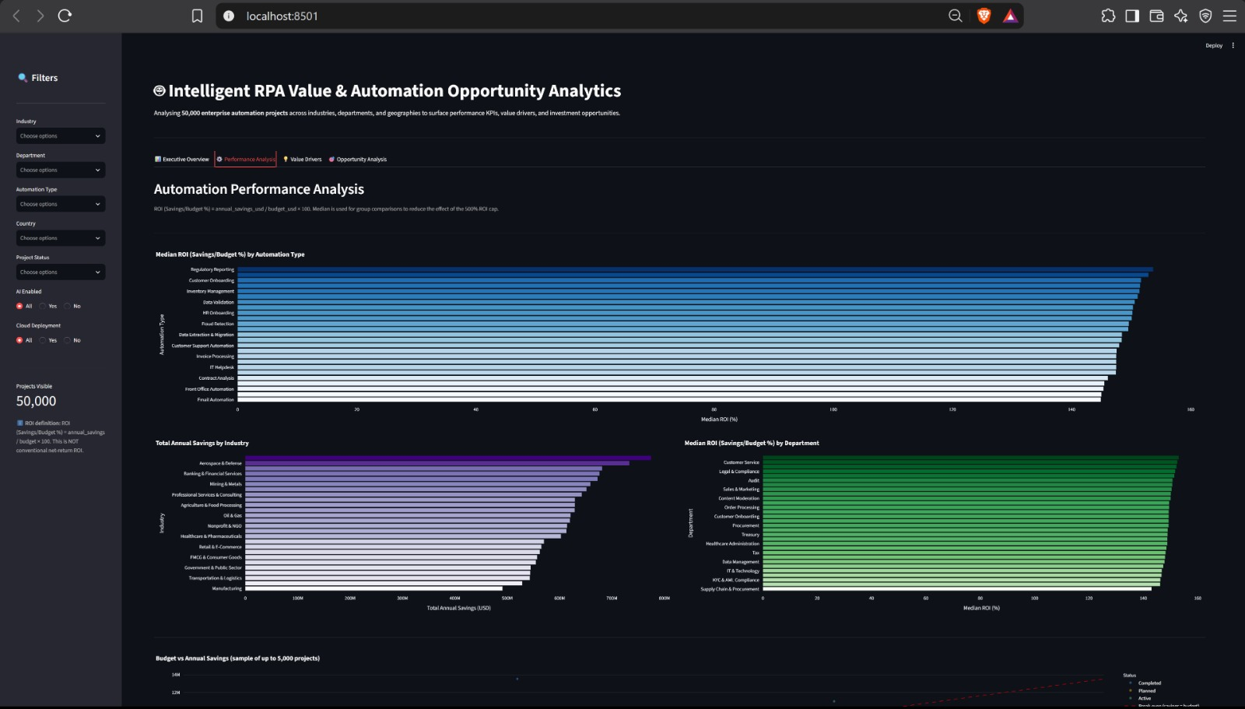
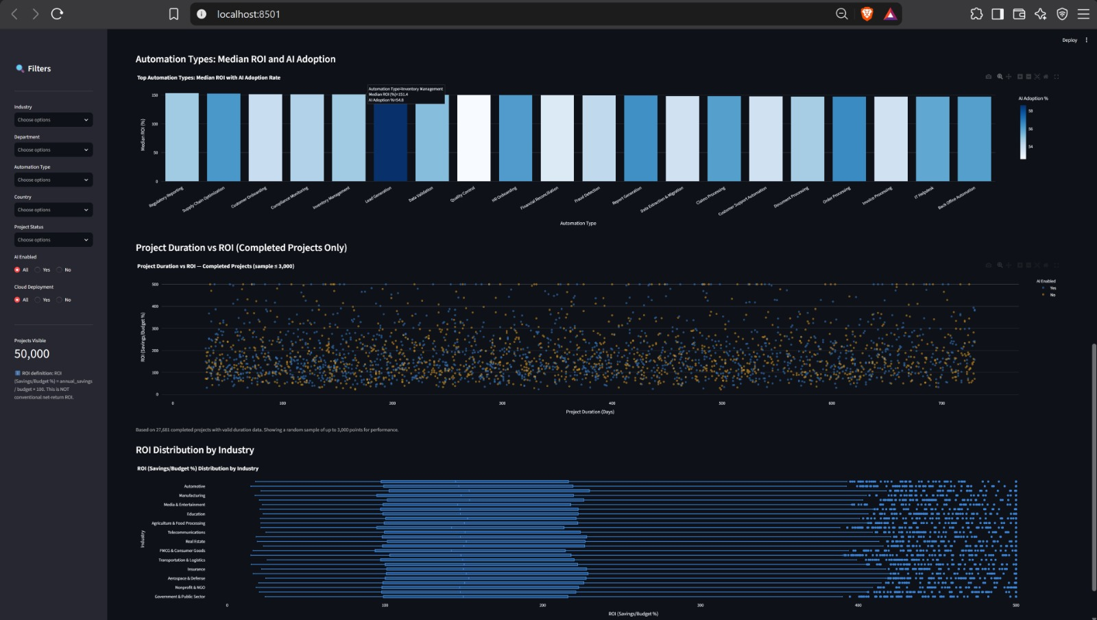
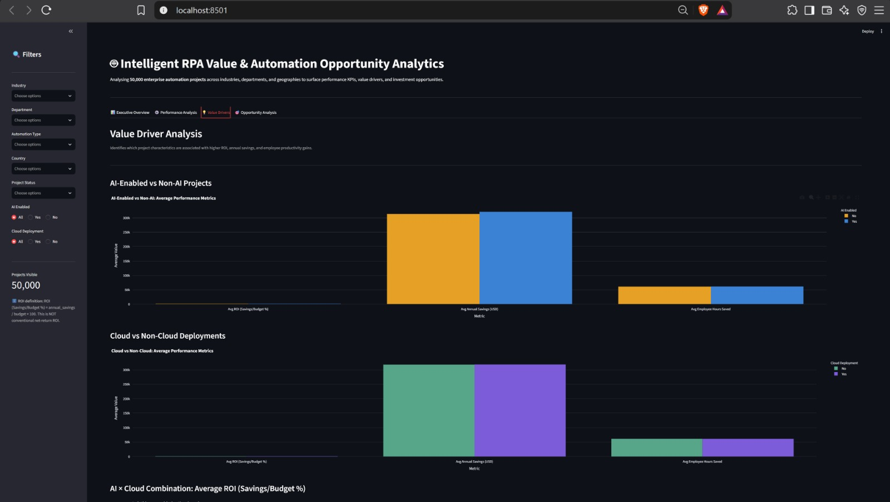
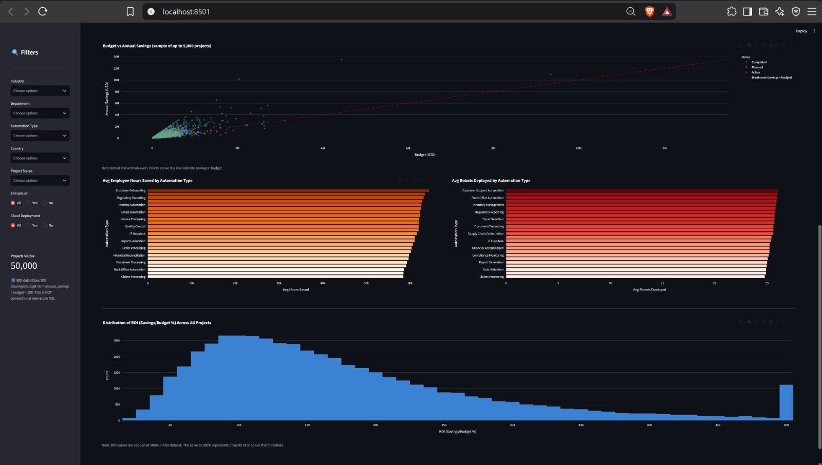
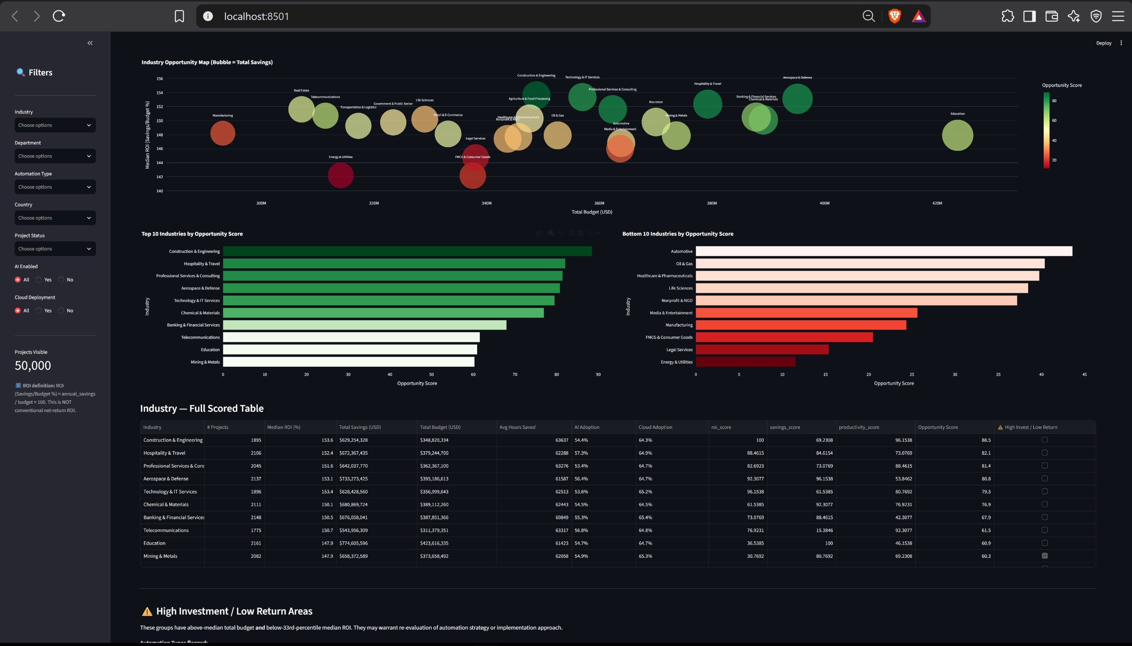
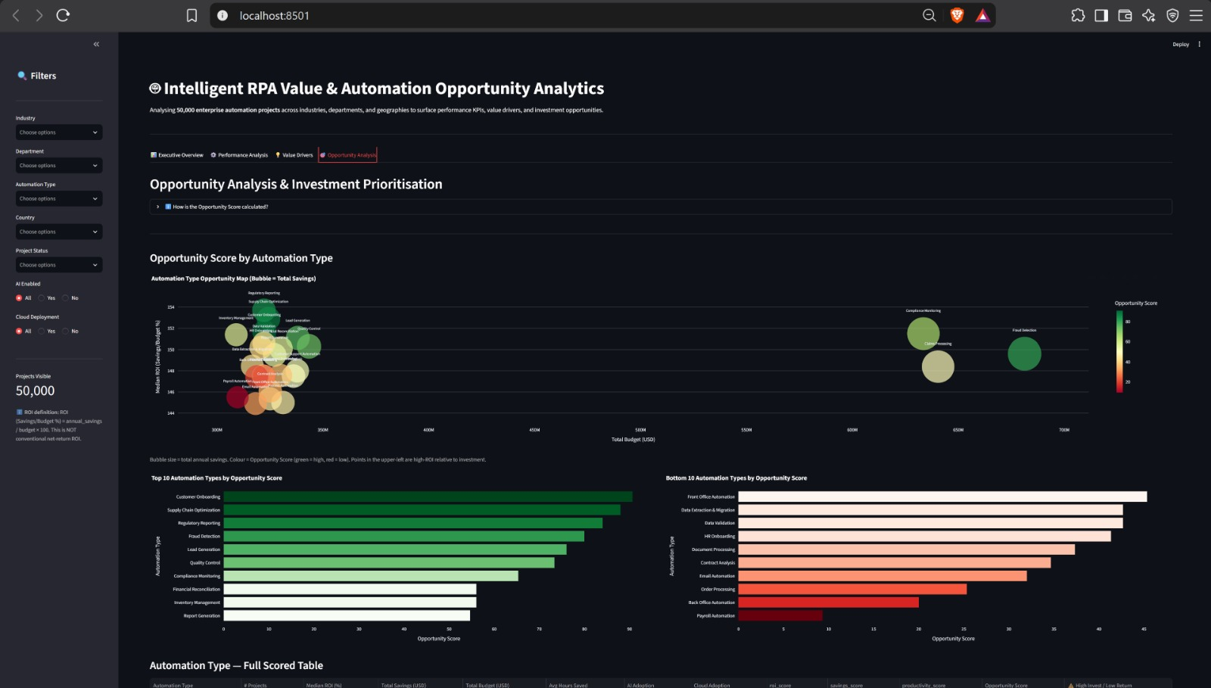

11. Value Driver Findings

AI-Enabled vs Non-AI Projects
Metric | AI Enabled = Yes | AI Enabled = No | Difference
Avg ROI (Savings/Budget %) | 175.22% | 173.72% | +1.50%
Avg Annual Savings (USD) | $321.5K | $313.9K | $7.6K
Avg Employee Hours Saved | 61,373 | 60,941 | +432

AI-enabled projects show a 1.50 percentage point higher average ROI compared to non-AI projects. The marginal difference suggests that AI enablement alone is not the primary ROI driver at the portfolio level. ROI performance appears broadly distributed across both AI and non-AI projects, indicating that project design, automation type, and implementation quality are likely more significant factors.

Cloud vs Non-Cloud Deployments
Metric | Cloud = Yes | Cloud = No | Difference
Avg ROI (Savings/Budget %) | 174.20% | 175.19% | -1.00%
Avg Annual Savings (USD) | $318.3K | $317.7K | $529
Avg Employee Hours Saved | 61,121 | 61,285 | -164

Cloud-deployed projects show a 1.00 percentage point lower average ROI than on-premise deployments. As with AI enablement, cloud deployment status does not show a strong systematic ROI advantage at the aggregate level.

AI × Cloud Combination Matrix
The 2×2 matrix below shows average ROI for each combination of AI enablement and cloud deployment:
 | Cloud=No | Cloud=Yes
AI=No | 172.9% | 174.2%
AI=Yes | 177.1% | 174.2%

The combination AI=Yes, Cloud=No yields the highest average ROI of 177.1%.

12. Opportunity Analysis Methodology & Findings

Opportunity Score Methodology
Each automation type (and separately each industry) is assigned a composite Opportunity Score from 0 to 100 using three equally-weighted components:
Component | Metric | Weight
ROI Score | Percentile rank of the group's median ROI among all groups | 33%
Savings Score | Percentile rank of the group's total annual savings among all groups | 33%
Productivity Score | Percentile rank of the group's avg employee hours saved among all groups | 34%

Opportunity Score = (ROI Score + Savings Score + Productivity Score) / 3
A 'High Investment / Low Return' flag is raised when a group has above-median total budget AND below-33rd-percentile median ROI. No machine learning is used; the framework is fully transparent and auditable.

Top 10 Automation Types by Opportunity Score
Rank | Automation Type | Opp. Score | Median ROI (%) | Total Savings | AI %
1 | Customer Onboarding | 90.7 | 151.7% | $591.94M | 54.0%
2 | Supply Chain Optimization | 88.0 | 152.9% | $584.30M | 56.2%
3 | Regulatory Reporting | 84.0 | 153.7% | $579.53M | 54.8%
4 | Fraud Detection | 80.0 | 149.6% | $1.17B | 54.2%
5 | Lead Generation | 76.0 | 151.1% | $597.99M | 58.6%
6 | Quality Control | 73.3 | 150.3% | $622.57M | 52.6%
7 | Compliance Monitoring | 65.3 | 151.5% | $1.11B | 54.5%
8 | Financial Reconciliation | 56.0 | 150.1% | $584.59M | 53.4%
9 | Inventory Management | 56.0 | 151.4% | $544.80M | 54.8%
10 | Report Generation | 54.7 | 149.5% | $582.12M | 56.4%

Bottom 5 Automation Types by Opportunity Score
Automation Type | Opp. Score | Median ROI (%) | Total Savings | ⚠️ High Invest/Low Return
Payroll Automation | 9.3 | 145.5% | $517.27M | No
Back Office Automation | 20.0 | 147.4% | $551.47M | No
Order Processing | 25.3 | 147.5% | $544.16M | No
Email Automation | 32.0 | 144.9% | $547.55M | No
Contract Analysis | 34.7 | 146.1% | $570.53M | YES

Top 10 Industries by Opportunity Score
Rank | Industry | Opp. Score | Median ROI (%) | Total Savings | AI %
1 | Construction & Engineering | 88.5 | 153.6% | $629.25M | 54.4%
2 | Hospitality & Travel | 82.1 | 152.4% | $672.37M | 57.3%
3 | Professional Services & Consulting | 81.4 | 151.6% | $642.04M | 53.4%
4 | Aerospace & Defense | 80.8 | 153.1% | $733.27M | 56.4%
5 | Technology & IT Services | 79.5 | 153.3% | $628.43M | 53.6%
6 | Chemical & Materials | 76.9 | 150.1% | $680.87M | 54.5%
7 | Banking & Financial Services | 67.9 | 150.5% | $676.06M | 55.3%
8 | Telecommunications | 61.5 | 150.7% | $543.96M | 56.8%
9 | Education | 60.9 | 147.9% | $774.61M | 54.7%
10 | Mining & Metals | 60.3 | 147.9% | $658.37M | 54.9%

High Investment / Low Return Flags
Automation types flagged: Process Automation, Contract Analysis
Industries flagged: Mining & Metals, Automotive, Media & Entertainment

13. Actionable Recommendations
Recommendation 1: Prioritise Regulatory Reporting, Supply Chain Optimization, and Customer Onboarding
These automation types rank highest by median ROI in the dataset. Organisations without active programmes in these areas should evaluate them as primary automation targets.

Recommendation 2: Investigate and Re-evaluate Process Automation and Contract Analysis
Both are flagged as High Investment / Low Return: they absorb above-median budgets but deliver below-33rd-percentile median ROI. A root-cause review of project design, scope, and implementation approach is recommended before committing further spend.

Recommendation 3: Focus industry investment on Construction & Engineering, Hospitality & Travel, and Professional Services
These industries achieve top Opportunity Scores, combining strong median ROI with high total savings and productivity gains. They represent the most balanced investment thesis across all three value dimensions.

Recommendation 4: Do not rely on AI or Cloud enablement alone as an ROI driver
The dataset shows only marginal differences in average ROI between AI-enabled and non-AI projects, and between cloud and on-premise deployments. Project design, automation type selection, and implementation quality are likely more consequential factors.

Recommendation 5: Use the Opportunity Score as a starting hypothesis, not a final decision
The composite score provides a transparent, data-driven starting point for investment prioritisation discussions. It should be supplemented with qualitative domain knowledge, organisation-specific constraints, and strategic context.

14. Limitations
ROI formula is not conventional net-return ROI
roi_percent = (savings/budget) × 100 is a savings-to-investment ratio. Projects with savings < budget have ROI < 100% but do not represent a 'negative' return in the conventional sense. All dashboard labels and this report use 'ROI (Savings/Budget %)' to make the definition explicit.
ROI cap at 500%
The dataset caps roi_percent at 500%. This affects mean calculations. The dashboard uses median for group comparisons to mitigate this.
Missing completion dates (~30% of rows)
Active projects lack a completion_date, making project duration analysis applicable only to Completed projects. No imputation is applied.
Opportunity Score is rule-based, not statistically validated
The three-component percentile-rank composite is intuitive but not derived from regression or other inferential analysis. It should be treated as a prioritisation heuristic rather than a statistically validated predictor.
No causal inference
All relationships observed in this analysis are correlational. The dataset does not support causal claims about which factors drive ROI.
Dataset scope
The dataset covers 50,000 projects but its provenance and representativeness of the broader enterprise automation market are not documented in the source.

15. Conclusion
This project delivered an interactive Streamlit analytics dashboard over a dataset of 50,000 enterprise automation projects. The dashboard provides four interconnected analytical perspectives: executive KPI overview, automation performance benchmarking, value driver identification, and opportunity prioritisation.
The portfolio generates $15.90B in annual savings from $9.11B in total investment — a portfolio-wide savings-to-budget ratio of 1.75x. The automation opportunity framework, built without machine learning, provides a transparent and auditable method for identifying where automation investment is likely to yield the strongest combined returns across ROI, savings, and employee productivity.
The implementation demonstrates how analytics can transform raw automation project records into actionable business intelligence using only standard data science tools: Python, pandas, NumPy, Plotly, and Streamlit.

Appendix A: Column Reference
Column | Type | Description | Missing?
project_id | string | Unique project identifier | No
company_id | string | Company identifier | No
project_name | string | Descriptive project name | No
start_date | date | Project start date (YYYY-MM-DD) | No
completion_date | date | Completion date; absent for Active projects | ~30%
project_status | categorical | Active / Completed / Planned | No
automation_type | categorical | 25 automation categories | No
robots_deployed | integer | Number of software robots (1–50) | No
budget_usd | float | Total project budget in USD | No
annual_savings_usd | float | Estimated annual cost savings in USD | No
roi_percent | float | roi = (savings/budget)×100; capped at 500% | No
department | categorical | Business department (30 categories) | No
implementation_partner | categorical | SI/consulting firm (38 partners) | No
country | categorical | Country of deployment (56 countries) | No
industry | categorical | Industry sector (26 sectors) | No
employee_hours_saved | integer | Annual employee hours saved | No
ai_enabled | Yes/No | AI/ML used in the project | No
cloud_deployment | Yes/No | Cloud infrastructure used | No

Appendix B: Technology Stack
Library | Version Requirement | Purpose
streamlit | >=1.32.0 | Interactive web dashboard framework
pandas | >=2.0.0 | Data manipulation and aggregation
numpy | >=1.26.0 | Numerical operations
plotly | >=5.20.0 | Interactive charts and visualisations
python-docx | >=1.1.0 | Programmatic Word document generation

