Practical-1
Aim: Develop the Software Requirements Specifications (SRS) document for

Chess Playing Robotic Arm

Introduction:

Purpose of the system:
The purpose of the Chess Playing Robotic Arm System is to develop an intelligent robotic system capable of playing chess against a human player by physically moving chess pieces on a standard chessboard.
The system addresses the following needs:
- Integration of robotics, computer vision, and artificial intelligence into a single application.
- Providing an interactive platform for learning chess and robotics.
- Automating chess gameplay with accurate piece recognition and movement.
The system will improve upon existing digital chess systems by offering:
- Physical interaction with real chess pieces.
- Autonomous decision-making using a chess engine.
- Real-time board detection and move execution.
- User-friendly interface for game monitoring.

Scope of the system:
The Chess Playing Robotic Arm System consists of a 6-DOF robotic arm, camera module, Raspberry Pi, Arduino Uno, and a chess engine. The system detects the current board state, calculates the best move, and physically moves the chess pieces.
Key feature include:
- Automatic chessboard recognition.
- Human move detection.
- AI-based move generation.
- Physical movement of chess pieces using a robotic arm.
- User interface for game control and monitoring.

General description of the system:

Overall description:
The system is an embedded robotic application that combines computer vision, artificial intelligence, and robotic manipulation. A camera continuously captures the chessboard image and processes it to identify piece positions. The chess engine computes the next move, and the robotic arm executes the move by controlling multiple servo motors.
The system ensures accuracy, reliability, and smooth interaction between hardware and software components.
Additionally, the system has following constraints:
- System should operate on 5V power supply.
- The robotic arm should move pieces without disturbing neighboring pieces.
- The camera should provide a clear top view of the chessboard.
- The system should support standard chess rules.
- Real-time response should be maintained during gameplay.

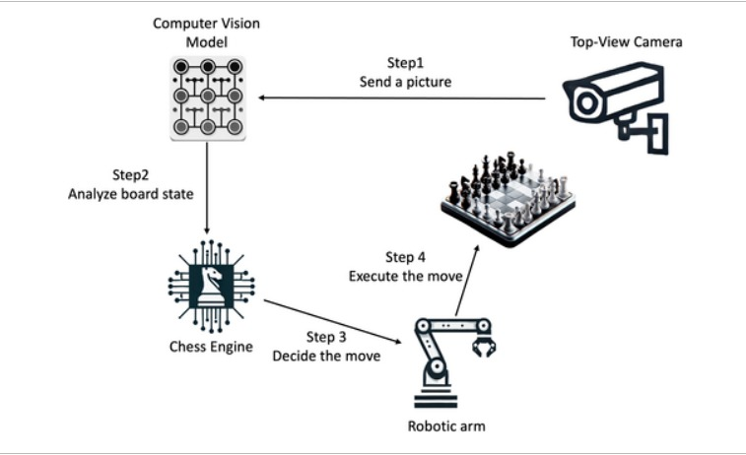
System Block Diagram
Figure 2.1 Block Diagram for Chess Playing Robotic Arm

Feasibility study:

Technical Feasibility:
- Required technologies such as Raspberry Pi, Arduino, OpenCV, and Stockfish Chess Engine are readily available.
- Servo motors and camera modules can accurately perform the required operations.
- Existing computer vision libraries simplify implementation.
- The system can be upgraded with stronger AI algorithms in the future.

Operational Feasibility:
- The system provides an engaging platform for chess players and robotics enthusiasts.
- Human interaction with the system is simple and intuitive.
- The project can be used for educational demonstrations and research purposes.

Economic Feasibility:
- The system uses affordable components such as Raspberry Pi, Arduino Uno, and servo motors.
- Open-source software significantly reduces development cost.
- Maintenance cost is low.

Functional Requirements:

Module description:

Functionality 1: Camera-Based Board Monitoring
- The Camera-Based Board Monitoring module is responsible for continuously observing the physical chessboard throughout the game. A top-mounted camera captures high-resolution images of the board after each player's move. Using image processing techniques with OpenCV, the module detects the chessboard boundaries, divides the board into 64 squares, and identifies the position of every chess piece. The captured board state is converted into a digital representation that is used by the remaining modules. Proper camera calibration and consistent lighting ensure accurate detection while minimizing recognition errors caused by shadows or reflections.

Functionality 2: Move Detection Module
- The Move Detection module identifies the move made by the human player by comparing the current board state with the previous one. It analyzes the changes in the positions of chess pieces to determine the source and destination squares of the move. The detected move is then validated according to standard chess rules before being accepted. This module also recognizes special moves such as castling, pawn promotion, en passant captures, and piece captures. If an invalid move is detected, the system notifies the player and waits until a legal move is performed before proceeding.

Functionality 3: Chess AI Engine
- The Chess AI Engine acts as the decision-making component of the system. After receiving the updated board state, it communicates with the Stockfish chess engine to calculate the optimal move. The board position is converted into Forsyth-Edwards Notation (FEN), which is provided as input to the engine. Based on the selected difficulty level, the engine evaluates numerous possible moves and returns the best move within the allotted computation time. The module also handles game logic such as check, checkmate, stalemate, draw conditions, and legal move generation, ensuring that the game strictly follows official chess rules.

Functionality 4: Coordinate Mapping Module
- The Coordinate Mapping module converts the chess engine's output into physical coordinates that the robotic arm can understand. Each chessboard square (A1 to H8) is mapped to predefined Cartesian coordinates based on the dimensions of the chessboard and the robotic arm's workspace. The module calculates the pick-up position, destination position, and intermediate safe movement positions required for smooth operation. It also accounts for piece captures by assigning designated storage locations for captured pieces. This mapping ensures that the robotic arm performs accurate and collision-free movements during gameplay.

Functionality 5: Robotic Arm Control Module
- The Robotic Arm Control module is responsible for physically executing the move generated by the chess engine. It receives the mapped coordinates from the Coordinate Mapping module and calculates the required joint angles using inverse kinematics. These joint angles are transmitted from the Raspberry Pi to the Arduino Uno, which controls the six servo motors through the servo driver. The robotic arm moves to the source square, grips the chess piece using its end-effector, lifts it safely, transports it to the destination square, and releases it accurately. During capture moves, the module first removes the opponent's piece before placing the moving piece. Smooth trajectory planning ensures precise movement while preventing collisions with adjacent pieces.

Functionality 6: Game Management Module
- The Game Management module coordinates the overall operation of the chess-playing robotic system. It maintains the current game state, records the sequence of moves, tracks player turns, and determines the progress of the match. The module initializes a new game with the standard chess setup, updates the board after every move, and stores game history for future reference or analysis. It also handles exceptional situations such as illegal moves, communication failures, or interrupted gameplay by providing appropriate notifications and recovery options. This module acts as the central controller that synchronizes communication among the camera, move detection, chess engine, coordinate mapping, and robotic arm control modules to ensure smooth and uninterrupted gameplay.

Functions of various user of the system:
There are mainly two users of the system:
Admin:
- Manage users
- Monitor game listings and activities
- Configure hardware settings
- Calibrate camera and robotic arm
- Update software and chess engine
Client:
- Start and stop games.
- Make chess moves.
- Select difficulty level.
- Monitor game progress.
- Perform game analysis.

1.4 Non- Functional Requirements:

Security:
- Only authorized users can modify system settings.
- Game data and configurations are protected.

Reliability:
- The system should operate continuously without crashes.
- Accurate piece movement should exceed 95%.

Availability:
- System should be available whenever powered on.
- Real-time responses should occur within a few seconds.

Maintainability:
- Modular software architecture.
- Easy replacement of hardware components.

Portability:
- Software should run on Raspberry Pi OS.
- Code should be portable to other Linux-based systems.

Reusability:
- Vision module can be reused in other board-game projects.
- Robotic arm control module can be reused in pick-and-place applications.

1.5 Interface Requirements:

1.5.1 GUI

Home Screen
- Start Game button.
- Difficulty selection.
- System status display
- Game History

Game Screen
- Clock Timer
- Error notifications

Hardware Interface
- Raspberry Pi 4
- Arduino Uno
- 6-DOF Robotic Arm
- Servo Motors
- External Power Supply.

Software Interface
- Programming Language: Python and C
- Operating System: Raspberry Pi OS
- Computer Vision Library: OpenCV
- Chess Engine: Stockfish
- Communication Protocol: Serial UART
- Arduino IDE for motor control programming.

Data Dictionary:

Table Name: user_table
Primary Key: user_id

Sr. No. | Name | Datatype | Constraint | Description
1 | user_id | INT AUTO INCREMENT | Primary key | Unique user ID
2 | password | password(10) | Not null | Encrypted Password
3 | email | varchar(10) | Not null | User email id
4 | username | Varchar(10) |  | User name as player

Table Name: game_table
Primary Key: game_id
Sr. No. | Name | Datatype | Constraint | Description
1 | game_id | INT | Primary key | Unique game ID
2 | User_id | INT | Foreign key | Reference to user table
3 | Start_time | DATETIME | Not Null | Game start time
4 | End_time | DATETIME | Not Null | Game end time
5 | Difficulty | Varchar | Not null | Easy/Medium/Hard
6 | result | VARCHAR(20) | Not null | Win/Loss/Draw

Table Name: move_table
Primary Key: move_id
Sr. No. | Name | Datatype | Constraint | Description
1 | move_id | INT | Primary key | Unique move ID
2 | game_id | INT | Foreign key | Reference to game table
3 | move_number | INT | Not Null | Move sequence number
4 | move | VARCHAR(20) | Not Null | Move displayed according to standard chess notation
5 | player | VARCHAR(20) | Not Null | Human or Robot

Table Name: motor_log
Primary key: client_id
Sr. No. | Name | Datatype | Constraint | Description
1 | log_id | INT | Primary key | Unique log ID
2 | motor_id | INT | Not null | Servo motor ID
3 | angle | FLOAT | Not null | Motor Angle
4 | timestamp | DATETIME | Not Null | Execution Time
5 | status | VARCHAR(20) | Not null | Success/Failure

