Acknowledgment
We would like to express our sincere gratitude to our project guide and Head of the IT Department, Keyur Sir, for his invaluable guidance, technical assistance, and continuous encouragement throughout the development of our Chess Playing Robotic Arm project. His valuable suggestions and support helped us overcome technical challenges and enhance the functionality of our project.
We would also like to thank the faculty members of the Information Technology Department for providing us with the necessary resources, support, and a conducive academic environment to carry out this project successfully. We are highly indebted to Birla Vishvakarma Mahavidyalaya for providing us with this opportunity to learn, innovate, and apply our technical knowledge to a practical real-world application.
Our Chess Playing Robotic Arm project is the result of our teamwork, dedication, and collaborative efforts. We would like to express our appreciation for the cooperation and commitment of both team members, Aashka Shah (23IT403) and Veera Agrawal (23IT431), whose combined efforts played a vital role in the successful development and completion of this project.
Finally, we would like to acknowledge everyone who directly or indirectly contributed to the successful completion of our project. Their support and encouragement have been invaluable throughout this journey.

Index

Acknowledgment i
Index ii
List of Figure iii
List of Collections v
Abstract vii
Chapter 1: Introduction 1
1.1 Aim of the Project 1
1.2 Project Scope 1
1.3 Project Objective 2
1.4 Project Modules 2
1.5 Project basic requirements Error! Bookmark not defined.
Chapter 2: Analysis, Design Methodology and Implementation Strategy Error! Bookmark not defined.
2.1 Literature review Error! Bookmark not defined.
2.2 Project Feasibility Study 12
2.3 Project Timeline chart 13
2.4 Detailed Modules Description 14
2.5 Project SRS 16
2.6 Database design and Normalization 23
2.7 Database Relation Diagram 30
2.8 Template Design 31
Chapter 3: Implementation and Testing 35
3.1 Software and Tools 35
3.2 User Interface and Snapshot 36
3.3 Testing using Use Cases 46
Chapter 4: Conclusion and Future work 53
4.1 Conclusion 53
4.2 Future work 53
References 55

List of Figures
Figure No. | Figure Name | Page No.
Figure 2.2.1 | Visual Representation of Project Timeline | 11
Figure 2.5.1 | Use Case Diagram | 15
Figure 2.5.2.1 | Level 0 DFD | 17
Figure 2.5.2.2 | Level 1 DFD | 18
Figure 2.5.2.3 | Level 2 DFD | 19
Figure 2.5.3 | Entity Relationship Diagram | 21
Figure 2.5.4 | Event Trace Diagram | 23
Figure 2.5.5 | Class Diagram | 26
Figure 2.7 | Database Relation Diagram | 34
Figure 2.8.1.1 | Login Page | 35
Figure 2.8.1.2 | Login Page Details Filled | 35
Figure 2.8.2.1 | Admin Dashboard | 36
Figure 2.8.2.2 | Admin Dashboard 2 | 36
Figure 2.8.2.3 | Admin Profile | 36
Figure 2.8.2.4 | Faculty Dashboard 1 | 36
Figure 2.8.2.5 | Faculty Dashboard 2 | 37
Figure 2.8.2.6 | Faculty Dashboard 3 | 37
Figure 2.8.2.7 | Faculty Dashboard 4 | 37
Figure 2.8.2.8 | Faculty Profile | 37
Figure 2.8.2.9 | HOD Dashboard 1 | 38
Figure 2.8.2.10 | HOD Dashboard 2 | 38
Figure 2.8.2.11 | HOD Profile | 38
Figure 3.2.1.1 | Faculty/HOD Registration | 40
Figure 3.2.1.2 | Admin/Principal Registration | 40
Figure 3.2.2.1 | Student Dashboard | 41
Figure 3.2.2.2 | Student Profile | 41
Figure 3.2.3.1 | Student Registration 1 | 42
Figure 3.2.3.2 | Student Registration 2 | 42
Figure 3.2.3.3 | Student Registration 3 | 42
Figure 3.2.4.1 | Face Registration 1 | 43
Figure 3.2.4.2 | Face Registration 2 | 43
Figure 3.2.4.3 | Admin Face Request | 43
Figure 3.2.4.4 | Admin Face Approval | 43
Figure 3.2.5.1 | Face Capture 1 | 44
Figure 3.2.5.2 | Face Capture 2 | 44
Figure 3.2.5.3 | Face Capture 3 | 44
Figure 3.2.6.1 | Attendance Marking 1 | 45
Figure 3.2.6.2 | Attendance Marking 2 | 45
Figure 3.2.6.3 | Faculty Attendance Marking | 45
Figure 3.2.7.1 | Liveness 1 | 46
Figure 3.2.7.2 | Liveness 2 | 46
Figure 3.2.7.3 | Liveness 3 | 46
Figure 3.2.8.1 | Attendance Record 1 | 47
Figure 3.2.8.2 | Attendance Record 2 | 47
Figure 3.2.8.3 | Attendance Record 3 | 47
Figure 3.2.8.4 | Attendance Record 4 | 47
Figure 3.2.9.1 | Report Page 1 | 48
Figure 3.2.9.2 | Report Page Student | 48
Figure 3.2.9.3 | Report Page Faculty | 48
Figure 3.2.9.4 | Report Page Hod | 49
Figure 3.2.9.5 | Report Page Principal/Admin | 49
Figure 3.2.9.6 | Report Page 2 | 49
Figure 3.2.9.7 | Report Page 3 | 49
Figure 3.2.9.8 | Report Page 4 | 49
Figure 3.2.9.9 | Report Page 5 | 49
Figure 3.3.1.1 | Test Auth 1 | 51
Figure 3.3.1.2 | Test Auth 2 | 51
Figure 3.3.1.3 | Test Auth 3 | 51
Figure 3.3.1.4 | Test Auth 4 | 51
Figure 3.3.2.1 | Test Face 1 | 51
Figure 3.3.2.2 | Test Face 2 | 51
Figure 3.3.2.3 | Test Face 3 | 51
Figure 3.3.2.4 | Test Face 4 | 51
Figure 3.3.3.1 | Test Ble 1 | 53
Figure 3.3.3.2 | Test Ble 2 | 53
Figure 3.3.4.1 | Test Recog 1 | 54
Figure 3.3.4.2 | Test Recog 2 | 54
Figure 3.3.4.3 | Test Recog 3 | 54
Figure 3.3.5.1 | Test Live 1 | 55
Figure 3.3.5.2 | Test Live 2 | 55
Figure 3.3.6.1 | Test Rep 1 | 56
Figure 3.3.6.2 | Test Rep 2 | 56
Figure 3.3.6.3 | Test Rep 3 | 56
Figure 3.3.6.4 | Test Rep 4 | 56

List of Collections
Table No. | Table Name | Page No.
Table 2.1.1 | Comparison of Existing Systems | 9
Table 2.2.1 | Timeline of project milestones | 10
Table 2.6.1 | Users Table | 27
Table 2.6.2 | Departments Table | 27
Table 2.6.3 | Subjects Table | 28
Table 2.6.4 | Divisions Table | 28
Table 2.6.5 | Attendance Records Table | 29
Table 2.6.6 | Timetable Slots Table | 29
Table 2.6.7 | BLE Events Table | 30
Table 2.6.8 | Attendance Sessions Table | 30
Table 2.6.9 | Face Enrollments Table | 31
Table 2.6.10 | Liveness Challenges Table | 31
Table 2.6.11 | College Events Table | 32
Table 2.6.12 | Cancelled Lectures Table | 32
Table 2.6.13 | Elective Enrollments Table | 33
Table 3.1 | Testing Report – Authentication | 50
Table 3.2 | Testing Report – Face Enrollment | 51
Table 3.3 | Testing Report – BLE Verification | 52
Table 3.4 | Testing Report – Face Recognition | 53
Table 3.5 | Testing Report – Liveness Detection | 54
Table 3.6 | Testing Report – Records & Reports | 55

Abstract
The Chess Playing Robotic Arm is an intelligent chess-playing system that combines computer vision, chess engine analysis, and robotic arm automation to enable physical chess gameplay between a human player and a computer. The system aims to automate the process of recognizing chessboard positions, determining moves, and physically executing the computer's moves on the chessboard. It reduces the need for manual intervention by integrating software-based decision-making with hardware-based movement.
The system uses computer vision techniques and a trained YOLO object detection model to identify chess pieces and map them to their corresponding squares on the chessboard. The detected board position is represented using Forsyth–Edwards Notation (FEN), which is processed by the Stockfish chess engine to determine a suitable move. The system then identifies the piece to be moved and translates the selected chess move into instructions for the robotic arm to execute. Python is used to coordinate the vision system, chess engine, and robotic control components.
The Chess Playing Robotic Arm demonstrates the practical application of artificial intelligence, computer vision, and robotics in an interactive environment. The current system focuses on chessboard rectification, piece detection, board-state tracking, move generation, and robotic move execution. Future enhancements may include improved detection accuracy under varying lighting conditions, more precise robotic movements, automated capture-piece handling, and enhanced real-time synchronization between the physical board and the software. These improvements can make the system more reliable, efficient, and suitable for advanced human–robot interaction.

Introduction

Brief Overview of the Work
The Chess Playing Robotic Arm is an intelligent automation project that integrates computer vision, artificial intelligence, chess engine analysis, and robotics to enable a human player to play chess against a computer on a physical chessboard. The primary purpose of the project is to bridge the gap between virtual chess intelligence and physical gameplay by allowing the system to recognize the current board position, generate chess moves, and execute the computer's moves using a robotic arm.
The system uses a camera to capture images of the chessboard. Computer vision techniques and a trained YOLO object detection model are used to detect chess pieces and determine their positions on the board. The detected information is mapped to the corresponding chess squares, and the board state is represented using Forsyth–Edwards Notation (FEN). This representation is passed to the Stockfish chess engine, which analyzes the position and generates a suitable move according to the current game state.
Once the computer's move is generated, the system identifies the piece to be moved and determines the source and destination squares. This information can then be translated into appropriate movement commands for the robotic arm to perform the move on the physical chessboard. The system also maintains the board state so that subsequent moves can be evaluated against the updated position.
The project combines software and hardware components to demonstrate how computer vision and intelligent decision-making can be integrated with robotic automation. It provides a practical application of concepts from artificial intelligence, image processing, chess algorithms, and robotics.

Objective
The main objective of the Chess Playing Robotic Arm project is to develop an automated chess-playing system capable of recognizing a physical chessboard, generating intelligent moves, and executing those moves using a robotic arm.
The specific objectives are:
- To develop a computer vision system that detects chess pieces from images of a physical chessboard.
- To train and utilize a YOLO-based object detection model for chess piece recognition.
- To map the detected pieces to their corresponding squares on the chessboard.
- To represent the current chessboard position using FEN.
- To integrate the Stockfish chess engine for generating legal and strategically appropriate chess moves.
- To identify the piece that must be moved and determine its source and destination squares.
- To update and maintain the board state after each move to support continuous gameplay.
- To integrate the chess-playing software with a robotic arm for physical move execution.
- To reduce manual intervention and demonstrate the practical integration of computer vision, artificial intelligence, and robotics.

Scope
The scope of the project is to develop a functional prototype that connects chessboard perception, chess move generation, and robotic movement into a unified system. The project focuses on automating the interaction between a human player, a chess engine, and a physical chessboard.
The system includes image acquisition, chessboard rectification, chess piece detection, square mapping, board-state representation, move generation, and robotic arm control. The Stockfish engine is responsible for selecting moves based on the current chess position, while the vision module provides information about the physical board.
The project can be applied in educational demonstrations, robotics laboratories, artificial intelligence experiments, and human–robot interaction systems. It also provides a foundation for studying the coordination of perception, decision-making, and physical action.
The current scope primarily covers the recognition of chess positions, generation of moves, and the intended execution of those moves using a robotic arm. The reliability of the system depends on factors such as camera positioning, lighting conditions, piece visibility, board calibration, and the precision of robotic movement.
Potential future enhancements include improved piece detection under different environmental conditions, automatic handling of captured pieces, more accurate arm calibration, real-time verification of executed moves, and support for more complex board interactions.

Project Modules
The system is divided into the following key modules:
- Camera-Based Board Monitoring: This module monitors the physical chessboard using a camera. It captures images of the board and uses computer vision techniques and a trained YOLO object detection model to identify chess pieces and determine their positions on the board. The detected piece positions provide the input required for move detection and board-state analysis.
- Move Detection Module: The Move Detection Module compares the current chessboard state with the previously recorded board state to identify changes in piece positions. By analysing these differences, the module determines the move made by the human player, including the source and destination squares. The detected move is then passed to the Chess AI Engine for validation and further processing.
- Chess AI Engine: The Chess AI Engine uses the Stockfish chess engine to analyse the current board position, validate moves according to chess rules, and generate appropriate responses for the computer player. It receives the board position in Forsyth–Edwards Notation (FEN) and determines a suitable move based on the current game state. The generated move is passed to the Coordinate Mapping Module for physical execution.
- Coordinate Mapping Module: The Coordinate Mapping Module converts standard chessboard coordinates, such as e2 and e4, into corresponding physical coordinates that the robotic arm can reach. It establishes the relationship between chessboard squares and the robotic arm's coordinate system. This mapping enables the system to calculate the required source and destination positions for moving a chess piece accurately.
- Robotic Arm Control Module: The Robotic Arm Control Module is responsible for physically executing the moves generated by the Chess AI Engine. It receives the mapped coordinates and controls the robotic arm to perform pick-and-place operations. The arm moves to the source square, picks up the required chess piece, transports it to the destination square, and places it in the appropriate position. Accurate calibration and coordinated motor control are essential for reliable execution.
- Game Management Module: The Game Management Module maintains the overall state of the chess game. It manages the current board position, updates the FEN representation after moves, and maintains the game history. It also coordinates the flow of information between the other modules to ensure that each move is processed using the correct board state. Maintaining an updated game state allows the system to support continuous gameplay between the human player and the robotic chess opponent.

Project Hardware/Software Requirements

Hardware
    - Raspberry Pi 3B+:
Runs the backend software, computer vision processes, and chess engine integration.
    - Arduino UNO R3:
Receives movement commands and controls the robotic arm through the servo driver.
    - 6-DOF Robotic Arm:
Performs physical pick-and-place operations to move chess pieces.
    - SG1501MG Servo Motors:
Provide movement for the robotic arm's joints.
    - PCA9685 Servo Driver:
Generates PWM signals to control multiple servo motors.
    - Camera/Camera Module:
Captures chessboard images for piece detection and board monitoring.
    - Camera Stand:
Maintains a stable camera position for consistent image capture.
    - External Power Supply:
Supplies appropriate power to the robotic arm and servo motors.
    - Jumper Wires and Connecting Cables:
Establish electrical connections between the control and hardware components.
    - Physical Chessboard and Chess Pieces:
Provide the environment for gameplay and system testing.

Software
    - Python:
Implements computer vision, move detection, chess engine integration, coordinate mapping, and game management.
    - C/C++:
Used for image processing, chessboard rectification, and computer vision operations.
    - YOLO Object Detection Model:
Programs the Arduino for robotic arm and servo motor control.
    - Flutter:
Develops the application interface for user interaction and game monitoring.
    - Dart:
Implements the logic and user interface of the Flutter application.
    - Raspberry Pi OS:
Provides the operating system for running the project software on the Raspberry Pi.
    - OpenCV:
Performs image processing and chessboard rectification.
    - YOLO (Ultralytics):
Detects and classifies chess pieces in camera images.
    - Stockfish:
Analyzes chess positions and generates suitable moves for the computer player.
    - python-chess:
Handles chessboard representation, FEN notation, move validation, and Stockfish communication.
    - Serial UART:
Enables communication between the Raspberry Pi and Arduino.
    - Arduino IDE:
Develops and uploads the motor-control program to the Arduino UNO R3.
    - PostgreSQL:
Stores structured application data and game records, where implemented.
    - Git and GitHub:
Manage source code, version history, and project collaboration.

Literature Review

Research Papers

Automated Chess Gameplay With Computer Vision and a Robotic Arm (AlKhatib et al., 2026, Engineering Reports)
Link: https://onlinelibrary.wiley.com/doi/full/10.1002/eng2.70607
- Implementation Approach: The researchers developed an autonomous chess-playing system integrating a fine-tuned YOLOv8 model for chess piece recognition, Stockfish for move generation, and a Quanser QArm for physical move execution. The board state is represented using FEN notation, and the robotic arm executes moves through pre-calibrated waypoints. The reported system completed 87% of moves on the first attempt and 97% by the second attempt.
- Tech Stack: Python, YOLOv8, Ultralytics, Stockfish, FEN notation, Quanser QArm, robotic motion control.
- Dataset Used: A custom chess-piece detection dataset, made available through Roboflow
- Comparison with Our System: Both systems integrate YOLO-based chess piece detection, Stockfish, board-state representation, and robotic arm control. Our project additionally emphasizes comparing consecutive board states to identify human moves, mapping chess squares to robotic coordinates, maintaining game history, and providing a Flutter-based application. The robotic hardware and software architecture also differ between the two systems.

Autonomous Chess Playing System with Computer Vision and Collaborative Robots (ICARA 2026)
Link: https://www.researchgate.net/publication/404057428_Autonomous_Chess_Playing_System_with_Computer_Vision_and_Collaborative_Robots

- Implementation Approach: This research presents an autonomous chess-playing system combining computer vision, a collaborative robotic arm, and chess engine-based decision-making. It investigates the integration of board perception, robot positioning, and physical move execution to support autonomous gameplay. The publication is listed in the proceedings of the 2026 International Conference on Automation, Robotics and Applications.
- Tech Stack: Computer vision, collaborative robotics, robotic motion control, chess engine integration.
- Dataset Used: A specific dataset could not be confirmed from the publicly accessible publication information
- Comparison with Our System: Both systems focus on connecting computer vision with robotic manipulation to enable physical chess gameplay. Our project uses a trained YOLO model, a dedicated move detection module, Stockfish, and coordinate mapping to connect chessboard positions with robotic movements. The Flutter application also provides a user-facing interface for interacting with our system.

Development of an Autonomous Chess Robot System Using Computer Vision and Deep Learning (Truong & Bui, 2025, Results in Engineering)
Link: https://www.researchgate.net/publication/388307913_Development_of_an_Autonomous_Chess_Robot_System_Using_Computer_Vision_and_Deep_Learning
- Implementation Approach: The researchers developed a low-cost autonomous chess robot using a camera, deep learning-based chess piece recognition, and a four-degree-of-freedom SCARA robotic arm. The detected board position is processed by a chess engine that uses Stockfish to generate moves. The robotic system then translates the selected moves into physical actions on the chessboard.
- Tech Stack: Computer vision, deep learning, image processing, Stockfish, SCARA robotic arm, robot control software.
- Dataset Used: A chess-piece recognition dataset was developed for training the deep learning model. The precise dataset composition and size should be verified from the full paper.
- Comparison with Our System: Both projects use computer vision and a chess engine to connect digital decision-making with physical chess gameplay. Our project focuses on YOLO-based object detection and comparison of successive board states for move identification. It also includes a dedicated coordinate mapping module, game-state management, and a Flutter application.

An Open-Source Reproducible Chess Robot for Human–Robot Interaction Research (Zhang et al., 2025, Frontiers in Robotics and AI)
Link: https://www.frontiersin.org/journals/robotics-and-ai/articles/10.3389/frobt.2025.1436674/full
- Implementation Approach: The researchers introduced an open-source chess robot called OpenChessRobot for studying human–robot interaction. The system recognizes chess pieces using computer vision, analyzes gameplay, and executes moves using a seven-degree-of-freedom Franka Emika Panda robotic arm. It also supports verbal interaction and non-verbal gestures. The study evaluates the robot's technical performance and people's perceptions of its potential applications.
- Tech Stack: Computer vision, robotic manipulation, open-source robotics software, speech interaction, large language models, Franka Emika Panda robot.
- Dataset Used: The researchers used chess recognition data and collected survey responses from 597 participants to evaluate perceptions of the robot.
- Comparison with Our System: Both systems combine chess perception, game analysis, and robotic move execution. OpenChessRobot places additional emphasis on human–robot interaction through speech and gestures, whereas our project focuses on reliable board-state tracking, move detection, Stockfish integration, physical coordinate mapping, and a Flutter-based application. Our system is designed around a different robotic hardware configuration.

Robust Computer Vision Chess Analysis and Interaction with a Humanoid Robot (Chen & Wang, 2019, Computers)
Link: https://www.mdpi.com/2073-431X/8/1/14
- Implementation Approach: This research presents a computer vision system for detecting chessboards, squares, and chess piece positions under varying lighting and perspective conditions. It uses image-processing methods, including Hough line transforms and edge- and morphology-based detection. Stockfish generates chess moves, while an inverse-kinematics solver supports physical execution using the Baxter humanoid robot.
- Tech Stack: Computer vision, image segmentation, OpenCV-related image-processing methods, Stockfish, Chessnut, IKFast, Baxter humanoid robot.
- Dataset Used: The paper evaluates the vision algorithm in standard and challenging lighting environments rather than relying on a conventional large-scale deep learning training dataset.
- Comparison with Our System: Both projects use camera-based board perception, chess engine analysis, and robotic manipulation. This research emphasizes traditional image-processing methods and robust board detection, while our project uses a trained YOLO object detection model and compares consecutive board states to identify moves. Our system also includes explicit chess-to-robot coordinate mapping, game management, and a Flutter application.

Existing Systems

EDGE-tronics – Chess-Robot
Link: https://github.com/EDGE-tronics/Chess-Robot
- Implementation Approach: The researchers developed an autonomous chess-playing system integrating a fine-tuned YOLOv8 model for chess piece recognition, Stockfish for move generation, and a Quanser QArm for physical move execution. The board state is represented using FEN notation, and the robotic arm executes moves through pre-calibrated waypoints. The reported system completed 87% of moves on the first attempt and 97% by the second attempt.
- Tech Stack: Python, YOLOv8, Ultralytics, Stockfish, FEN notation, Quanser QArm, robotic motion control.
- Dataset Used: A custom chess-piece detection dataset, made available through Roboflow
- Comparison with Our System: Both systems use a modular architecture to connect computer vision, chess logic, and robotic arm control. Our project uses a trained YOLO model and a dedicated move detection module to compare board states. It also incorporates coordinate mapping, game history management, and a Flutter application rather than the desktop interface used by this repository.

harirakul – ChessRobotArm
Link: https://github.com/harirakul/ChessRobotArm
- Implementation Approach: This repository is listed as a robotic chess arm project. Its primary relevance to our research is the robotic manipulation aspect of moving chess pieces through programmed arm movements. Detailed implementation and dependency information should be confirmed by examining the repository's source code and documentation.
- Tech Stack: Robotic arm control and movement-related software; the exact technologies could not be independently confirmed from the available information.
- Dataset Used: No dataset information could be confirmed
- Comparison with Our System: Our project integrates robotic movement with camera-based piece detection, board-state comparison, Stockfish move generation, and game management. The dedicated coordinate mapping module connects chess squares to physical arm positions, while the Flutter application provides a user-facing interface. These features form an integrated perception-to-action workflow.

harshpatel097 – Chess-Playing-AI-Bot
Link: https://github.com/harshpatel097/Chess-Playing-AI-Bot
- Implementation Approach: This project implements an autonomous chess-playing robot using a Raspberry Pi camera, computer vision, a trained convolutional neural network (CNN), Stockfish, and an Arduino-controlled robotic arm. Images of the board are divided into individual squares, and the trained model classifies the chess pieces. The resulting board representation is converted to FEN, passed to Stockfish, and used to generate instructions for the robotic arm.
- Tech Stack: Python, OpenCV, CNN, TensorFlow-related machine learning tools, Stockfish, python-chess, Raspberry Pi, Arduino, servo motors.
Dataset Used: The repository contains training, testing, and data-generation directories, along with chess-piece images and saved models.
- Comparison with Our System: Both systems use camera-based piece recognition, FEN representation, Stockfish, and an Arduino-controlled robotic arm. Our project uses a YOLO-based detection approach and explicitly compares consecutive board states to identify human moves. It also separates coordinate mapping and game management into dedicated modules and includes a Flutter-based application.

METU-KALFA – chess_mate
Link: https://github.com/METU-KALFA/chess_mate
- Implementation Approach: This open-source project implements a chess-playing robot using object detection, traditional computer vision, and robotic motion planning. Its game controller tracks the current game state, obtains board information, requests moves from Stockfish, and sends pick-and-place positions to the motion controller. It also accounts for special chess rules such as castling, en passant, and pawn promotion. Robot movement planning is handled using ROS and MoveIt.
- Tech Stack: Python, YOLOv8, OpenCV, Stockfish, python-chess, ROS, MoveIt, Gazebo, Franka Emika Panda robotic arm.
- Dataset Used: The repository references separate datasets for chessboard detection and chess-piece detection, with associated model weights.
- Comparison with Our System: Both projects integrate object detection, board-state management, Stockfish, coordinate mapping, and robotic move execution. METU-KALFA uses ROS and MoveIt for motion planning with a collaborative industrial robotic arm, while our project uses a different hardware-control architecture with a six-degree-of-freedom arm, Arduino-based control, and serial communication. Our system also includes a Flutter application for user interaction.

System Analysis & Design

Research Papers
Reference / Existing System | Product Limitations of Existing System | How Our System is Different & Better
DGE-tronics Chess-Robot | Uses a different robotic arm and desktop interface. | Uses YOLO detection, board-state comparison, and a Flutter app.
harirakul ChessRobotArm | Full system capabilities require source-code verification. | Integrates vision, Stockfish, move detection, and arm control.
harshpatel097 Chess-Playing-AI-Bot | Uses a CNN-based piece recognition approach. | Uses YOLO detection and dedicated move detection.
METU-KALFA chess_mate | Requires ROS and MoveIt for robotic motion planning. | Uses Raspberry Pi, Arduino, and serial communication.
AlKhatib et al. (2026) | Uses a different robotic arm and motion setup. | Uses custom coordinate mapping for our 6-DOF arm.
ICARA (2026) Chess System | Uses a collaborative robotics setup. | Integrates our camera, Arduino-controlled arm, and Flutter app.
Truong & Bui (2025) | Uses a 4-DOF SCARA robotic arm. | Uses a 6-DOF arm with dedicated coordinate mapping.
OpenChessRobot (2025) | Includes additional speech and gesture interaction features. | Focuses on board tracking, move detection, and physical execution.
Chen & Wang (2019) | Emphasizes traditional image-processing techniques. | Uses YOLO-based detection and board-state comparison.
Manual Chess Gameplay | Requires players to make and track all moves manually. | Automates move analysis and robotic execution of computer moves.
Table 2.1.1: Comparison of Existing Systems

Project Feasibility Study
  - Technical Feasibility: The project is technically feasible using a Raspberry Pi 3B+, Arduino UNO, camera, 6-DOF robotic arm, YOLO, OpenCV, Stockfish, and Flutter. Python handles vision and chess logic, while the Arduino controls the arm through serial communication.
  - Economic Feasibility: The project uses accessible development tools and reusable hardware, reducing software licensing and development costs. The main expenses are the robotic arm, camera, controller, servo driver, and power supply.
  - Operational Feasibility: The system provides a practical way to play chess against an AI opponent. Users can interact through the Flutter application, while the system detects board positions and performs moves automatically.
  - Schedule Feasibility: The project can be developed in stages, beginning with hardware setup and piece detection, followed by chess logic, robotic movement, integration, and testing.

Project Timeline chart
ID | Task Name | Start Date | Finish Date | Duration
1 | Problem identification & requirement analysis | 19-12-2025 | 26-12-2025 | 6 days
2 | Literature review & feasibility study | 24-12-2025 | 02-01-2026 | 8 days
3 | Final project design & workflow | 05-01-2026 | 09-01-2026 | 5 days
4 | Environment setup & library installation | 08-01-2026 | 12-01-2026 | 3 days
5 | Face capture module development | 13-01-2026 | 21-01-2026 | 7 days
6 | Dataset creation & preprocessing | 19-01-2026 | 27-01-2026 | 7 days
7 | Face encoding module development | 28-01-2026 | 05-02-2026 | 7 days
8 | Exam break | 02-02-2026 | 06-02-2026 | 5 days
9 | Initial face recognition implementation | 09-02-2026 | 13-02-2026 | 5 days
10 | Attendance management system | 16-02-2026 | 24-02-2026 | 7 days
11 | Database integration | 23-02-2026 | 27-02-2026 | 5 days
12 | Anti-spoofing implementation | 02-03-2026 | 06-03-2026 | 5 days
13 | Performance optimization | 09-03-2026 | 12-03-2026 | 4 days
14 | System integration | 13-03-2026 | 16-03-2026 | 2 days
15 | Testing & debugging | 17-03-2026 | 19-03-2026 | 3 days
16 | Documentation | 20-03-2026 | 20-03-2026 | 1 day
17 | Final review & presentation | 23-03-2026 | 23-03-2026 | 1 day
Table 2.2.2: Timeline of project milestones
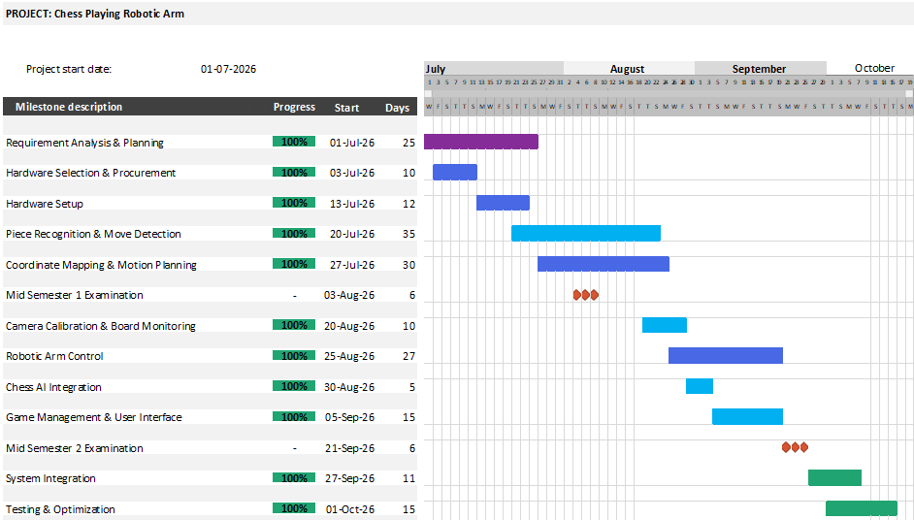
Figure 2.2.1: Visual representation of the project timeline

Detailed Modules Description
The system is divided into the following key modules:
    - Camera-Based Board Monitoring Module:
This module captures chessboard images and detects chess pieces using a trained YOLO model. OpenCV is used for image processing and board rectification, allowing detected pieces to be mapped to their respective squares. The resulting board representation is passed to the Move Detection Module.
Input: Chessboard images from the camera.
Output: Detected pieces and their board positions.
Technologies Used: Python, OpenCV, YOLO (Ultralytics)

    - Move Detection Module:
This module compares the current board position with the previous state to identify the player's move. It uses FEN notation to represent the chessboard and validates the detected move using chess rules. After validation, it updates the board state for further processing.
Input: Detected piece positions and previous board state.
Output: Identified move and updated FEN.
Technologies Used: Stockfish, Python, python-chess
    - Chess AI Engine Module:
This module generates the computer's response using Stockfish. It receives the updated chess position, evaluates possible moves, and selects a legal move according to the engine's analysis. The selected move is passed to the Coordinate Mapping Module for physical execution.
Input: Current chess position and game state.
Output: AI-generated chess move.
Technologies Used: Stockfish, Python, python-chess
    - Coordinate Mapping Module:
This module converts chessboard squares into physical coordinates for the robotic arm. Using board calibration and predefined coordinate mappings, it determines the source and destination positions for each move. These coordinates are then sent to the Robotic Arm Control Module.
Input: AI-generated move and board calibration data.
Output: Robotic arm movement coordinates.
Technologies Used: Python, coordinate mapping algorithms, calibration data
    - Robotic Arm Control Module:
This module executes chess moves physically using a 6-DOF robotic arm. The Raspberry Pi sends movement commands to the Arduino through serial UART communication, and the Arduino controls the servos to pick up and place chess pieces at the required positions.
Input: Movement coordinates and control commands.
Output: Physical chess-piece movement and execution status, where available.
Technologies Used: Arduino UNO, C/C++, servo motors, PCA9685, serial UART
    - Game Management Module:
This module coordinates the overall gameplay and maintains the current board state, move history, and game progress. It connects the different modules, handles game status and errors, and provides relevant information to the Flutter application for user interaction and monitoring.
Input: Board states, player moves, AI moves, and execution status.
Output: Updated game state, move history, and status information.
Technologies Used: Python, python-chess, Flutter, Dart, PostgreSQL or file storage if implemented.

Project SRS

Data Flow Diagrams
DFD provides the functional overview of a system. The graphical representation easily overcomes any gap between ’user and system analyst’ and ‘analyst and system designer’ in understanding a system. Starting from an overview of the system it explores detailed design of a system through a hierarchy. DFD shows the external entities from which data flows into the process and also the other flows of data within a system. It also includes the transformations of data flow by the process and the data stores to read or write a data.
Symbols used in Data Flow diagram:
Process | 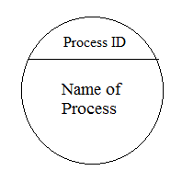 | or | 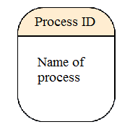
Data store | 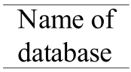 | or | 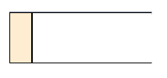
Data flow | 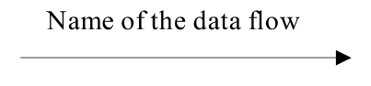
External entity | 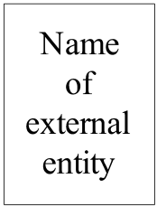

Data Flow Diagram of the System:

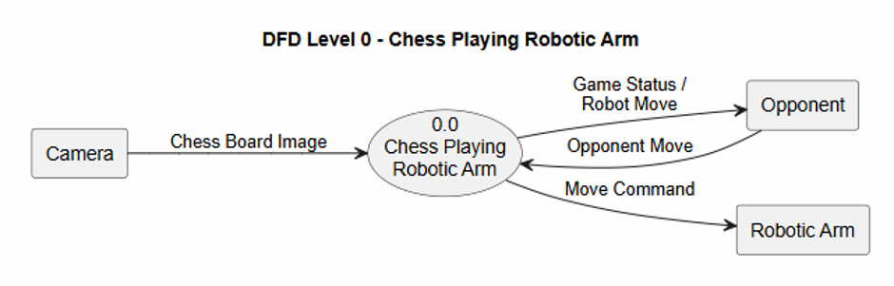
Context level DFD (level 0):
Figure 2.5.2.1: Level 0 DFD

Level 1 DFD:
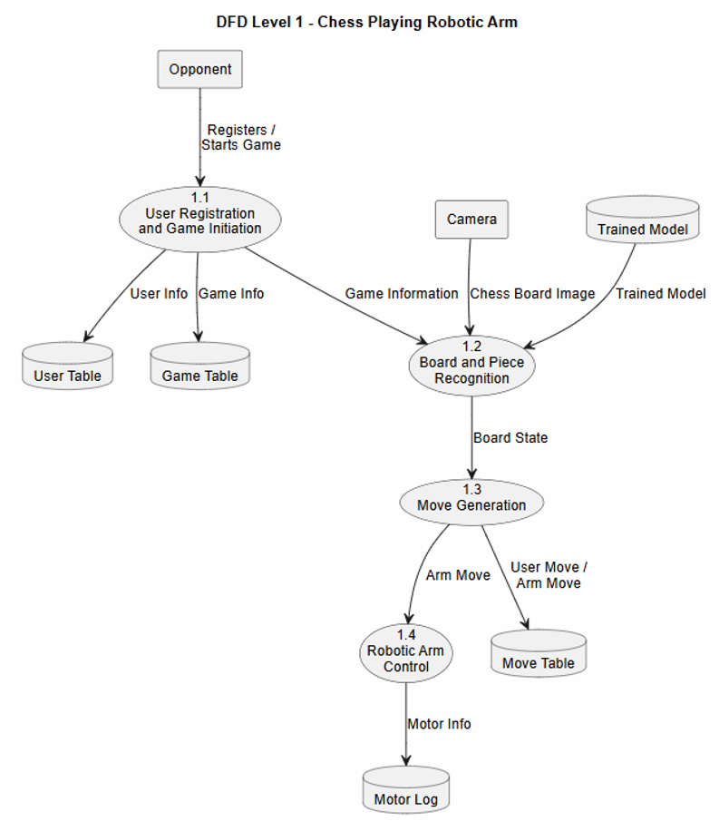

Figure 2.5.2.2: Level 1 DFD

Sequence diagram
Sequence diagram represents the behavioural aspects of a system. Sequence diagram shows the interactions between the objects by means of passing messages from one object to another with respect to time in a system. Sequence diagram contains the objects of a system and their life-line bar and the messages passing between them. Objects appear at the top portion of sequence diagram. Object is shown in a rectangle box. Name of object precedes a colon ‘:’ and the class name, from which the object is instantiated. The whole string is underlined and appears in a rectangle box. A down-ward vertical line from object-box is shown as the life-line of the object. A rectangle bar on life-line indicates that it is active at that point of time. Messages are shown as an arrow from the life-line of sender object to the life-line of receiver object and labelled with the message name.
Symbols used in Sequence diagram:
Object | 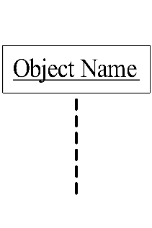
Life line bar | 
Call message | 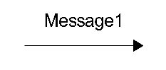
Return message | 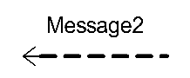

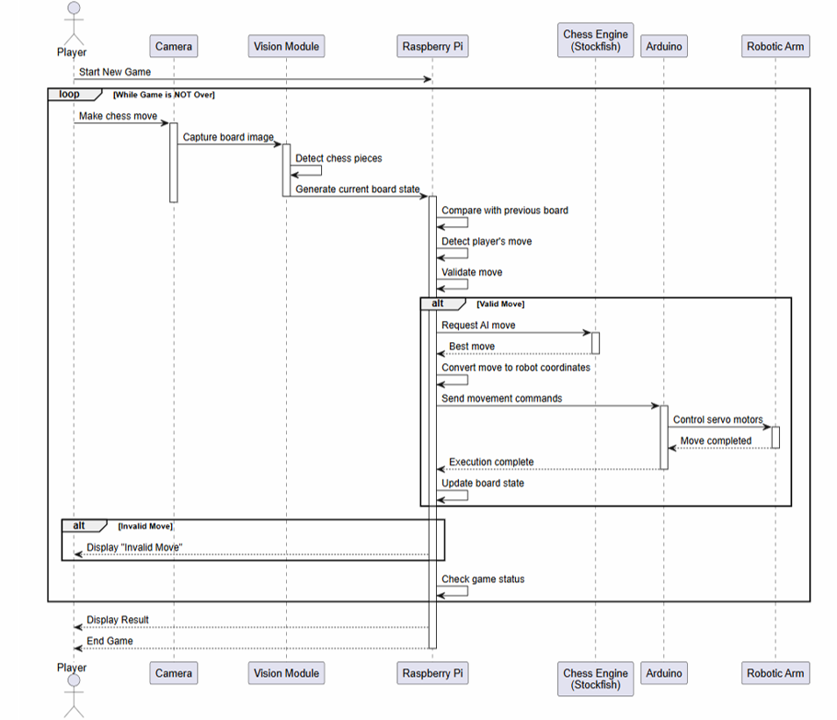
Sequence Diagram of the System:
Figure 2.5.5: Sequence Diagram

Activity diagram
An activity denotes a particular action taken in the logical flow of control. This could simply be invocation of a mathematical function, alter an object's properties and so on. An activity is represented with a rounded rectangle, as shown in figure. A label inside the rectangle identifies the corresponding activity. There are two special types of activity nodes: initial and final. They are represented with a filled circle, and a filled in circle with a border respectively. Initial node represents the starting point of a flow in an activity diagram. There could be multiple initial nodes, which mean that invoking that particular activity diagram would initiate multiple flows. A final node represents the end point of all activities. Like an initial node, there could be multiple final nodes. Any transition reaching a final node would stop all activities. A flow is represented with a directed arrow. A decision node, represented with a diamond, is a point where a single flow enters and two or more flows leave. This is represented with a diamond shape, with two or more flows entering, and a single flow leaving out. Fork is a point where parallel activities begin. A join is depicted with a black bar, with multiple input flows, but a single output flow. Physically it represents the synchronization of all concurrent activities.
Symbols used in Activity diagram:
Activity | 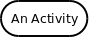 | Note | 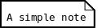
Flow | 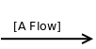
Decision | 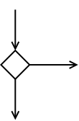 | Fork | 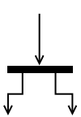
Merge | 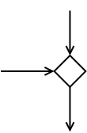 | Join | 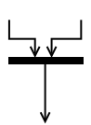

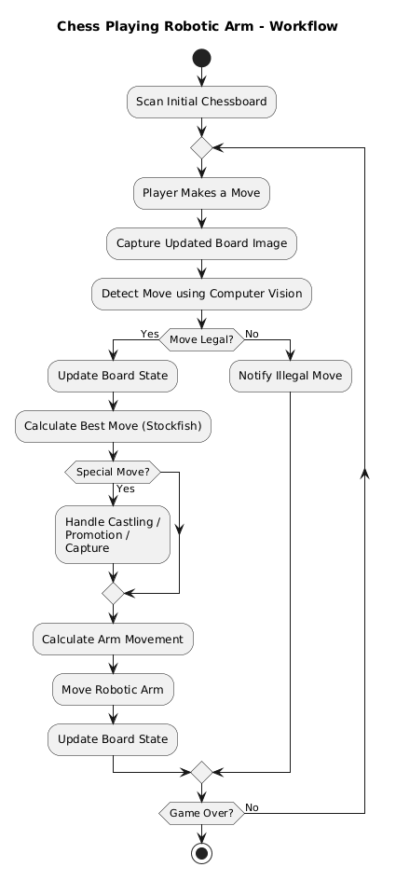
Activity Diagram of the System:

Figure 2.5.5: Activity Diagram

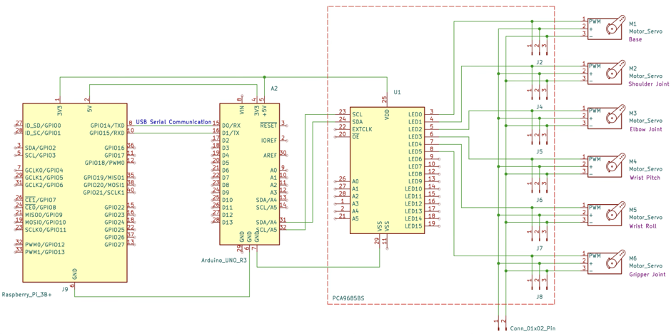
Hardware Circuit diagram

Figure 2.5.5: Hardware Circuit Diagram

Database design

Collection Name: user_table
Sr. No. | Name | Datatype | Constraint | Description
1 | user_id | INT | Primary key auto_increment | Unique user ID
2 | password | PASSWORD(10) | Not null | Encrypted Password
3 | email | VARCHAR(10) | Not null | User email id
4 | username | VARCHAR(10) | Not null | User name as player
Table 2.6.1: users_table

Collection name: game_table
Sr. No. | Name | Datatype | Constraint | Description
1 | game_id | INT | Primary key auto_increment | Unique game ID
2 | user_id | INT | Foreign key | Reference to user table
3 | start_time | DATETIME | Not Null | Game start time
4 | end_time | DATETIME | Not Null | Game end time
5 | difficulty | VARCHAR | Not null | Easy/Medium/Hard
6 | result | VARCHAR(20) | Not null | Win/Loss/Draw
Table 2.6.2: game_table

Collection name: move_table
Sr. No. | Name | Datatype | Constraint | Description
1 | move_id | INT | Primary key auto_increment | Unique move ID
2 | game_id | INT | Foreign key | Reference to game table
3 | move_number | INT | Not Null | Move sequence number
4 | move | VARCHAR(20) | Not Null | Move displayed in standard chess notation
5 | player | VARCHAR(20) | Not Null | Human or Robot
Table 2.6.3: move_table

Table Name: motor_log
Sr. No. | Name | Datatype | Constraint | Description
1 | log_id | INT | Primary key auto_increment | Unique log ID
2 | motor_id | INT | Not null | Servo motor ID
3 | angle | FLOAT | Not null | Motor Angle
4 | timestamp | DATETIME | Not Null | Execution Time
5 | status | VARCHAR(20) | Not null | Success/Failure
Table 2.6.1: users_table

Implementation and Testing

User Interface and Snapshot
    - Python:
Description: Core programming language used for implementing system logic and algorithms
    - InsightFace:
Description: Used for backend facial recognition processes such as face detection, facial embedding generation, and accurate face matching
    - Google ML Kit:
Description: Used on the client-side mobile application for real-time face detection and image processing through smartphone cameras
    - FastAPI:
Description: High-performance backend framework used to build APIs for communication between the mobile application, facial recognition system, and database
    - Flutter:
Description: Used for developing the mobile application interface for students and faculty members
    - Visual Studio Code:
Description: IDE use for coding and development
    - Github:
Description: Version Control system used for managing project code
    - PostgreSQL:
Description: Database management system used to store user information, facial data, attendance records, timetable details, and other system-related data
    - OS:
Description: Windows / Linux operating systems used for development and deployment of the system

User Interface and Snapshot
This section presents the graphical user interfaces developed for the Face Recognition Based Attendance System. Each interface is designed to ensure smooth user interaction, simplify attendance management, and improve system usability. Screenshots of each module should be included to demonstrate implementation.

Registration and Authentication:
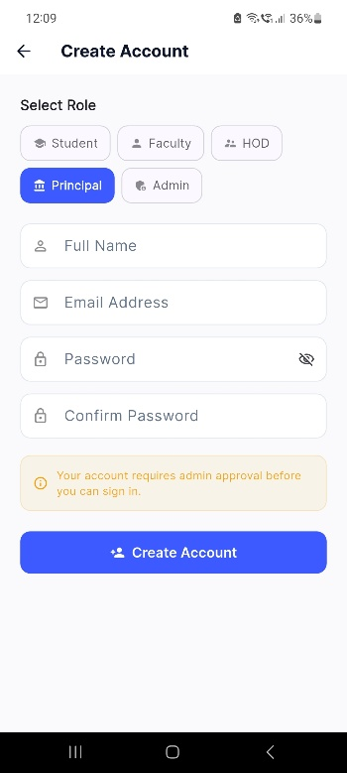
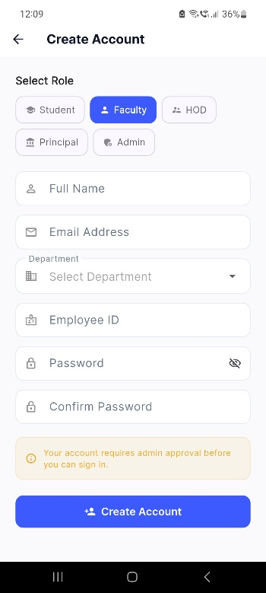
Figure 3.2.1.2
admin_principle_registration
The principal can select his role, enter the requested details and click create account. The account will be created once admin approves the registration request
Figure 3.2.1.1
faculty_hod_registration
The users can register themselves by entering the required details.
The user registration request (faculty and hod) will be approved by admin and then user account is created successfully

Purpose:
This module provides secure authentication for administrators and faculty members before accessing the system. It ensures that only authorized users can perform operations such as registering students, managing attendance sessions, and viewing reports.
Key Features:
- Secure login using email/username and password, Validation for incorrect credentials
- Session-based authentication
- Error handling for invalid login attempts
- Restricted access for unauthorized users
- Redirects authenticated users to dashboard.

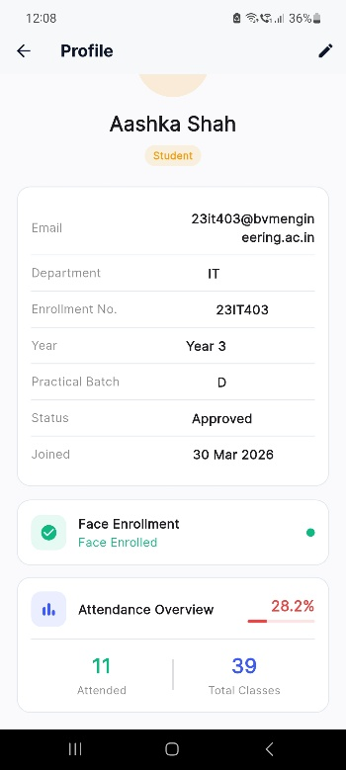
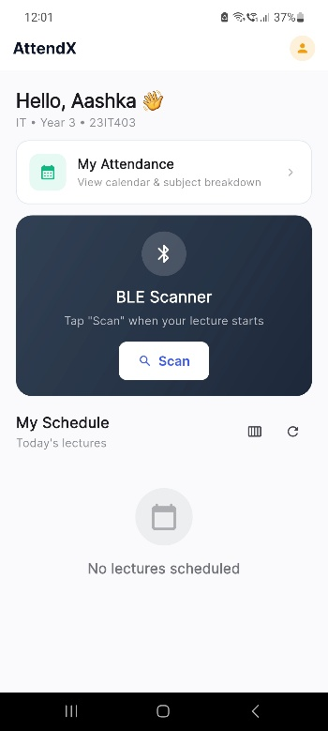
Dashboard:
Figure 3.2.2.2
student_profile
This is student profile. Students can view and edit their profiles from here. They can also view their attendance overview from here
Figure 3.2.2.1
student_dashboard
This is student dashboard. The student can mark attendance by scanning BLE signal from here. They can also view their attendance and schedule from here
Purpose:
The dashboard serves as the central control panel for administrators and faculty members. It provides quick access to all major modules and displays important system statistics.
Key Features:
- Displays total registered students
- Displays total faculty members
- Shows attendance summary
- Quick access to face enrollment module
- Quick access to attendance reports
- Navigation panel for system modules
- Displays current active attendance sessions.

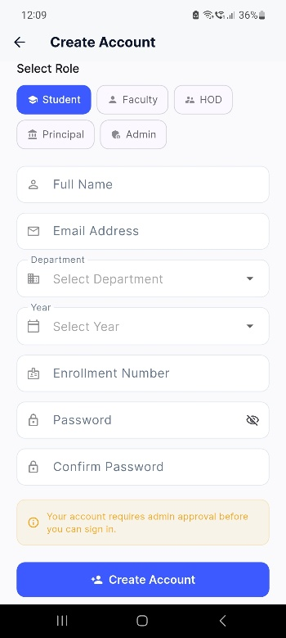
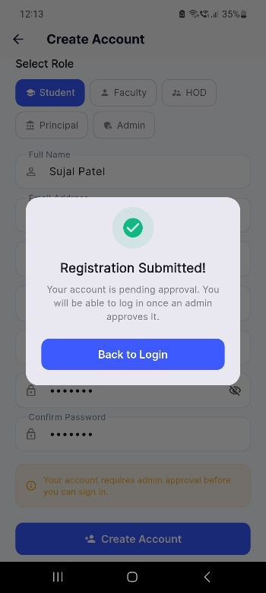
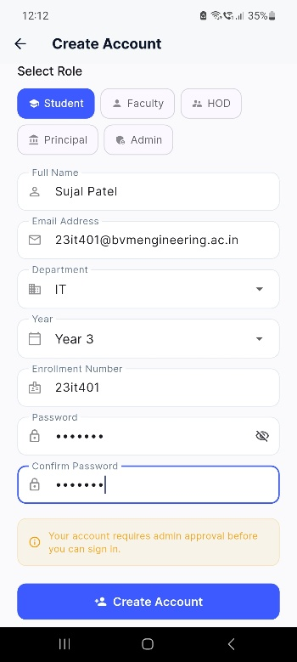
Student Registration:
Figure 3.2.3.1
student_registration_1
The student can create account by entering required details.
Figure 3.2.3.3
student_registration_3
The registration will be successful once the admin approves the account creation request
Figure 3.2.3.2
student_registration_2
On entering details and clicking create account, the request will be sent to admin.
Purpose:
This module allows administrators to register new students into the system by collecting their academic and personal details before face enrollment.
Key Features:
- Add student name
- Enrollment number entry
- Department selection
- Division allocation
- Academic year selection
- Batch allocation
- Email registration
- Validation for duplicate entries
- Stores student information in database

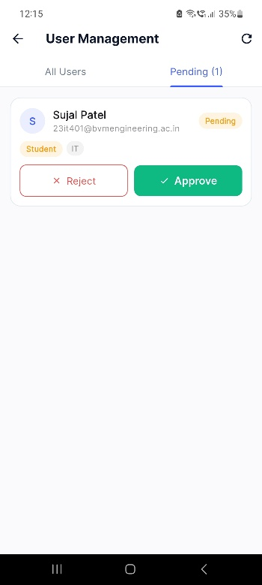
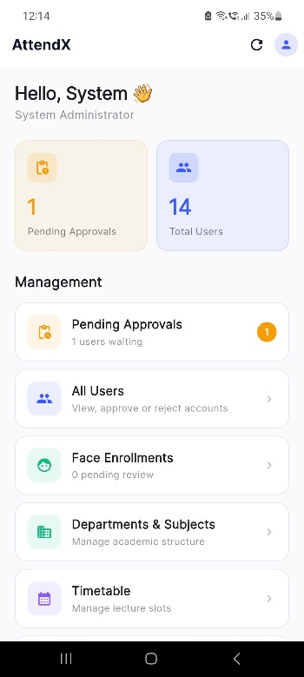
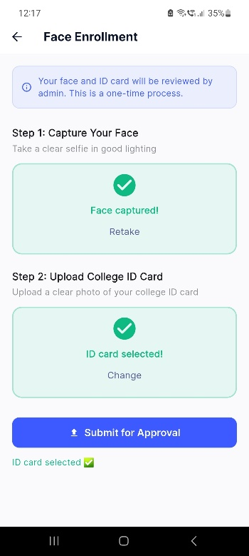
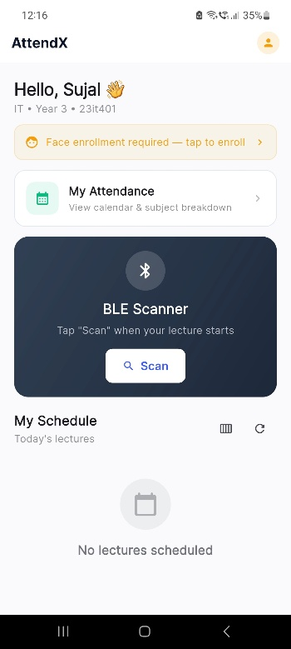
Face Enrollment:
Figure 3.2.4.4
admin_face_approval
Figure 3.2.4.3
admin_face_request
Figure 3.2.4.2
face_registration_2
Figure 3.2.4.1
face_registration_1
After student submits approval request, the admin can view all pending approvals in admin dashboard
The student needs to enrol their face, this can be done by clicking face enrolment required
The student needs to enter required photographs and submit them for admin approval
The admin approves or rejects the students’ face enrolment
Purpose:
This module captures and stores student facial data required for future recognition during attendance marking.
Key Features:
- Webcam integration
- Live video feed
- Capture multiple face samples
- Face embedding generation
- ID card verification upload
- Approval/rejection workflow
- Stores face data securely

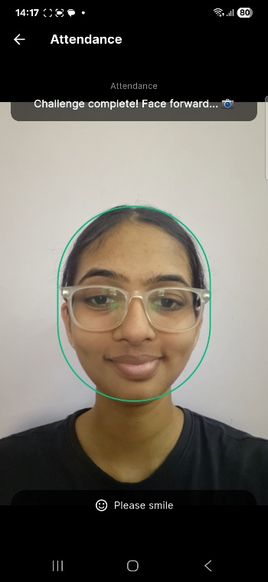
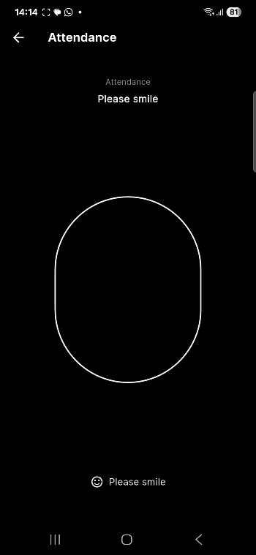
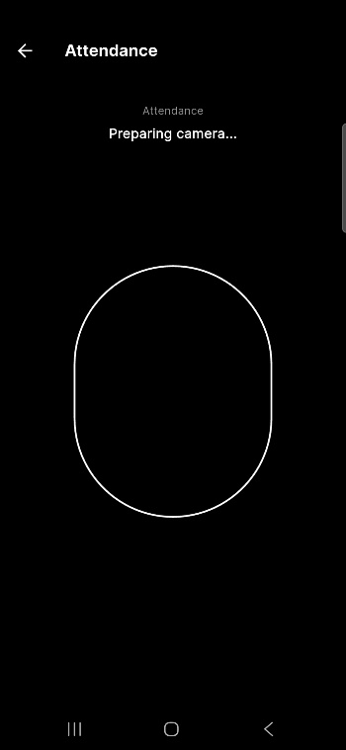
Face Recognition Attendance:
The student needs to perform the task given on the screen to mark their attendance
The attendance is marked if the task mentioned is completed, the student is marked absent otherwise
The camera will be opened for capturing the face
Figure 3.2.5.3
Face_capture_3
Figure 3.2.5.2
face_capture_2
Figure 3.2.5.1
face_capture_1
Purpose:
This module allows faculty members to initiate a live attendance session for a scheduled lecture.
Key Features:
- Start attendance session
- Generate session token
- Verify lecture schedule
- Activate attendance period
- End attendance session
- Session tracking

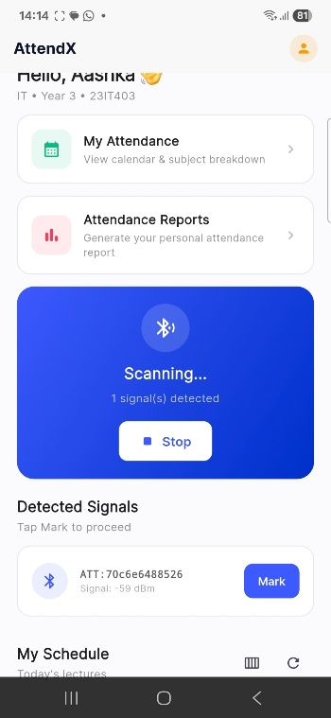
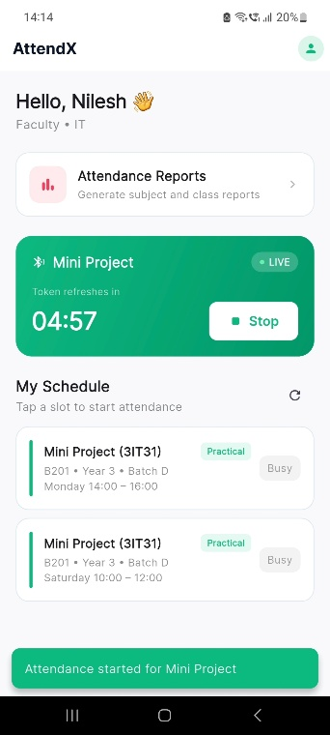
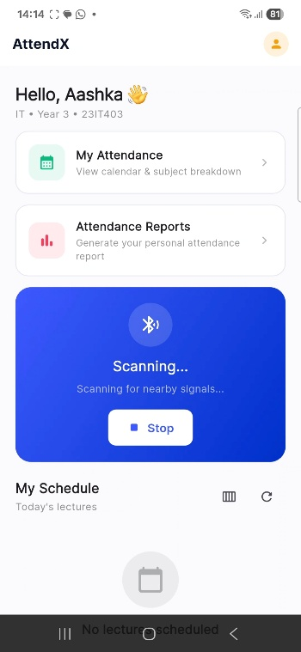
Attendance session:
The faculty starts the session by sending the signal. The default window is of 5 minutes, the faculty can stop the signal earlier as well
If student is present in class, means is in range of faculty’s BLE signal, the signal will be detected and student then can mark attendance
The student needs to scan nearby BLE signals to detect them
Figure 3.2.6.3
faculty_attendance_marking
Figure 3.2.6.2
attendance_marking_2
Figure 3.2.6.1
attendance_marking_1
Purpose:
This module performs real-time face detection and recognition to automatically mark attendance.
Key Features:
- Real-time webcam feed
- Face detection bounding box
- Student identity verification
- Face comparison with stored embeddings
- Automatic attendance marking
- Duplicate attendance prevention
- Unknown face rejection

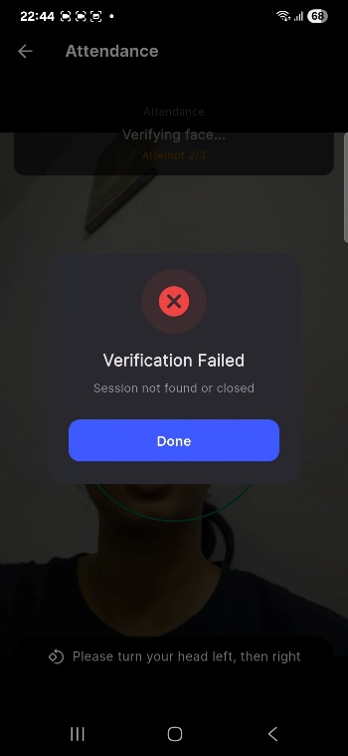
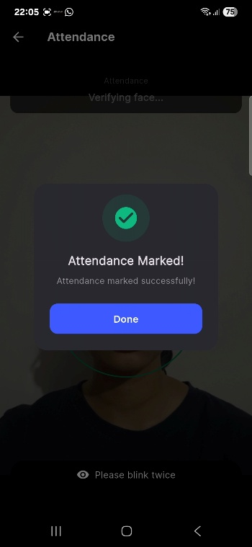
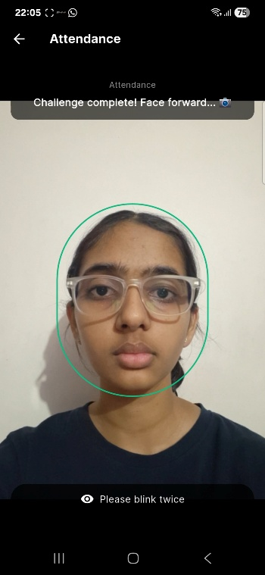
Anti-Spoofing/Liveness Detection:
Attendance marked when student completes the given task
The student was asked to blink twice
Verification fails is user fails to perform the given task
Figure 3.2.7.3
liveness_3
Figure 3.2.7.2
liveness_2
Figure 3.2.7.1
liveness_1

Purpose:
This module prevents fake attendance attempts using photographs, videos, or spoof attacks.
Key Features:
- Blink detection
- Head movement verification
- Random challenge generation
- Real-person validation
- Fake image rejection

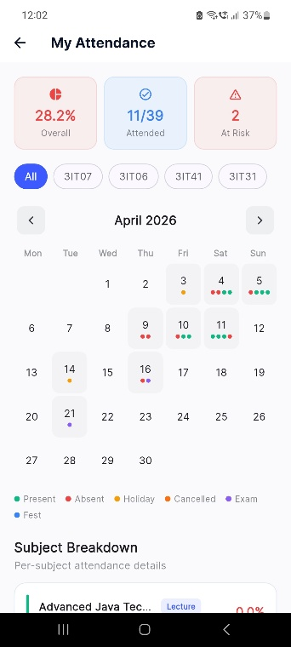
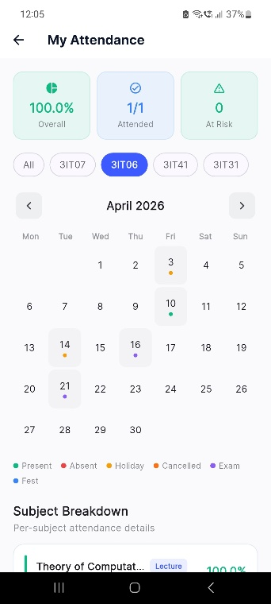
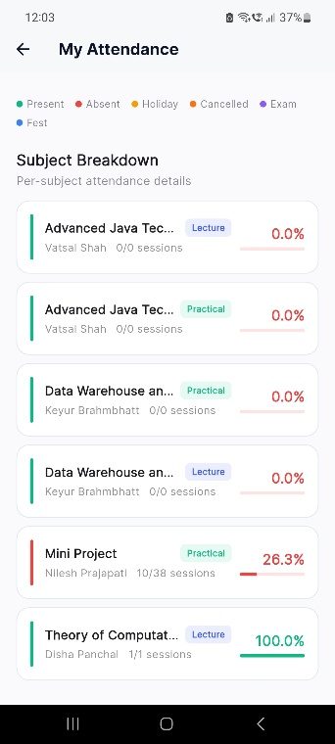
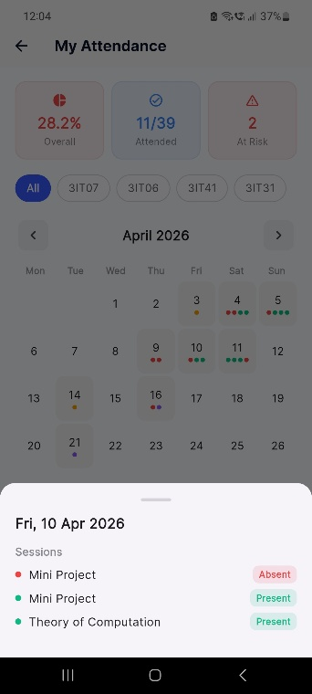
Attendance Records:
View of daily attendance of all subjects
View of daily attendance of specific subject
Attendance percentage of all subjects shown
List view that shows present and absent slots of particular day
Figure 3.2.8.1
attendance_record_1
Figure 3.2.8.2
attendance_record_2
Figure 3.2.8.3
attendance_record_3
Figure 3.2.8.4
attendance_record_4
Purpose:
This module stores and displays attendance history of students.
Key Features:
- Daily attendance records
- Subject-wise records
- Date filters
- Student-wise attendance history
- Attendance percentage tracking
- Export functionality

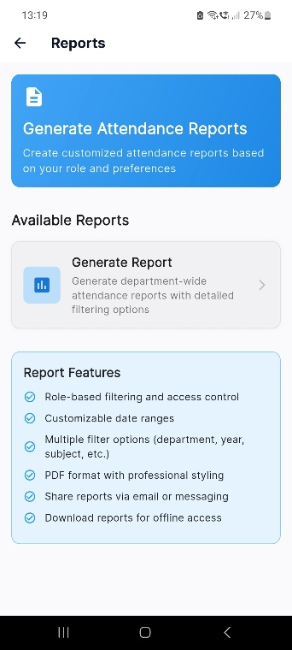
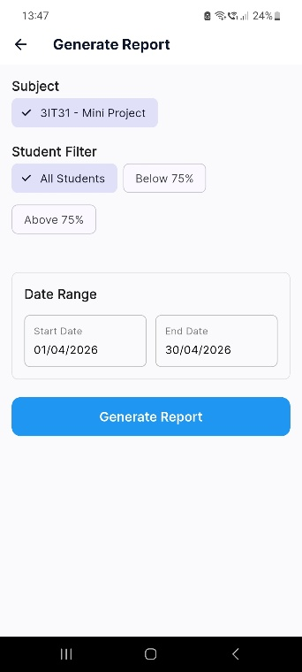
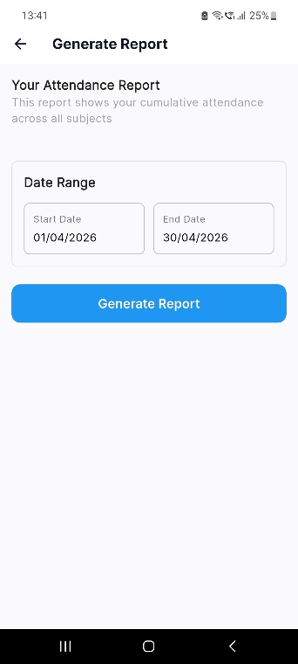
Reports and Analytics:
Figure 3.2.9.1
report_page_1
Report generation module. It lets the user generate attendance reports
Student filter can be used by faculty
The date range is to be selected by student
Figure 3.2.9.3
report_page_faculty
Figure 3.2.9.2
report_page_student

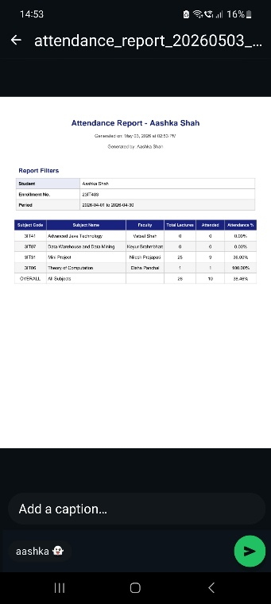
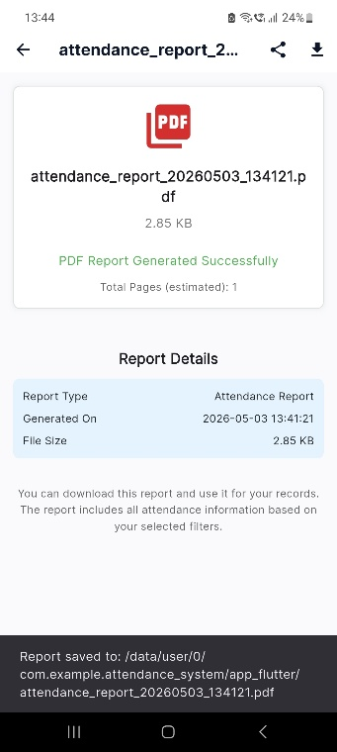
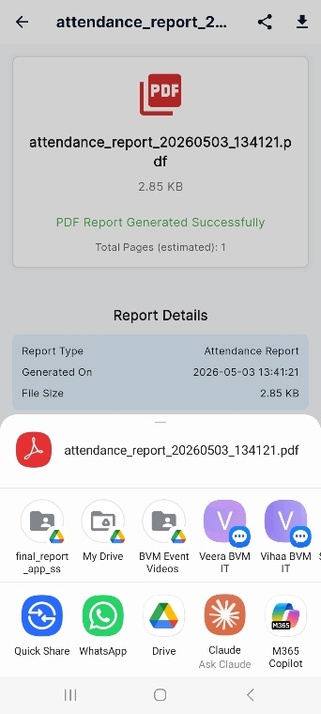
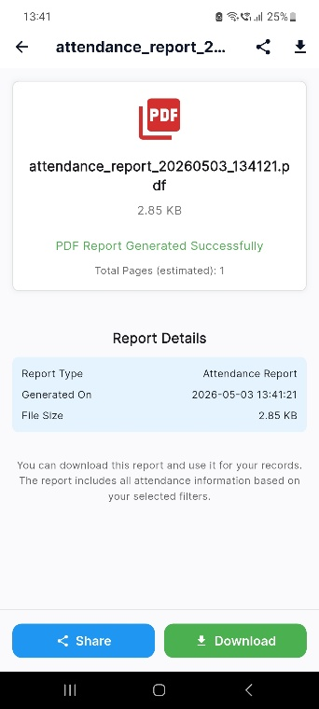
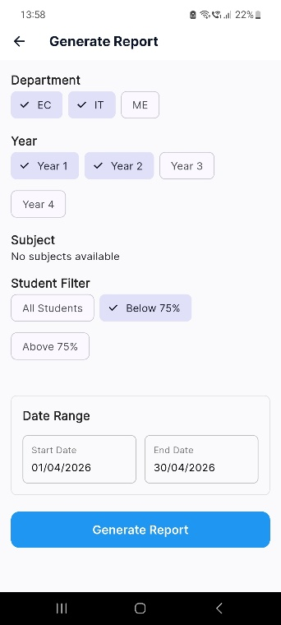
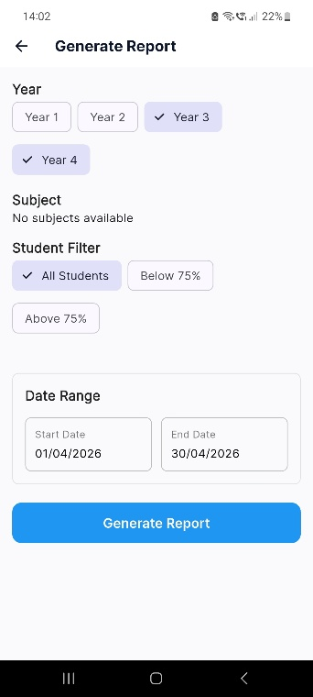
The information in report thus created.
Figure 3.2.9.9
report_page_5
The report saved successfully
Figure 3.2.9.8
report_page_4
The report is in pdf form and can be shared to other apps
Figure 3.2.9.7
report_page_3
Subject constraint and student filter can be applied by hod

Principal and admin can also select the year of students

Report is generated
Figure 3.2.9.5
report_page_ principle_admin
Figure 3.2.9.6
report_page_2
Figure 3.2.9.4
report_page_hod
Purpose:
This module generates attendance reports for monitoring student attendance trends.
Key Features:
- Monthly attendance reports
- Subject-wise reports
- Percentage calculation
- Graphical attendance analysis

Testing using Use Cases

Authentication Module Testing:
Scenario | Test Steps / Data | Expected Result
Login with valid credentials | Correct email/password | Dashboard access granted
Login with invalid credentials | Wrong password | Access denied
Empty login fields | Blank fields | Error message displayed
Unauthorized access attempt | Invalid role | Access restricted

Table 3.1 Testing Report – Authentication

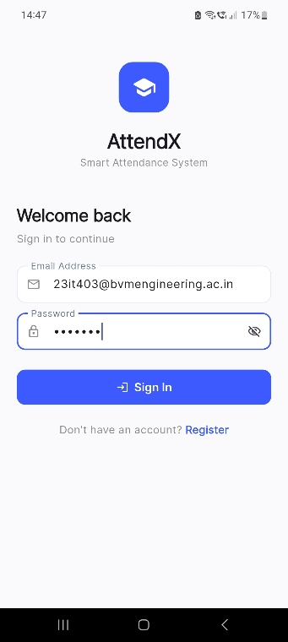
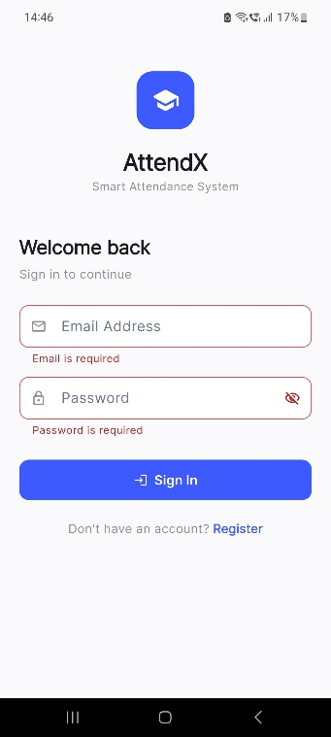
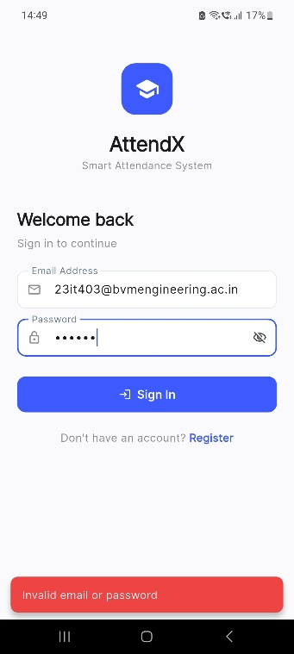
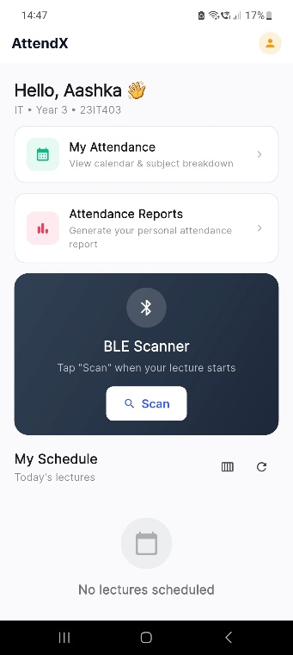
Figure 3.3.1.1
test_auth_1
Access is denied when user tries to login without entering credentials
The user enters invalid credentials and warning is shown
The system thus logs in the user
The user enters valid login credentials
Figure 3.3.1.2
test_auth_2
Figure 3.3.1.3
test_auth_3
Figure 3.3.1.4
test_auth_4

Face Enrollment Module Testing:
Scenario | Test Steps / Data | Expected Result
New face registration | Valid student details | Face enrolled successfully
Duplicate face enrollment | Existing face data | Error displayed
Blurry image capture | Low-quality image | Enrollment rejected
Missing required fields | Incomplete form | Validation error

Table 3.2 Testing Report – Face Enrollment

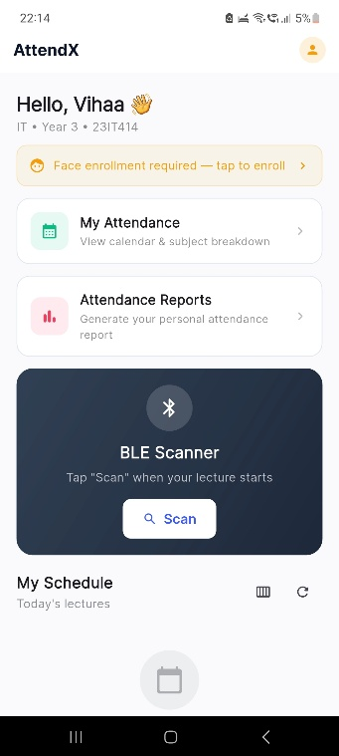
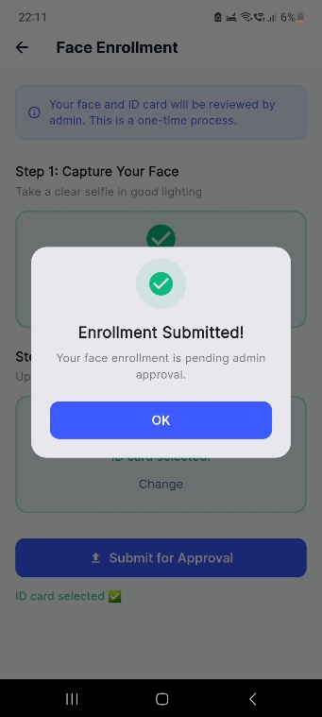
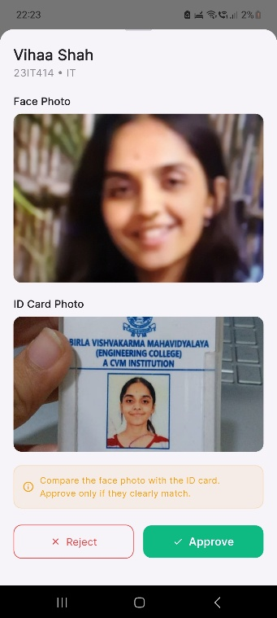
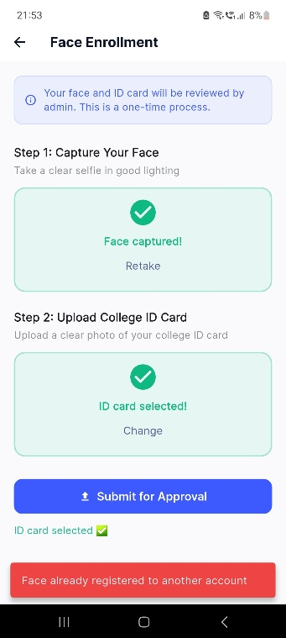
Figure 3.3.2.1
test_face_1
Figure 3.3.2.2
test_face_2
Figure 3.3.2.3
test_face_3
Figure 3.3.2.4
test_face_4
If existing user tries to enrol face again then error will be generated
The admin will approve or reject the request
The student needs to enrol their face
After submitting required photographs, request will be sent for admin approval

BLE/Location Verification Module Testing:
Scenario | Test Steps / Data | Expected Result
Detect valid beacon | Correct UUID | Access granted
Detect invalid beacon | Wrong UUID | Access denied
No beacon detected | No signal | Attendance blocked
Multiple beacon detection | Mixed UUIDs | Correct beacon selected

Table 3.3 Testing Report – BLE verification

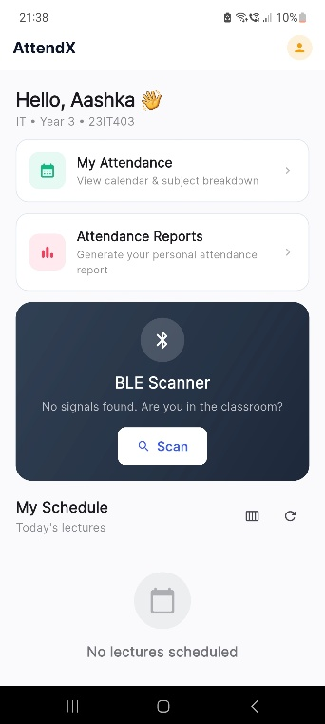
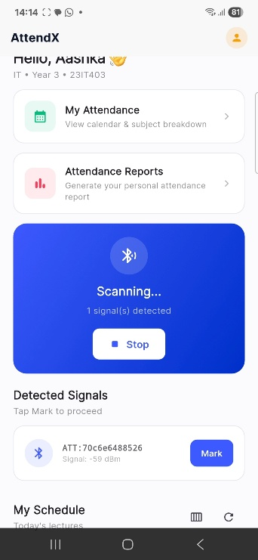
If student is not in classroom, the signal cannot be detected
The BLE signal is detected and student can mark attendance
Figure 3.3.3.2
test_ble_2
Figure 3.3.3.1
test_ble_1

Face Recognition Attendance Testing:
Scenario | Test Steps / Data | Expected Result
Valid attendance | Registered face | Attendance marked
Duplicate attendance | Same user twice | Second attempt rejected
Unknown user | Unregistered face | Access denied
Face mismatch | Wrong face data | Attendance rejected
Blink verification | Blink action | Accepted

Table 3.4 Testing Report – Face recognition

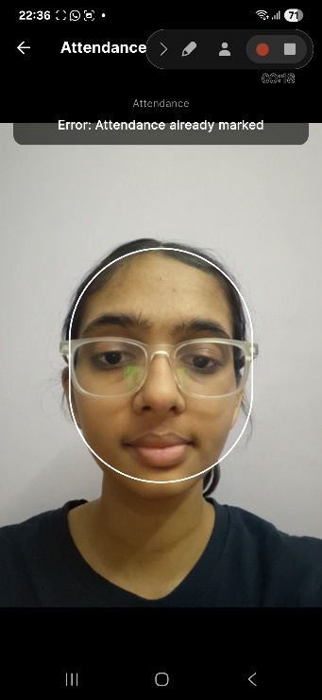
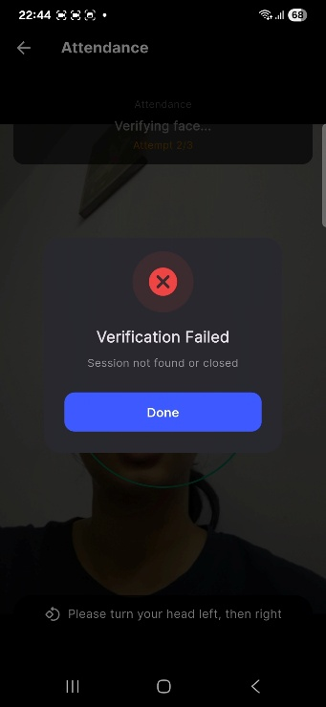
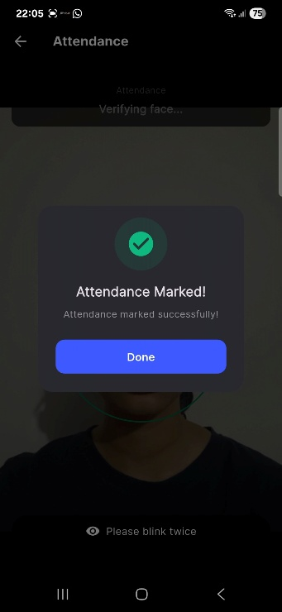
Does not allow marking duplicate attendance
Attendance marked if task completed
Verification fails if test not passed
Figure 3.3.4.3
test_recog_3
Figure 3.3.4.2
test_recog_2
Figure 3.3.4.1
test_recog_1

Liveness Detection Testing:
Scenario | Test Steps / Data | Expected Result
Real person detection | Live face | Accepted
Photo spoofing attack | Static image | Rejected
No movement challenge | Still face | Rejected

Table 3.5 Testing Report – Liveness Detection

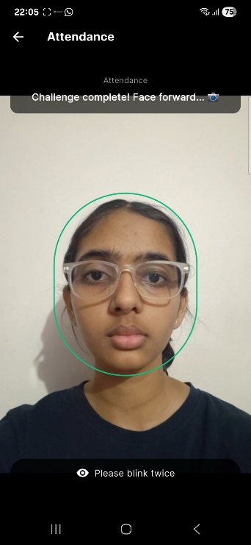
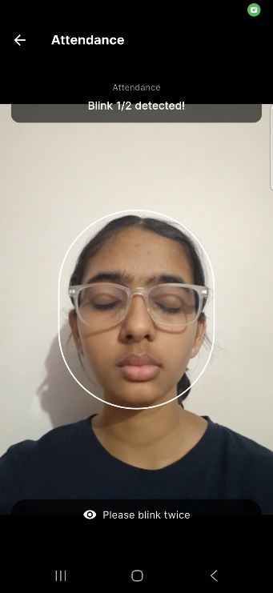
Photo spoofing attack prevented by blinking twice
The attendance is marked only when task is finished
Figure 3.3.5.1
test_live_1
Figure 3.3.5.2
test_live_2

Attendance Records & Reports Testing
Scenario | Test Steps / Data | Expected Result
Generate daily report | Date filter | Report generated
Generate monthly report | Month filter | Report generated
Export attendance | Export request | File downloaded
View student records | Student ID | Correct records displayed

Table 3.6 Testing Report – Records and Reports

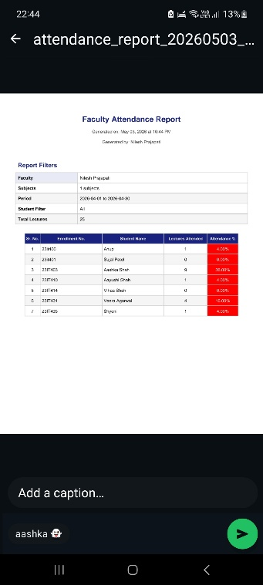
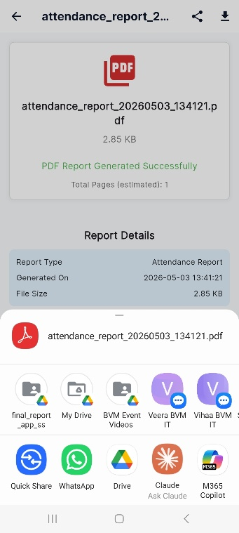
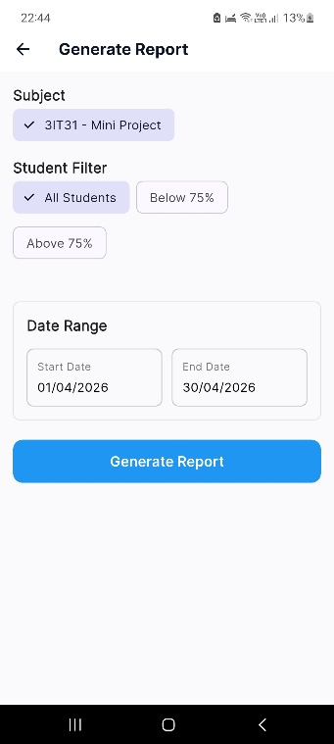
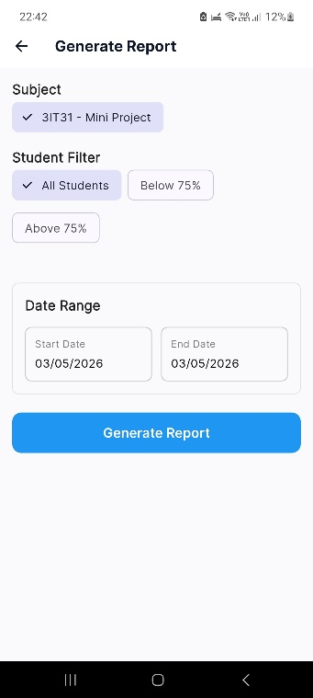
Figure 3.3.6.2
test_rep_2
Figure 3.3.6.1
test_rep_1
Monthly report filter
The report can be shared
The student records can be viewed
Daily report filter
Figure 3.3.6.3
test_rep_3
Figure 3.3.6.4
test_rep_4

Conclusion and Future work

Conclusion
The Face Recognition Based Attendance System was created to address the shortcomings of conventional attendance techniques, including human error, proxy attendance, and manual record keeping. By identifying registered users and properly recording their attendance in real time using facial recognition technology, the system automates attendance marking.
Important modules like user authentication, face registration, face detection, face recognition, attendance management, timetable handling, and report production are all integrated into the project. Together, these modules reduce manual labor while offering a seamless and effective attendance process.
Liveness detection, a crucial component of the system, enhances security and dependability by preventing efforts at fraudulent attendance using images. The database safely stores attendance records, which are readily accessible when needed.
Overall, the project successfully achieves its objective of creating an accurate, secure, and automated attendance solution that can be effectively used in schools, colleges, and organizations.

Future work
Although the current version of the Face Recognition Based Attendance System successfully fulfills its primary objectives, several enhancements can be implemented in future versions to improve functionality, scalability, and user experience.
- Cloud Database Integration: The current system can be upgraded to cloud-based infrastructure for better scalability, remote accessibility, and backup management.
- Advanced AI-Based Recognition: Implementation of deep learning models such as CNNs or advanced facial recognition frameworks can improve recognition accuracy under challenging conditions such as low lighting, masks, or different camera angles.
- Real-Time Notifications: Students can receive automatic notifications regarding attendance status, shortages, or warnings for low attendance percentages.
- Parent Notification System: For educational institutions, parents can receive attendance alerts when students remain absent.
- Multi-Camera Support: Future versions can support multiple cameras for larger classrooms and wider attendance coverage.
- Integration with College ERP Systems: The attendance system can be integrated with existing college ERP portals for seamless academic management.
- Advanced Analytics Dashboard: Machine learning-based analytics can be introduced to track attendance trends, identify irregular attendance patterns, and generate predictive reports.
- Mask Detection Support: Future systems can include recognition models capable of identifying students even while wearing masks.
- Voice-Based Authentication: A multi-factor authentication system combining facial recognition with voice recognition can further improve security.
These future enhancements would transform the current system into a more advanced, intelligent, and enterprise-level attendance management platform capable of handling larger institutions with higher security requirements.

References
Link of the websites:
- Google Search Engine – https://www.google.com
- GitHub – https://github.com
- Stack Overflow – https://stackoverflow.com
- OpenCV Official Documentation – https://opencv.org
- Flask Official Documentation – https://flask.palletsprojects.com
- Python Official Documentation – https://www.python.org
- Face Recognition Library Documentation – https://face-recognition.readthedocs.io
- YouTube – https://www.youtube.com
- ChatGPT (OpenAI) – https://chat.openai.com
- Google Gemini – https://gemini.google.com
- Claude AI – https://claude.ai

Research Papers:
- R. Rajkumar, H. S., P. S., and Y. C., “Smart Attendance System Using Facial Recognition,” International Journal of Advanced Research in Computer and Communication Engineering (IJARCCE), vol. 13, no. 12, Dec. 2024, doi: 10.17148/IJARCCE.2024.131207
- Smitha, P. S. Hegde, and Afshin, “Face Recognition Based Attendance Management System,” International Journal of Engineering Research & Technology (IJERT), vol. 9, no. 5, May 2020
- D. G. H. L., K. Vishal, K. B. R., N. K. Dubey, and P. M. R., “Face Recognition Based Attendance System,” International Journal of Engineering Research & Technology (IJERT), vol. 9, no. 6, Jun. 2020
- V. Suresh, S. C. Dumpa, C. D. Vankayala, H. Aduri, and J. Rapa, “Facial Recognition Attendance System Using Python and OpenCV,” Quest Journals, vol. 5, no. 2, pp. 18–29
- L. Zhang, Q. Duan, H. Ma, and K. Cen, “Design and Implementation of Face Recognition Attendance Management System,” in ITM Web of Conferences, CCCAR 2022, 2022

