
Birla Vishvakarma Mahavidyalaya
Information Technology Department
(An Autonomous CVM Institute)
Vallabh Vidyanagar

Subject: 4IT31 (Project-I), AY: 2026-27
Project Evaluation Report
Group | 09
Project Title | Chess Playing Robotic Arm
Faculty Guide | Dr. Keyur Brahmbhatt
Report | Progress Report - 2
Date of Evaluation

Group Members
Student ID | Name
23IT403 | Aashka Shah
23IT431 | Veera Agrawal

Comment:

Faculty Guide Signature

System Diagram

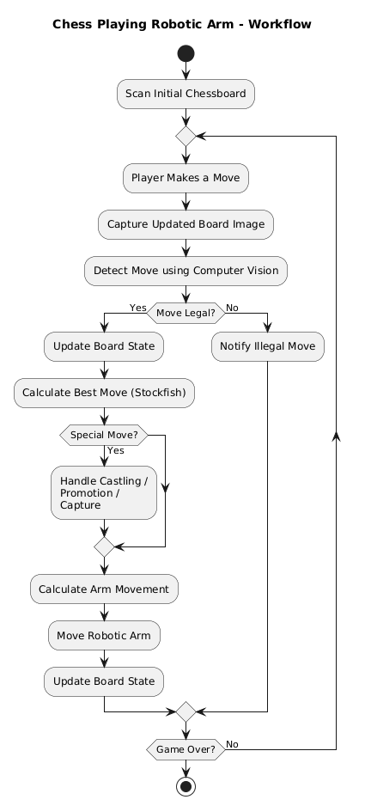
Activity Diagram
Figure 1.1 Activity Diagram

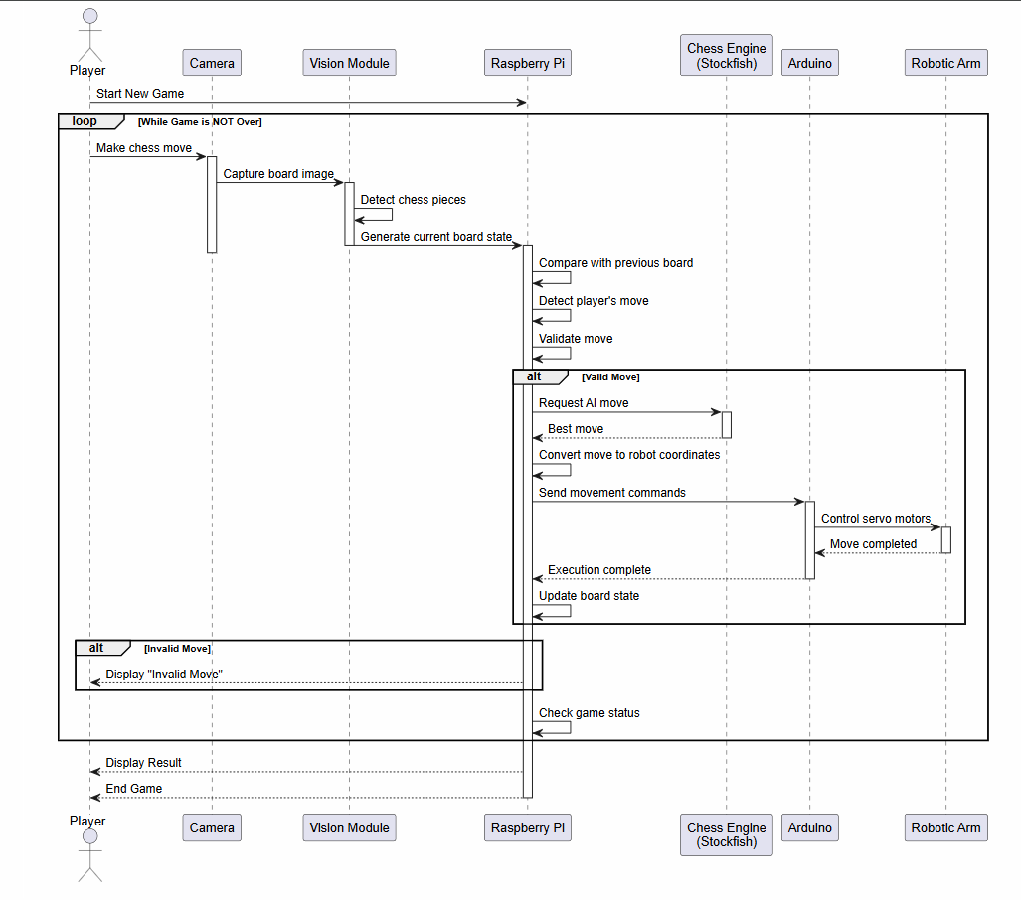
Sequence Diagram
Figure 1.2 Sequence Diagram

Module Specifications

Camera-Based Board Monitoring
This module captures images of the chessboard using a top-mounted camera and processes them to detect the board and the positions of all chess pieces. The processed board state is then provided to the move detection module.

Move Detection Module
This module compares consecutive board states to identify the player's move and validates it according to the rules of chess before forwarding it to the chess AI engine.

Chess AI Engine
This module uses the Stockfish chess engine to analyze the current board position and generate the optimal move based on the selected difficulty level while ensuring all chess rules are followed.

Coordinate Mapping Module
This module, running on the Raspberry Pi, converts the chess engine's move into physical coordinates, computes the required joint angles using inverse kinematics, and sends the corresponding servo angle commands to the Arduino Uno.

Robotic Arm Control Module
This module receives servo angle commands from the Raspberry Pi and controls the robotic arm by generating PWM signals for the servo motors, enabling accurate pick-and-place operations on the chessboard.

Game Management Module
This module manages the overall game flow by maintaining the game state, coordinating communication between all modules, handling player turns, and ensuring smooth execution of the chess game.

Technology Stack Selection

Software
- Programming Language: Python, C
- Game Interface: HTML, CSS, JavaScript
- Operating System: Raspberry Pi OS
- Computer Vision Library: OpenCV
- Chess Engine: Stockfish
- Communication Protocol: Serial UART
- Arduino IDE for motor control programming
- Database: PostgreSQL

Hardware
- Raspberry Pi 3B+
- Arduino UNO R3
- 6-DOF Robotic Arm
- Servo Motors – SG 1501MG
- Servo Driver – PCA9685
- Camera/Camera Module
- Camera Stand
- Miscellaneous: External Power Supply, Jumper Wires, etc.

Literature Review

Research Papers

Development of an Autonomous Chess Robot System Using Computer Vision and Deep Learning (Truong & Bui, 2025, Results in Engineering)
Link: https://www.researchgate.net/publication/388307913_Development_of_an_Autonomous_Chess_Robot_System_Using_Computer_Vision_and_Deep_Learning
Presents a complete low-cost chess robot using a 4-DOF SCARA robotic arm, deep learning for chess piece recognition, computer vision for board state detection, and the Stockfish engine for move generation.

Automated Chess Gameplay With Computer Vision and a Robotic Arm (AlKhatib et al., 2026, Engineering Reports)
Link: https://onlinelibrary.wiley.com/doi/full/10.1002/eng2.70607
Integrates YOLOv8, Stockfish, and a robotic arm into a unified autonomous chess-playing system. Uses FEN representation and robotic motion planning to execute moves.

Robust Computer Vision Chess Analysis and Interaction with a Humanoid Robot (MDPI Computers, 2019)
Link: https://www.mdpi.com/2073-431X/8/1/14
Focuses on robust chessboard and piece recognition using computer vision, while integrating Stockfish and inverse kinematics for robot interaction.

An Open-Source Reproducible Chess Robot for Human–Robot Interaction Research (Zhang et al., 2024)
Link: https://www.frontiersin.org/journals/robotics-and-ai/articles/10.3389/frobt.2025.1436674/full
Introduces an open-source chess robot capable of recognizing chess pieces, physically moving them, and interacting with users through speech and gestures. The work emphasizes modular software and reproducibility.

Autonomous Chess Playing System with Computer Vision and Collaborative Robots (ICARA 2026)
Link: https://www.researchgate.net/publication/404057428_Autonomous_Chess_Playing_System_with_Computer_Vision_and_Collaborative_Robots
Develops a chess-playing robot using computer vision, a collaborative robotic arm, ArUco marker calibration, and the Stockfish engine for autonomous gameplay.

Existing Systems

EDGE-tronics – Chess-Robot
Link: https://github.com/EDGE-tronics/Chess-Robot
A Raspberry Pi-based autonomous chess-playing robot using a 4-DOF robotic arm, OpenCV for board detection, and Stockfish as the chess engine. The system focuses on integrating computer vision with robotic manipulation for physical gameplay.

harirakul – ChessRobotArm
Link: https://github.com/harirakul/ChessRobotArm
Implements a robotic arm capable of executing chess moves. The repository mainly focuses on robotic arm motion, inverse kinematics, and move execution.

harshpatel097 – Chess-Playing-AI-Bot
Link: https://github.com/harshpatel097/Chess-Playing-AI-Bot
Primarily focuses on chess AI and move generation using computer vision and software algorithms, with limited emphasis on robotic manipulation.

METU-KALFA – chess_mate
Link: https://github.com/METU-KALFA/chess_mate
A ROS-based chess robot integrating robot motion planning, perception, and manipulation. It demonstrates coordinated operation between robotic components using ROS.

LuckCow – ChessRobot
Link: https://github.com/LuckCow/ChessRobot
An autonomous chess-playing robot combining robotic arm control, computer vision, and chess engine integration to physically play chess against a human.
Existing System | Limitation of the System | How Our System is Different and Better
EDGE-tronics – Chess-Robot | Uses a 4-DOF robotic arm, limiting flexibility and movement precision. The system focuses mainly on integrating computer vision with robotic manipulation | Uses a 6-DOF robotic arm, providing greater flexibility and more accurate pick-and-place operations. Includes dedicated coordinate mapping, inverse kinematics, and modular game management.
harirakul – ChessRobotArm | Primarily focuses on robotic arm motion and inverse kinematics without integrating computer vision. | Integrates computer vision, move detection, chess AI, coordinate mapping, and robotic arm control into a complete autonomous chess-playing system.
harshpatel097 – Chess-Playing-AI-Bot | Concentrates on chess AI and move generation with limited support for physical robotic manipulation. | Combines AI-based move generation with a physical robotic arm, enabling autonomous execution of moves on a real chessboard.
METU-KALFA – chess_mate | Relies on the ROS framework, making the system more complex to configure and deploy for beginners. | Uses a simpler Raspberry Pi–Arduino architecture without requiring ROS, making it easier to implement while still supporting computer vision, AI, and robotic arm control.
LuckCow – ChessRobot | Provides automation but has a less modular architecture and limited implementation | Follows a modular design, making it easier to develop, maintain, and extend.
Table 4.1 Comparison Study with Existing Systems

Hardware Requirements
Component | Quantity | Purpose
Raspberry Pi 3B+ | 1 | Runs YOLO model, Stockfish engine, and overall system control
Arduino Uno R3 | 1 | Controls servo motors of the robotic arm
6-DOF Robotic Arm | 1 | Physically moves chess pieces
Servo Driver PCA9685 | 1 | Controls multiple servo motors efficiently
Servo Motors SR 1501MG | 6 | Actuate each robotic arm joint
Camera | 1 | Captures the chessboard image
Camera Stand | 1 | Mount camera on top of the board
Power Supply | 1 | Supplies power to Raspberry Pi and robotic arm
Jumper Wires | As required | Electrical connections
Chessboard and Chess Pieces | 1 Set | Playing environment
Table 5.1 Parts required

Hardware Procurement

Selection Criteria
Raspberry Pi 3B+
- Quad-core processor suitable for running Python applications.
- Supports OpenCV and YOLO inference.
- Can communicate with Arduino via USB Serial.
- Low power consumption.
Arduino Uno R3
- Generates accurate PWM signals.
- Easy integration with servo motors.
- Widely supported libraries.
6-DOF Robotic Arm
- Sufficient reach to access every square on the chessboard.
- Six degrees of freedom allow flexible positioning.
- Ensuring servo motors provide enough torque.

Procurement Sources
- Raspberry Pi 3B+
https://quartzcomponents.com/products/raspberry-pi-3-model-b
- Arduino Uno R3
https://robu.in/product/arduino-uno-r3
- 6-DoF Robotic Arm with SR 1501MG Servo Motors
https://robu.in/product/6dof-robotic-arm-multi-degree-of-freedom-robot-servo-grab-maker-education-kit-unassembled
- Servo Driver PCA9685
https://robu.in/product/servo-driver-module-shield-16-channel/

Hardware BoM
Component | Quantity | Price | Total Amount | Comments
Raspberry Pi 3B+ | 1 | 4637 | 4637
Arduino Uno R3 | 1 | 420 | 420
6-DOF Robotic Arm | 1 | 8899 | 8899
Servo Driver PCA9685 | 1 | 547 | 547
Servo Motors SR 1501MG | 6 | - | - | incl. with 6-DoF Robotic Arm
Camera | 1 | - | - | Using phone camera
Camera Stand | 1 | 542 | 542
Misc. | - | 500 | 500 | Wires, Connectors, Power Supply
Chessboard and Chess Pieces | 1 Set | - | - | Available
Total |  |  | 15545
Table 7.1 Hardware BoM

Hardware Specifications

Raspberry Pi 3B+
- Processor: Broadcom BCM2837B0 Quad-Core Cortex-A53 @ 1.4 GHz
- RAM: 1 GB LPDDR2
- Connectivity: Wi-Fi, Bluetooth 4.2, Ethernet
- GPIO Pins: 40
- Operating System: Raspberry Pi OS
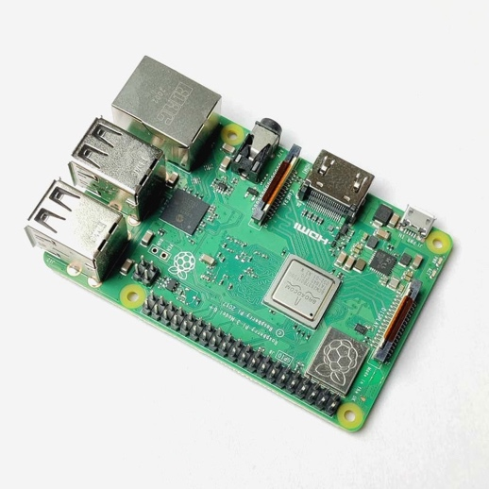
- Role: Image processing, AI execution, Motion planning
Figure 8.1 Raspberry Pi 3B+

Arduino Uno R3
- Microcontroller: ATmega328P
- Operating Voltage: 5 V
- Clock Speed: 16 MHz
- Digital I/O Pins: 14
- PWM Pins: 6
- Communication: USB, UART, I²C, SPI
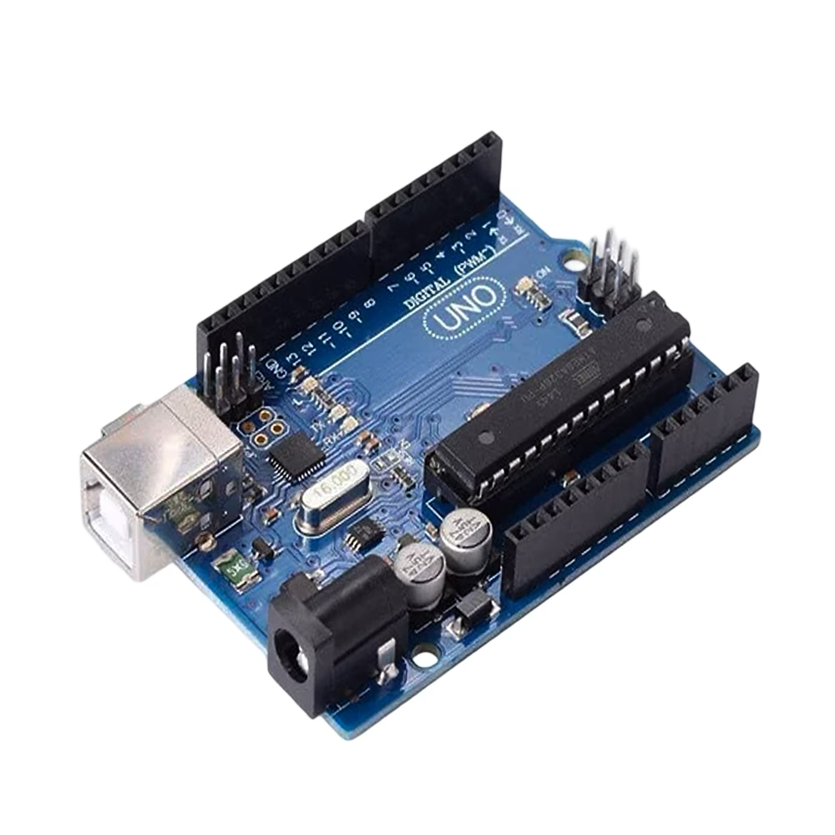
- Role: Receives servo angle commands from Raspberry Pi and controls servo motors via the PCA9685 servo driver
Figure 8.2 Arduino Uno R3

6-DOF Robotic Arm
- Degrees of Freedom: 6
- Material: Aluminium Alloy
- End Effector: Servo-operated gripper
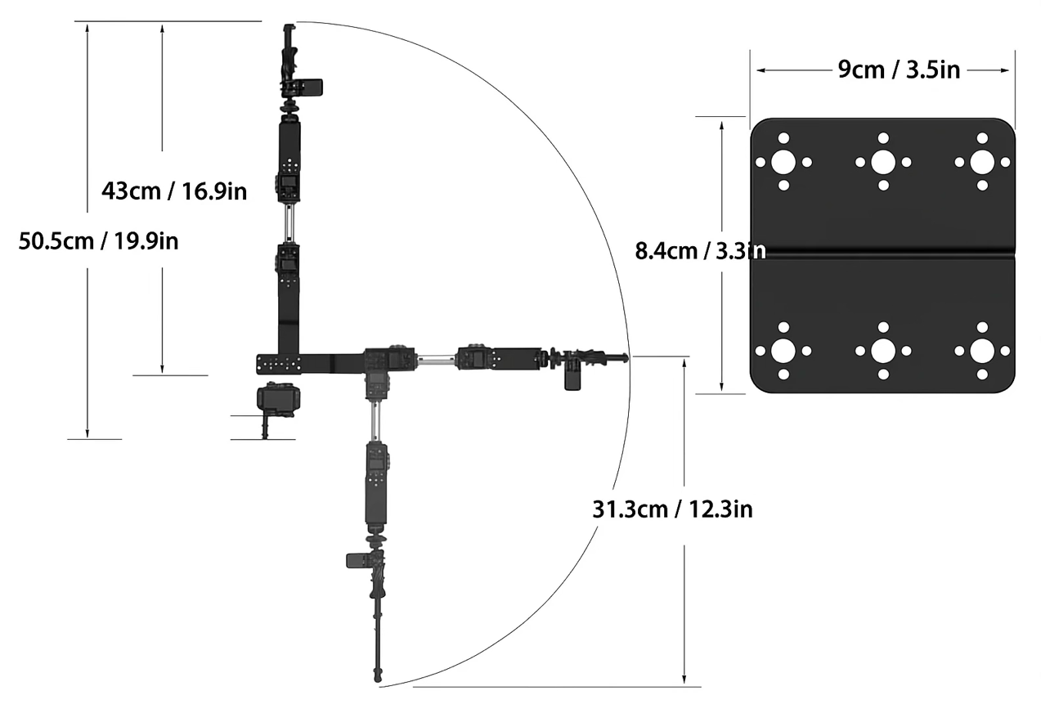
- Reach: 300 mm (approx.)
Figure 8.3 Arm reach
- Payload Capacity: 200–300 g (approx.)
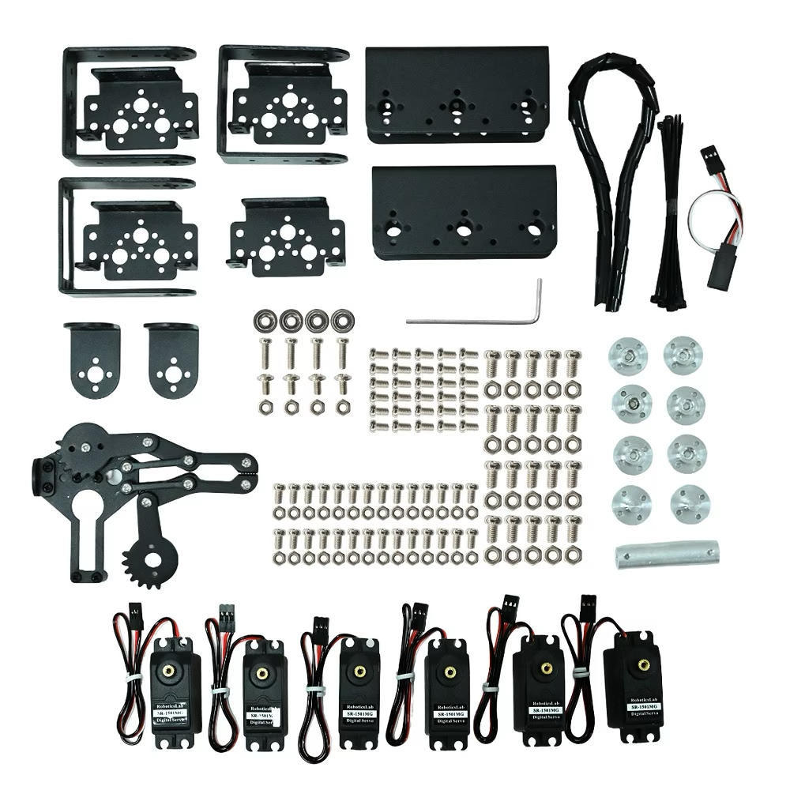
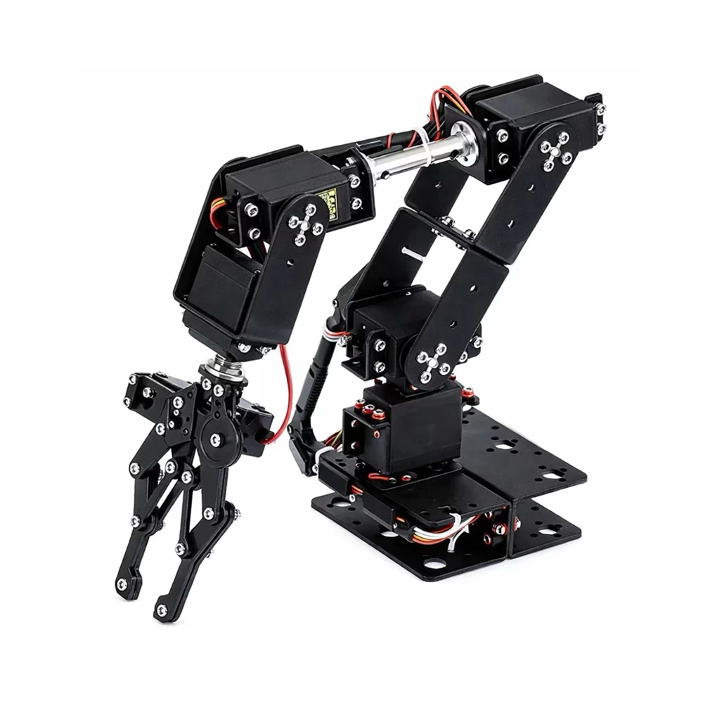
- Role: Performs pick-and-place operations of chess pieces on the chessboard
Figure 8.5 Unassembled Parts
Figure 8.4 Assembled 6 DoF Robotic Arm

Servo Driver PCA9685
- PWM Channels: 16
- PWM Resolution: 12-bit (4096 levels)
- Communication Protocol: I2C
- Logic Voltage: 3.3–5 V
- Servo Supply Voltage: Up to 6 V (external)
- Frequency Range: Up to 1.6 kHz
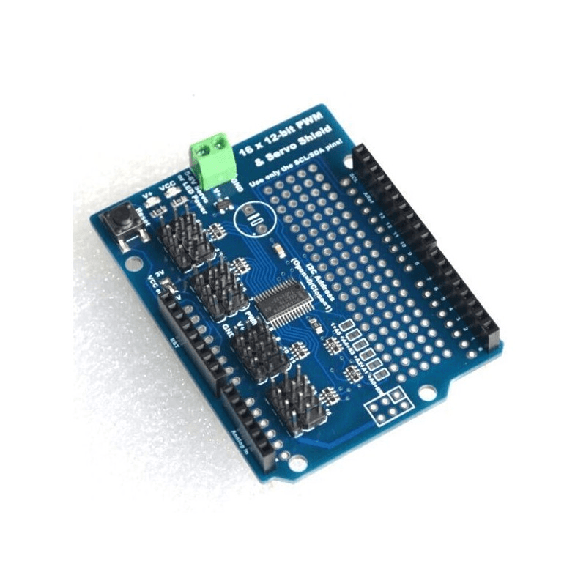
- Role: Generates PWM signals to control multiple servo motors simultaneously
Figure 8.4 Servo Driver PCA9685

Servo Motors SR 1501MG
- Model: SR1501MG
- Rotation Angle: 180°
- Operating Voltage: 4.8–6.0 V
- Gear Type: Metal Gear
- Control Signal: PWM
- Stall Torque: Approximately 15 kg·cm @ 6 V
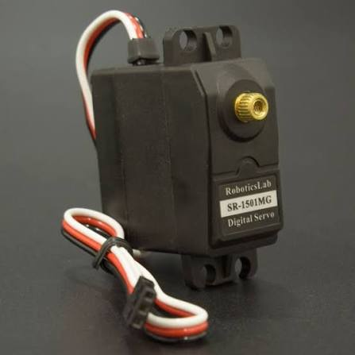
- Role: Provides rotational movement to the robotic arm joints for precise positioning and manipulation of chess pieces
Figure 8.5 Servo Motor SR 1501MG

Hardware Installation Steps
Referred:
- https://robu-prod-media.s3.ap-south-1.amazonaws.com/products/attachments/Eq0SH3f4IQXoK1XIIEUwK8F78xItwCXGfefhfO3I.pdf
- ⁠ https://youtu.be/bKY8MJDq3p0?si=Nmn4Yjr43cZ-oSZL

