5.0 | Software provisioning and configuration management with Ansible
5.1 | Introduction to Ansible hands-on
5.2 | YAML and Hands-on Exercises
5.3 | Build Ansible Inventory Files and modules
5.4 | Automate provisioning and web server deployment
  - Introduction to Ansible hands-on
Prerequisites
Two or more Ubuntu 18.04 servers. One of these will be used as our Ansible server
While another server will be used as your Ansible hosts.
Step1 : Set password for root and switch in both the servers.
❖ sudo passwd root
❖ su root
Step2 : Install Ansible in server
To get the latest version of Ansible for Ubuntu, you can add the project's PPA (personal
package archive) to your system, you should first ensure that you have the software-
properties-common package installed.
❖ sudo apt update
❖ sudo apt install software-properties-common
Then add the Ansible PPA by typing the following command:
❖ sudo apt-add-repository ppa:ansible/ansible
Next, refresh your system's package index once again so that it is aware of the packages available in the PPA:
❖ sudo apt update
Begin with ansible installation
❖ sudo apt install ansible

Step 3: Configuring SSH Access to the Ansible Hosts and generate a SSH Key in Server as well as Hosts
❖ ssh-keygen – the keys will be available in cat /root/.ssh/id_rsa.pub
Above public key ,we have copy into authorized_keys file
Step 4: Copy the rsa key of server and paste in hosts and vice versa.
- cd /root/.ssh –Switch to the location in server and hosts
- cat id_rsa.pub copy from server
nano authorized_keys -paste it on hosts
Step 5: Check connection of server and hosts
❖ ssh 172.31.36.39 (IP address of hosts checking in the server)
❖ ssh 172.31.43.84 (IP address of server checking in the hosts)
  - Build Ansible Inventory Files and modules
Step 1: Configure and Edit inventory file
nano /etc/ansible/hosts
[test-servers]
172.30.36.39
172.30.36.40

Step 2: Check the status of hosts
ansible –m ping test-servers
5.3 YAML and Hands-on Exercises
Step1 : create a playbook
nano conf.yml
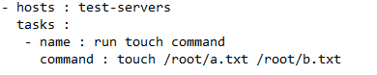
Step 2: Execute the playbook
ansible-playbook conf.yml
step3 : Check the files in the host in the location /root/ two files were created a.txt b.txt
  - Automate provisioning and web server deployment
Step1: Create a playbook for apache webserver installation –apache.yml
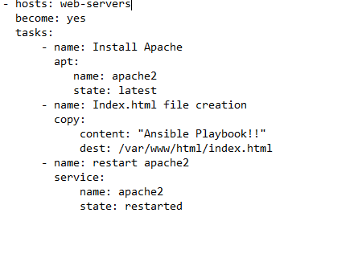
Step2: Execute Playbook
ansible-playbook apache.yml
- Check in host apache installed and check version apache2 –v
- Check Index.html in browser.

