4.0 | Getting Started with Jenkins on Windows (Hyper or Oracle VM box)
4.1 | Build the server on Hyper or Oracle VM box on on-premise machine
4.2 | Install and configure a Jenkins server
4.3 | Add plugins and create Jenkins jobs
4.4 | Run Jenkins jobs and examine outputs and results

  - Build the server on Hyper or Oracle VM box on on-premise machine
Step1 : Create an Ubuntu instance in AWS and access through putty
Step2: Debian package repository of Jenkins to automate installation and upgrade. To use this repository, first add the key to your system:

sudo wget -O /usr/share/keyrings/jenkins-keyring.asc \
https://pkg.jenkins.io/debian/jenkins.io-2023.key

When the key is added, the system will return OK.
Step3 : Then add a Jenkins apt repository entry:

echo "deb [signed-by=/usr/share/keyrings/jenkins-keyring.asc]" \
https://pkg.jenkins.io/debian binary/ | sudo tee \
/etc/apt/sources.list.d/jenkins.list > /dev/null
Step 4: We should ensure JDK installed, before we install Jenkins on the server.
Install Java:
Since Jenkins is a Java application, the first step is to install Java. Update the package index and install the Java 8 OpenJDK package with the following commands
sudo apt update
sudo apt-get install fontconfig openjdk-17-jre

  - Install and configure a Jenkins server
Step 1: Once the Jenkins repository is enabled, update the apt package list and install the latest version of Jenkins by typing:
sudo apt update
sudo apt install Jenkins
Jenkins service will automatically start after the installation process is complete. You can verify it by printing the service status:
sudo systemctl status Jenkins
Step2:
By default, Jenkins listen on port 8080. Access this port with your browser to start configuration.

Allowing 8080 port on Firewall By default, 8080 port is not allowed on firewall.
Click on “Description” on AWS instance (where you have created the instance).
Under Security Groups”launch-wizard-5”
Then click on “Inbound tab” Edit
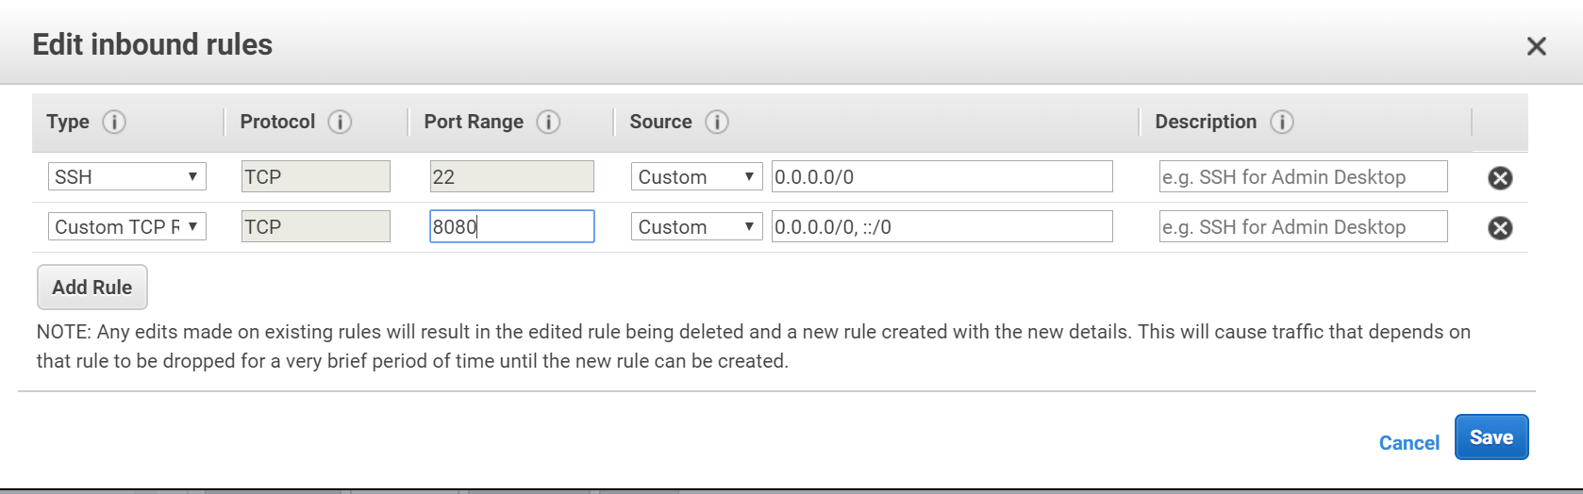

Add a new rule with the “Custom TCP rule” and the range “8080”save

Step3 :
Try to access the public ip with :8080 port on the browser.
Example: 35.153.127.253:8000

Step4: To Unlock the jenkins
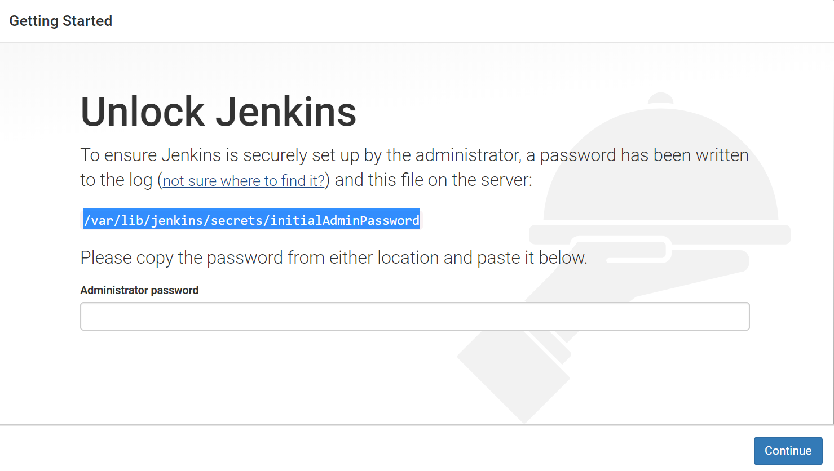
Make sure you access the “initialAdminPassword “ file with root permission.
root@ip-172-31-35-128:~# sudo su
root@ip-172-31-35-128:~# cd /var/lib/jenkins/secrets/
root@ip-172-31-35-128:/var/lib/jenkins/secrets# nano initialAdminPassword

  - Add plugins and create Jenkins jobs
Step1: Install suggested plugins
Step2: Create a Admin user
Step3: Login with Admission permission
Step4: Select Create a Job/New Item
Step5: Enter an Item name Sample, Select freestyle project, Click ok
Step6: Got to General, Give Description of the project
Step7: Trigger the build –select periodically, Example * * * * *
Step8: Build Step-Execute Shell –Provide a command ‘date’
Step9: Click on Save

