SYSTEM ARCHITECTURE
Advora
Classified Aggregator Platform

1. System Overview
Advora is a native Android classified advertisement aggregator that digitises local newspaper classifieds for tier-2 Indian cities. The system combines a Kotlin mobile client, a fully managed Firebase backend, an automated Python scraper pipeline, a Levenshtein-based duplicate detection algorithm, and a web-based admin moderation dashboard. All five layers work together to deliver a trustworthy, bilingual, always-fresh classified platform.

Platform | Native Android (Kotlin + Android Studio)
Backend | Firebase — Firestore, Auth, Storage, FCM
Scraper | Python + BeautifulSoup, scheduled via Cron (24h)
Duplicate Detection | Levenshtein string similarity algorithm
Admin Panel | Web Dashboard (HTML/JS, Firebase SDK)
Target Users | Residents of Ujjain and nearby tier-2 cities
Languages | English (EN) and Hindi (HI) — bilingual UI

2. Architecture Diagram
The diagram below shows all five layers of the Advora system — from the Android client at the top, through the Firebase backend, down to the scraper pipeline and admin panel — with data flow directions indicated between each layer.

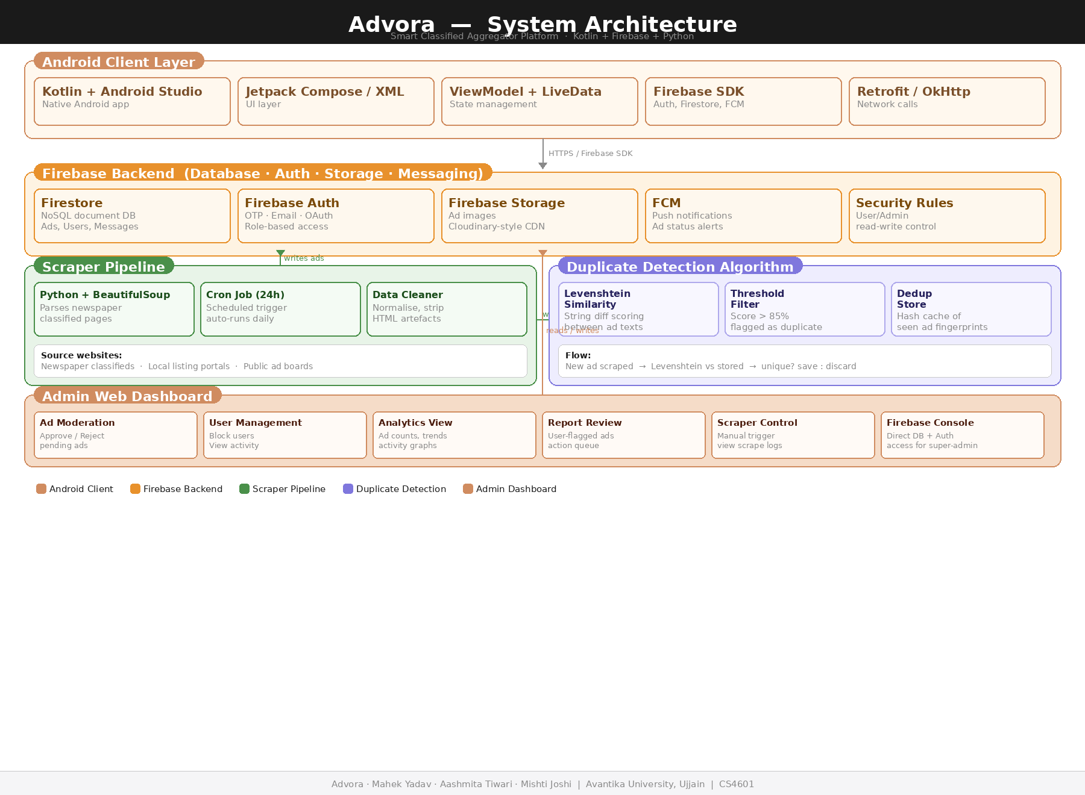

3. Layer-by-Layer Breakdown

3.1 Android Client Layer
The client is a native Android application built with Kotlin in Android Studio. It communicates exclusively with Firebase services — no custom REST backend is needed. The UI renders using Jetpack Compose or XML layouts, and all state is managed reactively through ViewModels backed by LiveData or StateFlow.

Android Client Layer — Kotlin + Android Studio
Kotlin + Android Studio  Native Android  development environment | Jetpack Compose / XML  Declarative UI  screen layouts | ViewModel + LiveData  Reactive state  lifecycle-aware | Firebase SDK  Auth, Firestore,  FCM integration | i18n (EN/HI)  Bilingual string  resource system

- Users can browse, search, filter, save, and report ads.
- Ad posting form includes image upload (Firebase Storage), title, price, category, location.
- In-app messaging lets buyers and sellers communicate without sharing phone numbers.
- Language toggle switches between English and Hindi at runtime.

3.2 Firebase Backend
Firebase provides the entire backend-as-a-service layer, replacing a custom Node.js server. This removes infrastructure management and provides built-in scalability, real-time sync, offline support, and security rules — critical for a student-built production app.

Firebase Backend — Firestore · Auth · Storage · FCM
Firestore  NoSQL document DB  Ads, users, messages | Firebase Auth  OTP · Email login  Role-based access | Firebase Storage  Ad image hosting  CDN-served URLs | FCM  Push notifications  Ad status alerts | Security Rules  User vs Admin  read-write control

- Firestore collections: /ads, /users, /messages, /reports, /notifications.
- Firebase Auth custom claims set role=admin for admin accounts.
- Security rules ensure users can only edit their own ads; admins can access all.
- FCM sends push notifications for new messages, ad approval, and reports.

3.3 Scraper Pipeline
The automated scraper runs as a Python script triggered by a Cron Job every 24 hours. It visits configured newspaper classified websites, extracts ad data using BeautifulSoup, runs it through the Levenshtein duplicate detector, and writes unique ads into Firestore as pending-review items.

Scraper Pipeline — Python + BeautifulSoup + Cron
Python + BeautifulSoup  Parses classified  website HTML | Cron Job (24h)  Auto-trigger  no manual input | Data Cleaner  Strip HTML tags  normalise fields | Levenshtein Algo  Dedup check  >85% score = discard | Firestore Writer  Writes unique ads  as status=pending

- Scraper targets: local newspaper classified sections, public listing portals.
- Fields extracted per ad: title, description, price, location, contact, category.
- Cron Job is configured on the server hosting the scraper (Linux crontab or cloud scheduler).
- Levenshtein algorithm compares new ad title + description against the last 500 stored ads.
- Similarity score above 85% causes the ad to be silently discarded, preventing spam.

3.4 Admin Web Dashboard
The admin panel is a lightweight web dashboard that connects directly to Firestore and Firebase Auth using the Firebase JavaScript SDK. Admins log in with a role=admin account, and all UI operations (approve, reject, block user, view analytics) directly update Firestore documents in real time.

Admin Web Dashboard — HTML/JS + Firebase SDK
Ad Moderation  Approve / Reject  pending scraped ads | User Management  Block users  view activity log | Report Review  User-flagged ads  action queue | Analytics  Ad counts, trends  scrape success rate | Scraper Control  Manual trigger  view scrape logs

- Admin dashboard is web-only — not accessible from the Android app.
- Real-time Firestore listeners keep the dashboard updated without page refresh.
- Approving an ad changes status to "active"; FCM notifies affected users.
- Blocking a user sets is_blocked=true in Firestore; Firebase Rules deny their writes.

4. Full Technology Stack
Component | Technology | Layer | Responsibility
Android App | Kotlin + Android Studio | Client | Native Android UI, user interactions, navigation
UI Framework | Jetpack Compose / XML Layouts | Client | Declarative UI building blocks and screen layouts
State Mgmt. | ViewModel + LiveData | Client | Reactive state, lifecycle-aware data handling
Database | Firebase Firestore | Backend | NoSQL document store for ads, users, messages
Authentication | Firebase Auth | Backend | Email/OTP sign-in, role-based access (user/admin)
File Storage | Firebase Storage | Backend | Ad image upload and CDN-served delivery
Push Notifs. | Firebase Cloud Messaging (FCM) | Backend | Ad status alerts, moderation updates to users
Web Scraper | Python + BeautifulSoup | Pipeline | Parses newspaper and classified listing websites
Scheduler | Cron Job (every 24 hours) | Pipeline | Auto-triggers scraper daily without manual input
Dedup Algorithm | Levenshtein string similarity | Pipeline | Detects near-identical ads before Firestore write
Admin Panel | Web Dashboard (HTML/JS) | Admin | Ad moderation, user management, analytics, reports
Security Rules | Firebase Security Rules | Backend | Read/write access control per user role

5. End-to-End Data Flow
The table below traces a complete lifecycle — from a cron trigger firing the scraper, through duplicate detection, Firestore storage, admin review, to the end user browsing approved ads on the Android app.

# | Step | Action | Detail
1 | Cron trigger | Scheduler fires every 24 hours | Python scraper process wakes up automatically
2 | Web scraping | BeautifulSoup parses HTML pages | Extracts ad title, description, price, location, contact
3 | Dedup check | Levenshtein similarity computed | New ad vs stored fingerprints — score > 85% = discard
4 | Data write | Unique ad written to Firestore | Stored under /ads collection with status = "pending"
5 | Image upload | Ad images pushed to Firebase Storage | CDN URL stored in Firestore ad document
6 | FCM trigger | Notification dispatched via FCM | Admin alerted: "New ad pending review"
7 | Admin review | Dashboard fetches pending ads | Admin approves or rejects — status field updated
8 | User browse | Android app queries Firestore | Only approved ads shown in home feed
9 | User action | Save, message, or report ad | Written to Firestore — FCM notifies seller

6. Firestore Collection Schema
Firestore stores data as flexible JSON documents. The five primary collections and their key fields are shown below.

/ads/{ad_id}
Field | Type | Description
ad_id | string | Auto-generated Firestore document ID
user_id | string (FK) | UID of the user who posted or null if scraped
title | string | Ad headline
description | string | Full ad body text
price | number | Price in INR; 0 = free
location | string | City / area string
category | string | Jobs, Rentals, Buy/Sell, Services
images | array<string> | Firebase Storage CDN URLs
status | string (enum) | pending | active | rejected | expired
source | string | user_posted | scraped
created_at | timestamp | Firestore server timestamp
expires_at | timestamp | Auto-set 30 days after creation

/users/{user_id}
Field | Type | Description
user_id | string | Firebase Auth UID
name | string | Display name
email | string | Login email
phone | string | Contact number (optional)
role | string | user | admin
is_blocked | boolean | Admin-set block flag
profile_pic | string | Firebase Storage URL
joined_at | timestamp | Account creation time

7. Security Architecture
Security is enforced at multiple layers — from Firebase Authentication and Firestore Security Rules, through the scraper's rate limiting, to the deduplication algorithm that prevents spam flooding.

Security Layer | Description
Firebase Authentication | All users must sign in before accessing Firestore. Anonymous access is blocked at the rule level.
Role-based Firestore Rules | Admin documents can only be written by accounts with role=admin claim. Users can only modify their own ads.
Firebase Storage Rules | Images can only be uploaded by authenticated users. Admin can delete any image.
Levenshtein Dedup Layer | Prevents spam flooding. Near-duplicate ads (>85% similarity) are silently discarded before DB write.
FCM Token Scoping | Push notifications are sent only to the specific user token, never broadcast to all users.
Scraper Rate Limiting | Cron runs once per 24 hours with polite request delays to avoid IP banning of source sites.

8. Duplicate Detection Algorithm

8.1 Levenshtein String Similarity
The Levenshtein distance measures the minimum number of single-character edits (insertions, deletions, substitutions) needed to transform one string into another. Advora converts this into a normalised similarity score between 0 and 1 by dividing the edit distance by the length of the longer string and subtracting from 1.

Similarity Score Formula:
similarity = 1 - (levenshtein_distance(a, b) / max(len(a), len(b)))

Threshold used: score > 0.85 → ad flagged as duplicate → discarded

8.2 Algorithm Steps
When a new ad is scraped, the pipeline executes the following sequence:
- Concatenate the new ad title + description into a single comparison string.
- Retrieve the last 500 approved and pending ad fingerprints from a Redis-like in-memory cache (or Firestore query).
- Compute Levenshtein similarity between the new ad and each stored fingerprint.
- If any similarity score exceeds 0.85, the ad is discarded silently.
- If no match found, the ad is written to Firestore with status = pending.

9. Deployment Notes
Android App | Built with Android Studio · Debug APK for testing · Signed APK for release · Published via Google Play or direct install
Firebase Project | Single Firebase project with Firestore, Auth, Storage, FCM enabled · google-services.json embedded in the Android app
Python Scraper | Hosted on any Linux server or cloud VM · Cron entry: 0 0 * * * /usr/bin/python3 /opt/advora/scraper.py
Admin Dashboard | Static HTML/JS files hosted on Firebase Hosting or any web server · Authenticated via Firebase Auth
Environment | Firebase environment config via .env file · Admin SDK service account key for server-side Firestore writes from scraper

Advora System Architecture · CS4601 Design Project · Avantika University, Ujjain · 2024–25
Mahek Yadav · Aashmita Tiwari · Mishti Joshi | Supervised by Prof. Deepak Yadav

