Advora
Asset Library & Specification
Icons · Images · Splash Screen · Asset Guidelines

1. Icons

All icons in Advora are drawn from the Material Icons (outlined style) set on Android, with SF Symbols equivalents used on iOS. Icon sizes follow the 8 dp grid. Active / selected state uses color.brand.primary (#C4825A); inactive state uses color.neutral.400 (#9E9E9E) unless noted.

1.1 Navigation Icons
Used in the Bottom Tab Bar and the Side Drawer for the admin panel.

Icon Name | Category | Size (dp) | Active Colour
Home | Navigation | 24 dp | #C4825A (active) / #9E9E9E
My Ads | Navigation | 24 dp | #C4825A (active) / #9E9E9E
Post Ad | Navigation | 28 dp | #FFFFFF (on FAB)
Map / Pin | Navigation | 24 dp | #C4825A (active) / #9E9E9E
Saved / Heart | Navigation | 24 dp | #C4825A (active) / #9E9E9E
Dashboard | Drawer Nav | 20 dp | #FFFFFF (active) / #C4825A
Manage Ads | Drawer Nav | 20 dp | #C4825A
User Mgmt | Drawer Nav | 20 dp | #C4825A
Reports | Drawer Nav | 20 dp | #C4825A
Profile | Drawer Nav | 20 dp | #C4825A
Map (Drawer) | Drawer Nav | 20 dp | #C4825A

1.2 User & Profile Icons
Icons associated with user identity, account management, and profile editing.

Icon Name | Category | Size (dp) | Active Colour
Profile / Person | User | 24 dp | #C4825A
Edit Profile (pen) | User | 16 dp | #C4825A (on avatar badge)
User Avatar (filled) | User | 64 dp | #C4825A tinted fill
Camera (edit photo) | User | 20 dp | #FFFFFF on brown circle badge
Account circle | User | 24 dp | #9E9E9E (inactive nav)

1.3 Action Icons
Icons used for in-card and in-list actions performed on listings or items.

Icon Name | Category | Size (dp) | Active Colour
Edit / Pencil | Action | 20 dp | #424242
Delete / Trash | Action | 20 dp | #E53935
Favorite / Heart | Action | 24 dp | #E53935 (saved) / #9E9E9E (unsaved)
Search / Magnify | Action | 20 dp | #9E9E9E (placeholder) / #C4825A (active)
Activate check | Action | 20 dp | #FFFFFF on #4CAF50 button
Block circle | Action | 20 dp | #FFFFFF on #E53935 button
Chevron right | Action | 16 dp | #9E9E9E
Filter sliders | Action | 20 dp | #FFFFFF on #C4825A square button

1.4 System Icons
Icons for app-level system functions — notifications, settings, and session management.

Icon Name | Category | Size (dp) | Active Colour
Notifications / Bell | System | 24 dp | #FFFFFF (dark bar) / #424242 (light bar)
Settings / Gear | System | 22 dp | #C4825A (profile rows)
Logout / Exit arrow | System | 22 dp | #E53935 (logout button)
Lock / Password | System | 22 dp | #C4825A
Help / Question mark | System | 22 dp | #C4825A
Alert triangle | System | 24 dp | #E53935 (report indicator)
Info circle | System | 20 dp | #C4825A (dashboard Reports tile)
Back arrow | System | 20 dp | #1A1A1A (light) / #C4825A (dark admin)
Hamburger menu | System | 24 dp | #C4825A (app bar)

1.5 Feature Icons
Icons tied to specific togglable features: theme switching and language selection.

Icon Name | Category | Size (dp) | Active Colour
Dark Mode Moon | Feature | 22 dp | #C4825A
Dark Mode Sun / Orbit | Feature | 22 dp | #C4825A
Language / Globe | Feature | 22 dp | #C4825A
Translate (खA) | Feature | 28 dp | #FFFFFF on dark pill (registration screen)
Privacy / Shield | Feature | 22 dp | #C4825A

1.6 Category Icons
Used in the home feed horizontal category filter strip and on listing cards.

Icon Name | Category | Size (dp) | Active Colour
All / Grid list | Category | 24 dp | #C4825A (selected) / #9E9E9E
Jobs / Briefcase | Category | 24 dp | #C4825A (selected) / #9E9E9E
Rentals / House | Category | 24 dp | #C4825A (selected) / #9E9E9E
Vehicles / Car | Category | 24 dp | #C4825A (selected) / #9E9E9E
Services / Wrench | Category | 24 dp | #C4825A (selected) / #9E9E9E
Buy/Sell / Cart | Category | 24 dp | #C4825A (selected) / #9E9E9E

1.7 Icon Specifications & Guidelines

Property | Specification
Style | Material Icons — Outlined (default), Filled for active/selected states
Grid | 24 × 24 dp base on 8 dp grid; drawable at 1×, 1.5×, 2×, 3× densities
Padding | 2 dp optical padding within the 24 dp bounding box (Material spec)
Stroke weight | 1.5 dp (outlined) · matches overall UI line weight
Touch target | Minimum 48 × 48 dp (WCAG / Material accessibility requirement)
Export format | SVG source + PNG exports at mdpi / hdpi / xhdpi / xxhdpi / xxxhdpi
Colour states | Default, Active (#C4825A), Disabled (#BDBDBD), On-dark (#FFFFFF)
Dark mode | Same icon assets; only colour token changes via theme — no separate icon set required

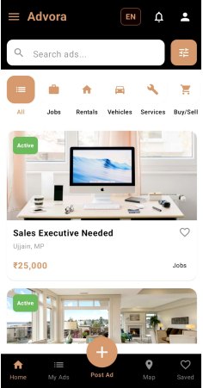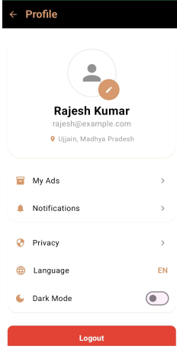

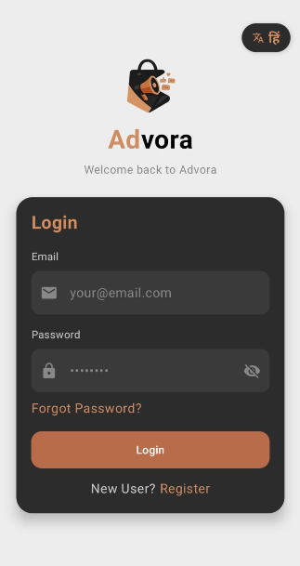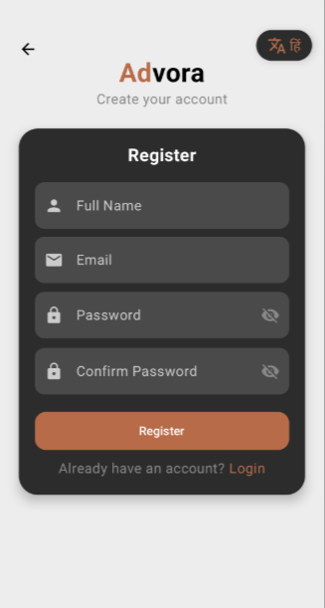

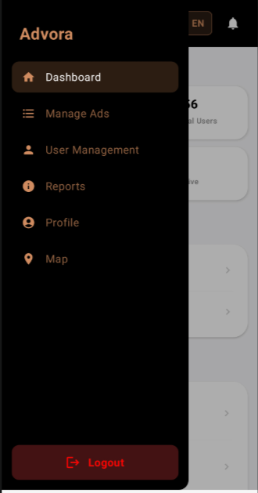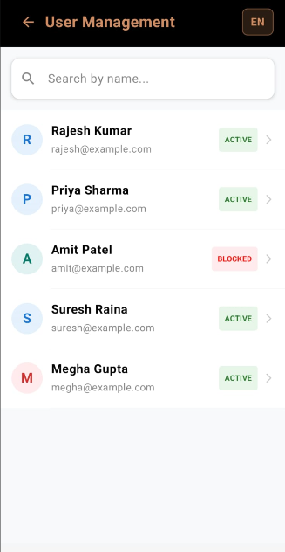

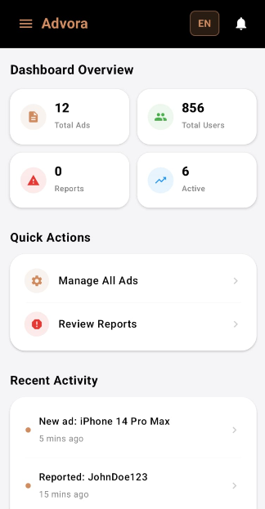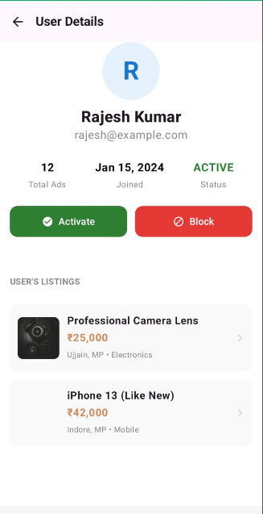

2. Images

Advora uses images in three primary contexts: listing / ad cards in the feed, hero images in the ad detail view, and default placeholder images for profile avatars and empty listings. All images are handled by a remote CDN with on-device caching.

2.1 Product & Ad Images
User-uploaded photographs that represent the item or service being listed.





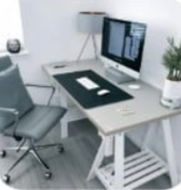

Image Type | Dimensions | Aspect Ratio | Format / Quality | Screen Context
Listing Card Thumbnail | 360 × 240 px | 3 : 2 | JPEG · 80 % quality | Home feed card top image
Hero / Detail Banner | 720 × 405 px | 16 : 9 | JPEG · 85 % quality | Ad detail top full-width image
Gallery Thumbnail | 120 × 120 px | 1 : 1 | JPEG · 75 % quality | Multi-image strip in detail view
My Ads Card Image | 80 × 80 px | 1 : 1 | JPEG · 75 % quality | "My Ads" list item left thumb
User Details Listing | 80 × 80 px | 1 : 1 | JPEG · 75 % quality | Admin User Details listing thumb

2.2 Category-Specific Image Guidelines

Jobs
› Show the workplace environment, office setup, or job role equipment (e.g. desktop/Mac setup as seen in "Sales Executive Needed").
› Avoid showing faces to respect privacy in anonymous listings.
› Preferred aspect ratio: 16:9 landscape for clean card crop.
› Typical dimensions submitted: 800–1200 px wide.

Real Estate / Rentals
› Interior or exterior property photographs. Wide-angle preferred to convey space.
› Multiple images encouraged — gallery strip visible in detail view (e.g. "2BHK Flat near Mahakal").
› Avoid HDR-over-processed images; natural white balance preferred.
› Upload minimum: 1 image. Recommended: 3–6 images.

Vehicles
› Side-profile exterior shot as the primary card image (e.g. Royal Enfield Classic 350).
› Interior, dashboard, and odometer shots uploaded as gallery items.
› White or neutral background preferred for primary photo.
› Minimum resolution: 640 × 480 px.

Electronics / Mobiles
› Product-on-surface or hand-held shot. Clean background preferred.
› Multiple angles encouraged (front, back, ports, accessories).
› For cameras/lenses: close-up detail shots showing mount and glass.
› For phones: screen-on shot showing condition of display.

2.3 Listing Images in Cards
The card component renders images with specific cropping and overlay behaviour.

Property | Value
Corner radius | 12 dp on all corners (top corners only when inside a card)
Crop mode | Center crop — images always fill their container without letterboxing
Aspect ratio enforced | 16:9 for feed cards; 1:1 for list-row thumbnails
"Active" chip overlay | Top-left · color.status.success · white Bold text · 6 dp radius · 8 dp margin
Heart overlay | Top-right · 24 dp · Filled red (#E53935) when saved, outlined grey otherwise
Loading state | Shimmer placeholder — neutral.200 to neutral.50 gradient animation
Error state | Grey background + broken-image icon centred · color.neutral.400
Max file size (upload) | 5 MB per image · enforced at upload validation

2.4 Banner-Style Images in Feed
The home feed renders listing cards in a single-column vertical list with a full-width hero image at the top of each card. These function as banner-style images for the listing.

Property | Value
Display width | Full card width (screen width − 32 dp margin)
Display height | ~200 dp (fixed, crop from centre)
Background fill | color.neutral.50 while loading
Elevation | 0 dp — cards use border, not shadow, to separate from background
Content below image | Title, location, price, category chip — 16 dp padding all sides

2.5 Default & Placeholder Images

Placeholder Type | Specification
User avatar — initial | Coloured circle 40 dp; initial letter in bold 18 sp white; colour derived from name hash (R=blue, P=teal, A=green, S=purple, M=red …)
User avatar — photo | Circular crop, 64 dp profile screen / 40 dp list items; border: 2 dp white ring
Admin avatar | 80 dp circle; default brown-tinted person icon on white (light) / dark brown (dark) bg
Listing — no image | Grey rectangle placeholder with image-outline icon centred; color.neutral.200 bg
Listing — loading | Shimmer animation over color.neutral.100 background, same dimensions as image
Map pin | Custom SVG pin: dark green fill (#2E7D32), white hand-tap icon inside, 48 dp tall

3. Splash Screen

The splash screen is the first visual the user sees on app launch. It establishes the Advora brand identity before the authentication flow begins. It is a full-screen, static composable with no interactive elements.

3.1 Visual Layout
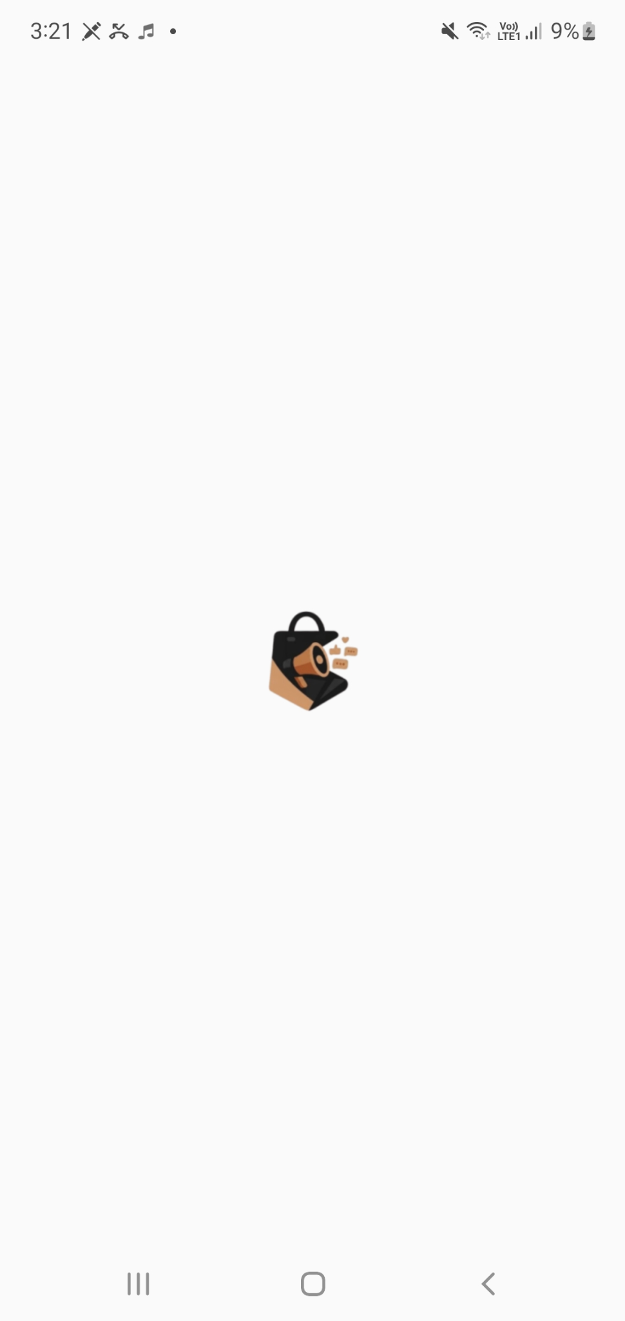

↑ Simulated representation of the splash screen on a dark background (actual launch screen)
3.2 App Logo


Property | Specification
Shape | Rounded square (squircle) — consistent with Android adaptive icon spec
Dimensions | 108 × 108 dp (adaptive icon canvas); 72 × 72 dp foreground layer; 48 × 48 dp safe zone
Background layer | Solid color.dark.background (#1A1A1A) or color.brand.primary (#C4825A) variant
Foreground layer | Stylised "A" or wordmark in white; centred within safe zone
Export formats | SVG (master) · PNG @1× 48 px · @2× 96 px · @3× 144 px · @4× 192 px
Android format | Adaptive Icon: ic_launcher_foreground.xml + ic_launcher_background.xml
iOS format | AppIcon.appiconset — all required sizes from 20 pt to 1024 pt

3.3 App Name Wordmark
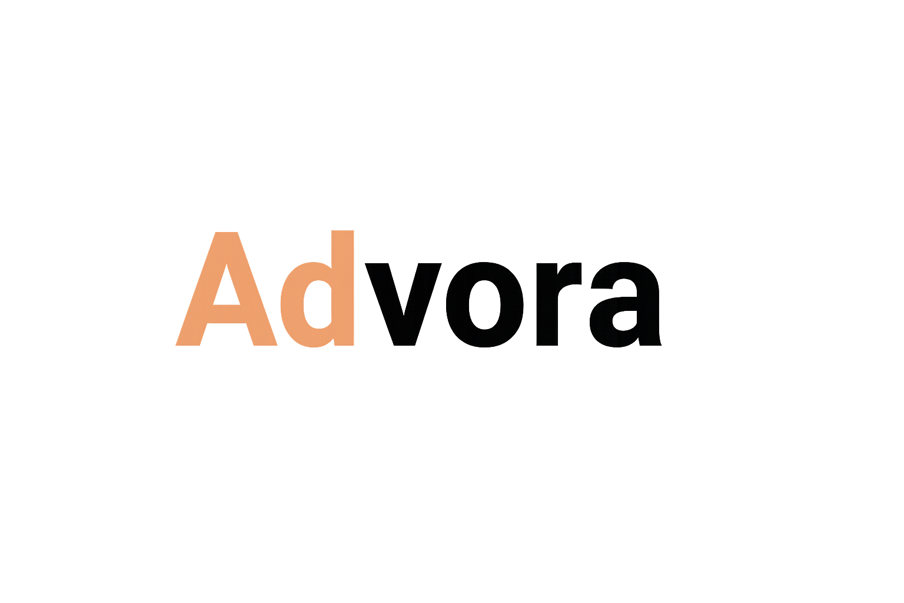

Property | Specification
"Ad" portion | color.brand.primary (#C4825A) · Bold 700 · 36 sp on splash (scales with screen)
"vora" portion | color.neutral.0 (#FFFFFF) · Bold 700 · Same size as "Ad"
Font family | Arial or system sans-serif; consistent with in-app type stack
Letter spacing | 0 (default; tight wordmark feel)
Tagline | "Buy · Sell · Discover" · type.body · color.neutral.400 · centred below wordmark
Tagline spacing | 12 dp gap between wordmark baseline and tagline top

3.4 Branding Colours on Splash

Element | Colour Token → Hex
Screen background | color.dark.background → #1A1A1A
"Ad" wordmark text | color.brand.primary → #C4825A
"vora" wordmark text | color.neutral.0 → #FFFFFF
Tagline text | color.neutral.400 → #9E9E9E
Logo background (icon) | color.dark.background → #1A1A1A OR color.brand.primary → #C4825A
Logo foreground (icon) | color.neutral.0 → #FFFFFF
Status bar style | Light content (white icons) on dark background
Navigation bar colour | color.dark.background → #1A1A1A (matches screen)

3.5 Animation & Timing
Property | Value
Display duration | 2 000 ms (cold start) / 800 ms (warm start — app already in memory)
Entry animation | Logo fades in over 400 ms with a 1.05 → 1.0 scale-down ease-out
Exit transition | Cross-fade to login / home screen over 300 ms
Loading indicator | None visible to the user; data pre-fetch runs silently during splash
Dark/Light mode | Splash is always dark — it does not respond to system light mode setting

3.6 Platform-Specific Notes
- Android: implement via SplashScreen API (API 31+); use windowSplashScreenBackground and windowSplashScreenAnimatedIcon attributes in res/values/themes.xml.
- Android fallback (API < 31): use a dedicated SplashActivity with a WindowBackground drawable referencing the logo in a layer-list.
- iOS: use LaunchScreen.storyboard with a dark UIView background (#1A1A1A) and a centred UIImageView of the logo asset.
- Do not use a static splash bitmap — always use vector/adaptive assets to support all screen densities.
- The splash screen must be dismissed programmatically only after the initial network/auth check completes (or times out at 3 000 ms max).

4. Asset Guidelines & Delivery

4.1 File Naming Convention

Asset Type | Naming Pattern
Navigation icon (active) | ic_nav_{name}_active.svg
Navigation icon (inactive) | ic_nav_{name}_inactive.svg
Action icon | ic_action_{name}.svg
System icon | ic_system_{name}.svg
Category icon | ic_category_{name}.svg
Feature icon | ic_feature_{name}.svg
Listing image (user upload) | {listing_id}_{index}.jpg (backend auto-named)
Default / placeholder image | img_placeholder_{context}.png
App icon (Android) | ic_launcher.png (per density folder)
App icon (iOS) | AppIcon-{size}@{scale}x.png
Splash logo | img_splash_logo.svg / .png

4.2 Export Density Requirements
Density | Scale · DPI · Folder (Android)
mdpi | 1× · 160 dpi · res/drawable-mdpi/
hdpi | 1.5× · 240 dpi · res/drawable-hdpi/
xhdpi | 2× · 320 dpi · res/drawable-xhdpi/
xxhdpi | 3× · 480 dpi · res/drawable-xxhdpi/
xxxhdpi | 4× · 640 dpi · res/drawable-xxxhdpi/
iOS @1x | 1× · 72 pt · (legacy, still required in xcassets)
iOS @2x | 2× · 144 pt · Most common iPhone size
iOS @3x | 3× · 216 pt · Pro / Plus / Max devices

4.3 Image Upload Validation Rules
- Accepted formats: JPEG, PNG, WebP.
- Maximum file size: 5 MB per image; 20 MB total per listing (max 5 images).
- Minimum dimensions: 300 × 200 px (below this, the upload is rejected with an error toast).
- EXIF data is stripped on server processing to protect user location metadata.
- Images are re-encoded to JPEG at 80 % quality and served via CDN at multiple resolutions.
- Explicit or misleading content is flagged by the automated review pipeline and held for admin review (visible in the Reports screen with "Fake images" reason).

4.4 CDN & Caching Strategy
Property | Value
CDN provider | Firebase Storage (observed from "Hello Firebase" listing titles in test data)
Cache-Control | max-age=31536000, immutable (content-addressed URLs; new upload = new URL)
On-device cache | Glide (Android) / SDWebImage (iOS) with 250 MB disk cache limit
Placeholder | Shimmer shown immediately; actual image cross-fades in on load (200 ms)
Retry policy | 3 attempts with 500 ms exponential back-off on network error
Thumbnail vs full | Card = thumbnail (compressed); Detail screen lazy-loads full resolution

