

CC7020NI Software Engineering Management
Level 7 – Software Engineering Management
Assessment Type
100% Group Coursework Semester
2025 Autumn
Credit: 20 Semester Long Module
Group Members:
London Met ID: | Student Name:
24059549 | Sneha Adhikari
24059547 | Sabina Ghising
24059546 | Rushka Khanal

Assignment Due Date: Wednesday, February 4, 2026
Assignment Submission Date: Wednesday, February 4, 2026 Submitted To: Ravi Maharajan
Word Count (Where Required):
I confirm that I understand my coursework needs to be submitted online via MySecondTeacher classroom under the relevant module page before the deadline in order for my assignment to be accepted and
marked. I am fully aware that late submissions will be treated as non-submission and a mark of zero will be awarded.
Table of Contents
Table of Figures 5
1. Introduction and Objectives 1
1.1. Introduction 1
1.2. Problem Statement 2
1.3. Project Objectives 3
1.4. Project Scope & Stakeholders 4
1.5. Significance of the Project 5
2. Initial Business Plan 6
2.1. Features 6
A. USER FEATURES 6
B. BUSINESS / SHELTER FEATURES 7
C. Admin Features 8
D. System-wise Features 8
2.2. Entity-Relationship Diagram 9
2.3. Time Estimation & Scheduling 10
2.4. Gantt Chart 13
3. System Architecture 16
3.1. Architecture Overview 16
3.2. Frontend Architecture & Technologies 17
3.3. Backend Architecture a& Technologies 17
3.4. Database Design 17
3.5. API Communication Flow 18
3.6. Security Considerations 18
3.7. Security Considerations 18
4. Engineering Management Aspects 19
4.1. Software Development Methodology 19
4.2. Justification for Methodology Selection 19
4.3. Sprint Planning, Estimation and Scheduling 20
4.4. Team Composition & Task Distribution 20
4.5. Risk Identification & Mitigation 21
4.6. Version Control & Collaboration Practices 21
4.7. Quality Assurance & Testing Strategy 21
5. Implementation Details 22
5.1. Frontend Implementation Overview 22
5.2. Backend Implementation Overview 23
5.3. Key Modules and Workflow 23
5.4. Integration Between Frontend and Backend 24
6. Testing and Validation 25
6.1. Testing Approach 25
6.2. Test Case Design 25
6.3. Validation of Function and Non-FunctionaL Requirements 26
6.4. Example Integration Test 27
6.5. Summary 28
7. Results and Discussions 28
7.1. System Functionality Evaluation 28
7.2. Performance and Usability Analysis 28
7.3. Limitations Of the System 29
8. Conclusion and Future Enhancements 30
8.1. Summary of Achievements 30
8.2. Learning Outcomes 30
8.3. Proposed Future Improvements 30
9. References 32

Table of Figures

Figure 1: Entity Relationship Diagram 9
Figure 2: Time Estimation and Scheduling 12
Figure 3: Gantt Chart 15
Figure 4: System Architecture 16
Figure 5: Testing 27

Introduction and Objectives

Introduction
Pet adoption and shelter management systems face several ongoing challenges, including fragmented information sources, inefficient adoption procedures, and limited transparency between shelters and potential adopters. Information about adoptable pets is often spread across multiple platforms, making it difficult for users to access accurate and up-to-date data. In addition, traditional adoption processes frequently rely on manual documentation and disconnected communication channels, which reduces efficiency and increases the risk of errors.
PetConnect is a mobile application developed to address these challenges by providing an integrated digital solution for pet adoption and shelter management. The application connects three primary stakeholder groups: individuals seeking to adopt pets, shelter organizations responsible for managing animals and adoption processes, and system administrators who oversee platform operations. By centralizing adoption-related activities within a single mobile platform, PetConnect improves accessibility, usability, and operational efficiency for all users.
The application extends beyond basic pet discovery and adoption features by supporting key operational functions such as shelter management, transparent communication, and secure payment handling. PetConnect includes an integrated digital payment system that allows adopters to complete adoption-related payments directly within the application. Payments are securely managed through a controlled workflow to ensure financial transparency and to protect both adopters and shelters during the adoption approval process.
Furthermore, PetConnect incorporates artificial intelligence–based compatibility assessment to help match pets with suitable adopters, thereby increasing the likelihood of successful and long-term adoptions. The application also provides real-time notifications and role-based dashboards tailored to adopters, shelter staff, and administrators. Through this comprehensive and mobile-first approach, PetConnect aims to enhance efficiency, trust, and effectiveness within the modern pet adoption ecosystem.

Problem Statement
The current pet adoption ecosystem is affected by several technical and operational limitations that hinder efficient adoption processes and negatively impact both adopters and shelter organizations. Existing pet adoption platforms often operate as fragmented systems, offering poor integration across the adoption workflow. As a result, users experience inconsistent interactions, while shelters struggle with inefficient management of pet listings, adoption applications, and financial records.
Potential adopters face difficulties in identifying suitable pets due to limited search and filtering capabilities, incomplete or inconsistent pet profile information, and the absence of a centralized database connecting multiple shelters. These limitations reduce accessibility and slow down the decision-making process. At the same time, shelter organizations rely on disconnected tools that fail to provide a unified view of animal inventory, adoption requests, and payment tracking, leading to operational inefficiencies and increased administrative burden.
From a technical standpoint, many existing systems lack modern software architectures required for scalability, maintainability, and security. Monolithic system designs restrict the ability to handle increasing user demand and complicate feature expansion. Weak authentication mechanisms and insufficient data protection measures introduce security risks. Additionally, payment processes often depend on external platforms, disrupting user flow and increasing the likelihood of application abandonment.
The absence of intelligent pet–adopter matching mechanisms further contributes to unsuccessful placements and higher pet return rates. Moreover, limited real-time communication and notification features reduce transparency, causing delays in application updates and lowering user trust. Administrative users are also constrained by the lack of centralized monitoring tools, which restrict effective oversight of system activity, financial transactions, and policy enforcement.
Collectively, these challenges result in an inefficient pet adoption ecosystem characterized by low adoption success rates, reduced transparency, and unsatisfactory experiences for adopters, shelters, and administrators. Therefore, there is a clear need for a secure, scalable, and intelligent mobile-based solution that integrates adoption management, payment processing, real-time communication, and administrative oversight within a unified platform.

Project Objectives
The primary objective of the PetConnect project is to design, implement, and deploy a comprehensive mobile-based digital platform that improves the pet adoption and shelter management process through modern software engineering practices and user-centered design. The system aims to enhance adoption efficiency, financial transparency, and scalability while supporting multiple stakeholder roles.
The specific objectives of the project are as follows:
- To develop a fully functional mobile application that supports adopters and shelter organizations, providing a consistent and intuitive user experience through a unified platform.
- To design and implement a custom-built digital wallet and payment management module that enables secure handling of adoption fees, internal wallet transfers, and payment confirmation without reliance on third-party payment services.
- To implement an artificial intelligence–based pet–adopter compatibility scoring mechanism that analyzes pet personality attributes and user lifestyle data to generate meaningful and explainable adoption recommendations.
- To integrate a secure, end-to-end adoption workflow that includes application submission, real-time status tracking (Pending, In Review, Approved, or Rejected), and automated payment verification upon adoption approval.
- To apply Clean Architecture principles and Riverpod-based state management in the frontend to ensure modularity, testability, and long-term maintainability of the mobile application.
- To architect the backend using a microservices-based and event-driven approach, incorporating RabbitMQ for asynchronous communication, Redis for caching, and layered architecture to support scalability and fault tolerance.
- To evaluate system performance by demonstrating measurable improvements through Redis caching benchmarks and to document system scalability through architectural analysis.

Project Scope & Stakeholders
The scope of the PetConnect project focuses on the design and implementation of a mobile-based software system that supports digital pet adoption and shelter management processes. The system addresses core functional and technical requirements within an academic and prototype context.
The scope of the project includes the following features:
- User registration, authentication, and role-based access control
- Shelter (business) account and pet management
- Pet listing creation and media management
- End-to-end adoption application workflow
- Favourite pets and AI-based compatibility scoring
- Custom digital wallet–based payment processing and transaction history
- Real-time notification system for adoption and payment updates
- Administrative monitoring and oversight through backend APIs and testing tools (e.g., Postman)
The project does not include physical shelter operations, real-world animal handling, or integration with external payment gateways. All financial transactions are handled through a simulated internal wallet system. The platform is developed for academic demonstration and prototype validation purposes rather than production deployment.
Stakeholders
The primary stakeholders of the PetConnect system include:
- Adopters (Users): Individuals seeking to discover, evaluate, and adopt pets through the mobile application.
- Shelter Organizations: Businesses responsible for managing pet listings, reviewing adoption applications, and confirming adoptions.
- System Administrators: Backend operators responsible for monitoring system activity, managing data integrity, and enforcing platform rules via administrative APIs.

Significance of the Project
The PetConnect platform delivers value across technical, operational, and societal dimensions.
- Technical Significance:
PetConnect demonstrates the application of modern software engineering principles, including microservices architecture, event-driven messaging, layered service design, and state management patterns. The implementation serves as a reference model for multistakeholder systems, validating architectural concepts widely discussed in software engineering literature. By leveraging these principles, the platform ensures scalability, maintainability, and performance, establishing a technically robust foundation for digital pet adoption solutions.
- Operational Significance:
The platform reduces the administrative workload of shelters by automating key processes such as adoption application tracking, payment reconciliation, and status communication. End users benefit from improved accessibility and transparency, with features like AI-driven pet compatibility recommendations and real-time adoption updates. These enhancements lead to measurable improvements, including faster adoption cycles, higher placement success rates, and reduced return rates due to better compatibility between pets and adopters.
- Societal Significance:
By improving the efficiency and effectiveness of the pet adoption process, PetConnect contributes positively to animal welfare. Shorter shelter occupancy durations and higher-quality adoptions help ensure that pets are placed in suitable homes. Simultaneously, adopters experience a smoother and more informed adoption process. Overall, the platform supports the mission of shelter organizations while promoting responsible pet ownership and enhancing the overall adoption experience.

Initial Business Plan

Features

USER FEATURES
- User Authentication
- Users sign up/login using email
- OTP verification
- Pet Listings (Shelter → Pets Structure)
- Shelter List View
- List of all shelters
- Location filter
- Shelter Detail Page
- Shelter info
- Address
- Contact details
- Adoption policies
- Pets available in this shelter
- Pet List inside Shelter
- Photos
- Name, breed, age
- Availability status
- Filters (breed, age, gender, vaccination)
- Pet Detail Page
- Full profile
- Medical info
- Personality
- Photos/videos
- Apply to adopt
- Contact shelter
- Pet Adoption Process
- Fill adoption form
- Submit application
- Adoption status:
- Pending
- In Review
- Approved / Rejected
- Adoption history
- Pet Compatibility System
- User Lifestyle questionnaire
- System analyzes:
- Pet Personality
- User Lifestyle preferences
- Generated Compatibility score (%)
- Explanation Text : “This pet suits you because you prefer calm pets and live in an apartment.”
- Payments
- Payment method
- Payment receipt
- Transaction history
- User Dashboard

BUSINESS / SHELTER FEATURES
- Business Authentication
- Register as business
- Submit documents
- Await admin approval
- Business Dashboard
- Manage pets
- View adoption requests
- View Payment records
- Pet Management (Shelter side)
- Add pets
- Edit pet details
- Change status (Available/Adopted/Reserved)
- Upload photos & medical files

Admin Features
- Admin-Side
- Total users
- Total shelters/businesses
- Total pets
- Total transactions
- User Management
- View users
- Business Management
- Approve/reject business registration
- Verify documents
- Manage shelter listings
- Pet Management
- View all pets
- Remove inappropriate listings
- Payment & Transaction Monitoring
- View all payments
- View transaction details

System-wise Features
- Notification System
- Adoption Status
- Payment Status

Entity-Relationship Diagram

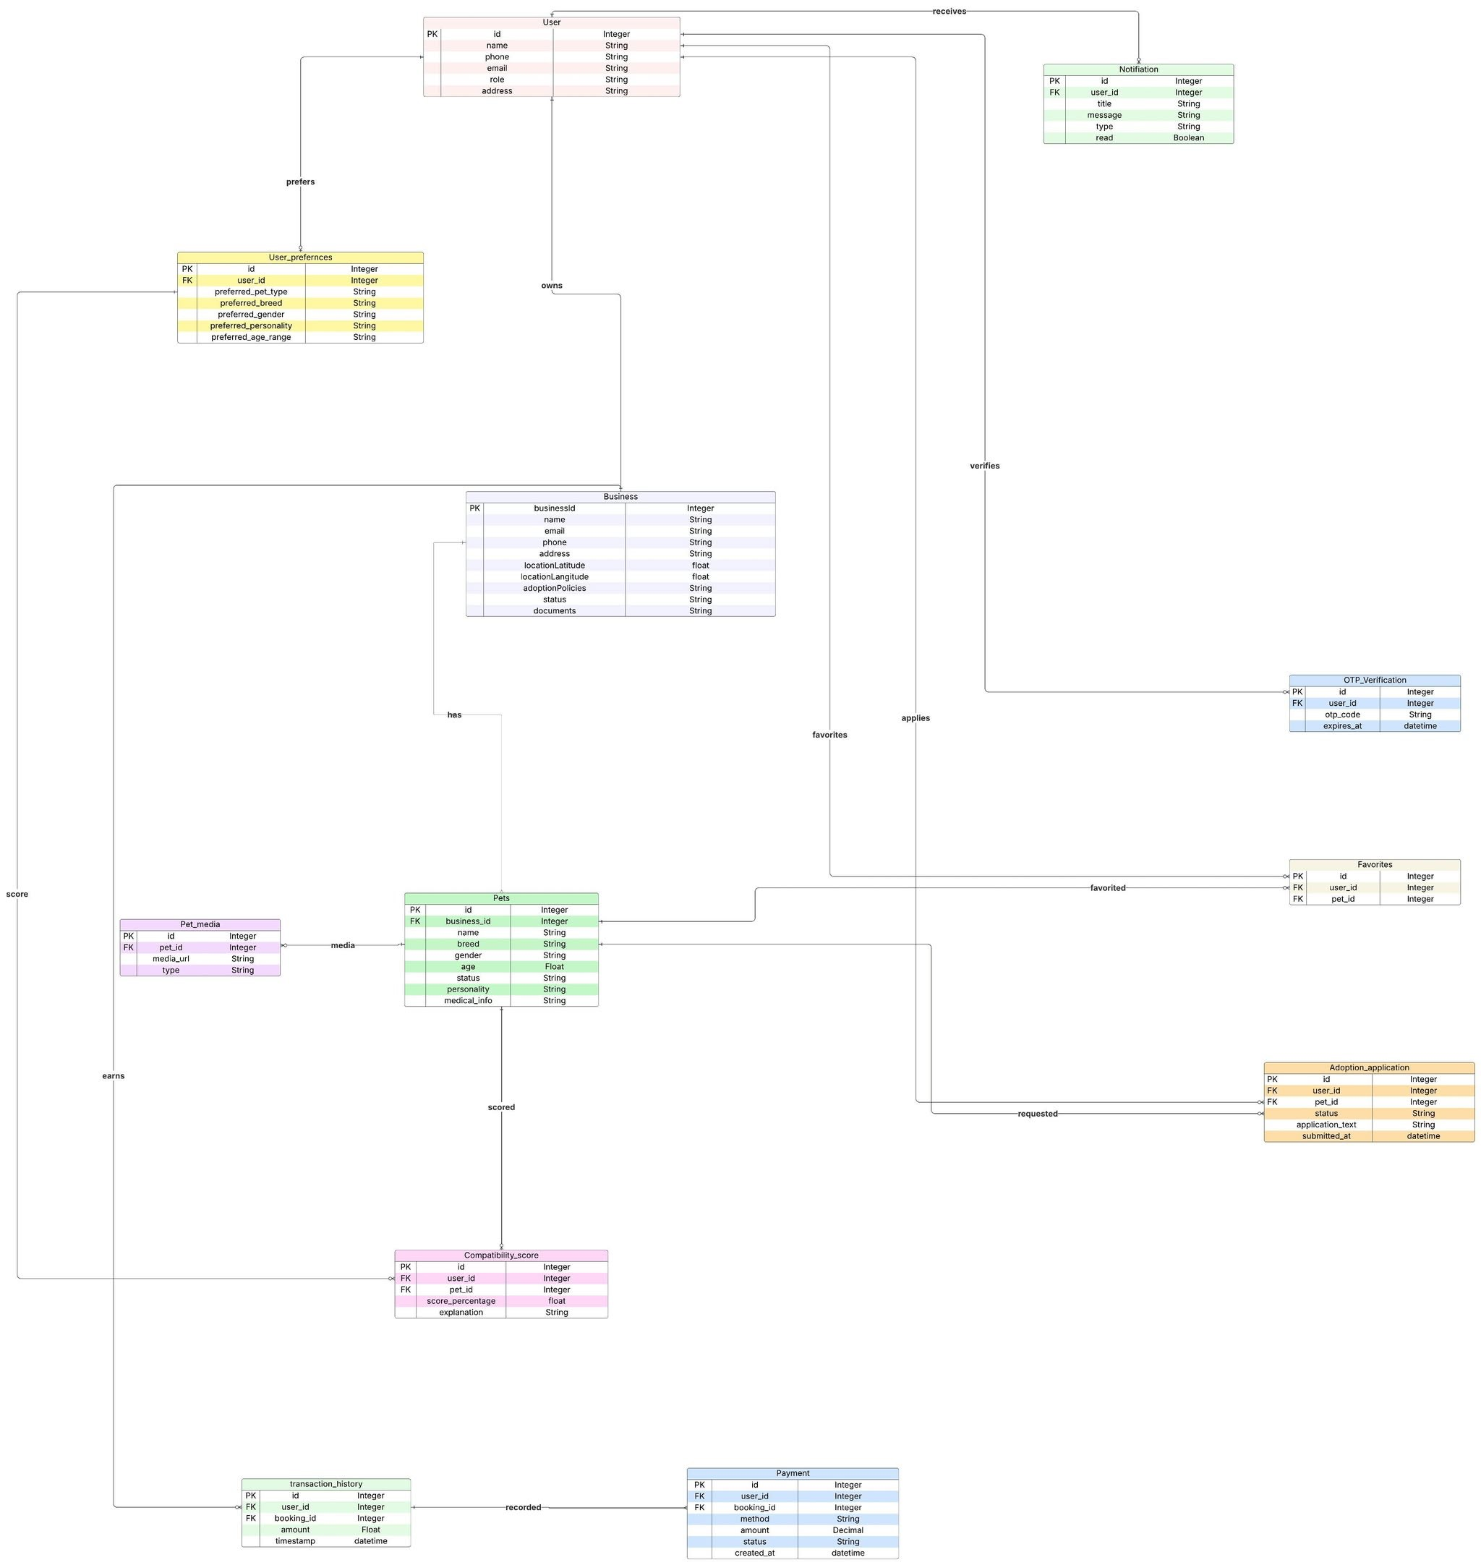

Figure 1: Entity Relationship Diagram

Time Estimation & Scheduling
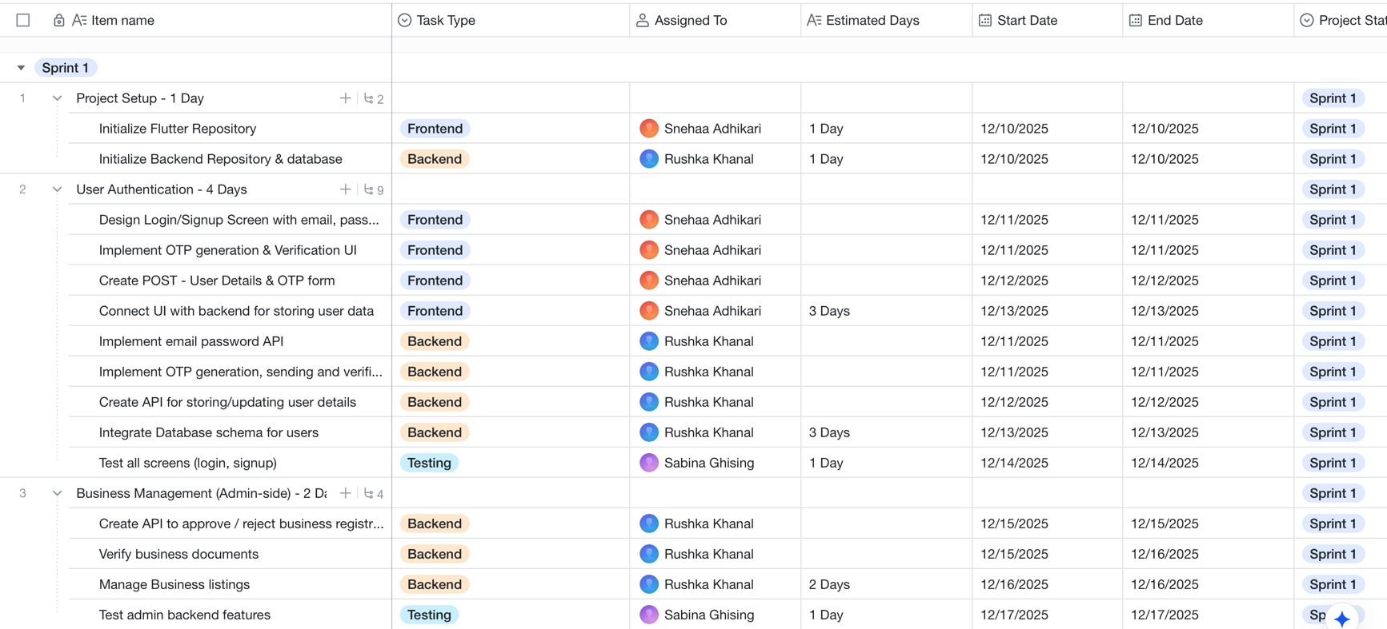
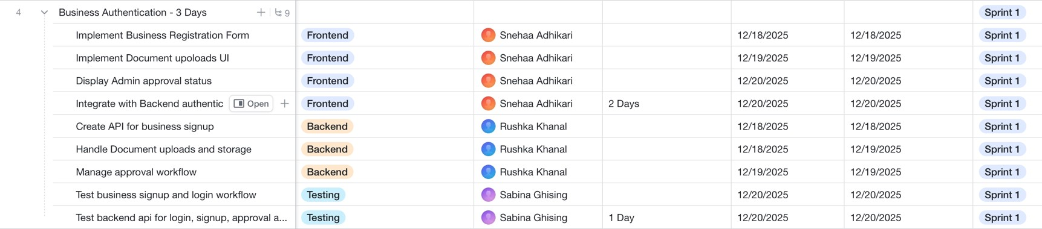
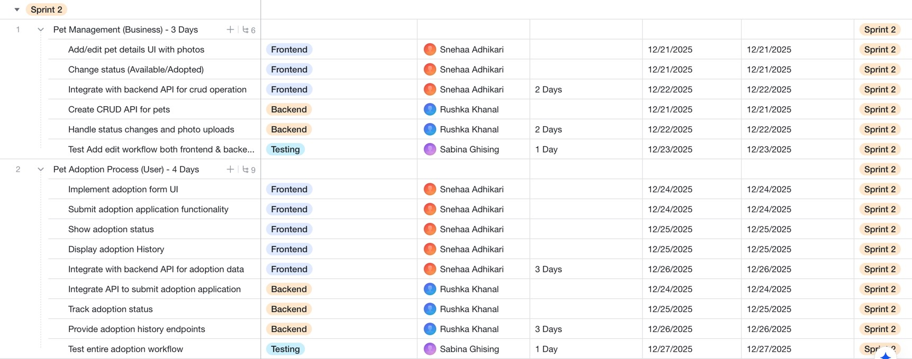

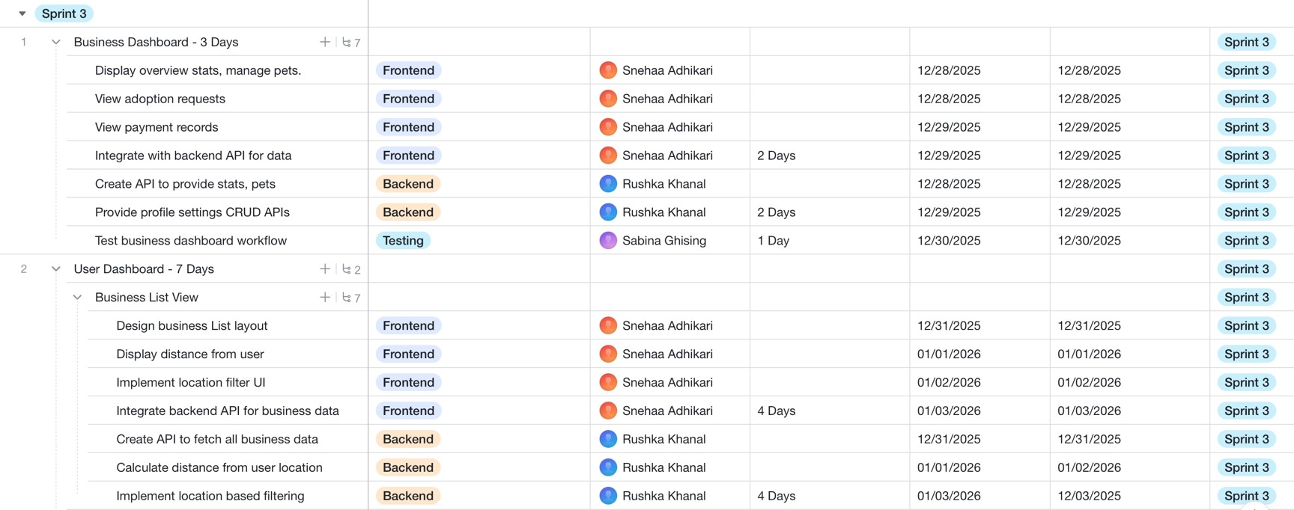
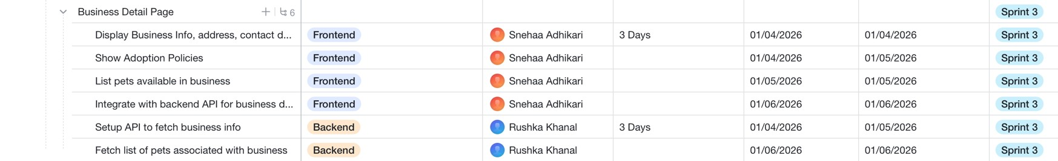
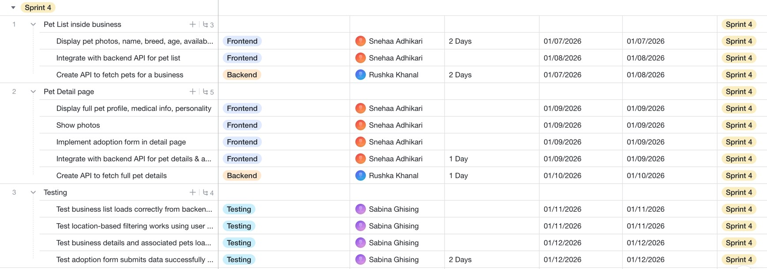
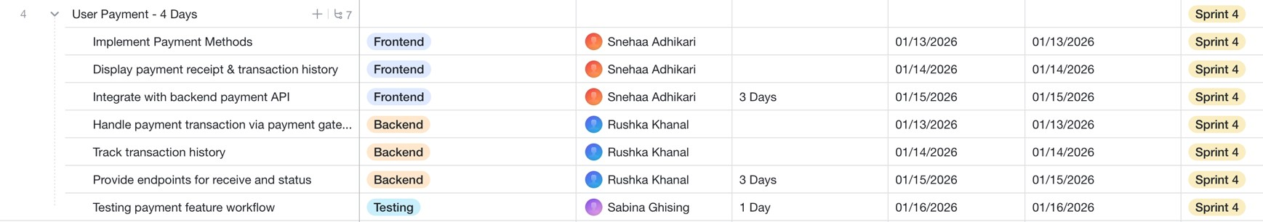
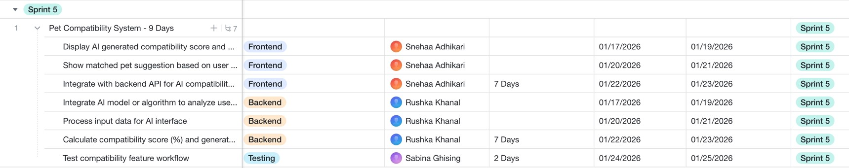

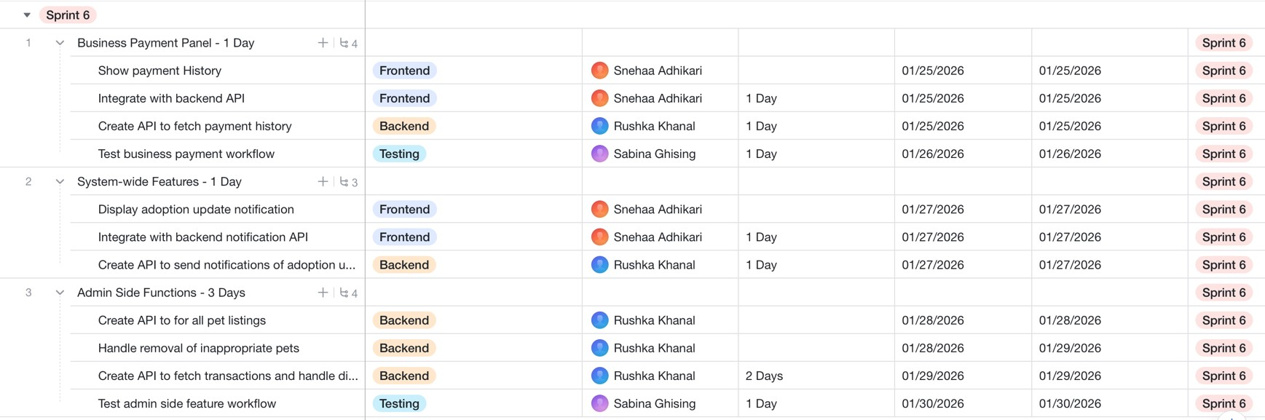

Figure 2: Time Estimation and Scheduling

Gantt Chart
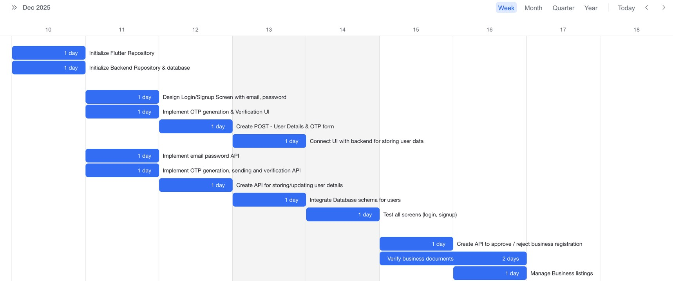

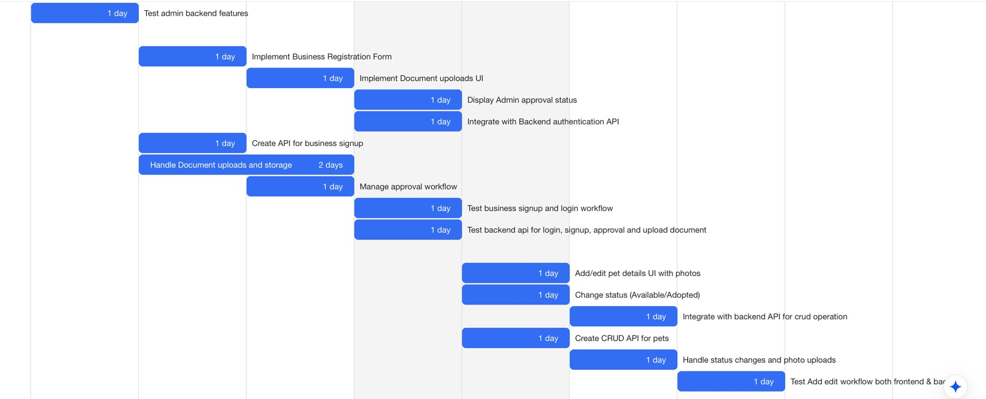

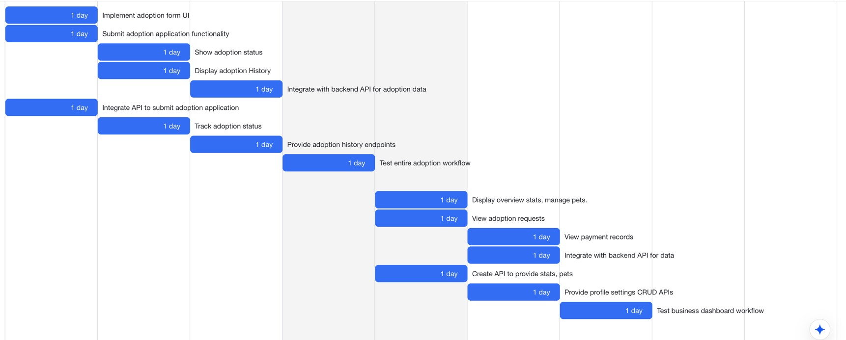
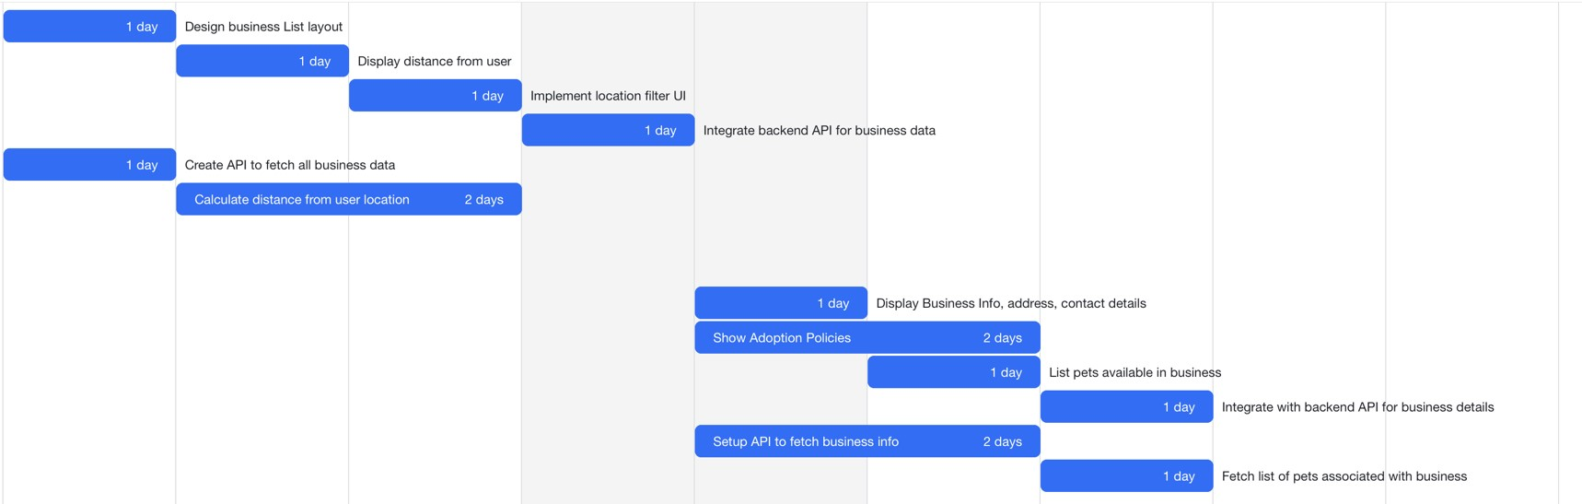
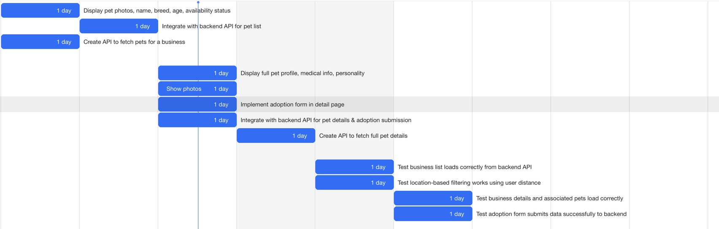

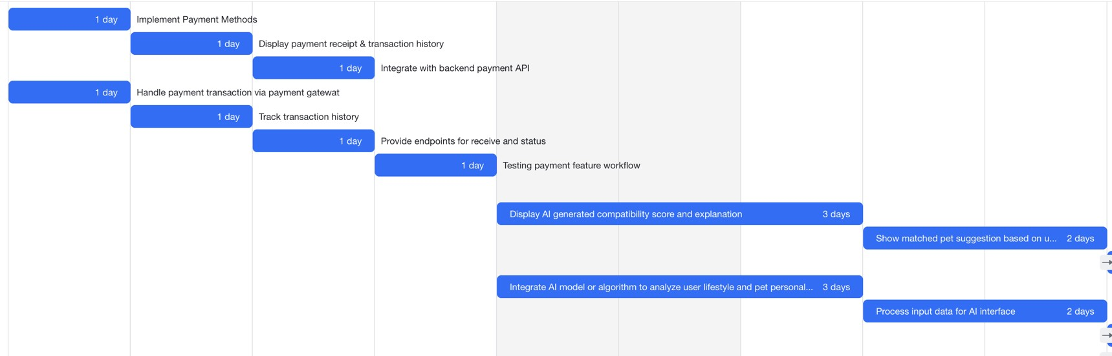
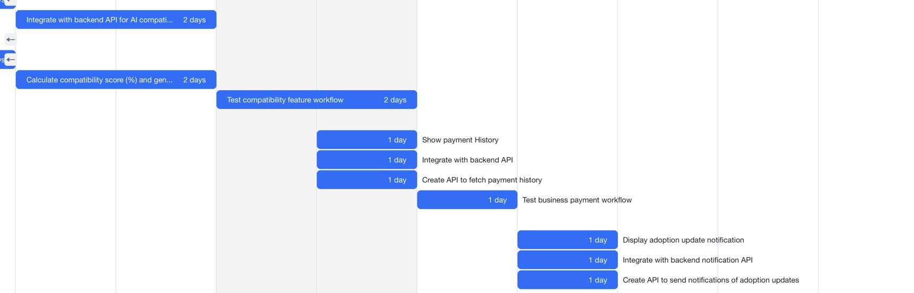
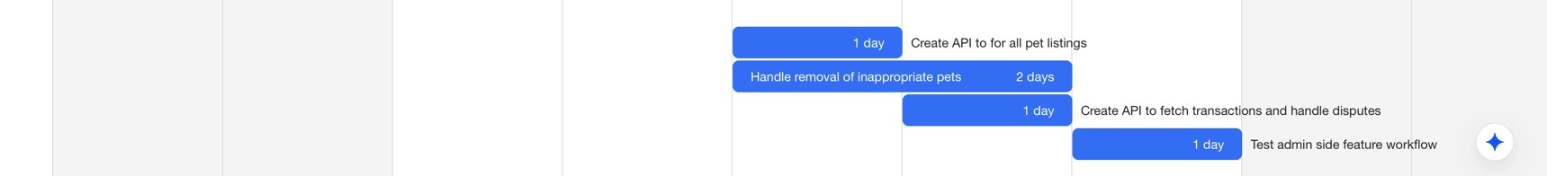

Figure 3: Gantt Chart

System Architecture

Architecture Overview
PetConnect follows a client–server architecture, where a mobile frontend communicates with backend microservices via RESTful APIs over HTTPS. The frontend, developed in Flutter using Clean Architecture principles and Riverpod for state management, ensures modularity, maintainability, and responsive UI updates.
The backend, implemented in Node.js with Express, follows a layered architecture within each microservice. Core microservices include Authentication, Pet Management, Business Management, Adoption Management, AI Compatibility, Payment, and Admin Management. Event-driven communication using RabbitMQ decouples services and supports asynchronous workflows, while Redis caching optimizes response times for frequently accessed data. Controller layers enforce authentication and business rules, ensuring security and proper data handling.
This architecture enables scalability, high performance, and clean separation of concerns across frontend and backend layers.
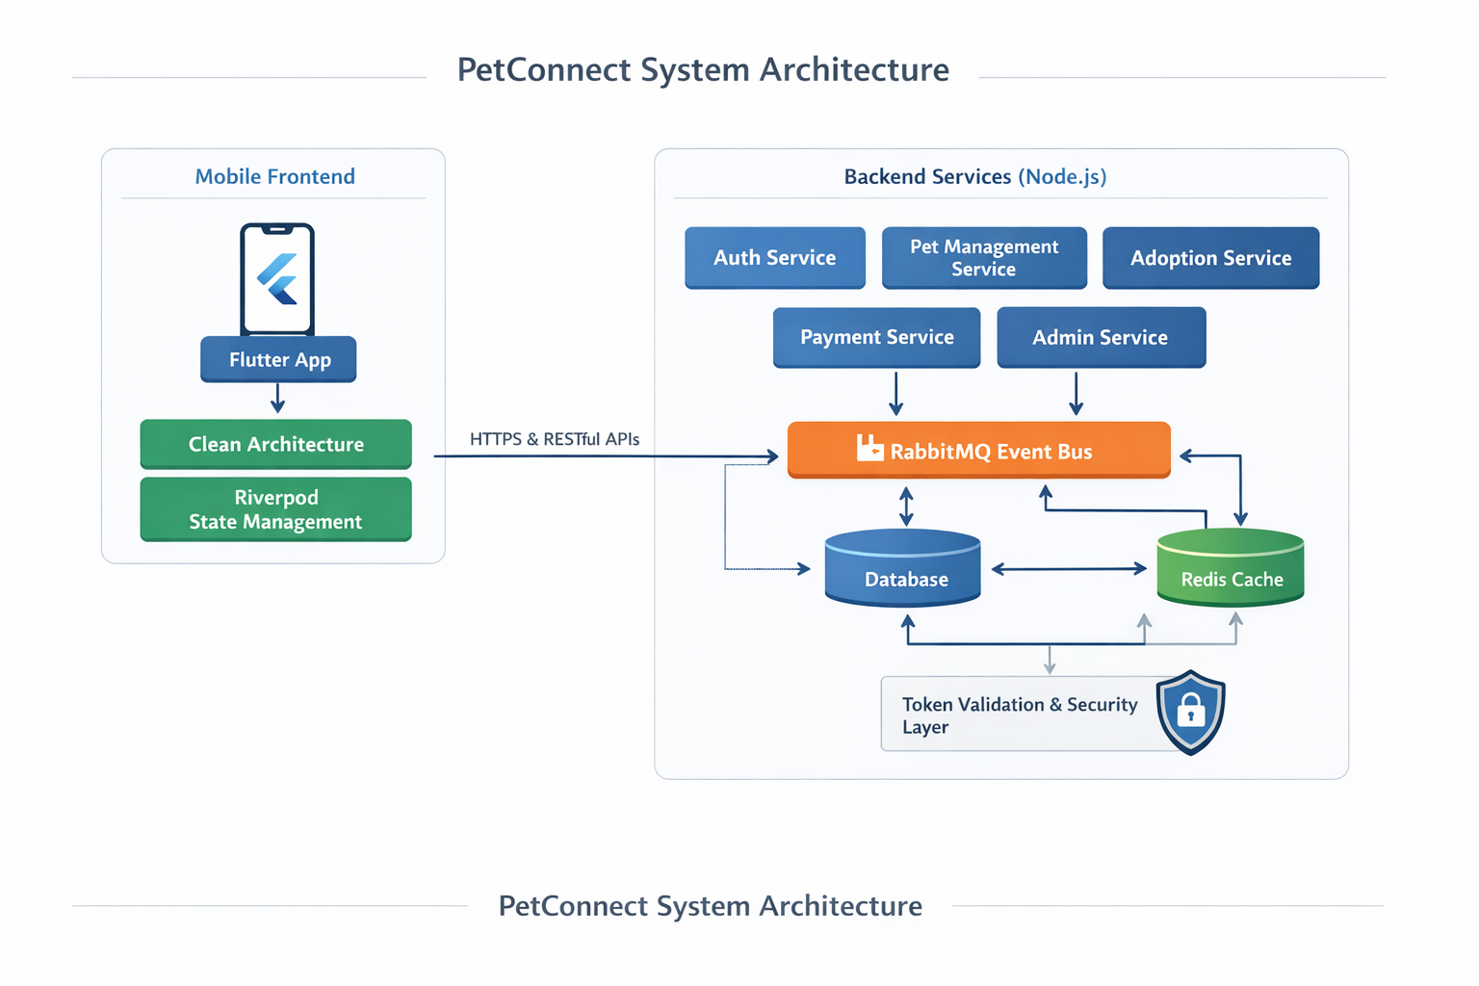

Figure 4: System Architecture

Frontend Architecture & Technologies
PetConnect’s frontend is built using the Flutter framework, enabling cross-platform mobile, web, and desktop applications from a single codebase. The code follows a feature-based structure, organizing modules by functional domains such as authentication, shelter browsing, pet listings, adoption management, and dashboards. State management is handled using Riverpod, employing providers like StateProvider, FutureProvider, and StateNotifierProvider to manage simple, asynchronous, and complex state. Scoped providers ensure isolated, memory-safe state management, improving performance and maintainability while allowing multiple developers to work on separate features concurrently.

Backend Architecture a& Technologies
The backend is implemented in Node.js with the Express framework and follows a microservices architecture. Core services include Authentication, Pet Management, Business Management, Adoption Management, AI Compatibility, Payment, and Admin Management. Each service follows a layered pattern: the controller layer handles HTTP requests and authentication, the service layer implements business logic, and the repository layer abstracts database operations. Communication between services and the frontend occurs over RESTful APIs, with event-driven messaging via RabbitMQ and caching handled by Redis to ensure scalability and responsiveness.

Database Design
PetConnect uses MongoDB as its database, supporting flexible document-based storage for the system’s entities. Key collections include Users, Businesses, Pets, Adoption, Compatibility, Notification, Wallet and Payments. Each document stores structured data relevant to its domain, such as user profiles, pet attributes, and transaction records. Relationships between collections are carefully designed to ensure data consistency while leveraging MongoDB’s flexible schema to handle evolving application requirements efficiently.

API Communication Flow
PetConnect’s backend exposes RESTful APIs, structuring endpoints around core resources such as users, pets, shelters, and adoption applications. Each API follows standard HTTP methods to perform operations: POST for creating resources, GET for retrieving data, PUT/PATCH for updates, and DELETE for removals. Authentication flows start with user registration via POST requests and OTP verification, after which all requests include JWT access tokens in the Authorization header. Pet browsing and adoption workflows illustrate multi-step API orchestration, such as fetching shelter lists, selecting specific shelters, and retrieving paginated pet data, ensuring efficient data transfer and consistent client–server interaction.

Security Considerations
Security is integrated across all layers of PetConnect. User passwords are securely hashed with bcrypt, while JSON Web Tokens (JWT) with cryptographic signatures ensure tamper-proof authentication. Role-based access control (RBAC) enforces permissions for adopters, shelter operators, and system administrators. All data in transit is encrypted over HTTPS using TLS, and sensitive information stored in the database is protected using field-level encryption where required. Additional measures, such as input validation and proper error handling, mitigate common web vulnerabilities.

Security Considerations
PetConnect is designed for scalable and high-performance operation. The microservices architecture allows independent scaling of services based on workload, while Redis provides an in-memory caching layer to reduce database load and speed up frequent queries. Event-driven processing using RabbitMQ offloads time-intensive operations, improving response times for users. Database performance is optimized through indexing, query tuning, and connection pooling, ensuring the system can handle growing adoption activity and concurrent users efficiently.

Engineering Management Aspects

Software Development Methodology
The PetConnect project adopted the Agile Scrum methodology as the primary framework for software development. This iterative and incremental approach aligns naturally with the project’s characteristics, including evolving requirements, multiple stakeholders, distributed team collaboration, and complex functionality across the frontend and backend. Scrum enabled the team to deliver working software continuously, respond quickly to requirement changes, and maintain transparent progress tracking through established ceremonies and artifacts.
The Scrum implementation consisted of two-week sprints, providing sufficient time for meaningful development while ensuring frequent opportunities for review and adaptation. Key ceremonies included sprint planning, daily standups, sprint reviews, and sprint retrospectives, ensuring that the team remained coordinated, informed, and productive throughout the development lifecycle.

Justification for Methodology Selection
Agile Scrum was chosen due to several compelling factors:
- Evolving Requirements: Features such as AI-based pet compatibility and Khalti payment integration required frequent refinements, which Scrum accommodates through backlog refinement and sprint-level commitments.
- Complex Architecture: The microservices-based backend has multiple integration points, demanding continuous validation of service interactions.
- Incremental Delivery: Scrum supports delivering potentially shippable increments at the end of each sprint, which aligns with the modular nature of both frontend and backend components.
- Risk Mitigation: Frequent sprint reviews and retrospectives enabled early detection of integration, performance, and security issues.
- Parallel Development: The feature-based frontend and microservices backend allowed multiple team members to work simultaneously without blocking each other.

Sprint Planning, Estimation and Scheduling
Sprint planning involved selecting high-priority backlog items, defining sprint goals, and breaking tasks into manageable subtasks. Each task was assigned story points to represent effort, complexity, and risk, ensuring realistic workload allocation.
Sprints were timeboxed to two weeks, balancing delivery pace with adequate time for testing and integration. The team followed a pull-based task assignment model, allowing members to take ownership of features while maintaining flexibility to adapt to emerging challenges. Sprint progress was monitored continuously through daily standups, backlog tracking, and burndown charts to identify and resolve bottlenecks early.

Team Composition & Task Distribution
The development team comprised three members: one backend developer, one frontend developer, and one tester. Responsibilities were distributed as follows:
- Frontend Developer: Implemented the Flutter mobile application using Riverpod for state management, organized feature-based modules, and ensured responsive UI behaviour.
- Backend Developer: Developed Node.js microservices following layered architecture patterns, implemented RESTful APIs, integrated RabbitMQ for event-driven workflows, and handled Redis caching.
- Tester: Conducted integration testing using Postman to validate cross-service communication, end-to-end adoption workflows, and payment transactions.
The team practiced cross-functional collaboration, with overlapping responsibilities to encourage skill sharing and continuous learning. Task allocation promoted ownership, accountability, and effective parallel development.

Risk Identification & Mitigation
Several project risks were identified and actively mitigated:
- Technical Risks: Integration challenges among microservices were addressed through contract-first API design and continuous integration testing.
- Performance Risks: Profiling, caching with Redis, and load testing ensured the system could handle concurrent users and high traffic.
- Security Risks: Secure coding practices, role-based access control, JWT authentication, and vulnerability scanning mitigated potential threats.
- Schedule Risks: Conservative sprint commitments and backlog prioritization helped manage delivery deadlines.
- Team-related Risks: Pair programming, cross-training, and knowledge sharing reduced single points of failure.

Version Control & Collaboration Practices
Version control was managed using Git and GitHub, supporting parallel development, detailed history tracking, and branch isolation. The team followed a modified Git Flow, with main, develop, and feature branches, and enforced atomic, well-documented commits. Pull requests and code reviews promoted quality, knowledge sharing, and early detection of issues.
Collaboration extended beyond version control to project management tools, documentation wikis, and communication channels. Although CI/CD pipelines were not implemented, the team maintained consistent build and testing practices using Docker containers and structured development environments.

Quality Assurance & Testing Strategy
Quality assurance prioritized prevention over detection, integrating testing into the development workflow. Testing included:
- Integration Testing: The primary strategy, validating end-to-end workflows across microservices.
- Test Case Design: Employed equivalence partitioning, boundary value analysis, and state-transition testing to ensure functional correctness.
- Automation Potential: While automated CI/CD was not implemented, test cases were structured for repeatability.
- Frontend Testing: Currently minimal; widget testing could be added to verify UI behaviour under various states.
Critical end-to-end scenarios tested included user authentication, adoption workflows, pet browsing under load, and payment processing, ensuring that integration and asynchronous events functioned as expected.

Implementation Details

Frontend Implementation Overview
The frontend of PetConnect is built using the Flutter framework, delivering responsive, intuitive, and feature-rich interfaces across mobile platforms. The architecture follows a feature-based modular structure, enabling independent development and maintenance of core functionalities.
- Authentication Module: Supports user registration with OTP verification, secure login, and session management.
- Shelter Browsing Module: Allows users to explore shelters through list and detail views with filtering and search functionality.
- Pet Discovery Module: Provides detailed pet profiles, advanced filtering, and compatibility scoring to enhance adoption matching.
- Adoption Workflows: Guides users through multi-step adoption applications with real-time status tracking.
- User Dashboards: Aggregates personalized information, including adopted pets, pending applications, and favorites.
- Payment Integration: Implements a custom payment system for adoption fees with secure transaction processing, confirmation, and status updates.
- Business Interfaces: Allows shelter administrators to manage pet listings, track adoption applications, and monitor operational activities.
State management is handled using Riverpod, with providers like StateProvider, FutureProvider, and StateNotifierProvider to manage simple, asynchronous, and complex states. Scoped providers ensure memory-safe and efficient state updates while minimizing unnecessary widget rebuilds.

Backend Implementation Overview
The backend is structured as independent Node.js microservices using the Express framework. Each service encapsulates a specific domain, supporting scalability, maintainability, and event-driven workflows.
- Authentication Service: Handles user registration, credential verification, OTP generation/validation, and JWT token issuance.
- Pet Management Service: Provides CRUD operations on pets, advanced querying, and management of biological, medical, and personality attributes.
- Adoption Service: Orchestrates the end-to-end adoption workflow, from application submission through administrative review, approval, and status updates.
- AI Compatibility Service: Implements matching algorithms analysing adopter preferences and pet characteristics to generate compatibility scores.
- Payment Service: Implements a custom, internal payment mechanism handling transaction initiation, confirmation, and adoption workflow integration without relying on third-party gateways.
- Notification Service: Handles asynchronous communication, delivering notifications for adoption status updates, payments, and other system events to users and shelter administrators.
- Admin Service: Provides platform oversight, including user management, shelter verification, adoption analytics, and payment monitoring.
The backend leverages MongoDB for flexible document storage, Redis for caching frequently accessed data, and RabbitMQ for asynchronous event-driven communication between services. This structure ensures high performance, reliability, and smooth orchestration of all adoption-related processes across microservices.

Key Modules and Workflow
PetConnect demonstrates effective orchestration of microservices through several key workflows:
- Adoption Workflow: Cross-service coordination from application submission, shelter administrator review, custom payment processing, to final adoption confirmation.
- Compatibility Scoring Workflow: AI-based analysis combining user and pet data to provide adoption recommendations.
- Business Registration Workflow: Shelter onboarding with administrative verification and automated data handling.
- Notification Delivery Workflow: Asynchronous event processing for system notifications, adoption updates, and user alerts through appropriate channels.
These workflows highlight the benefits of event-driven architecture, decoupled services, and scalable integration.

Integration Between Frontend and Backend
Frontend-backend communication follows RESTful patterns with JSON serialization and JWT-based authentication. Key integration features include:
- Repository Classes: Encapsulate API communication, providing clean interfaces to frontend business logic.
- HTTP Client Configuration: Includes request/response interceptors for error handling, logging, and token management.
- Data Serialization: Converts JSON responses into typed domain objects for type-safe application logic.
- Error Handling: Differentiates between expected validation errors and unexpected system failures.
- State Synchronization: Optimistic UI updates with background reconciliation for seamless user experience.
- File Uploads: Handles multipart form data for pet images, documents, and user uploads.
- Pagination and Filtering: Integrates frontend controls with backend query parameters for efficient navigation through large datasets.
This integration ensures a smooth, responsive, and secure experience for end-users while maintaining maintainable and scalable code on both client and server sides.

Testing and Validation

Testing Approach
The PetConnect project emphasized integration testing as the primary validation strategy, reflecting the distributed microservices architecture. The approach focused on verifying service-to-service interactions, frontend-backend communication, database consistency, and event-driven workflows under realistic conditions.
Key aspects of the testing environment included:
- Service Coverage: All core services (Authentication, Pet Management, Adoption, Payment, Notification, Business Management) were tested in isolation and as part of end-to-end workflows.
- Test Environment: Replicated production architecture with isolated test databases and environment-specific configurations to avoid data contamination.
- Validation Scope: Included RESTful API validation, JSON payload verification, token-based authentication flows, asynchronous event handling via RabbitMQ, and Redis cache consistency.
- Frontend Consideration: While the frontend did not have full automated tests, the integration tests validated the API responses consumed by the Flutter app, ensuring functional correctness from the client perspective. Widget testing may be added in future iterations to verify UI state handling.

Test Case Design
Test cases were designed systematically to cover functional, edge, and error scenarios:
- User Story-Based Testing: Each feature’s acceptance criteria provided the basis for test cases, covering both happy paths and alternative paths.
- Adoption Workflow: Scenarios included application submission, approval/rejection, payment processing, notification delivery, and final adoption confirmation.
- API Contract Validation: Endpoints were tested for adherence to expected request/response formats, including field names, status codes, and error handling.
- Data-Driven Testing: Separated input data from test logic, allowing multiple scenarios to be validated efficiently.
- Boundary and Equivalence Testing: Ensured inputs at extreme or representative values were correctly handled, preventing unexpected failures.

Validation of Function and Non-FunctionaL Requirements
The validation process confirmed both functional correctness and system quality attributes:
Functional Requirements:
- Verified end-to-end adoption workflows, including user authentication, shelter selection, pet application, payment confirmation, and notifications.
- Tested CRUD operations for pets, users, businesses, and adoption records.
- Confirmed AI compatibility scoring accurately reflected user and pet attributes.
- Ensured custom payment service handled transactions and workflow integration without relying on third-party gateways.
Non-Functional Requirements:
- Performance: Measured API response times, validated Redis caching behavior, and conducted load testing for multiple concurrent requests.
- Security: Verified JWT authentication, role-based access control, and secure data transmission via HTTPS. Vulnerability scanning was used to detect potential threats.
- Reliability: Confirmed asynchronous events were delivered in correct order under various load conditions, including adoption and payment notifications.
- Usability: Manual testing ensured intuitive user interfaces and smooth workflows on the Flutter frontend.

Example Integration Test
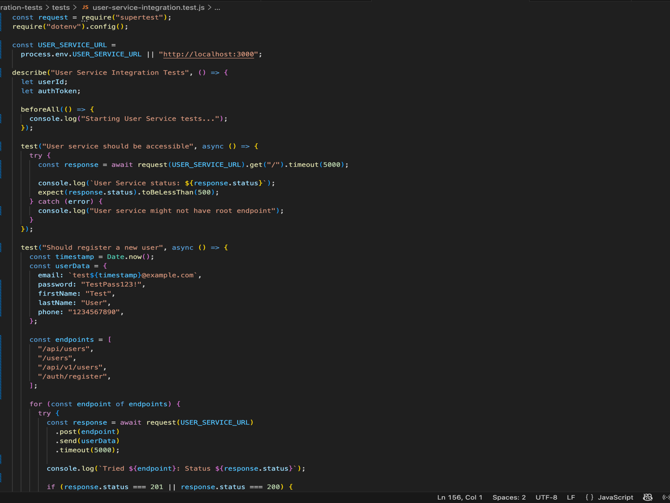

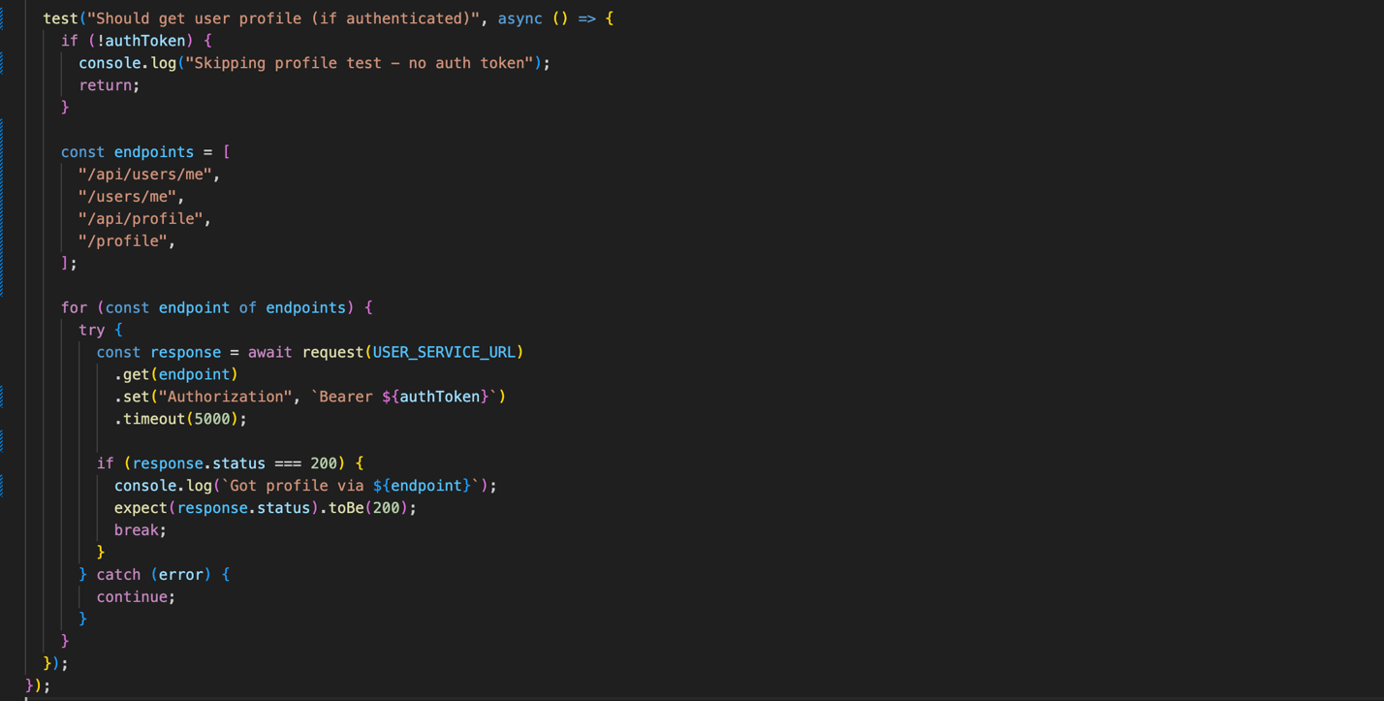
Figure 5: Testing

Summary
The integration testing strategy ensured robust validation of PetConnect’s microservices interactions, workflows, and data integrity. By focusing on end-to-end scenarios, including adoption, payment, and notification flows, the team could detect and resolve issues that unit testing alone would not capture. This testing approach guarantees that both functional and non-functional requirements are met, providing a reliable and secure adoption platform.

Results and Discussions

System Functionality Evaluation
The implemented PetConnect system successfully delivers a comprehensive suite of features aligned with the project’s objectives and stakeholder requirements. Key functional achievements include:
- End-to-End Adoption Workflow: Users can browse shelters, view pets with detailed profiles, submit adoption applications, complete payment, and receive confirmation notifications.
- Shelter Management: Centralized interfaces empower shelter administrators to manage pet listings, track applications, and update adoption statuses efficiently.
- Administrative Oversight: Admin services provide governance capabilities, including user and business verification, transaction monitoring, and reporting.
- AI Compatibility Scoring: Intelligent matching evaluates adopter preferences against pet characteristics, providing transparency and recommendation guidance.
- Payment Processing: The integrated, internal payment mechanism ensures secure and reliable adoption fee processing without relying on external gateways.
Overall, PetConnect realizes the vision of a unified pet adoption ecosystem, providing functionalities beyond traditional adoption platforms and streamlining operational workflows for adopters, shelters, and administrators.

Performance and Usability Analysis
Performance testing and usability evaluation demonstrate robust system behavior:
- Response Times: RESTful API endpoints exhibit latencies below 500 milliseconds under standard load conditions, ensuring smooth user interactions.
- Caching Benefits: Redis caching effectively reduces repeated database queries, leading to high cache hit rates and accelerated data retrieval.
- Scalability: Load testing confirms the system can handle multiple concurrent users, while database connection pooling prevents resource exhaustion.
- Usability: User interfaces are intuitive, responsive, and consistent across mobile, web, and desktop platforms. Users can complete tasks efficiently, while compatibility scoring enhances engagement and decision-making.
- Error Handling: Clear feedback is provided for failures, including invalid inputs, expired OTPs, or failed transactions, improving user trust and experience.

Limitations Of the System
Despite successful delivery of core functionalities, several limitations were identified, which also serve as opportunities for future enhancements:
- AI Compatibility: Currently employs rule-based algorithms rather than advanced machine learning models, limiting predictive accuracy.
- Notification System: Lacks real-time push notifications on mobile devices.
- Search Capabilities: Could benefit from semantic search, recommendations, and personalized filters.
- Communication: No integrated messaging or video consultation between adopters and shelters.
- Analytics: Dashboards are basic; advanced analytics for trend analysis and adoption insights are not implemented.
- Platform Coverage: Native mobile applications were excluded from initial development; internationalization is limited to English.

Conclusion and Future Enhancements

Summary of Achievements
The PetConnect project successfully delivered an integrated, modern pet adoption platform. Notable achievements include:
- Technical: Implementation of microservices architecture, event-driven workflows using RabbitMQ, Redis caching, and secure RESTful APIs.
- Frontend: Responsive, feature-rich Flutter interfaces with Riverpod state management and modular feature-based architecture.
- Functional: Complete adoption workflows, shelter management, AI compatibility scoring, internal payment processing, and administrative oversight.
- Process: Effective application of Agile Scrum methodology, enabling iterative delivery, backlog-driven prioritization, and continuous improvement.

Learning Outcomes
Team members gained extensive technical and professional experience:
- Distributed systems architecture expertise, including microservices and event-driven design.
- Frontend development proficiency with Flutter and advanced state management.
- Backend skills in Node.js, MongoDB, RESTful API design, and performance optimization.
- Practical experience with Agile Scrum, sprint planning, and incremental delivery.
- Integration testing skills ensuring correctness across distributed services.
- Improved collaboration, code review practices, and knowledge sharing.

Proposed Future Improvements
Future enhancements to PetConnect aim to expand functionality, accessibility, and technical sophistication:
- Advanced AI: Implement machine learning algorithms for more accurate pet-adopter matching.
- Mobile Applications: Develop native mobile apps to enhance performance and user experience.
- Enhanced Communication: Add real-time messaging, video consultations, and notifications.
- Analytics: Advanced dashboards with adoption trends, recommendation insights, and business KPIs.
- Search Improvements: Semantic search, visual similarity, and recommendation engines.
- Social Features: Community interactions, reviews, and sharing options to increase engagement.
- Ecosystem Integrations: Integration with veterinary services, pet supply retailers, and other external platforms.
- Internationalization: Multi-language support to expand accessibility globally.
These improvements ensure PetConnect evolves into a feature-rich, scalable, and globally accessible platform, setting a strong foundation for future adoption ecosystem innovations.

References
Bass, L., Clements, P., & Kazman, R. (2021). Software architecture in practice (4th ed.). AddisonWesley Professional.
Beck, K., et al. (2001). Manifesto for Agile software development. Agile Alliance.
https://agilemanifesto.org/
Fowler, M. (2002). Patterns of enterprise application architecture. Addison-Wesley Professional.
Gamma, E., Helm, R., Johnson, R., & Vlissides, J. (1994). Design patterns: Elements of reusable object-oriented software. Addison-Wesley Professional.
Humble, J., & Farley, D. (2010). Continuous delivery: Reliable software releases through build, test, and deployment automation. Addison-Wesley Professional.
Martin, R. C. (2017). Clean architecture: A craftsman's guide to software structure and design. Prentice Hall.
Newman, S. (2021). Building microservices: Designing fine-grained systems (2nd ed.). O'Reilly Media.
Pressman, R. S., & Maxim, B. R. (2020). Software engineering: A practitioner's approach (9th ed.).
McGraw-Hill Education.
Richardson, C. (2018). Microservices patterns: With examples in Java. Manning Publications.
Schwaber, K., & Sutherland, J. (2020). The Scrum guide: The definitive guide to Scrum: The rules of the game. Scrum.org.
Sommerville, I. (2016). Software engineering (10th ed.). Pearson Education.
Express.js Documentation. (2024). Express - Node.js web application framework.
https://expressjs.com/
Flutter Documentation. (2024). Flutter: Build apps for any screen. https://flutter.dev/
Khalti Payment Gateway. (2024). Khalti digital wallet and payment gateway. https://khalti.com/

Node.js Documentation. (2024). Node.js JavaScript runtime. https://nodejs.org/
Redis Documentation. (2024). Redis: The open source in-memory data store. https://redis.io/ Riverpod Documentation. (2024). Riverpod: A reactive caching and data-binding framework.
https://riverpod.dev/

