ReadyAPI Testing:

Import xml file from Readyapi directory under – MilltechFX challenge

Details: TC01_Wrong Country Code:

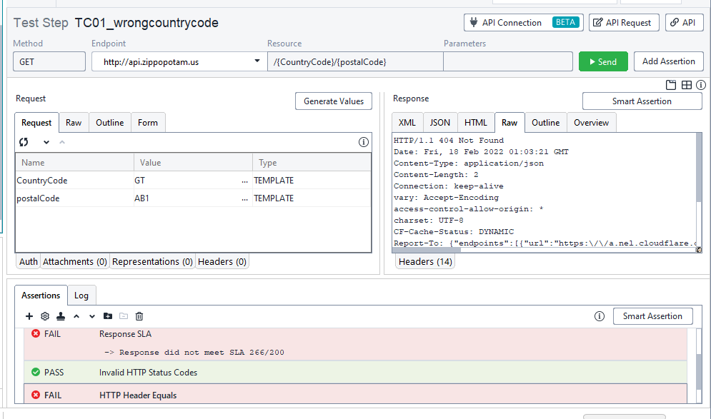

Details: TC02_Match Value:

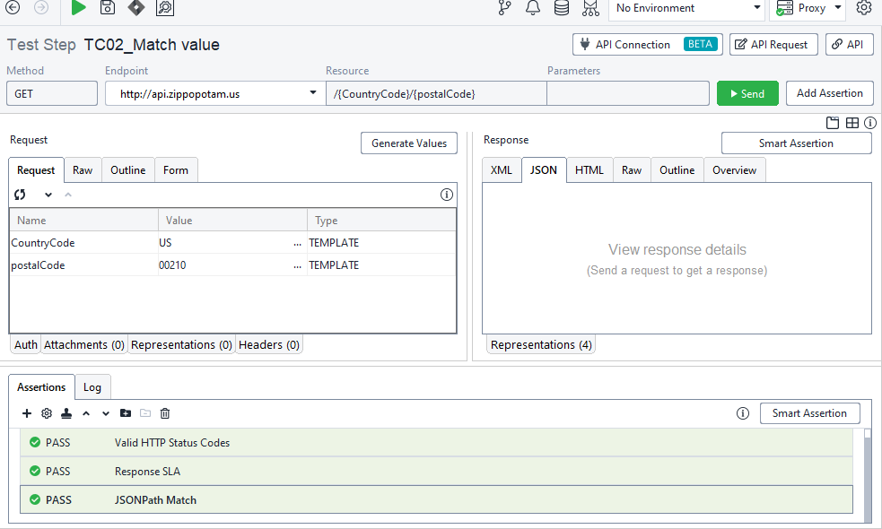

Details: TC03_Display all fields

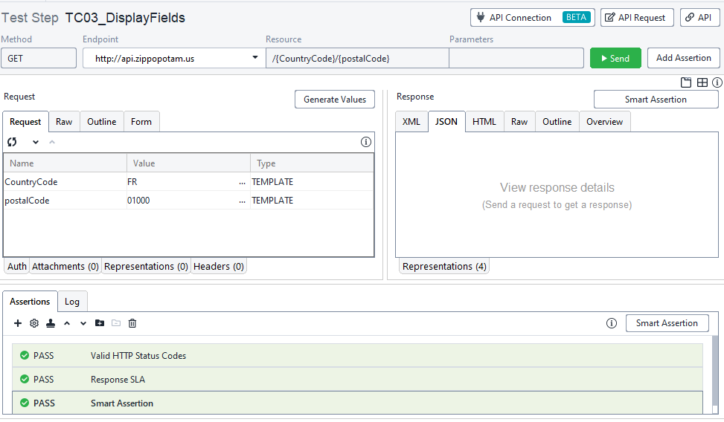

Details: TC04_WrongPost Code

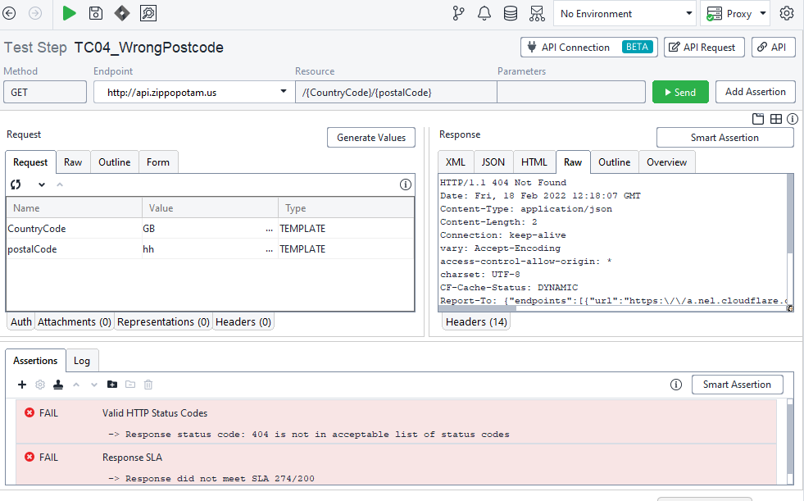

Details: TC05_Places 4 field return

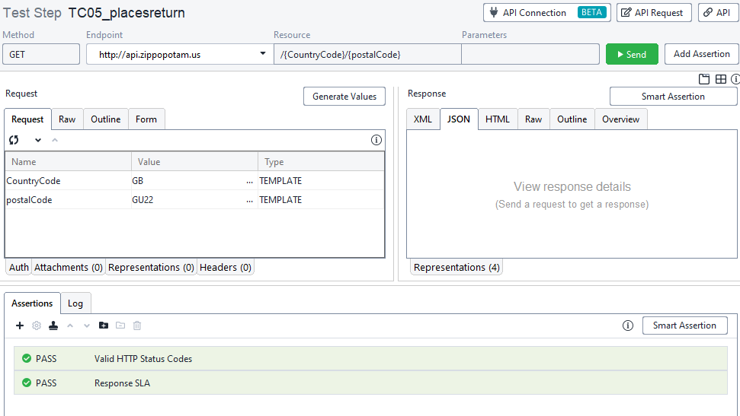

**FOR API TESTING**

1. How would you take scenarios listed above and improve them?

Ans:

1) I will analyse test failure data.

2) I will prioritize the test.

3) I will test the scenarios with all Rest Methods Like Get, Post, Put, Delete.

4) I will write negative test scenarios.

5) I will try to gather all data in Excel file and fetch the data in ReadyApi through the data source (Data Driven Testing)

6) I will match the result with status code and give assertions like Contains Place Name= "working"

7) I will match the results through parameter.

8) I will ensure the Implementation working correctly as expected- no bugs!!

9) I will verify response headers

10) I will execute test cases on different parameters like State and State abbreviation. I will try rest methods like Get post with validate

status codes, payloads.

2. What additional questions would you like to ask the product owner in regards to testing?

Ans:

A product owner is the person in the project team who has very clear vision about the product

and has the capacity of converting his or her product vision into precise agile user stories which

can be prioritized as backlog into the sprint within the team.

As a Tester I would like to ask:

1) Is actual requirement matched with the expected one?

2) Any customer additional requirements.

3) Priorities of product feature to testing.

4) What should we work on next?

5) Is my backlog clear?

3. What additional scenarios would you like to test to check the API is working?

Ans:

API tests effectively become end-to-end tests and should cover a complete user story.

API testing flow is quite simple with three main steps:

*Send the request with necessary input data.

*Get the response having output data.

*Verify that the response returned as expected in the requirement.

Additional Scenarios:

1) I will execute test cases on different parameters like State and State abbreviation.

2) I will use all Rest API methods like Get, Post, Put, delete to test the scenarios.

3) I will insert valid and invalid inputs and check the response codes.

4) I will check response code, response message and response body by using all HTTP methods.

5) I will search with country code, place name, state and input valid invalid data, check response time. I will use assertions.