COVID-19 Early Case Trend Analysis and Recovery Insights
South Korea patient-level records, 20 January to 1 March 2020
Minor Project Report | Prepared 25 October 2026

Executive summary
This project explores 4,212 patient records in the linked early-stage South Korea COVID-19 case file. The file covers confirmations from 20 January 2020 through 01 March 2020. Recorded confirmations rise sharply at the end of February: 2,951 records (70.1%) fall between 27 February and 1 March. The most frequent recorded infection reasons are contact with a known patient and travel to Daegu. Among the 28 records marked released with both dates available, the median time from confirmation to release is 16 days.
The main finding is also the main qualification: many fields are blank and the file is an early snapshot. Only 318 records have sex recorded, 301 have a geographic region, 130 have an infection reason, and 28 have a release date. These results describe the available records and cannot be treated as complete population estimates or reliable predictions.

Key results
Measure | Result
Patient records | 4,212; confirmation dates 20 January 2020 to 01 March 2020
Records confirmed 27 Feb to 1 Mar | 2,951 (70.1% of this file)
Most common recorded reasons | Contact with a patient: 66; visit to Daegu: 40
Confirmation-to-release duration | Median 16 days among 28 released records

Interpretation note: 4,171 of 4,212 records are still labelled isolated in this snapshot. Outcome percentages describe the file at its cutoff, not final recovery or mortality rates.

Project scope and data
The analysis follows the project brief: describe who appears in the case file, summarize recorded infection sources and locations, examine confirmation-to-release time, and assess whether the available variables can support a recovery model. The unit of analysis is one patient record.

Dataset snapshot
Item | Description
Records and fields | 4,212 records and 14 columns, including patient ID
Confirmation dates | 20 January 2020 to 01 March 2020
Recorded status | 4,171 isolated; 28 released; 13 deceased
Age measure | Approximate age = 2020 minus birth year; available for 292 records
Recovery measure | Calendar days from confirmed_date to released_date; available for 28 records

Data completeness
Field | Known records | Missing
sex | 318 | 92.5%
birth year | 292 | 93.1%
region | 305 | 92.8%
infection reason | 130 | 96.9%
infection order | 35 | 99.2%
contact number | 32 | 99.2%
released date | 28 | 99.3%

The dataset has 305 nonblank region values; four are the administrative label 'filtered at airport', leaving 301 geographic labels for the regional comparison. The broad 'capital area' label is not a single province.

Preparation and checks
- Parsed confirmation, release, and death fields as dates; retained blank values as missing instead of filling them with guesses.
- Derived approximate age from birth year using 2020, the year covered by all confirmation records; calculated recovery duration only where both confirmation and release dates exist.
- Patient IDs are unique. No release interval is negative. 4 death-date entries precede their confirmation date by one day and were not used to estimate a death interval.

Who was getting infected and when?
Among the 318 records with sex recorded, 163 are female (51.3%) and 155 are male (48.7%). This is close to an even split in the known subset, but sex is missing for 92.5% of records.
Approximate age is available for 292 records. The median is 48 years and the mean is 46.8 years (range 2 to 83). Because birth year is missing for 93.1% of the file, the age distribution should not be generalized to all patients in the dataset.
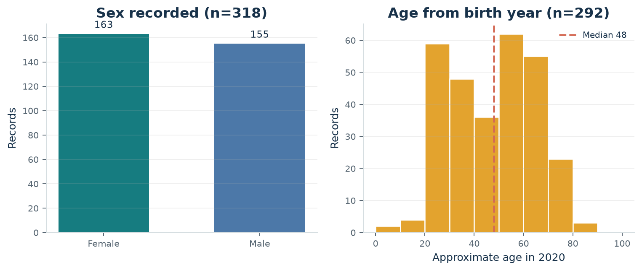
Figure 1. Demographic summaries use records with non-missing values.
All 4,212 records have a confirmation date. The file records 2,951 confirmations from 27 February through 1 March (70.1% of its records), with the largest one-day count on 01 March (1,062). This is the confirmation-date pattern in the supplied patient file, not a separate official national time series.
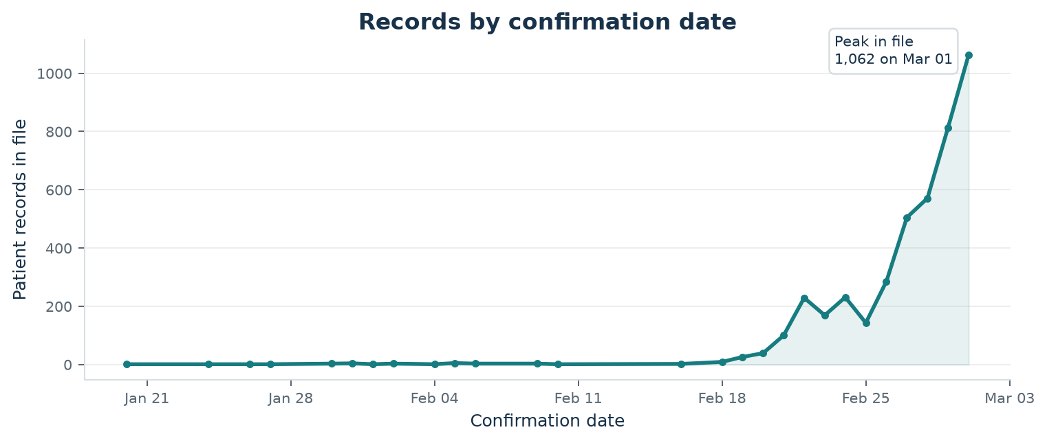
Figure 2. Daily count of patient records in the file by confirmation date.

How were infections spreading and where?
An infection reason is recorded for 130 patients (3.1% of the file). Among these known reasons, 'contact with patient' appears 66 times and 'visit to Daegu' appears 40 times. These are counts among documented reasons; 96.9% of records have no infection reason listed.
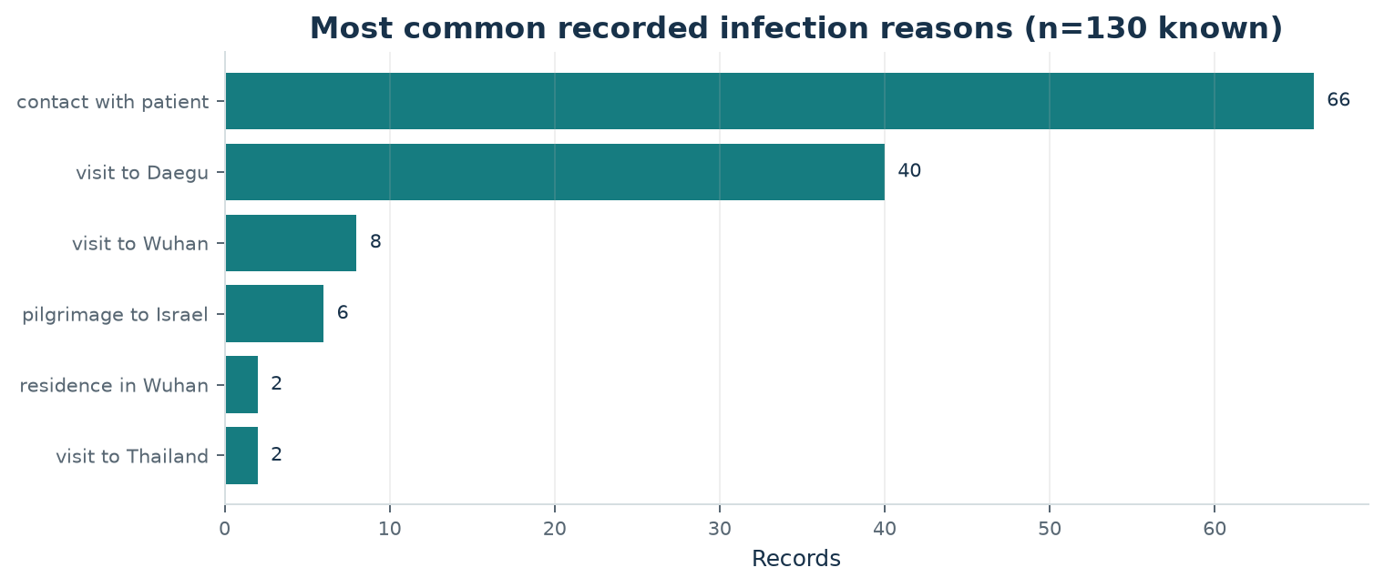
Figure 3. Most frequent documented infection reasons; missing reasons are not plotted.
Infection order is available for 35 records (median 2, range 1 to 6). Contact number is available for 32 records; its median is 16.5 and the range is 0 to 1160. The maximum is much larger than the median, so the median is the more useful typical-value summary.

Regional records and status
Of the 301 records with a geographic region value, the largest labels are Gyeongsangbuk-do (119), capital area (109), and Daegu (34). These labels account for most of the known-region subset, but regional information is missing for 92.8% of all records. The status counts by region are not comparable risk rates because the case file is incomplete and many cases were still isolated at the snapshot date.
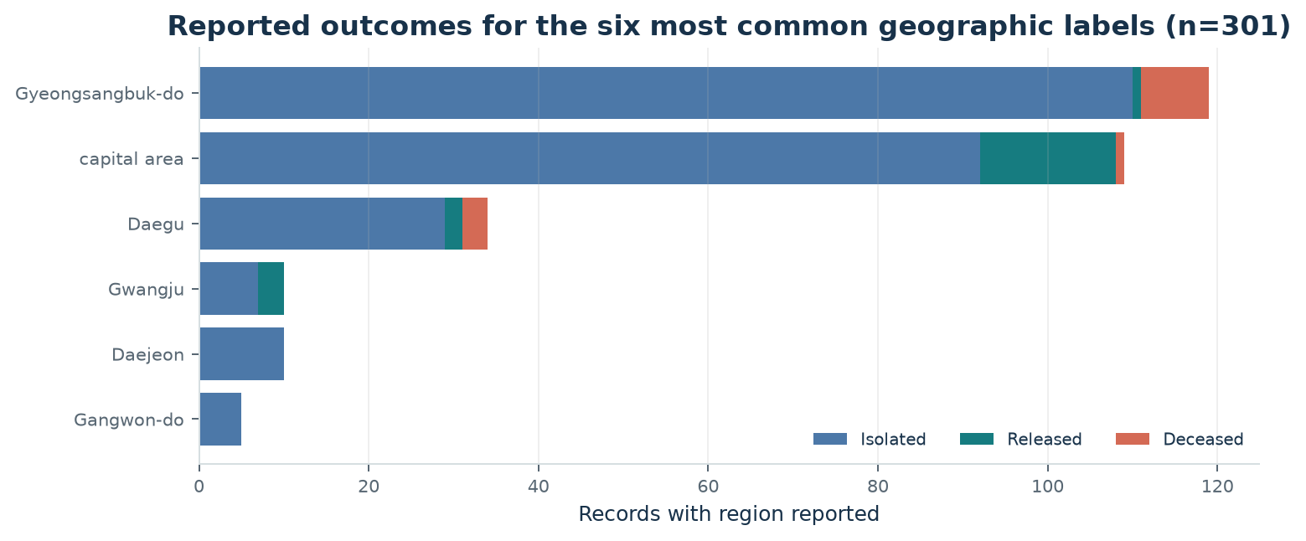
Figure 4. Recorded status counts across the six most common geographic labels; airport-filtered records are excluded.

Recovery patterns and influencing factors
Only 28 records contain both confirmation and release dates. In this small released subset, the median duration is 16 days, the mean is 15.1 days, the middle half ranges from 9.75 to 19.25 days, and the full observed range is 7 to 24 days. This describes the few patients already released by the file cutoff; it is not an estimate for all COVID-19 patients.
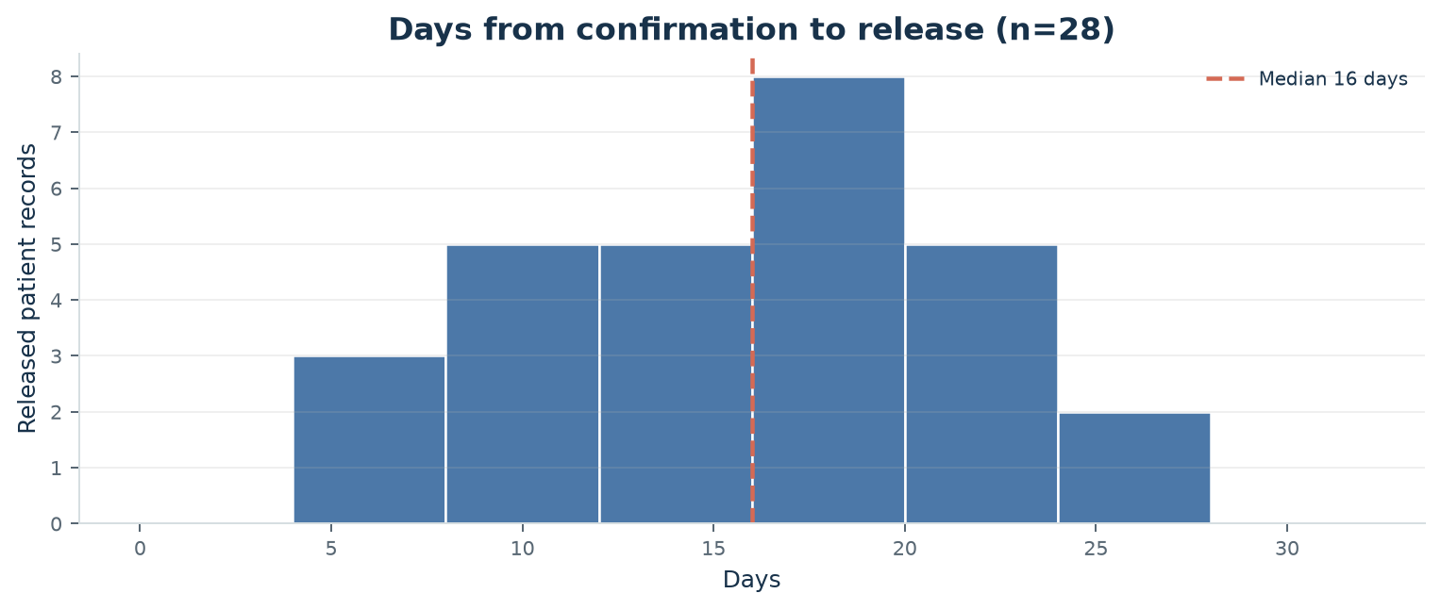
Figure 5. Confirmation-to-release duration among records with both dates available.

Exploratory association check
Variable | Released records with data | Spearman rho
Approximate age | 28 | -0.06
Infection order | 24 | 0.04
Contact number | 24 | -0.21

The rank correlations are close to zero for age and infection order, and weakly negative for contact number. They are descriptive only: the released sample is small, predictor data are incomplete, and this dataset cannot establish that any factor changes recovery time. A linear regression model was not fitted because it would be unstable and misleading with only 28 released cases (24 with infection order and contact number recorded).

Conclusion and recommendations
- The file shows a marked increase in recorded confirmations at the end of February 2020, and documented infection reasons most often name contact with a patient or a visit to Daegu.
- Among the 28 released records with dates, the median confirmation-to-release interval is 16 days. The available evidence is too limited for reliable recovery-time prediction.
- For stronger public-health comparisons, use a complete case list with consistent region definitions and routinely recorded sex, age, infection source, infection order, contact count, and final outcome dates.

References
1. Data Science Minor Project brief supplied for this project, 'COVID-19 Early Case Trend Analysis & Recovery Insights.'
2. Patient-level case dataset linked in the project brief: https://drive.google.com/file/d/1TXoqikmE0S3LGem8Ig-GktaJJyZPGMgN/view?usp=sharing (accessed 25 October 2026).

