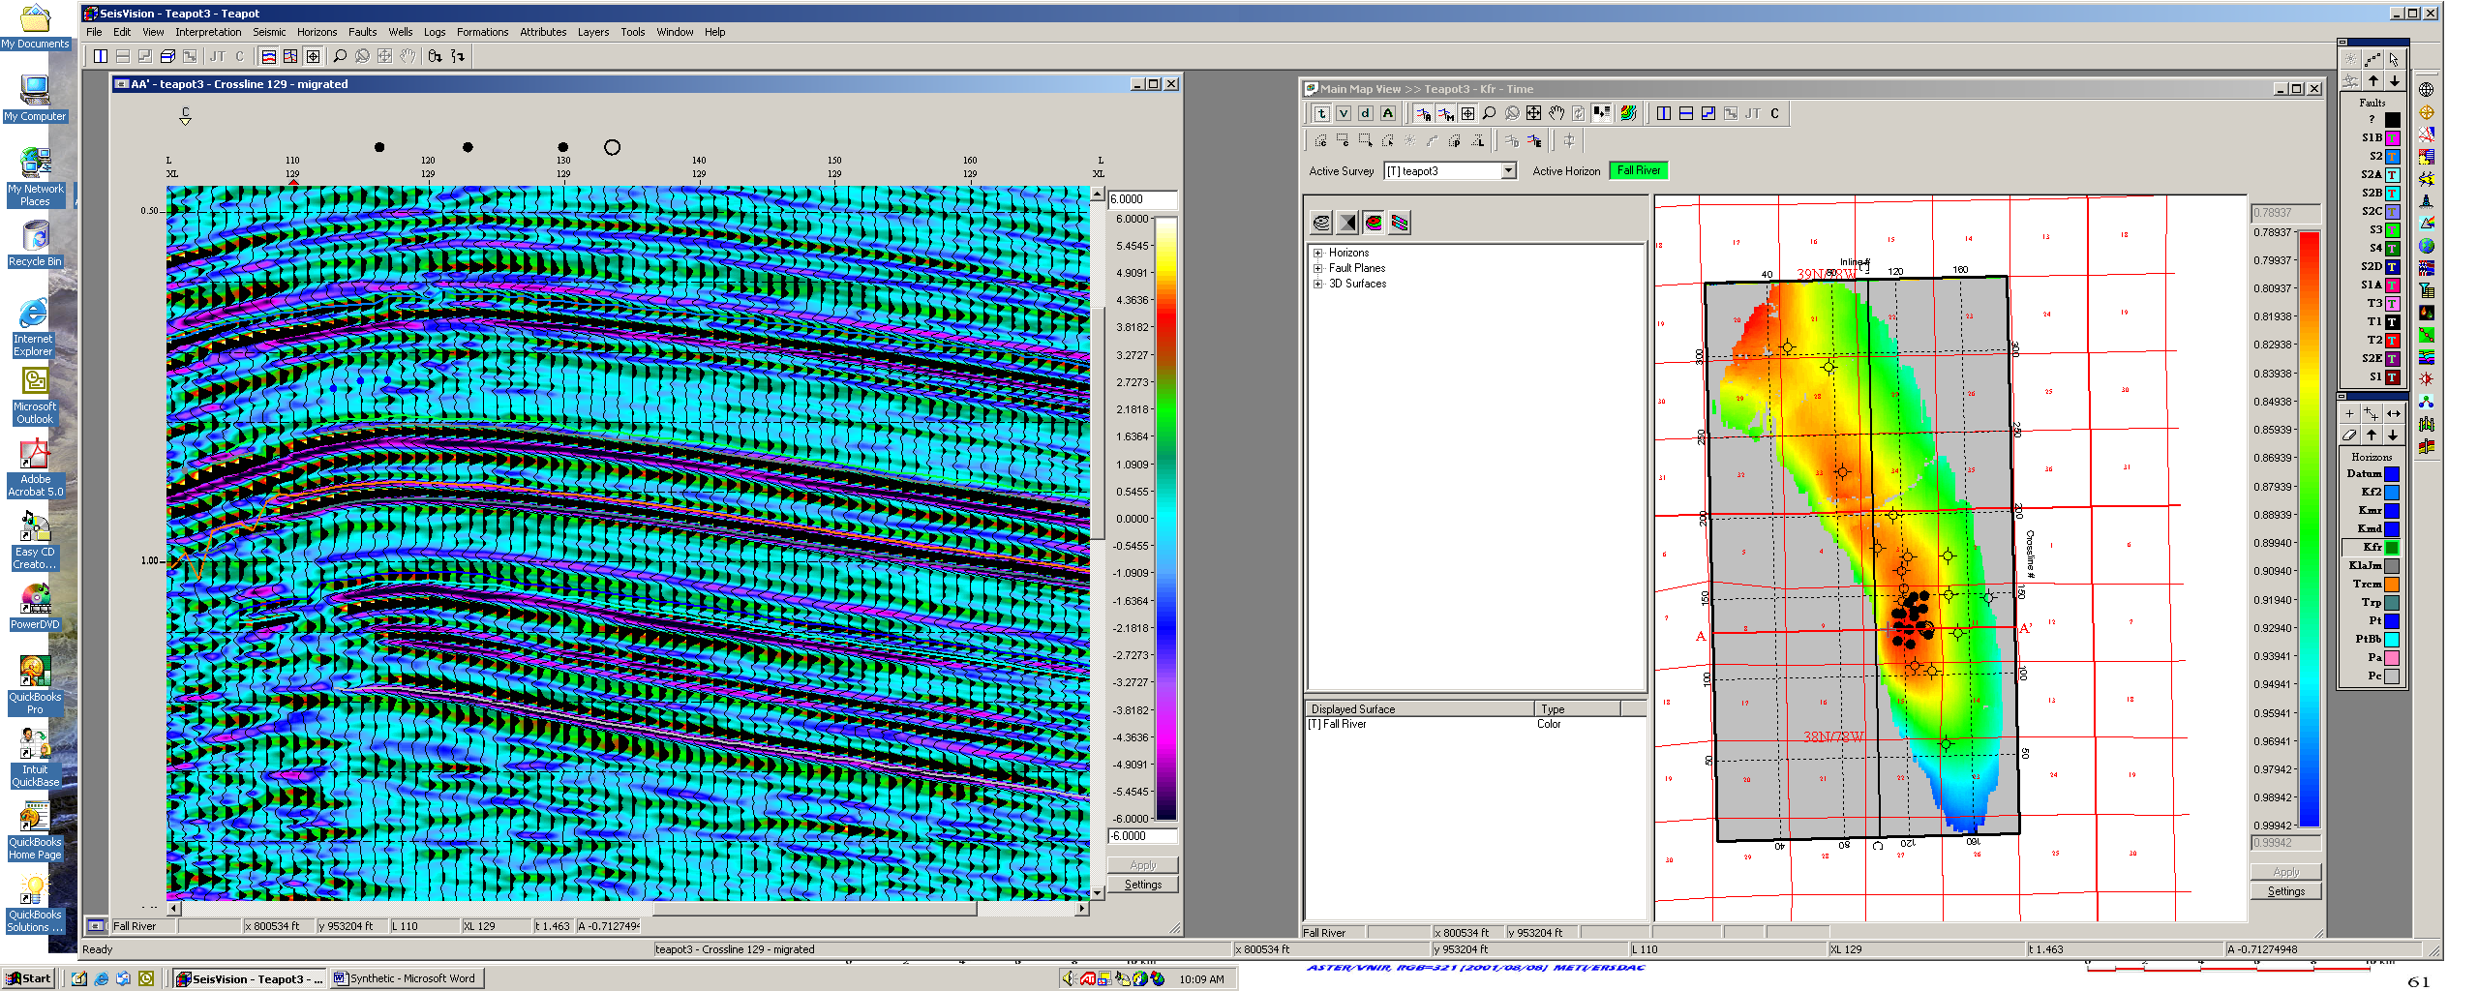
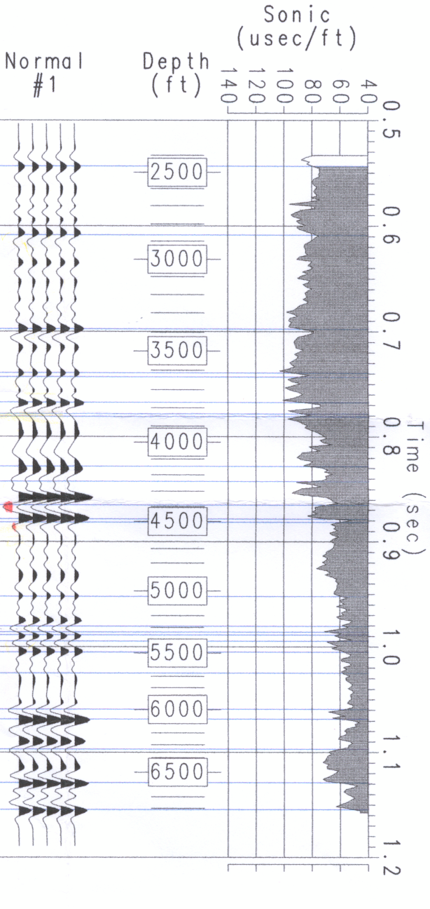
Crossline 129
Synthetic Seismogram
Precambrian
Madison
Tensleep
1st Wall Creek
2nd Wall Creek (KF2)
Fall River (Dakota)
Lakota
Sundance
Crow Mtn.
Red Peak
Figure 1. Composite synthetic seismogram match to 3D seismic data at NPR-3.

File: DOEPresentations/Synthetic.doc

