**DETECTION OF PNEUMONIA BASED ON TRANSFER LEARNING APPROACH**

##### Ladi Aashritha1, Vamsi Krishna Alla1, Goli Manikanta1,

##### Bonam Prudhvi Sai Reddy1 and B. Vamsi2

1,2Department of Computer Science & Engineering,

Vignan’s Institute of Information Technology (A),

Visakhapatnam, AP, India.

aashrithaladi@gmail.com,vamsichowdary.alla9@gmail.com,gmanikanta96@gmail.com, prudhvireddy800@gmail.com, vamsib11@gmail.com

**Abstract**

Pneumonia is a disease affecting lungs caused by either bacterial contamination or viral contamination and is life-threatening. It could be life-endangering on the off chance that not acted upon within the right time and hence an early detection of pneumonia is imperative. Advanced x-ray images are utilized to consequently identify the bacterial, viral pneumonia. Pneumonia is something else called Bronchopneumonia could be a state of the lungs as which it is basically impacts on the discuss sacks called the alveoli. It brings an approximately dry and a valuable hack, high fever, deficiency, chest torment, and the challenges in unwinding. The assurance of the pneumonia is which it compassed by exploring the X-beam pictures of the chest. This assurance is unique to the components, as we know the example, the tangled through appearance of the ailment within these X-beam picture. Hence, man-made thinking are based on systems are anticipated to flag the offices. In this audit, so we have carried out an amazingly celebrated convolutional brain network show known as VGG16 for the assurance of pneumonia. Within the over the planning organize, we have the utilized move to learning and tweaking. We had these alternatives to achieve an accuracy of 92.7% and loss of 20%.

**Keywords**: Pneumonia, Transfer Learning, VGG16, Deep Learning, Machine Learning.

**Introduction**

Machine learning has been applied in many different areas like agriculture, medical for the purpose of detection, classification, prediction and the segmentation. Almost seven percent of the world’s populace which contributes to about 2 million children’s deaths and is almost 23% of the pneumonia burden globally. The analysis of the X-rays is a time taking task and these can be attained by the professional radiologists. But in few cases, even the experienced radiologists cannot detect precisely. The most challenging situation which arises in detecting it is because of its fluidity nature, different boundaries and its occurrence at different locations. As a result, it is essential to create an automated method for detecting pneumonia to improve diagnosis accuracy.

In this paper, we develop a deep-transfer learning based approach by making use of complex Visual Geometry Group VGG16 model based architecture to detect the presence of Pneumonia. The proposed model will be trained using batches of training data. We Further analyzed our model with multiple optimizers to observe even the minute changes within the results and be able to diagnose pneumonia with satisfactory performance accuracy.

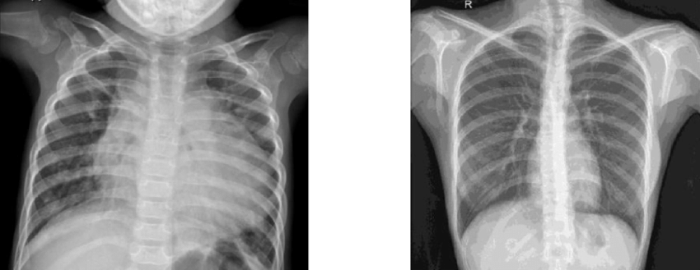

Fig 1:Pneumonia and Normal thoracic cavity X-ray images

**Statement of the Problem**

We have a collection of patient X-rays and for each image we need to determine whether it is a pneumonia class patient or a normal class patient. The two class classification’s aim is to detect pneumonia from a patient’s X-ray Image.

**Objectives of the study**

* To identify the factors affecting online shopping in Thanjavur District
* To analyze the correlation between the variables for online shopping
* To analyze the impact of convenience, product characteristics, web site quality and awareness on purchase intention

**Review of Literature**

Pneumonia is a common disease across world. The first person to identify the bacteria was Edwin Klebs in the year 1875. Initially there are two types of bacterial causes Streptococcus pneumonia and Klebsiella pneumonia are identified by Carl Friedlander and Albert Fraenkel. Pneumonia at one point of time had overtaken Tuberculosis. In the 1900’s several developments have improved the outcome for those with pneumonia. Vaccination for adults and children against Streptococcus pneumoniae began in the year 2000 which resulted in the decline of the cases. We have used Convolutional Neural Networks to identify the disease. The project takes the X-rays of the lungs and analyze the image. The model id trained with large datasets of X-rays with pneumonia and Non-pneumonia. Technology has achieved tremendous advancement through the years and play significant role in various disciplines including Medical field. Computer vision has numerous applications and can produce reliable results in identifying diseases. To achieve good results we used Convolutional Neural Networks for feature extraction and trained the model.

**Research Methodology**

To begin with few areas here, we displayed a fundamental graph of the framework and an outline of this full Pledged work through a flowchart. The mentioned portions highlight different profound learning techniques and Models utilized to precisely distinguish pneumonia.

Data Preprocessing: Data preprocessing includes the noise removal, cleaning the data, data augmentation etc.

1. Gathering of Data: This research project uses the Chest X-rays dataset in which the proposed model has been trained on a collection of 5856 chest X-Ray images (4273 scans of pneumonia class and 1583 scans of normal class).

2. Cleaning the data: Cleaning the data is the most important thing in any machine learning project. So we are cleaning the data before we are feeding that data into the machine learning model.

3. Building the model: In this paper, we are using the VGG-16 architecture which is a complete full convolutional. We will build the required model by adding convolutional layers, max pooling layers, We add normalization in batches and ReLU activation function to get non-linear in nature at every convolutional block. This model will be mainly used for bio- medical images and detect the disease.

4. Training the model: We use the training data to train the model we use in this proposed system.

5. Splitting the data: We will split the data available for the training into training data and the testing data. So during the model evaluation we can test the model against the testing data.

6. Evaluating the model: We finally evaluate the trained model using the testing dataset.

# **Block Diagram**

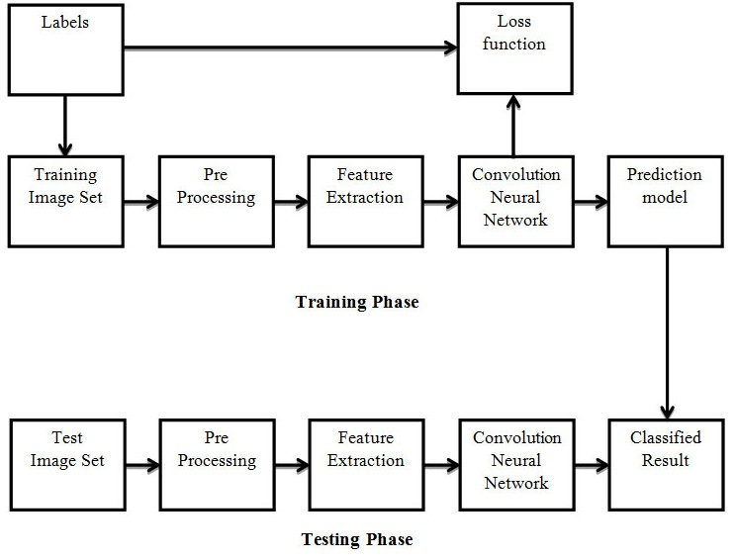

##### Figure 2: Block diagram for Pneumonia Detection

# **VGG16**

The model based on VGG16 is developed as a part of the convolutional neural network but it expanded with few new features that have been made to the CNN architecture. The complete architecture has 16 layers in total and a modified model known as VGG19 has that of 19 in total. The centrality of this appears is its weights are accessible clearly on the net and can be downloaded to utilize in their model. It is a CNN jointly designed by the Visual Geometry Group at the Oxford University and Google DeepMind. VGG Net could be a CNN of commonly used advanced by these Visual Calculation Gatherings at the University of Oxford and Google Deep Minds. DeepMind is a divisions of the Alphabet, Inc. responsible for the developing of general-purpose of artificial intelligence (AGI) technology.as we all know That technology is also known as the Google DeepMind. DeepMind uses raw pixels data as the input and learns from the experience. As shown in Figure 3, VGG Net plan can be of the considered a long Alex Net, depicted by the 3×3 convolutional bits and2×2 pooling of layers, and these organization of designing can be created by the utilizing smaller convolutional layers to progress the highlight learning. These two most ordinary current VGG Net versions are the VGGNet-16 and VGGNet-19.

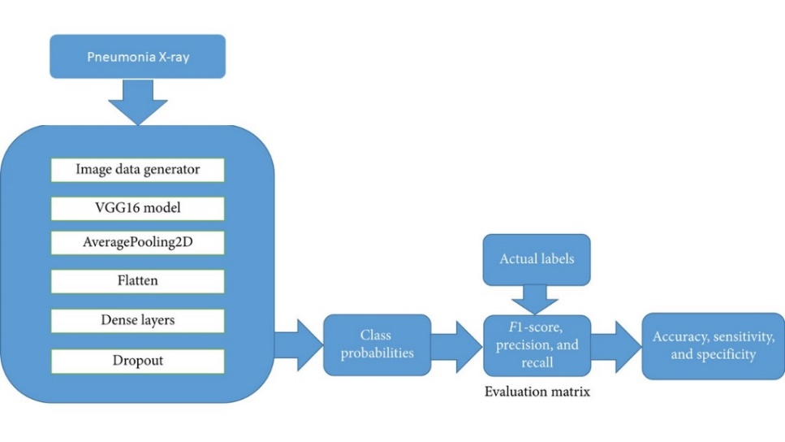

##### Figure 3: VGG for Pneumonia Detection

## **Architecture of VGG-16**

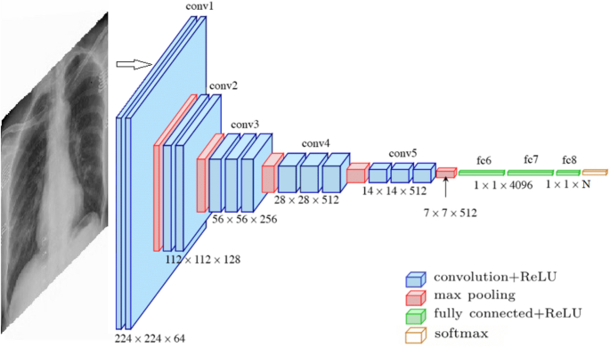

##### Figure 4: Graphical representation of VGG model

VGG16 is a standard deep architecture of convolutional deep neural network with multiple layers.

The term “deep” represents the number of layers within the models VGG16 or VGG19 .

## **Fully Convolutional Network**

1.Convolution Layer-This layer will takes input of picture with the estimations of the height, width and the channels. This is the layer of recuperates of which the features which these are like the color, edges, orientation etc. from these info images. It is which these bits thing of the info picture and then remembers map. Suppose for the case of the information of measure is 4X4 and there are 3 channels by then the yield gauge is 4X4X3. A portion of which the time direct doesn't be perfectly in to which the image be by then we must be perform a two stages to fit this channel entirely with in to the image. They are:

i) Pad the images with the zeroes. The most benefit of this is zero padding is that the proportions of that yield and exactly matches these proportion of which this is underlying input.

ii) Drop or remove these pieces of which these images where in channel which doesn't fit. Cushioning is which It can implies with number of Pixels which included to an image which when it is being handled in by the piece of the CNN.

2.ReLU Layer-It represents the Amended Straight in Unit. It is which otherwise called an Initiation Layer. This Layer which is utilized to add a non-linearity which connects to the network. The size of picture doesn't change in this particular layer.

3.Pooling- Max, Average and Global Max pooling are the three kinds of Pooling operations which selects the maximum, average elements from the region of the feature map covered by the filter respectively and down sample them. Feature map’s every channel is reduced to a single value in Global pooling. It prevents overfitting and when used with non-equal filters aids efficiency.

4.Fully Connected Layer-This layer takes input from the final convolutional layer or Pooling layer and is transformed into a single vector or is flattened. Each node in the fully connected layer is the output obtained from the previous pooling layer.

5.Sigmoid Activation Function: It continuously yields the output between zero to one in case of sigmoid being the activation function for that particular neuron.

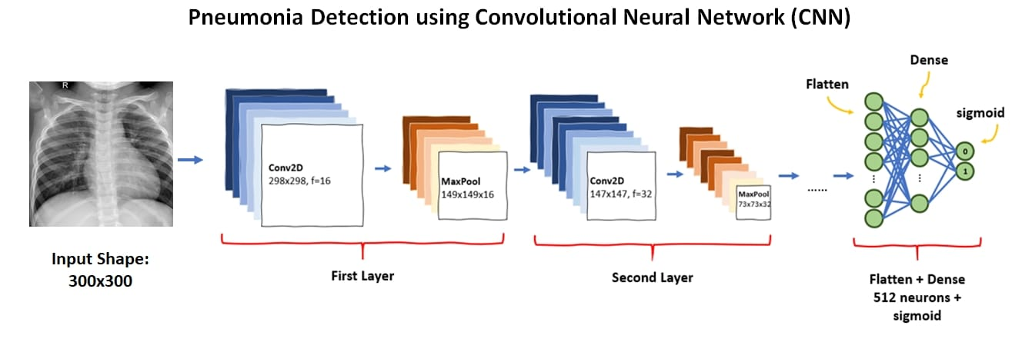

##### Figure 5: VGG for Pneumonia Detection

# **Model Evaluation**

Execution followed by performance evaluation is a key constituent within the pipeline of building any ML framework. We employed four metrics to assess the effectiveness of our Pneumonia Detection: accuracy, sensitivity, specificity, and dice coefficient, which may be computed as follows:

Accuracy = The ratio of (TP+TN) to (FP+TN+FN)

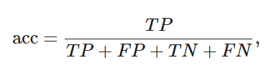

Sensitivity/Recall = The division of (TP) to the (TP+FN)

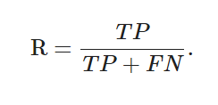

Precision = The division of (TN) by (TN+FP)

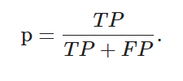

F1 = The float division of (TP) to (TP+FP+FN)

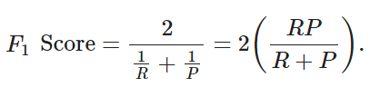

TP = True Positives will count how many count of pixels are accurately masked as a affected region.

TN = True Negatives denoted the pixels which are correctly segmented as a healthy.

FP = False Positives will denote the amount of pixel are not truly identified that is, incorrectly identified region.

FN = False Negatives is the wrongly identified as a healthy pixel.

METRICS:

1.Accuracy: This is the probability which shows the total predictions which are correct.

2.Sensitivity: This is the proportion of how good a machine learning model can be able to identify the correct and true positive instances.

3.Specificity: This is the proportion of true Positives over the true positives and false positives.

4.F1 Score: It’s Recall and Precision’s harmonic mean.

**Results and Discussion**

In this paper, after creating the model based on VGG16 architecture we trained the model using training data and after that we test the model using the testing data. After processing the data and evaluated the input using our model and predicted the output. The underneath figures shows the user interface followed by the output if normal or unaffected chest Image is given as an input and affected chest X-ray is given as an input to the model.

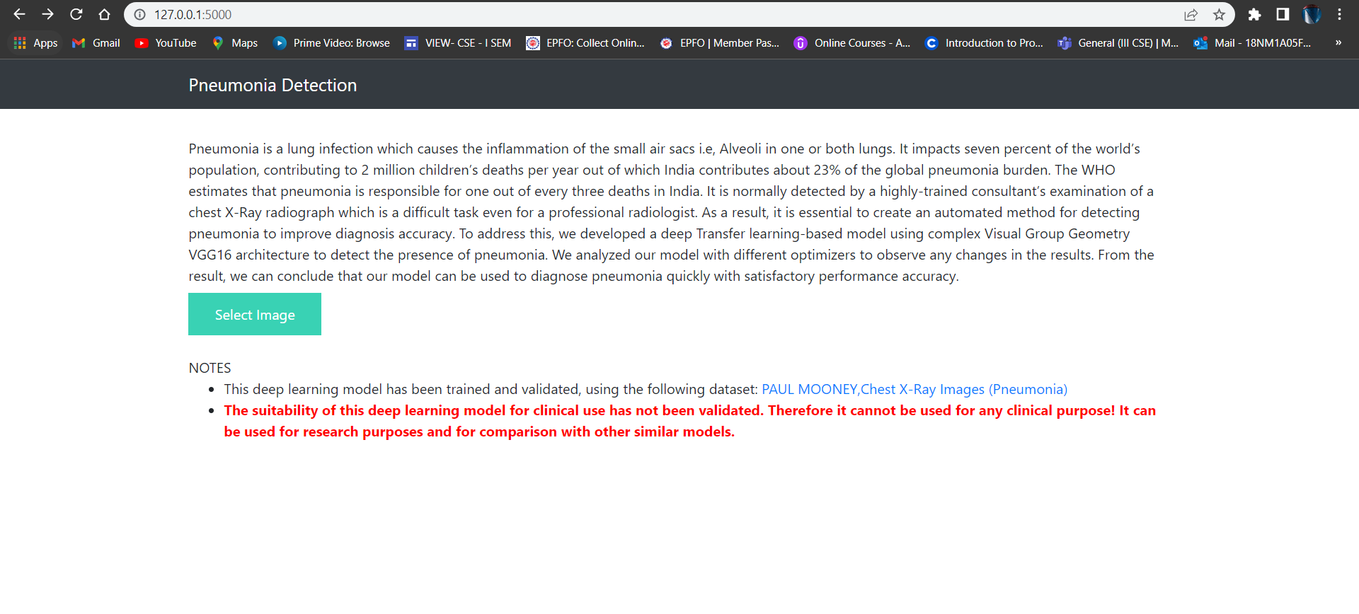

##### Figure 6: Home Screen of the UI

##### 

##### Figure 7: Original image and the predicted output.(Negative Case

Figure 8: Original image and the predicted output.(Positive Case)

The proposed solution has an accuracy of 92.3% with the loss rate being 0.20 as per the VGG architecture. The Inception model has achieved less accuracy compared to VGG16 that is 83.34% and is thus less efficient for producing accurate results. In our proposed work, the model does not have either overfitting or underfitting problem. The loss of Train data is less than the loss of Test data which is equals to the entire model loss.

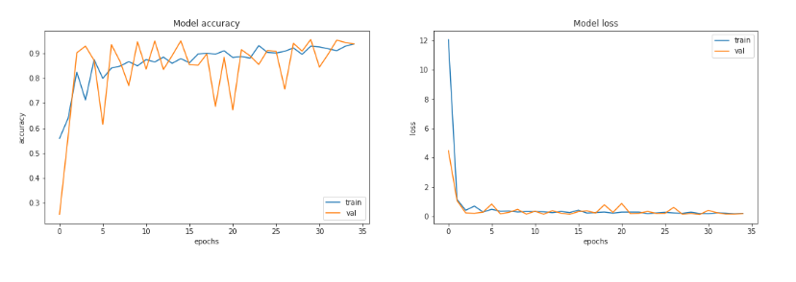 Figure9:Accuracy vs Epoch and Loss vs Epoch of train and validation data

**Conclusion**

In this study, we present an efficient diagnosis of Pneumonia using the transfer learning method. We've proven that the fine-tuned model exhibits promising results with an accuracy of 92.7% where the loss is evaluated to be 4%.The model built upon InceptionV3 performance has a lower accuracy comparatively which is 83.4% with the loss rate of the evaluation data being 10%.Thus VGG16 is felicitous for the detection of the disease which is the cause of mortality and morbidity.

**References**

1. Ayan, Enes, and Halil Murat Ãœnver. "Diagnosis of pneumonia from chest X-ray images using deep learning." 2019 Scientific Meeting Ieee, 2019.

2. Stephen, Okeke, et al. "An efficient deep learning approach to pneumonia classification in healthcare." Journal of healthcare engineering 2019 (2019).

3. S. Johnson and D. Wells, “Viral Pneumonia, Symptoms, Risk Factors, and More,” 2019. [Online]. Available: https://www.healthline.com/health/viral-pneumonia

4. K. Kallianos et al., “How far have we come? Artificial intelligence for chest radiograph interpretation,” Clinical radiology, vol. 75, no. 5, pp. 338-345, 2019, doi:10.1016/j.crad.2018.12.015.