Name - Aashrya Prakash Patel
Project – Worksphere(Workforce & Request Management System)
Day 1 – Requirement Analysis & System Design

1️] Business Model Understanding
Core Idea
A cloud-based workforce platform that helps businesses:
- Manage employee scheduling
- Track attendance & time
- Handle shift planning
- Manage payroll integration
- Track labor costs
- Approve leave requests
- Ensure compliance
Target Industries
- Retail
- Healthcare
- Hospitality
- Warehousing
- Restaurants
- Logistics

2️] Business Flow
Employee Lifecycle Flow
- Admin creates organization
- Add departments/locations
- Add employees
- Define roles & permissions
- Create shift schedules
- Employees view/accept shifts
- Employees clock-in / clock-out
- Timesheet auto-generated
- Manager approves timesheet
- Payroll export

Leave Request Flow
- Employee submits leave request
- Manager receives notification
- Approve / Reject
- Calendar auto-updated
- Payroll impact adjusted

3️] User Roles
Role | Description
Super Admin | Platform owner
Organization Admin | Company owner
Manager | Creates schedules, approves requests
Employee | View schedule, clock-in/out
HR / Payroll Officer | Approves timesheets, payroll export
Auditor | View compliance reports

4️] Functional Requirements (FR)
A. Authentication & Authorization
- Email/password login
- SSO (Google/Microsoft)
- Role-based access control
- Multi-tenant support
- Password reset
B. Organization Management
- Create organization
- Create departments
- Create locations
- Define pay rules
- Define compliance policies
C. Employee Management
- Add/edit employee
- Assign department
- Define hourly rate/salary
- Skill tagging
- Employment type (Full-time, Part-time, Contract)
D. Scheduling Module
- Create shifts
- Recurring shifts
- Drag & drop shift builder
- Shift conflict detection
- Auto-scheduling based on:
  - Availability
  - Skill match
  - Labor budget
- Publish schedule
- Shift swap request
E. Time & Attendance
- Clock-in / Clock-out
- GPS-based clock-in
- Biometric integration
- Overtime detection
- Break tracking
- Timesheet auto-generation
F. Leave Management
- Leave type configuration
- Leave balance tracking
- Leave approval workflow
- Holiday calendar
G. Payroll & Compliance
- Timesheet approval
- Payroll export (CSV/API)
- Overtime calculation
- Labor law compliance
- Wage rule enforcement
H. Reporting & Analytics
- Labor cost reports
- Overtime reports
- Attendance reports
- Forecasting trends
- Utilization analytics
I. Notification System
- Email alerts
- Push notifications
- Shift reminders
- Approval notifications

5️] Non-Functional Requirements (NFR)
Security
- Multi-tenant data isolation
- Data encryption (AES-256)
- Role-based data access
- Audit logs
- GDPR compliance
Performance
- Response time < 2 seconds
- Support 10,000+ concurrent users
- Efficient schedule rendering
Scalability
- Horizontal scaling
- Cloud-native deployment
- Microservices-ready
Availability
- 99.9% uptime
- Backup & recovery
- Auto-scaling infrastructure
Maintainability
- Clean architecture
- API-first design
- Modular services

6️] High-Level Architecture
Microservices (Production-Ready)
Client (Web/Mobile)
↓
API Gateway
↓
-------------------------------------
Auth Service
Organization Service
Scheduling Service
Attendance Service
Payroll Service
Notification Service
Reporting Service
-------------------------------------
↓
Database per service
↓
Message Queue (Kafka/RabbitMQ)
↓
Redis Cache
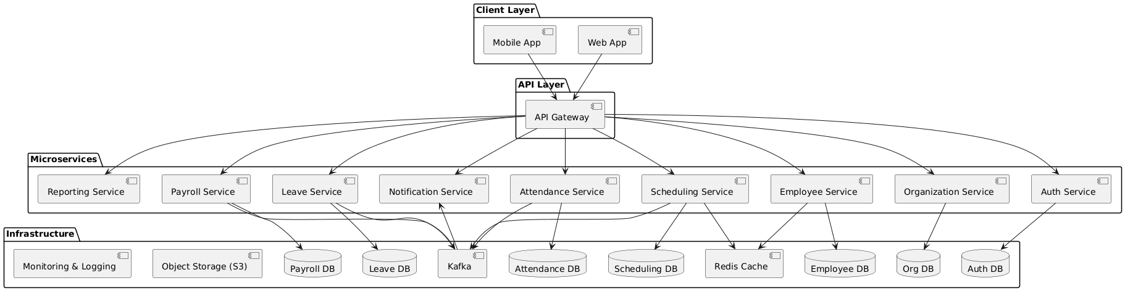

7️] Basic ER Diagram (Conceptual)
A. Entities
Organization
- id
- name
- industry
- subscription_plan
Department
- id
- organization_id
- name
Employee
- id
- organization_id
- department_id
- role
- pay_rate
- status
Shift
- id
- employee_id
- department_id
- start_time
- end_time
- status
Attendance
- id
- employee_id
- shift_id
- clock_in
- clock_out
- total_hours
Leave
- id
- employee_id
- leave_type
- start_date
- end_date
- status
Timesheet
- id
- employee_id
- total_hours
- overtime_hours
- approval_status
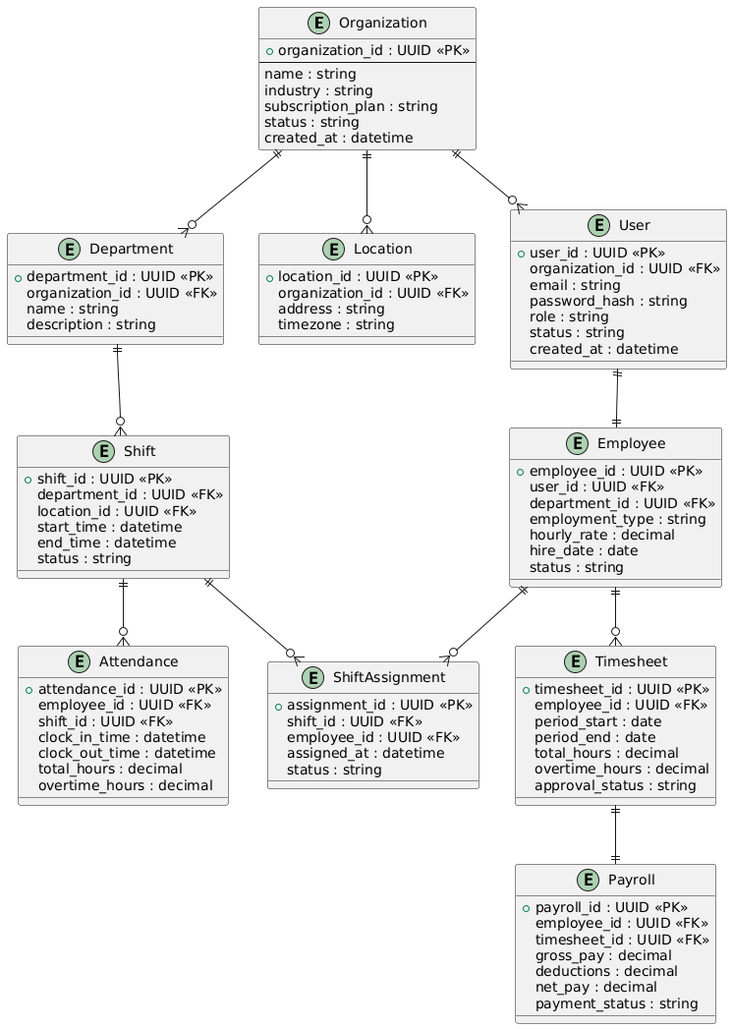

8️] Core Modules Definition
1️ Authentication Module
- JWT tokens
- Multi-tenant auth
- Role middleware
2️ Organization Module
- Manage departments
- Subscription plans
- Compliance rules
3️ Employee Module
- CRUD employees
- Skill management
- Availability tracking
4️ Scheduling Module
- Shift creation
- Conflict detection
- Auto-assign engine
5️ Attendance Module
- Time tracking
- Overtime detection
- Break policies
6️ Payroll Module
- Pay calculation
- Tax rules
- Payroll export
7️ Reporting Module
- KPI dashboards
- Labor forecasting

9️] Git Repository Setup
Repository Name:
workforce-management-system
Suggested Structure (Microservices)
workforce-system/
│
├── auth-service/
├── org-service/
├── employee-service/
├── scheduling-service/
├── attendance-service/
├── payroll-service/
├── notification-service/
├── reporting-service/
├── api-gateway/
├── docker-compose.yml
└── README.md

Deliverables for Day 1
- Business Flow Document
- Roles & Responsibilities
- Functional Requirements
- Non-Functional Requirements
- High-Level Architecture
- ER Diagram Draft
- Git Repo Initialized

