**DEERWALK INSTITUTE OF TECHNOLOGY**

**Tribhuvan University**

**Faculties of Computer Science**

**Bachelors of Science in Computer Science and Information Technology**

**Operating System (CSC259)**

**Semester: IV**

**A Lab report on:**

**Basic Linux Commands**

Submitted by:

Name: Aashutosh Pudasaini

Roll: 1202

Submitted to:

Binod Sitaula

Date: 25th June, 2024

**Theory**

**What is Linux?**

Linux is a community of open-source Unix like operating systems that are based on the [Linux Kernel](https://www.geeksforgeeks.org/the-linux-kernel/). It was initially released by Linus Torvalds on September 17, 1991. It is a free and open-source operating system and the source code can be modified and distributed to anyone commercially or non commercially under the GNU General Public License.   
Initially, Linux was created for personal computers and gradually it was used in other machines like servers, mainframe computers, supercomputers, etc. Nowadays, Linux is also used in embedded systems like routers, automation controls, televisions, digital video recorders, video game consoles, smartwatches, etc. The biggest success of Linux is Android (operating system) it is based on the Linux kernel that is running on smartphones and tablets. Due to android Linux has the largest installed base of all general-purpose operating systems. Linux is generally packaged in a Linux distribution.

**Linux Distribution**

Linux distribution is an operating system that is made up of a collection of software based on Linux kernel or you can say distribution contains the Linux kernel and supporting libraries and software. And you can get Linux based operating system by downloading one of the Linux distributions and these distributions are available for different types of devices like embedded devices, personal computers, etc. Around 600 + Linux Distributions are available and some of the popular Linux distributions are:

* MX Linux
* Manjaro
* Linux Mint
* elementary
* Ubuntu
* Debian
* Solus
* Fedora
* openSUSE
* Deepin

**Installation of Linux**

**Installing VirtualBox**

1. 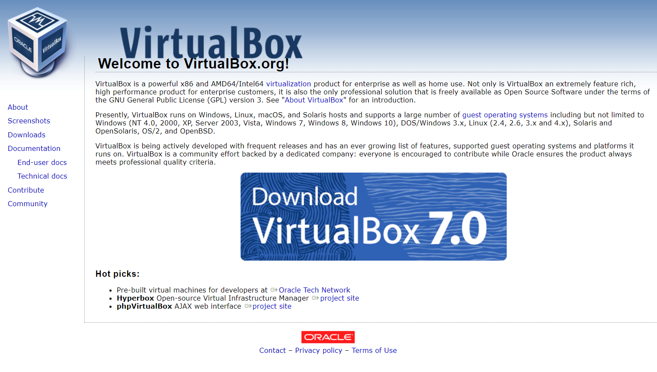Download and install Oracle VirtualBox from the official website (<https://www.virtualbox.org/>).
2. 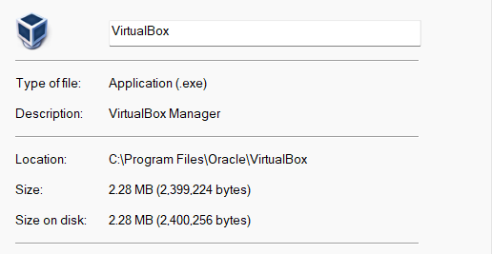**Locate** the VirtualBox installer file. Double-click the file to launch the VirtualBox Setup wizard and carry the installation process.

**Running Ubuntu using Oracle VirtualBox**

1. 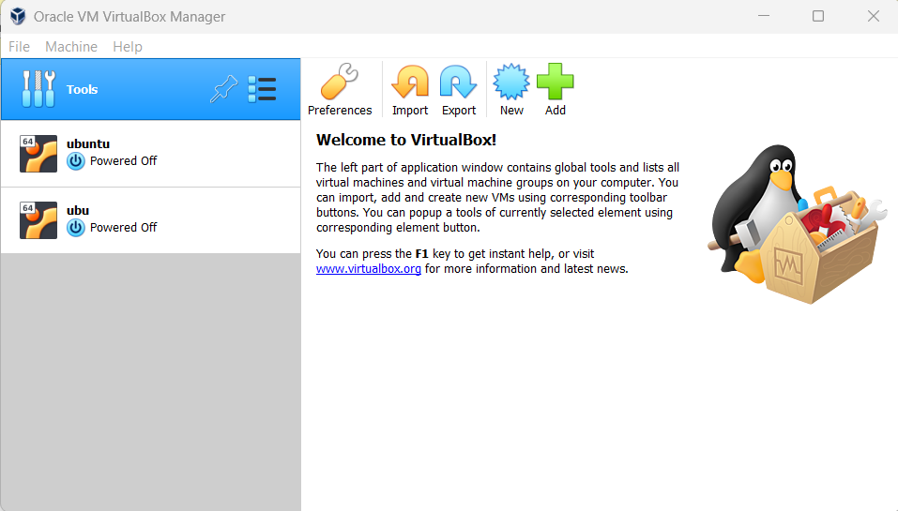After the installation is complete, run VirtualBox.
2. Open VirtualBox and click on the “New” button to create a new virtual machine.
3. 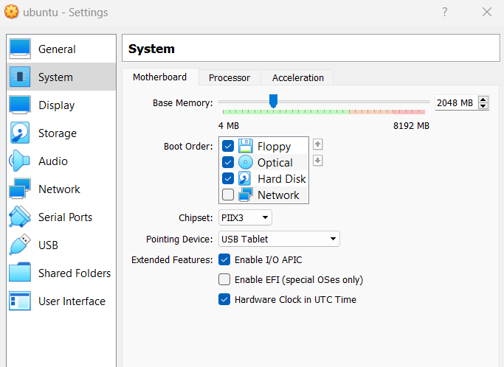Enter a name for the virtual machine and select “Linux” as the type and “Ubuntu” as the version.
4. Allocate memory to the virtual machine by selecting the amount of RAM to dedicate
5. Choose “Create a virtual hard disk now” and select the hard disk file type.
6. Choose “Dynamically allocated” as the hard disk storage option.
7. Allocate disk space to the virtual machine by selecting the amount of storage to dedicate. The recommended amount is at least 20GB.
8. Click “Create” to create the virtual machine.
9. Select the virtual machine from the list in the VirtualBox Manager and click on “Settings”.
10. 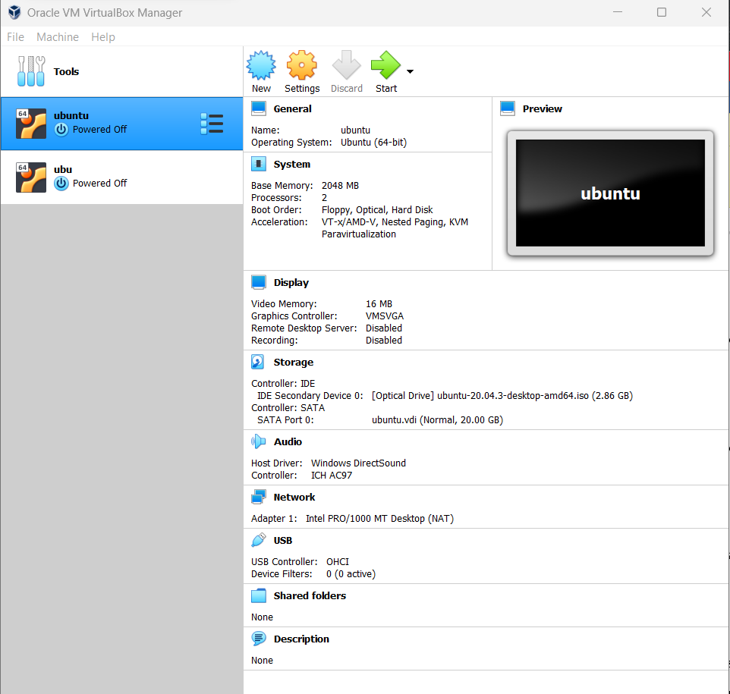Under “Storage”, click on the “Empty” CD icon and then click on the “Choose Virtual Optical Disk File” button.
11. Browse to the location where the Ubuntu ISO file was saved and select it.
12. Start the virtual machine by clicking on the “Start” button in the VirtualBox Manager.
13. Ubuntu will now start running in a virtual machine window.
14. Follow the remaining installation prompts to complete the installation process.
15. Once the installation is complete, restart the virtual machine and Ubuntu should now be ready to use within Windows using Oracle VirtualBox.

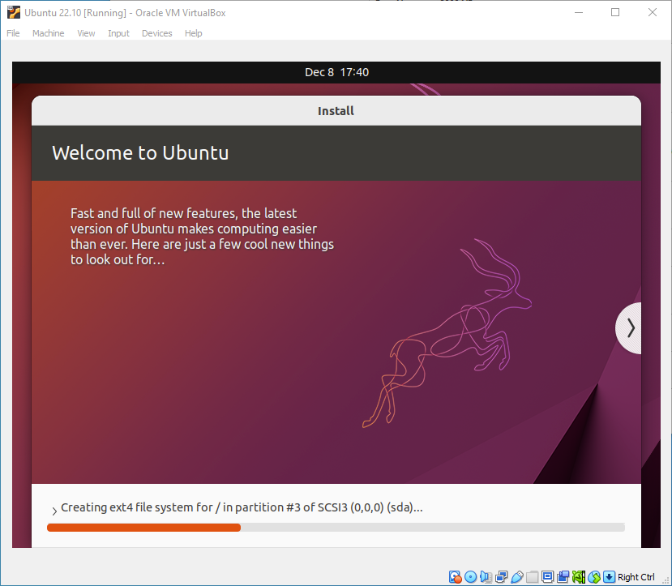

The machine automatically reboots to complete the installation after the installation is completed.

Finally, you can see Ubuntu log-in screen where you enter your username and password defined in the setup initially.

**Linux commands:**

**History**:

The history of Linux begins in 1991 when Linus Torvalds, a Finnish computer science student, created the first version of the Linux kernel. Since then, Linux has become a popular operating system for servers, supercomputers, and embedded systems. The open-source nature of Linux has led to its widespread adoption and use in many different industries.

**Kernel Modules**:

Linux uses kernel modules extensively to extend the functionality of the kernel. These modules can be loaded and unloaded at runtime, and they can provide additional system calls, device drivers, and other services. Examples of kernel modules in Linux include the Virtual File System (VFS) and the Network File System (NFS).

**Process Management**:

Linux uses a hierarchical process model, with the init process at the top of the hierarchy. The init process is responsible for starting and managing all other processes in the system. Linux also provides various system calls and utilities for process management, including fork(), exec(), and kill().

**Scheduling**:

Linux uses a variety of scheduling algorithms, including the Completely Fair Scheduler (CFS) and the Real-Time Scheduler (RT). The CFS is designed to provide fair scheduling for processes, while the RT scheduler is designed to provide deterministic scheduling for real-time applications.

**Inter-process Communication**:

Linux provides several methods for inter process communication, including pipes, message queues, shared memory, and sockets. These mechanisms allow processes to exchange data and information with each other, even if they are running on different machines.

**Memory Management**:

Linux uses a demand-paged virtual memory system to manage memory. This allows the operating system to allocate memory to processes as needed, and to swap out memory pages when necessary to free up space. Linux also provides various tools for monitoring and optimizing memory usage, including the top and vmstat utilities.

**File System Management Approaches**:

Linux supports a variety of file system formats, including ext4, XFS, and btrfs. These file systems provide different features and performance characteristics, and they can be optimized for different use cases. Linux also supports file permissions and access control lists (ACLs) to control access to files.

**Device Management Approaches**:

Linux provides a unified device driver model, which allows devices to be accessed through a common set of system calls and interfaces. Linux also supports hot-plug devices, which can be added or removed from the system without requiring a reboot. The udev utility is used to manage device events and configure device drivers.

**Conclusion**

In conclusion, the Linux operating system stands as a powerful, versatile, and secure platform that has revolutionized computing. Its open-source nature and collaborative development model have fostered innovation, customization, and a vibrant community. Linux's impact spans across industries, driving digital transformation and serving as a foundation for the Internet, cloud computing, and IoT ecosystems. With its stability, scalability, and commitment to open-source principles, Linux continues to shape the future of technology.