MS PROJECT — FINAL REPORT (CHAPTERS 1–5)
EMGT 7945 MS Project
Urban Mobility Equity Dashboard:
Mapping Who Gets Left Behind in U.S. Cities
Submitted by | Aashritha Krishna Kanagala
Program | Master of Science in Engineering Management (MSEM)
Course | EMGT 7945 MS Project
University | Northeastern University, Boston, Massachusetts
Supervisor | Professor Sivarit (Tony) Sultornsanee
Date | August 15, 2026
Abstract. Urban mobility infrastructure — public transit, walkable streets, bicycle facilities, and electric-vehicle (EV) charging — is unevenly distributed, yet existing measurement tools treat each dimension in isolation. This project constructs a Mobility Equity Score (MES): a transparent, reproducible composite index that integrates all four dimensions at the U.S. Census-tract level, and applies it to three structurally distinct cities (Chicago, Houston, Seattle) using only open data. Across all three cities the MES exhibits strong, significant spatial clustering (global Moran’s $I=0.82$–$0.92$) and is positively associated with the share of zero-vehicle and renter households, reflecting that supply-side infrastructure concentrates in dense, central tracts. The bivariate negative association with median income is largely accounted for by urban form: after controlling for population density and distance to the central business district — and after spatial-regression correction for the strong spatial dependence — it attenuates to non-significance in Houston, reverses weakly in Chicago, and persists only in Seattle. The results are therefore interpreted as associational and consistent with a supply–need mismatch (need proxied by car-free and renter households), not as evidence of a causal relationship. The methodology is released as an open-source pipeline and an interactive dashboard so any city with open data can reproduce the analysis.

Introduction and Motivation

Background
Transportation is a fundamental determinant of economic opportunity in urban America. A person’s ability to reach employment, healthcare, education, and essential services depends on a layered ecosystem of infrastructure: transit frequency and coverage, pedestrian networks, bicycle facilities, and access to electric-vehicle (EV) charging. Each dimension has documented equity gaps. Transit deserts disproportionately affect low-income and minority communities ; walkability is highly racialized, with communities of color inhabiting systematically less walkable neighborhoods ; disadvantaged communities have roughly 64% fewer public EV chargers per capita ; and bicycle infrastructure remains underfunded in lower-income areas . Despite this evidence, the available measurement tools remain siloed — the EPA National Walkability Index, the DOE Alternative Fuels Station Locator, the FTA National Transit Database, and OpenStreetMap bicycle data each capture one dimension in isolation.

Problem Statement
Low-income and minority neighborhoods may experience compounded, multi-dimensional mobility disadvantage — scoring poorly across several dimensions at once rather than in a single dimension. The magnitude of this compounding, and where it is most severe, have not been quantified in an integrated, reproducible framework. Equally unexamined is the direction of the supply-side relationship: whether infrastructure is scarcest where demand-side need (car-free, low-income households) is greatest, or whether it instead concentrates in dense cores for reasons of land use and density. Both questions impede evidence-based infrastructure-investment decisions.

Research Questions
The project is framed around one central question and four measurable sub-questions. Each sub-question names the specific quantity, statistical test, and decision criterion used to answer it (developed in Chapter 3).
- (Measurement.) Can four heterogeneous open datasets be integrated into a single tract-level composite (MES) whose components are related but non-redundant (inter-sub-index correlations reported) and whose downstream findings are stable under alternative weighting schemes (sign and significance unchanged across equal, entropy, PCA, and policy-priority weights)?
- (Distribution.) What share of tracts in each city are mobility deserts (MES below the 25th percentile) and compounded deserts (bottom quartile in $≥2$ sub-indices), and is that classification robust to the threshold (Jaccard overlap $≥0.75$ across the 20th/25th/30th percentiles)?
- (Equity.) What is the sign, magnitude ($|r|$), and significance ($p<0.05$, 95% CI excluding zero) of the association between the MES and each of median income, percent non-white, percent zero-vehicle, and percent renter?
- (Spatial structure and typology.) Do MES values cluster spatially (global Moran’s $I$, $p<0.05$), where are the statistically significant low-low cold spots (local Moran’s $I$), and how many distinct mobility “profiles” (K-means, silhouette-selected $k$) recur across neighborhoods?

Objectives
- Construct the MES from four equally-weighted, 0–100-normalized sub-indices at the census-tract level for three Phase-1 cities, with documented indicator selection and normalization.
- Quantify the association between the MES and four socioeconomic indicators with effect sizes, $p$-values, and confidence intervals.
- Classify and rank mobility deserts and compounded deserts, and validate the classification against threshold and weighting sensitivity.
- Characterize the spatial structure (Moran’s $I$/LISA) and the recurring neighborhood mobility typologies (K-means).
- Release a reproducible open-source pipeline and an interactive dashboard for dissemination and replication.

Research Contributions
The contribution of this work is methodological and empirical, not the visualization system (the dashboard is a dissemination layer over the analysis, not the result). Specifically:
- An integrated composite. The first open, reproducible integration of transit, walkability, bicycle, and EV-charging supply into a single tract-level index, where prior tools measure one dimension or one scale (Sec. 2.7).
- A transparent, tested methodology. Every modeling choice — indicator selection, within-city min–max normalization, equal-weight baseline, and desert thresholds — is stated and stress-tested through weighting (equal/entropy/PCA/AHP) and threshold (20/25/30th percentile) sensitivity analyses, addressing the reproducibility and value-ladenness concerns raised for composite indicators .
- An empirical finding. Across three structurally different cities, supply-side mobility infrastructure concentrates in dense, central tracts that tend to be higher-renter and car-free. The bivariate negative association with income is shown to be largely an urban-form artifact (it does not survive density/centrality controls or spatial regression, except in Seattle) — reframing the equity question, associationally, as a supply–need mismatch rather than a simple “poor areas are under-served” narrative (Sec. 5).
- A replication artifact. A documented Python pipeline (MIT-licensed) that reproduces the entire analysis for any U.S. city with open data.

Organization
Chapter 2 critically reviews prior work and isolates the gap. Chapter 3 specifies the methodology. Chapter 4 presents results. Chapter 5 discusses findings, implications, limitations, and future work.

Literature Review
Rather than summarizing studies individually, this chapter organizes prior work by what it measures and how, then isolates the specific gap the MES fills (Table 1).

Single-Dimension Equity Measurement
The strongest body of evidence is single-dimension. In transit, Aman and Smith-Colin operationalize “transit deserts” as a tract-level supply–demand gap from GTFS, and Maharjan et al. confirm the pattern nationally; both establish that low-income and minority tracts are under-served — consistent with evidence that transit access directly shapes job accessibility — but neither places transit alongside other modes. Walkability research standardizes on the EPA National Walkability Index and documents racialized disparities , while active-travel toolkits refine walk/bike access but again in isolation. EV-charging equity is the newest strand: Lou et al. and Chen and Li demonstrate severe under-provision for disadvantaged and renter households. The common limitation is dimensional siloing: each literature answers “is mode $X$ inequitable?” but none answers “which neighborhoods are disadvantaged across modes at once?”

Composite Indicators and Their Critique
Composite indicators are attractive for communication but contested on methodology. The OECD/JRC handbook warns that normalization and weighting are value judgments that must be paired with sensitivity analysis — a discipline frequently omitted in applied indices. This project treats that critique as a design requirement (Secs. 3.6–3.7) rather than an afterthought, distinguishing it from single-shot composites.

Existing Integrated Tools — and Why They Fall Short
The closest comparators are multi-dimensional tools, but each trades away tract-level, multi-modal, or open-data properties. The EPA Smart Location Database is multi-variable but built for walkability/location efficiency, not transit/bike/EV equity. The Urban Institute SITE tool measures infrastructure spending equity, not physical supply. The Oliver Wyman Urban Mobility Readiness Index ranks whole cities, not neighborhoods. Pandey et al. link urbanization to widening infrastructure inequality but at national/global scale. Table 1 summarizes the comparison.
Critical comparison of representative prior work. The MES is the only approach that is simultaneously multi-modal (all four dimensions), tract-level, open-data, and demographically cross-referenced.
Prior work | Dimensions | Spatial unit | Open data | Demographic cross-ref
Transit-desert models | Transit only | Tract | Yes | Yes
EPA walkability | Walk only | Block group | Yes | Partial
EV-charging equity | EV only | Tract/ZIP | Yes | Yes
Bikeability indices | Bike only | Varies | Yes | Partial
Urban Institute SITE | Spending (multi) | City/region | Partial | Yes
Oliver Wyman UMRI | Multi (readiness) | City | No | No
This work (MES) | All four | Tract | Yes | Yes

Spatial and Multivariate Methods
Because infrastructure is spatially structured, the analysis draws on established methods: global and local Moran’s $I$ for spatial clustering and cold-spot detection, and K-means with silhouette validation for typology discovery. These are chosen (Sec. 3.9– Sec. 3.11) because they directly answer the distributional and structural research questions, not merely because they are conventional.

Synthesis of the Gap
Three gaps motivate the MES: (i) no integrated, multi-modal, tract-level supply measure exists; (ii) integrated tools that do exist are either city-scale, spending-based, or closed; and (iii) the direction of the supply–demographic relationship is assumed rather than measured. The MES closes (i) and (ii) by construction and tests (iii) empirically.

Methodology

Study Area
The unit of analysis is the 2023 U.S. Census tract. Three cities were selected for Phase 1 to span mobility regimes (Table [tab:cities]); Phase 2 will add Phoenix, Atlanta, and Detroit. Selection criteria: population $>300,000$, complete GTFS feeds, demographic diversity, and contrasting transit-investment histories.
l l l r Y City & State (FIPS) & County (FIPS) & Tracts & Rationale
Chicago & Illinois (17) & Cook (031) & 1,332 & Mature high-frequency transit; diverse
Houston & Texas (48) & Harris (201) & 1,115 & Auto-oriented, sprawling; large low-income pop.
Seattle & Washington (53) & King (033) & 495 & Progressive transit and EV investment

Indicator Selection and Sub-Index Definition
Indicators were selected against three criteria: (a) construct validity — each must be an accepted proxy for its dimension in the literature (Sec. 2); (b) national open availability at $≤$ tract resolution for reproducibility; and (c) supply orientation — each measures infrastructure present near residents, keeping the composite conceptually coherent. Table [tab:subindex] lists the resulting metrics.
l c Y l Sub-index & Weight & Metric(s) & Source
Transit & 25% & Stop density; AM-peak (07–09h) trips/hr; service span within 0.5 mi of centroid & GTFS
Walkability & 25% & EPA National Walkability Index (areal-interpolated to tract) & EPA SLD v3
Bicycle & 25% & Dedicated bike-lane km per km$​^{2}$ of tract land area & OpenStreetMap
EV charging & 25% & Public-charger count and proximity to nearest DC-fast station & OSM (AFDC fallback)

Data Preprocessing, Missing Values, and Assumptions
All layers are reprojected to EPSG:4326 for storage and to EPSG:5070 (equal-area, metres) for all distance/area computation. GEOIDs are zero-padded strings to guarantee exact joins. The principal preprocessing challenge is geographic-vintage mismatch: the EPA walkability data is published on 2019-vintage block groups while the study uses 2023 tracts; a naive GEOID join loses $≈57\%$ of Houston’s tracts. We therefore areally interpolate — joining the index to 2019 block-group polygons (100% GEOID match) and area-weighting onto 2023 tracts, valid because the walkability index is an intensive quantity. Missing values are preserved, not imputed, so gaps remain visible; a tract missing any sub-index is excluded pairwise from that statistic rather than zero-filled, and normalization propagates NaN. Key assumptions: (i) supply near the tract centroid proxies residents’ access; (ii) the 0.5-mile transit buffer approximates walk-access to stops; (iii) OSM bike/EV coverage, though community-maintained, is spatially unbiased enough for within-city comparison (revisited as a limitation in Sec. 5.4).

Sub-Index Computation
Each raw metric is computed at the tract level before normalization. Transit. From GTFS stops and stop_times, AM-peak (07:00–09:00) departures per stop are converted to trips/hour and the daily service span (distinct hours with $≥1$ departure) is computed; stops are spatially joined to a 0.5-mile (804.7 m) buffer of each tract centroid, and the tract’s stop density (stops/km$​^{2}$), mean AM-peak frequency, and span are each normalized and averaged. Walkability. The area-weighted National Walkability Index per tract (Sec. 3.4). Bicycle. From the OpenStreetMap cyclable network extracted with OSMnx , edges are retained as dedicated infrastructure when the highway tag is cycleway/path/track or a positive cycleway tag is present; edges are clipped to tracts by geometric overlay and summed to bike-lane km per km$​^{2}$ of tract land area. EV charging. Public stations are spatially joined to tracts; chargers per 1,000 residents and the (inverted) distance from the tract centroid to the nearest DC-fast station are each normalized and averaged. The authoritative source is the DOE/NREL AFDC; where that API is unreachable the pipeline falls back to OSM amenity=charging_station points, a key-free lower-bound proxy (Sec. 5.4).

Normalization and MES Construction
Each raw metric is placed on a common 0–100 scale by within-city min–max normalization,
$$s^{\text{norm}}=\frac{x−x_{min}}{x_{max}−x_{min}}×100,$$
chosen over $z$-scores so scores are bounded, interpretable as “percent of the best-served tract in this city,” and comparable across sub-indices. Because normalization is within-city, the MES is a relative measure; cross-city levels are therefore interpreted with caution (Sec. 5.4), while within-city patterns and correlations are directly valid. The composite is the weighted sum
MES=k​wk sknorm, k​wk=1,
with an equal-weight baseline ($w_{k}=0.25$), the neutral default recommended absent strong prior information .

Weighting: Determination and Sensitivity
The equal-weight baseline is a deliberate, stated choice, but its influence is tested against three alternatives (Sec. 4.6): entropy weights (from each sub-index’s dispersion), PCA weights (first-component loadings), and AHP-style weights (illustrative expert priorities pending a formal Analytic Hierarchy Process elicitation: transit 0.40, walk 0.30, bike 0.15, EV 0.15). If the sign, magnitude, and significance of the equity correlations are stable across all four schemes, the substantive conclusions do not depend on the weighting choice — the criterion for RQ1.

Mobility-Desert Classification and Threshold Validation
A mobility desert is a tract below its city’s 25th MES percentile; a compounded desert is below the 25th percentile in $≥2$ sub-indices. Because the 25th-percentile cut is arbitrary, it is validated by recomputing the desert set at the 20th and 30th percentiles and reporting the Jaccard overlap with the baseline and the demographic profile at each threshold (RQ2).

Equity Correlation Analysis — Justification
Pearson correlation is used because the research question (RQ3) concerns the linear direction and strength of association between the continuous MES and continuous demographic variables; it yields an interpretable effect size ($r$), a significance test, and (via the Fisher $z$-transform) a confidence interval,
$$z=arctanh(r), SE=1/{\sqrt{n−3}}, {CI}_{95\%}=tanh​\left(z±1.96 SE\right).$$
Spearman rank correlation is computed as a monotonic robustness variant (reported in Sec. 4.2); it agrees in sign with Pearson across all cities.

Spatial Autocorrelation — Justification
Ordinary correlation ignores that tracts are spatially embedded. Global Moran’s $I$ (queen contiguity, row-standardized, 999 permutations) tests whether the MES is spatially clustered rather than random — necessary because a clustered pattern implies systematic, place-based (not idiosyncratic) inequity. Local Moran’s $I$ (LISA) then locates statistically significant low-low “cold spots” for targeting (RQ4).

Cluster Analysis — Justification
To move beyond a single score to actionable profiles, K-means clusters tracts on the four standardized sub-indices; $k$ is selected by maximizing the mean silhouette over $k∈\{2,…,7\}$ (with the inertia elbow reported), which serves as internal validation of cluster quality. The resulting typology answers “what kinds of mobility disadvantage exist?” — directly supporting differentiated policy (RQ4).

Validation and Reproducibility
Validation is multi-pronged: permutation inference for Moran’s $I$; silhouette scores for clustering; weighting and threshold sensitivity for the composite; and a pytest suite covering normalization, MES construction, and the correlation statistics. The full pipeline (Python 3.11; pandas, geopandas, scikit-learn, PySAL) is modular, cached, and released open-source so results are independently reproducible.

Results

MES Distribution and Sub-Index Profiles
Table 2 summarizes the MES per city. Each city’s tracts span the full 0–100 range on each sub-index (a consequence of within-city normalization), so the informative comparisons are distribution shape and sub-index balance, not raw cross-city means. Walkability is the strongest dimension everywhere (means 51–68), bicycle infrastructure is uniformly scarce and highly right-skewed (means roughly 5–7; most tracts near zero with a few high-provision corridors), and transit and EV sit in between. Houston shows the lowest walkability (51.0), consistent with its auto-oriented form.
MES summary statistics and mean sub-index scores (0–100) by city. “Desert” and “compounded” are the percent of tracts flagged.
City | Tracts | Mean MES | SD | IQR | Transit | Walk | Bike | EV
Chicago | 1,332 | 37.5 | 13.3 | 21.4 | 34.9 | 68.4 | 5.4 | 41.3
Houston | 1,115 | 31.7 | 15.0 | 26.6 | 30.7 | 51.0 | 4.8 | 40.4
Seattle | 495 | 36.2 | 14.1 | 18.9 | 33.5 | 63.8 | 7.2 | 40.3
By construction, $≈25\%$ of tracts are mobility deserts in each city. Compounded deserts (low in $≥2$ dimensions) are more common in Seattle (23.4%) and Chicago (15.6%) than Houston (12.7%), indicating that in Houston under-provision is more often single-dimension. Figure 1 maps the MES and its four sub-indices; the tract-level maps show the strong center-to-periphery gradient quantified below.
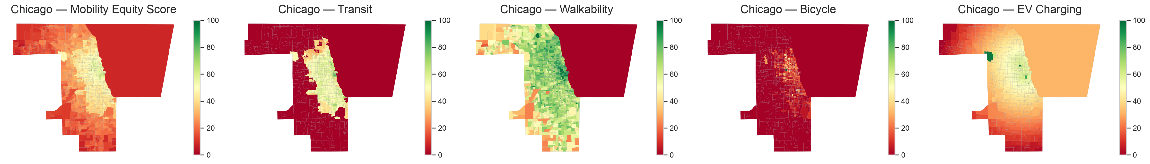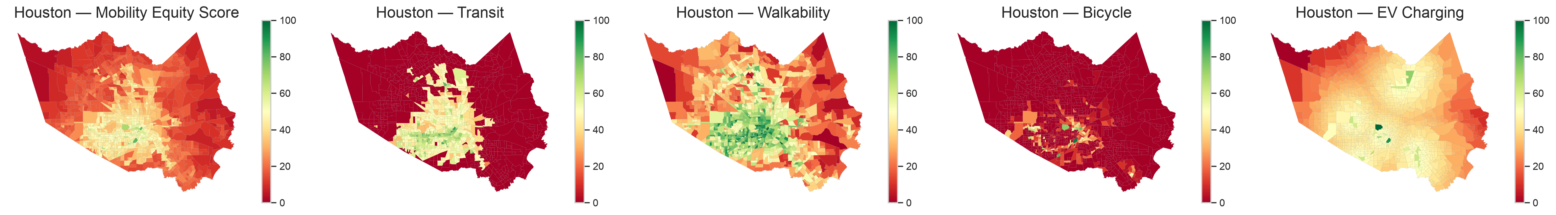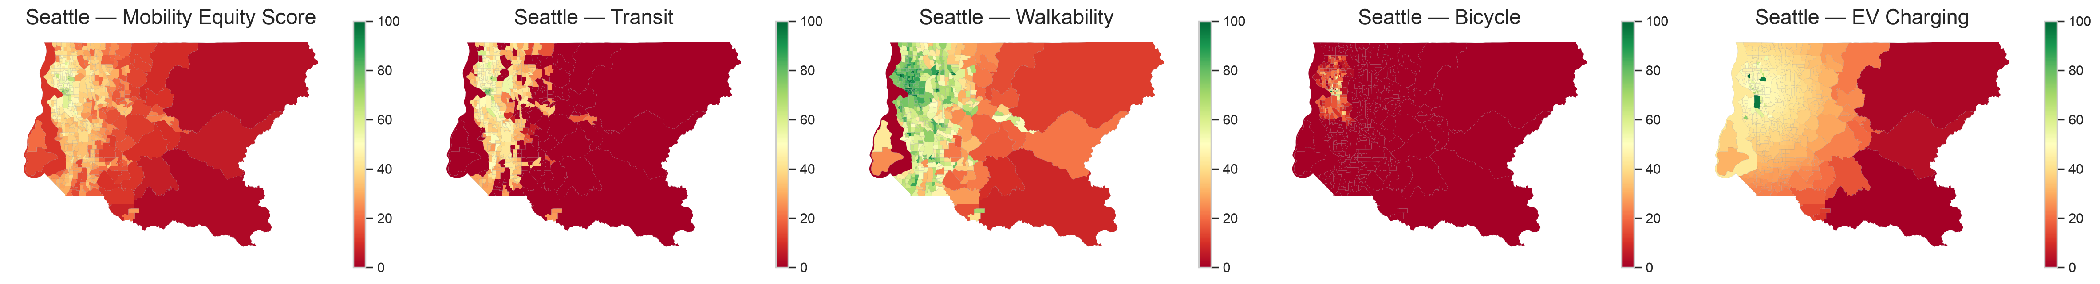
MES and sub-index choropleths (Chicago, Houston, Seattle). Green = better served, red = worse. Walkability and transit concentrate centrally; dedicated bicycle infrastructure is sparse citywide.

Equity Correlation Analysis
Table [tab:corr] reports the Pearson correlations. Three patterns hold across all cities and are all statistically significant ($p<0.05$, 95% CIs excluding zero): the MES is (i) negatively associated with median income ($r=−0.08$ to $−0.27$), (ii) positively and strongly associated with the share of zero-vehicle households ($r=0.41$ to $0.69$), and (iii) positively associated with renter share ($r=0.53$ to $0.69$). The association with percent non-white is positive but weak ($r=0.10$ to $0.14$). Descriptively, the MES co-occurs with higher shares of car-free and renter households — the dense urban core; the raw negative income association is probed for confounding in Sec. 4.7, where it largely disappears once urban form is controlled. All coefficients are associational, not causal, and (as Sec. 4.7 shows) their significance is overstated by spatial dependence. Figure 2 visualizes the full correlation structure for Chicago. A Spearman rank check agrees in sign with every Pearson coefficient in all three cities; the strong zero-vehicle and renter associations remain strong under ranks, while the weaker income and non-white associations attenuate — indicating the latter are more sensitive to distributional outliers and should be read cautiously. The four sub-indices show coherent but non-redundant internal structure (mean inter-sub-index Pearson $r=0.45$–$0.62$, pairwise range $0.26$–$0.81$), i.e. related enough to form a coherent composite yet distinct enough that each contributes non-redundant information — the appropriate validity evidence for a formative index, rather than a reflective-scale reliability statistic (RQ1).
l Y Y Y Variable & Chicago & Houston & Seattle
Median income & $−0.085$ $[−0.14,−0.03]$ & $−0.144$ $[−0.20,−0.09]$ & $−0.272$ $[−0.35,−0.19]$
% non-white & $+0.140$ $[0.09,0.19]$ & $+0.097$ $[0.04,0.16]$ & $+0.102$ $[0.01,0.19]$
% zero-vehicle & $+0.562$ $[0.52,0.60]$ & $+0.408$ $[0.36,0.46]$ & $+0.691$ $[0.64,0.73]$
% renter & $+0.576$ $[0.54,0.61]$ & $+0.535$ $[0.49,0.58]$ & $+0.686$ $[0.64,0.73]$
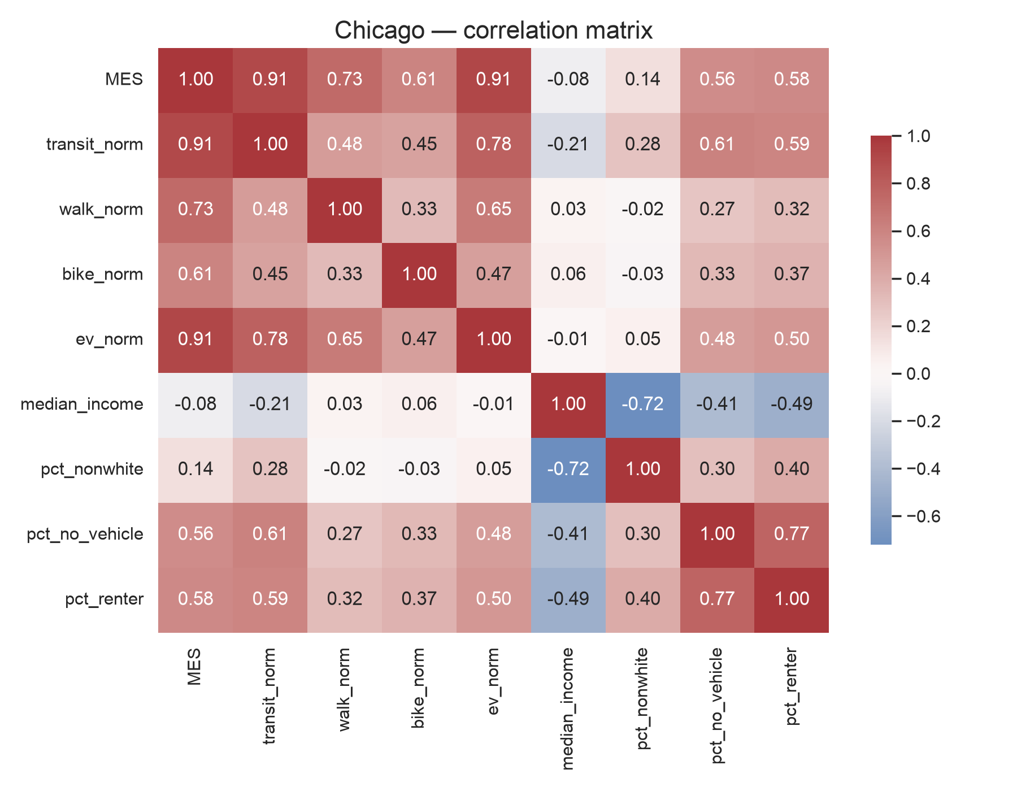
Chicago correlation matrix among the MES, its sub-indices, and demographic variables.

Spatial Autocorrelation
The MES is strongly spatially clustered in every city (Table [tab:moran]): global Moran’s $I$ ranges from 0.82 (Seattle) to 0.92 (Chicago), all with $p=0.001$ and large $z$-scores. Well-served and under-served tracts thus form contiguous patches, not a random scatter — confirming systematic, place-based inequity. Local Moran’s $I$ (Figure 3) locates the significant low-low cold spots (peripheral, lower-supply clusters) that are the natural targets for investment.
l Y Y Y Y City & Moran’s $I$ & $z$-score & $p$-value & $n$
Chicago & 0.916 & 60.9 & 0.001 & 1,332
Houston & 0.834 & 48.2 & 0.001 & 1,115
Seattle & 0.820 & 31.0 & 0.001 & 495
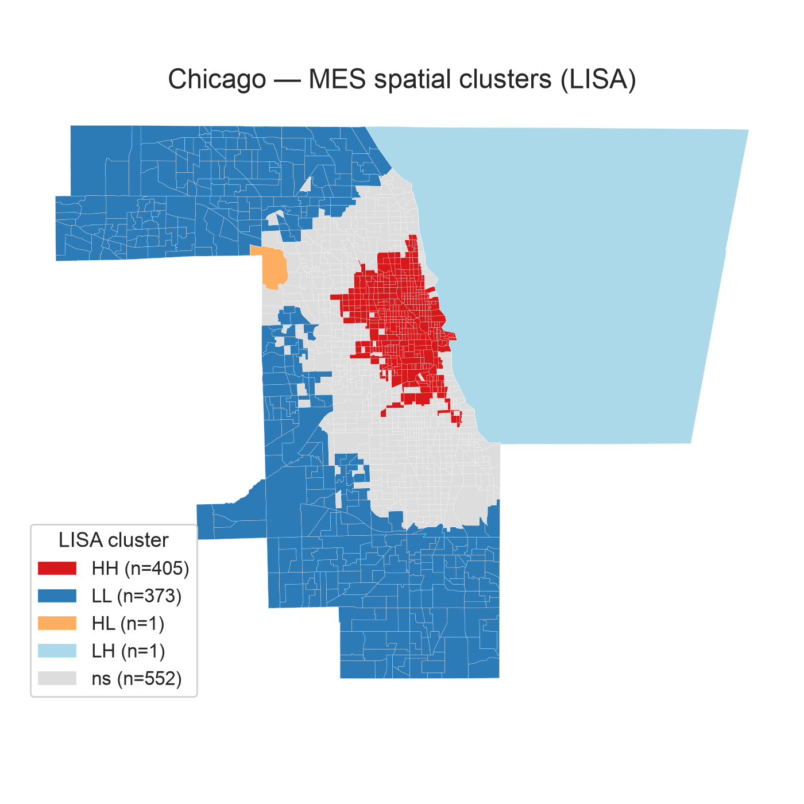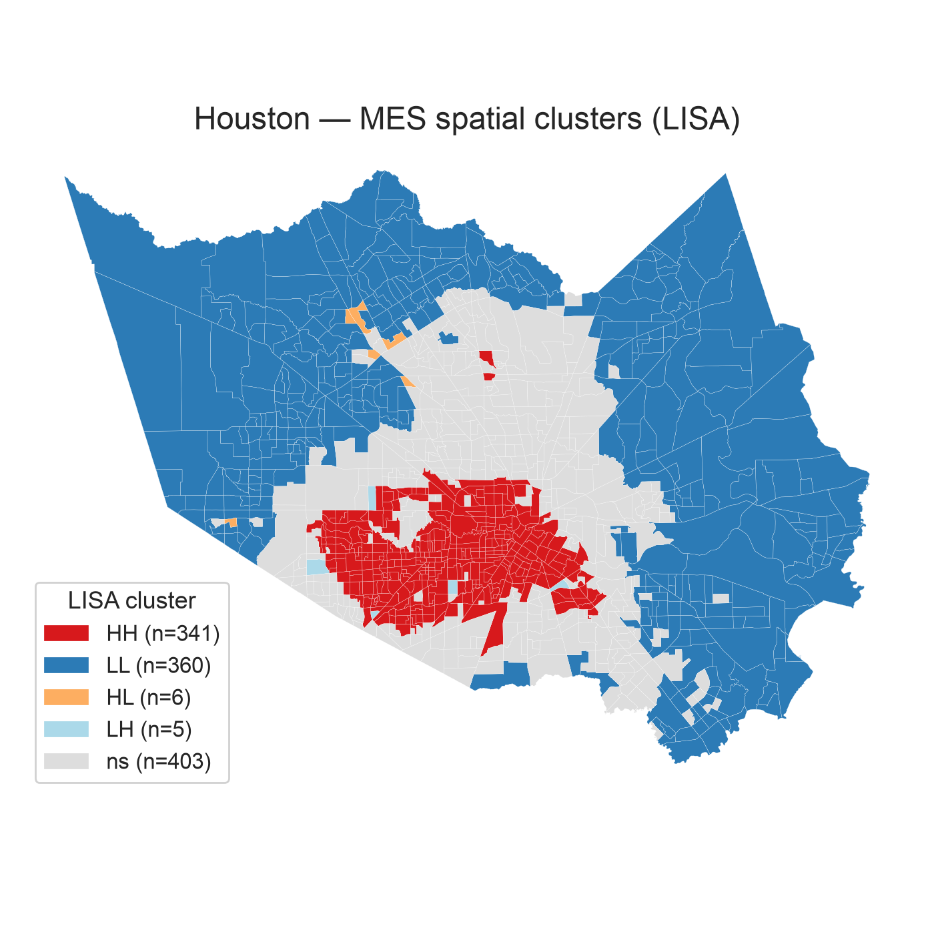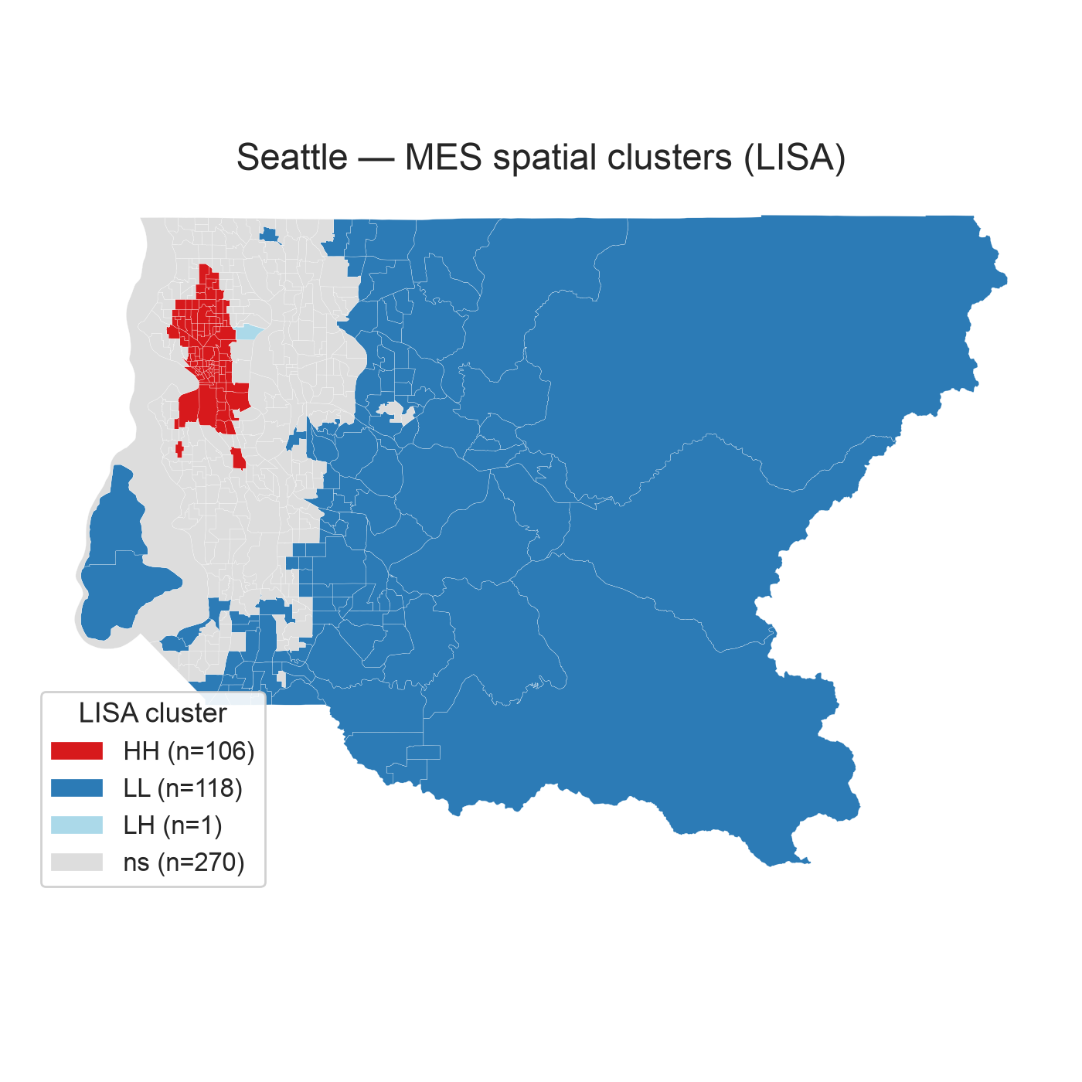
Local Moran’s $I$ (LISA) clusters. Red = high-high (well-served cores), blue = low-low (under-served cold spots).

Mobility-Desert Classification and Threshold Robustness
Table [tab:sensitivity] shows the desert classification is robust to the percentile threshold: moving from the 25th to the 20th or 30th percentile yields Jaccard overlaps of $0.80$–$0.83$ with the baseline set (well above the 0.75 criterion), and the demographic profile of flagged tracts is stable. Notably, the mean median income of desert tracts is high in every city (Chicago $96.8k, Houston $94.1k, Seattle $157.4k), and their mean non-white share is substantial (Chicago 52%, Houston 64%, Seattle 39%) — the deserts are higher-income peripheries that nonetheless include large minority populations.
l c Y Y Y City & Threshold & Jaccard vs. 25th & Mean income ($) & Mean % non-white
Chicago & 20th / 30th & 0.80 / 0.83 & 97.1k / 98.2k & 51.4 / 51.2
Houston & 20th / 30th & 0.80 / 0.83 & 95.6k / 94.2k & 63.0 / 64.9
Seattle & 20th / 30th & 0.80 / 0.83 & 158.4k / 153.9k & 38.7 / 40.9

Cluster Typology
Silhouette-selected K-means (Figure 4) yields interpretable profiles (Table [tab:typology]). Chicago and Seattle resolve into two groups — a well-served multimodal core and a uniformly under-served periphery — while Houston resolves into three, adding a distinctive “walk-rich, bike-poor” class (537 tracts) that has moderate walkability and transit but almost no cycling infrastructure. Across all cities the near-zero bicycle centroid confirms that cycling is the systematically weakest dimension. The silhouette for the selected $k$ is 0.48 (Chicago, $k=2$), 0.48 (Houston, $k=3$), and 0.41 (Seattle, $k=2$), and the partitions are perfectly reproducible across random initializations (Sec. 4.7). Because $k$ differs across cities, similarly named profiles are not assumed to represent identical neighborhood structures; cross-city comparison is by centroid shape, not by label.
l Y r r r r City & Profile & Transit & Walk & Bike & EV
Chicago & Well-served / multimodal (868) & 53.3 & 73.5 & 8.2 & 49.7
Chicago & Uniformly under-served (464) & 0.5 & 58.9 & 0.1 & 25.8
Houston & Walk-rich, bike-poor (537) & 53.1 & 67.0 & 2.5 & 44.6
Houston & Uniformly under-served (484) & 1.1 & 29.2 & 0.7 & 34.5
Houston & Well-served / multimodal (94) & 55.0 & 71.5 & 38.5 & 46.7
Seattle & Well-served / multimodal (170) & 52.4 & 82.4 & 20.6 & 50.4
Seattle & Uniformly under-served (325) & 23.6 & 54.0 & 0.3 & 34.9
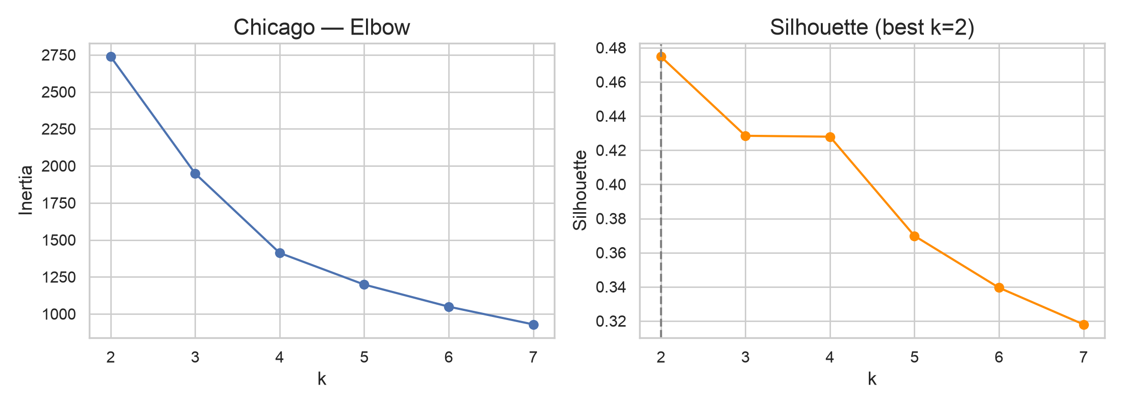
Elbow (inertia) and silhouette curves for Chicago; silhouette is maximized at $k=2$.

Weighting Sensitivity
The equal-weight baseline is treated as one scenario among several; entropy and PCA weights are objective sensitivity scenarios, and the policy-priority (expert-inspired) weights represent a plausible planner preference. The headline is stability: re-computing the MES under all four schemes leaves the equity associations unchanged in sign and significance (Chicago shown — MES–renter $r≈0.57$–$0.59$; MES–income negative and weak throughout). The entropy scheme up-weights bicycle (0.68) because that sub-index has the highest dispersion, yet even this extreme reweighting does not flip any sign (RQ1).

Robustness: Confounding, Spatial Dependence, and EV Data
Because the bivariate correlations (Sec. 4.2) neither control for confounders nor account for the strong spatial dependence (Sec. 4.3), four robustness checks were run (Table [tab:robust]).
Urban-form confounding. Adding population density and distance to the CBD to an OLS of the MES on income sharply changes the income coefficient: it is negative and significant bivariately in all three cities, but after controls it becomes non-significant in Houston ($p=0.64$), reverses to weakly positive in Chicago, and remains negative and significant only in Seattle ($p<{10}^{−20}$). The apparent “low-income cores are better served” pattern is thus largely an urban-form artifact (density and centrality), not an income effect per se — except in Seattle, where it persists.
Spatial regression. Fitting spatial-lag and spatial-error models (queen contiguity) of the MES on income, renter share, zero-vehicle share, density, and CBD distance, the error model is preferred for Chicago and the lag model for Houston and Seattle (by AIC). Once spatial dependence is modelled, the income association is negligible in Chicago/Houston and modest-negative in Seattle, corroborating the OLS result and confirming that ordinary significance was overstated.
Clustering stability. Across five random initializations the K-means partition is perfectly reproducible in every city (mean Adjusted Rand Index $=1.00$; silhouette $0.41$–$0.48$), so the typologies are not seed artefacts.
EV data. Recomputing a three-dimension MES without the (OSM-sourced) EV layer leaves the principal findings intact on every axis: the correlations with income, renter share, and zero-vehicle share all move by $|Δr|≤0.05$; the mobility-desert set overlaps the four-dimension set by a Jaccard of $0.71$–$0.92$; and the spatial clustering is essentially unchanged (Moran’s $I$ of $0.77$–$0.87$ versus $0.82$–$0.92$). The conclusions therefore do not depend on the least-certain dimension.
l Y Y l c c City & MES–income, bivariate & + urban-form controls & Spatial (AIC) & Cluster ARI & EV max $|Δr|$
Chicago & $−$, $p=.002$ & $+$, weak & error & 1.00 & 0.025
Houston & $−$, $p<.001$ & n.s. ($p=.64$) & lag & 1.00 & 0.009
Seattle & $−$, $p<.001$ & $−$, $p<.001$ & lag & 1.00 & 0.053

Dashboard Demonstration
The interactive dashboard (Figure 5) renders the tract-level MES and any sub-index, supports click-through inspection (score, city percentile, sub-index bars versus the city median, and demographics), and compares the equity gap across cities. It is the dissemination layer for the results above, not a separate analysis.
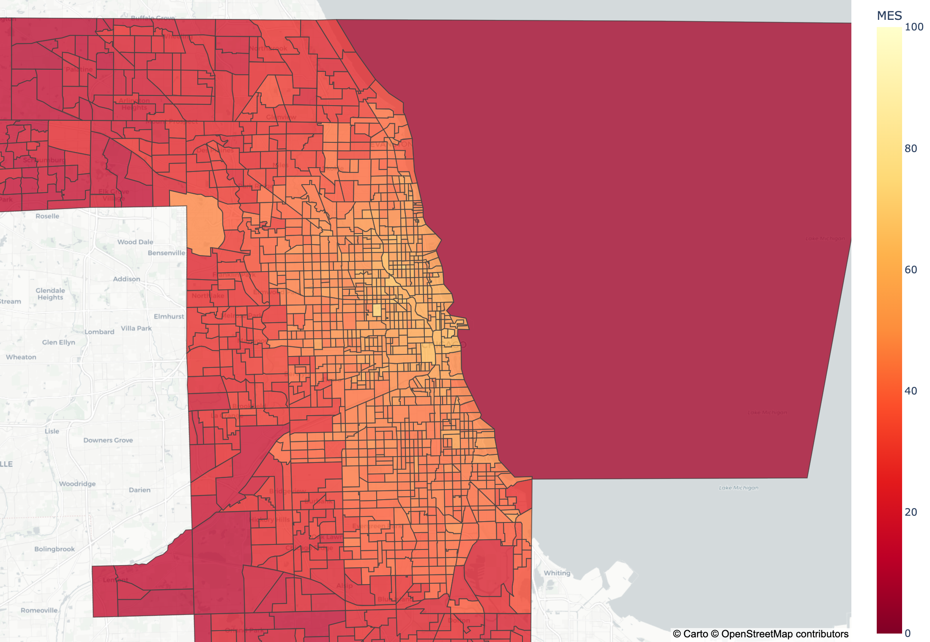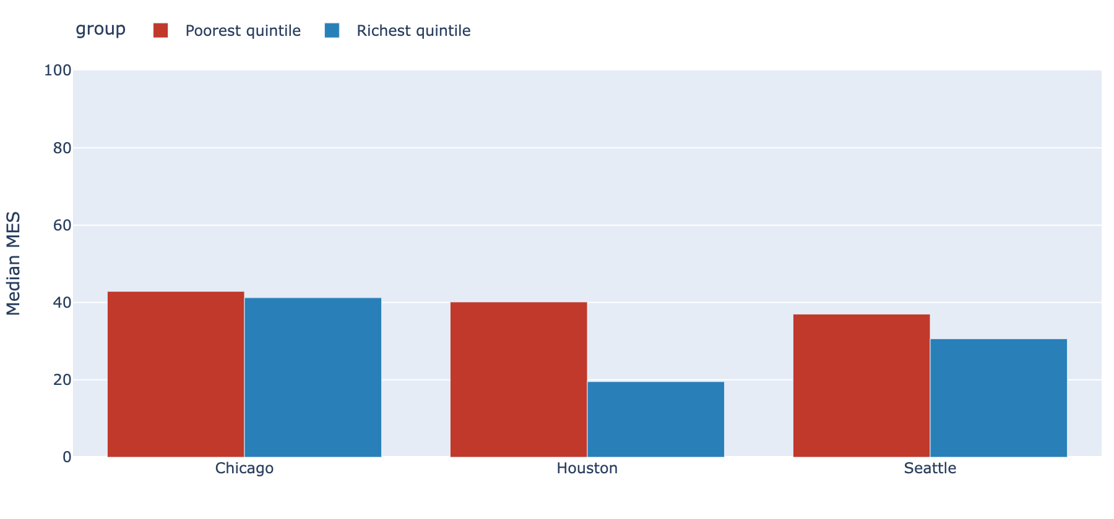
Dashboard: Chicago MES choropleth (top) and the city equity-gap panel (median MES of the poorest versus richest income quintile, bottom).

Discussion and Conclusions

What the Data Demonstrate
This chapter deliberately separates what the analysis demonstrates from what it infers. Four results are demonstrated and robust across all three cities. (1) The MES is strongly spatially clustered (Moran’s $I=0.82$–$0.92$): supply inequity is structural and place-based, not scattered. (2) The MES is positively associated with car-free and renter shares (associational; the ordinary significance is corrected via spatial regression, Sec. 4.7). (3) The bivariate negative MES–income association is largely explained by urban form — it does not survive density/centrality controls or spatial regression except in Seattle — so it must not be read as an income effect per se. (4) The composite is well-behaved: its four sub-indices are related but non-redundant, results are stable across weighting schemes, the clusters are perfectly reproducible (ARI $=1.0$), and the findings are insensitive to the EV layer. Bicycle infrastructure is the weakest dimension everywhere, defining a recurring “walk-rich, bike-poor” neighborhood type.

What We Infer: A Supply–Need Reframing
The following is interpretation, not demonstration. Because supply-side infrastructure co-occurs with density — and therefore with car-free and renter populations — the equity question is best framed, associationally, as a supply–need mismatch: the MES measures supply, while car-free and renter shares proxy need; travel demand itself is not modelled here. Where dense cores are well supplied, the residual concern is plausibly service quality and affordability, which supply counts do not capture; where higher-income peripheries score low, their residents are typically car-owning, so low supply is likely less acute — except for the car-free and minority households embedded in those peripheries (the Chicago/Houston desert tracts are 52–64% non-white), who plausibly face the widest supply–need gap. Compounded deserts and LISA cold spots locate those tracts and are where the framework most plausibly adds policy value. Seattle, where a negative income gradient persists under controls, is the one city that may warrant a closer income-specific look.

Implications
For practitioners, the MES operationalizes the Justice40 mandate at neighborhood resolution: it ranks tracts, distinguishes single- from multi-dimension deficits, and — via the typology — prescribes differentiated interventions (e.g., cycling investment for the “walk-rich, bike-poor” class; first/last-mile transit for uniformly under-served peripheries). Because the pipeline is open and reproducible, any city with GTFS and open data can generate the same diagnostics.

Limitations
Five limitations bound the conclusions. (1) Supply-side only: the MES measures infrastructure present, not realized accessibility, service quality, affordability, or travel behavior. (2) EV data: the EV sub-index uses community-maintained OpenStreetMap charging points — a reachable but lower-bound proxy for the authoritative DOE/NREL AFDC inventory, which was unavailable on the development network; EV results should be read as conservative and are the least certain of the four dimensions. (3) Within-city normalization: the MES is relative to each city, so cross-city levels are not directly comparable (within-city patterns and correlations are valid). (4) Cross-sectional, three cities: the analysis is a single snapshot for three metros and is not yet generalizable nationally. (5) Inferential: because the MES is strongly spatially autocorrelated (Moran’s $I≈0.9$), ordinary correlation $p$-values are optimistic; we therefore report spatial-lag/error models and urban-form controls (Sec. 4.7), which substantially attenuate the income association. Residual caveats are that the associations are ecological (tract-level, not individual-level) and that confounders beyond density and centrality are not modelled.

Future Research
Priorities are: extending to the Phase-2 cities (Phoenix, Atlanta, Detroit) and beyond for national generalizability; substituting authoritative AFDC EV data and adding transit service quality (headway reliability, e.g. from the FTA National Transit Database); layering EPA EJScreen environmental-justice indicators alongside the demographic cross-tabs; and, most directly, developing a demand-adjusted MES that combines infrastructure supply with transportation need (e.g., zero-vehicle households and jobs reachable within a travel-time budget) so that the supply–need relationship can be modelled rather than inferred. A longitudinal extension would then measure whether targeted investment narrows the gaps the MES identifies.

Answering the Research Questions
The four research questions of Sec. 1.3 are answered directly by the results:
- RQ1 (measurement). Yes — the four open datasets integrate into a coherent, non-redundant composite (inter-sub-index $r=0.45$–$0.62$) whose equity associations are stable in sign and significance across equal, entropy, PCA, and policy-priority weights (Sec. 4.2, Sec. 4.6).
- RQ2 (distribution). About a quarter of tracts are deserts by construction, but the informative results are that the classification is stable (Jaccard $0.80$–$0.83$ across thresholds), spatially concentrated in peripheral cold spots, and compounded (low on $≥2$ dimensions) in 13–23% of tracts (Sec. 4.4, Sec. 4.5).
- RQ3 (equity). The MES is positively associated with car-free ($r=0.41$–$0.69$) and renter ($r=0.53$–$0.69$) shares and negatively with income ($r=−0.08$ to $−0.27$); the income association is largely urban-form-driven and survives density/centrality controls and spatial regression only in Seattle (Sec. 4.2, Sec. 4.7).
- RQ4 (spatial structure and typology). The MES is strongly spatially clustered (Moran’s $I=0.82$–$0.92$, $p<0.001$) with mapped low-low cold spots, and silhouette-selected K-means recovers two-to-three reproducible neighborhood profiles per city (ARI $=1.00$) (Sec. 4.3, Sec. 4.5).

Conclusion
This project delivers an integrated, transparent, and reproducible measure of multi-modal mobility supply at the neighborhood scale, and uses it to show that mobility infrastructure in three major U.S. cities is spatially concentrated in dense, central tracts — with the apparent income gradient largely attributable to urban form once controls and spatial regression are applied. The equity question is therefore reframed, associationally, as a supply–need mismatch best examined through compounded deserts and cold spots. The open pipeline and dashboard make the method immediately transferable to other cities.
99
J. J. Aman and J. Smith-Colin, “Transit deserts: Equity analysis of public transit accessibility,” Journal of Transport Geography, vol. 89, p. 102869, 2020. Urban Institute, “Redefining Walkability: A Neighborhood-Level Analysis,” Urban Institute, Washington, DC, 2022. J. Lou, A. Chandra, and M. Gordon, “Equity and reliability of public electric vehicle charging stations in the United States,” Nature Communications, vol. 16, p. 4201, 2025. S. Ahmed, Z. Sultana, and M. Rahman, “A systematic review of bicycle infrastructure design principles within urban bikeability indices,” Sustainability, vol. 17, no. 14, p. 6409, 2024. A. Ermagun and N. Tilahun, “Transit equity and job accessibility,” Transportation Research Part A, vol. 134, pp. 191–204, 2020. S. Maharjan, F. Janatabadi, and A. Ermagun, “Spatial inequity of transit and automobile access gap across America for underserved populations,” Transportation Research Record, vol. 2678, no. 1, pp. 674–690, 2024. Argonne National Laboratory, “Electric Vehicle Charging Equity Considerations,” U.S. Department of Energy, 2022. U.S. EPA, “Smart Location Mapping and National Walkability Index,” EPA, 2024. Sustrans, “Cycling and Walking Investment Strategy: Equity in Active Travel Infrastructure,” Sustrans, Bristol, UK, 2023. A. Albashir et al., “15min City Score Toolkit: Urban Walkability Analytics,” Transform Transport Working Papers, Zenodo, 2024. X. Chen and Y. Li, “Electric vehicle charging equity and accessibility: A U.S. policy analysis,” Transportation Research Part D, vol. 118, p. 103748, 2024. Urban Institute, “Spending on Infrastructure toward Equity (SITE) Tool,” 2025. Oliver Wyman Forum, “2024 Urban Mobility Readiness Index,” 2024. B. Pandey, C. Brelsford, and K. C. Seto, “Rising infrastructure inequalities accompany urbanization and economic development,” Nature Communications, vol. 16, p. 1082, 2025. G. Boeing, “OSMnx: New methods for acquiring, constructing, analyzing, and visualizing complex street networks,” Computers, Environment and Urban Systems, vol. 65, pp. 126–139, 2017. M. Nardo, M. Saisana, A. Saltelli, et al., Handbook on Constructing Composite Indicators: Methodology and User Guide. OECD/JRC, 2008. L. Anselin, “Local Indicators of Spatial Association—LISA,” Geographical Analysis, vol. 27, no. 2, pp. 93–115, 1995. P. J. Rousseeuw, “Silhouettes: A graphical aid to the interpretation and validation of cluster analysis,” Journal of Computational and Applied Mathematics, vol. 20, pp. 53–65, 1987.

