A Reproducible Mobility Equity Score: Integrating Transit, Walkability, Bicycle, and EV-Charging Supply at the Census-Tract Level

Abstract
Urban mobility infrastructure—public transit, walkable streets, bicycle facilities, and electric-vehicle (EV) charging—is unevenly distributed, yet existing tools measure each dimension in isolation. We construct a Mobility Equity Score (MES): a transparent, reproducible composite index that integrates all four dimensions at the U.S. Census-tract level, and apply it to three structurally distinct cities (Chicago, Houston, Seattle) using only open data. The MES is strongly spatially clustered in every city (global Moran’s $I=0.82$–$0.92$) and is positively associated with the share of car-free and renter households. A bivariate negative association with median income is shown to be largely a function of urban form: after controlling for population density and distance to the central business district, and after spatial-regression correction, it attenuates to non-significance in Houston, reverses in Chicago, and persists only in Seattle. Findings are therefore interpreted as associational and consistent with a supply–need mismatch. The pipeline and an interactive dashboard are released open-source.
transportation equity, composite index, spatial analysis, GIS, open data, mobility deserts

Introduction
Access to jobs, health care, and education depends on a layered ecosystem of transit, pedestrian, cycling, and—increasingly—EV-charging infrastructure, each with documented equity gaps . Yet measurement remains siloed: the EPA walkability index, the DOE charger locator, transit GTFS feeds, and OpenStreetMap bicycle data each capture one dimension. No open, reproducible tool integrates all four into a single neighborhood-level equity measure.
This paper contributes: (i) an open, reproducible integration of four mobility dimensions into a tract-level composite; (ii) a transparent methodology whose normalization, weighting, and thresholds are stress-tested; and (iii) an empirical result—that the apparent income gradient in mobility supply is largely an urban-form artifact—obtained through confounder controls and spatial regression. The dashboard is a dissemination layer, not the contribution.
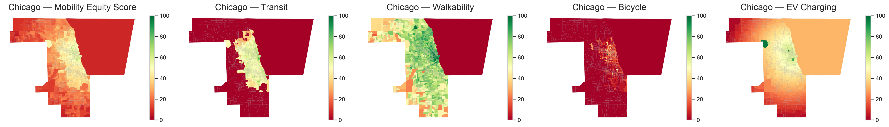
Chicago MES and its four sub-indices (green = better served, red = worse). Walkability and transit concentrate centrally; dedicated bicycle infrastructure is sparse citywide.

Related Work
Single-dimension equity evidence is strong but isolated: transit deserts , racialized walkability , and severe EV-charging gaps for disadvantaged and renter households . Composite-indicator methodology warns that normalization and weighting are value-laden and require sensitivity analysis . Integrated tools exist but trade away tract-level, multi-modal, or open-data properties (e.g., city-scale readiness indices, or spending-based equity tools). The MES fills this gap and, unlike prior work, measures rather than assumes the direction of the supply–demographic relationship.

Methodology

Study Area and Data
The unit of analysis is the 2023 Census tract for Cook County (Chicago; 1,332 tracts), Harris County (Houston; 1,115), and King County (Seattle; 495). All inputs are open: GTFS (transit), the EPA Smart Location Database (walkability), OpenStreetMap via OSMnx (bicycle and EV charging points), the Census ACS 5-year 2019–2023 (demographics), and TIGER/Line boundaries.

Mobility Equity Score
Each of four sub-indices (Table 1) is min–max normalized to 0–100 within each city, then combined as an equally weighted mean, MES=k​wk sknorm, k​wk=1. Because normalization is within-city, cross-city levels are not compared; only patterns are. Tracts below the 25th MES percentile are mobility deserts; those below the 25th percentile in $≥2$ sub-indices are compounded deserts.
The four MES sub-indices.
Sub-index | Metric | Source
Transit | Stop density; AM-peak freq.; span | GTFS
Walkability | Nat. Walkability Index (areal) | EPA SLD
Bicycle | Bike-lane km/km$​^{2}$ | OSM
EV charging | Charger count; dist. to DC-fast | OSM/AFDC

Analysis
Pearson correlations (with Fisher-$z$ confidence intervals and a Spearman robustness check) relate the MES to income, percent non-white, percent zero-vehicle, and percent renter. Global and local Moran’s $I$ (queen contiguity, 999 permutations) test spatial clustering. K-means with silhouette-selected $k$ and multi-seed Adjusted Rand Index (ARI) yields a stable typology. Because the MES is spatially autocorrelated, we additionally fit multivariable OLS with urban-form controls (population density, distance to the central business district) and spatial-lag/error models, and we recompute the MES without the EV layer as a robustness check.

Results

Distribution and Equity Associations
Walkability is the strongest dimension and dedicated cycling the weakest in all cities. The MES is strongly spatially clustered (Table [tab:res]: Moran’s $I=0.82$–$0.92$, all $p<0.001$), so supply inequity is contiguous and place-based. The MES is positively associated with car-free ($r=0.41$–$0.69$) and renter ($r=0.53$–$0.69$) shares, and bivariately negatively with income ($r=−0.08$ to $−0.27$). Fig. 1 maps the MES and its sub-indices.
City | Tracts | Mean MES | Moran’s $I$ | MES–income (bivariate) | + urban-form controls | Cluster ARI
Chicago | 1,332 | 37.5 | 0.92 | $−$ ($p=.002$) | $+$, weak | 1.00
Houston | 1,115 | 31.7 | 0.83 | $−$ ($p<.001$) | n.s. ($p=.64$) | 1.00
Seattle | 495 | 36.2 | 0.82 | $−$ ($p<.001$) | $−$ ($p<.001$) | 1.00

Spatial Cold Spots, Deserts, and Typology
Local Moran’s $I$ (Fig. 2) resolves the clustering into large, statistically significant low-low “cold spots” on each city’s periphery and high-high cores, identifying contiguous under-served areas rather than isolated tracts. Because a mobility desert is defined within each city (bottom MES quartile), the $≈25\%$ share is definitional; the substantive results are that desert tracts are higher-income peripheries that nonetheless contain large minority populations (52–64% non-white in Chicago/Houston), that the classification is stable under threshold changes (Jaccard $0.80$–$0.83$ across the 20th/25th/30th percentiles), and that compounded deserts (low on $≥2$ dimensions) concentrate the disadvantage. K-means recovers interpretable profiles—a well-served multimodal core, a uniformly under-served periphery, and, in Houston, a distinctive “walk-rich, bike-poor” class (537 tracts); silhouettes for the selected $k$ are $0.41$–$0.48$ and the partitions are reproducible across initializations (mean ARI $=1.00$). Because $k$ differs by city, similarly named profiles are compared by centroid shape, not label.
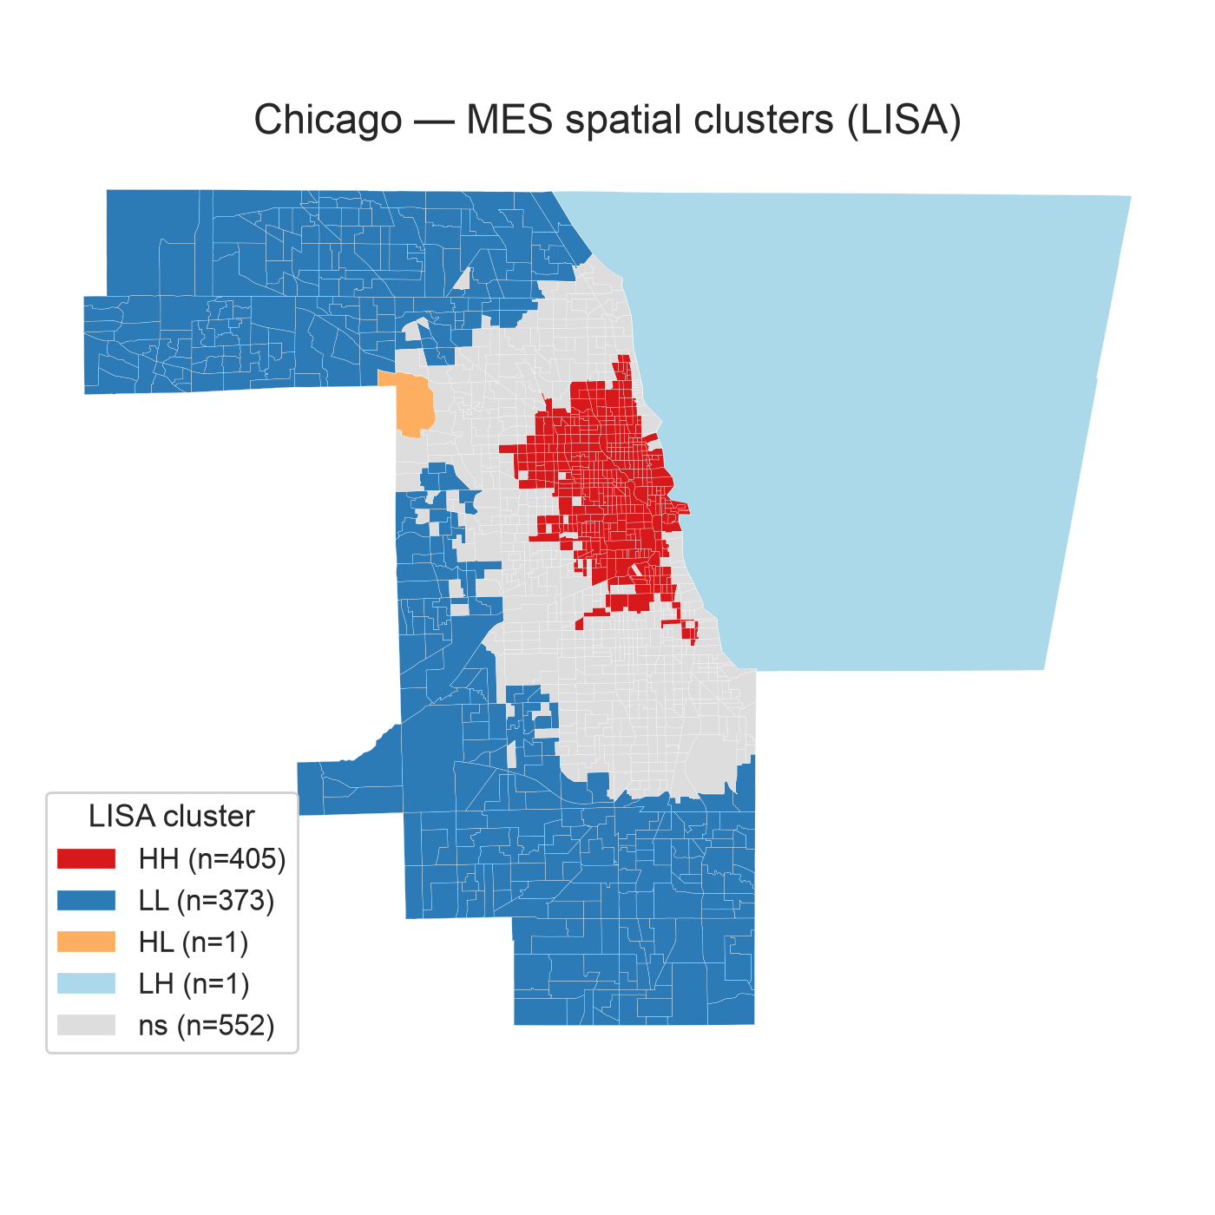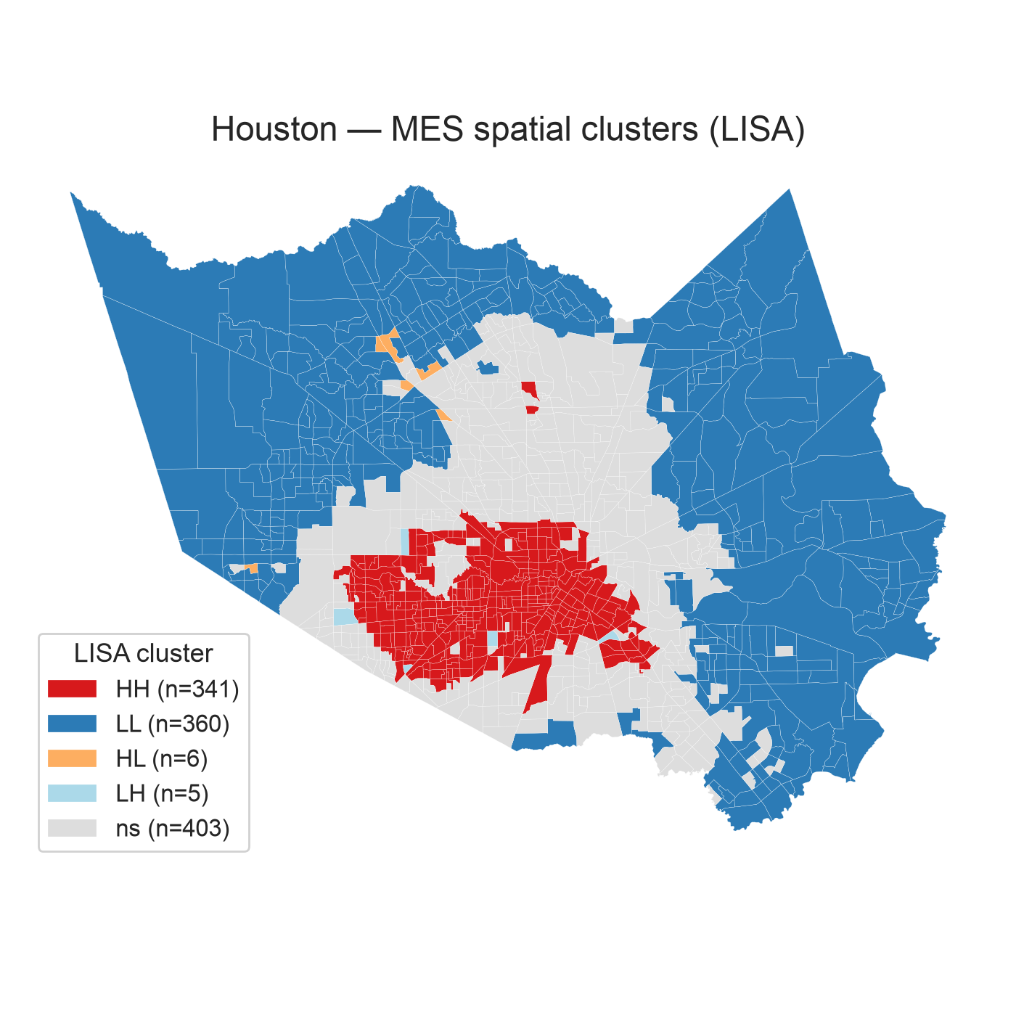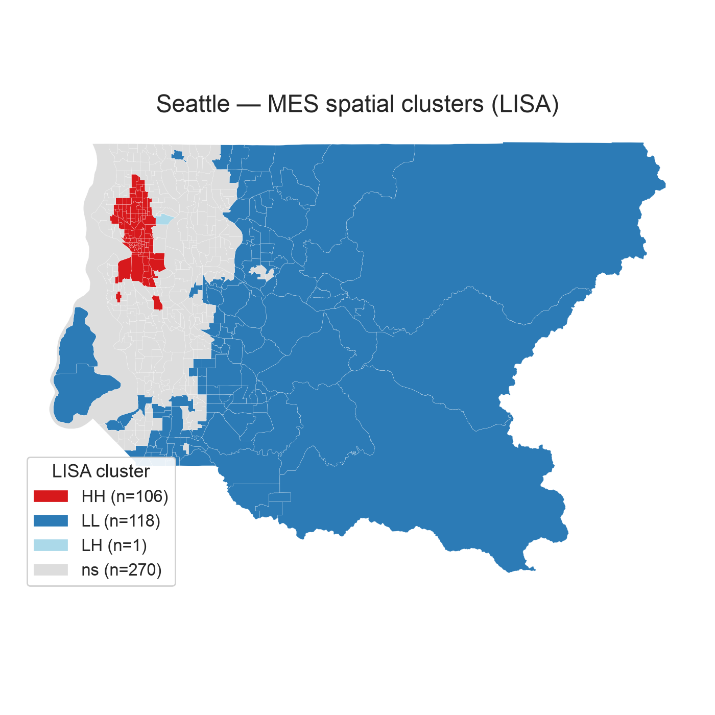
Local Moran’s $I$ (LISA) clusters of the MES (Chicago, Houston, Seattle). Red = high-high (well-served cores); blue = low-low (under-served cold spots).

Confounding, Spatial Dependence, Robustness
Adding density and CBD distance to an OLS of the MES on income changes the income coefficient sharply: it becomes non-significant in Houston, reverses to weakly positive in Chicago, and remains negative and significant only in Seattle. Spatial-lag/error models (error preferred for Chicago, lag for Houston and Seattle by AIC) corroborate this: once spatial dependence is modeled, the income association is negligible except in Seattle, confirming that ordinary significance was overstated. Dropping the OSM-sourced EV layer leaves the findings intact on every axis—the income, renter, and zero-vehicle correlations move by $|Δr|≤0.05$, the desert set overlaps by a Jaccard of $0.71$–$0.92$, and spatial clustering is essentially unchanged—so the conclusions do not depend on the least-certain dimension.

Discussion and Conclusion
What the data demonstrate: mobility supply is strongly spatially clustered, positively associated with car-free and renter shares, and its apparent negative income gradient is largely an urban-form artifact that does not survive density/centrality controls or spatial regression except in Seattle. The composite is well-behaved—related-but-non-redundant sub-indices, stable weighting, reproducible clusters, EV-insensitive conclusions.
What we infer: because supply co-occurs with density (and thus with car-free and renter populations), the equity question is best framed, associationally, as a supply–need mismatch; demand itself is not modeled. Compounded deserts and low-low LISA cold spots locate the tracts where car-free and minority households (52–64% non-white in the Chicago/Houston deserts) plausibly face the widest gap, and are where the framework adds most policy value. In practice this supports neighborhood-level targeting: ranking tracts, separating single- from multi-dimension deficits, and suggesting differentiated interventions such as cycling investment for walk-rich/bike-poor areas and first/last-mile transit for under-served peripheries.
Cross-city reading: because normalization is performed within each city, absolute MES levels are not comparable across cities—a score of 70 in Houston is not equivalent to 70 in Chicago. The robust comparative result is instead that the same qualitative pattern (strong spatial clustering, positive car-free/renter associations, and an income gradient largely explained by urban form) recurs in all three metros, with Seattle the one case where a negative income association survives controls and therefore merits city-specific study.
Limitations are the supply-side scope, the OSM EV proxy, within-city normalization (no cross-city levels), and a three-city cross-section. Future work extends to more cities, substitutes authoritative AFDC EV and FTA transit service-quality data, and—most directly—develops a demand-adjusted MES that combines infrastructure supply with transportation need so the supply–need relationship can be modeled rather than inferred. The full pipeline and dashboard are open-source, making the method transferable to any city with open data.
00 J. J. Aman and J. Smith-Colin, “Transit deserts: Equity analysis of public transit accessibility,” J. Transp. Geogr., vol. 89, p. 102869, 2020. Urban Institute, “Redefining Walkability: A Neighborhood-Level Analysis,” Washington, DC, 2022. J. Lou, A. Chandra, and M. Gordon, “Equity and reliability of public EV charging stations in the United States,” Nature Commun., vol. 16, p. 4201, 2025. S. Ahmed, Z. Sultana, and M. Rahman, “A systematic review of bicycle infrastructure design principles within urban bikeability indices,” Sustainability, vol. 17, no. 14, p. 6409, 2024. S. Maharjan, F. Janatabadi, and A. Ermagun, “Spatial inequity of transit and automobile access gap across America,” Transp. Res. Rec., vol. 2678, no. 1, pp. 674–690, 2024. X. Chen and Y. Li, “Electric vehicle charging equity and accessibility: A U.S. policy analysis,” Transp. Res. Part D, vol. 118, p. 103748, 2024. M. Nardo et al., Handbook on Constructing Composite Indicators. OECD/JRC, 2008. G. Boeing, “OSMnx: New methods for acquiring, constructing, analyzing, and visualizing complex street networks,” Comput. Environ. Urban Syst., vol. 65, pp. 126–139, 2017.

