Opinion Mining: Aspect Extraction

Objective : To extract aspects from the online review of products and to analyze the general opinion regarding the aspects (positive, negative or neutral)

Input : Text review of a product (extracted from online or magazine)

Output : A list of aspects and the opinion about them in the review

Platform : Python3

Packages : nltk (Natural Language Toolkit), ast (Abstract Syntax Tree), re (Regular Expression Operation)

Methodology
The general method for opinion mining involves the following steps

- Preprocessing : Removal of stop words.
- Tokenization : Formation of token of sentences / phrases
- Classification : Classification of words according to their parts of speech
- Aspect Extraction: Identification of Aspects in the text
- Opinion Mining : Determination of opinion of the extracted Aspects refering to available corpus

Example Case
Dataset Taken
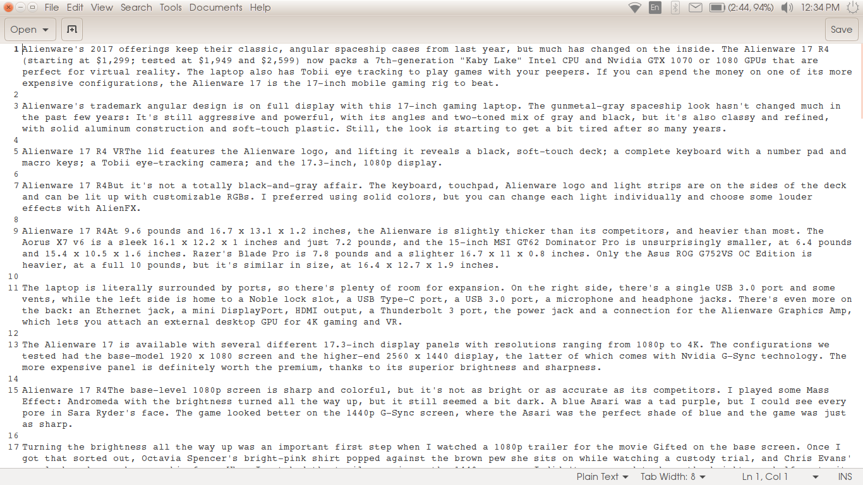
Driver Menu
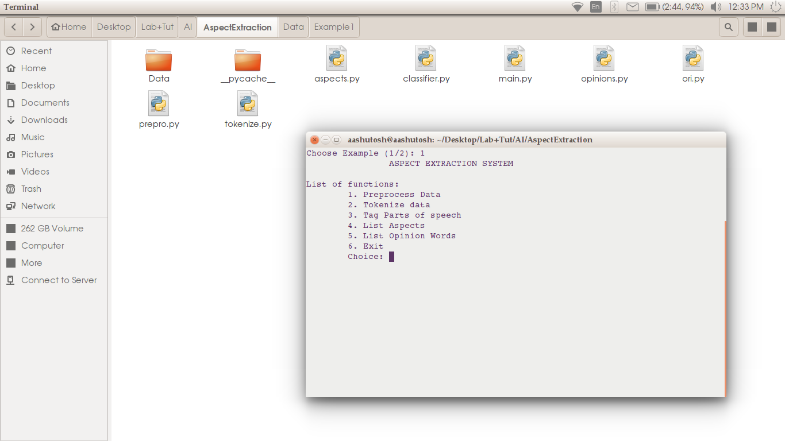
Final Output
