Discussion Questions: Python Identity, Aliasing, and Hash Tables
Aashutosh
Question 1: Equality, Identity, and List Aliasing
The == operator checks equality, meaning whether two objects hold the same value. The is operator checks identity, meaning whether two names point to the exact same object in memory. So [1, 2] == [1, 2] returns True, but each list is its own object, so is returns False.
Aliasing happens when several names refer to one mutable object (Noble et al., 1998). And that's where trouble starts. Python passes a list to a function by object reference, so the parameter is an alias, not a copy. If the function appends to it, the caller's list changes too. Nothing crashes, but the logic quietly breaks.
Picture a hospital app that hands a patient's medication list to a function that adds a default drug for a dosage preview. The function mutates the original, so the saved record now shows a drug no doctor ordered. That's a real patient-safety risk. Passing meds.copy() fixes it, though nested lists still need copy.deepcopy().
Figure 1
Identity Versus Equality and List Aliasing
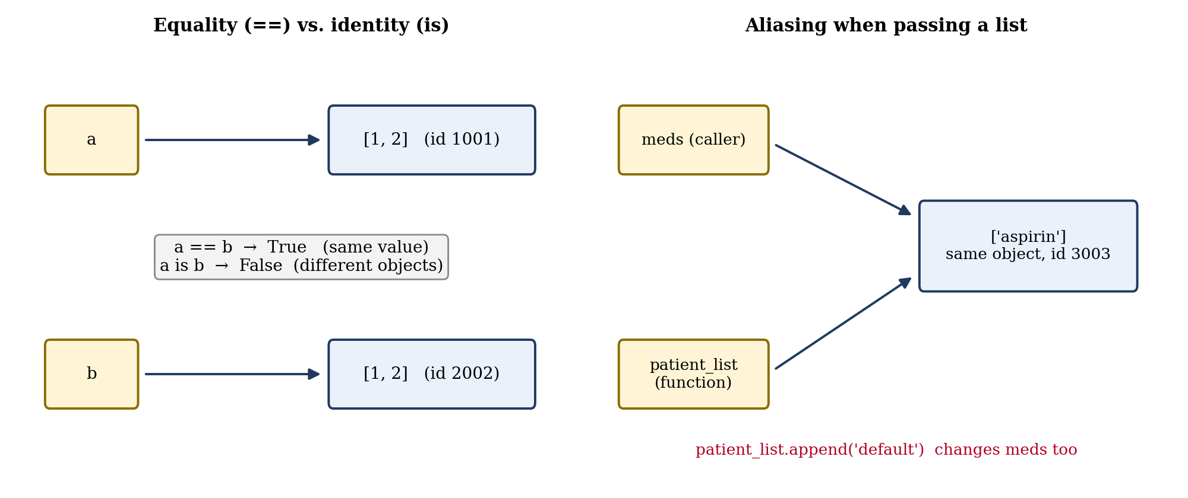
Note. Original diagram created by the author.
Question 2: Hash Tables and Tuples
A dictionary stores pairs in an array of slots. Python runs each key through a hash function, and the resulting integer points straight to a slot, so no scanning is needed. Good hash functions spread keys evenly, which keeps collisions rare (Carter & Wegman, 1979). That's why lookups average O(1).
But it's an average, not a guarantee. If many keys collide, lookups can slow toward O(n). Python handles collisions by probing for another open slot, and it resizes the table as it fills.
Use a tuple when data shouldn't change or when you need a hashable key. Immutable objects keep a stable hash, while a mutable list can't promise that (Potanin et al., 2013). A delivery app, for example, can store (latitude, longitude) tuples as keys to find a stop instantly. Lists suit collections that grow or change.
Figure 2
Hash Table Lookup and Tuple Keys
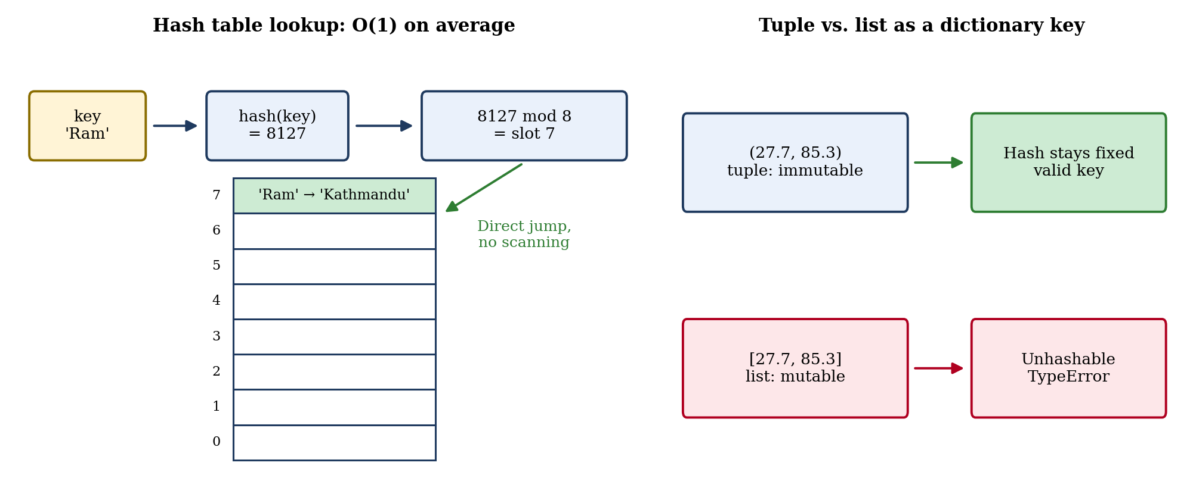
Note. Original diagram created by the author.
References
Carter, J. L., & Wegman, M. N. (1979). Universal classes of hash functions. Journal of Computer and System Sciences, 18(2), 143–154. https://doi.org/10.1016/0022-0000(79)90044-8
Noble, J., Vitek, J., & Potter, J. (1998). Flexible alias protection. In E. Jul (Ed.), ECOOP'98—Object-oriented programming (pp. 158–185). Springer. https://doi.org/10.1007/BFb0054091
Potanin, A., Östlund, J., Zibin, Y., & Ernst, M. D. (2013). Immutability. In D. Clarke, J. Noble, & T. Wrigstad (Eds.), Aliasing in object-oriented programming (pp. 233–269). Springer. https://doi.org/10.1007/978-3-642-36946-9_9

