In-Memory Inventory Management Tool

Aashutosh Chaudhary
AIM 401: Python Programming For Data Science
Professor Bashyal
October 1 , 2026
GitHub repository: https://github.com/aashutoshchaudhary1/AIM_401_ASSIGNMENT/tree/4909fd428af838d69a6a084ae3a4767fdaf8ef8a/assignment/week3.

In-Memory Inventory Management Tool

1. Introduction

This report details a Python script which simulates an order processing for a distribution centre. The inventory is stored in a dictionary, while the customer orders are received as a batch in a list of lists. The program compares each order against the inventory and ships what it can, logs what it can't and prints a summary at the end of the batch. The program will only be allowed to use lists, dicts, if-elif-else, loops, and the appropriate built-in methods .get(), .append(), and .items(), as per the constraints for the assignment. No custom functions, classes, imports or file operations.

2. Data Structures (Task 1)

The inventory is a dictionary, associating a name of an item (key) with an amount (value) of that item present (Python Software Foundation, n.d.-a). It holds five items: Widget (10), Gadget (5), Sensor (0), Cable (15), and Battery (20). The order queue consists of a list of two-element lists, [item, quantity]. A list keeps the order in which the elements are added to it; that is, the first element added to the list is the first to be removed from it (Matthes, 2023). There are nine orders in the batch, specifically intending to include all of the cases: full, partial, out-of-stock, and "Bolt" (which does not exist in the batch). Three trackers exist for the analytics: fully_fulfilled_count (an integer), and unfulfilled_items (a list of [item, shortfall] pairs).

3. Order-Processing Logic (Task 2)
Each order is read by a for loop and the key is looked up using the inventory.get(item) line. Unlike square-bracket access, .get() will return None if it doesn't contain a key, which means you don't need to use an except block to detect an invalid key.Unlike square-bracket access, .get() will return None if the key doesn't exist, so you don't need to use an except block to detect an invalid key (Sweigart, 2019). Then, an if-elif-else chain is executed to choose among 4 possible outcomes:
- If the stock is not found, an alert is printed and the entire request is added to the unfulfilled requests.
- Fulfillment: If the requested quantity is not available in each unit, but the total stock exceeds it, then the quantity is deducted, the counter increments and a success message is printed.
- Partial fulfillment: If the stock doesn't meet the request, but it is less than requested, the remaining stock is shipped, inventory is set to 0, and the remainder (requested − stock) is added to the unfulfilled list.
- Out of stock: stock = 0 – an alert prints and the entire request is marked as not fulfilled.
Immediately, the invalid-item test is added; there is a risk otherwise in comparing None with a number. The bottom part of the core loop is displayed below; the full script is found in the GitHub repository.
for order in orders:
item = order[0]
requested = order[1]
stock = inventory.get(item) # None if key missing

if stock is None: # invalid item
unfulfilled_items.append([item, requested])
elif stock >= requested: # full fulfillment
inventory[item] = stock - requested
fully_fulfilled_count += 1
elif stock > 0: # partial fulfillment
remainder = requested - stock
inventory[item] = 0
unfulfilled_items.append([item, remainder])
else: # out of stock
unfulfilled_items.append([item, requested])

4. Analytics and Summary (Task 3)
The program then prints: (1) the final inventory dictionary with .items() for an easy-to-read table, (2) the number of the orders completely fulfilled out of the total, and (3) all the items and quantities that could not be fulfilled. Formatted strings (f-strings) line up the result (Python Software Foundation, n.d.-b).
5. Test Output
The program has been executed with the sample batch and the result is shown in figures 1 and 2. Orders 1, 4, 7 and 9 were all received, while orders 3 & 6 were partial (Gadget & Widget each being short by 2), order 2 was out of stock and order 5 had a non-existent item, Bolt. The final inventory numbers are Widget 0, Gadget 0, Sensor 0, Cable 0 and Battery 14, with 4/9 orders complete, matching a manual trace of the data.
Figure 1. Order-processing messages for each order in the batch.
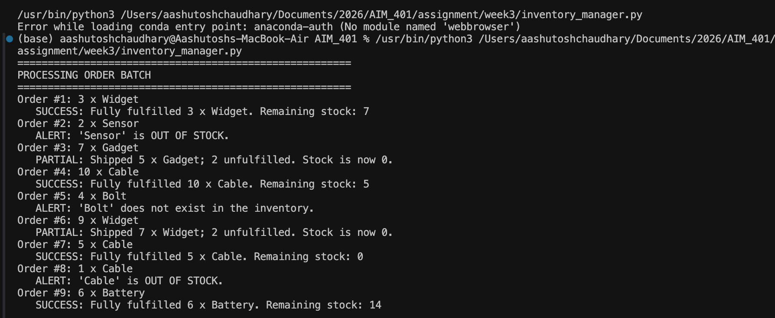
Figure 2. End-of-batch summary report.
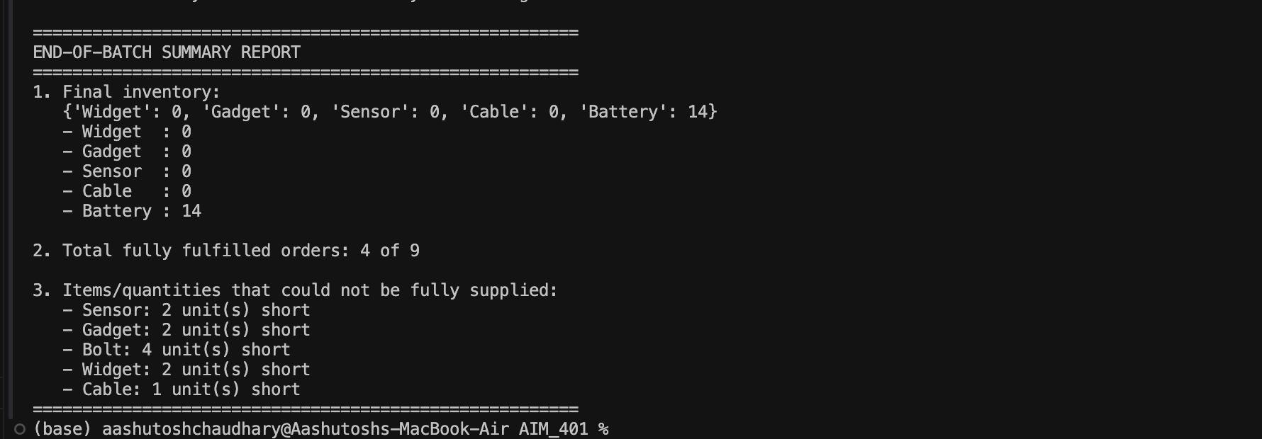

6. Conclusion
This script performs all three tasks with minimal Python constructs. The .get() method is used for dictionary lookups, which ensures that the code remains safe and compact; the unfulfilled-items list provides a reference for warehouse staff for restocking and backordering. What could be extended (not done here in the assignment) is the assignment of creating the logic as functions and reading the orders from a file.

References
Matthes, E. (2023). Python crash course: A hands-on, project-based introduction to programming (3rd ed.). No Starch Press.
Python Software Foundation. (n.d.-a). Built-in types: Mapping types — dict. Python 3 documentation. https://docs.python.org/3/library/stdtypes.html#mapping-types-dict
Python Software Foundation. (n.d.-b). Input and output: Formatted string literals. The Python tutorial. https://docs.python.org/3/tutorial/inputoutput.html
Sweigart, A. (2019). Automate the boring stuff with Python: Practical programming for total beginners (2nd ed.). No Starch Press.

