
Designing a Functional Audit Tool for a Digital Banking System
Aashutosh
International American University (IAU)
AIM 401: Python Programming for Data Science
Professor Bashyal
October 14, 2026

Designing a Functional Audit Tool for a Digital Banking System
This report describes the design and implementation of a small audit tool for a digital banking system. Not all transactions are flat: a single large transaction can cause sub transactions to be called, producing a large amount to be nested many layers deep within nested list structures. There are 3 questions that the tool addresses. Which of the following transactions are valid transactions? How many cents are each of these valid transactions worth after a service fee? How much is transferred along all the nested layers? The first two are solved by using clean_transactions() and apply_service_fee(), which make use of filter() and map() functions with lambda expressions. The third one is solved by the recursive function calculate_nested_total(), which is called from the assignment, with no global state and no loop.
Task 1: Cleaning and Fee Processing with Functional Tools
The function clean_transactions(amounts, min_threshold=10.0) removes the noise (reversals, zeros and amounts lower than the minimum threshold set by the bank) by passing a lambda to the filter() function that keeps an amount only if it is positive and has a value greater or equal than the minimum threshold. The result of filter() is an iterator, not a list, so it has to be put in a list for the next steps in the pipeline (Python Software Foundation, 2025b).
apply_service_fee(amounts, fee_rate=0.02) will then subtract the fee amount from each of the rest of the amounts. The line containing the lambda function takes the amount and subtracts it from the fee_rate so that (1 - fee_rate) times each amount, which is rounded to two decimal places crucial in banking since 117.60000000000001 is not acceptable on the statement. The default rate is 2 percent of the transaction, but it can easily be changed—for instance, if the bank changes to 1 percent, the caller passes fee_rate=0.01, and the function body remains the same. These are all higher-order functions and express a rule instead of using explicit loops, and the Python documentation suggests the former for simple transformations (Python Software Foundation, 2025a).
Figure 1
The clean_transactions() and apply_service_fee() Functions
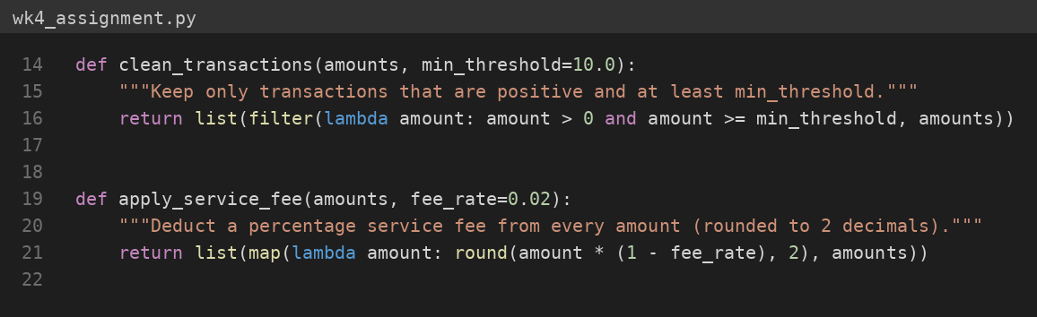
Task 2: The Recursive Nested-Total Engine
calculate_nested_total(data) accepts a single number or an arbitrarily nested list such as [100, [50, 25], [[10, 5], 40]]. Two base cases and one recursive step cover every input. The first base case returns 0.0 for an empty list. The second uses isinstance() to detect an int or float and returns it unchanged. For a non-empty list, the function splits it into a head (data[0]) and a tail (data[1:]), calls itself on both, and returns the sum. Because the tail is always one element shorter, every chain of calls reaches the empty-list base case and terminates. The function contains no for or while loop and keeps no global variable; all state travels through arguments and return values.
Figure 2
The calculate_nested_total() Recursive Function
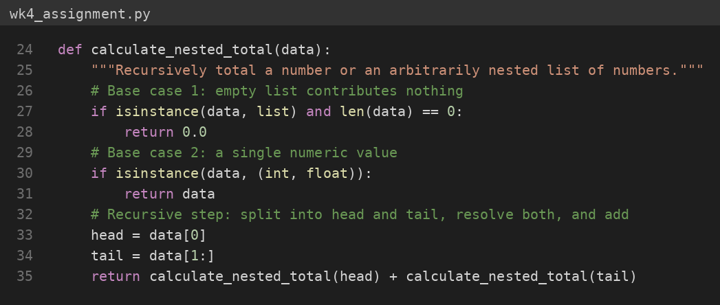
Recursion suits this problem because a nested list is itself a recursive structure: a batch is either empty, a single amount, or a batch followed by more batches. The code therefore mirrors the definition of the total. Rinderknecht (2014) notes that recursion is hard for learners because they must build a mental model of the call stack, and that small, clear examples help; head-and-tail decomposition is such an example, since each call does one small piece of work and delegates the rest. The trade-off is depth, because Python limits the number of nested calls, but realistic banking batches are shallow.
Testing and Results
The test batch contained both valid and problematic values: a reversal (−15.5), a zero, and two amounts below the threshold (8.75 and 9.99). Six of the ten values survived cleaning, and the 2% fee produced 117.6, 245.0, 41.65, 980.0, 73.5, and 9.8, matching hand calculation. The recursive engine returned 230.0 for the nested batch in the brief (100 + 50 + 25 + 10 + 5 + 40). Base cases also behaved correctly: [] returned 0.0, [1.0] returned 1.0, [[[1.0, 2.0], 3.0], 4.0] returned 10.0, and an input containing empty sublists, [[], [[]], 5], returned 5.0. Repeated runs gave identical output.
Figure 3
Console Output From a Real Run of the Audit Tool
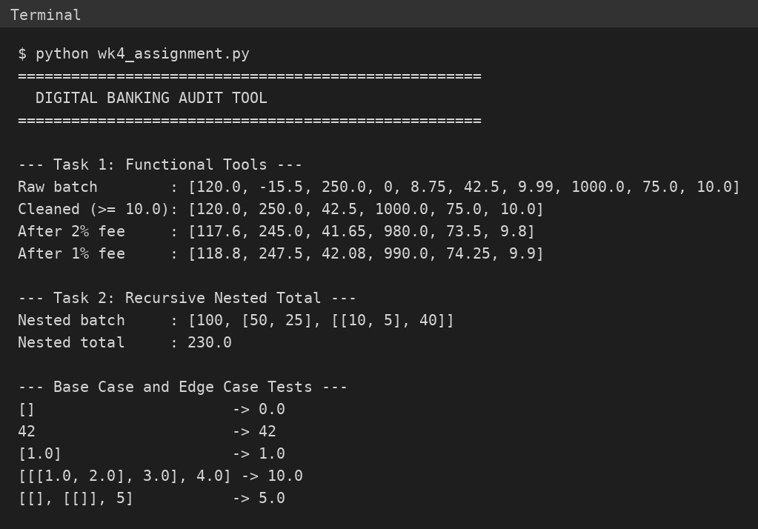
Conclusion
This assignment showed how lambda expressions with filter() and map() replace small loops with clear rules, and how recursion handles data of unknown depth without an explicit stack. Each function takes its input as arguments and returns a plain list or number, with default arguments supplying sensible banking values, which makes the design easy to test and reuse. The main lesson is that recursion becomes far less intimidating once the function has the same shape as the data.
The complete source code is available in my GitHub repository: [Paste your GitHub repository link here]

References
Python Software Foundation. (2025a). Functional programming HOWTO [Computer software documentation]. https://docs.python.org/3/howto/functional.html
Python Software Foundation. (2025b). Built-in functions [Computer software documentation]. https://docs.python.org/3/library/functions.html
Rinderknecht, C. (2014). A survey on teaching and learning recursive programming. Informatics in Education, 13(1), 87–119. https://www.infedu.vu.lt/journal/INFEDU/article/420/file/pdf

