Question 1: The Call Stack and Tail Calls
The execution stack is a memory structure that manages function calls in Python. Each function call creates a stack frame that stores local variables and the return address. During recursion, a function calls itself repeatedly, creating a new stack frame for each call (Clinger, 1998). When the number of recursive calls exceeds Python's recursion limit, a RecursionError occurs.
Tail-call optimization is a technique that reuses the current stack frame when a recursive call is the final operation of a function. But, Python does not support this optimization. Therefore, deep recursion can consume excessive stack space and cause errors, particularly when processing large amounts of data.
One way to prevent recursion-related errors is to convert a recursive function into an iterative solution using a loop. Unlike recursion, a loop does not create a new recursive function call for every repetition. This approach reduces stack usage and is more suitable for operations that require many iterations.
Python code using Recursion
def countdown(n):
if n == 0:
print("Finished")
else:
print(n)
countdown(n - 1)
countdown(5)
Figure1: Output of code using recursion
Python code using Iteration:
def countdown(n):
while n > 0:
print(n)
n -= 1
print("Finished")
countdown(5)
Figure2: Output of code using recursion
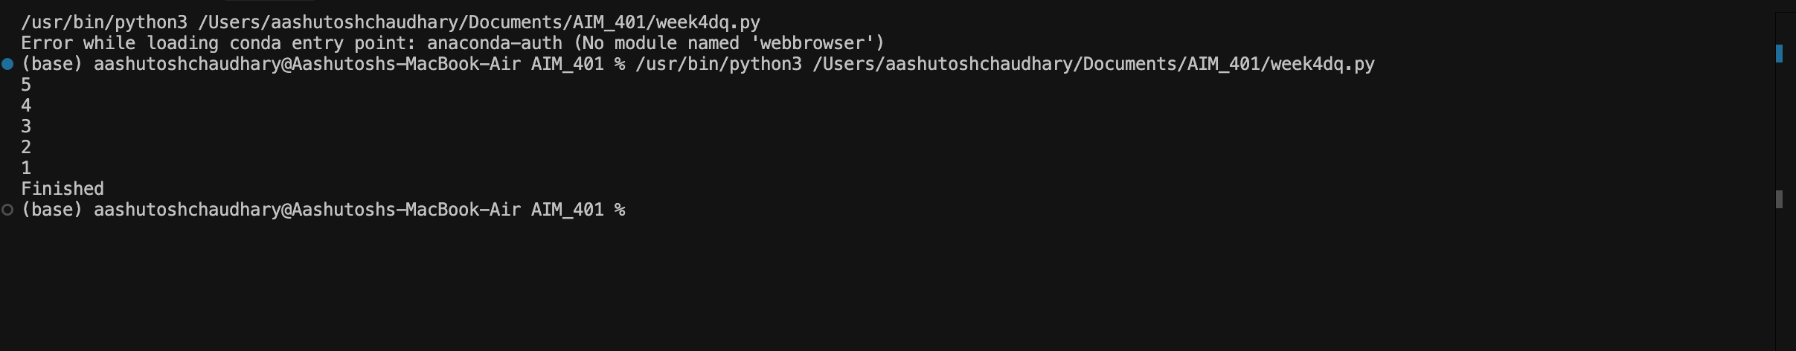
Both programs gives same output. However, the iterative solution avoids creating additional recursive stack frames. Therefore, using loops instead of recursion can help prevent RecursionError in tasks that involve many repetitions.
Figure 3
Call Stack Growth Versus a Loop
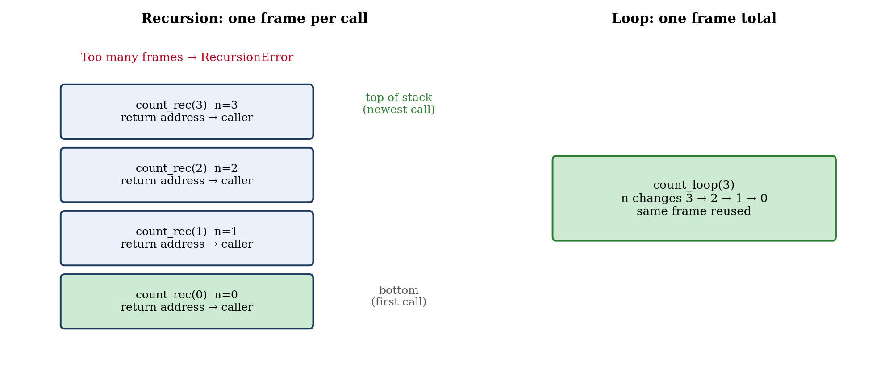
Question 2: map(), filter(), and lambda
In traditional programming, for loops are commonly used to process collections of data. However, these loops may require additional variables, conditional statements, and repeated code. This can make some data-processing tasks longer and more difficult to maintain.
Python provides functional programming tools such as map(), filter(), and lambda expressions to simplify these tasks. The map() function transforms each item in a collection, filter() selects items that satisfy a condition, and lambda creates a small anonymous function (Hughes, 1989). These tools can improve code readability and reduce repetitive statements when applied appropriately.
Functional programming tools can simplify data processing by expressing operations directly rather than writing explicit loops for every task.
#Using map() to calculate squares

numbers = [1, 2, 3, 4, 5]
squares = list(map(lambda x: x * x, numbers))
print(squares)

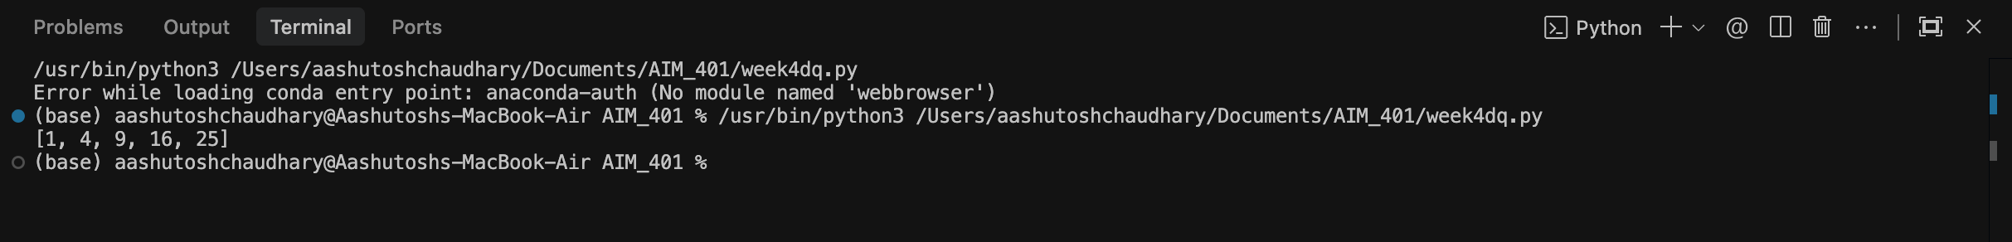
Figure 4: Screenshot of output using map()

The map() function applies the lambda expression to every number and returns the squared values. This reduces the need to create a result list and append each value manually.
#Using filter() to select even numbers
numbers = [1, 2, 3, 4, 5, 6, 7, 8]
even_numbers = list(filter(lambda x: x % 2 == 0, numbers))
print(even_numbers)

Figure 5: Screenshot of output using filter()

The filter() function selects only the numbers that satisfy the specified condition. In this example, the lambda expression checks whether each number is divisible by two.

#Using lambda to multiply a number
multiply = lambda x: x * 2
print(multiply(5))
Figure 6: Screenshot of output using lamda()
The lambda expression defines a short function that multiplies a number by two. It provides a concise alternative to defining a separate function using def.
Figure 7
Filter-Then-Map Pipeline
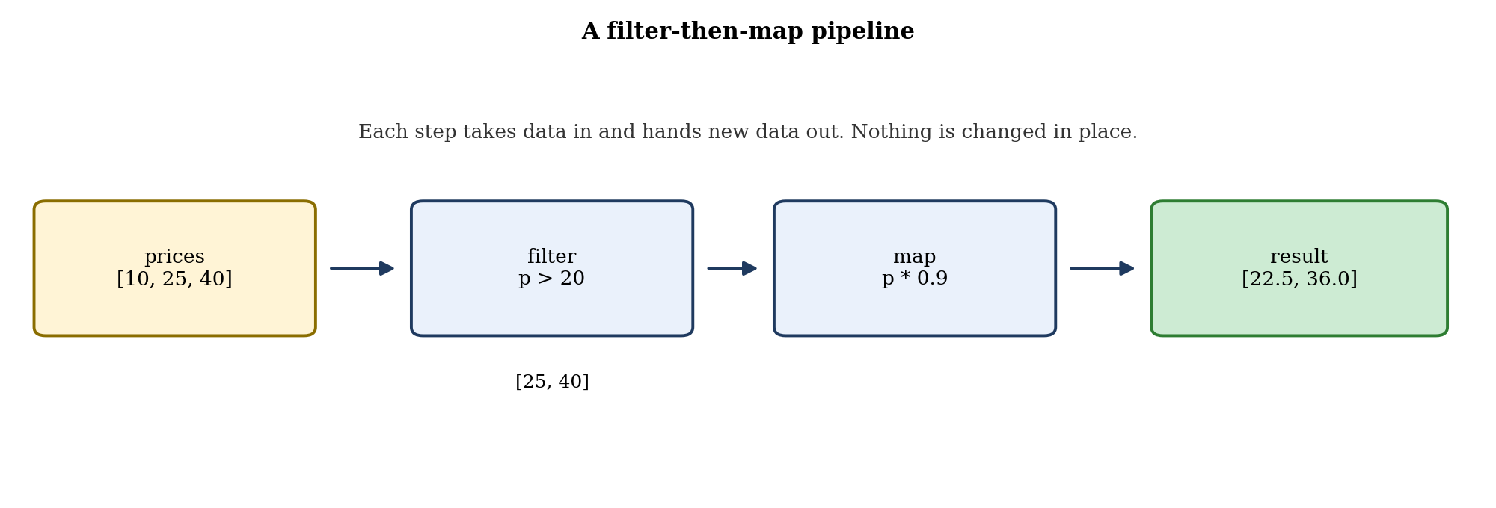
References
Clinger, W. D. (1998). Proper tail recursion and space efficiency. ACM SIGPLAN Notices, 33(5), 174–185. https://doi.org/10.1145/277652.277719
Hughes, J. (1989). Why functional programming matters. The Computer Journal, 32(2), 98–107. https://doi.org/10.1093/comjnl/32.2.98

