3-Day Budget Traker: A Python Program for Tracking Daily Spending Against a Budget

Aashutosh Chaudhary
AIM 401: Python Programming For Data Science
Professor Bashyal
September 25, 2026

3-Day Budget Traker: A Python Program for Tracking Daily Spending Against a Budget

1. Introduction

One of the most popular applications of simple programming in the real world is the management of spending habits. Here is a simple Python program, called budget.py, that was designed to assist a user in recording the amount of money they spend over three days and to determine if they spent the money within a daily budget of $20 and a total of $60 during the three days. The aim of this assignment was to use basic programming concepts such as variables, user input, type conversion, loops and conditional logic while limiting the language features used (Kirst, 2023). In particular, the program was not allowed to include custom functions, classes, file input/output or data collections like lists or dictionaries. This requirement made the design more simple and linear, easy-to-read and follow from top to bottom.

2. Program Overview and Design

The program is divided into three sensible tasks that can be mapped one-to-one with the assignment requirements. It first asks the user for his or her name and sets up a running total. Second, it gets repeated three times, each for one day, and asks for the spending for each day, converts to a float, adds that to the running total, and prints a message to the user whether they exceeded their $20 spending limit per day. Third, after the loop is done, the program prints out how much money they had used over the three days, and if they were under the $60 limit or not.

Since the assignment does not allow data collections like lists, the amount that was spent on each day is not stored for later use. Rather, it uses only one accumulator variable, total_spent, that is incremented once each time through the loop. A common and efficient pattern for problems that just need a running sum and do not need access to each historical value (Downey, 2015).

2.1 Task 1: Collecting the Name and Initializing the Total

It is started by asking the user for her name using the built-in function input( ) . Since the input returned by input( ) is always a string, it is suitable here because a name is not needed to be used in any numeric calculations. Then, total_spent is created and initialized to 0. This variable will be used to hold the total total amount of money spent: it will be initialized to 0, and each time the loop below adds the amount of money spent during one day, this variable will be incremented.

2.2 Task 2: The Daily Spending Loop

The main part of the program is the for loop which is repeated 3 times, once per day, using the range(1, 4) instruction. The program prompts the user within the loop for the amount of money spent that day. Note that the output of input() is always a string, so the output has been passed as a float through float() which will convert the string to a decimal number so it can be used in arithmetic (Python Software Foundation, 2024). The value spent is then added to the current running total total_spent with the assignment statement total_spent = total_spent + spent, with the running total of total_spent being updated at the end of each day.

Once the total has been updated, the program has an if/else statement that checks that one day's spending. For values of spent greater than 20, the program prints the warning "Over your $20 budget today!".The program prints "Over your $20 budget today!" when spent > 20. Otherwise, it prints “Great!”. Under budget today." The user receives feedback after every day of the program, not at the end of the program.

2.3 Task 3: Final Summary

The program prints the final value of total_spent followed by a label, after completing all three iterations of the loop; string concatenation and str() work magic to convert the numeric total back to text, so that it can be displayed. Total spent is then compared to 60 in a second if/else statement. The program prints a message acknowledging that the user has not exceeded their overall three-day budget, if the total is not greater than 60, otherwise it prints a message informing the user that they have exceeded their overall three day budget.

3. Complete Source Code
The complete program, exactly as submitted to the GitHub repository, is shown below.
name = input("Enter your Name: ")
total_spent = 0

for day in range(1, 4):
spent = float(input("Enter money spent today ($): "))
total_spent = total_spent + spent
if spent > 20:
print("Over your $20 budget today!")
else:
print("Great! Under budget today.")

print("Total money spent over 3 days: $" + str(total_spent))
if total_spent <= 60:
print("Overall Result: You stayed under your $60 total budget!")
else:
print("Overall Result: You went over your $60 total budget!")

4. Sample Program Runs and Output
The program was tested using two samples of input to confirm that both branches of each if/else statement behave correctly, and that the final summary correctly shows the total spending.

4.1 Sample Run 1: Staying Under Budget
In first, the user (Aashutosh) has spent $15, $25, and $10 on the three days. Day 2 exceeds the $20 daily budget and triggers the warning message, but the total of $50.00 is still under the $60 overall budget, so the program reports an overall success.
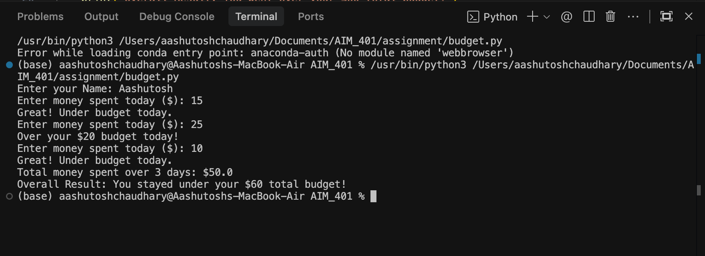
Figure 1.Terminal output for Sample Run 1 (total = $50.00, under budget).

4.2 Sample Run 2: Going Over Budget
In second run, the user (Shyam) has spent $30, $35, and $20. The first two days each exceed the $20 daily budget, and the three-day total of $85.00 exceeds the $60 overall budget, so the program correctly reports an overall failure to stay within budget.
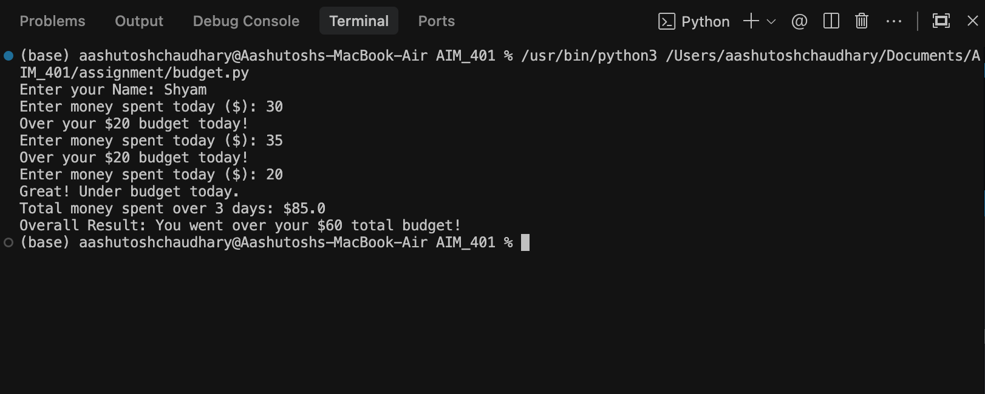
Figure 2. Terminal output for Sample Run 2 (total = $85.00, over budget).

5. Conclusion

This assignment was designed to show how a collection of primitive elements of programming, such as variables, parsing input, a for loop, and if/else statements can be used together to create a truly useful financial tracking application. The program has no functions or data collections, but it still cleanly distinguishes between the three tasks it needs to perform: collect starting info; process three days of spending in a loop; and report a summary. Two sets of contrasting inputs were tested and both the check of the daily budget and the check of the overall budget functioned as expected in all cases.

6. GitHub Repository
The complete source code (budget.py) has been submitted to the following GitHub repository:
https://github.com/aashutoshchaudhary1/AIM_401/blob/ce1dca413b7f18bcb103c5fa9476615e71676983/assignment/budget.py

References

Downey, A. B. (2015). Think Python: How to think like a computer scientist (2nd ed.). O'Reilly Media.

Python Software Foundation. (2024). The Python tutorial. Python 3.12 documentation. https://docs.python.org/3/tutorial/index.html

Zelle, J. M. (2017). Python programming: An introduction to computer science (3rd ed.). Franklin, Beedle & Associates.

