Decrypting Corporate Security Logs:
A Caesar Shift Log Decryption Utility in Python
Lesson 2 Individual Assignment
Prepared for: Corporate Security Firm – Data Analytics Team
GitHub Repository: [INSERT YOUR GITHUB REPOSITORY LINK HERE]

1. Introduction

A common task in my role as junior data analyst in a corporate security firm is analyzing the meaning of system logs that have been obfuscated prior to being stored on disk as an automatic process. This report describes a Python program developed for the decryption of the Caesar shift ciphered batch server log, converting the log back to the plaintext and isolating any lines that make mention of a security breach to an alert file. This program was created using a very limited set of rules that included no use of built-in data structures, such as lists, dictionaries, and sets, no use of user-defined functions and no use of external modules. This is similar to an exercise in a basic level programming class that involves demonstrating knowledge of basic programming skills without using advanced features.

This report proceeds to outline the context and rationale for the problem, discuss the design of the program and its code, show examples of program output and its analysis.

2. Scenario and Requirements

An external server generates a set of system event logs. Prior to the logs getting saved onto the disk, they undergo a simple Caesar shift cipher, where each character in the alphabet is substituted for the same number of positions away from the alphabet position of the original character (Kahate, 2013). In this specific case, all characters were encrypted by moving three steps ahead in the alphabet, which means that decryption will involve moving each character three steps back in the alphabet, looping around from Z/A to A/Z.

There are three tasks that the program should undertake. The first one is to read in the encrypted file (raw_logs.txt) while creating two other files for writing into: decrypted_master.txt, where all decrypted logs would be written, and security_alerts.txt, where only those logs are stored that mention a breach. The second part is decryption of the logs on character-by-character basis via ord() and chr() and preserving spaces and newline characters as they are. Finally, the third task is to strip all whitespace from the decrypted lines, write them to the master logs and search for the string "BREACH" without regard for letter casing; lines containing it should be copied to the alerts file.

3. Design and Implementation Approach

Since the assignment does not allow the use of lists, dictionaries, sets, or any custom functions, the implementation relies solely on primitive string operations, loops, and conditions. A for loop in Python may iterate over an open file object line-by-line, and it may iterate over individual characters of the string as well, without requiring any additional collections to store the file lines or the individual line characters (Python Software Foundation, 2024). Each decrypted line is constructed using string concatenation into one string variable, decrypted_line, and is never constructed using lists and joined afterwards.

Three different actions are performed depending on the character being decrypted: whitespace characters, including the space and newline, are passed as is according to the requirements; uppercase letters from 'A' to 'Z' are shifted back by three positions with checking whether their code exceeds the code of 'A'; lowercase letters from 'a' to 'z' are processed in the same manner, but relatively to the letter 'a'. All other characters – punctuation, digits, and other symbols, like ":" in "Warning:", remain unchanged. That behavior mimics the historical implementation of the Caesar cipher which encoded only alphabetic letters and left all other symbols unencoded (Singh, 1999).

The decrypted line, after .strip() removes any leading or trailing whitespace from it, is written to the file decrypted_master.txt followed by the newline character. Then the temporary uppercase version of the line is created using .upper() method, and the Python substring membership operator in checks whether the substring "BREACH" occurs in it. The use of .upper() allows to make the search case-insensitive, so both "SYSTEM BREACH DETECTED" and "possible breach attempt" would be considered as containing the keyword. In case of the match, the original (case-correct) version of the line is written to the security_alerts.txt file in order to preserve its readability.

All three files are opened once and explicitly closed at the end with .close(). Although the with statement (a slightly more idiomatic approach) is used deliberately not to introduce any operations beyond those mentioned in the assignment.

4. Test Data
To validate the program, a sample raw_logs.txt file was created containing six lines of dummy log data, each encrypted with a Caesar shift of three. Three of the six lines were written to include the word “BREACH” in varying positions and letter cases, so the case-insensitive keyword filter could be verified against realistic log wording, such as an intrusion notice, a perimeter warning, and an internal firewall alert. Figure 1 shows the encrypted contents of raw_logs.txt as viewed in the terminal before the script is run.
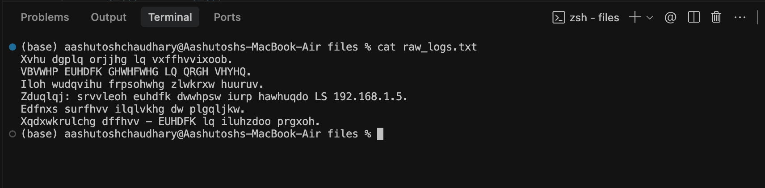
Figure 1. Contents of the encrypted input file, raw_logs.txt.
5. Program Listing
The complete source code for decrypt_logs.py is reproduced below. The same file is included as a standalone .py file in the accompanying GitHub repository.
"""
Lesson 2 Individual Assignment
Caesar Shift Log Decryption Utility

This script reads an encrypted server log (raw_logs.txt), decrypts each
line using a left Caesar shift of 3, writes every decrypted line to
decrypted_master.txt, and additionally writes any line containing the
keyword "BREACH" to security_alerts.txt.

Constraints followed:
- No lists, dictionaries, or sets
- No custom functions (no 'def')
- No external libraries (only built-ins: open, ord, chr, str methods)
"""
SHIFT = 3

# Task 1: Open the input file for reading and both output files for writing
input_file = open("raw_logs.txt", "r")
master_file = open("decrypted_master.txt", "w")
alert_file = open("security_alerts.txt", "w")

line_count = 0

# Task 2: Iterate through each line of the input file
for line in input_file:
decrypted_line = ""

# Iterate through each character in the line and apply a left shift of 3
for char in line:
if char == "\n":
# Preserve newline characters without shifting
decrypted_line = decrypted_line + char
elif char == " ":
# Preserve spaces without shifting
decrypted_line = decrypted_line + char
elif char >= "A" and char <= "Z":
# Uppercase letters, with wrap-around at the alphabet boundary
shifted_code = ord(char) - SHIFT
if shifted_code < ord("A"):
shifted_code = shifted_code + 26
decrypted_line = decrypted_line + chr(shifted_code)
elif char >= "a" and char <= "z":
# Lowercase letters, with wrap-around at the alphabet boundary
shifted_code = ord(char) - SHIFT
if shifted_code < ord("a"):
shifted_code = shifted_code + 26
decrypted_line = decrypted_line + chr(shifted_code)
else:
# Punctuation, digits, colons, etc. are left unchanged
decrypted_line = decrypted_line + char

# Task 3: Strip leading/trailing whitespace from the decrypted string
decrypted_line = decrypted_line.strip()

# Write every decrypted line into the master log file
master_file.write(decrypted_line + "\n")

# Convert to uppercase and check for the "BREACH" keyword
upper_check = decrypted_line.upper()
if "BREACH" in upper_check:
alert_file.write(decrypted_line + "\n")

line_count = line_count + 1

# Close all file handles
input_file.close()
master_file.close()
alert_file.close()

print("Decryption complete.")
print("Lines processed:", line_count)
print("Decrypted log written to decrypted_master.txt")
print("Security alerts written to security_alerts.txt")

6. Execution and Output
The script was executed from the command line with python3 decrypt_logs.py. As shown in Figure 2, the program reports the number of lines processed and confirms that both output files were created successfully. 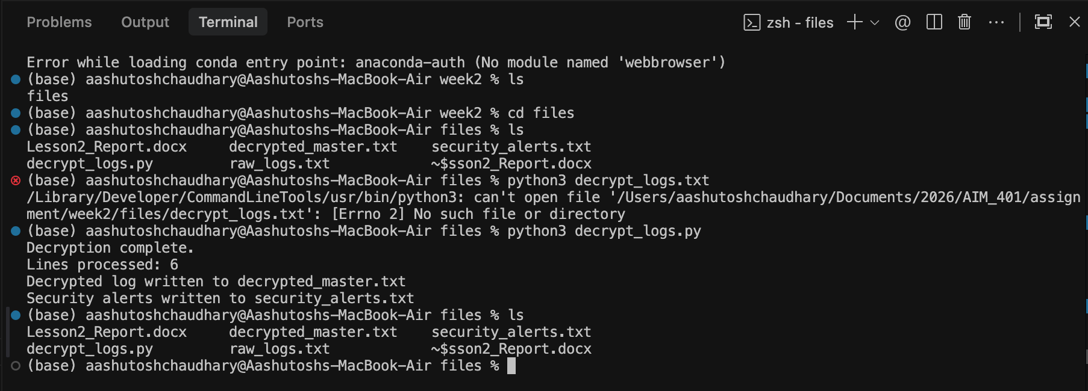

Figure 2. Running decrypt_logs.py from the terminal.
Figure 3 shows the resulting decrypted_master.txt, containing all six log lines restored to plain, readable text. Figure 4 shows security_alerts.txt, which contains only the three lines that matched the “BREACH” keyword during the case-insensitive check. Comparing the two files confirms that the filtering logic correctly identifies breach-related events without omitting or duplicating any unrelated lines.
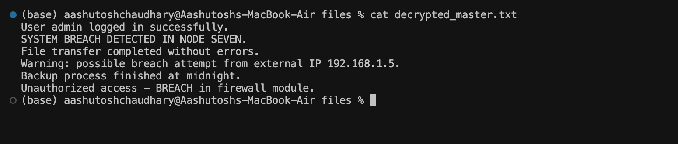
Figure 3. Contents of decrypted_master.txt after decryption.
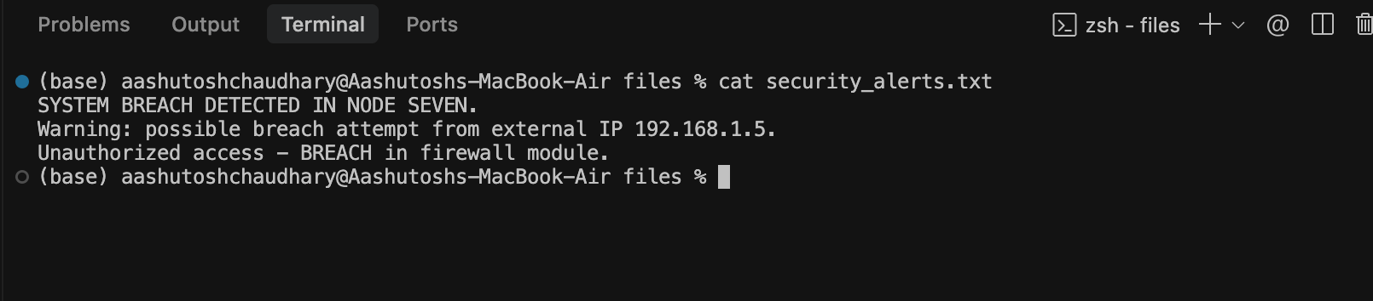
Figure 4. Contents of security_alerts.txt showing only breach-related lines.

7. Discussion

The completed program meets all specified requirements within the scope of the assignment. The limitations set on the use of string indexing and slicing, string methods, ord() and chr() functions, file I/O operations, and loops and conditionals make the student pay attention to the representation of characters in Python as numeric code points – exactly the purpose of the assignment (Downey, 2015). On the other hand, those limitations show an actual problem: without creating a function, the decryption routine cannot be used again anywhere else without simply copying the code, and without using a dictionary or a list, there is nowhere else where statistics can be accumulated (the number of breach alerts from external and internal sources, respectively).

In terms of security, it is worth mentioning that the use of a Caesar shift cipher does not provide any effective encryption mechanism in practice. With only 26 shift options in the English alphabet, the attacker could quickly decrypt the cipher with a brute-force attack in several milliseconds, and the appearance of words in the output after only one attempt makes the exact value of the shift obvious (Stallings, 2020). In a production environment, the output produced by this program would have to be handled the same way as the output produced by any other decryption program, including access control.

8. Conclusion
This assignment involved the implementation of a constrained Python function that decrypts a log from an encrypted server using a reverse three-place Caesar cipher letter by letter, saving the output log into a master file while tagging any log entry that contains a mention of the word “BREACH.” Using a sample log consisting of six lines where three lines had the word “BREACH,” either in uppercase or lowercase, the decryption and filtering procedures were found to be functioning properly. This task helped reinforce basic Python programming principles like arithmetic with character codes, reading and writing files, and string testing using conditions, all without using any advanced language functions.

References
Downey, A. B. (2015). Think Python: How to think like a computer scientist (2nd ed.). Green Tea Press.
Kahate, A. (2013). Cryptography and network security (3rd ed.). McGraw Hill Education.
Python Software Foundation. (2024). The Python standard library: Built-in functions. Python 3 documentation. https://docs.python.org/3/library/functions.html
Singh, S. (1999). The code book: The science of secrecy from ancient Egypt to quantum cryptography. Doubleday.
Stallings, W. (2020). Cryptography and network security: Principles and practice (8th ed.). Pearson.

