Question 1: Python String Immutability
Python strings are immutable because once an object is created in memory, its content cannot be altered; any operation that appears to "change" a string actually produces a brand-new object (Hajiyeva, 2025). This design choice supports hashability, meaning strings can safely serve as dictionary keys since their hash value never changes over the object's lifetime. Immutability also enables thread safety, because multiple threads can reference the same string without risk of one thread corrupting data for another.
Example:
# Creating a string
name = "Aashutosh"

print("Original string:", name)
print("ID before:", id(name))

# Trying to change the first character
# name[0] = "B" # This will cause an error

# Instead, we create a new string
name = "B" + name[1:]

print("New string:", name)
print("ID after:", id(name))

Output: 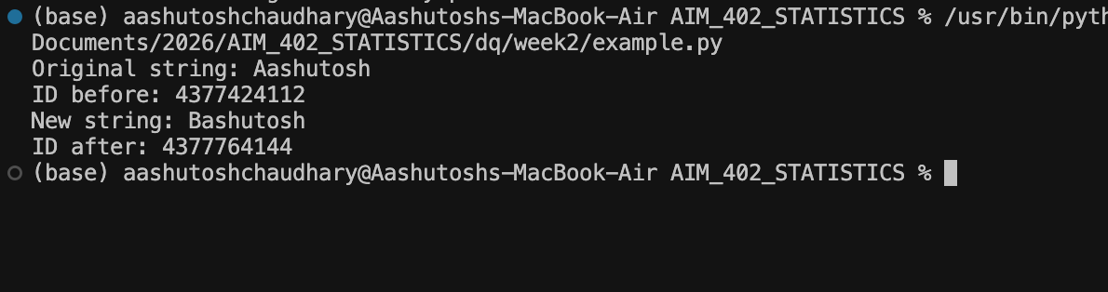
Structurally, immutability allows Python to reuse identical string objects through a process called interning, which reduces memory overhead in large programs (Coblenz et al., 2016). This predictability also simplifies debugging, since developers can trust that a string's value will not silently change elsewhere in the code.
However, this design introduces a real performance trade-off. Every concatenation operation, such as repeatedly using the "+" operator inside a loop, forces Python to allocate an entirely new object and copy existing characters, which can produce O(n²) time complexity as data size grows. A general real-world example is a system processing large text logs or user-generated data; naively concatenating thousands of lines in a loop can cause severe slowdowns in production applications, directly affecting response times for end users. Developers typically resolve this by using methods like str.join() or lists, which minimize repeated memory allocation.
In conclusion, immutability trades some computational efficiency for safety, consistency, and memory optimization, making Python code more reliable overall.
References
Coblenz, M., Sunshine, J., Aldrich, J., Myers, B., Weber, S., & Shull, F. (2016). Exploring language support for immutability. Proceedings of the 38th International Conference on Software Engineering (ICSE '16), 736–747. Association for Computing Machinery.
Hajiyeva, R. (2025). Functional programming and software reliability. Journal of Baku Engineering University – Mathematics and Computer Science, 9(2), 196–204. https://doi.org/10.30546/09090.2025.1010.2019

Question 2: File Safety Mechanisms and Buffering
Software that reads and writes external files must include several safety mechanisms to prevent data loss. These include validating file paths and permissions before access, using exception handling (try-except blocks) to catch I/O errors, and employing context managers to guarantee files close properly even after an error. Developers should also verify data integrity through checksums and implement atomic write strategies, such as writing to a temporary file before renaming it, to avoid leaving partially written files (Pillai et al., 2015).
File buffers exist because directly writing every byte to disk is slow; instead, data is temporarily held in memory and periodically flushed to storage. This improves performance but creates risk, since data sitting in a buffer is vulnerable to loss if the program terminates unexpectedly, such as during a crash or power failure. To reduce this danger, programs can explicitly call flush() or fsync() to force buffered data onto persistent storage immediately (Rebello et al., 2021).
A general real-world example illustrates this impact clearly: hospital record-keeping systems and financial transaction databases rely heavily on proper buffer management. If a system crashes mid-write without flushing its buffer, patient records or financial transactions could be partially saved, resulting in corrupted or missing data with serious real-world consequences. This is why many database systems use write-ahead logging, ensuring changes are recorded safely before being finalized.
In summary, combining defensive coding practices with proper buffer flushing significantly reduces the risk of data corruption during unexpected termination.
References
Pillai, T. S., Chidambaram, V., Alagappan, R., Al-Kiswany, S., Arpaci-Dusseau, A. C., & Arpaci-Dusseau, R. H. (2015). Crash consistency: Rethinking the fundamental abstractions of the file system. Communications of the ACM, 58(10), 46–51. https://doi.org/10.1145/2788401
Rebello, A., Patel, Y., Alagappan, R., Arpaci-Dusseau, A. C., & Arpaci-Dusseau, R. H. (2021). Can applications recover from fsync failures? ACM Transactions on Storage, 17(2), Article 12.

