Project Report: Trekking Management Application

Author
Name: Aashvi Verma
Student Roll No.: 24f2004405
Student email address: 24f2004405@ds.study.iitm.ac.in

Project Details

Question Statement
Adventure organizations require efficient systems to manage trekking activities involving trek organizers, staff, and participants. Many trekking groups currently rely on spreadsheets, phone calls, or manual coordination, which makes it difficult to manage trek approvals, track bookings, avoid overbooking, and maintain trek history. The goal of this project is to build a Trekking Management Application — a role-based web application that allows an Admin, Trek Staff, and Users (Trekkers) to interact with the system based on their respective roles.

Approach to Problem Statement
I approached this project by building a full-stack Flask application structured around three distinct user roles, with a shared authentication layer and role-specific dashboards and permissions.
- User & Role Management: Implemented a centralized User model handling authentication and login, linked via one-to-one relationships to specialized Staff and Trekker profile tables depending on the account's role.
- Role-Based Access Control: Used Flask-Login to manage sessions and protect routes, with explicit role checks on every route so a user can only access dashboards and actions meant for their role (admin, staff, or trekker).
- Staff Approval Workflow: New staff registrations remain inactive until an Admin explicitly approves them; unapproved or blacklisted staff are blocked from accessing the staff dashboard even if they log in successfully.
- Trek & Booking Lifecycle: Built a Trek model (with total and available slot counts) and a Booking model that links Trekkers to Treks, tracking booking status (Booked, Cancelled, Completed) and payment status end-to-end.
- Overbooking Prevention: The booking route checks trek status and remaining available_slots before creating a booking, decrements the slot count on confirmation, and blocks duplicate bookings by the same trekker for the same trek.
- Search & Filtering: Implemented case-insensitive search for the Admin (across treks, staff, and trekkers) and filter/search options for trekkers browsing available treks by name, location, and difficulty.

Frameworks and Libraries Used
The application is built using the Python ecosystem with the following libraries:
- Flask: The core web framework used for routing, request handling, and backend logic.
- Flask-SQLAlchemy: Used as the Object Relational Mapper (ORM) to define models and interact with the SQLite database.
- Flask-Login: Managed user session authentication, login state, and protected private routes via the @login_required decorator.
- Werkzeug: Utilized for secure password hashing (generate_password_hash / check_password_hash).
- Jinja2: Used for server-side templating to render dynamic HTML views.
- Bootstrap 5: Employed for responsive front-end design and styling, as required by the problem statement.
- SQLite: Used as the relational database, created and seeded programmatically via SQLAlchemy's db.create_all().

ER Diagram of Database
The database consists of five interconnected tables that manage authentication, role-specific profiles, treks, and bookings.
- User Table: Stores login credentials, role (admin / staff / trekker), and account status.
- Staff Table: Contains staff profile details, experience, and approval / blacklist status, linked one-to-one with a User.
- Trekker Table: Contains trekker profile details, emergency contact, and blacklist status, linked one-to-one with a User.
- Trek Table: Manages trek details — name, location, difficulty, slots, duration, dates, status, and the staff member assigned to it.
- Booking Table: Records every trekker's booking of a specific trek, including booking status, payment status, and timestamps.
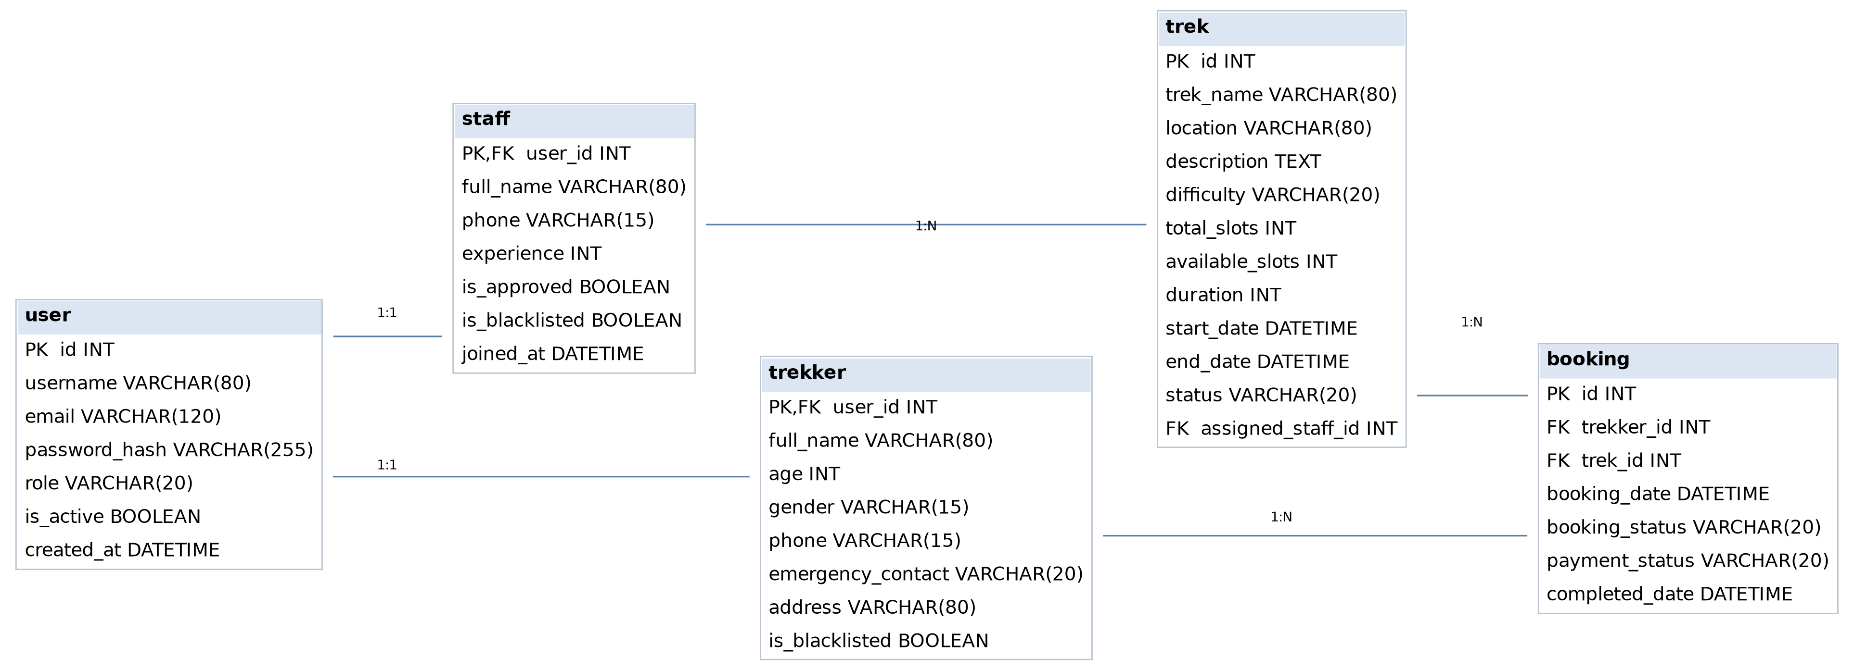

Architecture and Features
The project follows an MVC-like architecture:
- app.py: Main controller handling all routes, request processing, database interaction, and template rendering (48 routes across all three roles).
- models/database.py: Defines the SQLAlchemy models — User, Staff, Trekker, Trek, and Booking — along with their relationships.
- templates/: Contains dynamic HTML templates (views) using Jinja2, organized by role (admin, staff, user).
- static/: Stores static assets such as CSS.
- seed.py: A standalone script used to populate the database with sample data for demonstration.

Key Features Overview
1. Core Features
- Role-Based Authentication: Single login page that redirects Admin, Staff, and Trekker users to their respective dashboards based on the role stored on their account.
- Pre-Seeded Admin: The Admin account is created programmatically on app startup (no admin self-registration), satisfying the requirement that Admin is a pre-existing superuser.
- Self-Registration: Trek Staff and Trekkers can self-register; Staff accounts additionally require Admin approval before dashboard access is granted.
- Blacklist System: Blacklisted staff or trekkers are signed out and blocked from logging back in or performing actions.
- Flash Messaging: Consistent success / warning / danger flash messages across the app for actions like login, booking, and access control.
2. Admin Features (Control & Oversight)
- Global Statistics Dashboard: Displays total treks, total staff, total trekkers, and total bookings at a glance.
- Trek Management: Full create, edit, and delete functionality for treks, including assigning an approved staff member to each trek.
- Staff Management: View, search, edit, approve, blacklist / unblacklist, and delete staff accounts.
- Trekker Management: View, search, edit, blacklist / unblacklist, and delete trekker accounts.
- Booking Oversight: A dedicated view of all bookings across the platform, plus a complete historical trek record.
- Advanced Search: Case-insensitive search across treks (by name, location, difficulty, status), staff (by name, email, phone), and trekkers.
3. Trek Staff Features
- Approval Gate: Staff dashboard access is blocked with a flash message until the Admin explicitly approves the account.
- Assigned Treks View: Staff can see only the treks assigned to them by the Admin, along with live participant counts and active-trek counts.
- Trek Management: Staff can update slot availability and status (Open / Closed) for treks assigned to them.
- Participant Tracking: View the list of trekkers registered for a specific assigned trek and update each participant's booking status.
- Profile Management: Staff can view and edit their own profile details.
4. Trekker (User) Features
- Trek Discovery: Dashboard shows only open treks that still have available slots.
- Search & Filter: Trekkers can search treks by name/location and filter by difficulty and location.
- One-Click Booking: Streamlined booking flow that blocks duplicate bookings for the same trek and prevents booking once a trek is closed or full.
- Booking History: A permanent, chronologically ordered record of all past and current bookings with their status.
- Profile Management: Trekkers can view and edit their personal details.
5. Security & Logic Features
- Overbooking Prevention: available_slots is checked before booking and decremented atomically on confirmation, so a trek can never be booked beyond capacity.
- Duplicate Booking Guard: A trekker cannot create a second active (Booked / Completed) booking for the same trek.
- Route-Level Authorization: Every protected route checks current_user.role, redirecting unauthorized users back to login with an "Access Denied" message.
- Password Security: All passwords are hashed with Werkzeug before storage; plaintext passwords are never persisted.
- Staff-Trek Restriction: A trek can only be assigned to staff who are both approved and not blacklisted.

Video Presentation Link
[Google Drive link to be added]

