PROJECT REPORT OF CO-OP Project at Industry (Module-2)
ON
Impact of Quick Commerce on Consumer Buying Behaviour in Urban India
submitted in partial fulfilment of the requirements for the award of degree of

BACHELOR OF ENGINEERING
In
COMPUTER SCIENCE AND ENGINEERING

Submitted by: Supervised By:
Aashwin Garg (2210991125) Dr.Monika
Tisha (2210992465)
Kamaljeet Kaur (2210990470)
Saurabh Abrol (2210992268)



DEPARTMENT OF COMPUTER SCIENCE AND ENGINEERING

CHITKARA UNIVERSITY INSTITUTE OF ENGINEERING AND TECHNOLOGY
CHITKARA UNIVERSITY, PUNJAB, INDIA

CONTENTS

S.No. | Title | Page No.
 | Acknowledgement | 4
 | List of Figures and Tables | 5
 | Abstract | 6
1 | Introduction | 7,8
2 | Methodology | 9
3 | Tools and Technologies | 10
4 | Implementation | 11
5 | Major Findings/Outcomes/Output/Results | 12
6 | Conclusion and Future Scope | 13
 | References | 14
 | Appendices

DECLARATION

I hereby certify that the work which is being presented in the project report entitled “Impact of Quick Commerce on Consumer Buying Behaviour in Urban India” in partial fulfilment of requirement for the award of the degree of Bachelor of Engineering (Computer Science and Engineering) submitted in the department of Computer Science and Engineering at Chitkara University Institute of Engineering and Technology, Chitkara University, Punjab, India, is an authentic record of my own work carried out under the supervision of Dr.Monika Agarwal. The matter presented in this project report has not been submitted in any other university/institute for the award of any degree.

Place: Rajpura Aashwin Garg (2210991125)
Date: 29-04-2026 Tisha(2210992465)
Kamaljeet Kaur(2210990470)
Saurabh Abrol (2210992268)
This is to certify that the above statement made by the candidate is correct to the best of my knowledge and belief.

Dr.Monika
<Academic Teacher>
Department of Computer Science and Engineering
Chitkara University Institute of Engineering and Technology,
Chitkara University, Punjab, India

ACKNOWLEDGEMENT
We would like to express our sincere gratitude to our faculty guide and mentors at Chitkara University, Punjab, for their constant support, valuable guidance, and encouragement throughout the completion of this research paper on “Consumer Behaviour on Quick Commerce.”
We are thankful for their insightful suggestions and constructive feedback, which helped us improve the quality and depth of our study. Their academic expertise and motivation played an important role in shaping our understanding of the topic.
We also extend our gratitude to the industry reports, market research platforms, and public data sources such as Bain & Company, Redseer, Statista, IBEF, and other published resources that provided valuable information and practical insights for this research.
Lastly, we would like to thank our family and friends for their continuous support, patience, and motivation during the entire research process.

LIST OF FIGURES AND TABLES

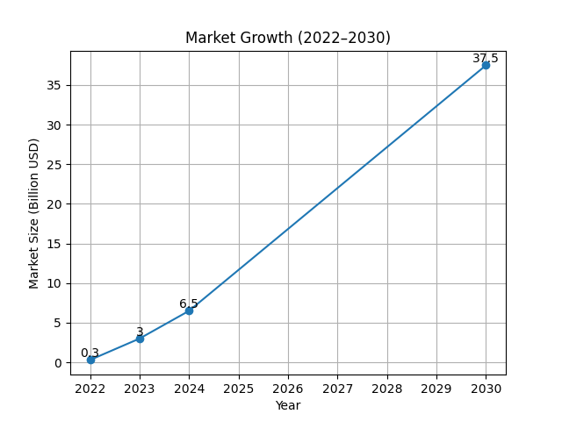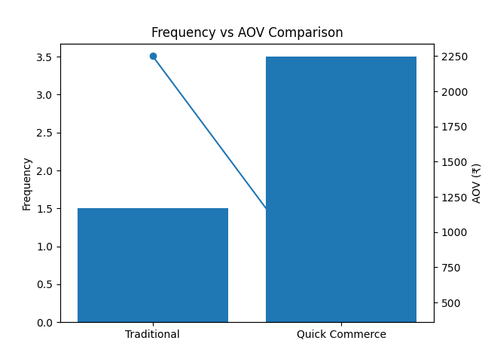
Fig. 1 - Market Growth (GMV) Fig. 2 - Consumer Behaviour Shift

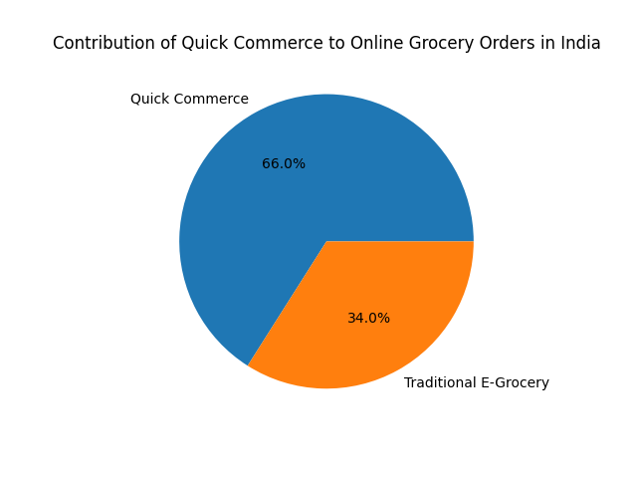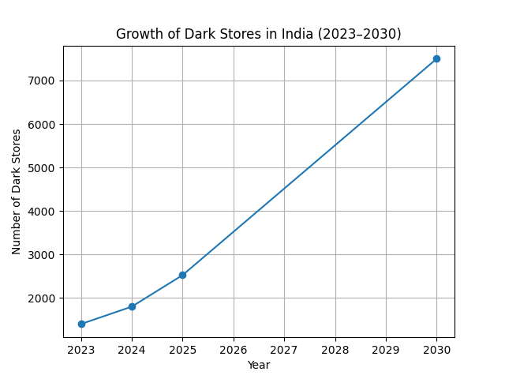
Fig. 3 - Share of Online Grocery Orders Fig. 4 - Dark Store Growth in India

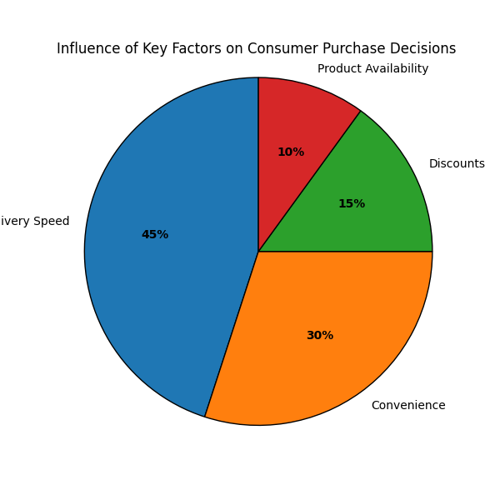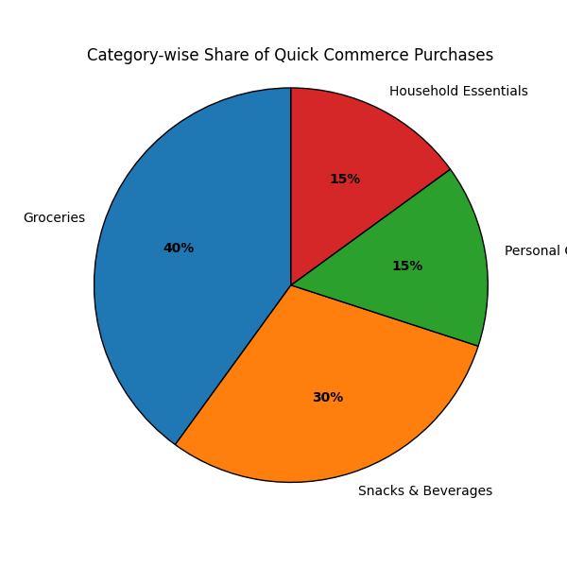
Fig. 5 - Influence Share of Key Factors Fig. 6 - Category-wise share of quick com purchases

ABSTRACT

Quick commerce (Q-commerce) has emerged as one of the fastest-growing segments of digital retail by offering ultra-fast delivery of groceries, personal care items, and daily essentials within 10 to 30 minutes. In India, platforms such as Blinkit, Zepto, and Swiggy Instamart have significantly changed consumer buying behaviour by shifting purchasing patterns from planned shopping to instant, need-based consumption. The rapid adoption of smartphones, digital payments, and hyperlocal delivery infrastructure has further accelerated the growth of this sector, especially in urban markets.
The primary objective of this research is to study consumer behaviour in the quick commerce ecosystem and identify the major factors influencing purchase decisions. Key variables such as delivery speed, convenience, promotional offers, pricing strategies, product availability, brand familiarity, purchase frequency, and basket size were examined to understand consumer preferences and repeat usage patterns.
The study follows a secondary research methodology and is based on practical insights derived from search advertising campaign performance and industry reports. Data from paid search campaigns, keyword trends, click-through rates (CTR), conversion rates (CVR), cost per click (CPC), return on ad spend (ROAS), and basket behaviour were analysed to evaluate consumer intent and purchase patterns across quick commerce platforms.
The findings reveal that consumer behaviour in quick commerce is highly intent-driven. Branded keywords generate higher conversion rates and stronger ROAS, while generic keywords attract traffic but deliver lower efficiency. Promotional offers improve short-term conversions and increase basket size, whereas stock-outs negatively impact customer experience and purchase decisions. Smaller basket sizes and higher purchase frequency indicate a strong preference for urgency-driven, convenience-based shopping.
The study concludes that quick commerce is transforming urban consumer behaviour by encouraging frequent, smaller, and faster purchase decisions. Businesses operating in this sector must focus on delivery efficiency, product availability, strategic promotions, and optimized search advertising to sustain growth and meet evolving consumer expectations.

INTRODUCTION

The rapid advancement of digital technology has significantly transformed the retail industry across the world. Over the past few years, online shopping platforms have gained strong popularity among consumers because of their convenience, accessibility, and wide variety of products. However, a new retail model known as quick commerce (Q-commerce) has emerged as the next stage of digital retail by offering ultra-fast delivery of everyday essentials. Unlike traditional e-commerce, which focuses on product variety and delivery within a few days, quick commerce emphasizes speed and instant fulfillment, usually delivering products within 10 to 30 minutes.
Quick commerce refers to the rapid delivery of groceries, personal care products, household items, medicines, snacks, and other daily necessities. This model operates through hyperlocal fulfillment centers known as dark stores, which are strategically located within cities to ensure faster deliveries. These dark stores allow platforms to reduce delivery time and improve operational efficiency by serving customers within a short radius of 2 to 3 kilometers.
In India, quick commerce has witnessed remarkable growth due to increasing urbanization, smartphone penetration, digital payment adoption, and changing consumer lifestyles. Platforms such as Blinkit, Zepto, and Swiggy Instamart have rapidly expanded across metropolitan cities like Delhi, Mumbai, Bangalore, and Hyderabad. The sector has grown nearly 20–25 times between 2022 and 2025 and has reached a gross merchandise value of over ₹65,000 crore. A significant share of online grocery orders in India is now fulfilled through quick commerce platforms, reflecting a major shift in consumer shopping habits.
Consumer buying behaviour has also undergone a significant transformation with the rise of quick commerce. Traditional shopping generally involved planned purchases made weekly or monthly, where customers bought products in bulk to minimize shopping trips. In contrast, quick commerce encourages smaller basket sizes with higher purchase frequency, where consumers order products as and when the need arises. This shift highlights the growing preference for convenience, immediacy, and need-based consumption.
Delivery speed is one of the strongest drivers behind the success of quick commerce. Busy urban lifestyles, long working hours, and dual-income households have increased the demand for faster solutions for daily needs. Consumers value the ability to receive groceries and essentials instantly without visiting physical stores. Along with speed, factors such as attractive discounts, promotional offers, app usability, product availability, and brand trust also strongly influence purchase decisions.
Promotional strategies play an important role in driving user adoption and repeat purchases. Quick commerce platforms frequently use discounts, cashback offers, limited-time deals, and loyalty rewards to attract and retain customers. These promotions often trigger impulse buying and increase short-term basket value. Brand familiarity and positive past experiences also improve customer confidence and platform loyalty.

Despite the rapid growth of quick commerce, limited academic research has focused specifically on its impact on consumer buying behaviour. Most existing studies concentrate on market growth, investments, and operational strategies rather than behavioural changes among consumers. Understanding these behavioural shifts is essential for businesses to design effective marketing strategies and improve customer retention.
Therefore, this research aims to study consumer behaviour in the quick commerce ecosystem and identify the key factors influencing purchase decisions. The study focuses on urban India and analyses how convenience, speed, pricing, promotional strategies, and brand familiarity affect consumer adoption and repeat usage of quick commerce platforms.

METHODOLOGY

This research follows a secondary research methodology to analyse consumer buying behaviour in the quick commerce sector. Instead of conducting primary surveys or interviews, the study relies on existing industry reports, market research publications, public databases, and performance marketing insights related to quick commerce operations. This approach helps in understanding consumer patterns using already available large-scale market information and practical campaign performance data.
Secondary research is highly effective for studying rapidly growing industries like quick commerce, where reliable market data is continuously generated by consulting firms, digital commerce reports, and platform analytics. The study focuses on understanding how factors such as delivery speed, convenience, promotional offers, pricing, and product availability influence consumer decisions across quick commerce platforms.
Data for this research was collected from multiple trusted sources including reports by Bain & Company, Redseer Strategy Consultants, McKinsey & Company, IBEF, Statista, ET Retail, and public business updates from Blinkit and Swiggy Instamart. These sources provided valuable insights into market size, order frequency, average basket value, consumer preferences, and platform-level growth patterns.
In addition to industry reports, practical observations from search advertising campaign performance were also considered. Performance metrics such as click-through rate (CTR), conversion rate (CVR), cost per click (CPC), return on ad spend (ROAS), and keyword performance were analysed to understand consumer intent and buying patterns. Keywords were categorized into branded, generic, and competitor segments to evaluate how search intent affects purchasing decisions.
The geographical focus of the study is urban India, particularly metropolitan cities such as Delhi NCR, Mumbai, Bangalore, and Hyderabad, where quick commerce adoption is highest. These cities represent the major operational markets for leading platforms like Blinkit, Zepto, and Swiggy Instamart due to high population density, strong digital infrastructure, and faster lifestyle patterns.
Several behavioural variables were considered during the research to study consumer buying behaviour effectively. These include frequency of purchases, basket size, delivery urgency, promotional influence, brand familiarity, impulse buying behaviour, and customer loyalty. These factors were analysed to identify recurring behavioural trends among users of quick commerce platforms.
The collected data was examined using descriptive analysis methods. Comparisons were made across different industry reports and campaign performance indicators to identify common patterns and reliable conclusions. The findings were then interpreted to understand how consumer behaviour is changing in response to the rapid growth of quick commerce in India.

TOOLS and TECHNOLOGIES

This research primarily uses analytical tools, digital marketing platforms, and secondary data sources to study consumer behaviour in quick commerce. Since the study is based on secondary research and performance marketing insights, the tools used focus on data collection, campaign analysis, market observation, and behavioural interpretation rather than software development implementation.
One of the major tools used in this research is search advertising campaign dashboards available across quick commerce and e-commerce advertising platforms. These dashboards provide detailed performance metrics such as impressions, clicks, click-through rate (CTR), conversion rate (CVR), cost per click (CPC), advertising cost of sales (ACOS), return on ad spend (ROAS), and total orders. These metrics help in understanding customer intent, buying behaviour, and purchase efficiency across different product categories.
Keyword analysis tools were also used to classify search terms into branded, generic, and competitor keywords. This helped in identifying which type of customer intent generates better conversions and stronger purchase decisions. Branded keywords were observed to produce higher conversion rates, while generic keywords generated broader traffic with relatively lower efficiency.
Industry research platforms such as Statista, Bain & Company reports, Redseer Strategy Consultants, McKinsey reports, IBEF reports, and ET Retail articles were used as major secondary data sources. These platforms provided market size estimates, consumer behaviour trends, order frequency data, average basket values, and growth projections related to quick commerce in India.
Spreadsheet tools such as Microsoft Excel and Google Sheets were used for data organization, comparison, and descriptive analysis. These tools helped in sorting campaign-level observations, comparing performance trends, and identifying behavioural patterns across different platforms and product segments.
Visualization tools were also used to represent findings through charts and graphs such as market growth trends, basket size patterns, consumer behaviour shifts, and influence of key purchase factors. These graphical representations improved the clarity of the analysis and helped in drawing practical conclusions from the available data.
Overall, the combination of campaign analytics tools, market research reports, spreadsheet analysis, and visualization techniques made it possible to understand how quick commerce platforms influence modern consumer buying behaviour and purchasing decisions.

IMPLEMENTATION

The implementation of this research was carried out through a structured analysis of consumer behaviour patterns using secondary market data and practical performance marketing observations from quick commerce platforms. Since the study focuses on understanding consumer purchase behaviour rather than developing a software product, the implementation stage involved data collection, campaign evaluation, behavioural analysis, and result interpretation.
The first step of implementation involved collecting industry-level data from trusted reports published by Bain & Company, Redseer Strategy Consultants, Statista, McKinsey & Company, IBEF, ET Retail, and business performance updates from Blinkit and Swiggy Instamart. These reports provided information related to market growth, gross merchandise value (GMV), purchase frequency, basket size, and customer adoption patterns in urban India.
The second stage involved analysing search advertising campaign performance across quick commerce-related product categories. Paid search campaigns were observed to understand how users interact with product listings and advertisements before making purchase decisions. Key performance indicators such as impressions, clicks, CTR, CVR, CPC, ROAS, and ACOS were studied to identify behavioural trends and conversion efficiency.
Keywords were then segmented into three major groups: branded keywords, generic keywords, and competitor keywords. Branded keywords represented high purchase intent and showed stronger conversion rates, while generic keywords generated broader visibility and traffic but lower conversion efficiency. Competitor keywords helped in understanding comparative brand interest and platform switching behaviour among consumers.
Promotional campaign performance was also monitored during implementation. Discount offers, limited-time deals, cashback campaigns, and pricing changes were observed to study their effect on basket size and short-term conversions. It was found that promotional pushes often increased order volume and encouraged impulse buying, especially for snacks, beverages, and ready-to-cook products.
Another important part of implementation was evaluating the effect of stock availability on customer behaviour. Stock-outs and product unavailability were tracked to understand their negative impact on conversions and repeat purchases. Since quick commerce is highly dependent on immediate fulfilment, availability played a major role in maintaining customer trust and platform loyalty.
Platform-level comparisons were also performed to analyse behavioural differences across channels. Consumer response patterns were compared across major quick commerce platforms to understand how delivery speed, pricing strategy, and brand recognition affect platform preference and purchase decisions.
Finally, all collected observations were organized using spreadsheet tools and descriptive analysis methods. Charts, figures, and comparative tables were created to identify consistent behavioural patterns and draw practical conclusions regarding the changing nature of consumer buying behaviour in quick commerce.

MAJOR FINDINGS

The analysis of industry reports and search advertising performance data reveals several important findings regarding consumer buying behaviour in the quick commerce sector. The results show that consumer decisions are strongly influenced by urgency, convenience, delivery speed, promotional offers, and brand familiarity.
One of the major findings is that quick commerce users prefer smaller basket sizes with higher purchase frequency rather than bulk purchases. Most consumers place multiple orders per week, usually around 3 to 4 times, with an average order value of approximately ₹400 to ₹500. This indicates a clear shift from planned shopping to need-based and instant consumption.
Delivery speed emerged as one of the strongest factors affecting platform preference. Consumers show a strong preference for platforms that deliver products within 10 to 20 minutes, as this saves time and reduces the need to visit physical stores. Fast delivery has become a major competitive advantage for platforms like Blinkit, Zepto, and Swiggy Instamart.
Convenience also plays a major role in influencing customer behaviour. Easy-to-use mobile applications, simple payment methods, quick checkout processes, and reliable order tracking improve customer satisfaction and increase repeat purchases. Consumers are more likely to remain loyal to platforms that provide a smooth and hassle-free shopping experience.
Search advertising data shows that branded keywords generate significantly higher conversion rates and better return on ad spend (ROAS) compared to generic keywords. This indicates that consumers often enter quick commerce platforms with strong purchase intent and clear brand preference. Generic keywords generate traffic and visibility but produce lower conversion efficiency.
Promotional offers such as discounts, cashback, combo deals, and limited-time offers significantly improve short-term sales performance. These campaigns increase basket size and trigger impulse buying, especially in categories like snacks, beverages, ready-to-cook meals, and personal care products. Promotions are highly effective in driving repeat usage and attracting first-time customers.
Stock availability was found to be a critical factor affecting customer satisfaction and conversion rates. Since quick commerce depends heavily on instant delivery, stock-outs negatively impact the customer experience and reduce platform trust. Product unavailability often leads to order cancellations and customer switching to competitor platforms.
Another important finding is that quick commerce is creating strong competition for traditional offline retail stores. Consumers increasingly prefer ordering daily essentials online rather than visiting nearby grocery stores, especially in metropolitan cities where time convenience is highly valued.
Overall, the findings confirm that quick commerce is reshaping urban consumer buying behaviour by encouraging faster decisions, frequent smaller purchases, and convenience-driven shopping patterns. Businesses must align their marketing strategies with these changing consumer expectations to achieve long-term growth.

CONCLUSION AND FUTURE SCOPE

Quick commerce has emerged as one of the most significant transformations in the digital retail sector by changing the way consumers purchase daily essentials. The ability to deliver groceries, personal care products, snacks, and household items within 10 to 30 minutes has created a strong preference for convenience-based shopping, especially in urban India.
This study examined the impact of quick commerce on consumer buying behaviour by analysing secondary market data, industry reports, and search advertising performance. The research found that delivery speed, convenience, promotional offers, product availability, and brand familiarity are the major factors influencing consumer decisions. Consumers now prefer smaller and more frequent purchases instead of traditional bulk shopping, showing a clear shift toward need-based and instant consumption.
Branded keyword searches showed stronger conversion rates and higher return on ad spend, indicating that consumer behaviour in quick commerce is highly intent-driven. Promotional strategies such as discounts, cashback offers, and limited-time deals were also found to increase basket size and encourage impulse buying. At the same time, stock-outs and delivery delays negatively affected customer trust and platform loyalty.
The study concludes that quick commerce is not only changing purchasing patterns but also redefining consumer expectations from retail services. Speed, reliability, and seamless user experience have become essential for customer satisfaction and repeat usage. Businesses operating in this sector must focus on strong delivery infrastructure, efficient inventory management, and optimized digital marketing strategies to remain competitive.
For future scope, further research can be conducted using primary data collection methods such as surveys and customer interviews to gain deeper insights into customer psychology and platform loyalty. Comparative studies between quick commerce and traditional retail models can also provide a better understanding of long-term sustainability. Additionally, future studies may explore the role of artificial intelligence, demand forecasting, and logistics optimization in improving quick commerce operations and consumer satisfaction.

REFERENCES

- Bain & Company. (2024). How India Shops Online: Digital Commerce Report. Bain & Company.
- Redseer Strategy Consultants. (2023). India Quick Commerce Market Update. Redseer Research.
- Statista. (2024). Quick Commerce Market Size in India. Retrieved from https://www.statista.com
- ET Retail. (2024). Quick Commerce Growth Trends in India. The Economic Times Retail.
- McKinsey & Company. (2023). The Future of Retail in Emerging Markets. McKinsey Insights.
- IBEF. (2024). Indian E-commerce Industry Report. India Brand Equity Foundation.
- Zomato Ltd. (2024). Blinkit Business Performance Update. Zomato Investor Relations.
- Swiggy. (2023). Instamart Market Expansion Report. Swiggy Corporate Insights.

