Impact of Quick Commerce on Consumer Buying Behaviour in Urban India

Tisha  2210992465  B.E. – CSE  Chitkara University, Rajpura, Punjab  tisha2465.be22@chitkara.edu.in | Kamaljeet Kaur  2210990470  B.E. – CSE  Chitkara University, Rajpura, Punjab  kamaljeet470.be22@chitkara.edu.in | Aashwin Garg  2210991125  B.E. – CSE  Chitkara University, Rajpura, Punjab  aashwin1125.be22@chitkara.edu.in | Saurabh Abrol  2210992268  B.E. – CSE  Chitkara University, Rajpura, Punjab  saurabh2268.be22@chitkara.edu.in

ABSTRACT
Quick commerce or Q-commerce is a rapidly rising sector within e-commerce owing to its potential to deliver products at ultrahigh speeds within the range of 10 to 30 minutes. Quick commerce has achieved high popularity in the Indian market, where it has reached a gross merchandise volume of about USD 6 to 7 billion (₹65,000+ crore) by 2024-25 from a significantly smaller base in recent years. This research aims to identify the buying behaviour of consumers in relation to quick commerce, considering delivery speed, convenience, and promotions. The widespread usage of smartphones, digital transactions, and online shopping apps have helped the expansion of quick commerce services in metropolitan cities.
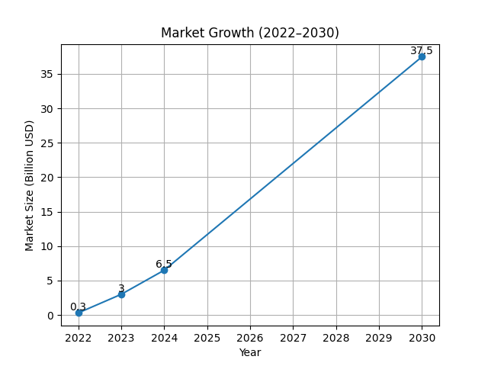
Fig. 1 - Market Growth (GMV)
Firstly, the aim of this research paper is to understand the consumer purchase behavior in the quick commerce ecosystem and identify the key variables that have a direct impact on consumers' purchasing decisions.
The paper adopts a secondary research methodology and analyzes the key variables, including consumer intent, purchase frequency, impulse buying, and consumer loyalty, by collecting insights and observations through various sources, including industry reports, market research articles, and public performance data available for quick commerce companies.
The analysis of the research data concludes that consumer behavior in the quick commerce platform ecosystem is driven by intent, with average 3-4 weekly purchases made by the users, along with a relatively lower average order value (₹400-₹500), as both convenience and speedy deliveries act as key drivers behind choosing these platforms. Keyword performance analysis indicates high levels of consumer conversion rates with branded search keywords, whereas promotional campaigns act as significant triggers for consumers' purchasing decisions. Moreover, smaller basket sizes show that need-based consumption drives the current trend of purchases in the quick commerce platforms. 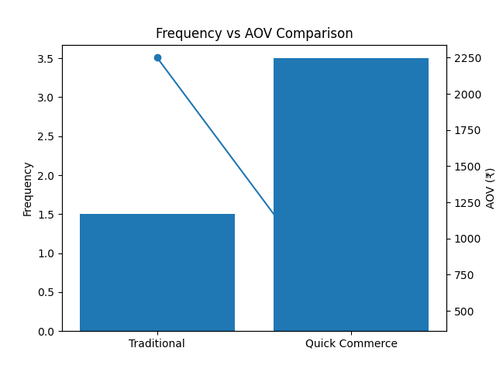
Fig. 2 - Consumer Behaviour Shift
Conclusion:
In conclusion, it can be seen that quick commerce is revolutionizing the shopping behaviors in cities through rapid decisions and increased purchase frequencies. This requires that the firms working in this field focus on improving delivery effectiveness, ensuring availability of products, and deploying appropriate promotion policies to facilitate growth.
Keywords: Quick Commerce, Consumer Behaviour, Digital Retail, Purchase Intent, Performance Marketing
- INTRODUCTION
The fast-paced development of digital technology has brought about significant changes in the retail environment around the globe. Over the past few years, online shopping websites have gained prominence among consumers because of their ease, availability, and extensive range of merchandise. However, a new retail approach called quick commerce (q-commerce) has taken shape as the future of online retailing, offering extremely swift delivery of daily necessities. From convenience to immediacy, the growth of digital retail has witnessed many changes over time. While regular e-commerce emphasizes selection and home delivery in a few days, q-commerce takes this one step further by providing instant deliveries.
Quick commerce is a term used to describe the instantaneous delivery of grocery items, personal care goods, household products, and other common goods usually delivered in less than 30 minutes after ordering them. Traditional e-commerce platforms utilize large warehouses and lengthy delivery processes, whereas quick commerce websites use small hyperlocal fulfillment centers, commonly known as dark stores, that are situated within the city limits.
The rise in quick commerce is quite noticeable in the Indian economy as well. The quick commerce sector has seen a growth of close to 20–25x from 2022 to 2025, with the gross order value of over ₹65,000 crore. However, what needs to be noted is that 65% of online grocery orders are made via quick commerce.
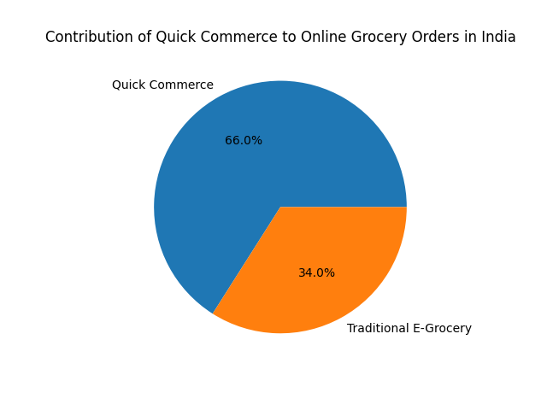
Fig. 3 - Share of Online Grocery Orders
India is one of the fastest-growing markets for quick commerce because of factors like dense urban population, rapid penetration of smartphones, and digital payments. Companies like Blinkit, Zepto, and Swiggy Instamart have made rapid expansions in metro cities like Delhi, Mumbai, Bangalore, and Hyderabad. In terms of infrastructure, quick commerce utilizes dark stores (size – 2,500-4,000 sq. ft.), and these can deliver products within a distance of 2-3 km from the store, thus leading to fast deliveries. The process utilizes real-time tracking of inventory and route optimization to ensure that the deliveries are made as fast as possible, sometimes taking less than 10-15 minutes.
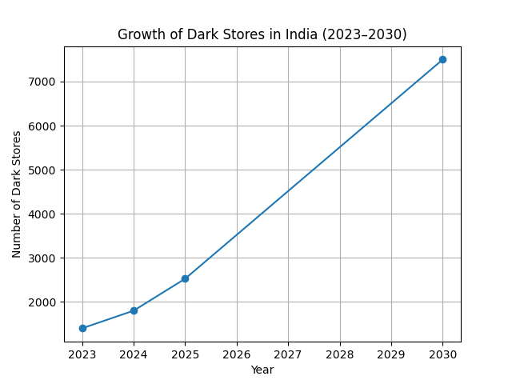
Fig. 4 - Dark Store Growth in India
The fast proliferation of dark stores along with the high efficiency in which the latter operate, handling up to 1,800 orders a day, emphasizes the importance of quick commerce in making such business scalable. The level of consumer adoption has also risen dramatically. Research shows that after the emergence of quick commerce, more than 87 percent of urban consumers prefer to buy their daily necessities online rather than offline compared to about 33 percent prior to its advent. What is important, this process is indicative of behavioral changes rather than mere preferences. As opposed to bulk shopping, customers are currently using quick commerce solutions to address their needs instantly; hence, multiple purchases are made each week. Among the main drivers of this process is the need for convenience, as urban dwellers have busy lives, long hours at work, and two incomes in many cases. They require quick solutions for daily tasks, including grocery shopping, and quick commerce offers a simple solution in form of an easy-to-use online platform.
As far as consumer behavior is concerned, this model could revolutionize conventional shopping practices in many ways. Conventional shopping usually occurs in the form of planned shopping that is done either weekly or monthly. People make shopping lists and buy products in large quantities in order to minimize shopping trips to the store. Quick commerce, however, leads to high-frequency purchases in smaller baskets. In other words, people shop for what they need whenever they need to buy something. Quick commerce also means that impulse buying is likely to happen more often because there is no need for consumers to plan their purchases in advance due to instantaneous delivery.
Promotions are another significant variable that impacts the usage rate. Quick commerce companies use different promotional schemes, discounts, special offers, and even applications' rewards. These promotions not only stimulate people to try the services of a certain platform but also encourage returning customers to place orders more often. Moreover, brand recognition and popularity of certain apps have an important effect as well as they create consumer confidence. However, despite the fast development and success of various quick commerce companies, not much research about their effects on consumer behavior has been carried out yet. It seems that most scholars who discuss this phenomenon do not touch upon behavioral changes; instead, they analyze market developments and investment strategies in quick commerce.
Therefore, the purpose of the current study is to reveal the effects of quick commerce platforms on consumer buying behavior. Since there is almost no scholarly research on the effects of quick commerce, this study focuses on secondary data collection and analysis. To conduct a detailed investigation and obtain more accurate results, the study will concentrate on consumer behavior in urban India.
- METHODOLOGY
The current research follows a secondary research approach in investigating consumer purchasing behavior in the field of quick commerce. Rather than engaging in primary data collection, this research utilizes secondary resources from the industry reports, public databases, and performance marketing perspectives pertaining to quick commerce operations.
Secondary research proves to be highly valuable for analyzing industries that have already been established enough for data to be generated. For this research, data was collected from several sources, such as reports by consulting firms, journals on digital commerce, and databases of market research firms.
Sources of information:
• Reports of consulting firms, such as Bain & Company and Redseer Strategy Consultants
• Statistics provided by digital commerce research firms, such as Statista
• Insights from the public domain relating to the growth of quick commerce in India
• Performance marketing information gathered from search advertisements
In terms of geographic focus, the research centres around urban markets where rapid uptake of the quick commerce model is observed. The big metropolitan cities like Delhi NCR, Mumbai, Bangalore, and Hyderabad act as the main areas of operations for the majority of the quick commerce service providers.
Several behavioural metrics have been considered by the researchers in this research to get an understanding of the purchasing patterns of consumers through the quick commerce channel. These metrics are as follows:
• Frequency of purchases
• Size of the basket
• Preference for speed and convenience
• Effect of promotional discounts on purchase decisions
• Brand affinity
The gathered data was subjected to descriptive analysis methods to gain insight into any recurring behavioural patterns. Conclusions were made after making comparisons between various industry sources.
- RESULTS AND FINDINGS
Based on the evaluation of the data from different industries and the analysis of market reports, there are a number of notable trends that can be observed regarding consumer behavior in the quick commerce industry in India.
Firstly, one can note a behavioral trend toward increased purchase frequency combined with lower order sizes. Contrary to the traditional shopping experience when customers buy different groceries once during their visit, quick commerce users are more likely to place orders several times a week. In essence, the behavior in this situation is linked to the tendency toward the need-based consumption when customers order a product when they have a need for something.
The delivery speed appears to be one of the most significant drivers behind the increasing popularity of quick commerce. Specifically, there are many customers who prefer platforms where delivery is performed very quickly, i.e., in 10–20 minutes. In essence, such an approach helps to avoid the necessity to visit physical stores and spend much time while ordering things online.
Convenience is another key factor influencing consumer behavior. Firstly, quick commerce platforms are equipped with convenient interfaces allowing customers to perform purchases via smartphones in just seconds. Secondly, there is an easy-to-use system of payments.
The use of promotions is another key aspect in influencing purchase decisions. Many digital platforms offer discounts, packages, and time-limited offers that prompt consumers to make more purchases. In most cases, these promotions help to boost sales volume in the short run by increasing the size of baskets. They work well with snack foods, drinks, and ready-to-cook meals. In terms of search behavior on digital platforms, branded searches usually result in higher conversions than non-branded ones. This shows that many consumers using quick commerce platforms have intentions to buy at the beginning of the search process. Another important discovery involves product availability. Since customers use these platforms because they promise fast deliveries, stockouts can negatively influence their shopping experience, especially if the items are basic necessities.
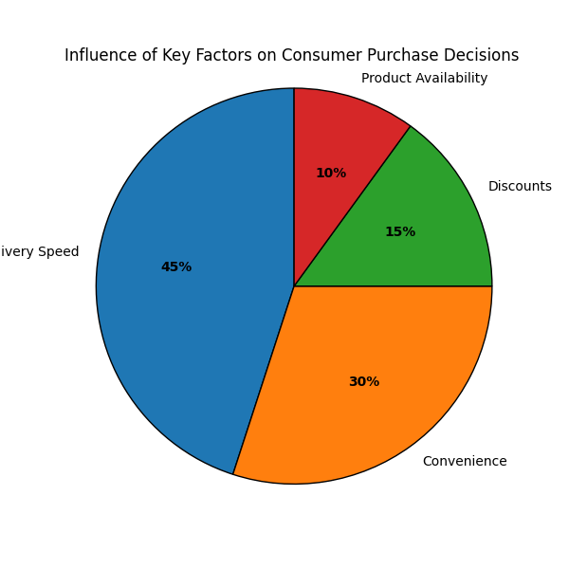
Fig. 5 - Influence Share of Key Factors
The emergence of quick commerce businesses will also have ramifications for brick-and-mortar retailing systems. Despite the continued importance of local grocery stores in the retail network, quick commerce applications are increasingly competing with physical stores for purchases made out of convenience.
In general, it can be concluded that quick commerce sites are changing consumer buying behaviour through faster decision making, more frequent orders, and impulse buys.

It is also reported in the industry literature that snacking products, beverages, and prepared foods constitute a considerable percentage of quick commerce sales, implying the prevalence of impulse consumption in this sector (Statista, 2024).
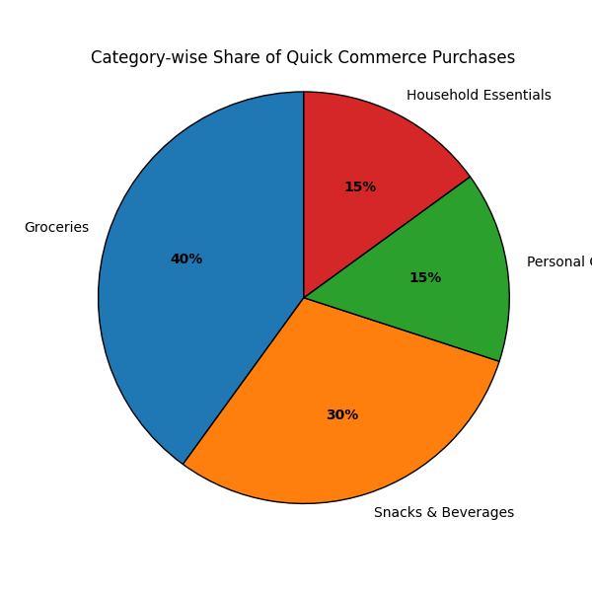
Fig. 6 - Category-wise share of quick commerce purchases
- CONCLUSION
With the advent of quick commerce, there has been considerable change in the digital retail industry. With quick commerce providing consumers with fast deliveries of their daily items, this trend has fulfilled consumers' increasing demands for convenience.
For this study, the impacts of quick commerce platforms on consumers' purchasing behavior were investigated with an analysis of industry insights and data from the secondary market. It was concluded that convenience, delivery speed, and promotion strategy are the critical elements influencing consumers' decisions for using these quick commerce platforms. Quick commerce is being used more for small and frequent purchases by consumers instead of bulk purchases. This shows a trend where consumers now prefer immediacy and convenience while making purchases. With immediate availability of products in less time, the need for planning beforehand becomes unnecessary.
Apart from these trends, quick commerce also focuses on its efficiency regarding customer service delivery and promotions.
In light of the continuous growth of quick commerce services in India, firms need to develop new marketing and logistical strategies to cater to the changing demands of consumers. In future studies, the economic sustainability of the industry could be examined along with the competition between quick commerce and conventional retailing formats. The role of quick commerce in the development of logistics management could also be analyzed further.
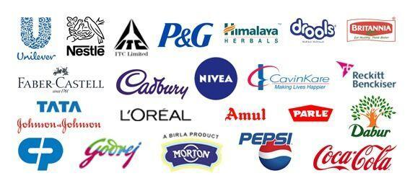

References
- Bain & Company. (2024). How India Shops Online: Digital Commerce Report. Bain & Company.
- Redseer Strategy Consultants. (2023). India Quick Commerce Market Update. Redseer Research.
- Statista. (2024). Quick Commerce Market Size in India. Retrieved from https://www.statista.com
- ET Retail. (2024). Quick Commerce growth trends in India. The Economic Times Retail.
- McKinsey & Company. (2023). The Future of Retail in Emerging Markets. McKinsey Insights.
- IBEF. (2024). Indian E-commerce Industry Report. India Brand Equity Foundation.
- Zomato Ltd. (2024). Blinkit Business Performance Update. Zomato Investor Relations.
- Swiggy. (2023). Instamart Market Expansion Report. Swiggy Corporate Insights.

