UI/UX DESIGN BRIEF

KAIRO
Visual and interaction design for Release 1
Document  UI/UX Design Brief | Version  0.1
Status  Draft for review | Date  11 October 2026
Implements  PRD, TRD and App Flow v0.1 | Course  Project-Based Learning

Contents
1. Document control
2. Design intent
3. Brand identity
4. Color
5. Typography
6. Layout, spacing and surfaces
7. Iconography
8. Components
9. Screen designs
10. Legal and trust pages
11. Report and PDF design
12. Responsive design
13. Motion
14. Content design
15. Accessibility
16. Design tokens
17. Assets and hand-off
18. Traceability
19. Open questions and decisions
20. Sources

1. Document control
This brief gives every screen in the App Flow its visual and interaction design, and it adopts the KAIRO brand identity exactly as the owner supplied it.
Field | Value
Product | KAIRO
Document | UI/UX Design Brief
Version | 0.1
Status | Draft for review
Implements | PRD v0.1 (section 14, brand guardrails), TRD v0.1 (section 15), App Flow v0.1
Audience | Designers, front-end engineers, faculty guide, evaluators
Source of truth for identity | The owner's KAIRO Geometric Brand Identity Guide, reproduced in section 3
Companion files | A brand asset pack: icon.svg, icon-ink.svg, favicon.ico, apple-icon.png, icon-192.png, icon-512.png, icon-maskable-512.png, opengraph-image.png, manifest.webmanifest

How to read this brief
- Sections 3 to 7 define the system: identity, color, type, layout and icons.
- Sections 8 to 13 apply it: components, screens, legal pages, reports, responsive behavior and motion.
- Sections 14 and 15 govern content and accessibility, and section 16 turns the system into design tokens that the build enforces (TRD section 15).
- Mockups use sample data and are labeled as such. They show structure, hierarchy and styling. The final copy belongs to the owners.
- Sizes are real pixels at a 16 px base. The mockups are drawn at roughly three quarters of that scale, so they look smaller than the real screens.

2. Design intent
KAIRO should look like a precise instrument built by a careful team: calm, dense where it needs to be, and never decorative for its own sake.

What the design is for
People arrive worried that something they shipped is unsafe. The design has to turn a long list of technical findings into a short, ordered list of things to do, and to make it obvious how sure KAIRO is about each one. Trust is the product, so every visual choice either helps a person read evidence or is removed.

Principles
Principle | What it means on screen
Evidence first | Findings show what was observed, where, and how sure KAIRO is, before any advice. Evidence blocks are visually distinct from explanations
Words before symbols | Severity, confidence and status are always written. Shapes support the words. Color only reinforces them (BR-15)
One thing to do next | Every screen has one primary action, drawn once and drawn in emerald
Flat and exact | Hard-edged geometry that echoes the logo's 45 degree cuts. Surfaces separate with 1 px lines, not shadows or gradients
Quiet by default | Neutral surfaces carry the page. Emerald marks action and brand only. Semantic colors appear only on labels and messages
Honest about limits | Warnings, partial results and AI-assisted findings are labeled in plain text and placed where the reader will see them
Same everywhere | A component looks and behaves the same on every screen. There are no one-off styles

Patterns this product does not use
These come from the owner's list and from PRD section 14. Each has a defined replacement, so designers are not left guessing.
Avoided | Replaced by
Purple or violet gradients, and gradient backgrounds | Flat fills from the palette in section 4. The token check rejects any hue between 250 and 300 degrees
Pill-shaped buttons and fully rounded controls | Rectangles with a 3 px radius, echoing the logo tile's square corners
Em dashes in any text | Commas, colons, periods and parentheses
Scroll-triggered effects, parallax, reveal-on-scroll | Static layouts. Content is present when the page loads
Custom cursors and cursor-following effects | The system cursor
Emoji as icons or bullets | One icon family (section 7) with words beside it
Sparkle, star and wand symbols for AI features | A plain label: "AI-assisted"
Invented statistics, testimonials, customer logos, ratings | Nothing. Only facts the product can prove, with their source or date
AI-generated images and stock photos of people | Real product screens, diagrams and typography
"Made with AI" or "Powered by AI" badges | No badge. Where AI influenced a finding, the finding says so in words
The framework's default favicon and starter assets | The KAIRO icon set in section 3
Hype words and exclamation marks in copy | The voice rules in section 14

3. Brand identity
The identity is a chamfered tile holding a K, followed by the letters AIRO, so that the tile is the first letter of the name.
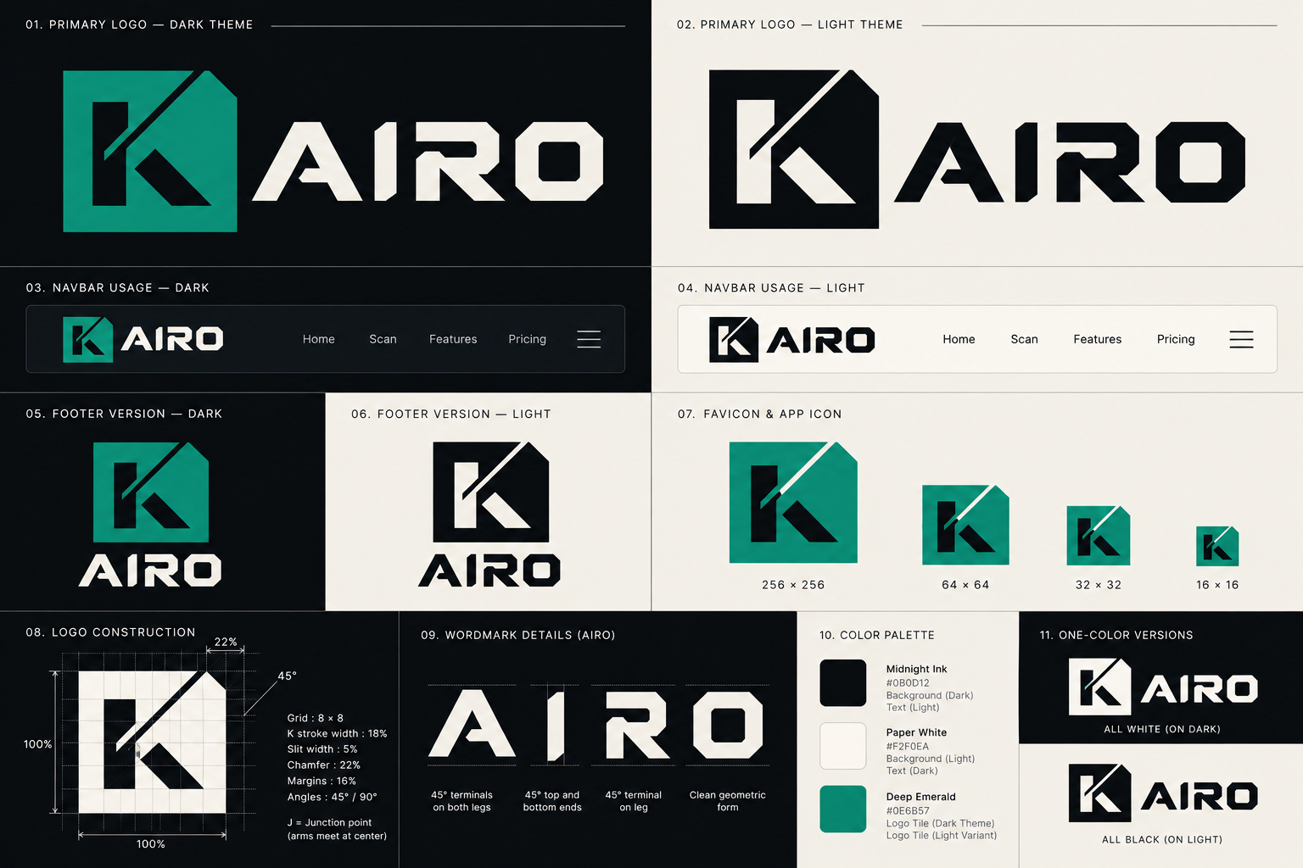
The owner's brand identity guide, reproduced as the reference for this brief

Logo system
Lockup | Where it is used | Rules
Primary, dark theme (panel 01) | Dark backgrounds: the sign-in screen in dark theme, social preview, presentations | Emerald tile with a Midnight Ink K and Paper White letters
Primary, light theme (panel 02) | Light backgrounds: print, the PDF cover, documents | Midnight Ink tile with a Paper White K and Midnight Ink letters
Navbar lockup (panels 03 and 04) | The header on every page | Tile and letters on one line. Height 32 px on desktop, 28 px on phones
Footer lockup (panels 05 and 06) | The page footer and the PDF back cover | Tile above the letters, centered
Tile only (panel 07) | Favicon, app icon, avatar-sized spaces under 96 px | Never shown with a rounded corner. The chamfer is always at the top right
One-color versions (panel 11) | Single-color print, stamps, low-quality output | All white on dark, or all black on light

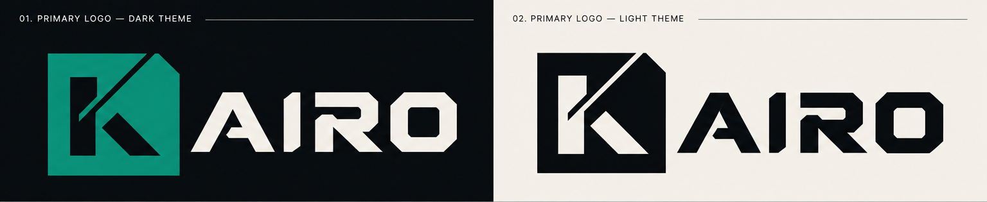
Primary logos, dark and light theme
Navbar usage, dark and light theme

Construction
The guide gives the construction numbers below. They are the only numbers the redraw may use.
Property | Value
Grid | 8 by 8
K stroke width | 18 percent of the tile
Slit width | 5 percent
Chamfer | 22 percent, at the top right
Margins | 16 percent
Angles | 45 degrees and 90 degrees only
Junction point | Where the arms meet at the center of the K

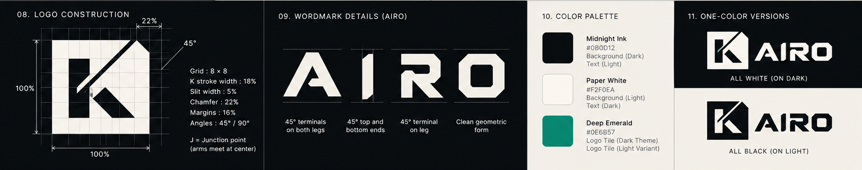
Construction, wordmark details, palette and one-color versions

Clear space and minimum size
Rule | Value
Clear space | At least the width of the K stem on every side of any lockup
Minimum size, tile | 16 by 16 px on screen, 6 mm in print
Minimum size, lockup | 96 px wide on screen, 25 mm in print
Smallest lockup in the header | 28 px tall on phones

Do and do not
- Do place the lockup on Midnight Ink, Paper White, or a plain surface from the palette with enough contrast.
- Do use the one-color version when only one ink is available.
- Do not recolor the tile, add a gradient, outline, glow or shadow, rotate, stretch or round its corners.
- Do not place the lockup on photographs or busy backgrounds. There are no such backgrounds in the product.
- Do not retype the wordmark in another font. The letters are drawn, not typed.
- In running text, write the name in capitals: KAIRO. A lockup image always has the alternative text "KAIRO".

Favicon and app icon set
The set below is derived from panel 07 and uses the emerald tile with a Midnight Ink K. Dimensions and files are final. The vector in this pack is a faithful redraw of the guide's raster, fitted to the construction numbers above, and it must be replaced by the designer's master vector when that exists (section 19).
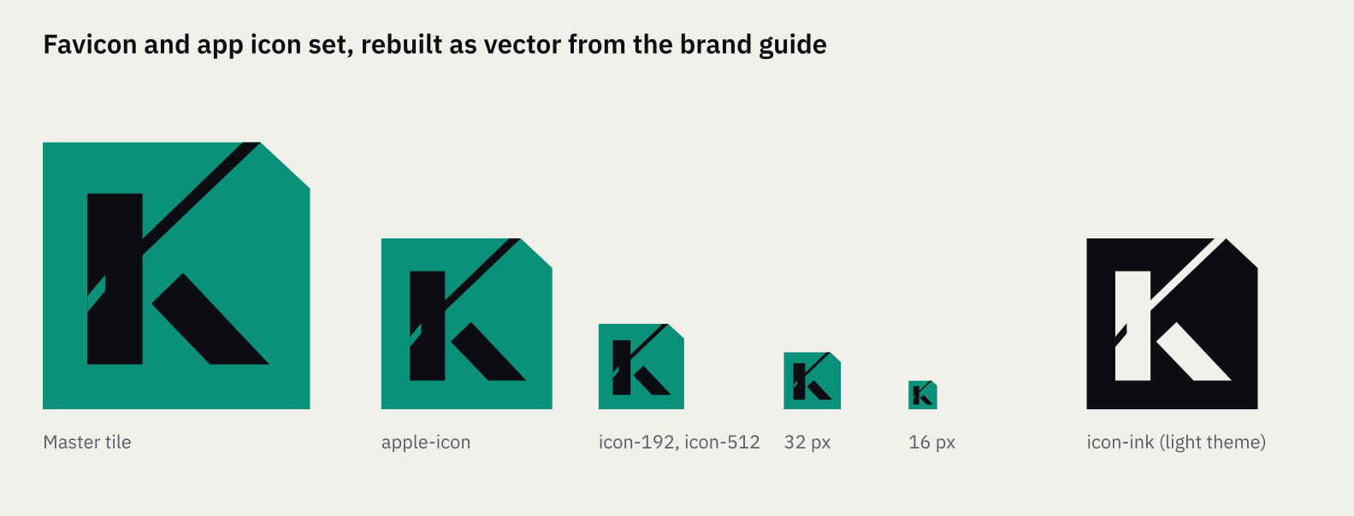
Favicon and app icon set
File | Size | Used for
icon.svg | Vector | Primary favicon in modern browsers
favicon.ico | 16, 32 and 48 px in one file | Older browsers and some tools
apple-icon.png | 180 by 180 | iOS home screen. Midnight Ink background with the tile inset, because iOS masks the corners itself
icon-192.png and icon-512.png | 192 and 512 | Web manifest icons, with a transparent surround
icon-maskable-512.png | 512 by 512 | Android adaptive icons. The tile sits inside the central safe zone on a Midnight Ink field
icon-ink.svg | Vector | Light-theme tile for documents and print
opengraph-image.png | 1200 by 630 | Social preview: the dark primary lockup and one plain statement
manifest.webmanifest | Not applicable | Name, theme color Midnight Ink, background color Paper White, icon list

Social preview
The preview is a typographic card: the dark primary lockup at the top left, the statement "Find access-control flaws in AI-built apps before you launch." in IBM Plex Sans SemiBold, and one supporting line. It contains no screenshot, no gradient and no figure. A screenshot version may replace it only once real product screens exist.

4. Color
The palette is the three colors from the brand guide plus a restrained extension, and emerald is the only accent.
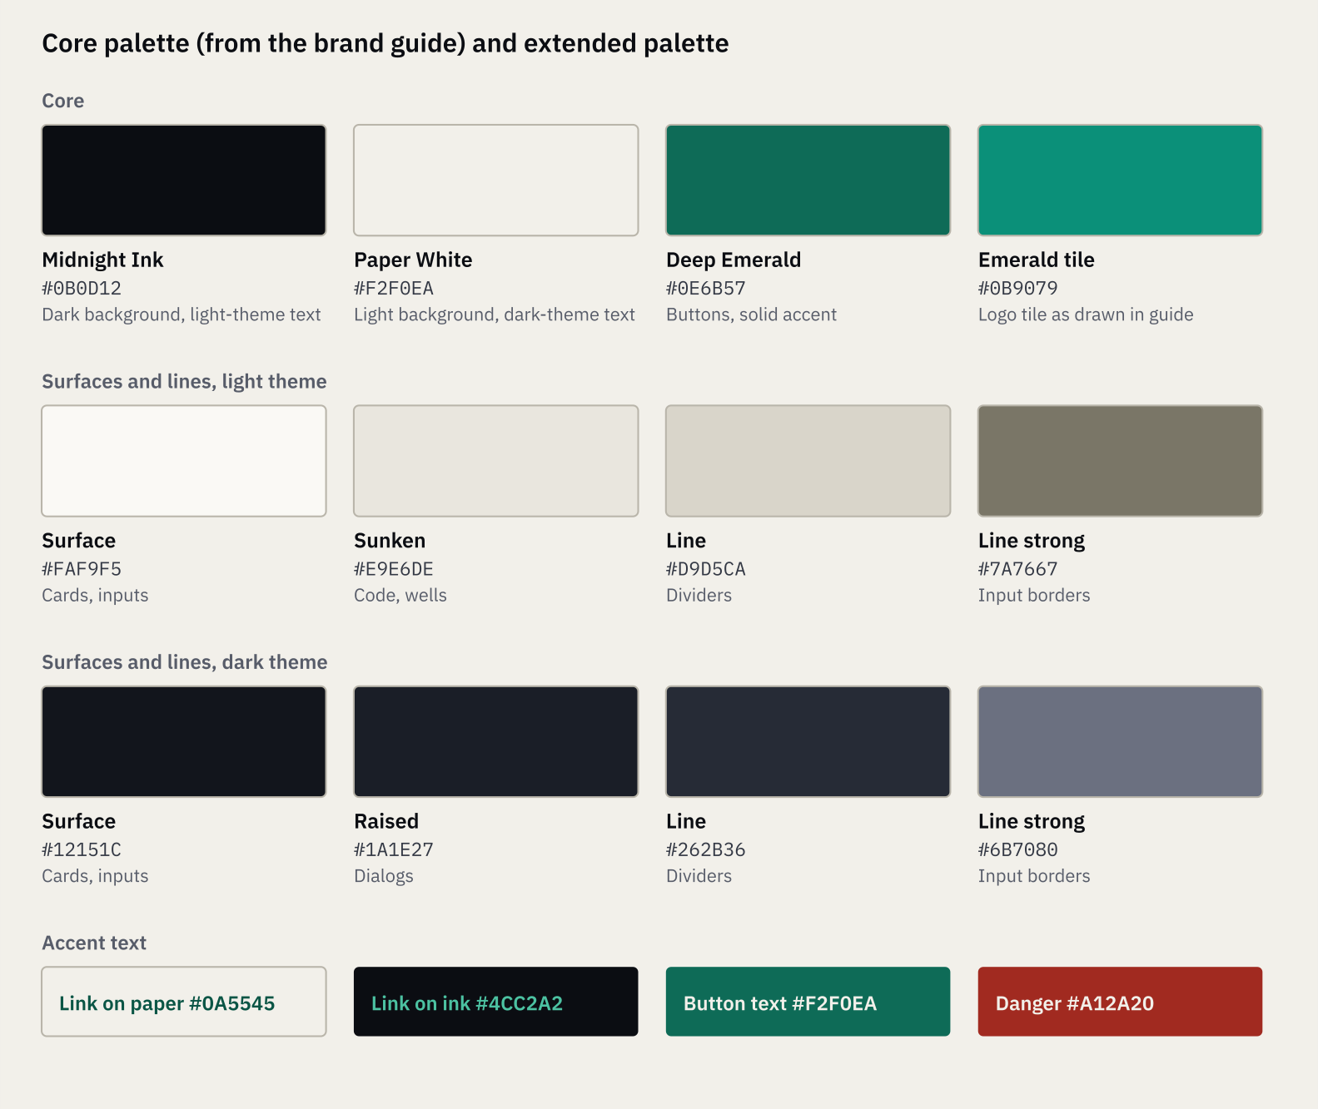
Core and extended palette

Core colors
Name | Value | Role
Midnight Ink | #0B0D12 | Dark theme background, light theme text, logo tile on light
Paper White | #F2F0EA | Light theme background, dark theme text, button text
Deep Emerald | #0E6B57 | Primary buttons, solid accent fills, focus ring on light
Emerald tile | #0B9079 | The logo tile, as drawn in the guide (see section 19)

Theme tokens
Both themes are first-class. The default follows the person's system setting, and a setting on the Account screen can force either one.
Token | Light | Dark | Use
bg | #F2F0EA | #0B0D12 | Page background
surface | #FAF9F5 | #12151C | Cards, inputs, tables
raised | #FAF9F5 | #1A1E27 | Dialogs and menus
sunken | #E9E6DE | #080A0E | Code, wells, disabled controls
text | #0B0D12 | #F2F0EA | Primary text
text-2 | #333844 | #CFCCC2 | Secondary text
muted | #575C69 | #A3A39F | Captions, help text, metadata
line | #D9D5CA | #262B36 | Dividers and card borders
line-strong | #7A7667 | #6B7080 | Input borders and checkbox outlines
accent | #0E6B57 | #0E6B57 | Primary button fill
on-accent | #F2F0EA | #F2F0EA | Text on the primary button
accent-text | #0A5545 | #4CC2A2 | Links and active tab text
accent-tint | #DDEDE7 | #0F2A23 | Informational banners, selected rows
focus | #0E6B57 | #4CC2A2 | Focus ring
danger | #A12A20 | #A12A20 | Destructive button fill

Semantic colors
These appear only on severity labels, status labels and messages. Each pairs a text color with a tint, and both themes meet the contrast targets in section 15.
Meaning | Light text on tint | Dark text on tint
Critical | #A12A20 on #F8E5E2 | #FF9A8A on #2C1613
High | #8F3F0B on #FBEBDD | #FFB885 on #2B1C10
Medium | #6E5300 on #F8F0D2 | #EFCB62 on #2A2310
Low | #2D4C74 on #E6ECF4 | #9CC1EE on #131F2E
Informational | #3A3F4B on #E9E6DE | #CFCCC2 on #1A1E27
Fixed | #0A5545 on #DDEDE7 | #4CC2A2 on #0F2A23

Rules for using color
- Emerald means action or brand. A primary button, a link, an active tab, a focus ring and the logo tile are emerald. Nothing else is.
- A screen has one emerald fill: its primary button. Banners use the tint, not the fill.
- Semantic colors never appear as backgrounds for large areas. They are labels and message tints only.
- Color never carries meaning alone. Every colored label has a word and a shape beside it.
- Surfaces are flat. There are no gradients, no glows and no decorative shadows.
- Paper White is a warm off-white. Do not substitute pure white for page backgrounds. Inputs and cards use the surface token, which is lighter than the page.

5. Typography
KAIRO uses IBM Plex Sans for the interface and IBM Plex Mono for code, both under the SIL Open Font License 1.1 and both self-hosted.
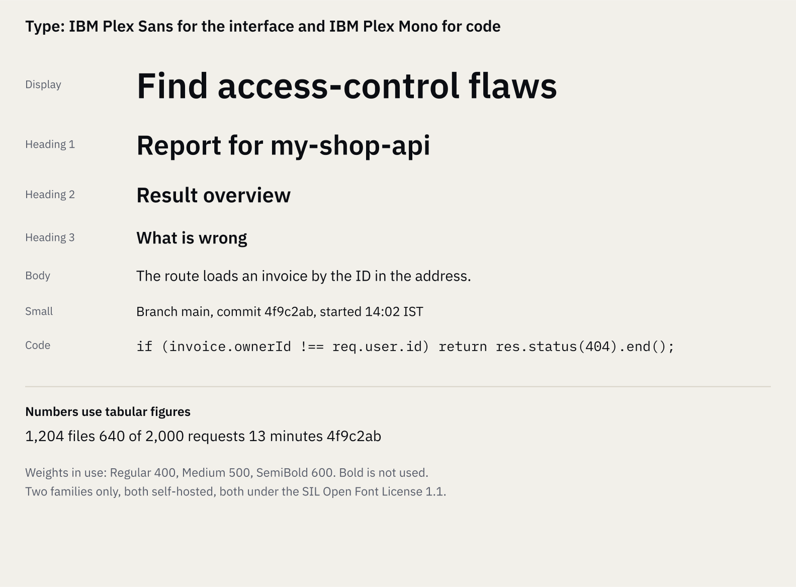
Type scale in IBM Plex Sans and IBM Plex Mono

Why these families
The wordmark is drawn from hard geometry and 45 degree terminals. IBM Plex Sans has the same engineered, slightly squared character without competing with the logo, and its Mono companion shares the same proportions, so code blocks sit comfortably beside prose. Both have a full range of weights, tabular numerals and wide language support. The packages from the project's npm registry carry the OFL-1.1 license.

Scale
Style | Desktop size and line height | Phone size and line height | Weight | Use
Display | 40 / 48 | 30 / 38 | 600 | The home page headline only
Heading 1 | 32 / 40 | 26 / 34 | 600 | Page titles
Heading 2 | 24 / 32 | 22 / 30 | 600 | Section titles
Heading 3 | 20 / 28 | 18 / 26 | 600 | Subsections
Heading 4 | 16 / 24 | 16 / 24 | 600 | Block labels such as "What is wrong"
Body | 16 / 24 | 16 / 24 | 400 | Running text
Small | 14 / 20 | 14 / 20 | 400 | Table cells, secondary text
Caption | 12 / 16 | 12 / 16 | 400 | Metadata, help text
Label | 12 / 16, tracked 0.06 em | 12 / 16 | 600 | Small eyebrow labels, the only uppercase text
Code | 14 / 20 in Plex Mono | 13 / 20 | 400 | Code, commands, paths, commit identifiers

Rules
- Weights in use: 400, 500 and 600. Bold 700 is not used.
- Line length in running text is 60 to 75 characters. Legal pages are held to 68.
- Numerals in tables, counters and progress text use tabular figures, so columns of numbers align.
- Headings are sentence case. Letter-spacing is normal except on Label text.
- Text is left-aligned. Nothing is justified or centered except short statements on error and sign-in screens.
- Fallback stack: IBM Plex Sans, then system-ui, then Segoe UI, Helvetica Neue, Arial, sans-serif. For code: IBM Plex Mono, then ui-monospace, Consolas, monospace.
- Fonts are subset to Latin, self-hosted, served with font-display: swap, and the Regular and SemiBold files of Plex Sans are preloaded. Two families at most (TRD section 15).

6. Layout, spacing and surfaces
The layout is a 12 column grid on a 4 px unit, held to a 1120 px content width, with hard-edged surfaces separated by 1 px lines.
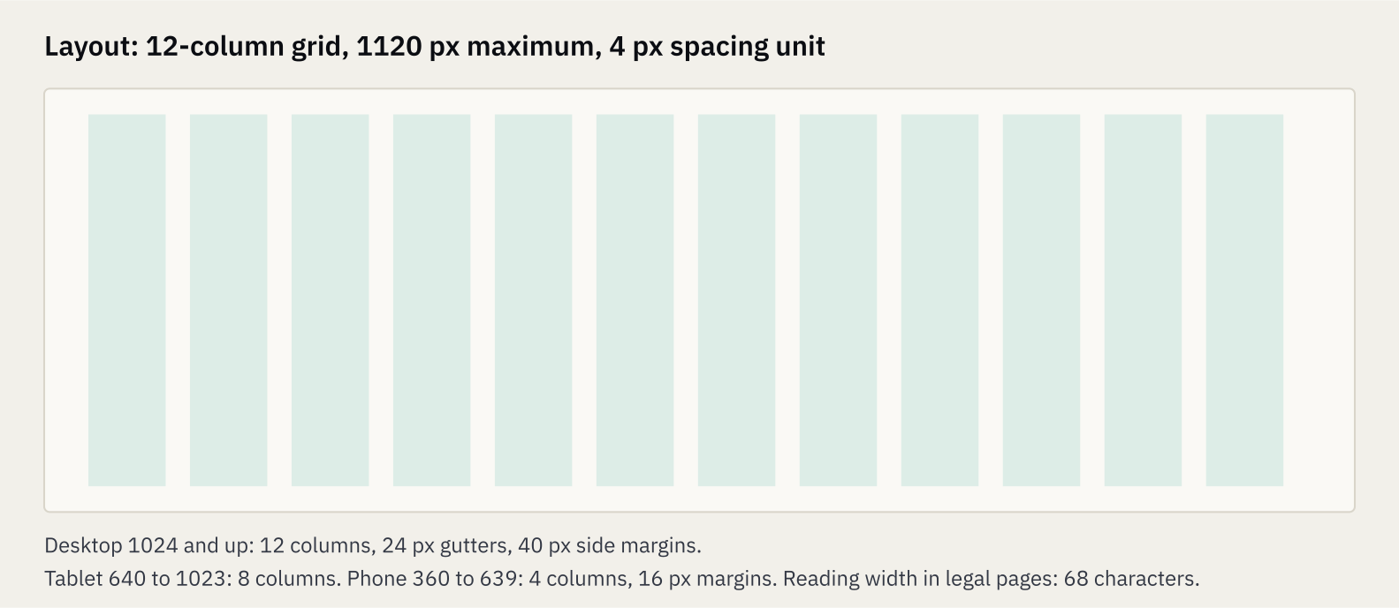
Grid and breakpoints

Grid and breakpoints
Range | Columns | Gutter | Side margin | Notes
1024 px and up | 12 | 24 px | 40 px | Content is held to 1120 px and centered
640 to 1023 px | 8 | 24 px | 32 px | Tables keep their columns where they fit
360 to 639 px | 4 | 16 px | 16 px | Layouts stack. Tables become labeled blocks
Below 360 px | 4 | 12 px | 12 px | Content reflows. No sideways scrolling, except code and wide tables inside their own container

Spacing, radius and borders
Token | Values
Spacing | 4, 8, 12, 16, 24, 32, 48, 64, 96
Radius | 0 for tables and the page shell, 2 for labels, 3 for buttons and fields, 4 for cards and menus, 6 for dialogs. Nothing exceeds 8
Borders | 1 px in the line token for cards and dividers. 1 px in line-strong for inputs. Focus and error borders are 2 px
Elevation | None on the page. Dialogs and menus use a 1 px line-strong border over a 55 percent scrim. No drop shadows
Density | One density. Table rows are 48 px, form fields 40 px

Page structure
- Header: 56 px tall, nav surface, a 1 px line below. Lockup at the left, navigation and account menu at the right.
- Main: one column, 1120 px maximum. The page title block sits at the top: trail, Heading 1, one line of metadata, and the page actions aligned right.
- Footer: a 1 px line above, then the five legal links and the version. It appears on every page (BR-12).
- Page padding: 48 px above the title block on desktop, 24 px on phones.

7. Iconography
One icon family, Lucide, is used throughout, drawn with square caps, mitered joins and a 1.75 stroke so it matches the hard geometry of the logo.
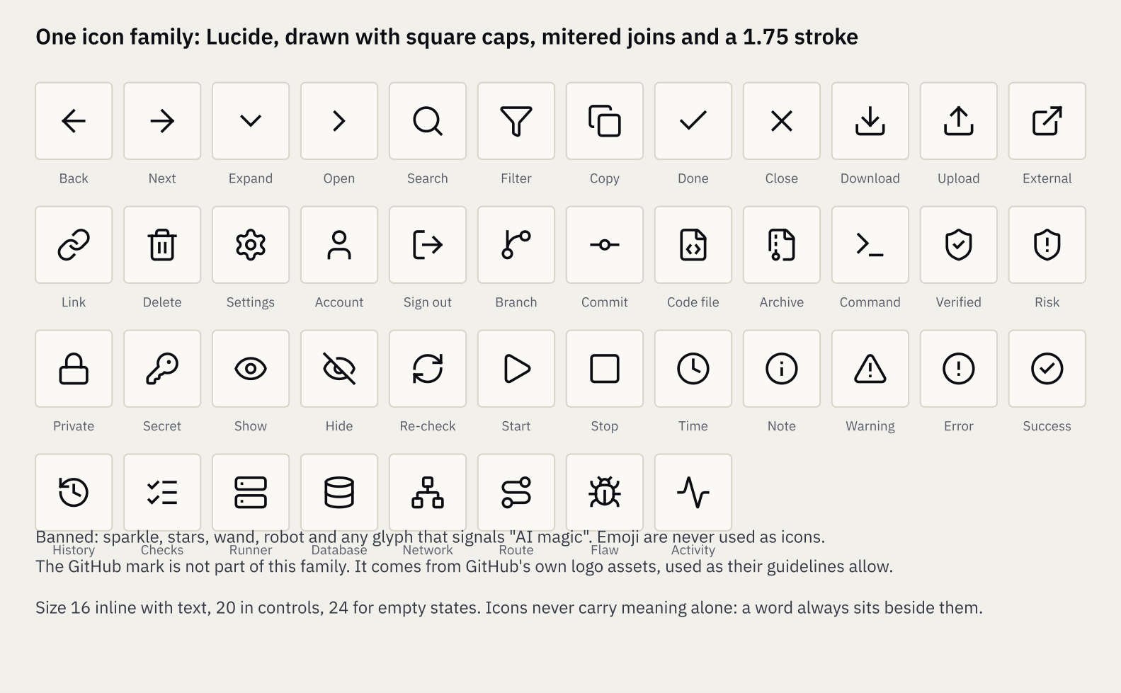
The icon set in use, with its meaning

Why Lucide, and how it is customized
Lucide is licensed under the ISC License, is free for commercial use, and has more than 2,000 icons on a consistent 24 px grid. Version 1 removed all brand icons, which keeps trademarks out of the set. The default round caps look soft next to the logo, so the product draws every icon with a square line cap, a miter join and a 1.75 stroke, which gives crisp corners that echo the chamfered tile. Phosphor and Tabler were considered. Neither is needed, because the 44 icons on the sheet cover every function in the App Flow.

Rules
- Icons are 16 px inline with text, 20 px inside controls, and 24 px in empty states. They inherit the text color.
- An icon never stands alone. A word always sits beside it, or the control has a visible text label. Icon-only buttons carry an accessible name and a visible tooltip.
- Only the 44 icons on the sheet are used. Adding one needs a review against the banned list.
- Banned: sparkle, stars, wand, robot, brain, magic and any other glyph that suggests "AI magic". Emoji are never used.
- The GitHub mark is not part of this family. It comes from GitHub's own logo assets and follows their guidelines. It appears only on the "Continue with GitHub" button.
- Severity, confidence and status use the drawn shapes in section 8, not icons from the family.

8. Components
Every component below is drawn once and reused. The sheet shows the main controls in both themes, and the tables give the numbers.
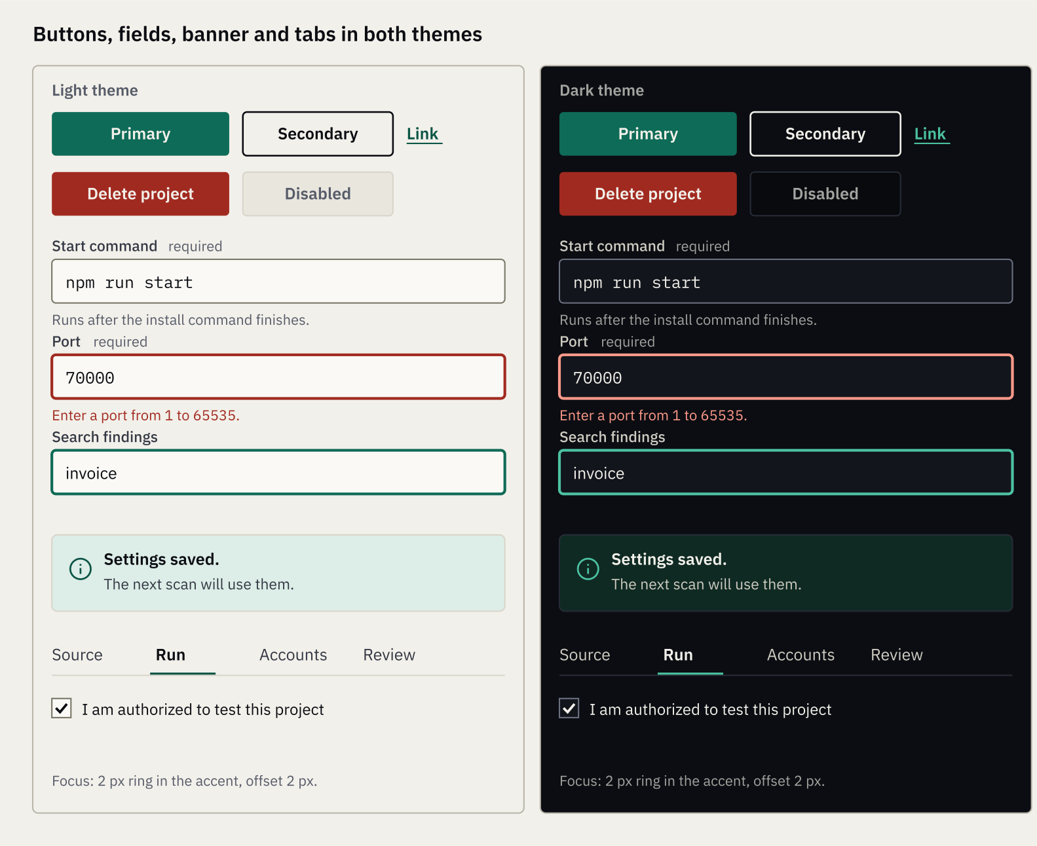
Buttons, fields, banner, tabs and checkbox in both themes

Buttons
Type | Fill and text | Use
Primary | Deep Emerald fill, Paper White text | The single next step on a screen
Secondary | No fill, 1.25 px border in the text color, text in the text color | Other actions beside a primary
Link | Accent text, underlined | Low-emphasis actions inside content
Danger | Danger fill, Paper White text | Irreversible actions, always inside a confirming dialog
Disabled | Sunken fill, muted text, line border | An action that is not available, with the reason stated beside it

Property | Value
Heights | 32 px small, 40 px default, 48 px on the home page
Padding | 16 px sides, 20 px on the 48 px size
Radius | 3 px. Never fully rounded (BR-2)
Text | 15 px SemiBold, sentence case, a verb and an object: "Start scan", "Add project"
States | Hover darkens the fill one step. Focus shows the 2 px ring with a 2 px offset. Busy keeps the width and changes the label, for example "Saving". There is no spinner animation
Minimum width | 96 px

Fields
Property | Value
Label | Above the field, 14 px Medium. The word "required" follows it in muted text. A symbol alone is never used
Control | 40 px tall, surface fill, 1 px line-strong border, 3 px radius, 12 px padding. Commands, paths and ports use Plex Mono
Help | 13 px muted text under the control, linked to it
Error | The border becomes 2 px in the error color. The message starts with the word "Error:" and replaces the help text
Focus | 2 px border in the focus color
Secret field | Masked after saving. Shows "Replace" and "Remove". A "Show" and "Hide" text button reveals text while typing
Checkbox and radio | 18 px box, line-strong border, a drawn check or dot. The label sits to the right and is part of the target
File picker | A bordered area with the limits written inside it and a "Choose file" button. Dropping a file works too

Severity, confidence and status
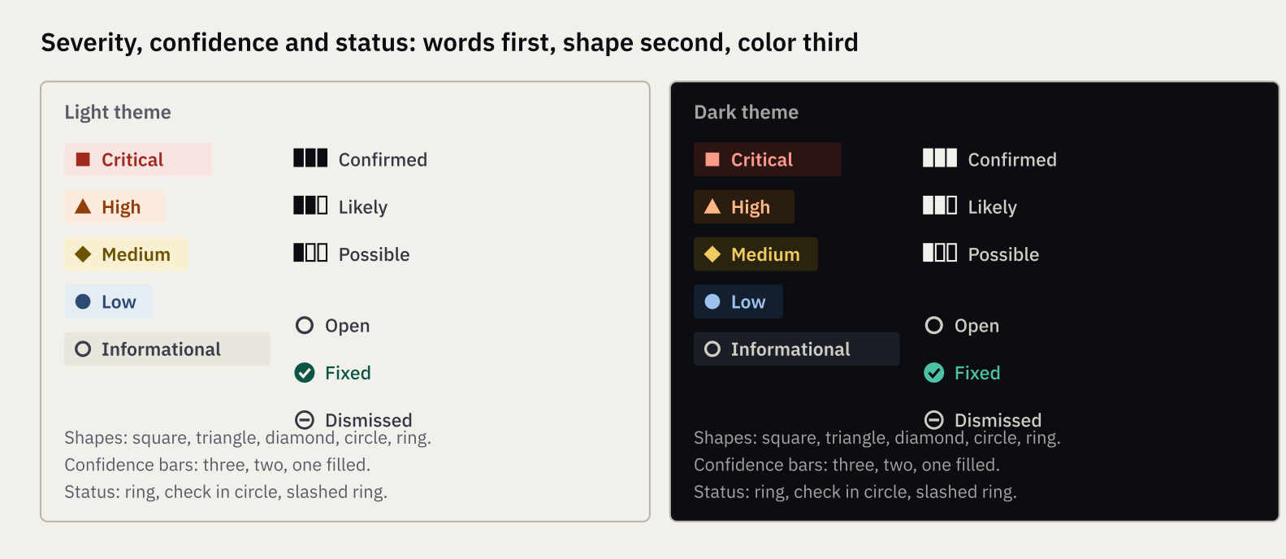
Severity, confidence and status in both themes
Element | Design
Severity label | A tinted rectangle with a 2 px radius, a shape and the word. Critical: filled square. High: filled triangle. Medium: filled diamond. Low: filled circle. Informational: ring
Confidence | Three small bars, filled three, two or one, followed by the word Confirmed, Likely or Possible
Status | Open: ring. Fixed: check in a filled circle. Dismissed: a ring with a slash. The word always follows

Other components
Component | Specification
Banner | Tint fill, 1 px line border, 4 px radius, a 20 px icon, a bold first line and one supporting line. Variants: information, warning, error, success. There is no colored side stripe
Tabs | Text only. The active tab is SemiBold with a 2 px accent underline. A 1 px line runs under the row. Targets are 40 px tall
Dialog | 480 px wide, 640 px for the larger ones, 24 px padding, 6 px radius, line-strong border, 55 percent scrim. Title in Heading 3. A close icon button at the top right. Focus is trapped inside
Table | No zebra. A 1 px line between rows. Header cells are 12 px SemiBold muted. Rows are 48 px. The row title is a link in accent text
Stage row | A state marker, the stage name in SemiBold, the state word, and one detail line. States: complete is a check in a filled circle, running is a half-filled ring, queued is a dashed ring. No animation
Finding row | Severity label, confidence, status, title as a link, then the route and file in Plex Mono
Code block | Sunken fill, 1 px line border, 3 px radius, Plex Mono 14 px, line numbers in muted text, the highlighted line marked by a 3 px accent bar at the left, a Copy button at the top right
Request and response block | The code block with a heading that says "Request" or "Response", and the note "Passwords, tokens and cookies were removed."
Filter bar | Controls on one line. Each shows its name and current value. The state lives in the address
Empty and error block | A 24 px icon, a Heading 3 sentence, one line of body text, and one action. Left-aligned inside the content area. No illustration
Header, footer, trail | As in section 6. The trail uses slashes, the current part is plain text
Copy button | A 16 px copy icon with the word "Copy". On success the word becomes "Copied"
Show more | A link-style button under a list, never infinite scroll

9. Screen designs
Each mockup below shows the structure, hierarchy and styling of one screen, using sample data, and the notes call out the decisions that are not obvious from the picture.

P-01 Home
The home page states what the product does in one headline, shows a real-looking report as proof of how it reads, and explains the three steps and one honest limit.
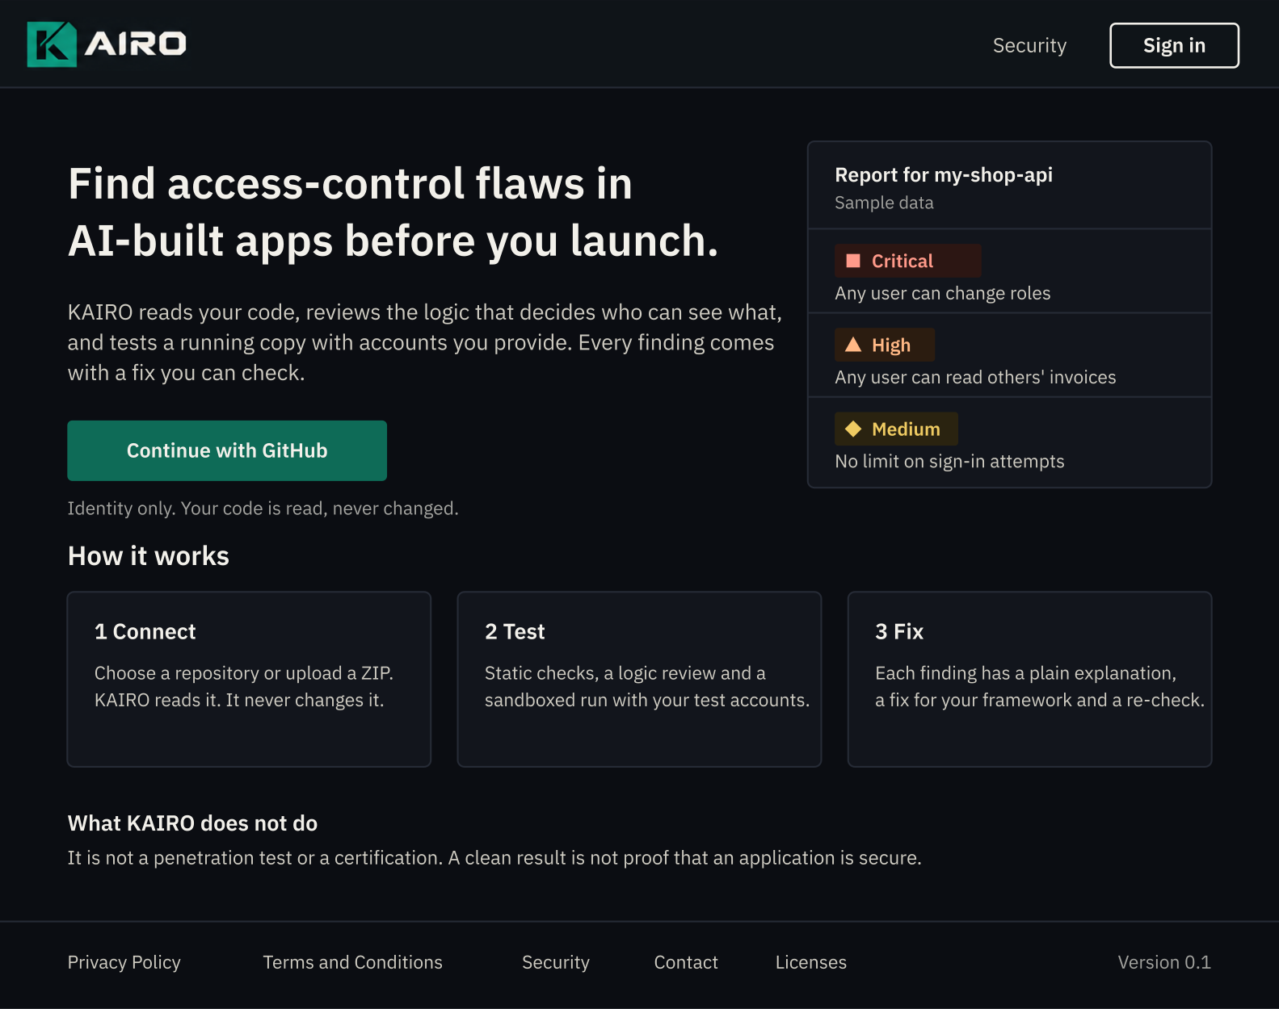
P-01 Home, dark theme, with sample data
- Layout: header, a two-part hero (headline and action at the left, a report panel at the right), a "How it works" row of three cards, a plain limits statement, and the footer.
- The only emerald fill is the "Continue with GitHub" button. The GitHub mark sits inside it, from GitHub's own assets.
- The report panel is built from the real finding components with sample data and the label "Sample data". It is not a screenshot and carries no numbers about usage.
- There are no logos of customers, no counts, no testimonials and no stock imagery (BR-6, BR-8).
- The statement "What KAIRO does not do" is on the page itself, not in the footer.
- The copy shown is a draft. The headline mirrors the social preview.

A-02 Projects
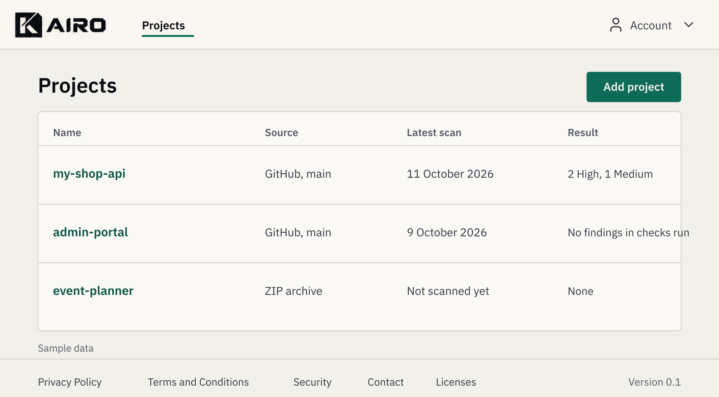
A-02 Projects, light theme, with sample data
- The table uses the standard table component. The project name is the link. The result column gives counts in words, and "No findings in checks run" is worded to avoid claiming safety.
- "Add project" is the page's primary action. With no projects the table is replaced by the empty block E-03.

A-07 Project settings, Run tab
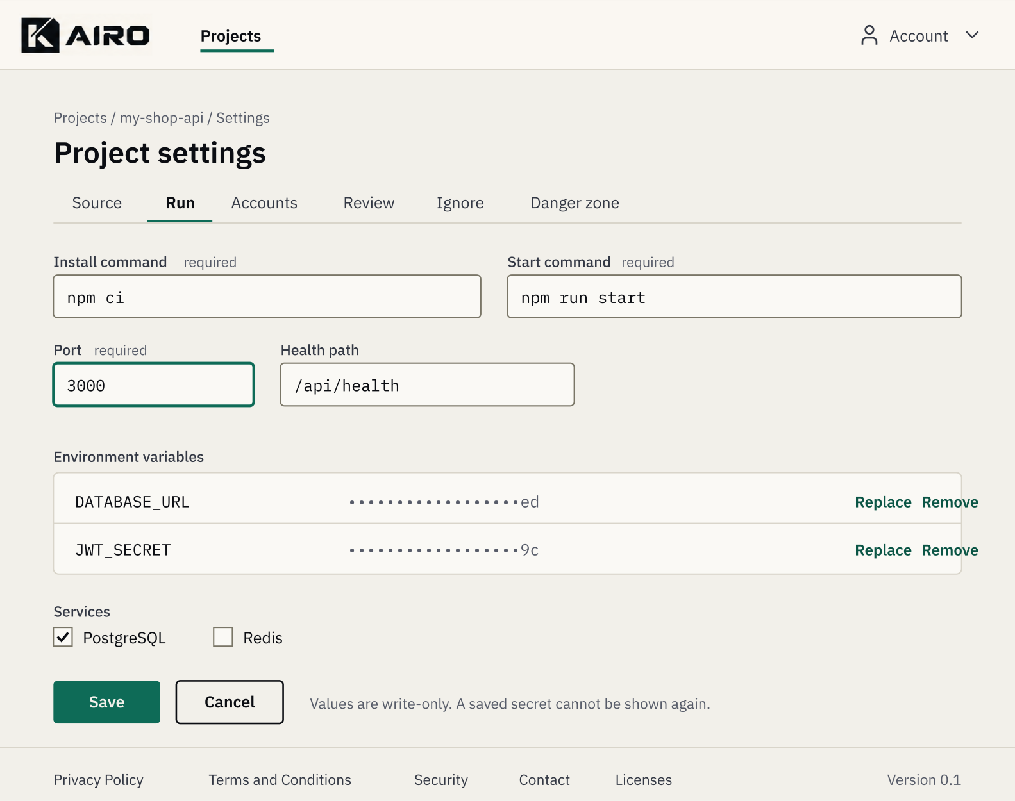
A-07 Settings, Run tab, light theme
- Tabs follow the App Flow: Source, Run, Accounts, Review, Ignore, Danger zone.
- Secret values show the last two characters with "Replace" and "Remove". The page says "Values are write-only. A saved secret cannot be shown again."
- Save is primary and Cancel is secondary. Leaving with unsaved changes opens dialog D-12.

A-08 Scan progress
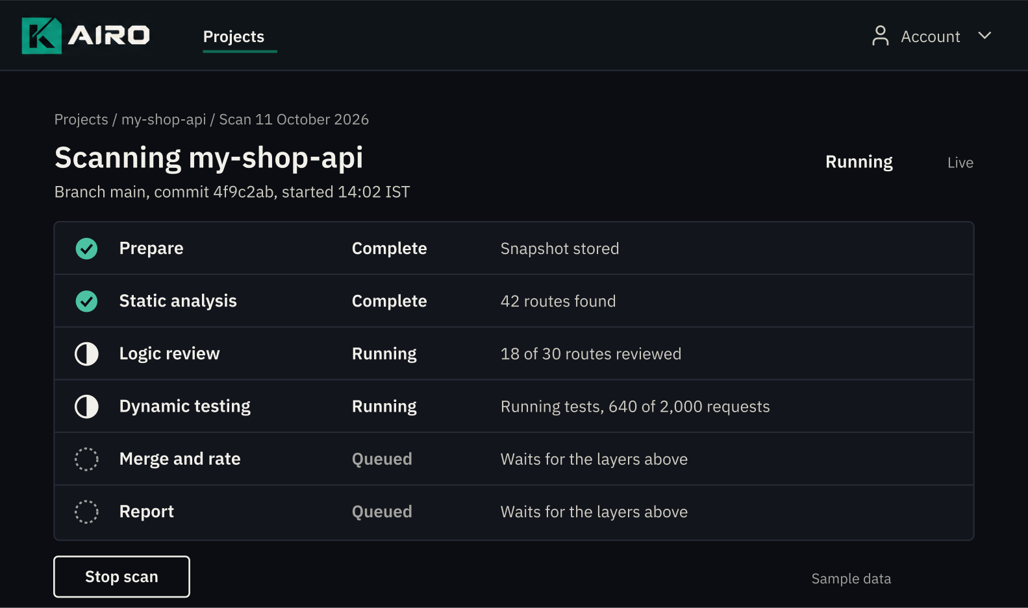
A-08 Scan progress, dark theme, with example values
- One row per stage, each with a state marker, a name, a state word and a detail line.
- The overall state and the word "Live" sit at the top right. Stop scan is secondary, because stopping is never the next step.
- There is no spinner or moving bar. Counters change as text.

A-09 Report
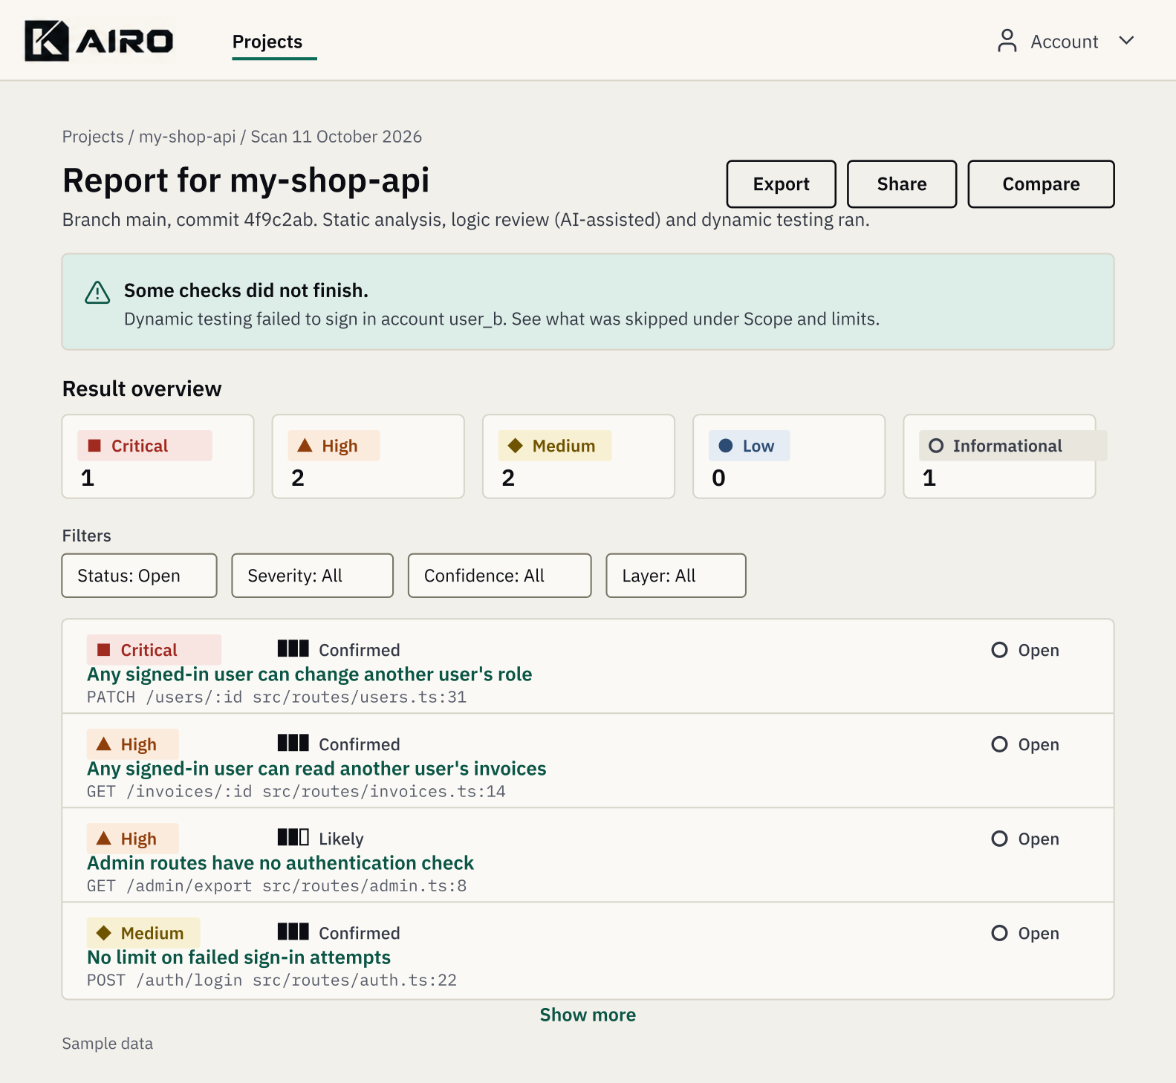
A-09 Report, light theme, with sample data
- Order: trail, title, metadata line, page actions, warning banner when needed, result overview, filters, finding list, Show more.
- The overview cards show severity labels with counts and no composite score.
- The banner appears above the overview whenever a stage failed, was partial or was skipped (N-02). It is never placed below the fold.

A-10 Finding
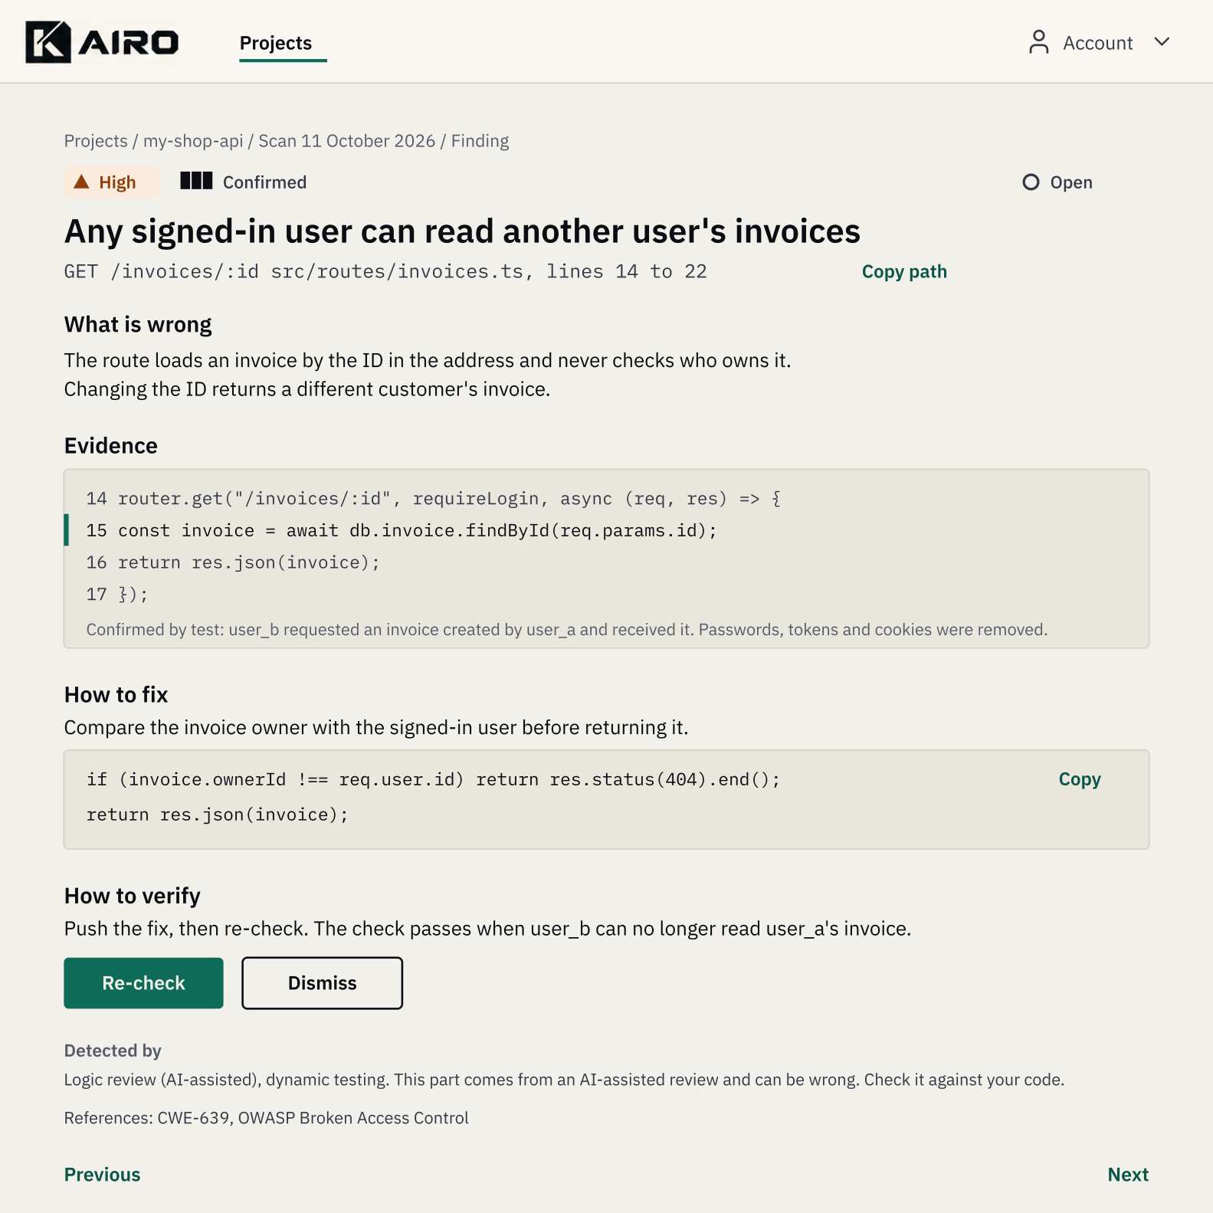
A-10 Finding, light theme, with sample data
- Severity, confidence and status sit above the title. The title is Heading 1.
- Blocks appear in a fixed order: What is wrong, Evidence, How to fix, How to verify, Detected by, References.
- Evidence and fix use the code block. The evidence note states what was removed from it.
- The AI-assisted note appears under "Detected by" in plain text whenever logic review contributed.
- Re-check is the primary action. Dismiss is secondary.

D-03 Dialog
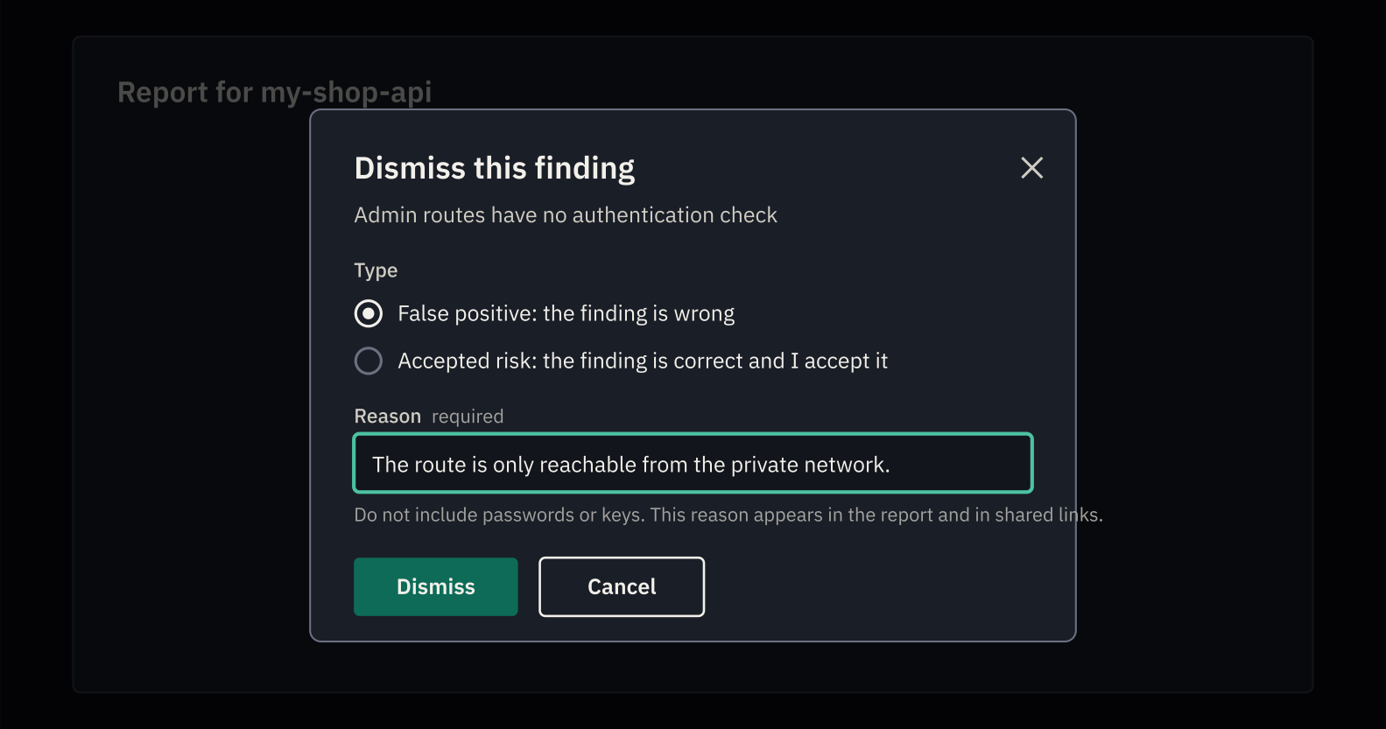
D-03 Dismiss a finding, dark theme
- The dialog follows the component rules. The reason field shows the warning that the reason appears in reports and shared links.
- Dismiss is primary. Cancel is secondary. Escape closes the dialog. Focus starts on the first choice.

O-02 Operator dashboard
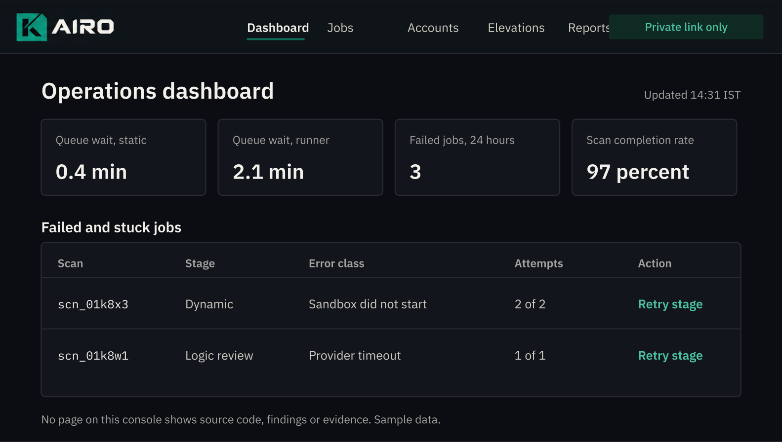
O-02 Operations dashboard, dark theme, with sample data
- The operator console uses the dark theme only and a visible "Private link only" tag in the header, so it cannot be mistaken for the product.
- It shows queue, error and runner figures and nothing about customer content.

The remaining screens
Every other screen uses a pattern already drawn above, so this table is the specification.
Screen | Pattern | Notes
P-02 Sign in | Centered card, 400 px wide | The tile at 40 px, Heading 1 "Sign in", the GitHub button, one line "KAIRO asks GitHub for your identity only", and the Privacy and Terms links
P-05 Security, P-06 Contact | Legal page layout (section 10) | P-05 leads with how to report a vulnerability. P-06 lists each address with its purpose
P-07 Licenses | Legal page layout with a table | Component, license and link, generated from the software bill of materials
P-08 Shared report | Report layout without owner actions | A banner reads "Shared report. Read only. Expires on {date}." Each finding without evidence says so
P-09, P-10 Errors | Centered block, 560 px | Heading 1 with the message from the App Flow, one line of help, and links to Home and Projects
A-01 Welcome | Centered card, 480 px | The two document names with their versions as links, and one primary button "Accept and continue"
A-03 Add project | Two option cards | "GitHub repository" and "Upload archive", each with one line of description and its own primary-weight button
A-04 Choose repository | Search field and a list | Rows with repository name and visibility. A link "Missing a repository? Change access on GitHub" sits below
A-05 Upload archive | File picker and limits | The limits are written inside the picker. A progress line states the percentage in words while uploading
A-06 Project overview | Summary block and table | Source, latest scan, a "Start scan" primary button and the scan history as a table
A-11 Route inventory | Wide table | Method, path, handler, and the three checks as words: Detected, Absent, Unknown
A-12 Compare scans | Two selectors and three groups | New, Fixed and Unchanged, each a titled list with a count
A-13 to A-15 Account | Stacked sections | Each section is a bordered card with a Heading 3, a description and its action
A-16 Shared links | Table | Created, expires, evidence included, and a Revoke link
O-01, O-03 to O-06 | Operator shell | The same header and table patterns as O-02
D-01, D-02, D-04 to D-13 | Dialog component | Width and content from the App Flow. The authorization checkbox in D-01 is not pre-checked

10. Legal and trust pages
The legal pages are designed as documents first: a clear version bar, a stable table of contents and a comfortable reading column.
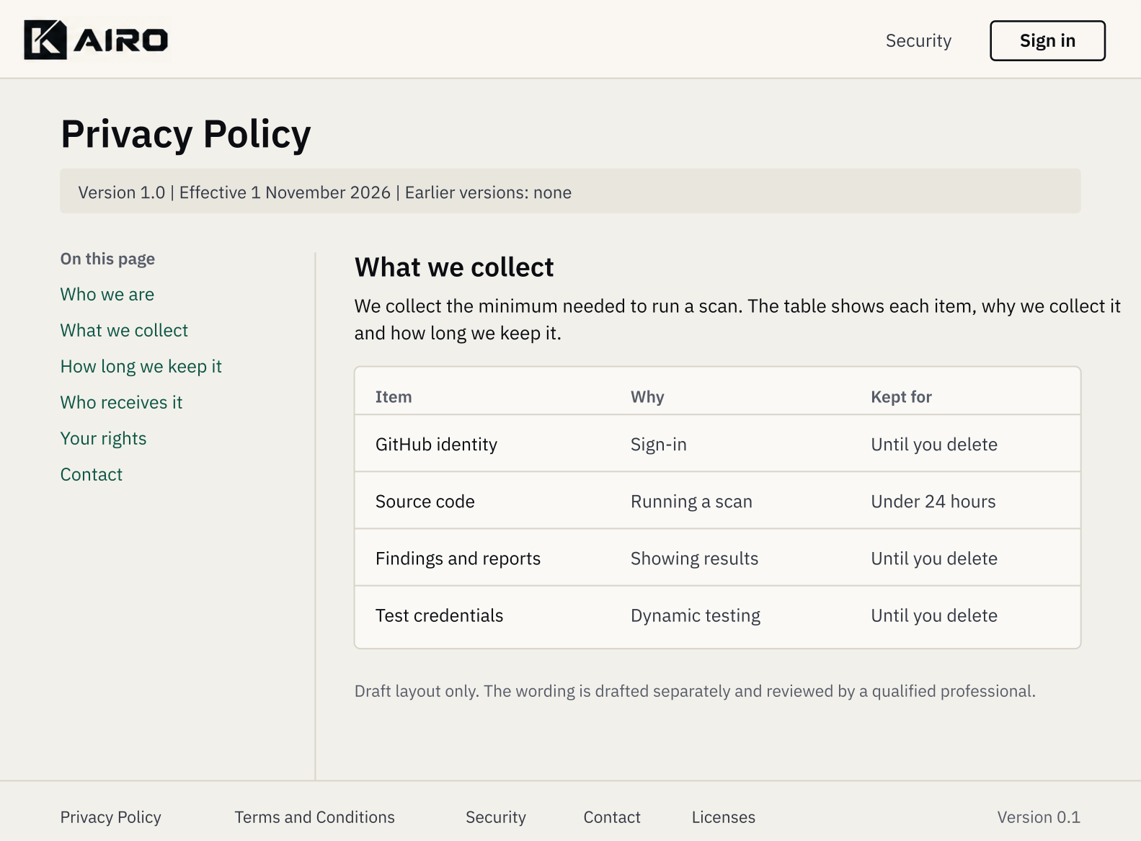
P-03 Privacy Policy layout, light theme. The wording is a draft and is not final text

Layout
- A narrow left column holds "On this page" with anchor links to each section. A 1 px line separates it from the reading column.
- The reading column is 68 characters wide. Headings are Heading 2 and Heading 3. Body text is 16 px with 24 px line height.
- Directly under the title sits a version bar: version number, effective date, and a link to earlier versions. Each earlier version has its own address under /privacy/archive/{version} or /terms/archive/{version} (App Flow section 15).
- Data tables, such as what is collected and how long it is kept, use the standard table component.
- On phones the table of contents becomes a collapsed "On this page" control above the text.
- There are no cookie banners in Release 1 because only strictly necessary cookies are used. If one is ever added it must follow LR-7, with Accept and Reject buttons of equal size and style.

Content structure the layout must support
Page | Sections
Privacy Policy (P-03) | Who we are, What we collect, Why we collect it, How long we keep it, Who receives it, How code is reviewed by a model, Your rights, Children, Security, Changes, Contact
Terms and Conditions (P-04) | Acceptance, Authorized use, Your content, Reports, No guarantee, AI-assisted review, Service changes and termination, Liability, Governing law, Changes, Contact
Security (P-05) | Report a vulnerability, Scope, What we ask of reporters, How we handle your code, Contact
Contact (P-06) | Support, Privacy and grievances, Abuse reports, Security reports
Licenses (P-07) | Third-party components and their licenses

The wording is drafted separately and reviewed by a qualified professional before launch (LR-11). The layout carries no placeholder text when it ships (BR-13).

11. Report and PDF design
The PDF is the same report as the web view, set for A4 paper and designed to read well in black and white.

Page setup
Property | Value
Page | A4, portrait
Margins | 20 mm on all sides
Header | The light-theme navbar lockup at 24 px height at the left. The project name and scan date at the right in 9 pt muted text. A 0.5 pt line below
Footer | "Page x of y" at the right, the commit identifier in Plex Mono at the left, a 0.5 pt line above
Fonts | IBM Plex Sans for text and IBM Plex Mono for code, embedded in the file. Body 10 pt on 14 pt, code 8.5 pt
Color | Midnight Ink on white. Severity labels print as a shape plus a word and stay legible in grayscale
Accessibility | A tagged PDF with real headings, table headers and alternative text

Structure
- A first page with the report title, the scan summary table, the result overview as a table, and the scope and limits statement.
- Findings, grouped by severity, each starting with its label, confidence and title. A finding is kept together on a page where it fits.
- Dismissed items, with reasons.
- An appendix with the route inventory and the glossary.
- A back page with the footer lockup.

Rules
- A warning banner on the web becomes a boxed paragraph on the first page with the word "Warning" at its start.
- Code blocks never split across pages when shorter than 30 lines.
- Evidence is included in the PDF only when the owner chose to include it (App Flow section 13).
- Every export states the KAIRO version, rule set version and model identifier at the foot of the first page (FR-R9).

12. Responsive design
The product is designed for desktop first and must remain fully usable from 360 px wide, with content that reflows at 320 px.
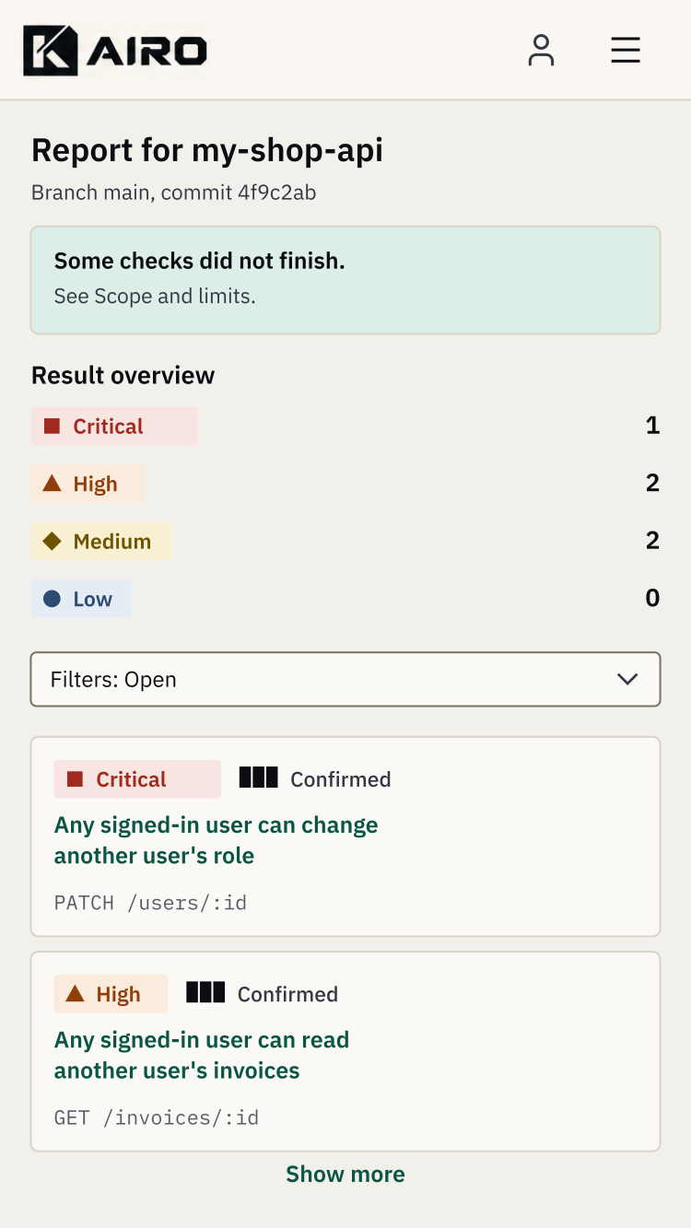
A-09 Report on a phone, light theme

Behavior below 640 px
Element | Behavior
Header | The lockup at 28 px height. A labeled menu button replaces the links. The account control stays visible
Page title block | Actions move below the title, full width, stacked
Result overview | Counts stack as a list, one severity per line
Finding rows | Become cards with severity and confidence on the first line, the title below, and the location last
Tables | Narrow tables become labeled blocks. Wide tables scroll sideways inside their own container, which can be focused and scrolled by keyboard
Tabs | Become a labeled select or a vertical list
Dialogs | Fill the screen with the actions fixed at the bottom
Code | Scrolls sideways inside its block. Lines are never wrapped, so indentation stays accurate
Forms | Fields are full width. Buttons are full width

Targets are at least 24 by 24 px, and 44 px where space allows. Text can be enlarged to 200 percent without loss of content or function.

13. Motion
Motion confirms a change of state and nothing else.
Item | Specification
Durations | 0 ms, 120 ms for color and border changes, 150 ms for dialog fade
Easing | A single standard curve: cubic-bezier(0.2, 0, 0, 1)
Allowed | Hover and focus color changes. Dialog and menu fade. Disclosure open and close with no movement of surrounding content
Not allowed | Scroll-triggered animation, parallax, reveal-on-scroll, cursor effects, looping or decorative animation, spinners, shimmer, bouncing or elastic easing
Progress | Text and counters change in place. Running stages show a static half-filled marker
Loading | A static placeholder shaped like the content, with no shimmer
Reduced motion | When the person asks for reduced motion, every transition duration becomes 0 ms

14. Content design
KAIRO writes the way a careful colleague would: plain, specific and calm.

Voice
- Say what happened, then what to do. Use short sentences in the present tense.
- Address the person as "you". Refer to KAIRO by name, not as "we", when describing what the product did.
- Be specific. "The application did not start within 120 seconds" beats "Something went wrong".
- Be honest about limits. Never claim safety. Say what was checked and what was not.
- No hype words (unlock, supercharge, seamless, revolutionize, elevate, game-changing, cutting-edge, leverage), no exclamation marks, no rhetorical questions in headings, no em dashes.

Vocabulary
Use | Avoid
Finding | Issue, alert, threat
Scan | Audit, assessment, analysis run
Fix | Remediation, mitigation
Re-check | Retest, rerun
Dismiss | Suppress, ignore
Project | Application, app (except when describing the person's code)
Test account | Dummy user, fake user
AI-assisted | AI-powered, smart, intelligent
Sign in, sign out | Log in, log out

Patterns
Pattern | Rule | Example
Buttons | A verb and an object. No "Submit", "OK" or "Yes" | "Start scan", "Add project", "Accept and continue"
Page titles | A noun phrase naming the thing | "Report for my-shop-api"
Empty states | What is missing, then the action | "No projects yet. Add a repository or upload an archive to run your first scan."
Errors | What happened, why if known, what to do | The 37 messages in App Flow section 17
Warnings | State the consequence | "Some checks did not finish. See what was skipped."
Confirmations | Name the object and the effect | "Delete my-shop-api and its scans"
Numbers | Digits with thousands separators and units written out | "2,000 requests", "13 minutes"
Dates and times | Day, month name, year. Time with its zone | "12 October 2026, 14:30 IST"
AI involvement | A plain label wherever logic review contributed | "Logic review (AI-assisted)"

The messages themselves are fixed in the App Flow and are not rewritten here.

15. Accessibility
The product meets WCAG 2.2 level AA, and the palette was chosen so that every text and control pair passes before any screen is designed.

Contrast results
Ratios were calculated from the hex values. Text needs at least 4.5 to 1, and borders and focus indicators need at least 3 to 1.
Pair | Light | Dark
text on bg | 17.05 | 17.05
text on surface | 18.45 | 16.03
text-2 on bg | 10.30 | 12.10
muted on bg | 5.87 | 7.68
muted on surface | 6.35 | 7.22
accent-text on bg | 7.68 | 8.83
accent-text on accent-tint | 7.23 | 6.94
on-accent on accent (button text) | 5.65 | 5.65
line-strong on bg (input border) | 3.99 | 3.94
line-strong on surface | 4.32 | 3.70
focus on bg (focus ring) | 5.65 | 8.83
danger button text | 6.43 | 6.43
Critical label | 6.03 | 8.32
High label | 6.25 | 9.75
Medium label | 6.34 | 9.94
Low label | 7.37 | 8.93
Informational label | 8.45 | 10.38
Fixed label | 7.23 | 6.94

The logo tile is exempt from text contrast rules. For reference, the Midnight Ink K on the emerald tile measures 4.89 to 1.

Requirements
Area | Requirement
Focus | A 2 px solid ring in the focus token with a 2 px offset on every interactive element, never removed and never hidden under sticky content
Targets | At least 24 by 24 px. Buttons are 40 px tall by default
Color independence | Severity, confidence, status and form errors are conveyed by words and shapes as well as color
Text | Resizable to 200 percent. Line height of 1.5 for body text, and 16 px between paragraphs
Motion | Honors the reduced-motion setting (section 13)
Forced colors | In high-contrast modes the borders, focus rings and shapes still carry meaning. The logo keeps its own colors
Keyboard | Every function works without a mouse, in a logical order, with a skip link and no keyboard traps outside dialogs
Screen readers | One level 1 heading per page, landmarks for header, navigation, main and footer, table headers, labels linked to fields, errors linked to fields, and the live announcements in App Flow section 18
Names | The lockup has the text alternative "KAIRO". Icon-only controls have accessible names
Language | The page language is declared on the root element

How it is checked
- A script reads the token file, converts every pair in the table above and fails the build if any falls below its threshold (TRD section 15).
- axe-core runs on every route in the staging pipeline.
- Before each release a person walks through sign-in, starting a scan and reading a finding using only a keyboard, and again with a screen reader, in both themes.

16. Design tokens
All visual values live in one file, and Tailwind reads them from there, so a color or size can be changed in one place and checked in one place.
:root {
color-scheme: light dark;
/* light theme (default) */
--bg: #F2F0EA; --surface: #FAF9F5; --raised: #FAF9F5; --sunken: #E9E6DE;
--text: #0B0D12; --text-2: #333844; --muted: #575C69;
--line: #D9D5CA; --line-strong: #7A7667;
--accent: #0E6B57; --on-accent: #F2F0EA; --accent-text: #0A5545; --accent-tint: #DDEDE7;
--focus: #0E6B57; --danger: #A12A20;
--sev-critical: #A12A20; --sev-critical-bg: #F8E5E2;
--sev-high: #8F3F0B; --sev-high-bg: #FBEBDD;
--sev-medium: #6E5300; --sev-medium-bg: #F8F0D2;
--sev-low: #2D4C74; --sev-low-bg: #E6ECF4;
--sev-info: #3A3F4B; --sev-info-bg: #E9E6DE;
--status-fixed: #0A5545; --status-fixed-bg: #DDEDE7;
/* type */
--font-sans: "IBM Plex Sans", system-ui, "Segoe UI", "Helvetica Neue", Arial, sans-serif;
--font-mono: "IBM Plex Mono", ui-monospace, Consolas, monospace;
/* space, radius, motion */
--space-1: 4px; --space-2: 8px; --space-3: 12px; --space-4: 16px; --space-6: 24px; --space-8: 32px; --space-12: 48px; --space-16: 64px;
--radius-label: 2px; --radius-control: 3px; --radius-card: 4px; --radius-dialog: 6px;
--dur-fast: 120ms; --dur-dialog: 150ms; --ease: cubic-bezier(0.2, 0, 0, 1);
}
:root[data-theme="dark"] {
--bg: #0B0D12; --surface: #12151C; --raised: #1A1E27; --sunken: #080A0E;
--text: #F2F0EA; --text-2: #CFCCC2; --muted: #A3A39F;
--line: #262B36; --line-strong: #6B7080;
--accent-text: #4CC2A2; --accent-tint: #0F2A23; --focus: #4CC2A2;
--sev-critical: #FF9A8A; --sev-critical-bg: #2C1613;
--sev-high: #FFB885; --sev-high-bg: #2B1C10;
--sev-medium: #EFCB62; --sev-medium-bg: #2A2310;
--sev-low: #9CC1EE; --sev-low-bg: #131F2E;
--sev-info: #CFCCC2; --sev-info-bg: #1A1E27;
--status-fixed: #4CC2A2; --status-fixed-bg: #0F2A23;
}
@media (prefers-color-scheme: dark) {
:root:not([data-theme="light"]) { /* the same values as the dark block above */ }
}
@media (prefers-reduced-motion: reduce) {
*, *::before, *::after { transition-duration: 0ms !important; animation-duration: 0ms !important; }
}

Rules the build enforces (TRD section 15)
- Color literals appear only in this file.
- No gradient functions appear anywhere. No token falls between 250 and 300 degrees of hue.
- The radius scale stops at 6 px, and only the avatar component may use a full radius.
- Every pair in section 15 is converted to a contrast ratio and checked.
- The icon package may not import its sparkle, star or wand glyphs.

17. Assets and hand-off
The brand asset pack accompanies this brief, and the checklist below is what remains before design is complete.

Delivered in the asset pack
File | Purpose
icon.svg and icon-ink.svg | The tile as vector, emerald and ink versions
favicon.ico | 16, 32 and 48 px
apple-icon.png, icon-192.png, icon-512.png, icon-maskable-512.png | Platform icons
opengraph-image.png | Social preview, 1200 by 630
manifest.webmanifest | Manifest with theme and background colors

Still needed from the designer
☐ Master vector files for the tile, the wordmark letters and every lockup (dark, light, navbar, footer, one-color). The pack's tile is a redraw from the raster guide.
☐ Confirmation of the emerald used on the tile (section 19).
☐ The GitHub mark file and a check against GitHub's logo guidelines.
☐ Self-hosted font files for IBM Plex Sans (400, 500, 600, italic 400) and IBM Plex Mono (400, 500), subset to Latin.
☐ Final copy for the home page and the legal documents, from the owners.

Visual quality checklist for release
☐ Every page shows the footer with five links, in both themes.
☐ No gradient, no pill-shaped control, no emoji, no sparkle icon and no em dash appears anywhere.
☐ Every severity, confidence and status reads correctly with color removed.
☐ Every screen in the App Flow has a designed default, loading, empty and error state.
☐ The favicon shows correctly in a browser tab, a bookmark and an iOS home screen.
☐ The PDF report is legible printed in black and white.
☐ Every page passes the axe-core check and the keyboard walkthrough.

18. Traceability
Each brand guardrail in the PRD has a design decision here, and each component the App Flow asked for has a specification.
PRD guardrail | Design decision | Section
BR-1 No purple or violet gradients | Flat fills only. A hue check on every token | 2, 4, 16
BR-2 No pill-shaped controls | 3 px radius on controls and a scale that stops at 6 px | 6, 8
BR-3 No em dashes | Voice rules and a repository check | 14
BR-4 No scroll or cursor effects | Motion specification | 13
BR-5 One icon family, no emoji, no sparkle | Lucide with a banned list | 7
BR-6 No fabricated proof | The home page and mockups use only labeled sample data | 2, 9
BR-7 Copy rules | Voice, vocabulary and patterns | 14
BR-8 No generated or stock imagery | Product screens, diagrams and typography only | 2, 9
BR-9 No AI badges | A plain "AI-assisted" label where relevant | 2, 14
BR-10 Favicon set | The icon files and manifest | 3, 17
BR-11 Metadata | Social preview and manifest | 3
BR-12 Footer links | Footer in the page structure and on every mockup | 6, 9
BR-13 No placeholders | The legal layout ships without placeholder text | 10
BR-14 Error and empty states | A designed block, with messages from the App Flow | 8, 14
BR-15 Accessible severity and contrast | Words, shapes and a contrast table | 8, 15

App Flow component | Specified in
Header, footer, location trail | Sections 6 and 8
Banner and error summary | Section 8
Dialog with a typed-confirmation variant | Section 8
Stage row | Section 8
Severity, confidence and status labels | Section 8
Finding row and result overview | Sections 8 and 9
Code and evidence blocks | Section 8
Settings tabs, secret field, test account form | Sections 8 and 9
File picker, repository list, filter bar | Section 8
Data table and stacked variant | Sections 8 and 12
Empty and error blocks | Section 8
Legal document layout | Section 10
Operator console shell | Section 9

19. Open questions and decisions
Eight points need a decision from the owner or the designer before the design is final.
☐ Emerald value. The guide states Deep Emerald as #0E6B57 for the logo tile, but the tiles drawn in the guide measure about #0B9079, which is brighter. This brief uses #0E6B57 for buttons and accents and #0B9079 for the tile so that the tile matches the drawn logo. Confirm which value is intended for the tile.
☐ Paper White value. The guide states #F2F0EA, while the swatch drawn in the guide measures a slightly lighter #FAF6EF. This brief uses the stated value.
☐ Master vectors. The tile in the asset pack is a redraw from a raster. The designer's vector master replaces it, and the wordmark letters need a vector master too.
☐ Navbar links. The guide's navbar sample shows Home, Scan, Features and Pricing. The product header shows Projects and Account when signed in, and Security and Sign in when signed out, because billing and pricing are outside Release 1. Confirm.
☐ Dark theme in Release 1. The guide defines both themes. This brief ships both and adds an Appearance setting (System, Light, Dark) to the Account screen, which the App Flow does not yet include. Confirm, or defer dark to Release 2.
☐ Operator console theme. The console is dark only, to separate it from the product. Confirm.
☐ Home page copy. The headline and the three steps are drafts. The owners write the final words.
☐ Icon family. Lucide with square caps is proposed. Confirm, or name another family that satisfies BR-5.

20. Sources
- The owner's KAIRO Geometric Brand Identity Guide, supplied with this brief, for the logo system, construction numbers, palette and favicon sizes
- Lucide on GitHub, for the ISC License and the statement that brand logos are not accepted
- Lucide version 1 guide, for the removal of brand icons
- IBM Plex Sans and IBM Plex Mono packages from the npm registry, licensed OFL-1.1
- Product Requirements Document v0.1, Technical Requirements Document v0.1 and App Flow v0.1, which this brief implements
- WCAG 2.2 level AA, the accessibility standard that sections 8 and 15 follow

