f = read.csv("fulltime.csv")

f$Total <- rowSums(f[, -1])

barplot(f$Total,names.arg=f$Year,xlab="Year",ylab="Count of People",main="People Working Fulltime The Last 20 Years ",col=rainbow(20), cex.names=0.50)

p = read.csv("partime.csv")

p$Total <- rowSums(f[, -1])

barplot(p$Total,names.arg=p$Year,xlab="Year",ylab="Count of People",main="People Working Part-Time The Last 20 Years ",col=rainbow(20), cex.names=0.50)

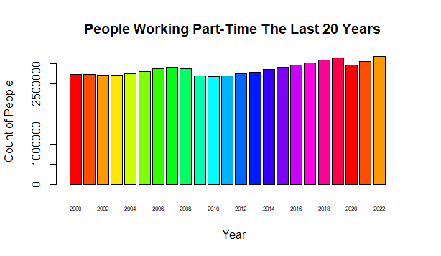

monthly_mean <- colMeans(p[, -1])

# Calculate the year with the highest total sales

max_year <- p[which.max(p$Total), "Year"]

# Calculate the month with the highest sales on average

max_month <- names(monthly_mean)[which.max(monthly_mean)]

min_year <- p[which.min(p$Total), "Year"]

min_month <- names(monthly_mean)[which.min(monthly_mean)]

p = read.csv("partime.csv")

pt <- rowMeans(p[, -1])

f = read.csv("fulltime.csv")

ft <- rowMeans(f[, -1])

Year = f$Year

plot(Year,pt, xlab = "Year", ylab = "Number of Workers", main = "Full-Time vs. Part-Time Workers From 2000-2022", type="l", col = "red", xlim =c(2000,2022), cex.names =.5)

par(new=TRUE)

plot(Year, ft, type="l", col="green", axes=FALSE,)

axis(4, col="green",col.axis="green",las=1)

