**7PAM2000 Applied Data Science 2  
Assignment 2: Statistics and trends.**

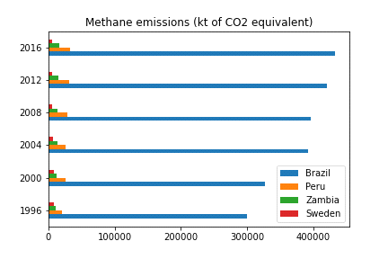

This graph represents that Brazil is the largest producer of methane and it is continuously increasing. The second is Peru as compared to Brazil. This is because all other countries emit less methane. However, methane production is increasing due to a decrease in arable land and population. Methane is a dangerous gas for the environment

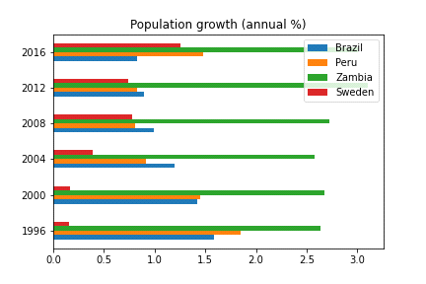

The bar graph illustrates that Brazil has the most arable land, but it also shows a slight increase. Second is Sweden, but it's a decrease, which is related to methane emissions. Peru, Zambia, and Ghana occupy the last spot, which means the more arable land the more methane emissions.

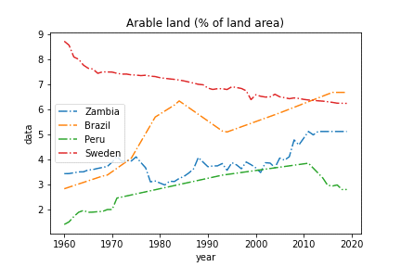

The line graph shows the populations of Peru, Zambia, Brazil, and Sweden. Brazil shows the highest population growth and a huge jump in population increase. This will increase methane and the second country in the line graph is Peru which has the second highest population.

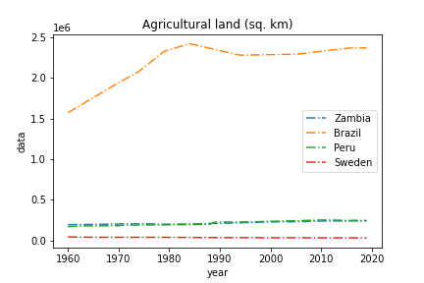

The agricultural land in the line graph shows that Brazil has the largest agricultural land which is related to higher methane emissions. This is the most relevant indicator, since the other countries have no increase in agricultural land, but they show steady growth.

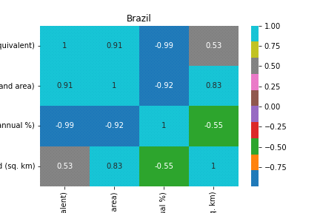

The heat map correlates with indicators of methane gas emissions. Methane gas is directly related to available arable land. An increase in population is a mean increase in methane. I don’t have a strong relationship action with other indicators.

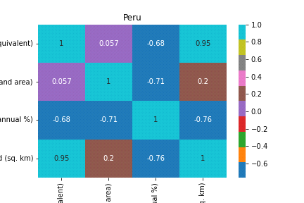

The Peru heatmap shows that methane gas emissions have a strong relation to agricultural land and population. It's in a negative trend with arable land. The more the population the more methane emissions will be produced.

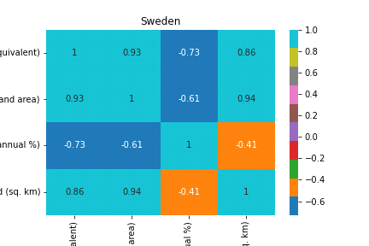

The Sweden heatmap clearly demonstrates that methane emissions relate to arable land and agricultural land. This shows a positive and strong connection but here it interestingly shows a negative relationship with a population in which as the population increases methane decreases which is very surprising.

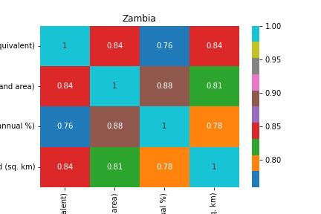

This heat map shows Zambia's indicators of methane emission have strong relation with population, arable land, and agricultural land. This means all these indicators are related to increases in methane emissions which is alarming as all these indicators are directly proportional to methane gas emissions.

**Student ID:** 21084757  
**Full Name:** Aasim Ghaffar   
**Data Development:** [https://data.worldbank.org](https://data.worldbank.org/)  
**Data Link:** <https://data.worldbank.org/topic/climate-change>  
**Databank:** World Development Indicators

**GitHub Repo:** <https://github.com/aasimghaffar/7PAM2000-Applied-Data-Science-2-Assignment-2-Statistics-and-trends>

**Data xlsx File:** <https://github.com/aasimghaffar/7PAM2000-Applied-Data-Science-2-Assignment-2-Statistics-and-trends/blob/main/data.csv>