 

Module code: Module Name: Module assessment 4CS017 Internet Software Architecture Prototype2

Student ID: 2407702 Student Name: Aasim Khan

Section: L4CG4

Module leader: Mr. Bishal Khadka

## Module lecturer: Mr. Bishal Khadka

Submitted on: 01—02-2024

Contents

1. Prototype 1 3
   1. Strengths 3
   2. Weakness 4

## Prototype 1:

# Strengths:

This is the initial weather website prototype. This website uses HTML, CSS and JavaScript so it is easy to code, and this prototype collects required data through OpenWeatherMap API and shows the data of temperature, pressure, humidity and wind speed. This website displays real-time

weather data of the city “Glasgow” initially and desired city details when searched and it utilizes symbols which show the visual representation of the weather. PastData functionality feature allows the user to retrieve the past data and shows the weather conditions over time. Moreover, the app handles the error too ,when city is not found a user-friendly error message is shown.

# Weakness:

In this prototype, Temperature, pressure, humidity and wind speed data of only one place is presented and limited weather data of the place is presented. Data presented on the website is not very exact as this prototype simply collects the data through API and presents them on webpage through HTML and CSS. This weather website is made with basic code with no security. The codes of this prototype are written in different files and collected in a single folder. Moreover, the forecast of the upcoming days is not presented to user and sunrise and sunset time is also not available on this prototype. Website cannot be viewed without internet, and it does not have its own software for weather application. It requires internet and browser to view data of weather website. Past data of the initial city Glasgow is only shown in the past data and other searched cities data is not showing in the past data.

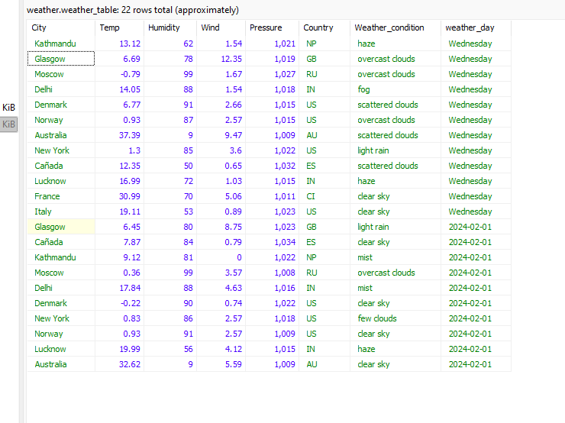

Figure SQL data