Example Knowledge Graph Queries and Exploration
This document provides example Neo4j knowledge graph queries used to explore rare disease–related entities and their relationships. Each query is accompanied by a short description explaining its purpose and the type of subgraph it generates.

Neo4j Connection Configuration
NEO4J_URI: neo4j://<HOST>:<PORT>
NEO4J_USERNAME: "<USERNAME>"
NEO4J_PASSWORD: "<PASSWORD>"
These values are placeholders and should be replaced with secure credentials when deploying the framework in a production environment.

Query 1: Disease-Centric Multi-Entity Subgraph
Description:
This query retrieves a comprehensive subgraph centered on diseases, linking them to associated variants, chemicals, genes, and chromosomes. It demonstrates how multiple biological relationships can be explored simultaneously to understand the broader molecular context of a disease.
Cypher Query:
MATCH (d:Disease)-[r1:risk]->(v:Variant),
(d)-[r2:side_effect]->(c:Chemical),
(d)-[r3:mutation]->(g:Gene),
(d)-[r4:deletion]->(ch:Chromosome)
RETURN *
Output:
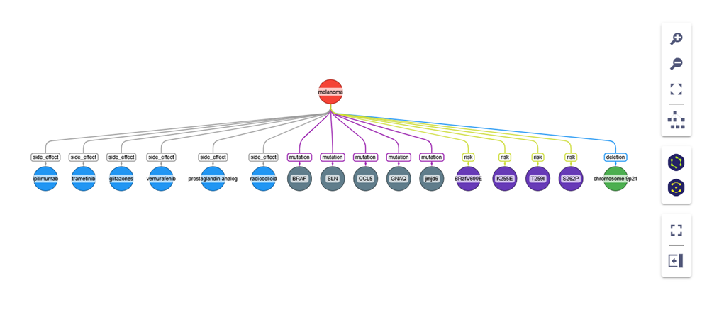

Query 2: Literature-Specific Relationship Exploration
Description:
This query extracts all relationships supported by a specific PubMed article, identified by its PMID. It highlights how literature provenance can be used to trace extracted knowledge back to its original source.
Cypher Query:
MATCH (a)-[r]-(b)
WHERE r.pmid = '35321276'
RETURN a, r, b
Output:
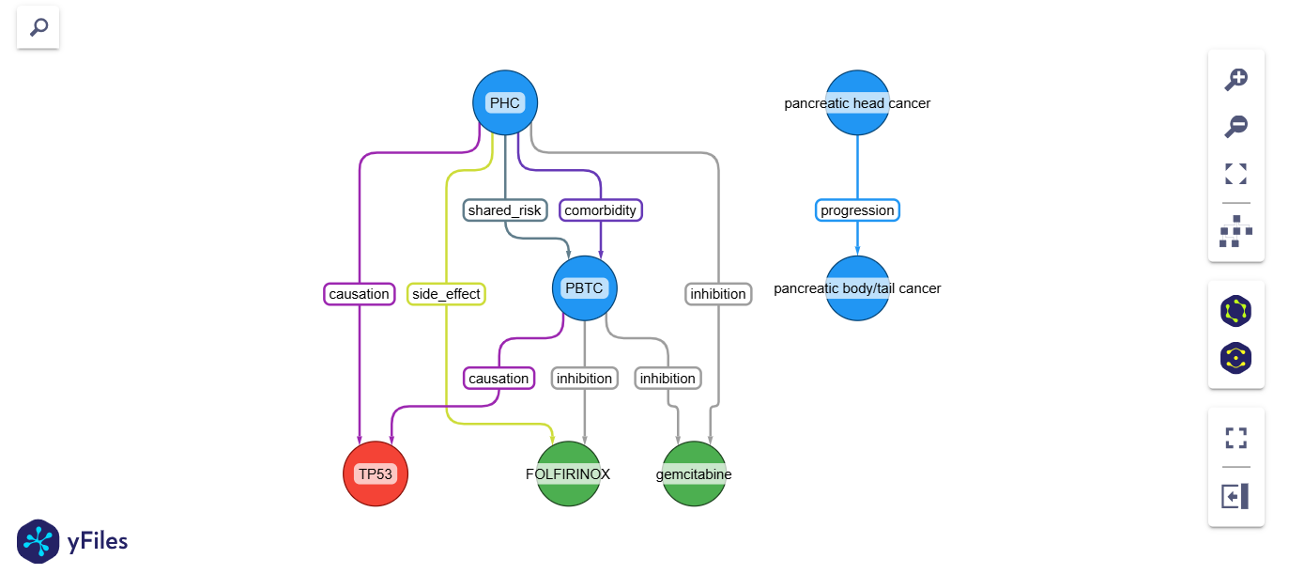

Query 3: Disease-Specific Subgraph Exploration
Description:
This query focuses on a specific disease entity and retrieves all directly connected nodes and relationships. It is useful for zooming into a single disease (e.g., KS) and examining its associated biological and chemical entities.
Cypher Query:
MATCH p=(n:Disease)-[r]->(m)
WHERE n.name IN ['KS']
RETURN *
Output Screenshot:

