Elevatelabs_task2

The user will be on home screen user will choose which rentals he want (car,bike,hoses,hotels) then the user will navigate to the item list he will add that to cart checks for coupans and make the payment with his preferred type of payment.

**Example:**

Bike🡪bike in the list🡪add to cart 🡪 apply coupon🡪payment.

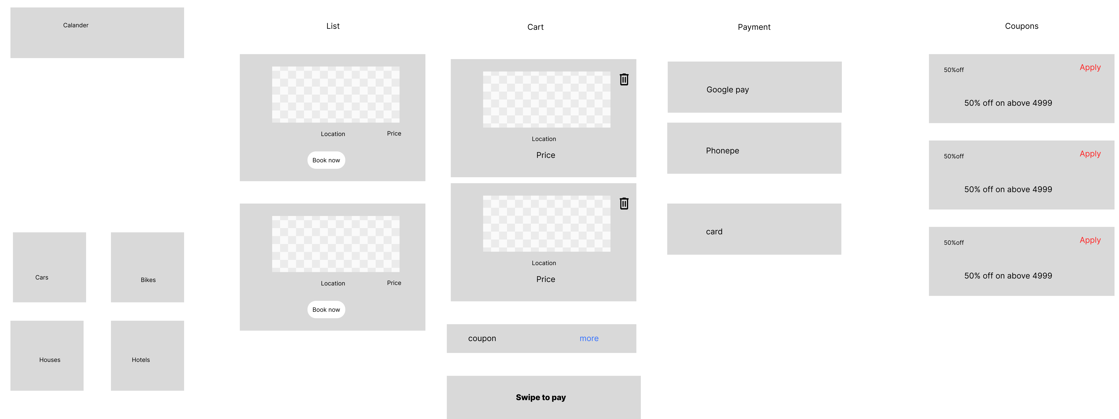

link :https://www.figma.com/design/tlvYRUPeYaqrFASB9nYf4X/vacation-rentals?node-id=22-8&t=bFkGynlpeqjAta1U-1