Elevate_labs Task-4

Official site:

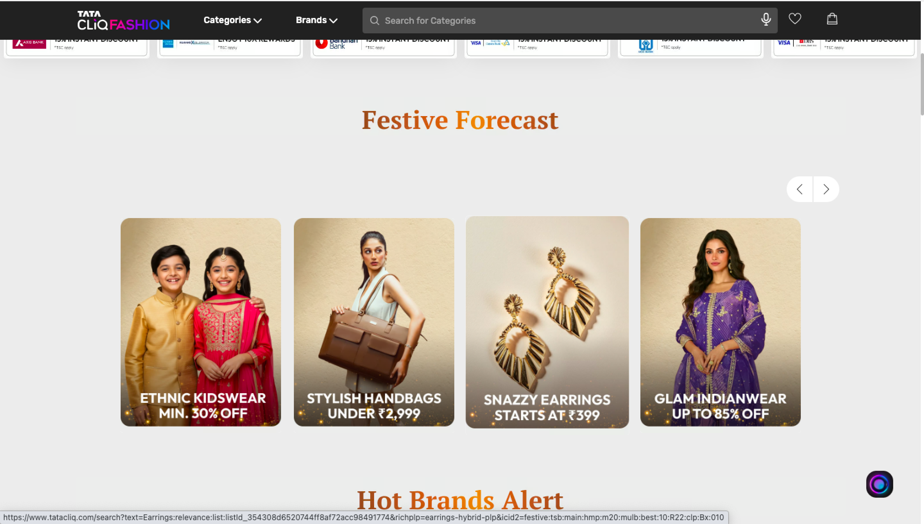

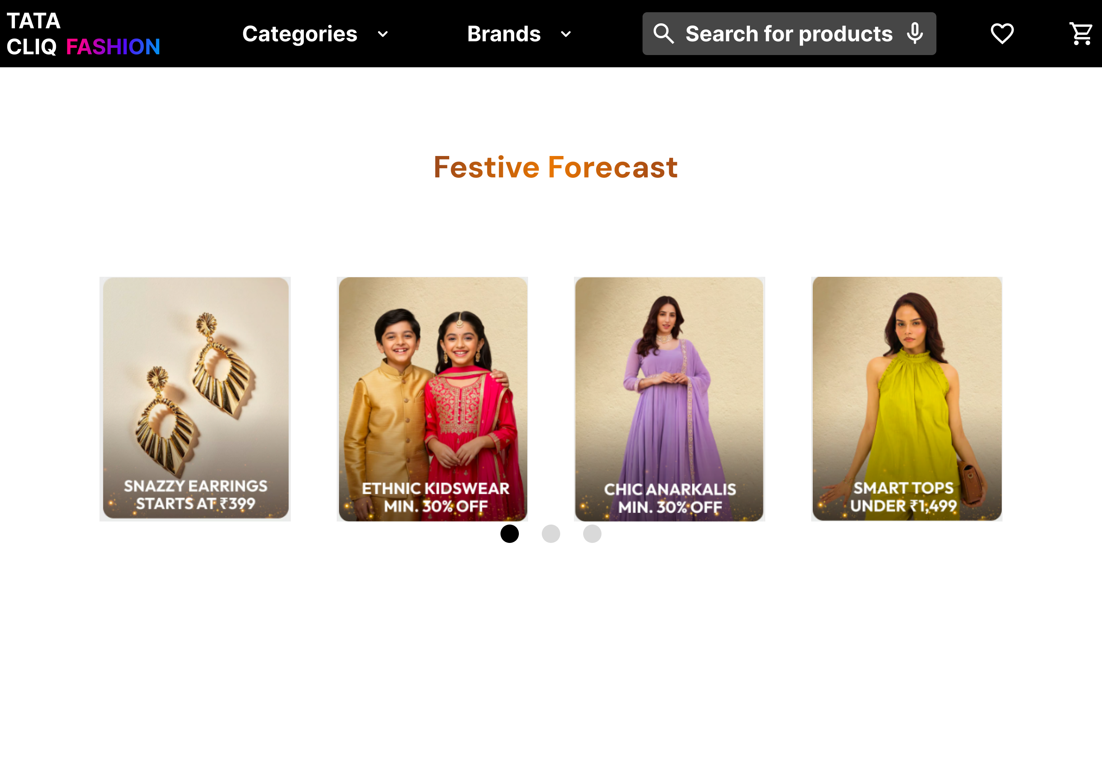

Description:

While analyzing the TataCliq official application, I noticed that the product carousel only allows navigation through left and right arrow buttons. This interaction felt inconvenient, as users have to click repeatedly to view each item, which can become frustrating. Additionally, there was no clear indication of how many cards were available in the carousel.

To improve the user experience, I replaced the click-based navigation with a drag-based interaction, allowing users to easily swipe through items. I also added clickable indicators at the bottom of the frame to show the number of cards and enhance overall usability.

Figma:

https://www.figma.com/design/tlvYRUPeYaqrFASB9nYf4X/vacation-rentals?node-id=33-8&t=nnOnyaRsHylAr155-1