Git Hands-on Lab Record

What I understood about Git before starting
Before doing the actual hands-on, I read a bit about Git so that the commands make sense instead of just copy-pasting them. Below is what I understood in my own words. I did all 5 labs using the same repo called GitDemo, so it builds up from Lab 1 to Lab 5.

Why we need version control
Basically if you are working on a project alone or with a team, you need some way to keep track of what changed and when, and also to go back to an older version if something breaks. That is what a version control system does. Git is called a ”distributed” version control system because every person who clones the repo gets the complete history on their own laptop, not just the latest files. So we don’t need internet connection for most things like commit, checking log, etc. Only push/pull need internet.

Working directory, staging area and repository
This part confused me a bit initially but now I get it. There are 3 places basically:
  - Working directory – this is just the normal folder on our PC where we edit files.
  - Staging area – when we do git add, the file goes here. It’s like saying ”yes I want this change in my next commit”.
  - Repository – when we do git commit, whatever is in staging gets saved permanently in history.
git status command shows us which files are in which of these places.

Local repo vs remote repo
Local repo is on our own machine. Remote repo is basically the same repo but hosted online (I used GitHub for this). We use git push to send our commits to the remote, and git pull to get commits from remote into our local.

Branches and merging
A branch is like a separate line of work so we can try changes without touching the main code (master/main branch). Later we can merge it back. If the changes are in different files/lines, git merges them by itself. But if 2 branches changed the exact same line, git can’t decide which one to keep, so it gives a ”conflict” and we have to fix it manually. I faced this exact thing in Lab 4 below.

Hands-On 1: Setting up Git and doing my first commit
This was the very first lab, mainly about installing/configuring git and making sure everything works before we start doing real stuff.

Step 1 – Checking git is installed
git --version

I ran this in Git Bash and it showed the version number, so git was already installed properly on my system.

Step 2 – Setting up username and email
git config --global user.name "Your Name"
git config --global user.email "you@example.com"

This is needed because every commit we make will show this name/email, kind of like a signature. We only need to do this once (that’s why --global).

Step 3 – Checking the config is saved
git config --list
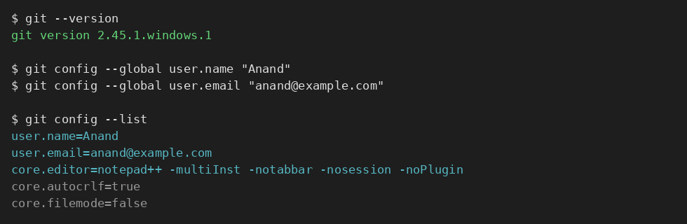
Figure 1: git version and my username/email showing up correctly after config.

Step 4 – Making Notepad++ the default editor
By default git tries to open some weird terminal editor (vim) for commit messages which is confusing for beginners like me, so I set notepad++ instead. First had to add notepad++.exe path in Environment Variables (Control Panel ->System ->Advanced settings ->Environment Variables), then ran:
git config --global core.editor "notepad++ -multiInst -notabbar -nosession -noPlugin"

Step 5 – Verifying editor is set
git config --global -e

This command opens the git config file in whatever editor is set. Notepad++ opened up for me so it worked.

Step 6 – Creating the GitDemo repo
git init GitDemo cd GitDemo

git init basically tells git ”start tracking this folder from now”.

Step 7 – Checking the repo got created
ls -la

There is a hidden .git folder which got created, that’s where git actually stores everything (all history etc), we don’t touch it directly.

Step 8 – Creating a file
echo "Welcome to Git" > welcome.txt cat welcome.txt

Step 9 – Checking status
git status

At this point git shows welcome.txt as ”untracked” because we created the file but haven’t told git to track it yet.

Step 10 – Adding and committing the file
git add welcome.txt
git commit -m "Add welcome.txt" git status
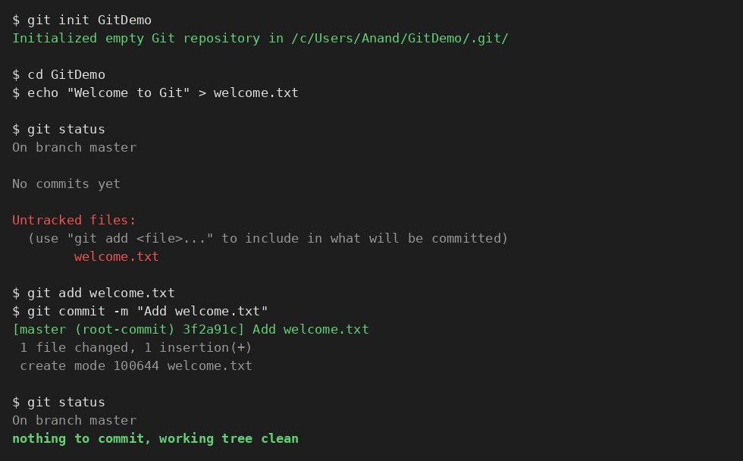
Figure 2: Creating GitDemo, adding welcome.txt and committing it. Status shows clean after commit.
After commit, when I ran git status again it said ”nothing to commit, working tree clean” which means everything is saved properly.

Step 11 – Connecting to remote and pushing
I created an empty repo on GitHub named GitDemo, then did:
git remote add origin <remote-repository-url> git pull origin master
git push origin master

I did pull first before push because if the remote already had some file (like README), pushing directly without pulling first can give an error.

Hands-On 2: Ignoring files using .gitignore
This lab is about how to tell git to NOT track certain files, like log files which we don’t really need in version control.

Step 1 – Creating some files that we don’t want to track
mkdir log
echo "startup entry" > app.log
echo "startup entry" > log/session.log

Step 2 – Checking status before ignoring
git status

Right now both app.log and the log folder show up as untracked, which is what we want to fix using .gitignore.

Step 3 – Creating .gitignore file
notepad++ .gitignore

I added these 2 lines inside it:
*.log log/

First line means ignore any file ending with .log, second line means ignore the whole log folder.

Step 4 – Checking status again
git status
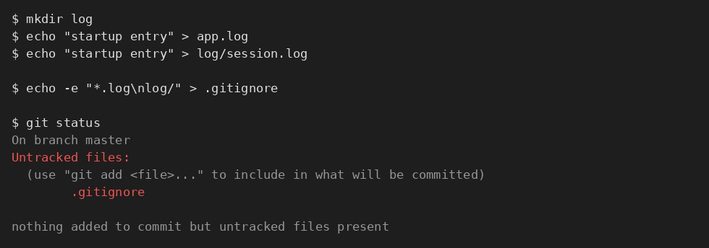
Figure 3: After adding .gitignore rules, app.log and log folder are not showing as untracked anymore.
This time app.log and the log folder are gone from the untracked list, only .gitignore itself shows up as new (since we haven’t committed it yet).

Step 5 – Committing the .gitignore file
git add .gitignore
git commit -m "Ignore log files and log folder"

I got a bit confused here initially thinking .gitignore itself doesn’t need to be committed, but actually it does – otherwise other people who clone the repo won’t have these ignore rules.

Hands-On 3: Branching and merging
In this lab we create a branch, make some changes only in that branch, then merge it back to master. This one had no conflict, that comes in the next lab.

Step 1 – Creating a new branch
git branch GitNewBranch

Note: this only creates the branch, it does not switch to it. We are still on master after this command.

Step 2 – Listing all branches
git branch -a
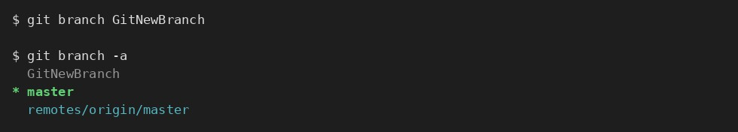
Figure 4: Local and remote branches. The * next to master shows which branch I’m currently on.
The * mark is in front of master here, meaning that’s our current branch.

Step 3 – Switching to the new branch and adding a file
git checkout GitNewBranch
echo "Feature work in progress" > feature.txt

Step 4 – Committing on the branch
git add feature.txt
git commit -m "Add feature.txt on GitNewBranch"

Step 5 – Checking status
git status

Clean working tree on this branch. feature.txt exists here but if I switch to master it won’t be there yet.

Step 6 – Switching back to master
git checkout master

Step 7 – Seeing the difference between master and branch
git diff master GitNewBranch

This shows the difference in the terminal itself (command line). Our lab also asked to check it visually using P4Merge tool, command for that is:
git difftool master GitNewBranch

Step 8 – Merging the branch into master
git merge GitNewBranch

Since master never touched feature.txt, this merge happened automatically with no issues (this is called a fast-forward merge I think).

Step 9 – Checking the log
git log --oneline --graph --decorate
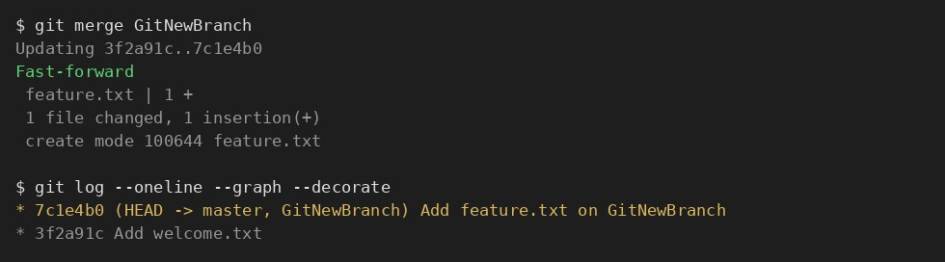
Figure 5: Commit history after merge, both master and GitNewBranch pointing to same commit now.

Step 10 – Deleting the branch after merge
git branch -d GitNewBranch git status

We can delete the branch safely now because all its work is already inside master after the merge, so nothing is lost.

Hands-On 4: Fixing a merge conflict
This lab was the hardest one honestly. Here we purposely make master and a branch edit the exact same line of the same file, so git can’t auto merge and we have to fix it ourselves.

Step 1 – Making sure master is clean first
git status

Step 2 – Creating a branch and a new file in it
git checkout -b GitWork
echo "<root><item>version 1</item></root>" > hello.xml git add hello.xml
git commit -m "Add hello.xml on GitWork"

git checkout -b creates the branch and switches to it in one shot, easier than doing it in 2 separate commands like before.

Step 3 – Changing the file content again in this branch
echo "<root><item>version 2 from GitWork</item></root>" > hello.xml git status

Step 4 – Committing this update
git commit -am "Update hello.xml on GitWork"

(the -a flag here directly stages tracked files so I didn’t need to type git add separately)

Step 5 – Going back to master
git checkout master

Step 6 – Creating the same file with different content on master
echo "<root><item>version 1 from master</item></root>" > hello.xml git add hello.xml
git commit -m "Add hello.xml on master"

Now master has its own hello.xml which has nothing to do with the branch’s version, this is what causes the conflict later.

Step 7 – Checking log of both branches
git log --oneline --graph --decorate --all

Step 8 – Checking difference before merging
git diff master GitWork -- hello.xml
git difftool master GitWork -- hello.xml

Second command opens P4Merge so we can see both versions side by side, easier to understand than plain text diff.

Step 9 – Trying to merge (this is where it fails)
git merge GitWork

Git stopped here and said there is a conflict in hello.xml. This is expected since we made the same file get 2 different contents on 2 branches.

Step 10 – Opening the file to see what git did
cat hello.xml
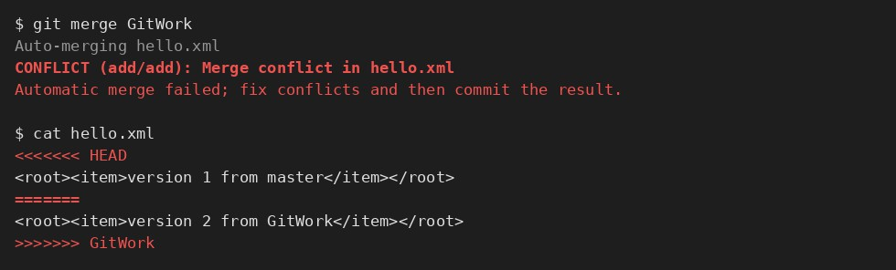
Figure 6: The CONFLICT message from git, and the conflict markers it puts inside hello.xml.

Git puts both versions inside the same file with some symbols to separate them. Everything between <<<<<<< HEAD and ======= is what’s on master, and everything between ======= and
>>>>>>> GitWork is what’s on the branch. We need to manually decide what the final content should be.

Step 11 – Fixing the conflict
I opened the file in P4Merge (3-way merge tool) to compare both sides properly, then edited it in Notepad++ to remove the <<<<<<<, =======, >>>>>>> lines and kept the correct content.
notepad++ hello.xml

Step 12 – Committing after fixing
git add hello.xml
git commit -m "Resolve merge conflict in hello.xml"

Git already fills in a default commit message for merges, I just kept it and added a bit of my own text to it.
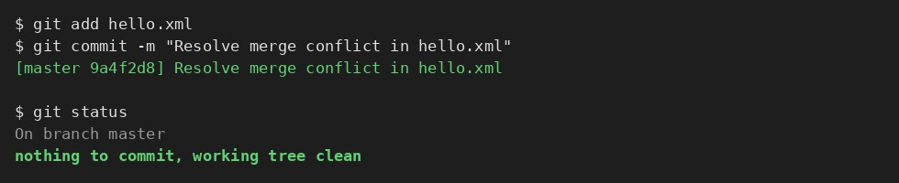
Figure 7: git status showing clean tree after I fixed the conflict and committed it.

Step 13 – Ignoring backup files created by merge tool
P4Merge sometimes leaves a .bak backup file behind, so I added that to .gitignore too:
echo "*.bak" >> .gitignore git add .gitignore
git commit -m "Ignore backup files created by the merge tool"

Step 14 – Cleaning up the branch
git branch
git branch -d GitWork
git log --oneline --graph --decorate

Now the branch GitWork is deleted since its changes are already part of master, and the log shows a proper merge commit joining both histories together.

Hands-On 5: Cleanup and pushing everything back
Last lab, pretty short. Just making sure everything we did in the previous labs actually reaches the remote repo (GitHub).

Step 1 – Checking master is clean
git status

Step 2 – Checking remaining branches
git branch -a

Since I already deleted GitNewBranch and GitWork in the earlier labs, only master should be left (plus the remote tracking one).

Step 3 – Pulling first
git pull origin master

I always pull before push, just to be safe in case something changed on remote side that I don’t have locally yet.

Step 4 – Pushing everything
git push origin master
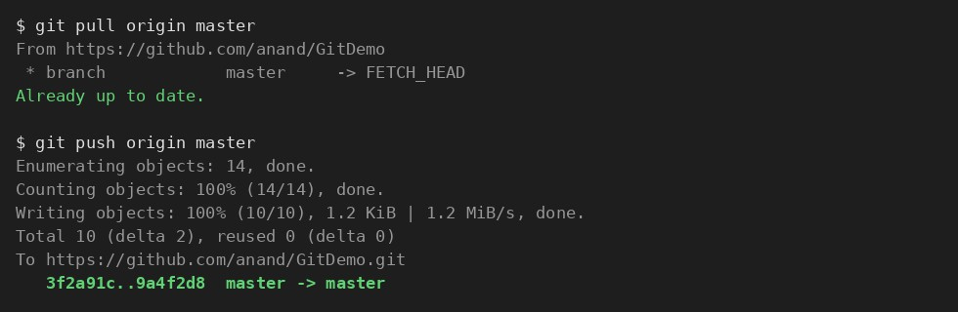
Figure 8: Pulling then pushing all my commits (welcome.txt, .gitignore, merged branch, resolved conflict) to GitHub.

Step 5 – Double checking on GitHub
I opened the GitHub repo in the browser and checked that welcome.txt, .gitignore, feature.txt and the final hello.xml (with the conflict fixed) are all there, and the commit history matches what I see locally with git log.
That’s basically all 5 labs done – set up git and made first commit (Lab 1), learned how .gitignore works (Lab 2), did a normal branch + merge (Lab 3), got a real conflict and fixed it myself (Lab 4), and pushed everything back to GitHub at the end (Lab 5). Definitely learned a lot more about git by actually doing it than just reading theory.

