Angular Hands-on Lab Record

What I understood about Angular before starting
All 10 hands-on exercises build the same project called student-course-portal, so it’s not like 10 separate mini projects – each one just adds something new on top of what’s already there. Below is what I understood about the main concepts before starting, in my own words.

Components and standalone API
An Angular app is basically a tree of components. Each component has a .ts file (logic), .html (template) and .css (styles). Angular 20 uses standalone components by default now, so I didn’t see an app.module.ts in my project, instead there’s app.config.ts. This confused me a bit at first since most tutorials online still show NgModules, but I understood that standalone just means each component declares its own imports directly instead of relying on a shared module.

Binding types
There are basically 4 ways data flows between the component class and the template:
  - Interpolation {{ value }} – just displays a value.
  - Property binding [property] – one-way, from component to the DOM.
  - Event binding (event) – from DOM back to the component (like button clicks).
  - Two-way binding [(ngModel)] – both directions at once, mainly used in forms.

Directives and pipes
Directives change how the DOM looks/behaves (*ngIf, *ngFor, ngClass). Pipes transform what’s displayed without changing the actual data (date, currency, or a custom one I made later). I get confused between the two sometimes but the rule I use is – if it changes struc-ture/attributes it’s a directive, if it just formats a value being printed it’s a pipe.

Services and Dependency Injection
Instead of writing the same logic in every component, we put shared logic/data in a service and @Injectable it. Angular then ”injects” the same instance wherever it’s needed via the constructor. providedIn: ’root’ means the whole app shares one instance – this is basically how I passed data between components without using @Input/@Output everywhere.

Routing, HTTP and state
Routing lets us have multiple ”pages” without actually reloading the browser – Angular just swaps out components inside <router-outlet>. HttpClient is what talks to a backend API

and always gives back an Observable, not the actual data directly (you have to .subscribe() to it). NgRx was the hardest part for me – it’s basically a very structured way of managing shared state using actions, reducers and a central store, instead of just services.

Hands-On 1: Setting up the project and my first component
This was the setup lab, mostly about getting comfortable with the CLI and understanding what all the generated files actually do.

Creating the project
npm install -g @angular/cli
ng new student-course-portal --routing --style=css cd student-course-portal
ng serve

I accepted the default options when it asked me prompts. After ng serve, I opened http://localhost:4200 and the default Angular page loaded fine.
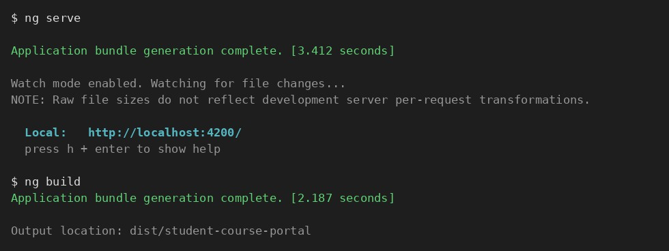
Figure 1: ng serve compiling the project successfully and showing the local address.

I also ran ng build once just to see the dist/ folder – the compiled JS files are in there, that’s what actually gets deployed, not our raw src folder.
For the files it asked us to write one line about, here’s what I put in my notes.txt:
- angular.json – overall project + build configuration.
- tsconfig.json – base TypeScript compiler settings.
- tsconfig.app.json – TypeScript settings specific to the app build.
- package.json – npm dependencies and scripts.
- src/main.ts – entry point, this is what actually bootstraps the app.
- src/app/app.config.ts – since my project is standalone, this replaces app.module.ts and registers providers.
- src/app/app.component.ts – the root component everything else lives inside.
- src/index.html – the one real HTML file, Angular injects everything into here.
I also checked angular.json for the production budgets setting – it has maximumWarning and maximumError sizes, basically if our bundle grows past these sizes it warns us or fails the build, so we don’t ship a huge JS file by accident.

Creating the core components

ng generate component components/header ng generate component pages/home
ng generate component pages/course-list
ng generate component pages/student-profile

Each one of these created 4 files (.ts, .html, .css, .spec.ts) – I didn’t have to register them manually anywhere since standalone components just import what they need directly.

header.component.html
<nav>
<span>Student Course Portal</span>
<a routerLink="/">Home</a>
<a routerLink="/courses">Courses</a>
<a routerLink="/profile">Profile</a>
</nav>

home.component.html
<h1>Welcome to the Student Course Portal</h1>
<p>Track your courses, grades and notifications all in one place.</p>
<div class="stats">
<span>Courses Available: 12</span>
<span>Enrolled: 3</span>
<span>GPA: 3.8</span>
</div>

Then in app.component.html I removed the default boilerplate and just kept:
<app-header></app-header>
<router-outlet></router-outlet>

After this, ng serve still compiled fine and I could see the header nav and the home page stats in the browser.

Hands-On 2: Data binding, lifecycle hooks and component communication
This lab was about making the portal actually dynamic instead of just static HTML.

Trying out all 4 binding types on the Home page
export class HomeComponent {
portalName = ’Student Course Portal’; isPortalActive = true;
message = ’’; searchTerm = ’’;
onEnrollClick() {
this.message = ’Enrollment opened!’;
}
}
<h1>{{ portalName }}</h1>
<button [disabled]="!isPortalActive" (click)="onEnrollClick()">Enroll Now</button>
<p>{{ message }}</p>
<input [(ngModel)]="searchTerm" placeholder="Search courses">
<p>Searching for: {{ searchTerm }}</p>

I had to remember to add FormsModule to the component’s imports array, otherwise ngModel just throws an error saying it’s not a known property. Once that was added, typing in the search box updated the ”Searching for:” text live, which was satisfying to see working.
The difference I understood between [property] and [(ngModel)] – one-way binding only pushes data from the component TO the screen, but ngModel does both directions at once, so typing in the input actually changes the searchTerm variable in the class too.

Lifecycle hooks
I added ngOnInit and ngOnDestroy in HomeComponent:
ngOnInit() {
console.log(’HomeComponent initialised courses loaded’);
}
ngOnDestroy() { console.log(’HomeComponent destroyed’);
}

Then I made a small CourseCardComponent to test ngOnChanges:
@Input() course: any;
ngOnChanges(changes: SimpleChanges) {
console.log(’course changed from’, changes[’course’]?.previousValue, ’to’, changes[’course’]?.currentValue);
}

I navigated away from Home and back to see ngOnDestroy actually fire, and it did. This made it clear why we’re supposed to unsubscribe from things in ngOnDestroy – if the component gets

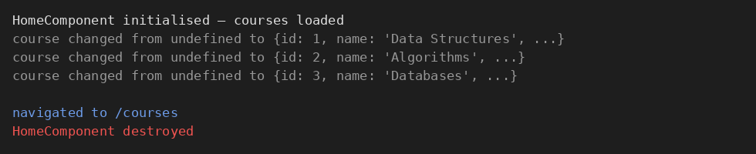
Figure 2: Browser console showing ngOnInit on load, ngOnChanges per card, and ngOnDestroy after navigating away.

destroyed but something is still running in the background (like a subscription), that’s basically a memory leak.

@Input / @Output between CourseList and CourseCard
// course-card.component.ts
@Input() course!: { id: number; name: string; code: string; credits: number }; @Output() enrollRequested = new EventEmitter<number>();
<button (click)="enrollRequested.emit(course.id)">Enroll</button>
<!-- course-list.component.html -->
<app-course-card *ngFor="let c of courses" [course]="c" (enrollRequested)="onEnroll($event)"></app-course-card>
<p *ngIf="selectedCourseId">Selected course ID: {{ selectedCourseId }}</p>
onEnroll(courseId: number) { console.log(’Enrolling in course: ’ + courseId); this.selectedCourseId = courseId;
}

So basically data flows down through @Input and events go back up through @Output – clicking Enroll on any card now logs the ID and shows it below the list.

Hands-On 3: Directives and pipes
This one was about controlling the DOM with directives and formatting values with pipes – and also building my own custom versions of each.

Structural directives
<p *ngIf="isLoading">Loading courses...</p>
<div *ngIf="!isLoading">
<app-course-card *ngFor="let course of courses; let i = index; trackBy: trackByCourseId"
[course]="course"></app-course-card>
</div>
trackByCourseId(index: number, course: any) { return course.id;
}

I used setTimeout in ngOnInit to flip isLoading to false after 1.5 seconds, just to simulate loading. trackBy was explained to us as – without it, Angular re-creates every single item in the list even if only one changed, which is wasteful for big lists. With trackBy, it only touches the item that actually changed.
I also added a grade status badge using *ngSwitch inside CourseCardComponent:
<span [ngSwitch]="course.gradeStatus">
<span *ngSwitchCase="’passed’" class="badge green">Passed</span>
<span *ngSwitchCase="’failed’" class="badge red">Failed</span>
<span *ngSwitchDefault class="badge grey">Pending</span>
</span>

And an else block for when there are no courses at all:
<div *ngIf="courses.length > 0; else noCourses">...</div>
<ng-template #noCourses><p>No courses available.</p></ng-template>

ngClass and ngStyle
<div class="card"
[ngClass]="{ ’card--enrolled’: course.enrolled, ’card--full’: course.credits >= 4
}"
[ngStyle]="{ ’border-left-color’: borderColor }">
</div>

I later moved the ngClass object into a getter because the inline object in the template was getting a bit long:
get cardClasses() {
return { ’card--enrolled’: this.course.enrolled, ’card--full’: this.course.credits
>= 4 };
}

This is cleaner because the template just says [ngClass]="cardClasses" instead of a big inline object, easier to read.

Custom directive and custom pipe
ng generate directive directives/highlight ng generate pipe pipes/credit-label
// highlight.directive.ts @Input() appHighlight = ’yellow’;
@HostListener(’mouseenter’) onEnter() { this.el.nativeElement.style.backgroundColor = this.appHighlight;
}
@HostListener(’mouseleave’) onLeave() { this.el.nativeElement.style.backgroundColor = ’’;
}
// credit-label.pipe.ts transform(value: number): string {
if (!value) return ’No Credits’;
return value === 1 ? ’1 Credit’ : value + ’ Credits’;
}
<app-course-card appHighlight [course]="course"></app-course-card>
{{ course.credits | creditLabel }}

Hovering over a card now highlights it in yellow (or whatever colour I pass in), and the credits number shows as a proper sentence instead of a raw number. I checked 3 | creditLabel and null | creditLabel and both gave the right text.

Hands-On 4: Template-driven forms and validation
This lab was about building the enrollment form the ”old” simpler way, using ngModel directly in the template.

Building the form
ng generate component pages/enrollment-form
<form #enrollForm="ngForm" (ngSubmit)="onSubmit(enrollForm)">
<input name="studentName" [(ngModel)]="model.studentName" required minlength="3" # nameCtrl="ngModel">
<span *ngIf="nameCtrl.touched && nameCtrl.errors?.[’required’]">Name is required</ span>
<span *ngIf="nameCtrl.touched && nameCtrl.errors?.[’minlength’]">Name must be at least 3 characters</span>
<input name="studentEmail" [(ngModel)]="model.studentEmail" required email>
<input name="courseId" type="number" [(ngModel)]="model.courseId" required>
<select name="preferredSemester" [(ngModel)]="model.preferredSemester">
<option>Odd</option>
<option>Even</option>
</select>
<input type="checkbox" name="agreeToTerms" [(ngModel)]="model.agreeToTerms" required
>
<button type="submit" [disabled]="enrollForm.invalid">Submit</button>
<button type="button" (click)="enrollForm.resetForm()">Reset</button>
</form>
<div *ngIf="submitted">Enrollment request submitted successfully!</div> onSubmit(form: NgForm) {
console.log(form.value, form.valid); this.submitted = true;
}

The thing I kept forgetting is that every input needs a name attribute or Angular complains – it uses the name as the key inside form.value.
I used touched instead of dirty for showing the errors, because touched only becomes true once the user has actually clicked into and left the field. If I used dirty it would show errors while the person is still typing which felt annoying.
.ng-invalid.ng-touched { border-color: red; }
.ng-valid.ng-touched { border-color: green; }

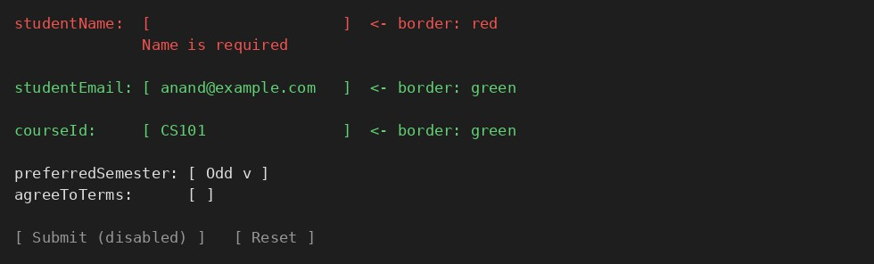
Figure 3: Enrollment form – red border with error text on an untouched-then-blurred invalid field, green border once valid.

Hands-On 5: Reactive forms with FormBuilder and FormAr-ray
Here we basically rebuilt the same enrollment form, but this time the whole form structure is defined in the TypeScript class instead of the template. Took me a while to get used to but I can see why it’s more powerful.

Building the reactive form
constructor(private fb: FormBuilder) {}
ngOnInit() {
this.enrollForm = this.fb.group({
studentName: [’’, [Validators.required, Validators.minLength(3)]], studentEmail: [’’, [Validators.required, Validators.email], [this. simulateEmailCheck]],
courseId: [null, [Validators.required, this.noCourseCode]], preferredSemester: [’Odd’, Validators.required], agreeToTerms: [false, Validators.requiredTrue], additionalCourses: this.fb.array([])
});
}
<form [formGroup]="enrollForm" (ngSubmit)="onSubmit()">
<input formControlName="studentName">
<input formControlName="studentEmail">
<input formControlName="courseId">
<button type="submit" [disabled]="enrollForm.invalid">Submit</button>
</form>

No ngModel anywhere here, just formControlName matching the keys I defined in the group. enrollForm.value skips disabled controls but enrollForm.getRawValue() gives everything including disabled ones – I only understood the difference after actually disabling a control and comparing both outputs in the console.

Custom validators
noCourseCode(control: AbstractControl): ValidationErrors | null {
return control.value?.toString().startsWith(’XX’) ? { noCourseCode: true } : null;
}
simulateEmailCheck(control: AbstractControl) {

return new Promise(resolve => { setTimeout(() => {
resolve(control.value?.includes(’test@’) ? { emailTaken: true } : null);
}, 800);
});
}
The async validator was new to me – it runs only after the normal sync validators already pass, which makes sense otherwise it would be firing an ”API call” (simulated here) on every keystroke even when the email format itself is wrong.

FormArray for extra courses
get additionalCourses() {
return this.enrollForm.get(’additionalCourses’) as FormArray;
}
addCourse() {
this.additionalCourses.push(this.fb.control(’’, Validators.required));
}
removeCourse(i: number) { this.additionalCourses.removeAt(i);
}
<div *ngFor="let ctrl of additionalCourses.controls; let i = index">
<input [formControl]="ctrl">
<button (click)="removeCourse(i)">Remove</button>
</div>
<button (click)="addCourse()">Add Another Course</button>

I made additionalCourses a typed getter instead of casting it inline in the template every time, mainly because it’s cleaner and I only have to write the as FormArray cast once.
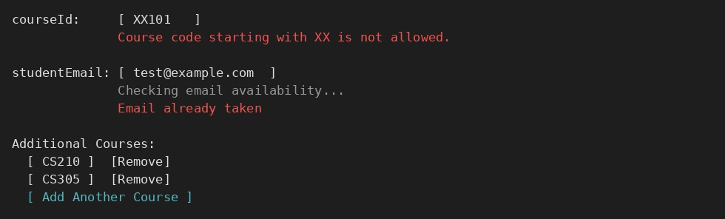
Figure 4: Reactive form – custom validator error on courseId, async ”email taken” message, and extra FormArray course rows.

Hands-On 6: Services and Dependency Injection
This lab was mainly about moving hardcoded data out of components and into a shared service.

CourseService
ng generate service services/course
export interface Course { id: number;
name: string; code: string; credits: number;
gradeStatus: ’passed’ | ’failed’ | ’pending’;
}
@Injectable({ providedIn: ’root’ }) export class CourseService {
private courses: Course[] = [ /* 5 hardcoded course objects */ ];
getCourses(): Course[] { return this.courses; }
getCourseById(id: number) { return this.courses.find(c => c.id === id); } addCourse(course: Course) { this.courses.push(course); }
}
I injected this same service into both HomeComponent (for the stats count) and CourseListComponent (for the actual list), and just to double check it’s really a singleton, I added a course from one component and watched the count update in the other without doing anything special – that’s what providedIn: ’root’ gives us, one shared instance everywhere.

EnrollmentService and service-to-service injection
@Injectable({ providedIn: ’root’ }) export class EnrollmentService {
private enrolledCourseIds: number[] = []; constructor(private courseService: CourseService) {}
enroll(courseId: number) { this.enrolledCourseIds.push(courseId); } unenroll(courseId: number) {
this.enrolledCourseIds = this.enrolledCourseIds.filter(id => id !== courseId);
}
isEnrolled(courseId: number) { return this.enrolledCourseIds.includes(courseId); } getEnrolledCourses(): Course[] {
return this.enrolledCourseIds
.map(id => this.courseService.getCourseById(id))
.filter((c): c is Course => !!c);
}
}
I found it interesting that a service can inject another service the exact same way a component injects a service – so EnrollmentService uses CourseService internally to turn IDs back into full course objects.
For the component-level provider part, I made a NotificationComponent with providers: [NotificationService] directly in its own @Component decorator – this creates a fresh instance just for that component (and its children) instead of sharing the root one, which is useful if you want that component’s state to reset every time it’s created.

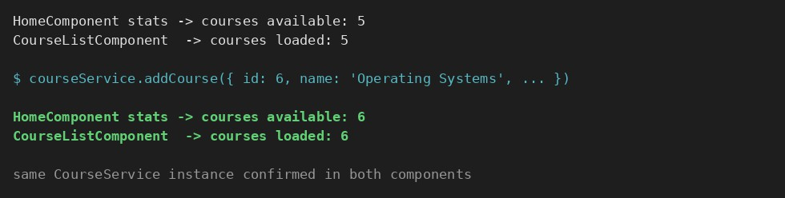
Figure 5: Console confirming both components read from the same CourseService instance – adding a course in one updates the count in the other.

Hands-On 7: Routing, guards and lazy loading
This lab was about making the portal feel like an actual multi-page app, plus protecting some routes.

Routes with parameters
export const routes: Routes = [
{ path: ’’, component: HomeComponent },
{ path: ’courses’, component: CourseListComponent },
{ path: ’courses/:id’, component: CourseDetailComponent },
{ path: ’profile’, component: StudentProfileComponent, canActivate: [authGuard] },
{ path: ’**’, component: NotFoundComponent }
];

I made sure the ** wildcard route is last – learned the hard way that Angular checks routes top to bottom, so if wildcard was first it would swallow every route.
// course-detail.component.ts ngOnInit() {
const id = Number(this.route.snapshot.paramMap.get(’id’)); this.course = this.courseService.getCourseById(id);
}

For search, I pushed the term into the URL as a query param instead of just keeping it in a variable:
this.router.navigate([’courses’], { queryParams: { search: this.searchTerm } });

Lazy loading the enrollment feature
{
path: ’enroll’,
loadChildren: () => import(’./features/enrollment/enrollment.routes’)
.then(m => m.ENROLLMENT_ROUTES)
}
I checked Chrome DevTools Network tab and confirmed a separate JS chunk only downloads the first time /enroll is visited, not on the initial page load – that’s the whole point of lazy loading, keeping the first load smaller.

Guards

export const authGuard: CanActivateFn = () => { const auth = inject(AuthService);
const router = inject(Router);
if (auth.isLoggedIn) return true; router.navigate([’/’]);
return false;
};
export const unsavedChangesGuard: CanDeactivateFn<ReactiveEnrollmentFormComponent> = ( component) => {
if (component.enrollForm.dirty) {
return window.confirm(’You have unsaved changes. Leave?’);
}
return true;
};
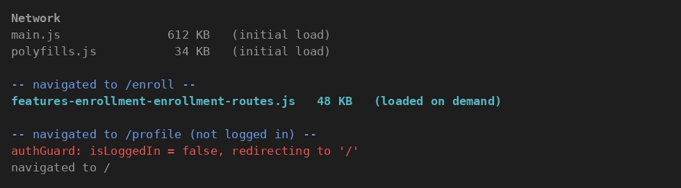
Figure 6: Network tab showing the lazy-loaded enrollment chunk, and the guard redirecting an unauthenticated visit to /profile.
Testing this was fun – I tried going to /profile without setting isLoggedIn = true first and it did bounce me back to home like expected. And leaving the reactive form half filled and clicking away triggered the confirm popup.

Hands-On 8: HttpClient, RxJS operators and interceptors
This is where the portal stopped using fake hardcoded arrays and actually talked to a (mock) backend.

Setting up JSON Server
npm install -g json-server
json-server --watch db.json --port 3000

My db.json just had a courses array similar to the hardcoded one from before.

Switching CourseService to real HTTP calls
constructor(private http: HttpClient) {}
getCourses(): Observable<Course[]> {
return this.http.get<Course[]>(’http://localhost:3000/courses’).pipe( tap(courses => console.log(’Courses loaded:’, courses.length)), map(courses => courses.filter(c => c.credits > 0)),
retry(2), catchError(err => {
console.error(err);
return throwError(() => new Error(’Failed to load courses. Please try again.’));
})
);
}
this.courseService.getCourses().subscribe({ next: courses => this.courses = courses, error: err => this.errorMessage = err.message, complete: () => this.isLoading = false
});

I understood tap as ”do something on the side without touching the actual data” (just logging here), while map is for actually transforming what comes back. I turned off json-server for a second just to see the error message show up properly, and turned it back on to confirm it recovers.
switchMap was used to chain a second call – loading enrolled students once a course is picked:
this.selectedCourseId$.pipe(
switchMap(courseId => this.enrollmentService.getStudentsByCourse(courseId))
);

The reason switchMap is used here instead of something like mergeMap is that if the user quickly picks a different course before the first request finishes, switchMap cancels the old one so we don’t accidentally show students for the wrong course.

Interceptors
export const authInterceptor: HttpInterceptorFn = (req, next) => {
const cloned = req.clone({ setHeaders: { Authorization: ’Bearer mock-token-12345’ }
});
return next(cloned);
};

// app.config.ts
provideHttpClient(withInterceptors([authInterceptor, errorHandlerInterceptor, loadingInterceptor]))
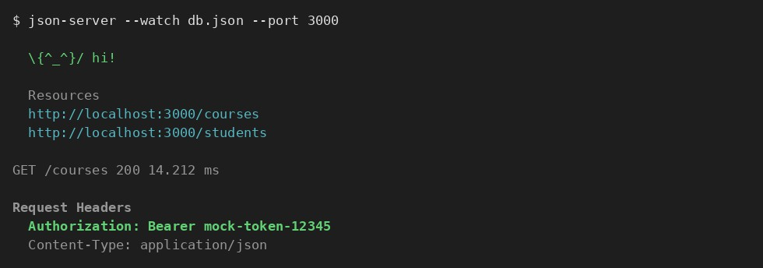
Figure 7: json-server serving requests, and the Authorization header attached to every outgoing API call by the interceptor.

For the loading interceptor I used a BehaviorSubject in a small LoadingService, set it true before the request and false inside finalize() so it turns off whether the call succeeds or fails – learned that finalize is basically like a ”finally” block for Observables.

Hands-On 9: NgRx – store, actions, reducers, effects
Honestly this was the toughest hands-on for me. Took some time to understand why we even need this on top of services, but eventually got that it’s mainly for bigger apps where a lot of components need the same state and debugging becomes hard with plain services.

Installing and setting up the store
npm install @ngrx/store @ngrx/effects @ngrx/entity @ngrx/store-devtools
// course.actions.ts
export const loadCourses = createAction(’[Course] Load Courses’);
export const loadCoursesSuccess = createAction(’[Course] Load Courses Success’, props
<{ courses: Course[] }>());
export const loadCoursesFailure = createAction(’[Course] Load Courses Failure’, props
<{ error: string }>());
// course.reducer.ts
export const courseReducer = createReducer( initialState,
on(loadCourses, state => ({ ...state, loading: true })),
on(loadCoursesSuccess, (state, { courses }) => ({ ...state, courses, loading: false
})),
on(loadCoursesFailure, (state, { error }) => ({ ...state, error, loading: false }))
);
// course.selectors.ts
export const selectCourseState = createFeatureSelector<CourseState>(’course’); export const selectAllCourses = createSelector(selectCourseState, s => s.courses);
export const selectCoursesLoading = createSelector(selectCourseState, s => s.loading);

The [Course] prefix on every action type was explained as just a naming convention so the Redux DevTools timeline is readable – you can filter by feature name and only see actions related to that slice of state.

Effects for the actual HTTP call
loadCourses$ = createEffect(() => this.actions$.pipe( ofType(loadCourses),
switchMap(() => this.courseService.getCourses().pipe( map(courses => loadCoursesSuccess({ courses })),
catchError(error => of(loadCoursesFailure({ error: error.message })))
))
));

In the component I stopped subscribing to the service directly and instead did:
this.courses$ = this.store.select(selectAllCourses); this.store.dispatch(loadCourses());

Seeing the whole flow light up in Redux DevTools (dispatch ->effect ->new action ->reducer
->state update ->component re-render) is what finally made this click for me, reading about it beforehand didn’t help as much as actually watching it happen.
I added a second slice for enrollment state the same way, and used a ”cross-slice” selector that reads from both the course state and enrollment state together to figure out which courses are enrolled – that part took a couple of tries to get right.

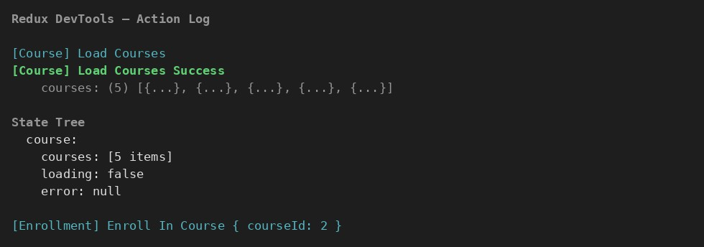
Figure 8: Redux DevTools action log: loadCourses dispatched, effect fires the HTTP call, loadCoursesSuccess updates the state tree.

Hands-On 10: Unit testing with Jasmine, Karma and TestBed
Last one – writing actual tests for the components and services we built in the earlier labs.

Testing CourseCardComponent
beforeEach(() => {
TestBed.configureTestingModule({ imports: [CourseCardComponent] }); fixture = TestBed.createComponent(CourseCardComponent);
component = fixture.componentInstance;
});
it(’should create’, () => { expect(component).toBeTruthy();
});
it(’should display the course name’, () => {
component.course = { id: 1, name: ’Data Structures’, code: ’CS101’, credits: 4, gradeStatus: ’passed’ };
fixture.detectChanges();
const title = fixture.debugElement.query(By.css(’h3’)).nativeElement.textContent; expect(title).toContain(’Data Structures’);
});
it(’should emit enrollRequested with the course id on click’, () => { component.course = mockCourse;
fixture.detectChanges(); spyOn(component.enrollRequested, ’emit’);
fixture.debugElement.query(By.css(’button’)).nativeElement.click(); expect(component.enrollRequested.emit).toHaveBeenCalledWith(1);
});

I kept forgetting to call fixture.detectChanges() after changing a component property – without it, the template just doesn’t update and the test looks for something that isn’t there yet.

Testing CourseService with HttpClientTestingModule
beforeEach(() => { TestBed.configureTestingModule({
imports: [HttpClientTestingModule], providers: [CourseService]

});
service = TestBed.inject(CourseService);
httpMock = TestBed.inject(HttpTestingController);
});
it(’should fetch courses’, () => {
service.getCourses().subscribe(courses => expect(courses.length).toBe(2)); const req = httpMock.expectOne(’http://localhost:3000/courses’); req.flush(mockCourses);
httpMock.verify();
});

httpMock.verify() checks that we didn’t accidentally leave any HTTP call unhandled in the test – if there’s a request we forgot to .flush(), this fails and tells us.

Testing the NgRx-connected component
TestBed.configureTestingModule({ providers: [
provideMockStore({ initialState: { course: { courses: mockCourses, loading: false, error: null } } })
]
});
store = TestBed.inject(MockStore);
it(’should show loading indicator when loading is true’, () => { store.setState({ course: { courses: [], loading: true, error: null } }); fixture.detectChanges(); expect(fixture.debugElement.query(By.css(’.loading’))).toBeTruthy();
});
ng test --code-coverage
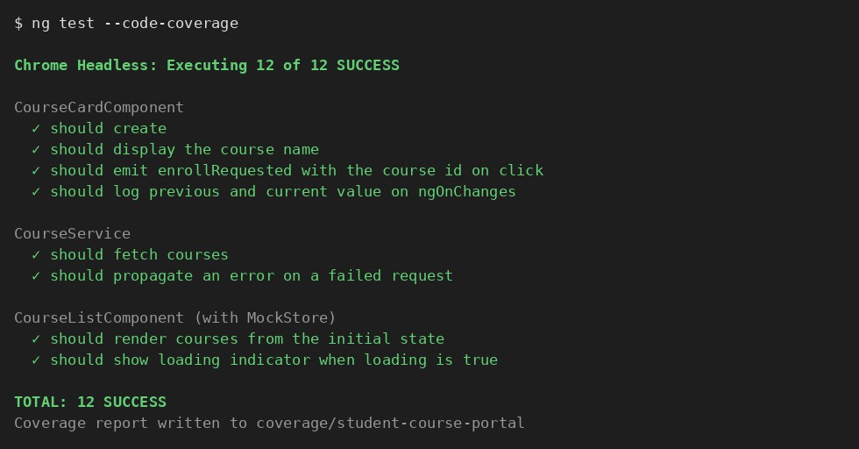
Figure 9: ng test running all spec files – component, service and store-connected component tests all passing.

That’s basically the whole portal done, start to finish – setup and a first component (Lab 1), binding + lifecycle hooks (Lab 2), directives and pipes (Lab 3), 2 different form styles (Labs 4-5), services and DI (Lab 6), routing with guards and lazy loading (Lab 7), real HTTP calls

with interceptors (Lab 8), NgRx for shared state (Lab 9), and tests covering all of it (Lab 10). NgRx and the async validator in reactive forms were the 2 things that took me the longest to actually understand instead of just copying the syntax.

