SIGNALS
Program 1: Simple Signal Handler — SIGINT
#include <stdio.h>
#include <signal.h>
#include <unistd.h>
void handle_signal(int sig) {
printf("\nSIGINT received!\n");
} int main() {
signal(SIGINT, handle_signal);
while (1) {
printf("Program is running...\n");
sleep(2);
}
return 0;
}
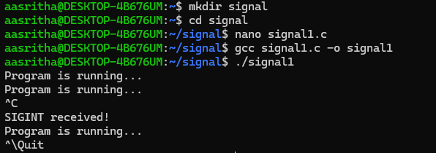

Program 2: SIGINT Without a Handler
#include <stdio.h>
#include <unistd.h>
int main() {
while (1) {
printf("Program is running...\n");
sleep(2);
}
return 0;
}
