INTERNSHIP PROJECT REPORT
Super Store Sales Dashboard
A Power BI Business Sales Analytics Project (2014–2017)
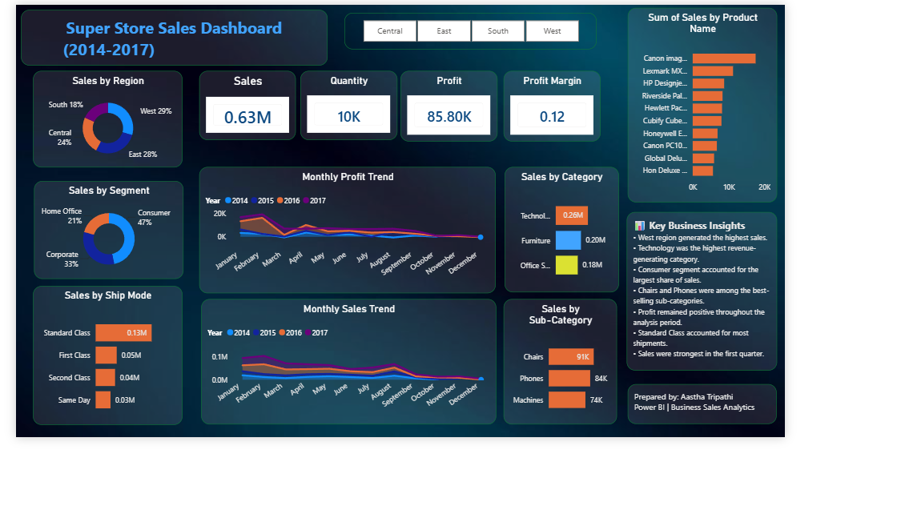

Prepared by: | Aastha Tripathi
Tool Used: | Microsoft Power BI
Dataset: | Super Store Sales Data (2014–2017)
Domain: | Business / Sales Analytics

1. Introduction
This report documents the Super Store Sales Dashboard developed during my internship using Microsoft Power BI. The dashboard consolidates four years of retail sales data (2014–2017) into a single, interactive view that enables quick, data-driven decision-making around regional performance, product profitability, and customer segments. The objective of this project was to gain hands-on experience with the complete business intelligence workflow — from raw data to a polished, decision-ready dashboard — and to strengthen practical skills in data visualization, DAX-based calculations, and dashboard storytelling.

2. Objectives
- To analyze Super Store sales data and identify key business performance drivers.
- To design an interactive Power BI dashboard summarizing sales, profit, and quantity across regions, segments, and product categories.
- To visualize monthly sales and profit trends over the 2014–2017 period.
- To identify top-performing products, sub-categories, and shipping modes.
- To translate raw data into actionable business insights for stakeholders.

3. Tools & Technologies Used
- Microsoft Power BI Desktop — data modeling, DAX measures, and dashboard design.
- Power Query — data cleaning and transformation.
- Super Store Sales dataset — order-level retail transactions (2014–2017).

4. Dataset Overview
The underlying dataset contains order-level transaction records for a retail superstore across four regions (Central, East, South, West), covering customer segments (Consumer, Corporate, Home Office), product categories (Technology, Furniture, Office Supplies), and shipping modes (Standard Class, First Class, Second Class, Same Day). Key fields used in the analysis include Sales, Profit, Quantity, Order Date, Region, Segment, Category, Sub-Category, Product Name, and Ship Mode.

5. Dashboard Design & Methodology
The dashboard was built in Power BI by first importing and cleaning the raw sales data in Power Query, then modeling relationships between orders, products, and locations. Key performance indicators — Sales, Quantity, Profit, and Profit Margin — were calculated using DAX measures and placed as summary cards at the top of the report for immediate visibility. Interactive slicers for Region (Central, East, South, West) allow the viewer to filter every visual on the page dynamically.
The layout follows a top-down, left-to-right visual hierarchy: high-level KPIs and regional filters at the top, category and segment breakdowns in the middle, and detailed product- and sub-category-level rankings on the sides. A dark theme with orange accent highlights was used to make key figures stand out and give the report a professional, boardroom-ready appearance.

6. Dashboard Preview
The completed dashboard is shown below.

Figure 1: Super Store Sales Dashboard (2014–2017), built in Power BI

7. Key Performance Indicators
Metric | Value | Metric | Value
Total Sales | 0.63M | Total Profit | 85.80K
Quantity Sold | 10K | Profit Margin | 0.12

8. Dashboard Section Breakdown

8.1 Sales by Region
Sales are broken down across the four company regions: West leads with 29% of total sales, followed by Central (24%), East (28%), and South (18%). This view immediately highlights the West region as the strongest-performing market.

8.2 Sales by Segment
Customer sales are split by segment: Consumer accounts for the largest share at 47%, followed by Corporate at 33% and Home Office at 21%. This indicates that individual consumers are the primary revenue driver for the business.

8.3 Sales by Ship Mode
Standard Class is by far the most-used shipping method, generating 0.13M in sales, followed by First Class (0.05M), Second Class (0.04M), and Same Day (0.03M). This reflects a customer base that generally prioritizes cost over delivery speed.

8.4 Monthly Sales & Profit Trends
Line charts track sales and profit month-by-month across 2014, 2015, 2016, and 2017. Both metrics show a recurring seasonal pattern, with a dip through the middle of the year and a noticeable ramp-up toward Q4, suggesting stronger year-end and holiday-season demand.

8.5 Sales by Category & Sub-Category
Technology is the top-performing category at 0.26M in sales, ahead of Furniture (0.20M) and Office Supplies (0.18M). At the sub-category level, Chairs (91K), Phones (84K), and Machines (74K) are the leading contributors.

8.6 Sum of Sales by Product Name
A horizontal bar chart ranks individual products by total sales, with the Canon imageCLASS printer/copier line topping the list, followed by Lexmark and HP DesignJet products — highlighting that high-ticket office and imaging equipment drives a disproportionate share of revenue.

9. Key Business Insights
- The West region generated the highest overall sales, making it the top-performing market.
- Technology was the highest revenue-generating category, driven largely by printers, copiers, and phones.
- The Consumer segment accounted for the largest share of sales at 47%, ahead of Corporate and Home Office.
- Chairs and Phones were among the best-selling sub-categories.
- Profit remained positive throughout the analysis period, indicating healthy overall business performance.
- Standard Class shipping accounted for the majority of shipments, reflecting cost-conscious customer behavior.
- Sales were strongest in the first quarter, pointing to a seasonal opportunity for targeted promotions.

10. Conclusion
This project provided practical, end-to-end experience in business intelligence — from cleaning raw transactional data to designing an interactive, insight-driven Power BI dashboard. The Super Store Sales Dashboard successfully consolidates four years of sales performance into a single view, making it easy to identify top-performing regions, segments, and products at a glance. Beyond the technical skills gained in Power BI (data modeling, DAX, and visual design), the project strengthened my ability to translate raw data into clear, actionable business recommendations — a core skill for any data or business analytics role.
Overall, this internship task deepened my understanding of retail sales analytics and reinforced the value of well-designed dashboards in supporting faster, more confident business decisions.

11. Prepared By
Aastha Tripathi
Power BI | Business Sales Analytics Internship

