
The British College
KATHMANDU
Coursework Submission Coversheet
(individual coursework only)
Faculty of Arts, Environment and Technology
LBU Student ID:
77466810
For checking by the student:
Please ensure all information is complete and correct and attach this form securely to the front of your work before posting it in a coursework collection box.
Award name: BSc (Hons) Computing
Module code: 14806 – LTP - 202510
Module name: Production Project
Module run: 2026
Coursework title: Component 3: Final Report
Due Date: 05/11/2026
Module leader: (In LBU) : Mr. Patrick Ingham
Module Supervisor: (In TBC) : Mr. Saroj Sharma
TURNITIN Checked: NO (please circle)

Submission date & time: Date: 05/11/2026 Time: 23:59 PM
Total Word Count: Total Number of Pages (including this front sheet):
In submitting this form with your assignment, you make the following declaration:
I declare, that the coursework submitted is my own work and has not (either in whole or part) been submitted towards the award of any other qualification either at LBU or elsewhere. I have fully attributed/referenced all sources of information used during the completion of my assignment, and I am aware that failure to do so constitutes an assessment offence.
Signed: 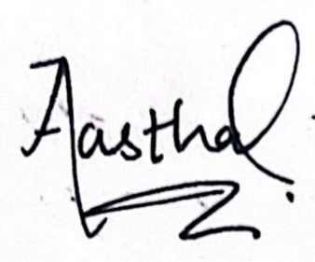 ` Date: 05/11/2026

You are strongly advised to retain a second copy of your work in case of any query about the assignment.

YES

83
12600

For completion by the faculty:
This mark is provisional and subject to moderation and approval by the relevant examining board
Teacher's Feedback

Teacher's Signature: _____________________ Date: ________________

SecureVote Nepal: Decentralised Blockchain-Based Mobile E-Voting Application
Final Year Project Report

Student Name: Aastha Dhital
Student ID: 77466810
Course: BSc (Hons) Computing
Module: Final Year Project
Supervisor: Mr. Saroj Sharma
Institution: The British College / Leeds Beckett University
Submission Date: 05/11/2026

Abstract
SecureVote Nepal is a blockchain-based mobile voting application built as a Final Year Project. With the rising interest in blockchain technology being applied to election processes, there is a necessity to investigate whether using a Solidity smart contract combined with an Android mobile application can create an independently verifiable voting process for end users at a prototype level.
The mobile application was created using Kotlin and Jetpack Compose for the mobile application, Solidity 0.8.28 for the smart contract deployed on a local Hardhat blockchain, and used the Web3j library to handle on device communication with the blockchain without the need for a middleware server. Three different types of users can interact with the application: administrators, voters, and observers. Administrators are able to create elections, register candidates for those elections, whitelist voters, perform a QR code check in to confirm their attendance, close elections, and view the results of those elections. Voters are able to perform a QR code check in, vote on the candidates in the election by creating a blockchain transaction, and viewing the transaction hash as proof of their vote being cast. Observers are able to view live figures for the number of voters that have voted so far in the election, as well as the election results after the election has been closed.
The QR code that voters scan contains a nonce and expiration date to prevent votes from being replayed. Furthermore, administrators must login using Firebase authentication and a six-digit one-time passcode sent to their registered email with EmailJS to provide two-factor authentication for login access to the application.

Student Declaration
This document is my own work unless stated otherwise and where quoting or referencing published works, I have used the Harvard Referencing Style and references have been made to them throughout the document, following the guidelines set by Leeds Beckett University.
I confirm I understand the University regulations on academic integrity and that this work adheres to these regulations. Ethical approval was gained before any development work took place and the project worked within the University ethical guidelines throughout.

Signature: 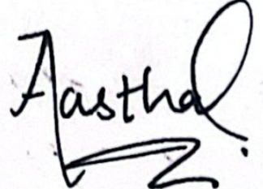
Name: Aastha Dhital
Student ID: 77466810
Date: 05/11/2026

Table of Contents
Abstract i
Student Declaration ii
List of Figures vi
List of Tables vii
List of Appendices vii
List of Abbreviations / Acronyms viii
Acknowledgements ix
Chapter 1: Introduction 1
1.1 Background 1
1.2 Project Aims and Objectives 2
1.3 Scope and Limitations 3
1.4 Report Structure 4
Chapter 2: Review of Literature 4
2.1 Introduction 4
2.2 Traditional E-Voting Systems and Their Problems 4
2.3 Similar Systems and Solutions 5
2.4 Blockchain Properties for Voting 6
2.5 QR Codes and Physical Verification 6
2.6 Key Findings and Their Influence 7
Chapter 3: Review of Technology 9
3.1 Introduction 9
3.2 Mobile Platform: Kotlin and Jetpack Compose 9
3.3 Blockchain Development Environment: Hardhat 10
3.4 Android Blockchain Library: Web3j 10
3.5 Smart Contract Language: Solidity 11
3.6 Admin Authentication: Firebase and EmailJS 12
3.7 QR Code Libraries: ZXing and Google Play Services Code Scanner 12
3.8 Summary 12
Chapter 4: Methodology 14
4.1 Introduction 14
4.2 Alternative Methodologies Assessed 14
4.3 Chosen Methodology: Iterative and Incremental 15
4.4 Link to Project Plan 16
4.5 Design Techniques Used 16
4.6 Ethical Considerations 17
Chapter 5: Product Design 18
5.1 System Architecture 18
5.2 Smart Contract Design 18
5.3 Navigation and Role Separation 20
5.4 QR Check-In Design 21
5.5 Admin Authentication Design 21
5.6 User Interface Design 22
5.7 Security and Auditability Design 23
Chapter 6: Software Requirement Analysis 24
6.1 Introduction 24
6.2 Functional Requirements 24
6.3 Non-Functional Requirements 26
6.4 Feasibility Study 27
Chapter 7: Implementation and Testing 28
7.1 Introduction 28
7.2 Smart Contract Implementation 28
7.3 BlockchainRepository Implementation 28
7.4 QR Check-In Implementation 29
7.5 Voting and Receipt Verification Implementation 30
7.6 Testing 30
7.6.1 Smart Contract Unit Tests 30
7.6.2 Android Build Verification 32
7.6.3 Manual End-to-End Testing 32
Chapter 8: Product Evaluation 34
8.1 Introduction 34
8.2 Functional Requirements Evaluation 34
8.3 Non-Functional Requirements Evaluation 35
8.4 Incomplete Features 36
8.5 Overall Assessment 36
Chapter 9: Project Evaluation 38
9.1 Introduction 38
9.2 Project Management Techniques 38
9.3 Assessment Against Aims and Objectives 39
9.4 Problems Encountered 40
9.5 Project Successes 40
Chapter 10: Summary and Conclusion 42
10.1 Summary of Findings 42
10.2 Recommendations 42
10.3 Future Work 43
10.4 Conclusion 44
Bibliography 45
Books 45
Journal Articles and Conference Papers 45
Online Sources 46
Appendix A: Ethical Approval Form 47
Appendix B: SDLC Design Documentation 52
B.1 Use Case Diagram 52
B.2 Sequence Diagram 53
B.3 On-Chain Data Model (ERD) 54
Appendix C: Testing Evidence 55
C.1 Smart Contract Unit Test Terminal Output 55
C.2 Manual End-to-End Test Log 55
C.3 Android Build and Unit Test Evidence 57
Appendix D: Project Management Evidence 57
D.1 Gantt Chart 57
D.2 Supervision Meetings 58
D.3 Risk Register 62
D.4 Version Control Evidence 62
Appendix E: Project Plan Versions and Commentary 64
Appendix F: User Guide 65
F.1 Prerequisites 65
F.2 Starting the Local Blockchain Node 65
F.3 Deploying the Smart Contract 65
F.4 Configuring the RPC URL 65
F.5 Building and Installing 65
F.6 Running the app 66
Appendix G: Source Code Listings 67
G.1 Vote Validation Function 67
G.2 Batch Voter Whitelisting Function 67
G.3 Signed Transaction Submission 68
G.4 QR Payload Validation 69
G.5 Receipt Verification 70
G.6 Smart Contract Unit Test Example 71
G.7 Deployment Script 71

List of Figures
Figure 1: High-Level System Architecture Diagram 19
Figure 2: EVoting Smart Contract 20
Figure 3: Three-Role Navigation Flow Diagram 21
Figure 4: QR Check-In 22
Figure 5: Admin Two-Factor Authentication Sequence Diagram 23
Figure 6: End-to-End Voting Sequence 31
Figure 7: Smart Contract Unit Test Results 33
Figure D.1: Final Project Gantt Chart 57
Figure G.1: Vote validation function in EVoting.sol 67
Figure G.2: Batch voter whitelisting function in EVoting.sol 68
Figure G.3a: Creating and signing a raw blockchain transaction using Web3j 68
Figure G.3b: Sending the signed transaction and returning the transaction hash 69
Figure G.4a: Data classes 69
Figure G.4b: Expiry/nonce validation and valid payload return 69
Figure G.5: Contract address, VoteCast event and receipt verification success checks 70
Figure G.6: Hardhat unit test for double vote prevention 70
Figure G.7: Hardhat deployment script creating the EVoting contract and Android contract configuration 71

List of Tables
Table 1: Technology Alternatives Comparison 10
Table 2: Methodology Comparison 15
Table 3: Functional Requirements 27
Table 4: Non-Functional Requirements 27
Table 5: Smart Contract Unit Test Cases 33
Table 6: Requirements vs Implementation 36
Table 7: Project Risk Register 39

List of Appendices
Appendix A: Ethical Approval Form 47
Appendix B: SDLC Design Documentation 51
Appendix C: Testing Evidence 55
Appendix D: Project Management Evidence 57
Appendix E: Project Plan Versions and Commentary 64
Appendix F: User Guide 65
Appendix G: Source Code Listings 67

List of Abbreviations / Acronyms
Abbreviation | Full Form
ABI | Application Binary Interface
API | Application Programming Interface
APK | Android Package Kit
EVM | Ethereum Virtual Machine
FYP | Final Year Project
JSON | JavaScript Object Notation
MVVM | Model-View-ViewModel
OTP | One-Time Password
QR | Quick Response
RPC | Remote Procedure Call
SDLC | Software Development Life Cycle
SDK | Software Development Kit
UI / UX | User Interface / User Experience
UUID | Universally Unique Identifier

Acknowledgements
I would like to express my sincere thanks to my project supervisor, Mr. Saroj Sharma, for the guidance, constructive feedback, and encouragement provided throughout this project. The regular supervision sessions were genuinely helpful in keeping the work on track and in improving both the quality of the software and this report.
Likewise, I also want to thank all my teachers and The British College for the academic support and resources made available throughout the course. The computing facilities and library access made a real practical difference during development and research.
Finally, I am grateful to my family and friends for their patience and support during what was a demanding semester. Their encouragement during long evenings of debugging and writing encouraged me to work confidently and patiently.

Chapter 1: Introduction

1.1 Background
Voting is a cornerstone of equality, whether in a national general election or university student body elections. Ensuring that voting processes are accurate and transparent is therefore crucial to establish legitimacy in both contexts. Paper-based voting methods have been used for centuries, but they suffer from certain inherent shortcomings, including the risk of ballot fraud, manual counting errors, and lack of transparency, thereby often generating controversy and fuelling public distrust (Kshetri and Voas, 2018).
In a bid to tackle problems such as manipulation and auditability, Electronic voting systems were piloted in many countries. Some of these systems further introduced issues by being centralised, concentrating all voting information on a server operated by an authority. This authority then becomes both the single point of trust and the single point of failure; those who do not trust the operator have no way of verifying that their vote was recorded correctly (Shahzad and Crowcroft, 2019).
Antonopoulos and Wood (2018) note that in addition to the issues of poor security in voting systems we also need to be concerned with how verifiable and auditable the results of a democratic election are. Blockchain technology provides a possible answer to this problem. A blockchain is a distributed, append-only ledger with unique addresses and cryptographic hashes that link together a series of records, each copied across the network of participating computers or nodes. It is therefore impossible for someone to alter a transaction and remain undetected because such a change would render the entire blockchain void.
Although the Election Commission of Nepal has experimented with computer-based voting and citizen registration using mobile phones, it currently conducts most of its elections by paper ballot and there exists no auditable and cryptographically verifiable digital voting system across the country that the institution can utilize. This project sought to investigate the possibility and user experience of utilizing a mobile app that records and collates paper votes and provisions a blockchain smart contract that formalizes voters’ commitments to their selections. Hence the project’s name, SecureVote Nepal.
I started from a mobile-first design: Voting on a smartphone is something people are familiar with, and we can demonstrate the user experience without needing special hardware for the polling station setup. We deliberately chose to use the Nepal context to set up a realistic trust problem, but one that is not intended for direct deployment in Nepal. The goal is to demonstrate how you could link together attendance, eligibility, vote submission, and audit evidence in a controlled workflow or process.

1.2 Project Aims and Objectives
The aim of this project is to create a mobile-based decentralised e-voting prototype that uses blockchain smart contracts to securely and transparently record votes. The prototype will include a QR check-in step at polling locations to confirm voter attendance before voting. It will also provide a transaction receipt or hash to allow for vote verification and auditing.
The specific objectives are as follows:
1. To investigate the limitations of traditional and centralised e-voting systems, particularly issues relating to trust, result manipulation, transparency, auditability and dependence on a central authority.
2. To examine how blockchain technology can provide tamper resistance, transparency and independent verification, and how smart contracts can enforce election rules automatically.
3. To define a realistic project scope suitable for a final-year academic prototype, including clear boundaries between demonstrable functionality and production-level election security.
4. To design the complete system architecture, including the Android mobile application, Solidity smart contract, admin workflow, voter workflow, observer workflow and QR-based check-in process.
5. To implement a Solidity smart contract capable of creating elections, registering candidates, whitelisting eligible voters, recording check-ins, accepting valid votes and exposing final vote counts after closure.
6. To implement a QR-based polling-station check-in mechanism so that voters must present a time-limited credential before they are permitted to vote.
7. To develop the Android mobile screens required for voters, administrators and observers, including election viewing, candidate selection, vote confirmation, QR check-in management, election management and result viewing.
8. To provide voters with a transaction hash receipt that allows them to verify that their vote transaction was successfully recorded on the blockchain.
9. To test both successful and invalid voting scenarios, including valid voting, double-vote attempts, voting without check-in, voting outside the election period and attempts by non-eligible addresses.
10. To evaluate the completed prototype against its requirements, identify limitations honestly, and recommend future improvements relating to privacy, security, scalability and production readiness.

1.3 Scope and Limitations
This project is scoped as an academic prototype for demonstration and assessment purposes. It is not designed for deployment in real institutional or national elections. The blockchain is a local Hardhat development network. Demo wallet private keys are bundled inside the application assets, which is only acceptable in a controlled demo setting. QR nonces are held in memory for the duration of a check-in screen session rather than persisted to a database, and the Nepali language translation was started but not completed within the project timeline.

1.4 Report Structure
Chapter 2 reviews relevant literature on electronic voting and blockchain-based systems. Chapter 3 reviews the technologies selected, including rejected alternatives. Chapter 4 covers the methodology and design approach. Chapter 5 presents the detailed product design. Chapter 6 defines the software requirements. Chapter 7 describes implementation and testing with code extracts. Chapter 8 evaluates the product against original requirements. Chapter 9 evaluates the project management process. Chapter 10 summarises findings and presents conclusions and future work.

Chapter 2: Review of Literature

2.1 Introduction
This chapter provides a review of existing research on electronic voting and blockchain-based voting utilising relevant academic sources. The key points to note from the sources reviewed include: others have proposed similar solutions to e-Voting; existing ideas and methods have been expanded upon; key findings from the literature which influenced the development of this project; alternative approaches that were investigated and not pursued.

2.2 Traditional E-Voting Systems and Their Problems
Electronic voting has been studied in various forms since at least the 1970s, ranging from punch-card machines to internet-based systems. Sommerville (2016) argues that any critical software system must be evaluated not only for functional correctness but also for dependability and security, two properties that centralised e-voting systems have historically found difficult to satisfy together. When the system is centralised, satisfying voter anonymity while also enforcing double-vote prevention becomes extremely difficult without introducing a trusted intermediary, which itself becomes a potential point of manipulation.
Pawlak, Poniszewska-Maranda and Kryvinska (2018) identify this as the fundamental tension in e-voting design: the need to simultaneously guarantee that votes are anonymous and that each eligible voter casts exactly one vote. In a traditional client-server architecture, satisfying both at once requires placing significant trust in the system operator. A fully offline paper-trail-based hybrid system was considered as an alternative approach during the literature review. While paper-trail systems improve audit confidence, they do not eliminate the fraud risk at the physical counting stage and are not realisable as a purely software prototype. This approach was therefore rejected for this project.

2.3 Similar Systems and Solutions
There are several existing implementations of blockchain voting systems in both practical applications and academic research. Voatz is a commercial mobile voting application that was used to allow some overseas military voters to cast ballots in the 2018 US midterm elections. A security audit of the 2018 midterm election code carried out by Trail of Bits (2020) found several serious vulnerabilities, including that the server could alter or reject votes at will. Although ultimately not directly influencing the current project, it was an important finding regarding existing implementations that supported the decision to use a fully public and transparent Ethereum-compatible smart contract rather than a permissioned chain.
The Follow My Vote open-source blockchain voting project was built on the BitShares blockchain. The system provided full end-to-end verifiability by generating a cryptographic receipt for each vote that was displayed to the voter immediately after submitting the vote. However, the system required voters to have a cryptocurrency account and sufficient knowledge to handle it, creating a usability issue. For this project, I decided to abstract key management from voters and created a demo wallet for the prototype.
Hardwick et al. ( 2018) proposed a decentralised e-voting protocol on Ethereum that distributed pseudonymous tokens anonymously without the involvement of a trusted authority. While their protocol offers better privacy than the approach taken in this project, it is much more complex to implement. In contrast, the work of Khan, Arshad and Khan (2018) identified a simpler voting model that can be more directly translated into code using Solidity, and highlighted three critical security properties: eligibility (only registered voters should be able to vote), uniqueness (each voter must be able to vote once), and verifiability (voters should be able to verify that their vote was counted).

2.4 Blockchain Properties for Voting
Kshetri and Voas (2018), in a widely cited IEEE Software article, argue that blockchain provides three properties that centralised systems cannot easily replicate: immutability, transparency, and verifiability. Once a vote is recorded as a confirmed blockchain transaction, it cannot be altered without invalidating the chain. Every transaction is visible to any participant, and voters can independently confirm their vote was counted by checking the transaction hash. The transaction hash receipt mechanism in this project directly addresses the verifiability property identified by Kshetri and Voas (2018).
Shahzad and Crowcroft (2019) add an important caveat: standard Ethereum wallet addresses are pseudonymous rather than truly anonymous. If a wallet address can be linked to an individual through a voter registration record, the secrecy of the vote is compromised. This is an acknowledged limitation of the current project. The literature suggests zero-knowledge proofs or ring signatures would be required for true anonymity, both of which were assessed as beyond the scope of a single-semester project.

2.5 QR Codes and Physical Verification
Dalia et al. (2022) review a comprehensive set of blockchain-based e-voting systems and observe that systems combining a physical check-in step with digital verification provide stronger guarantees of voter presence than purely online systems. Requiring a voter to physically present a time-limited credential to a human polling officer adds a temporal and physical layer that is difficult to automate or bypass remotely. This finding was a direct influence on the design of the QR check-in mechanism in this project.
Zhang et al. (2018) propose cryptographic commitment schemes in e-voting to prevent the voting authority from seeing or manipulating choices before counting. While full commitment schemes were not implemented in this project, the nonce-and-expiry format of the QR pass reflects the same underlying principle of making each credential unique, time-bound, and non-reusable.

2.6 Key Findings and Their Influence
The literature review produced several findings that directly shaped the design of this project. The Voatz audit confirmed the importance of using a genuinely public blockchain rather than a permissioned system. The Follow My Vote usability analysis justified abstracting key management from voters. The three-property framework from Khan, Arshad and Khan (2018) provided clear criteria for smart contract design. The physical check-in recommendation from Dalia et al. (2022) validated the QR-based voter verification approach. And the pseudonymity limitation identified by Shahzad and Crowcroft (2019) set a clear boundary on the privacy claims that can honestly be made for this prototype.
The literature also influenced the decision to keep the observer role read-only. In many election systems, public confidence depends not only on who can vote, but also on who can monitor turnout and results. SecureVote Nepal therefore separates the observer from the administrator. The observer can view turnout and closed-election results, but cannot create elections, whitelist voters, check in voters or close elections. This design decision supports transparency without increasing the number of users who can change election state.
Another theme from the literature is the difference between transparency and secrecy. Blockchain systems are attractive because they make transactions visible and auditable, but voting also requires ballot secrecy. This creates a design tension: the more transparent the ledger is, the more carefully the system must protect the relationship between a voter and a candidate choice. In this project the trade-off is handled honestly by using pseudonymous demo wallets and by treating the prototype as a proof of concept. The design demonstrates verifiable recording, but it does not claim the same privacy guarantees as a national voting system.
The literature also shaped the testing strategy. Research on e-voting repeatedly emphasises that the most damaging failures are not always interface errors but rule-enforcement failures, such as allowing an ineligible voter to vote, allowing a voter to vote twice, or accepting a vote after the election has closed. For that reason, the automated tests focus on contract-level rejection scenarios rather than only testing the Android screens. This decision reflects the principle that the smart contract is the final authority for election rules in the prototype.
A final finding was that blockchain-based e-voting should be evaluated against realistic threat boundaries. The ledger can show that a transaction occurred and that contract rules were followed, but it cannot prove that the voter was free from coercion, that the mobile device was uncompromised, or that the person holding the phone was the rightful voter. These issues are normally addressed through organisational controls, strong identity verification and more advanced cryptographic protocols. As a result, SecureVote Nepal is evaluated as a controlled prototype that demonstrates auditability and eligibility enforcement, not as a complete replacement for national election infrastructure.
A further implication from the literature is that blockchain should not be presented as a complete solution to election security. Blockchain improves auditability after a transaction has been submitted, but it does not automatically solve voter coercion, device compromise, identity verification or ballot secrecy. This influenced the wording of this report because SecureVote Nepal is evaluated as a transparent and auditable prototype rather than as a deployable national election system. The prototype deliberately focuses on eligibility, check-in, vote recording and receipt verification, while acknowledging that full political election security would require additional cryptographic and organisational safeguards.

Chapter 3: Review of Technology

3.1 Introduction
This chapter reviews the technologies selected for SecureVote Nepal. For each key technical decision, alternative options were assessed before a final choice was made. Practical research included writing small proof-of-concept tests with competing technologies. Table 1 summarises the main decisions and the alternatives that were rejected.
Decision Area | Chosen | Rejected Alternatives
Mobile Platform | Android / Kotlin + Compose | React Native, Flutter, iOS Swift
Blockchain Dev Tool | Hardhat | Truffle (deprecated), Foundry
Android Blockchain Lib | Web3j | ethers.js via WebView, server relay
Smart Contract Language | Solidity 0.8.28 | Vyper, Fe
Admin Authentication | Firebase Auth + EmailJS OTP | Hardcoded PIN, SMS OTP, Google Sign-In only
QR Libraries | ZXing + ML Kit Scanner | Online QR API, CameraX barcode only
Table 1: Technology Alternatives Comparison

3.2 Mobile Platform: Kotlin and Jetpack Compose
Kotlin has been the recommended language for Android development since Google designated it as the preferred option in 2019 (Android Developers, 2024). For this project, its coroutine support was particularly important because all blockchain calls are slow and asynchronous and must not block the main thread. Jetpack Compose was chosen as the UI toolkit because its declarative approach lets the interface be described as a function of state, automatically recomposing only what has changed. This significantly reduces the boilerplate compared to XML-based View layouts and made rapid iteration on the UI much faster.
React Native was assessed first as an alternative because it allows a single JavaScript codebase to target both Android and iOS. However, the Ethereum library ecosystem for React Native is considerably less mature than for native Android. Signing transactions in React Native typically requires a JavaScript bridge or an external signing service, adding complexity that was unnecessary for a prototype. Flutter was ruled out for the same reason: the Flutter Ethereum tooling is smaller and less documented. iOS Swift was not viable because the development machine runs Windows, and iOS builds require macOS. Since cross-platform frameworks had ecosystem drawbacks, native Android was the practical choice.

3.3 Blockchain Development Environment: Hardhat
Hardhat provides a local Ethereum development node, a Solidity compiler, deployment scripts, and a TypeScript-native testing framework. Its deployment scripts can write output files to any directory, which made it straightforward to automate writing the deployed contract address and ABI directly into the Android assets folder after each deployment (Hardhat, 2024).
Truffle was the industry standard before approximately 2021 but has since been deprecated by ConsenSys. Using a deprecated tool on a new project would introduce maintenance risk with no offsetting benefit. Foundry was assessed as an alternative: it is significantly faster than Hardhat for compilation and testing because it is written in Rust. However, Foundry uses Solidity for test scripts rather than TypeScript, and its integration with custom post-deployment file-writing scripts is less straightforward. Since the deployment automation was important for keeping the Android project in sync with the contract, Hardhat was the better fit.

3.4 Android Blockchain Library: Web3j
Web3j is a Java and Android library for interacting with Ethereum nodes. It handles ABI encoding and decoding, raw transaction construction, signing, and JSON-RPC communication. Critically, it works directly on Android without any JavaScript bridge or server intermediary (Web3j, 2024). A proof-of-concept test was written in week one of the project that successfully sent a signed transaction from an Android emulator to a local Hardhat node, confirming the approach was viable before any UI work began.
Using ethers.js inside an Android WebView was the first alternative considered. This approach is used in some browser-based dApps but introduces a significant attack surface through the WebView, complicates state synchronisation between the JavaScript layer and the Kotlin layer, and is harder to test and debug. Relying entirely on WalletConnect was the second alternative: this is the correct approach for a production app where users have their own external wallets, but it was unsuitable here because the demo voters do not have Ethereum wallets of their own. Web3j allows the application to manage signing internally using the demo private keys, which is appropriate for the prototype context.

3.5 Smart Contract Language: Solidity
Solidity 0.8.28 was chosen because it is the dominant language for Ethereum smart contract development and has by far the largest community, most comprehensive documentation, and broadest tooling support (Solidity, 2024). The 0.8.x series includes built-in arithmetic overflow checking, which removes an entire category of common vulnerabilities without requiring additional libraries.
Vyper was the main alternative considered. Vyper is a Python-inspired smart contract language designed to be more readable and formally auditable than Solidity, with deliberate restrictions on complex patterns. However, its ecosystem is smaller and the available documentation for learners is considerably thinner. Given that the focus of this project was demonstrating a working full-stack application rather than formal contract verification, Solidity was the more pragmatic choice.

3.6 Admin Authentication: Firebase and EmailJS
Firebase Authentication handles email and password credential verification for the admin login without requiring a custom authentication server (Firebase, 2024). A hardcoded PIN was the simplest alternative but was rejected because a PIN would be visible in the decompiled APK, providing essentially no security. Using only Google Sign-In without a second factor was also considered but rejected because it provides no OTP mechanism. An SMS OTP service would have required a paid phone number for the demo environment, which was an unnecessary cost when the admin email address is directly under the developer's control. Firebase combined with EmailJS satisfied the two-factor requirement without any server infrastructure.
The OTP is generated using Java's SecureRandom class, providing cryptographic randomness. A five-minute validity window, five-attempt limit, and thirty-second resend cooldown are enforced in the application state.

3.7 QR Code Libraries: ZXing and Google Play Services Code Scanner
ZXing (Zebra Crossing) was chosen for QR generation and scanning because of its maturity, wide Android adoption, and the availability of the zxing-android-embedded wrapper that provides a ready-made scanning Activity (ZXing, 2024). In the final implementation, QR scanning is handled through the JourneyApps ZXing embedded ScanContract, while the Google Play Services code scanner dependency was included during experimentation but was not the primary scanner used in the final check-in flow. An online QR generation API was assessed and immediately rejected: sending voter wallet addresses to an external service would be a privacy risk even in a demo context. A pure CameraX barcode implementation without ZXing was also considered but would have required substantially more custom scanning UI code for no meaningful advantage.

3.8 Summary
A practical technology review was also carried out before committing to the final stack. The Android-to-Hardhat proof of concept was especially important because it tested the highest-risk assumption: that a mobile app could sign and submit Ethereum-compatible transactions directly to a local node. This experiment confirmed that Web3j could encode function calls, sign raw transactions using a private key, and return a transaction receipt that the app could interpret. It also exposed the gas-price issue that later became a specific implementation fix in BlockchainRepository.
The technology selection was therefore not based only on popularity or documentation. It was based on whether each tool supported the exact workflow required by the product: local deployment, direct mobile signing, QR-assisted physical check-in, and visible verification evidence for the user. This practical validation reduced development risk and made the final architecture more defensible in the report.
Each technology decision was made after assessing practical alternatives against the specific constraints of this project: solo development, a single-semester timeline, a Windows development machine, and the requirement for a self-contained demo. The chosen stack minimises external runtime dependencies while providing enough maturity and documentation to support confident implementation within those constraints.

Chapter 4: Methodology

4.1 Introduction
This chapter explains the methodology and design approach used to develop SecureVote Nepal. It reviews the alternative methodologies that were assessed, justifies the choice made, describes the design techniques used, and explains how the methodology was linked to the project plan. A methodology is understood here as the structured framework of processes and practices that guides the full software development lifecycle, following Sommerville (2016).

4.2 Alternative Methodologies Assessed
Methodology | Strengths | Weaknesses in this context
Waterfall | Clear sequential phases; suits stable requirements | Requirements evolved during development; poor fit for technical uncertainty
Scrum | Iterative sprints; embraces changing requirements | Designed for teams; ceremonies impractical for solo work
Iterative / Incremental | Flexible; suits solo work; allows exploratory development | Less formal; requires self-discipline to stay on track
Table 2: Methodology Comparison

Waterfall was the first option assessed. It organises development into strict sequential phases: requirements, design, implementation, testing, and deployment. Waterfall works well when requirements are completely known and stable before implementation begins. It was rejected here because several design decisions could not be fully specified before building: the exact format of the QR check-in payload, how Web3j would handle Hardhat's zero gas price, and the shape of the role-based navigation all needed exploratory implementation to settle. Committing to a full design upfront would have meant redesigning on paper multiple times rather than discovering the right answer through working code.
Scrum was the second option. As the most widely used agile framework, Scrum uses two-week sprints, a product backlog, daily stand-ups, and retrospectives to give structure and accountability. However, Scrum is fundamentally a team methodology. Daily stand-ups with yourself and sprint reviews without a product owner carry overhead without the corresponding benefit. A solo adaptation of Scrum was assessed but judged to produce ceremony without substance.

4.3 Chosen Methodology: Iterative and Incremental
An iterative and incremental approach was adopted, drawing on the principles of agile development but stripped of team-oriented ceremony. Development was structured into a series of focused iterations, each of which added one new capability to an always-working system. Each iteration followed a short cycle: plan what to build, build it, test it in context, then feed findings into the next iteration.
This suited the project for three reasons. First, placing the blockchain integration iteration first meant the most technically uncertain part was validated early. If Web3j had proved incompatible with the Android target, an alternative could have been explored without having invested weeks on UI screens. Second, an always-working system meant there was always a demonstrable product, even if not all planned features were complete. Third, the approach aligned naturally with the Git feature-branch workflow used throughout development, where each feature branch corresponded to one iteration.
The methodology was also useful for controlling scope. Features were divided into core, desirable, and stretch items. Core items included the smart contract, voting flow, QR check-in, role separation and receipt verification. Desirable items included improved interface feedback and observer screens. Stretch items included full Nepali translation and production wallet integration. This separation prevented the project from becoming too broad and made it easier to prioritise the features that most directly supported the original aim.

4.4 Link to Project Plan
The project was planned at the outset using a Gantt chart (see Appendix D) that mapped the major iterations to the available sixteen academic weeks. The five phases were: smart contract development (weeks 1 to 3), Android blockchain integration (weeks 4 to 6), role-based UI implementation (weeks 7 to 10), authentication and QR features (weeks 11 to 13), and testing and documentation (weeks 14 to 16). The actual delivery followed this plan closely, with the QR check-in design iteration requiring approximately one additional week beyond the original estimate.

4.5 Design Techniques Used
Several design techniques were applied during the design phase, with alternatives considered for each.
Use case analysis was the primary technique for capturing functional requirements. Use cases were written for each role describing actors, preconditions, main success flows, and alternative flows. These are documented in Appendix B. Class diagrams were considered as an alternative for requirements capture but rejected as less useful for a system where the most important behaviour is a flow rather than a set of data relationships.
Sequence diagrams were used to design the multi-step interactions for the admin login flow and the QR check-in flow. These were essential for identifying the precise order of operations and the state that needed to be threaded between components. For simpler flows such as the observe-results path, sequence diagrams were judged unnecessary and informal sketches were used instead.
On-chain data modelling was used before writing any Solidity code to design the contract storage layout. Because Solidity storage is permanent and expensive to revise after deployment, the Election struct, Candidate struct, and three voter status mappings needed to be finalised on paper before implementation began. UML class diagrams were considered for this step but the simpler struct-and-mapping notation native to Solidity was more directly useful.

4.6 Ethical Considerations
An ethics form was submitted and approved before any development work began, as required by the University. The project does not collect or process any real personal data. All wallet addresses, election data, and vote records are fabricated solely for demonstration purposes on a local blockchain that is never connected to the internet. No real voter identities, names, or preferences are involved at any point. The approved ethics form is included as Appendix A.

Chapter 5: Product Design

5.1 System Architecture
SecureVote Nepal consists of two main layers connected by the Web3j library. The Android application layer handles all user interaction, state management, and local data persistence. The blockchain layer consists of a single Solidity smart contract deployed on a local Hardhat node that acts as the authoritative store for all election data. There is no centralised database between the two layers.
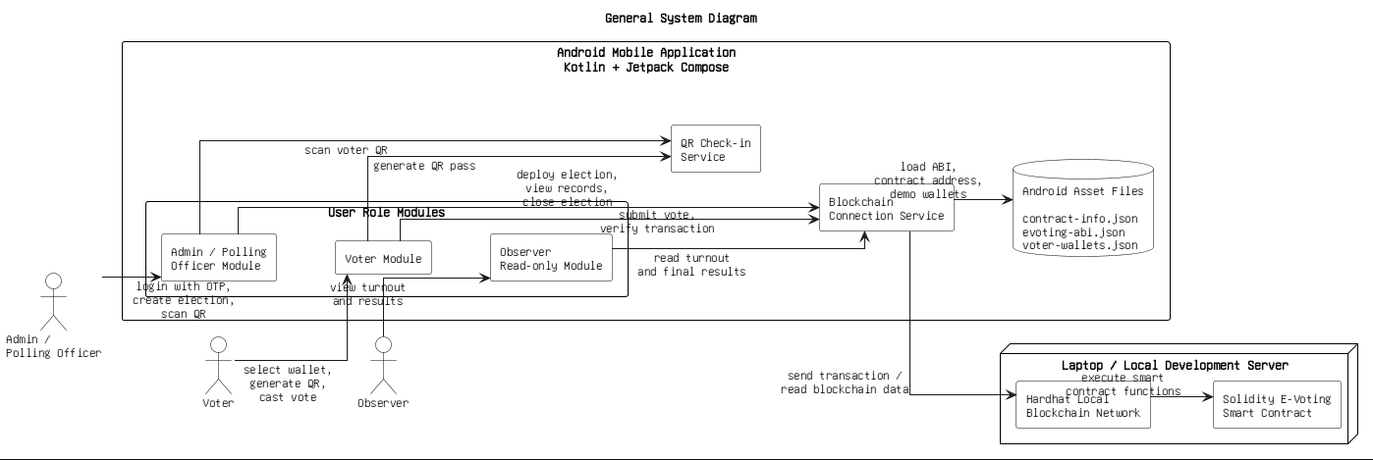
Fig 1: High-Level System Architecture Diagram
Within the Android layer, the MVVM architecture pattern is used throughout. Compose UI screens observe StateFlow streams exposed by the AdminViewModel, which is the central state holder for the application. The AdminViewModel delegates all blockchain operations to the BlockchainElectionRepository, which in turn calls the lower-level BlockchainRepository for direct smart contract communication using Web3j. A local ElectionCacheStore using Android SharedPreferences maintains session state between screen navigations.

5.2 Smart Contract Design
The EVoting.sol contract is the authoritative source of truth for all voting data. Three core data structures are stored in Solidity mappings. The elections mapping stores Election structs indexed by election ID. Each Election struct holds the title, start and end timestamps, an existence flag, a closed flag, a candidate count, and a total vote count. A nested candidates mapping stores Candidate structs ID, name, and vote count keyed by election ID and candidate ID. Three separate boolean mappings per election track voter status: eligibleVoters, checkedInVoters, and hasVoted, all indexed by voter address.
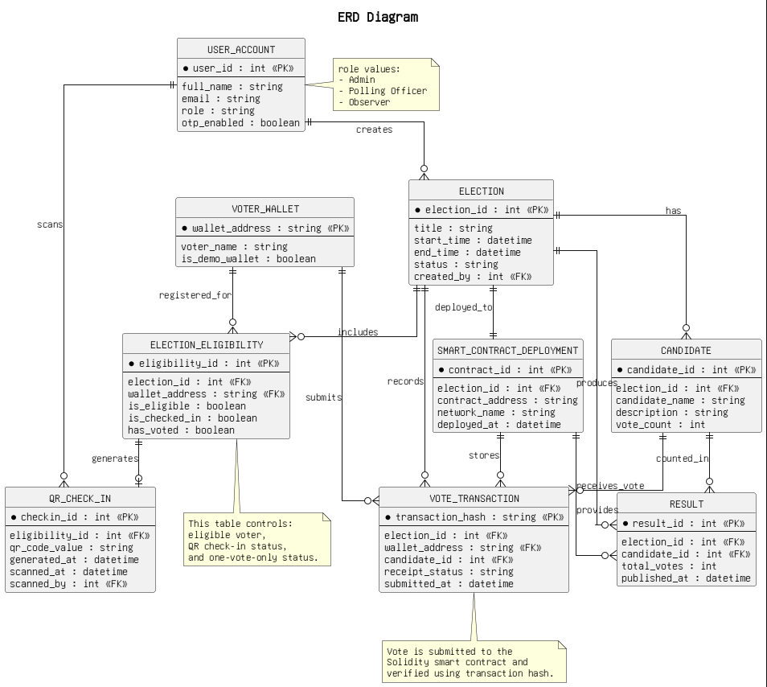
Fig 2: EVoting Smart Contract
Access control is enforced through an onlyOwner modifier that restricts all administrative functions to the contract deployer's address. The vote function enforces eight validation checks through Solidity require statements: the election must exist, not be manually closed, be within its time window, the calling address must be whitelisted, must have checked in, and must not have voted previously. Any failed condition reverts the transaction with a descriptive error message. The contract emits events for all state changes, forming an immutable on-chain audit trail.

5.3 Navigation and Role Separation
All route names are defined as constants in an AppRoutes object and the single NavHost in AppNavGraph.kt uses them throughout.
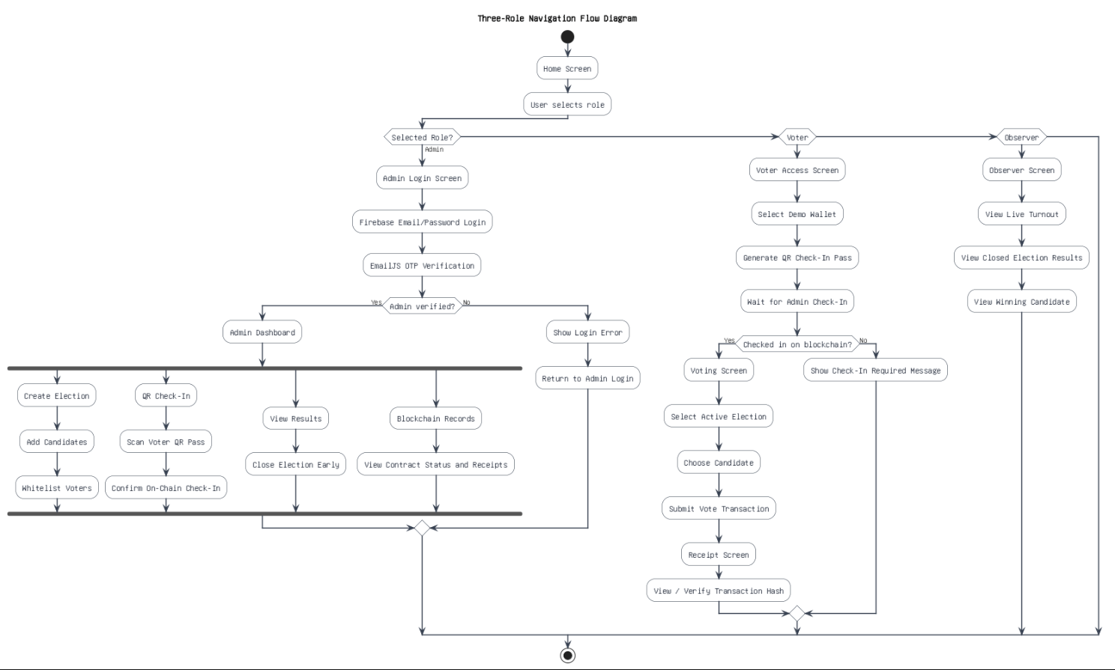
Fig 3: Three-Role Navigation Flow Diagram
The AuthSessionViewModel holds the current wallet address and the active role enum. Admin-protected routes are wrapped in a RequireAdminAccess composable that checks the session state and redirects to the login screen if no valid admin session exists. Voter-protected routes use an equivalent RequireVoterAccess wrapper. The observer screen carries no authentication wrapper, making it publicly accessible as intended.

5.4 QR Check-In Design
The QR pass format was designed after reviewing the findings from Dalia et al. (2022) on the importance of physical and temporal verification. The pipe-delimited payload includes four fields:
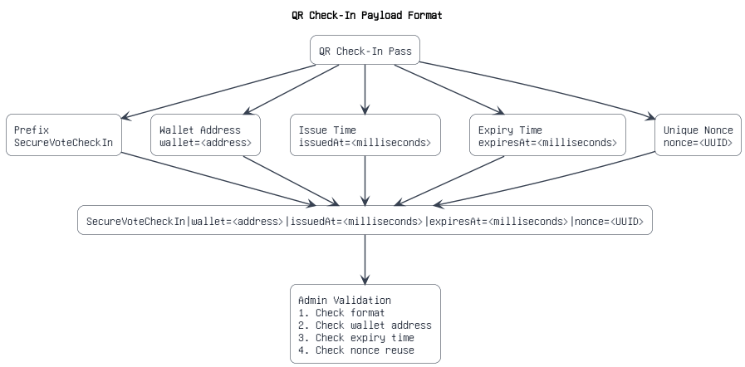
Fig 4: QR Check-In
The two-minute validity window ensures a pass cannot be reused in a different check-in session. The UUID nonce makes every pass unique even for the same voter on the same device. On the admin side, scanned nonces are added to an in-memory set for the duration of the check-in screen session, preventing the same pass being accepted twice within that session.

5.5 Admin Authentication Design
The two-factor admin login was designed to provide meaningful security while remaining practical without a server infrastructure.
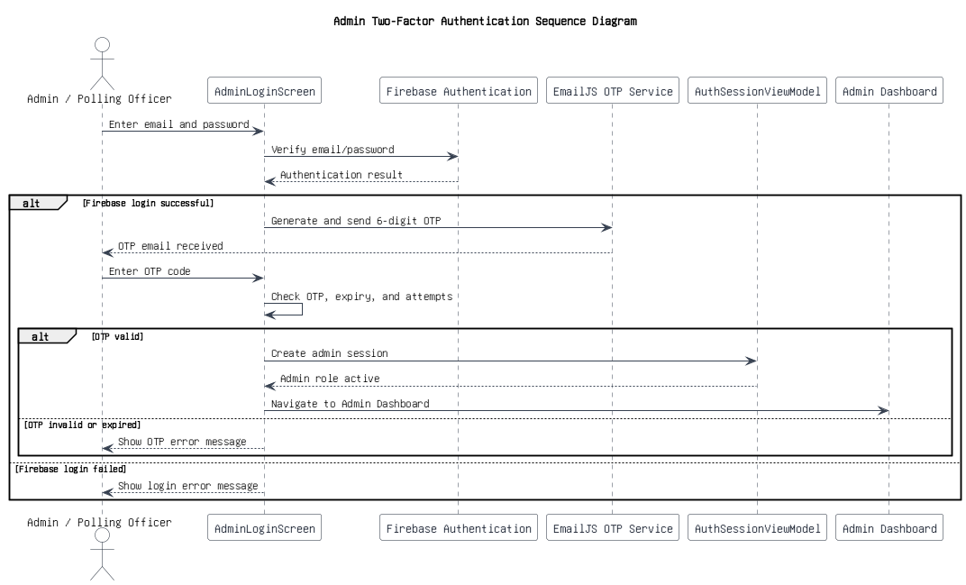
Fig 5: Admin Two-Factor Authentication Sequence Diagram
The flow works in two steps. In the first step, the admin enters an email address and password, which are verified against Firebase Authentication. If this fails, the flow stops entirely. In the second step, once Firebase confirms the credentials, a six-digit OTP is generated using Java's SecureRandom and sent via the EmailJS API to the registered address. The OTP is stored in Compose rememberSaveable state with an expiry timestamp. The admin enters the received code; if it matches and has not expired, the admin session is established in AuthSessionViewModel.

5.6 User Interface Design
The interface was designed around three distinct role colour themes applied consistently across all role-specific screens: indigo for admin, teal for voter, and coral for observer. This consistent colour coding helps users immediately understand which role context they are operating in. The Manrope typeface was chosen for its clean geometric style and good legibility at small sizes on mobile screens. All screens use Material 3 components from Jetpack Compose, including Cards, OutlinedTextFields, LinearProgressIndicators, and AlertDialogs, to maintain visual consistency throughout the application.

5.7 Security and Auditability Design
Auditability is provided through two mechanisms. First, smart contract events are emitted when important actions occur, including election creation, candidate addition, voter whitelisting, check-in, vote casting and closure. Second, the voter receives a transaction hash receipt after voting. The application verifies this receipt by checking the transaction status, the destination contract address and the VoteCast event topic. Together, these mechanisms allow the prototype to demonstrate independent verification without relying on a hidden server database.
From a security design perspective, the most important boundary in the system is the smart contract. The Android application improves usability, role separation and workflow guidance, but it is not trusted to enforce final voting rules. A modified APK could attempt to call contract functions in a different order, but the contract still rejects invalid actions such as voting without eligibility, voting without check-in, voting outside the time window or voting more than once. This separation is important because the blockchain layer acts as the authoritative control point.
The design also records important prototype limitations. Demo private keys are bundled with the app only to make assessment testing possible; they would need to be replaced with secure external wallet signing in a production version. Similarly, the QR nonce set is held for the check-in session and is not a permanent anti-replay database. Finally, because the blockchain is transparent, the Android interface can delay results until closure but cannot make raw on-chain data fully secret. A privacy-preserving production design would require a commit-reveal scheme, zero-knowledge proof or another specialised voting protocol.

Chapter 6: Software Requirement Analysis

6.1 Introduction
This chapter defines the functional and non-functional requirements for SecureVote Nepal. Requirements were derived from the project objectives in Chapter 1, the key findings from the literature review in Chapter 2, and the use case analysis conducted during the design phase. A feasibility study was also conducted at the project outset to confirm the work was achievable within the available time, skills, and resources.

6.2 Functional Requirements
Table 3 lists all functional requirements organised by user role.
Each requirement was treated as a testable statement rather than just a design intention. Functional requirements were marked as complete only when the related behaviour could be demonstrated through the app or through the Solidity contract. For example, a voter being blocked without check-in was not considered complete simply because the voting button was disabled in the user interface; it was considered complete only because the smart contract itself rejects that transaction. This distinction is important because the project uses the blockchain layer as the trusted enforcement point.
The requirements also separate prototype behaviour from production behaviour. A requirement such as receipt verification is satisfied when the app can verify a local Hardhat transaction against the deployed contract address and VoteCast event. It does not imply that the same workflow is ready for a public election without stronger wallet custody, identity assurance and privacy controls. This separation keeps the evaluation fair and prevents the report from overclaiming what the implemented software proves.

ID | Role | Requirement
FR01 | Admin | Admin must log in using Firebase email/password followed by an email OTP (2FA)
FR02 | Admin | Admin must create elections with a title, candidate list, time window, and voter whitelist
FR03 | Admin | Election creation must be recorded on-chain through smart contract transactions
FR04 | Admin | Admin must scan and validate a voter QR pass (format, expiry, nonce) before check-in
FR05 | Admin | Admin must complete check-in by sending a checkInVoter transaction to the contract
FR06 | Admin | Admin must be able to close an election early via a smart contract transaction
FR07 | Admin | Results must only be shown in the app interface after an election is closed
FR08 | Admin | A blockchain records screen must show contract status and session vote receipts
FR09 | Voter | Voter must select a demo wallet and generate a time-limited QR check-in pass
FR10 | Voter | Voter must only access the voting screen after QR check-in is confirmed on-chain
FR11 | Voter | The blockchain must validate eligibility and check-in status before vote submission
FR12 | Voter | Voter must cast a vote as a signed blockchain transaction
FR13 | Voter | The vote transaction hash must be displayed as a receipt after a successful vote
FR14 | Voter | Voter must be able to verify a receipt hash against the blockchain
FR15 | Observer | Observer view must be accessible without any authentication
FR16 | Observer | Observer view must show live turnout data per election: eligible, checked-in, voted counts
FR17 | Observer | Observer view must show closed election results and the winning candidate
Table 3: Functional Requirements

6.3 Non-Functional Requirements
The non-functional requirements were prioritised according to prototype risk. Security, responsiveness and maintainability were treated as high-priority requirements because weaknesses in these areas would undermine the main aim of the project. Portability was treated as medium priority because the app only needed to run on Android devices for the assessment, but it still had to support both an emulator and a physical phone connected to the laptop-hosted Hardhat node.
ID | Category | Requirement
NF01 | Security | Admin access must require two-factor authentication
NF02 | Security | All voting rules must be enforced on-chain, not in client code only
NF03 | Performance | All blockchain calls must run on background threads; UI must remain responsive
NF04 | Usability | All major actions must show loading, success, and error feedback states
NF05 | Reliability | Network failures must show descriptive error messages rather than crashing
NF06 | Maintainability | Code must follow MVVM with a repository layer separating blockchain from UI
NF07 | Portability | Minimum SDK version 26 (Android 8.0 Oreo)
Table 4: Non-Functional Requirements

6.4 Feasibility Study
Technical feasibility was assessed by writing a small proof-of-concept in week one that sent a signed raw transaction from an Android emulator to a local Hardhat node using Web3j. The test succeeded, confirming the core approach was viable before committing to it. The main technical risk identified was gas price management: the Hardhat development node returns a gas price of zero by default, which required the custom resolveGasPrice method with a minimum floor value to prevent transaction failures.
Operational feasibility was confirmed by verifying that all required tools are freely available and that the development hardware, a Windows laptop with 16 GB RAM, was sufficient to run Android Studio, the Hardhat node, and an Android emulator simultaneously without performance problems.
Schedule feasibility was assessed by listing all major features and estimating development time for each. The estimate confirmed the core voting flow could realistically be completed within twelve weeks, with four weeks remaining for testing and documentation. Features including full Nepali translation and production-level wallet integration were designated as stretch goals from the outset.

Chapter 7: Implementation and Testing

7.1 Introduction
This chapter describes how SecureVote Nepal was built, covering the smart contract, the blockchain repository, the QR check-in system, and the voting flow. Short code extracts are used to illustrate the most important implementation decisions. Full source code listings are in Appendix G, and the full manual test log is in Appendix C.

7.2 Smart Contract Implementation
The vote function is the most critical part of the contract and illustrates the multi-layered validation approach.
The six require statements ensure a vote can only succeed when every condition is genuinely satisfied. Any failed condition reverts the entire transaction with a descriptive message, and no state change is recorded on-chain for rejected votes. This means the enforcement lives entirely in the contract and cannot be bypassed by modifying the Android application.
The addEligibleVoters batch function was added after initial development to allow multiple voter addresses to be whitelisted in a single transaction, reducing setup time significantly for elections with several voters.

7.3 BlockchainRepository Implementation
The resolveGasPrice method fetches the current network gas price and applies a minimum floor of 2 gwei. This was necessary because the Hardhat development node can return a gas price that is unsuitable for the transaction flow, which caused early transaction failures before the fix was implemented. The chain ID is hardcoded as 31337, the standard Hardhat network ID. The polling processor waits up to 40 seconds for confirmation, polling every second; during testing on the local node, receipts consistently arrived within two to three seconds.
Receipt verification performs three sequential checks. First, the receipt status must be 0x1 (success). Second, the transaction's to address must match the configured contract address. Third, the transaction logs must contain the VoteCast event topic.
This three-step verification ensures a receipt hash genuinely represents a vote transaction on the correct contract, not just any successful Ethereum transaction.

7.4 QR Check-In Implementation
QR pass generation in VoterAccessScreen uses ZXing's QRCodeWriter to encode the payload string into a 900x900 pixel bitmap.
The VotingScreen (Figure 6) uses a state machine gated by VotingAccessUiState. When the voter selects an election, the AdminViewModel launches a background coroutine to call validateVoting in the repository, which runs all four checks against the live blockchain: eligibility, check-in status, election timing, and double-vote status. The Submit Secure Vote button only becomes enabled once all checks pass and a candidate is selected.
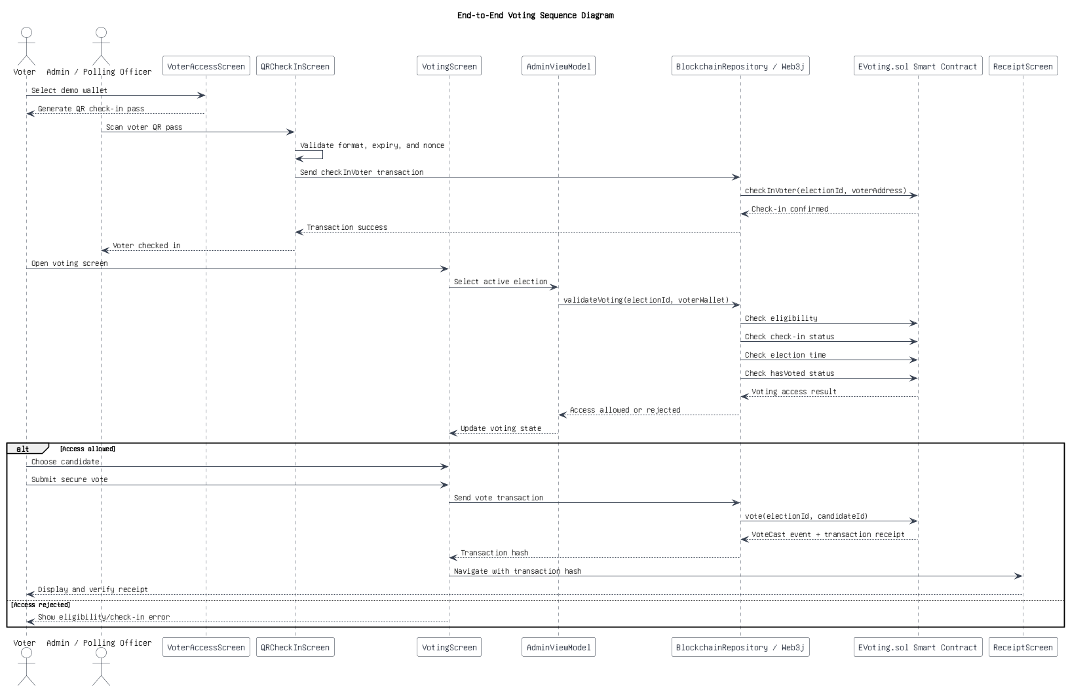
Fig 6: End-to-End Voting Sequence

7.5 Voting and Receipt Verification Implementation
The voting implementation combines UI gating with contract-level enforcement. The Android screen prevents accidental invalid submissions by checking the selected election, candidate, wallet session and live blockchain access state before enabling the vote button. However, this client-side gating is treated only as a usability layer. The decisive validation still occurs inside EVoting.sol, where the vote transaction is rejected if the caller is not eligible, has not checked in, has already voted, chooses an invalid candidate, or attempts to vote outside the permitted time window. This layered approach makes the workflow smoother for normal users while keeping final authority on-chain.
The receipt screen was implemented to make blockchain audit evidence understandable to a non-expert user. Instead of only showing a success message, the app displays the transaction hash and provides verification actions. This supports the project aim because the voter is not expected to trust a hidden database or a server message. The receipt can be checked against the same blockchain network that stores the election data, which demonstrates the verifiability benefit discussed in the literature review.
On successful vote submission, the transaction hash is extracted from the receipt and passed to the ReceiptScreen where it is displayed with options to view the full receipt details, scan or enter a different hash to verify, and share the hash as a QR code. The receipt verification flow calls the three-step check described in section 7.3 and displays the result as either verified or invalid.

7.6 Testing

7.6.1 Smart Contract Unit Tests
Ten automated unit tests were written in TypeScript using Hardhat and Chai. Each test deploys a fresh contract instance in a beforeEach hook, ensuring complete isolation between tests. Table 5 shows all ten test cases and their results.

TC | Test Description | Result
TC01 | Create election: correct event emitted and state initialised | PASS
TC02 | Add candidates and whitelist voters: state updated correctly | PASS
TC03 | Eligible checked-in voter can vote; voteCount incremented | PASS
TC04 | Non-eligible voter cannot check in; reverts "Voter is not eligible" | PASS
TC05 | Eligible voter without check-in cannot vote; reverts "Voter not checked in" | PASS
TC06 | Double voting prevented; reverts "You have already voted" | PASS
TC07 | Invalid candidate ID rejected; reverts "Invalid candidate" | PASS
TC08 | Owner closes election early; correct event emitted, isClosed = true | PASS
TC09 | Voting rejected after early closure; reverts "Election is closed" | PASS
TC10 | Non-owner admin actions rejected; reverts "Only owner can perform this action" | PASS
Table 5: Smart Contract Unit Test Cases
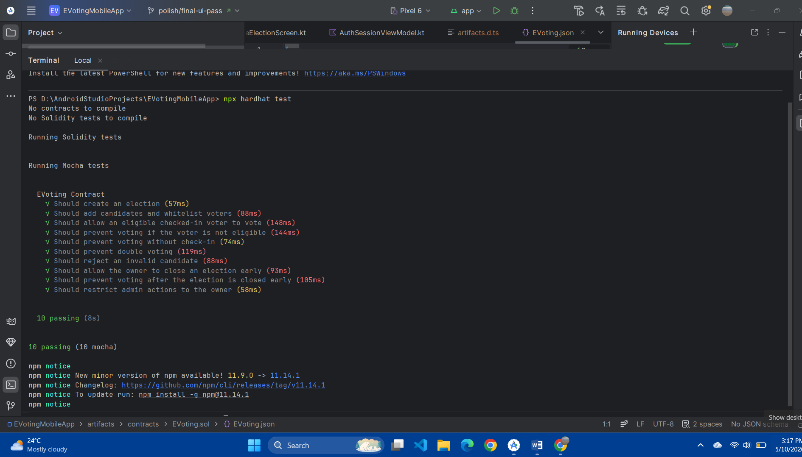
Fig 7: Smart Contract Unit Test Results
All ten tests passed on first run with the command npx hardhat test. The full terminal output is included in Appendix C.

7.6.2 Android Build Verification
The application was compiled using the command .\gradlew :app:assembleDebug. All Kotlin source files compiled without errors and a debug APK was produced successfully. The Android unit test task .\gradlew :app:testDebugUnitTest also completed with BUILD SUCCESSFUL. The existing ExampleUnitTest contains only a placeholder assertion and does not test application logic; writing meaningful ViewModel and repository unit tests is identified as future work in Chapter 10.

7.6.3 Manual End-to-End Testing
A complete end-to-end test was performed on a physical Android 12 device connected over Wi-Fi to a Hardhat node running on the development laptop. The laptop's local Wi-Fi IP address was configured as the RPC URL. The full twelve-step test sequence and results are in Appendix C. The sequence covered: admin two-factor login, election creation with two candidates and five voter addresses, QR check-in for one voter, vote submission and receipt display, receipt verification, early election closure, results display, a rejected double-vote attempt, and a rejected expired QR scan. All twelve steps passed successfully.

Chapter 8: Product Evaluation

8.1 Introduction
This chapter evaluates the success of the product by comparing what was actually delivered against the original requirements defined in Chapter 6. Product evaluation is distinct from testing. Testing asks whether the software functions correctly; evaluation asks whether it delivers what was originally planned and to what degree. The requirements traceability matrix in Table 6 drives this evaluation.

8.2 Functional Requirements Evaluation
ID | Requirement | Status | Notes
FR01 | Admin 2FA login (Firebase + OTP) | Complete | Fully implemented and tested manually
FR02 | Create elections with full details | Complete | Works; date field is text input not a picker
FR03 | Election creation recorded on-chain | Complete | All creation steps are on-chain transactions
FR04 | Validate QR pass before check-in | Complete | Format, expiry, and nonce all validated
FR05 | On-chain checkInVoter transaction | Complete | Signed admin transaction sent to contract
FR06 | Admin can close election early | Complete | closeElectionEarly function implemented
FR07 | Results only after election closure | Complete | isClosed flag checked before UI rendering; raw on-chain data remains transparent in the prototype
FR08 | Blockchain records screen | Complete | Contract status and session receipts shown
FR09 | Voter generates time-limited QR pass | Complete | 2-min expiry + UUID nonce implemented
FR10 | Voting only after on-chain check-in | Complete | VotingAccessUiState gating enforced
FR11 | On-chain eligibility/check-in validation | Complete | All checks run against live blockchain
FR12 | Vote as signed blockchain transaction | Complete | Signed with voter wallet via Web3j
FR13 | Transaction hash receipt displayed | Complete | Hash shown in ReceiptScreen post-vote
FR14 | On-chain receipt verification | Complete | Three-step verification implemented
FR15 | Observer view without authentication | Complete | No auth wrapper on observer route
FR16 | Live turnout data per election | Complete | Voted count is read on-chain; eligible and checked-in counts are supported by cached setup/check-in state
FR17 | Closed election results and winner | Complete | Winner = highest voteCount candidate
Table 6: Requirements vs Implementation

8.3 Non-Functional Requirements Evaluation
NF01 (two-factor authentication) is fully satisfied through the Firebase and EmailJS OTP flow. NF02 (on-chain enforcement) is fully satisfied: all voting rules are in the contract's require statements and cannot be bypassed by modifying the client. NF03 (background threading) is satisfied throughout: every blockchain call uses Dispatchers.IO coroutines and the UI remained responsive during all testing. NF04 (feedback states) is satisfied: loading spinners, success dialogs, and error snackbars are present on all key screens. NF05 (reliability) is partially satisfied: errors are caught and displayed, though some error messages reflect the raw exception text rather than a user-friendly description. NF06 (MVVM) is fully satisfied across the codebase. NF07 (minSdk 26) is satisfied as confirmed in app/build.gradle.kts.

8.4 Incomplete Features
Two planned features were not completed. The Nepali language support exists as a string resource file at values-ne/strings.xml but it contains the same English text as the default file, meaning no actual translation is active in the app. This was deliberately deprioritised after the core voting flow was confirmed working, as completing it within the remaining time would have left less time for testing and documentation. The Reown WalletConnect integration is present as an imported dependency and the initialisation scaffold exists in EVotingApplication.kt but was intentionally left inactive to avoid performance issues during the demo. Both gaps are clearly documented in the project's PROTOTYPE_LIMITATIONS.md file.

8.5 Overall Assessment
The product delivers all core blockchain voting functionality as originally planned. The smart contract is clean, well-tested, and extensible. The end-to-end voting flow works correctly on a physical device. The code is well-structured with consistent MVVM layering, the Kotlin Result type used throughout for error propagation, and a clear separation between blockchain concerns and UI concerns. The known limitations are honest and proportionate to the prototype scope of the project.
The evaluation also shows that the strongest evidence for the product is contract-level behaviour. A mobile interface can guide the user, but a voting system is only trustworthy if invalid actions fail even when attempted directly. The contract tests and manual test flow therefore provide stronger evidence than screenshots alone. At the same time, the evaluation identifies that some usability and production-readiness qualities, such as polished date pickers, persistent QR replay storage and complete localisation, remain outside the completed scope.
From a user-experience perspective, the product is successful because each role has a clear path through the system. The administrator controls election setup and check-in, the voter performs only wallet selection, QR presentation and vote submission, and the observer remains read-only. This separation reduces confusion during demonstration and also reflects the access-control design. The evaluation therefore treats role clarity as a product strength, even though wider usability testing with real users would be needed before making stronger claims about accessibility.
For this reason, the product should be understood as a working proof of concept. It demonstrates the technical feasibility of connecting an Android application directly to a Solidity voting contract, but a production version would need professional security review, stronger identity management, external wallet support, formal privacy controls, larger-scale testing and deployment to a properly managed blockchain network.
Although all core functional requirements were completed, the evaluation must be interpreted within the academic prototype scope. The system proves that the chosen architecture can support an auditable voting workflow, but it does not prove that the application is ready for a real election environment. The strongest parts of the product are the smart contract enforcement, the end-to-end mobile flow, the transaction receipt and the clear role separation. The weakest areas are production wallet security, privacy protection beyond pseudonymous addresses, persistence of QR nonces across sessions and complete multilingual support.

Chapter 9: Project Evaluation

9.1 Introduction
This chapter evaluates the success of the project as a whole. It covers the project management techniques used, assesses how well the original aims and objectives were addressed, identifies the problems encountered, and reflects on what went well. Evidence of project management tools and processes is in Appendix D.

9.2 Project Management Techniques
Three main project management tools were used throughout the project: a Gantt chart for timeline planning, a risk register for identifying and tracking risks, and a Git feature-branch workflow for version control.
Version control supported this management approach by allowing work to be separated into focused changes instead of one large untracked development effort. The project folder includes Git history, and the testing evidence records work on the fix/core-voter-flow-stability branch. This was useful when changes to the voter flow and QR check-in logic needed to be reviewed separately from UI styling and documentation updates. In a solo project, this workflow also provided a practical substitute for team-based code review by making each stage easier to inspect and, if necessary, roll back.
The Gantt chart (Appendix D) divided the sixteen-week project into five phases, with milestones marking the end of each. A revised version of the chart was produced in week eight after the blockchain integration phase ran slightly long, and a second revision was made in week twelve after the QR check-in redesign added time. Both revisions are in Appendix E with commentary on the reasons for each change.
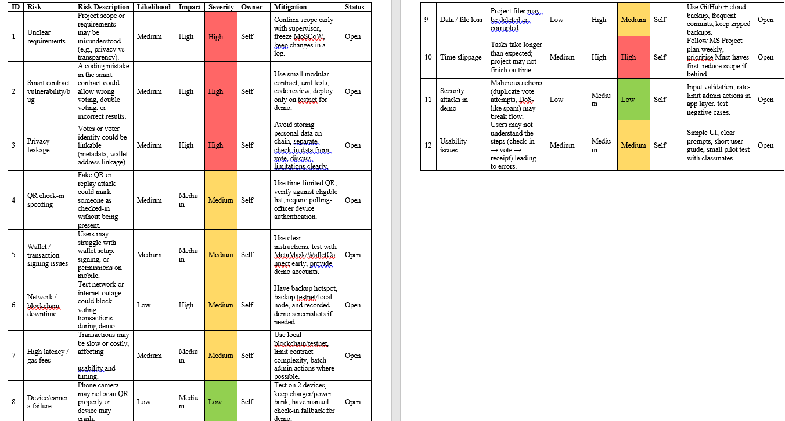Table 7: Project Risk Register

Supervision meetings were held regularly throughout the project, with minutes recorded for each session (Appendix D). The meetings were useful for resolving technical decisions that had stalled, checking that the project was on track against the plan, and getting feedback on early drafts of report sections.

9.3 Assessment Against Aims and Objectives
The primary aim was to design, develop, and evaluate a blockchain-based mobile voting application demonstrating a transparent, role-separated, and auditable election process. This aim was fully achieved. The application supports three clearly separated roles, all voting data is recorded on a blockchain, and voters can independently verify their vote receipt without trusting any central authority.
All ten specific objectives were met. The smart contract handles all election logic on-chain. The Android app connects via Web3j. Role-based access control separates all three flows. The QR check-in uses time-limited nonce-based passes. Firebase and EmailJS provide two-factor admin login. Transaction hash receipts are generated and verifiable. Ten smart contract unit tests pass and manual end-to-end testing was completed on a physical device. The product was evaluated against requirements in Chapter 8 with limitations documented throughout.

9.4 Problems Encountered
The most significant technical problem was getting Web3j transaction signing to work reliably. Early in development, transactions were being rejected by the Hardhat node because the node returns a gas price of zero by default and the application was using that value directly. The fix was implementing the resolveGasPrice method with a minimum floor of 2 gwei. Finding this took longer than expected because the error messages from failed transactions were not immediately descriptive.
A second challenge was managing state correctly in the MVVM architecture when blockchain calls could take one to three seconds. Selecting and changing elections quickly caused stale validation results to be applied to the wrong election. This was resolved by introducing the votingAccessCheckJob AtomicReference in AdminViewModel, which tracks the latest request and discards results from earlier ones if a newer request has already started.
The QR check-in design required two full iterations. The initial version used a plain wallet address as the QR payload with no time-bounding or replay protection at all. After reviewing the literature from Dalia et al. (2022) and Zhang et al. (2018), the format was redesigned to include the expiry timestamp and UUID nonce. This added approximately one week to the timeline but was the right decision from a security standpoint.

9.5 Project Successes
The smart contract is the most successful element of the project. It is concise, fully tested, and provides a genuinely solid foundation. The multi-layered vote validation, the event-based audit trail, and the batch voter whitelisting function all represent careful engineering decisions rather than just getting something to work.
The iterative development methodology was well-suited to this project. Validating the blockchain integration in week one before building any UI meant that the most technically uncertain part was de-risked early. If Web3j had proved unsuitable, the discovery would have happened with weeks still available to find an alternative.

Chapter 10: Summary and Conclusion

10.1 Summary of Findings
This project set out to investigate whether an Android mobile application backed by a blockchain smart contract could provide a transparent, role-separated, and independently auditable voting experience at a prototype level. The answer, based on the completed system, is yes.
SecureVote Nepal delivers a complete election lifecycle on a Solidity smart contract: creation, candidate registration, voter whitelisting, QR check-in, vote submission, receipt generation, election closure, and result display. A clean MVVM Android application communicates with the contract directly through Web3j without any backend server. Three user roles are cleanly separated in both the navigation architecture and the access control logic. All voting rules are enforced at the contract level through require statements that cannot be bypassed by modifying the Android client. Ten smart contract unit tests cover all critical behaviours and all pass. The complete end-to-end flow was successfully demonstrated on a physical Android device.
The literature review confirmed that blockchain provides immutability, transparency, and verifiability that centralised systems cannot easily replicate (Kshetri and Voas, 2018), and identified the persistent challenges around voter privacy and key management that remain as limitations of this prototype. The technology review showed that a direct Android-to-blockchain architecture using Web3j is feasible and practical for a prototype context.

10.2 Recommendations
A further recommendation is to preserve evidence throughout development rather than collecting it only at the end. Screenshots of test results, Git commits, meeting notes and build outputs are useful not only for the appendix but also for evaluating the project honestly. In this project, the testing evidence and prototype limitation notes helped separate completed functionality from future work. For similar projects, maintaining a small evidence folder from the first week would make final report preparation more efficient and would reduce the risk of unsupported claims. This also strengthens academic transparency and final assessment confidence.
Based on the experience of building this project, three recommendations stand out for anyone developing a similar system. First, always validate the blockchain integration layer with a working proof-of-concept before committing to any UI work. The exact behaviour of Web3j around gas pricing and transaction confirmation is not fully apparent from documentation alone and needs empirical testing. Second, design on-chain data structures carefully before writing any Solidity code. Changing storage layouts after deployment means redeploying the contract and migrating any existing state. Third, write automated smart contract tests from the very beginning. The Hardhat test suite runs in seconds and catching contract bugs through unit tests is far faster than debugging through a mobile UI.

10.3 Future Work
If development were to continue, the most important next step would be replacing the bundled private key approach with a proper WalletConnect or Reown integration. This is the correct production solution and would allow voters to sign transactions from a secure external wallet without exposing private keys inside the APK.
Deploying the smart contract to a public Ethereum testnet such as Sepolia would be the next significant step after that. This would eliminate the dependency on a locally running Hardhat node and make the application demonstrable across different devices and networks without shared local infrastructure.
For privacy, incorporating a commit-reveal voting scheme or zero-knowledge proofs would address the pseudonymity limitation that Shahzad and Crowcroft (2019) identify as inherent to public blockchain wallet addresses. These techniques would allow votes to be verified as valid without revealing the specific wallet behind each transaction.
Completing the Nepali language translation by extracting all remaining hardcoded strings to resource files and providing proper Nepali text would make the application genuinely accessible to its intended geographic audience rather than just partially localised.

10.4 Conclusion
SecureVote Nepal demonstrates that blockchain technology can be applied in a practical mobile voting context to provide transparency and independent verifiability that a centralised system cannot easily match. The system works. The smart contract enforces voting rules correctly and its behaviour is confirmed by ten passing unit tests. The Android application handles the complete voting lifecycle from admin login through to result display. The end-to-end flow was successfully tested on a physical device.
The known limitations are clearly acknowledged and are appropriate for an academic prototype. The private key management, local-only blockchain, and prototype-level QR security are not failures of the design but honest trade-offs made to produce a demonstrable system within a single semester. The foundation that has been built is solid enough to support the future work described above, and the project has been a substantial learning experience in both Ethereum smart contract development and Android application engineering.

Bibliography

Books
Antonopoulos, A.M. and Wood, G. (2018) Mastering Ethereum: Building Smart Contracts and DApps. Sebastopol: O'Reilly Media.
Phillips, J. (2019) IT Project Management: On Track from Start to Finish. 4th edn. New York: McGraw-Hill Education.
Sommerville, I. (2016) Software Engineering. 10th edn. Harlow: Pearson Education.
Tanenbaum, A.S. and Van Steen, M. (2016) Distributed Systems: Principles and Paradigms. 3rd edn. Scotts Valley: CreateSpace Independent Publishing.

Journal Articles and Conference Papers
Dalia, A.A., Ahmed, A.I.A., Saleh, S.A., Alghamdi, M.I. and Eldin, S.M. (2022) 'A comprehensive review of blockchain-based e-voting system', IEEE Access, 10, pp. 19668-19687.
Hardwick, F.S., Akram, R.N., Markantonakis, K. and Gnan, L. (2018) 'E-voting with blockchain: an e-voting protocol with decentralisation and voter privacy', arXiv preprint, arXiv:1805.10258. Available at: https://arxiv.org/abs/1805.10258 (Accessed: 10 April 2026).
Khan, K.M., Arshad, J. and Khan, M.M. (2018) 'Secure digital voting system based on blockchain technology', International Journal of Electronic Government Research, 14(1), pp. 53-62.
Kshetri, N. and Voas, J. (2018) 'Blockchain-enabled e-voting', IEEE Software, 35(4), pp. 95-99.
Pawlak, M., Poniszewska-Maranda, A. and Kryvinska, N. (2018) 'Towards the intelligent agents for blockchain e-voting system', Procedia Computer Science, 141, pp. 239-246.
Shahzad, B. and Crowcroft, J. (2019) 'Trustworthy electronic voting using adjusted blockchain technology', IEEE Access, 7, pp. 24477-24488.
Zhang, W., Yuan, Y., Hu, B., Tong, H. and Wang, F.Y. (2018) 'A privacy-preserving voting protocol on blockchain', in Proceedings of the 2018 IEEE International Conference on Cloud Computing. San Francisco: IEEE, pp. 401-408.

Online Sources
Android Developers (2024) Jetpack Compose overview. Available at: https://developer.android.com/jetpack/compose (Accessed: 12 April 2026).
Election Commission Nepal (2024) Official website. Available at: https://election.gov.np (Accessed: 5 April 2026).
Ethereum Foundation (2024) Ethereum developer documentation. Available at: https://ethereum.org/en/developers/docs/ (Accessed: 10 April 2026).
Firebase (2024) Firebase Authentication documentation. Available at: https://firebase.google.com/docs/auth (Accessed: 11 April 2026).
Hardhat (2024) Hardhat documentation. Available at: https://hardhat.org/docs (Accessed: 8 April 2026).
Reown (2024) Reown AppKit documentation. Available at: https://docs.reown.com (Accessed: 11 April 2026).
Trail of Bits (2020) 'Voatz security review'. Available at: https://blog.trailofbits.com/2020/03/13/our-full-assessment-of-the-voatz-app/ (Accessed: 8 April 2026).
Solidity (2024) Solidity documentation v0.8.28. Available at: https://docs.soliditylang.org (Accessed: 7 April 2026).
Web3j (2024) Web3j documentation. Available at: https://docs.web3j.io (Accessed: 9 April 2026).
ZXing (2024) ZXing open source barcode library. Available at: https://github.com/zxing/zxing (Accessed: 10 April 2026).

Appendix A: Ethical Approval Form

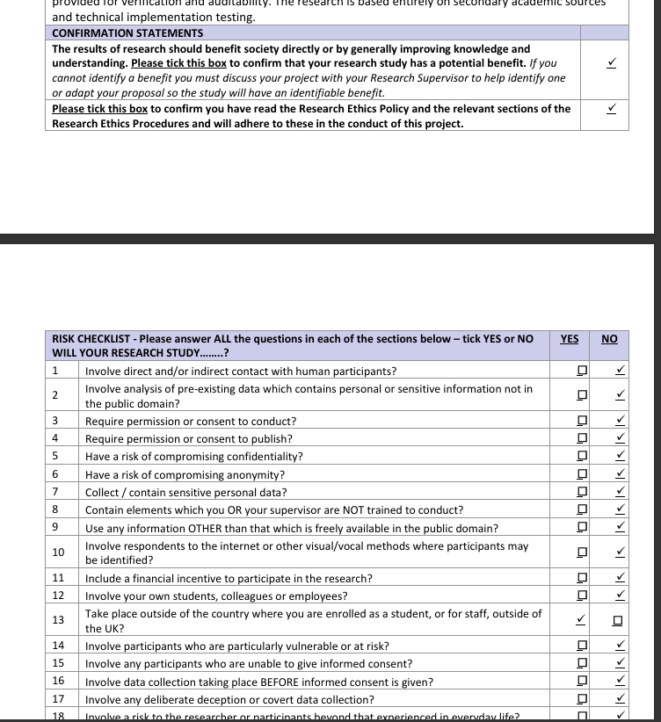
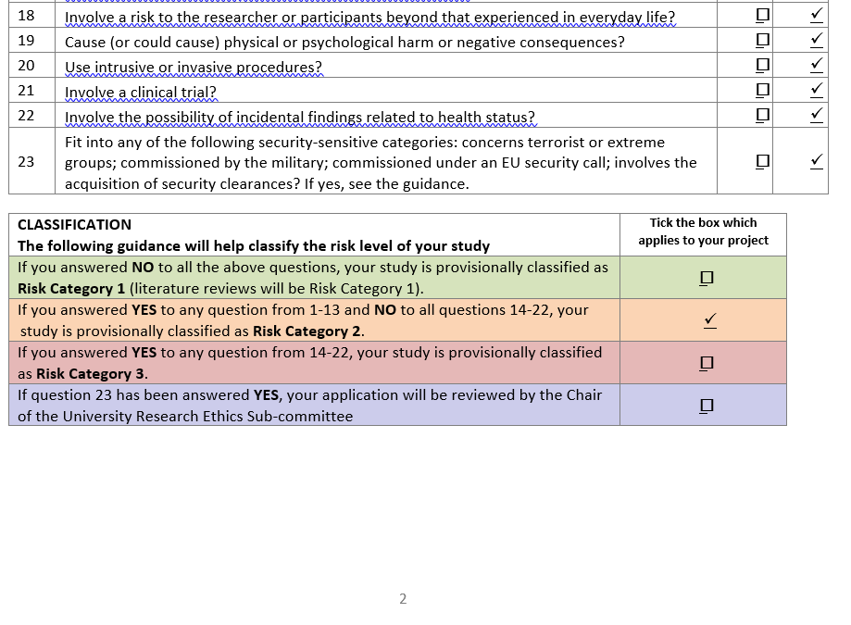
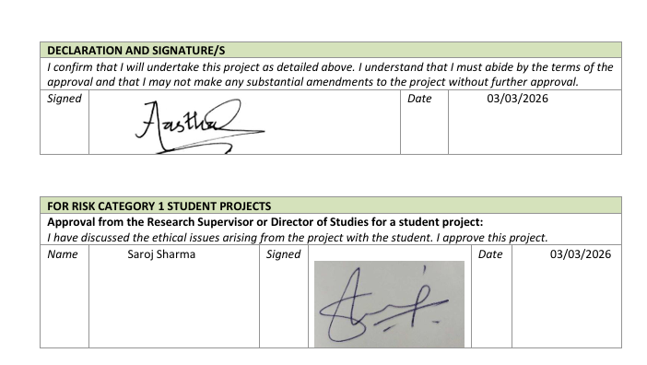
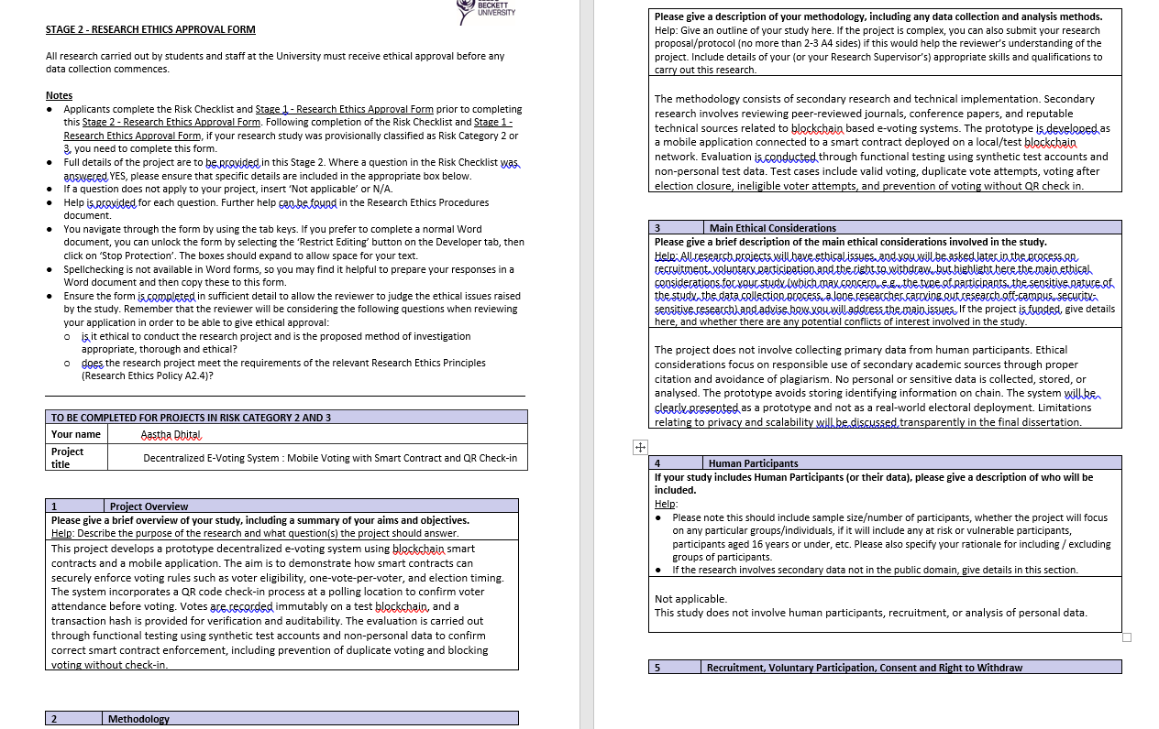

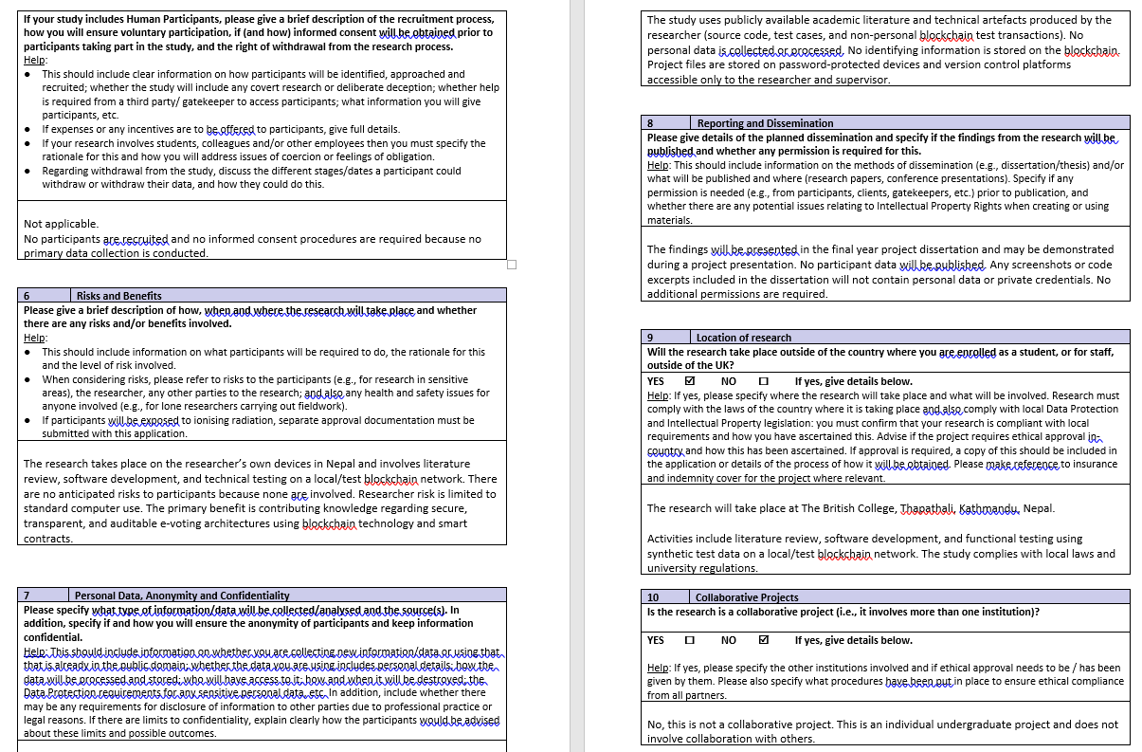
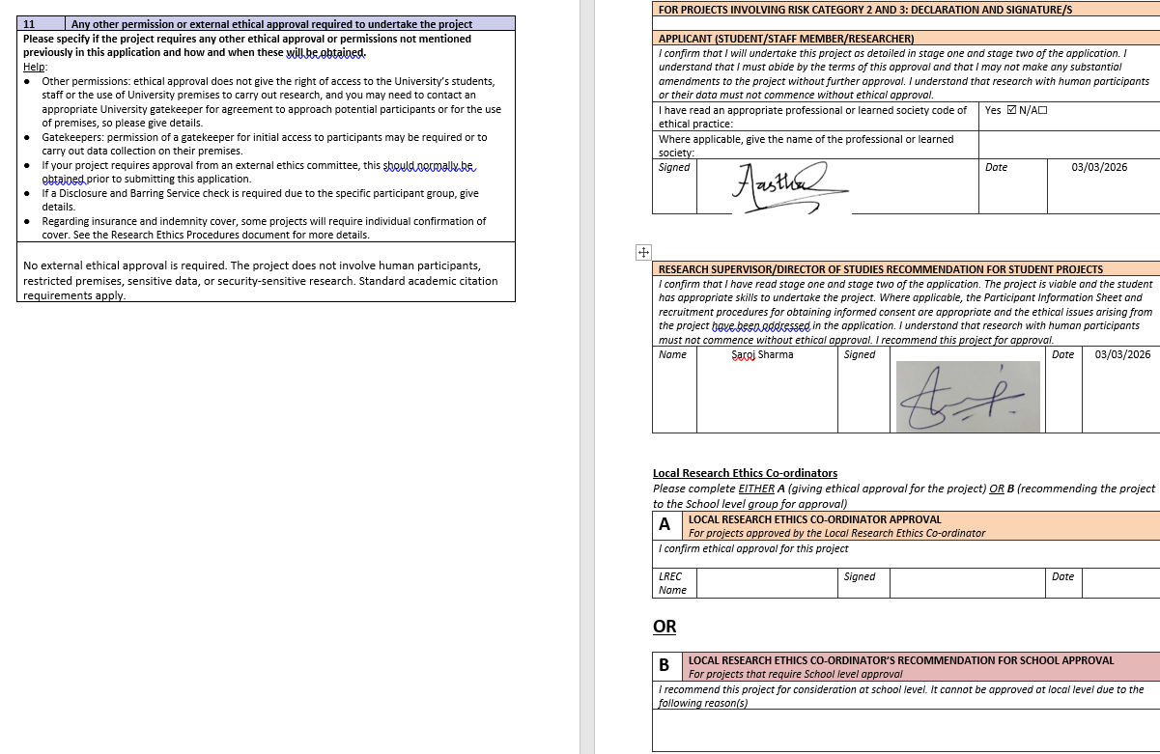

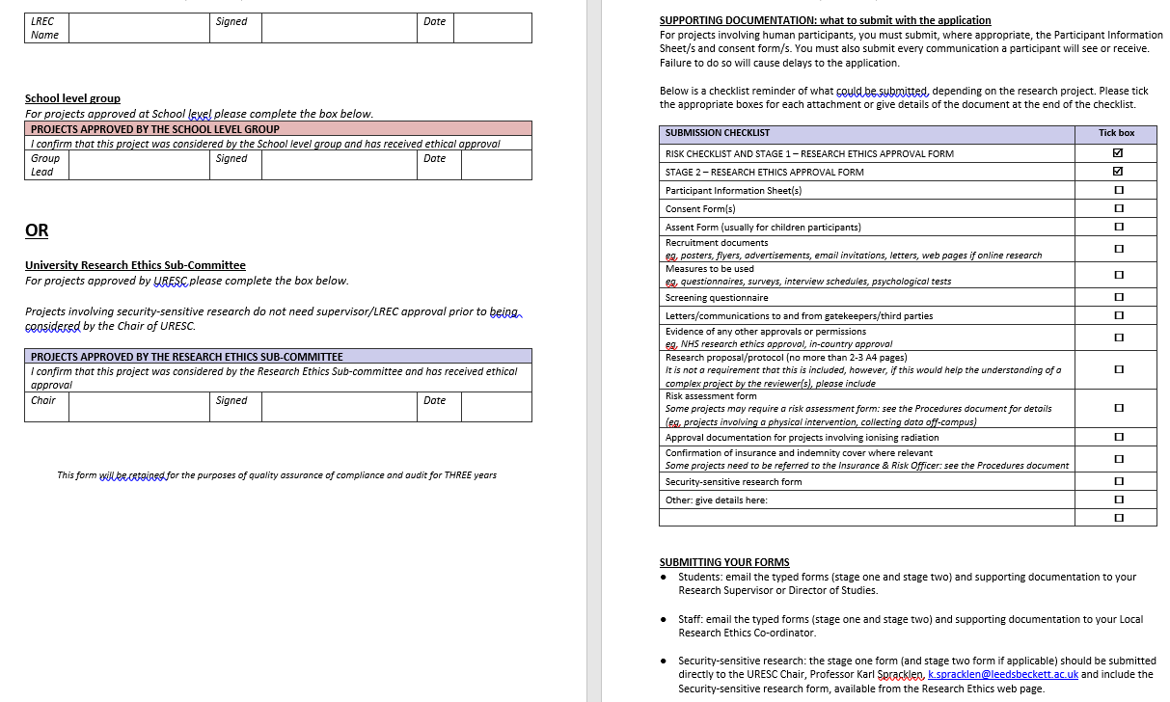

Appendix B: SDLC Design Documentation

B.1 Use Case Diagram
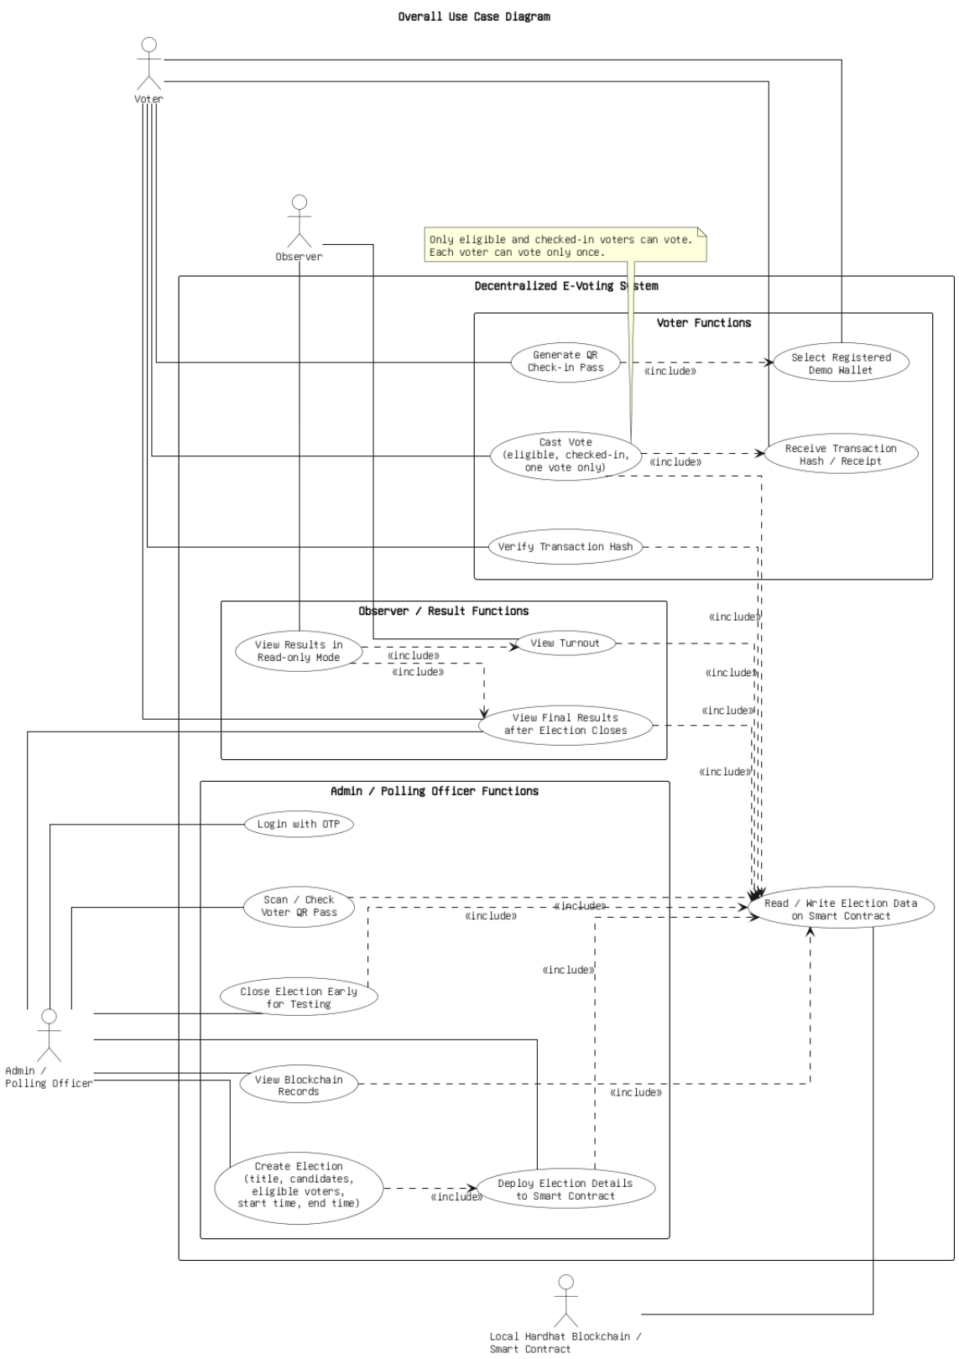

B.2 Sequence Diagram
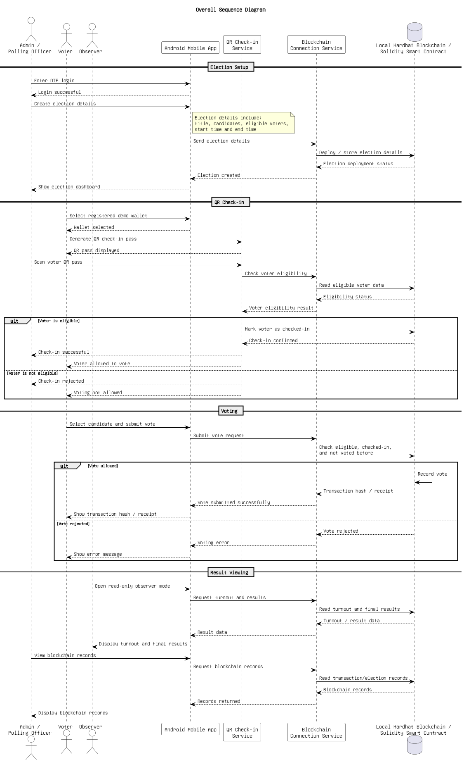

B.3 On-Chain Data Model (ERD)


Appendix C: Testing Evidence

C.1 Smart Contract Unit Test Terminal Output
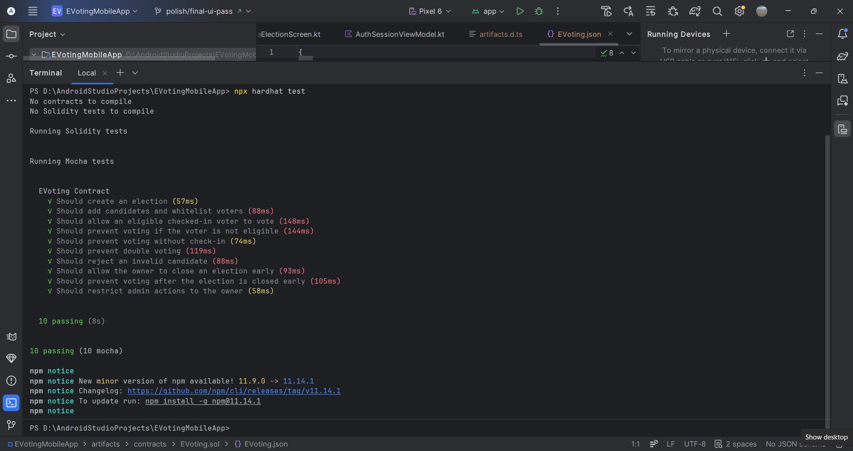

C.2 Manual End-to-End Test Log
Step | Action | Expected Result | Outcome
1 | Admin enters Firebase credentials, requests OTP | OTP email received within 30s | PASS
2 | Admin enters correct OTP within time window | Admin dashboard displayed | PASS
3 | Admin creates election: 2 candidates, 5 voter wallets | Election visible on-chain in list | PASS
4 | Voter selects wallet and generates QR pass | QR displayed with 2-minute timer | PASS
5 | Admin scans valid QR pass within expiry | Voter wallet address shown for confirmation | PASS
6 | Admin confirms check-in | Voter marked checked-in on blockchain | PASS
7 | Voter selects candidate and submits vote | Transaction sent; hash receipt displayed | PASS
8 | Voter verifies receipt hash | Verified: valid VoteCast transaction | PASS
9 | Admin closes election early | Election marked closed on blockchain | PASS
10 | Admin views results | Correct winner and vote counts shown | PASS
11 | Same voter attempts to vote again | Rejected: "You have already voted" | PASS
12 | Admin scans an expired QR pass | Rejected: "QR expired" | PASS

C.3 Android Build and Unit Test Evidence
The Android build was verified using .\gradlew :app:assembleDebug and completed with BUILD SUCCESSFUL. The Android unit test task .\gradlew :app:testDebugUnitTest also completed with BUILD SUCCESSFUL. These results support the build verification discussion in Chapter 7, while the existing ExampleUnitTest is acknowledged as a placeholder rather than a full logic test suite.

Appendix D: Project Management Evidence

D.1 Gantt Chart

Fig D.1: Final Project Gantt Chart

D.2 Supervision Meetings
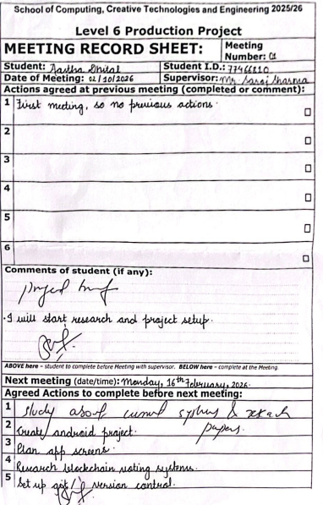





D.3 Risk Register

D.4 Version Control Evidence
Git was used during development to maintain a recoverable project history and to separate stabilisation work from other changes. The submitted project folder includes the repository metadata, and the testing evidence notes the fix/core-voter-flow-stability branch used when finalising the core voter flow. This supports the project evaluation discussion of version control and professional working practice.


Appendix E: Project Plan Versions and Commentary


Appendix F: User Guide

F.1 Prerequisites
The following must be installed on the development machine before running the application: Node.js version 18 or later, npm, Java Development Kit (JDK) 17 or later, Android Studio (latest stable release). A physical Android device running Android 8.0 (API 26) or later, or an Android emulator, is required for running the app.

F.2 Starting the Local Blockchain Node
Open a terminal in the project root folder (EVotingMobileApp) and run:
npm install
npx hardhat node
Leave this terminal open and running. Note the IP address of your development machine on the local Wi-Fi network (for example, 192.168.1.100).

F.3 Deploying the Smart Contract
In a second terminal, still in the project root, run:
npx hardhat run scripts/deploy.ts --network localhost
This compiles the contract, deploys it to the local Hardhat node, and automatically writes the deployed contract address and full ABI to app/src/main/assets/. This step must be completed before building the Android app.

F.4 Configuring the RPC URL
Open app/build.gradle.kts and update the RPC_URL BuildConfig field to your machine's local Wi-Fi IP address:
buildConfigField("String", "RPC_URL", "\"http://192.168.1.100:8545\"")
If testing on an emulator rather than a physical device, use 10.0.2.2 instead of the Wi-Fi IP address.

F.5 Building and Installing
In Android Studio, click Build > Make Project, then Run > Run 'app' to install the debug APK on the connected device or emulator. Alternatively, run from the terminal:
.\gradlew :app:assembleDebug

F.6 Running the app
Admin login: Tap Admin on the home screen. Enter the configured Firebase admin email and password. Wait for the OTP to arrive by email (usually within 30 seconds). Enter the six-digit code.
Creating an election: From the admin dashboard, tap Create New Election. Enter a title, at least two candidates, a start time (use a past time for immediate testing), an end time, and select voter wallet addresses from the list. Tap Create Election and wait for all on-chain transactions to confirm.
Voter check-in: On the voter device, tap Voter and select one of the five demo wallet addresses. The QR check-in pass is displayed with a two-minute timer. On the admin device, navigate to QR Check-In and scan the voter's QR code. Confirm the wallet address and tap Check In Voter.
Voting: Once check-in is confirmed, the voter device shows the voting screen. Select an active election, choose a candidate, and tap Submit Secure Vote. The transaction hash receipt is displayed on success.
Observer view: Tap Observer from the home screen at any time to see live turnout data and, once an election is closed, the results and winner.

Appendix G: Source Code Listings
The full source code is included in the project submission ZIP file. The files below are the key ones referenced in this report:

G.1 Vote Validation Function
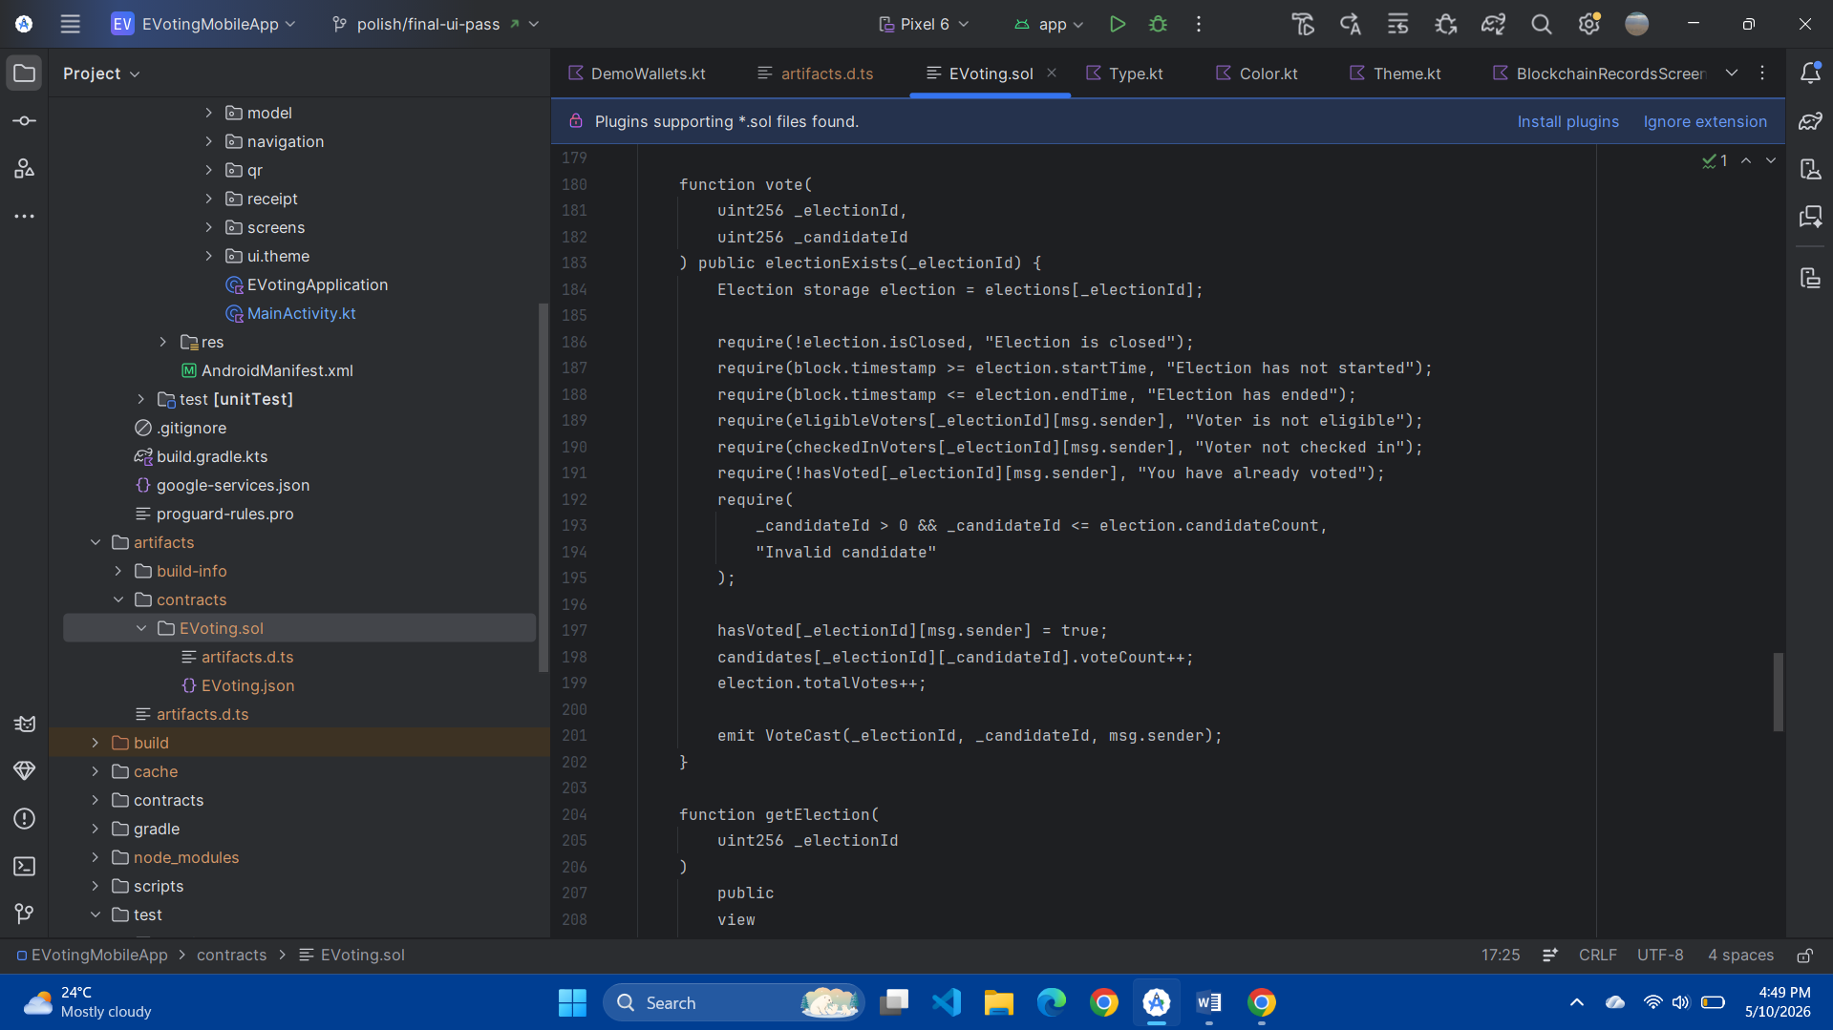
Fig G.1: Vote validation function in EVoting.sol

G.2 Batch Voter Whitelisting Function
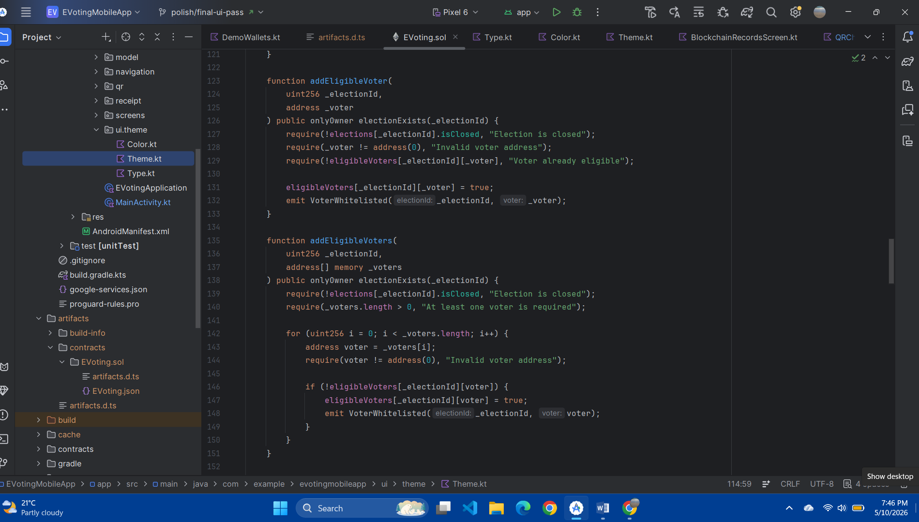
Fig G.2: Batch voter whitelisting function in EVoting.sol

G.3 Signed Transaction Submission
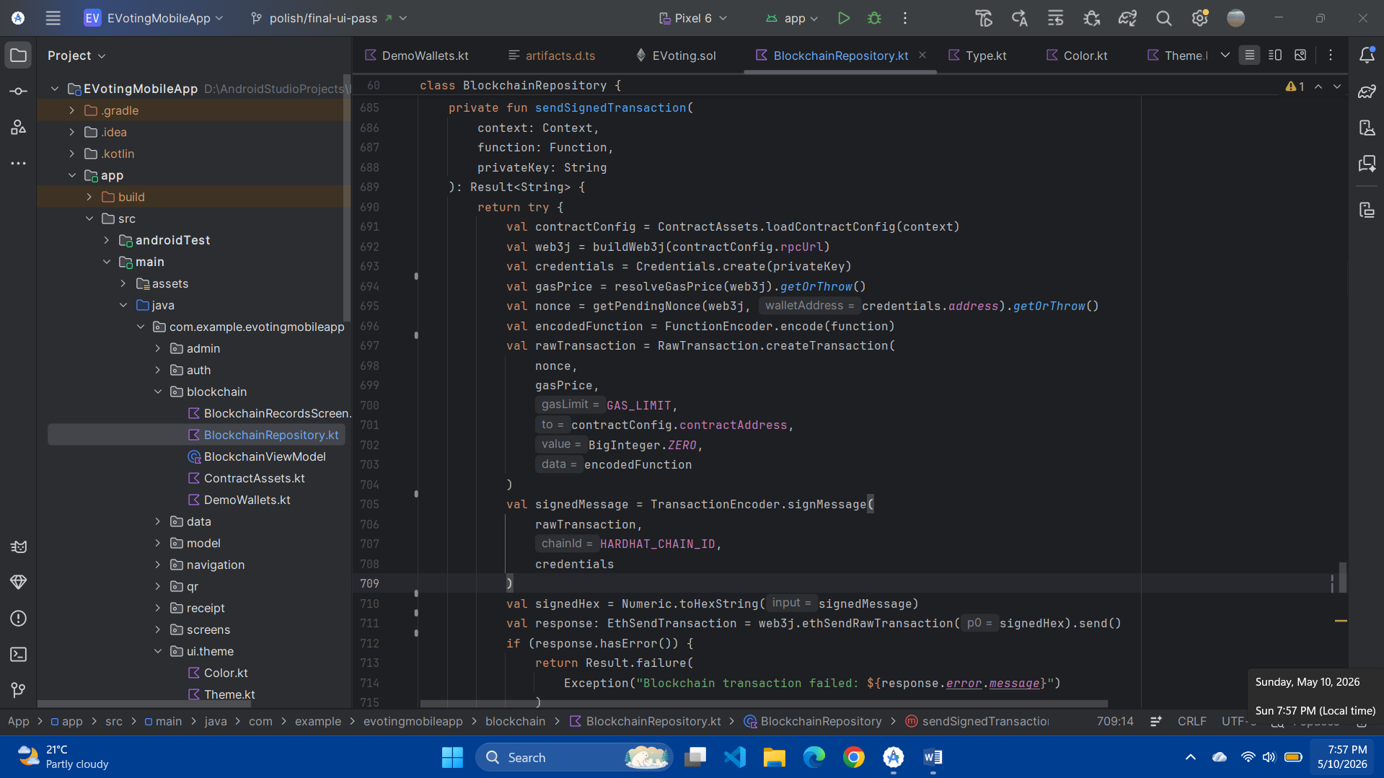
Fig G.3a: Creating and signing a raw blockchain transaction using Web3j
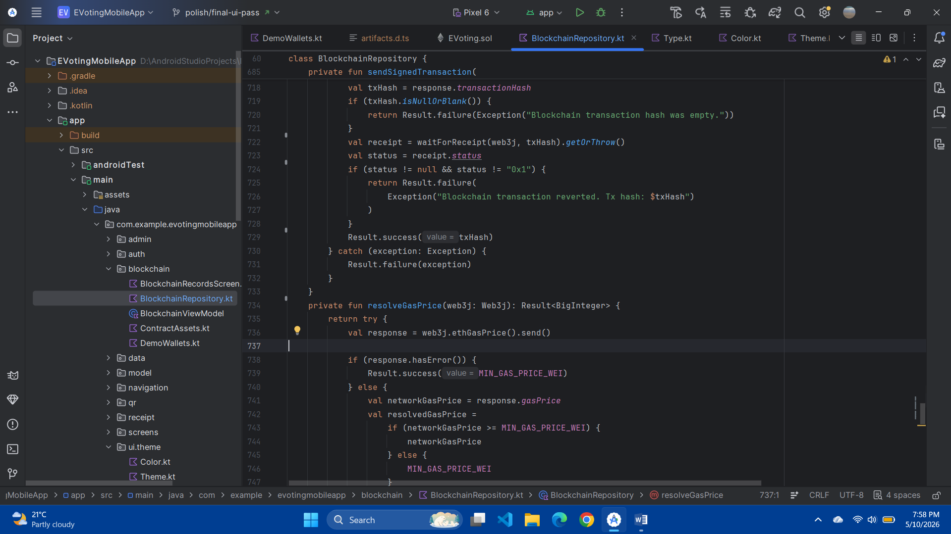
Fig G.3b: Sending the signed transaction and returning the transaction hash

G.4 QR Payload Validation
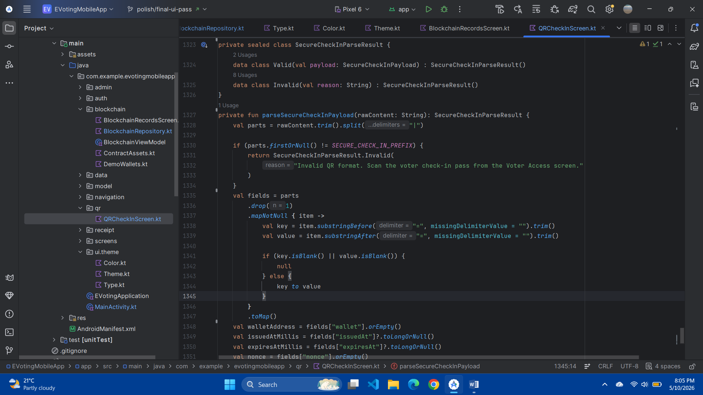
Fig G.4a: Data classes
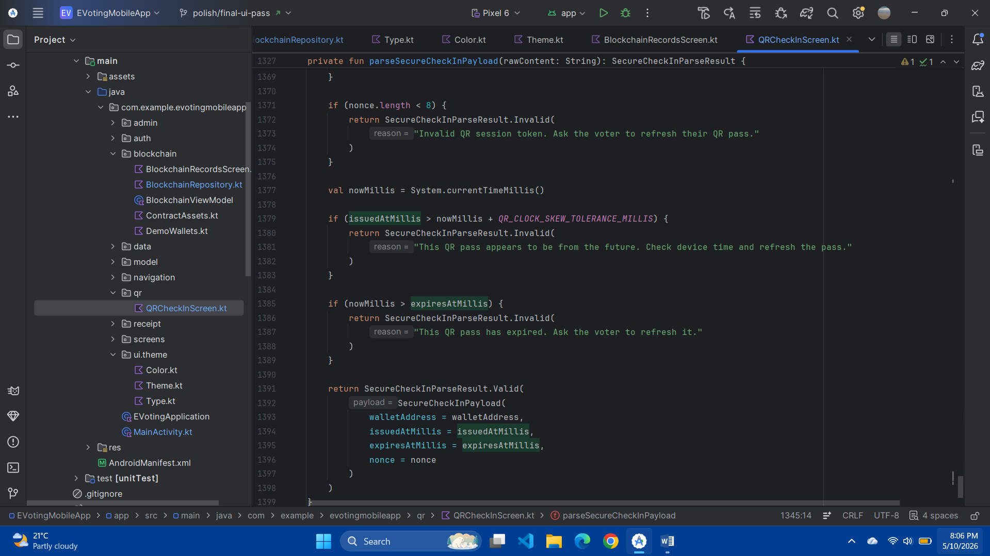
Fig G.4b: Expiry/nonce validation and valid payload return

G.5 Receipt Verification
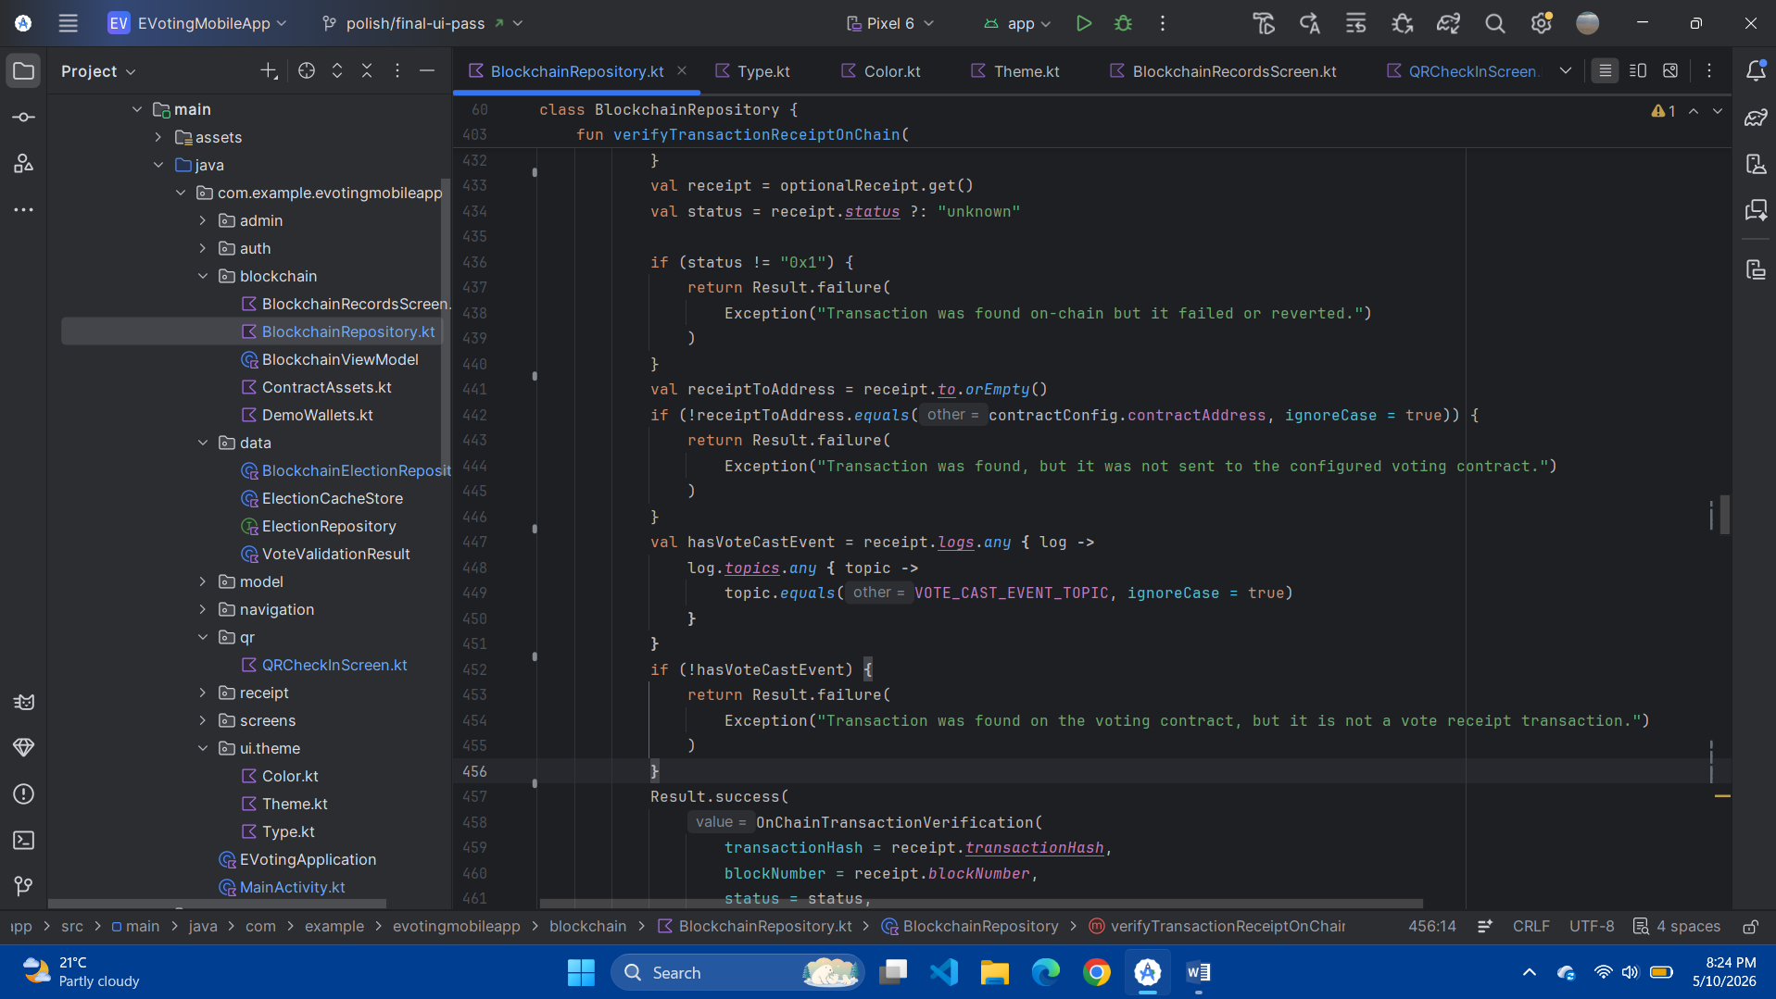
Fig G.5: Contract address, VoteCast event and receipt verification success checks

G.6 Smart Contract Unit Test Example
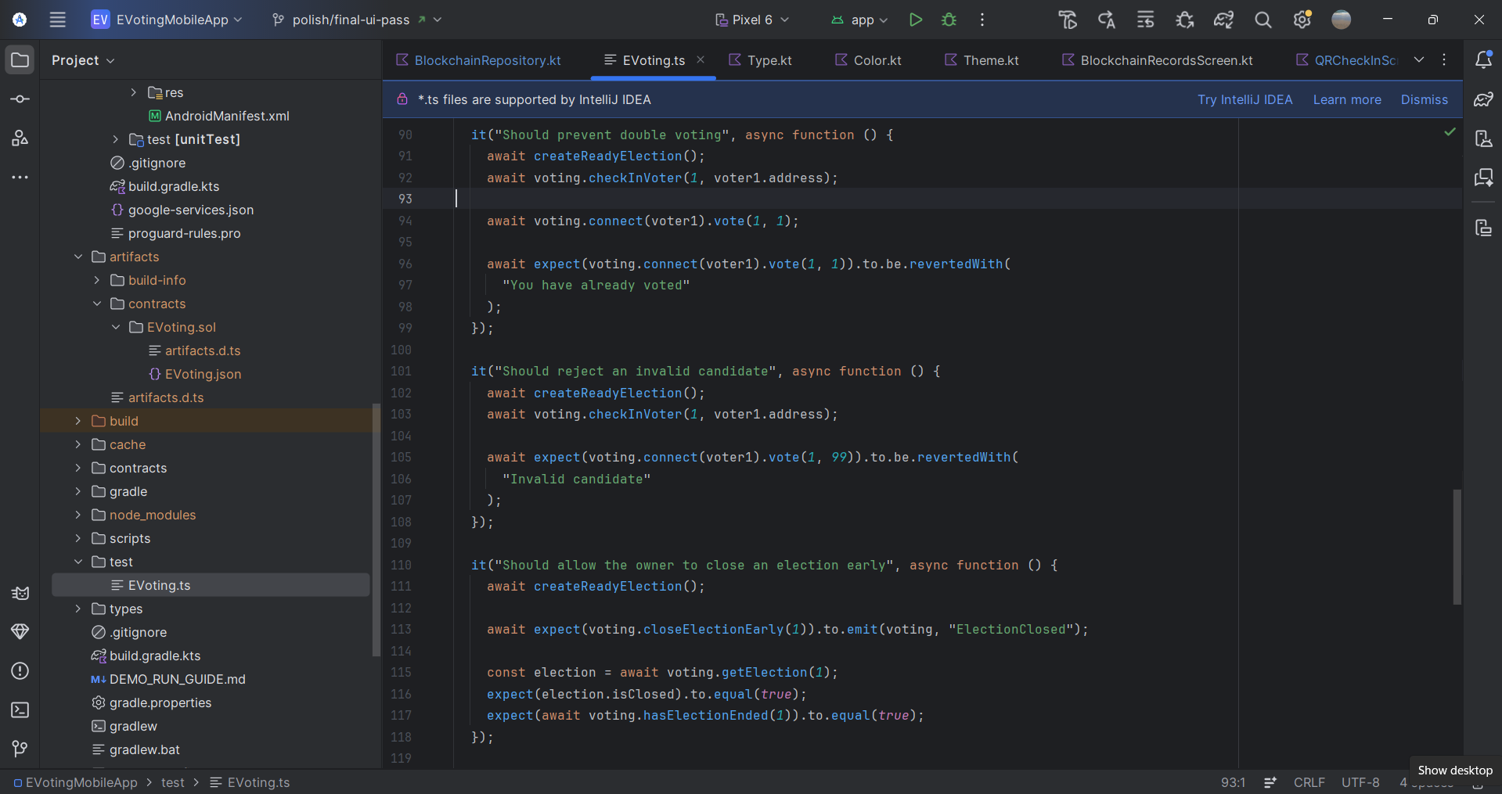
Fig G.6: Hardhat unit test for double vote prevention

G.7 Deployment Script
s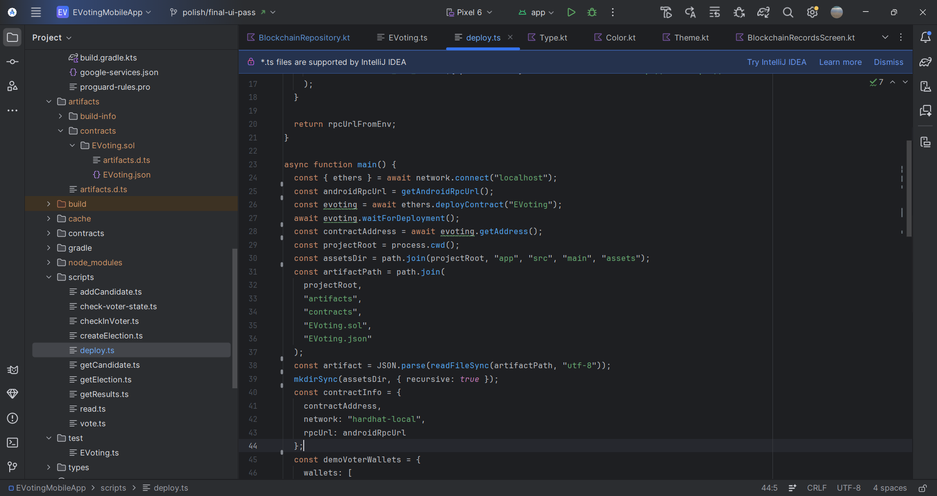
Fig G.7: Hardhat deployment script creating the EVoting contract and Android contract configuration

