HOTEL MANAGEMENT SYSTEM – COMPLETE SQL DOCUMENTATION

1. Introduction
The Hotel Management System is designed to digitalize and streamline core hotel operations including room booking, customer management, room categorization, billing, and payment processing. The goal of the system is to provide an efficient and user‑friendly structure to manage hotel records such as customers, rooms, reservations, bills, and invoices.

This documentation includes:
- System overview
- ER diagram description
- Relational schema
- SQL Table creation commands
- Oracle‑compatible insert queries
- Analytical SQL queries
- Final conclusion

2. System Overview
The system centralizes the digital management of multiple hotel operations:
- Customer information management
- Room types, pricing, and availability tracking
- Room booking and reservation handling
- Payment and invoice management
- Bill generation and reporting

The system ensures:
✔ Faster hotel operations
✔ Easy tracking of customer reservations
✔ Accurate billing and invoice management
✔ Reduced manual record handling

3. ER Diagram Explanation
The ER diagram consists of the following major entities and relationships:

Entities:
- Customer
- Hotel
- Room_Category
- Rooms
- Reservation
- Bill
- Payment
- Invoice

Key Relationships:
- A Customer makes one or more Reservations.
- A Hotel owns many Rooms.
- Rooms belong to one Room_Category.
- A Reservation generates a Bill.
- A Customer makes a Payment.
- A Payment results in an Invoice.

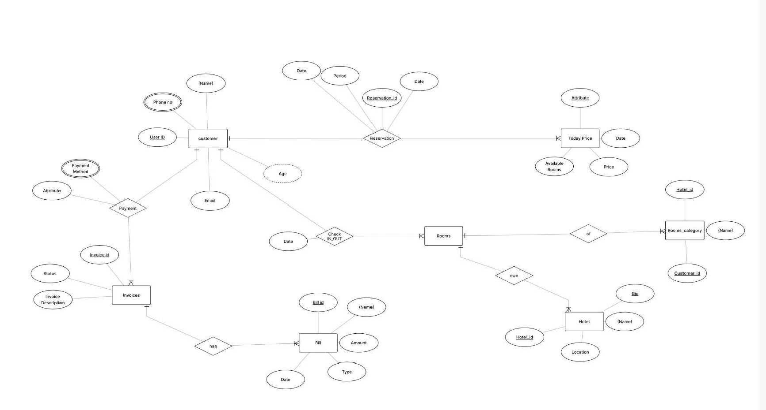

4. Relational Schema
The relational schema from the uploaded document includes:

Customer(User_ID, Name, Phone_No, Email, Age)
Hotel(Hotel_ID, Name, Location)
Room_Category(Category_ID, Category_Name)
Rooms(Room_ID, Hotel_ID, Category_ID, Type, Price, Availability_Status)
Reservation(Reservation_ID, User_ID, Room_ID, Hotel_ID, Date, Period)
Bill(Bill_ID, Room_ID, Amount, Type, Date)
Payment(Payment_ID, User_ID, Payment_Method, Date)
Invoice(Invoice_ID, Payment_ID, Status, Invoice_Description)

5. SQL Table Creation Statements
CREATE TABLE Customer s(
User_ID INT PRIMARY KEY,
Name VARCHAR2(100),
Phone_No VARCHAR2(20),
Email VARCHAR2(100),
Age INT
);

CREATE TABLE Hotel (
Hotel_ID INT PRIMARY KEY,
Name VARCHAR2(100),
Location VARCHAR2(150)
);

CREATE TABLE Room_Category (
Category_ID INT PRIMARY KEY,
Category_Name VARCHAR2(50)
);

CREATE TABLE Rooms (
Room_ID INT PRIMARY KEY,
Hotel_ID INT,
Category_ID INT,
Type VARCHAR2(50),
Price DECIMAL(10,2),
Availability_Status VARCHAR2(20),
FOREIGN KEY (Hotel_ID) REFERENCES Hotel(Hotel_ID),
FOREIGN KEY (Category_ID) REFERENCES Room_Category(Category_ID)
);

CREATE TABLE Reservation (
Reservation_ID INT PRIMARY KEY,
User_ID INT,
Room_ID INT,
Hotel_ID INT,
Date DATE,
Period INT,
FOREIGN KEY (User_ID) REFERENCES Customers(User_ID),
FOREIGN KEY (Room_ID) REFERENCES Rooms(Room_ID),
FOREIGN KEY (Hotel_ID) REFERENCES Hotel(Hotel_ID)
);

CREATE TABLE Bill (
Bill_ID INT PRIMARY KEY,
Room_ID INT,
Amount DECIMAL(10,2),
Type VARCHAR2(50),
Date DATE,
FOREIGN KEY (Room_ID) REFERENCES Rooms(Room_ID)
);

CREATE TABLE Payment (
Payment_ID INT PRIMARY KEY,
User_ID INT,
Payment_Method VARCHAR2(50),
Date DATE,
FOREIGN KEY (User_ID) REFERENCES Customer(User_ID)
);

CREATE TABLE Invoice (
Invoice_ID INT PRIMARY KEY,
Payment_ID INT,
Status VARCHAR2(50),
Invoice_Description VARCHAR2(255),
FOREIGN KEY (Payment_ID) REFERENCES Payment(Payment_ID)
);
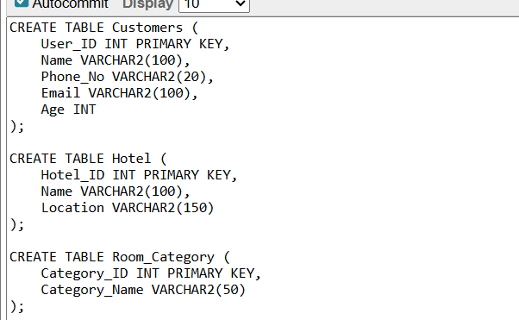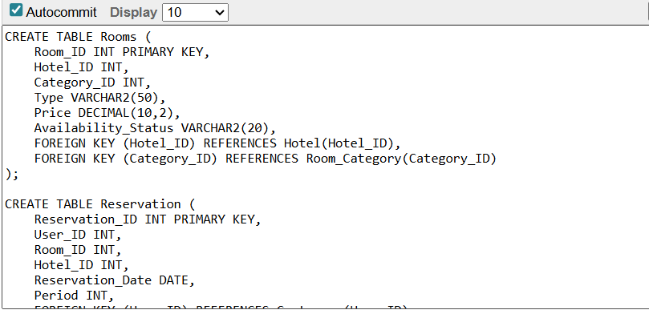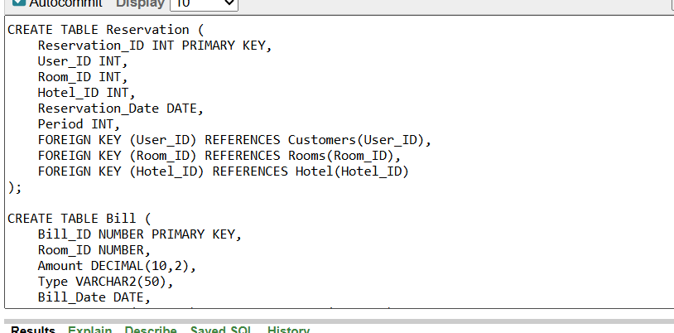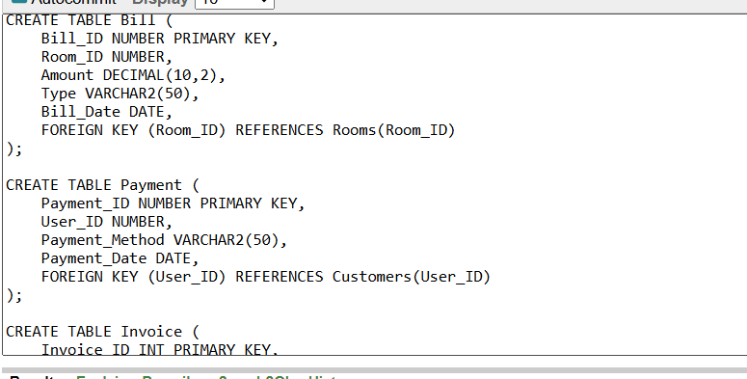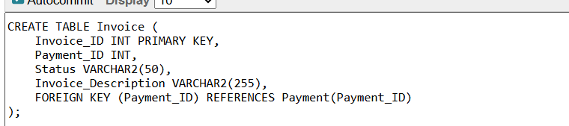

6. Insert Queries
INSERT ALL
INTO Customer VALUES (1,'Aastha Sheoran','9876543210','aastha@gmail.com',22)
INTO Customer VALUES (2,'Rohan Kumar','9876501234','rohan@gmail.com',25)
SELECT 1 FROM DUAL;

INSERT ALL
INTO Hotel VALUES (101,'Taj Palace','New Delhi')
INTO Hotel VALUES (102,'Oberoi Grand','Kolkata')
SELECT 1 FROM DUAL;

INSERT ALL
INTO Room_Category VALUES (1,'Deluxe')
INTO Room_Category VALUES (2,'Suite')
SELECT 1 FROM DUAL;

INSERT ALL
INTO Rooms VALUES (301,101,1,'AC',4500,'Available')
INTO Rooms VALUES (302,101,2,'Suite',7000,'Booked')
INTO Rooms VALUES (401,102,1,'AC',4000,'Available')
SELECT 1 FROM DUAL;

INSERT ALL
INTO Reservation VALUES (5001,1,301,101,DATE '2024-12-01',3)
INTO Reservation VALUES (5002,2,302,101,DATE '2024-12-05',2)
SELECT 1 FROM DUAL;

INSERT ALL
INTO Payment VALUES (9001,1,'UPI',DATE '2024-12-01')
INTO Payment VALUES (9002,2,'Card',DATE '2024-12-05')
SELECT 1 FROM DUAL;

INSERT ALL
INTO Invoice VALUES (8001,9001,'Paid','Room and service charges')
INTO Invoice VALUES (8002,9002,'Pending','Delayed payment')
SELECT 1 FROM DUAL;
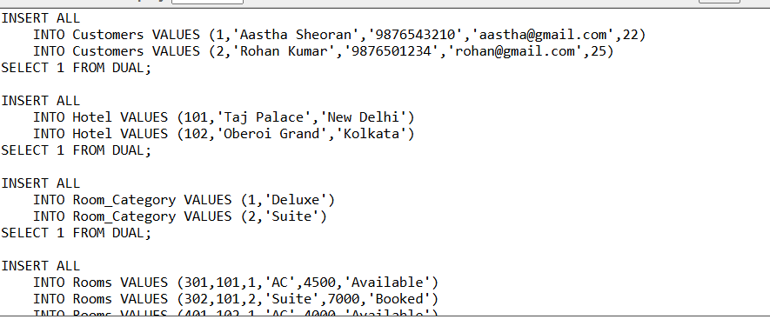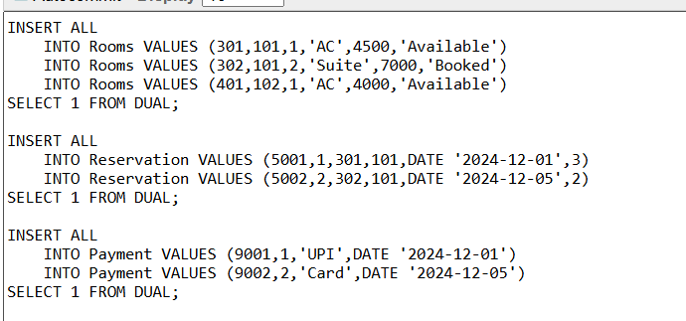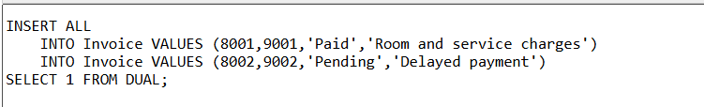

7. Important SQL Queries
1. Show all customers
SELECT * FROM Customers;
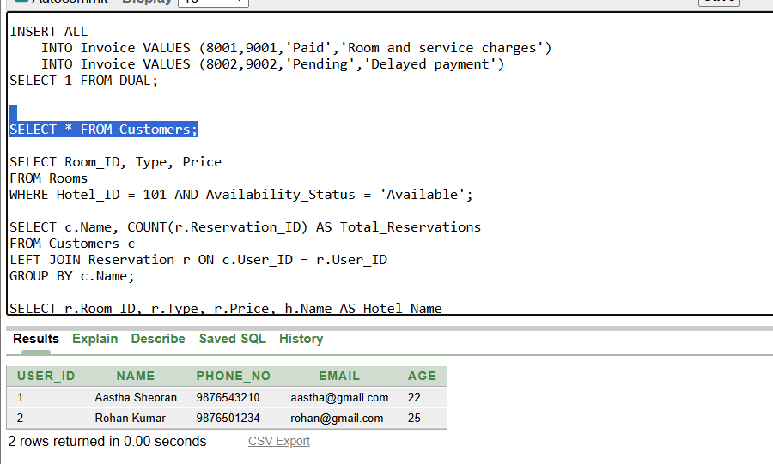

2. List available rooms in a hotel
SELECT Room_ID, Type, Price
FROM Rooms
WHERE Hotel_ID = 101 AND Availability_Status = 'Available';
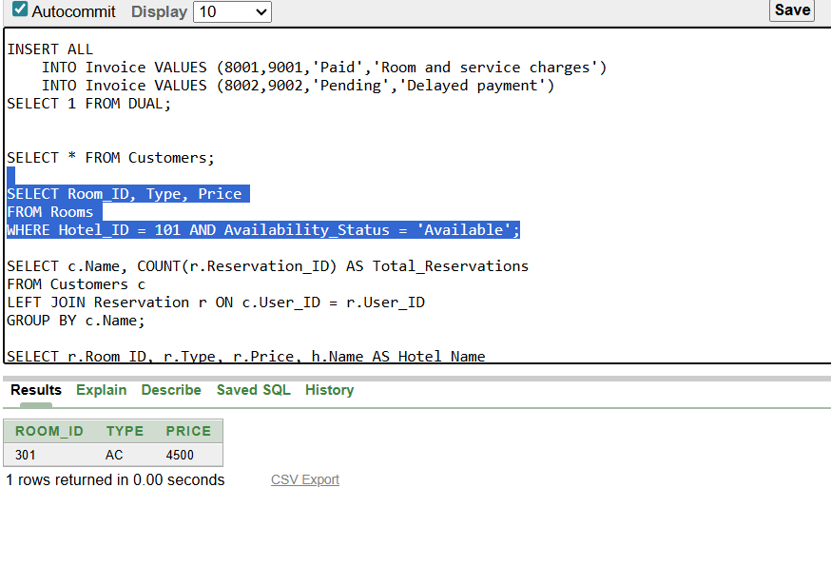

3. Count reservations per customer
SELECT c.Name, COUNT(r.Reservation_ID) AS Total_Reservations
FROM Customers c
LEFT JOIN Reservation r ON c.User_ID = r.User_ID
GROUP BY c.Name;
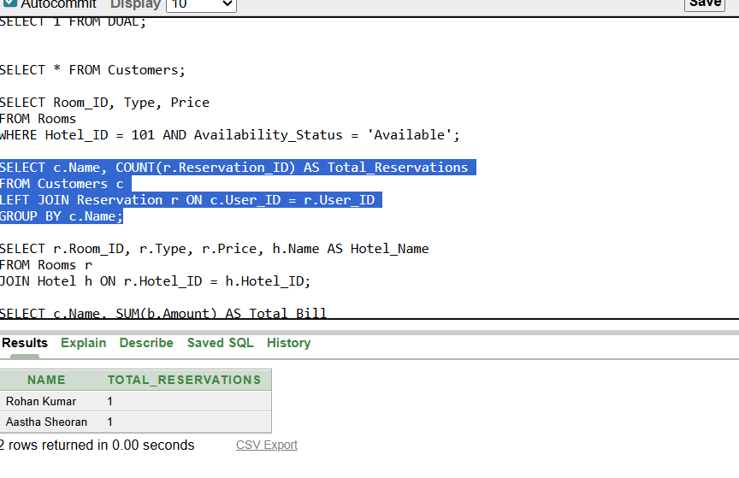

4. Room details with hotel
SELECT r.Room_ID, r.Type, r.Price, h.Name AS Hotel_Name
FROM Rooms r
JOIN Hotel h ON r.Hotel_ID = h.Hotel_ID;
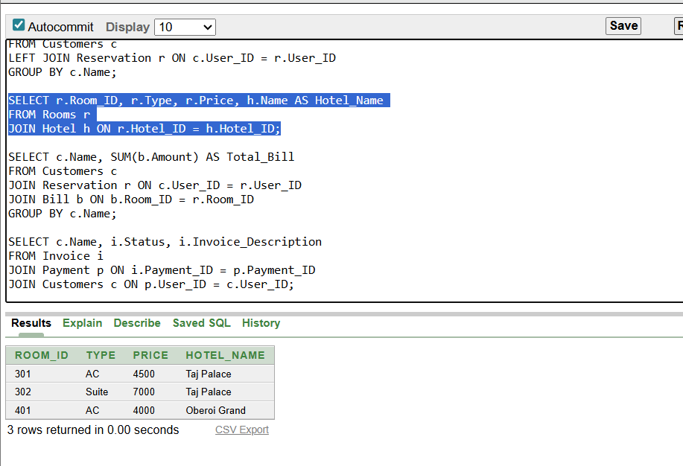

5. Total bill per customer
SELECT c.Name, SUM(b.Amount) AS Total_Bill
FROM Customers c
JOIN Reservation r ON c.User_ID = r.User_ID
JOIN Bill b ON b.Room_ID = r.Room_ID
GROUP BY c.Name;
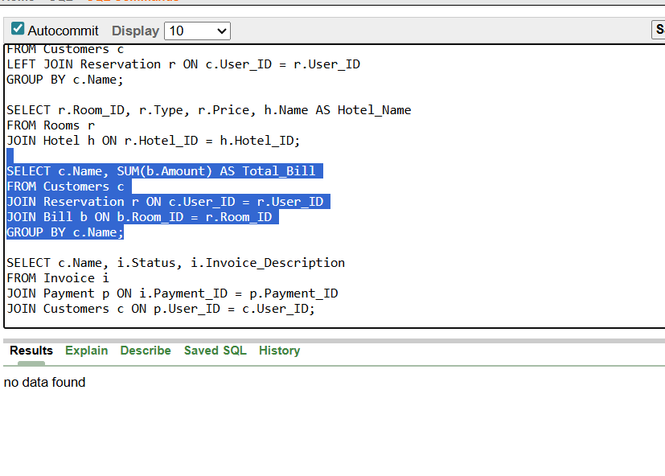

6. Invoice status
SELECT c.Name, i.Status, i.Invoice_Description
FROM Invoice i
JOIN Payment p ON i.Payment_ID = p.Payment_ID
JOIN Customers c ON p.User_ID = c.User_ID;
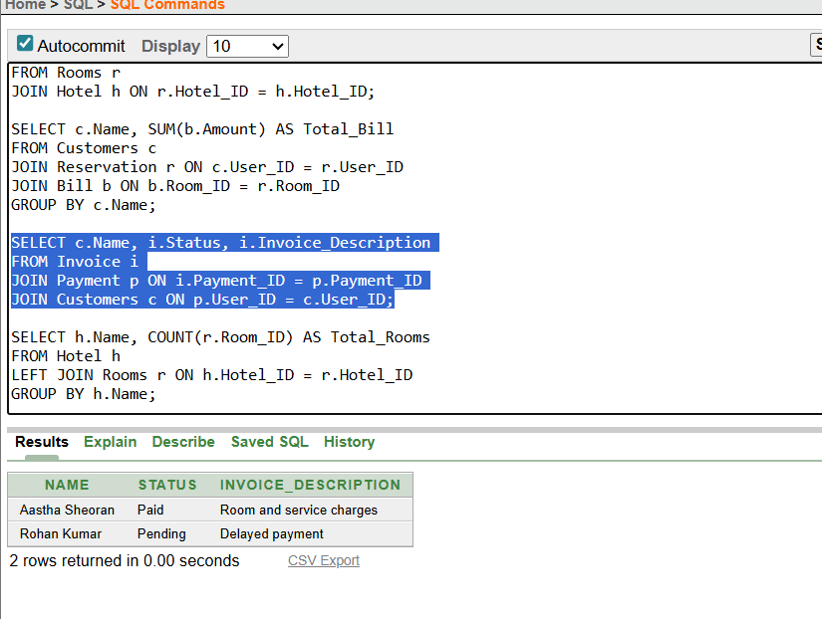

7. Hotel‑wise room count
SELECT h.Name, COUNT(r.Room_ID) AS Total_Rooms
FROM Hotel h
LEFT JOIN Rooms r ON h.Hotel_ID = r.Hotel_ID
GROUP BY h.Name;
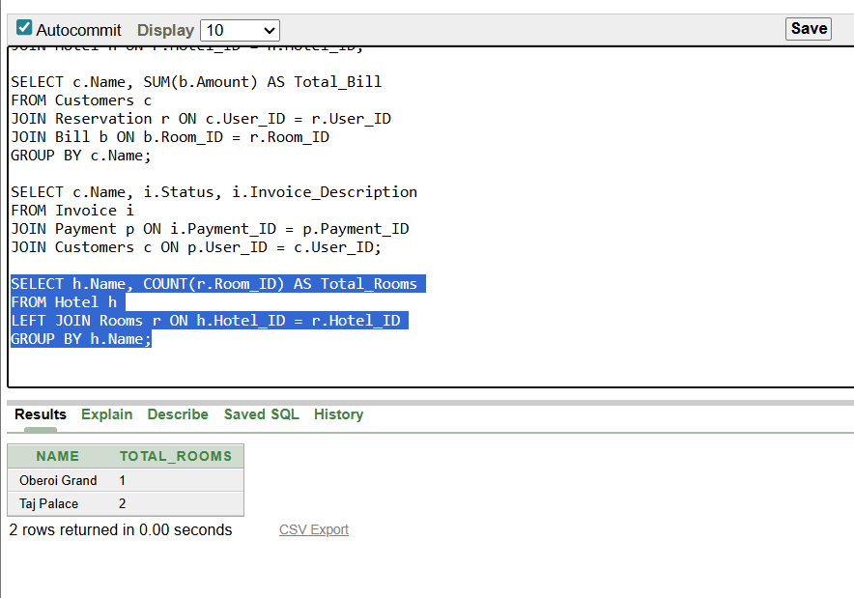

8. Conclusion
The Hotel Management System database structure ensures efficient handling of all operations related to customers,
rooms, hotels, reservations, bills, and payments. The ER diagram and relational schema help visualize relationships
clearly, while SQL tables organize the system into structured components. Using SQL queries, the system can generate
reports, track reservations, compute bills, and monitor payments, resulting in a fully functional and scalable hotel
management solution.

