Game Design Document

Fill up the following document

1. Write the title of your project.

Sky Fighters

1. What is the goal of the game?

To escape from the lazers of the enemies and to not reduce the health points

1. Write a brief story of your game.

Their is bunch of enemies ships and they are attacking on the main ship, so the main ship has to move forward and had to avoid all the lazers of the enemies. The main ship also has to focus on the health points and the earning points if the ship is attacked by one of the lazer , it will lose 5 points and if main ship will attack eneme ship it will score 5 points. There are total 100 health points and if it is attacked 50 times the game will be over .

1. Which are the playing characters of this game?

* Playing characters are the ones who respond to the user based on the input from the user.
* Cars, monkeys, dinos, wizards, etc., are the playing characters in the game.

|  |  |  |
| --- | --- | --- |
| Number | Character Name | What can this character do? |
| 1 | The playing ship | Ship has to attack the enemy and avoid the enemies attack. It has to earn points and not let down the health points |
| 2 |  |  |
| 3 |  |  |
| 4 |  |  |
| 5 |  |  |
| 6 |  |  |
| 7 |  |  |
| 8 |  |  |

1. Which are the Non-Playing Characters of this game?

* Non-Playing characters are the ones that don't have an action or behavior when the user interacts with the game.
* Hurdles, stones, bananas, coins, etc., are non-playing characters in the game.

|  |  |  |
| --- | --- | --- |
| Number | Character Name | What can this character do? |
| 1 | Enemy 1 | They can come randomly and attack the ship ,wil create obstacles atleast 400 times |
| 2 | Enemy 2 | Same as enemy 1 |
| 3 | Enemy 3 | Same as enemy 1 |
| 4 |  |  |
| 5 |  |  |
| 6 |  |  |
| 7 |  |  |
| 8 |  |  |

Draw your imagination of this game. What does this game look like?

* Draw the game either on your computer or on paper.
* Add images of the game scenes to show each of the playing and non-playing characters at least once.

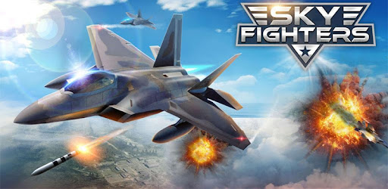

How do you plan to make your game engaging?

By not letting downthe health points and to attack on enemies and earn more points