ASSESSMENT – 2 GIT

1. sudo apt install git – to set up git

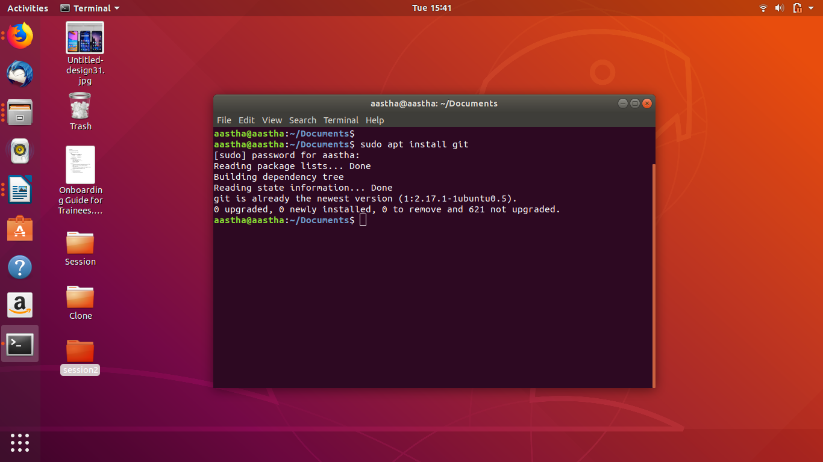
2. git init – initialise git
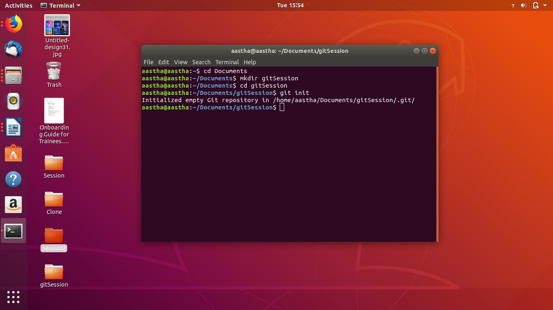
3. gedit file.txt = add file to txt
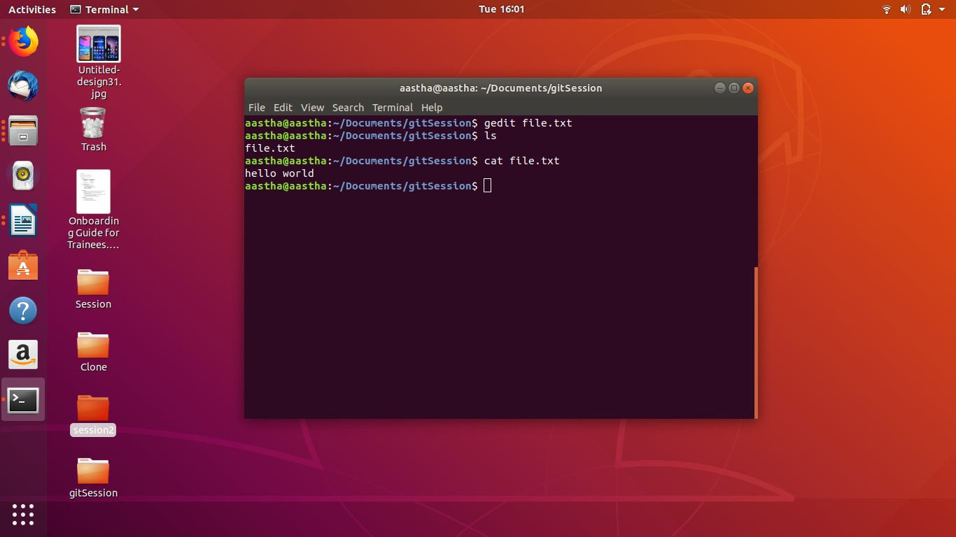
4. git rm –cached file.txt = unstage 1 file

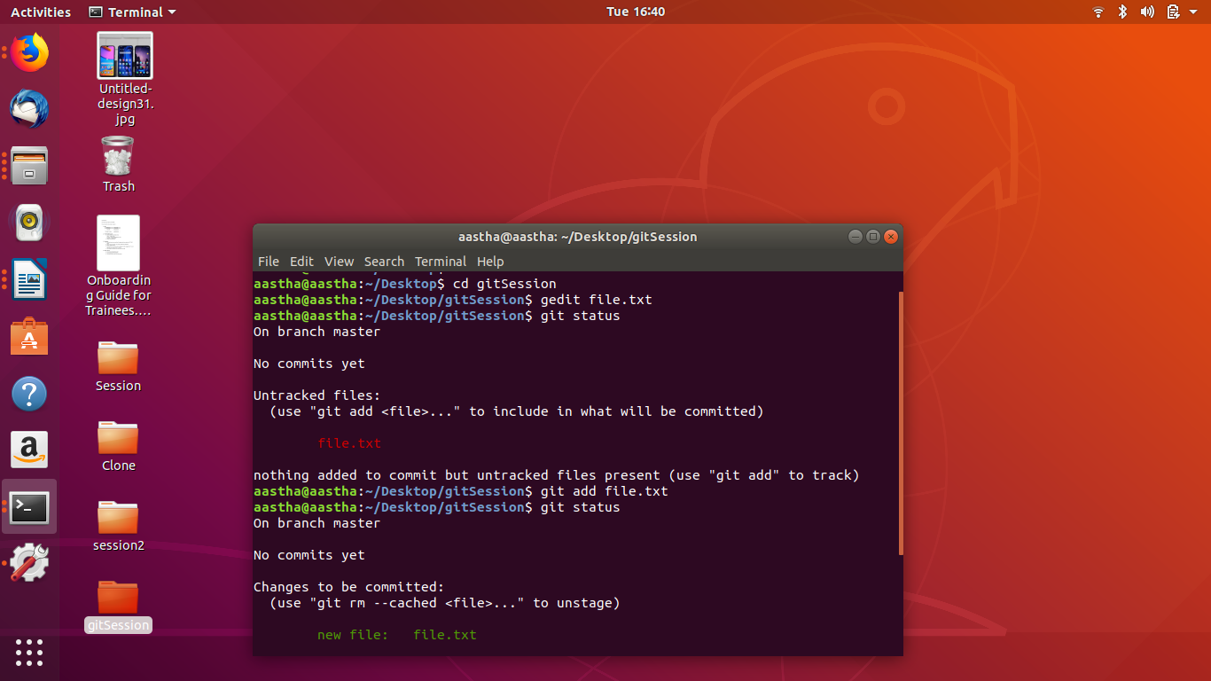
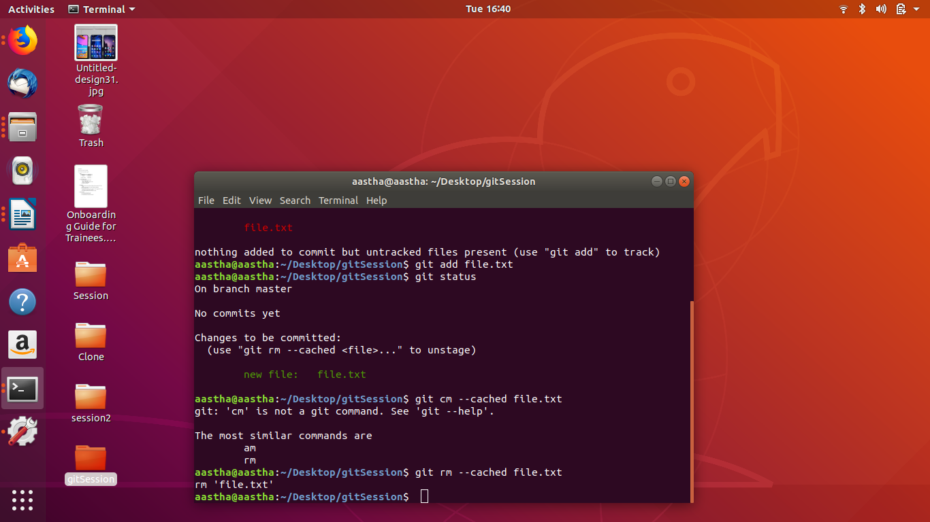

5. git commit -m “for master” = to commit file
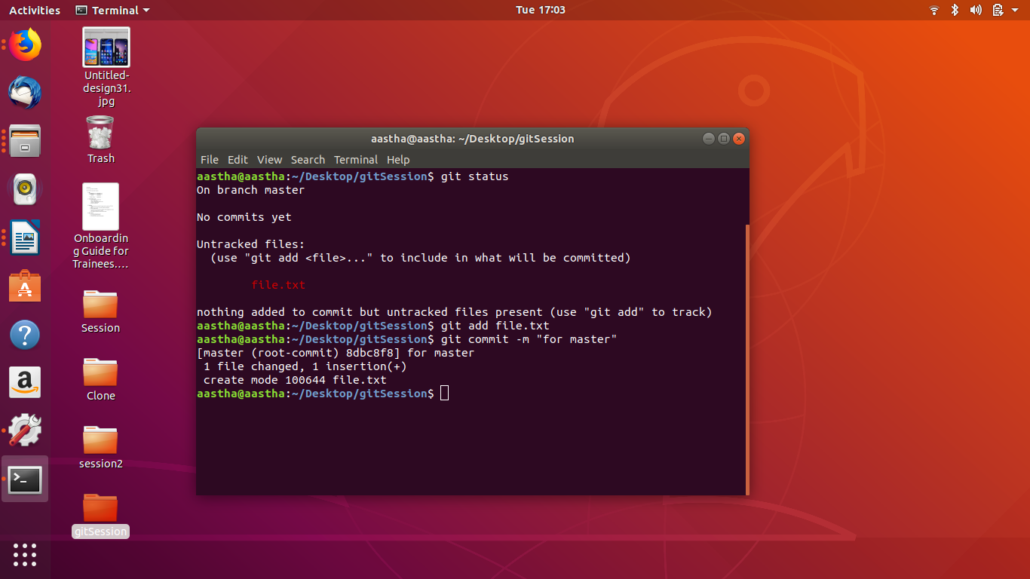
6. git remote add origin <cloneurl> = add a remote
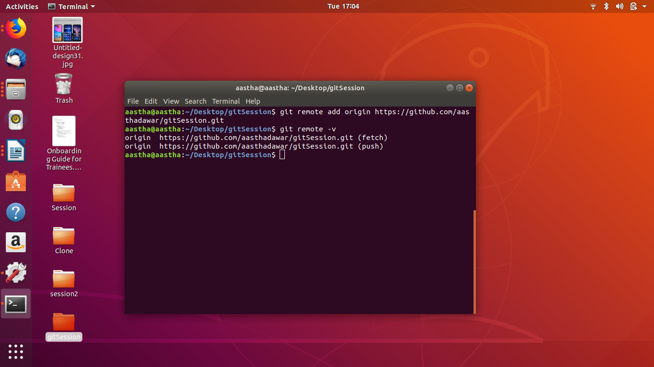

7. git reset –hard = undo changes to a file

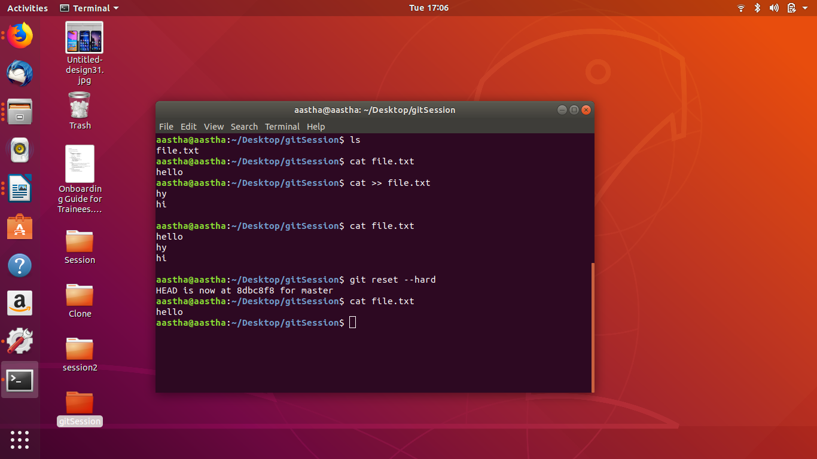

8. git push origin master = push to git
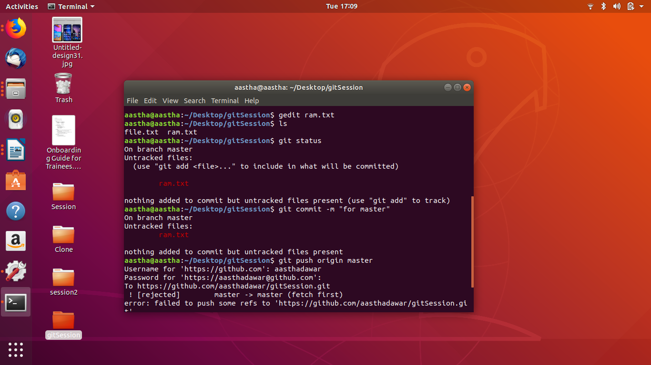
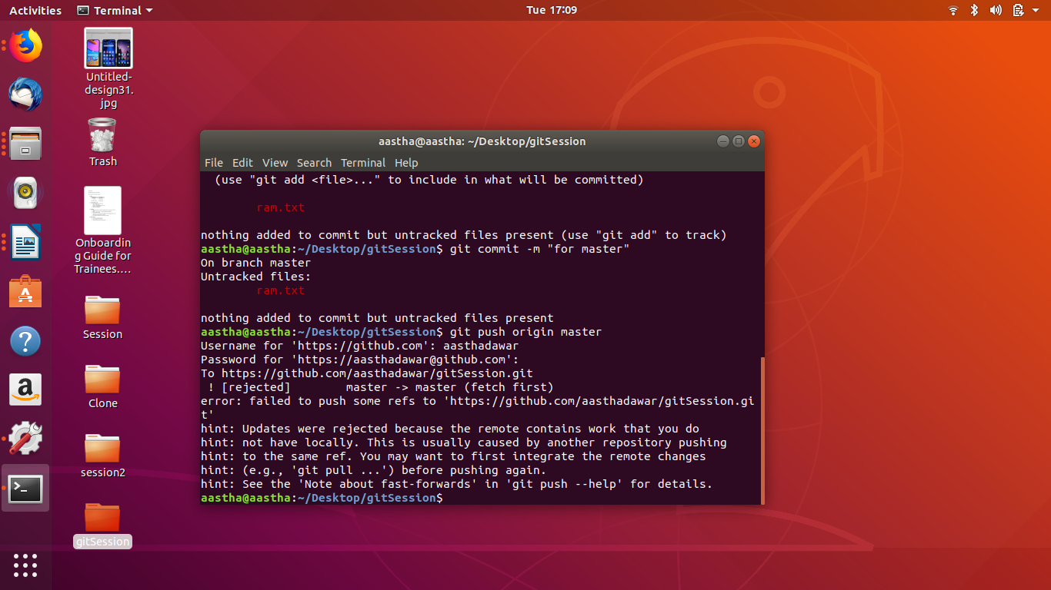
9. git clone <cloneurl> = clone a file

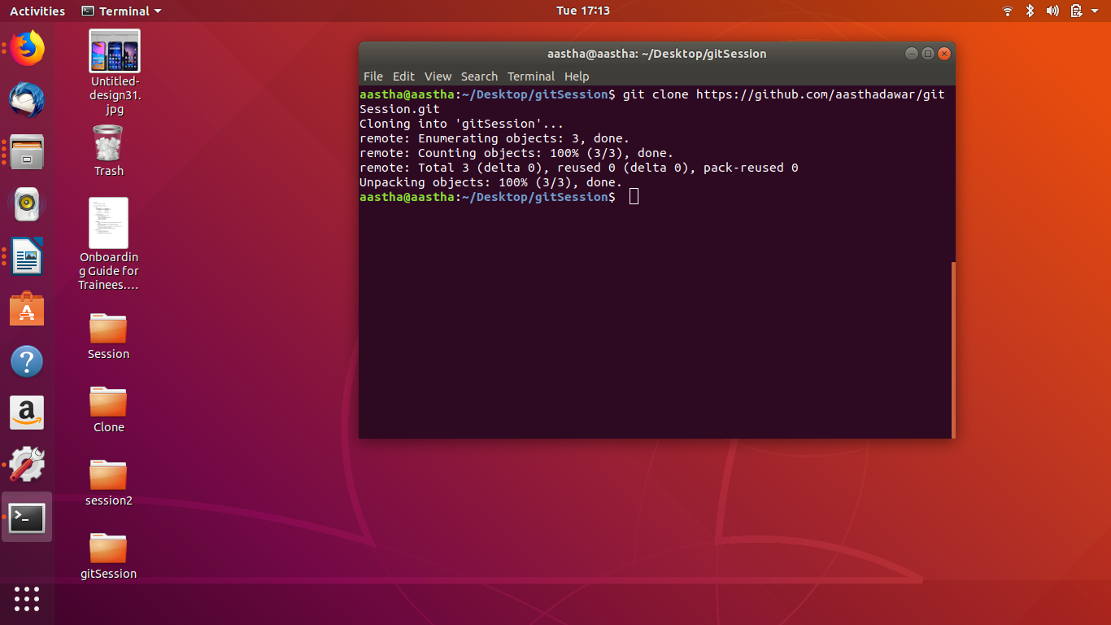
10.
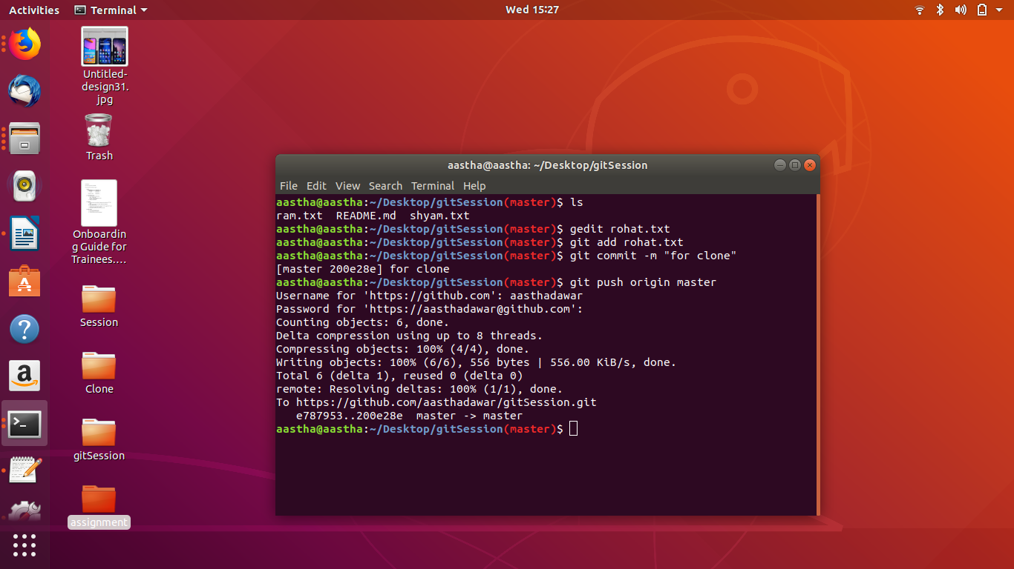
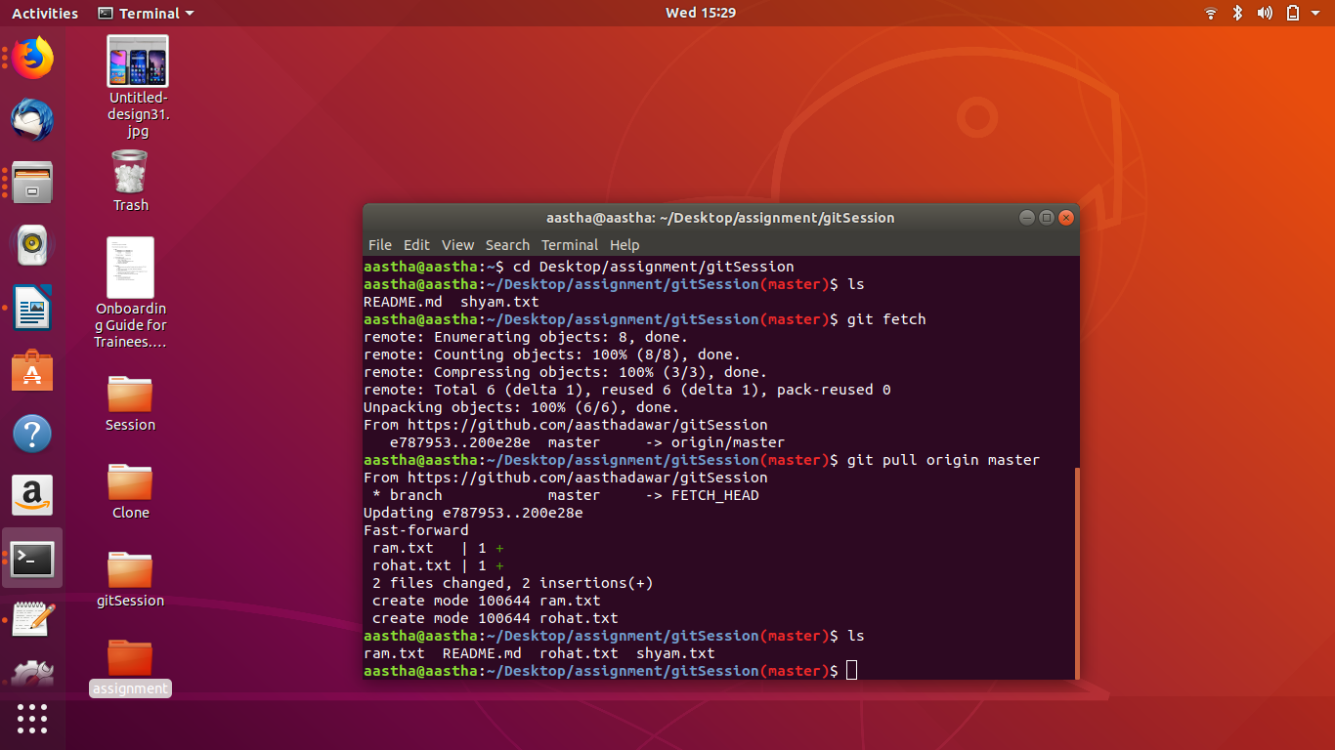

11.

A file is a collection of data stored in one unit, identified by a filename.
A staged is a version of a file when all the modifications are done in a file and it is ready to commit.

A file can be made with many command:- gedit file.txt .
A file enters a staged version when we write command:- git add file.txt

12.

vim .gitignore = to make a .gitignore file which will contain the name of files to be ignore
git commit -am “for ignored” = to commit .gitignore file

further whatever changes made to the file added in file to be ignored, will never be shown under modified status if we edit
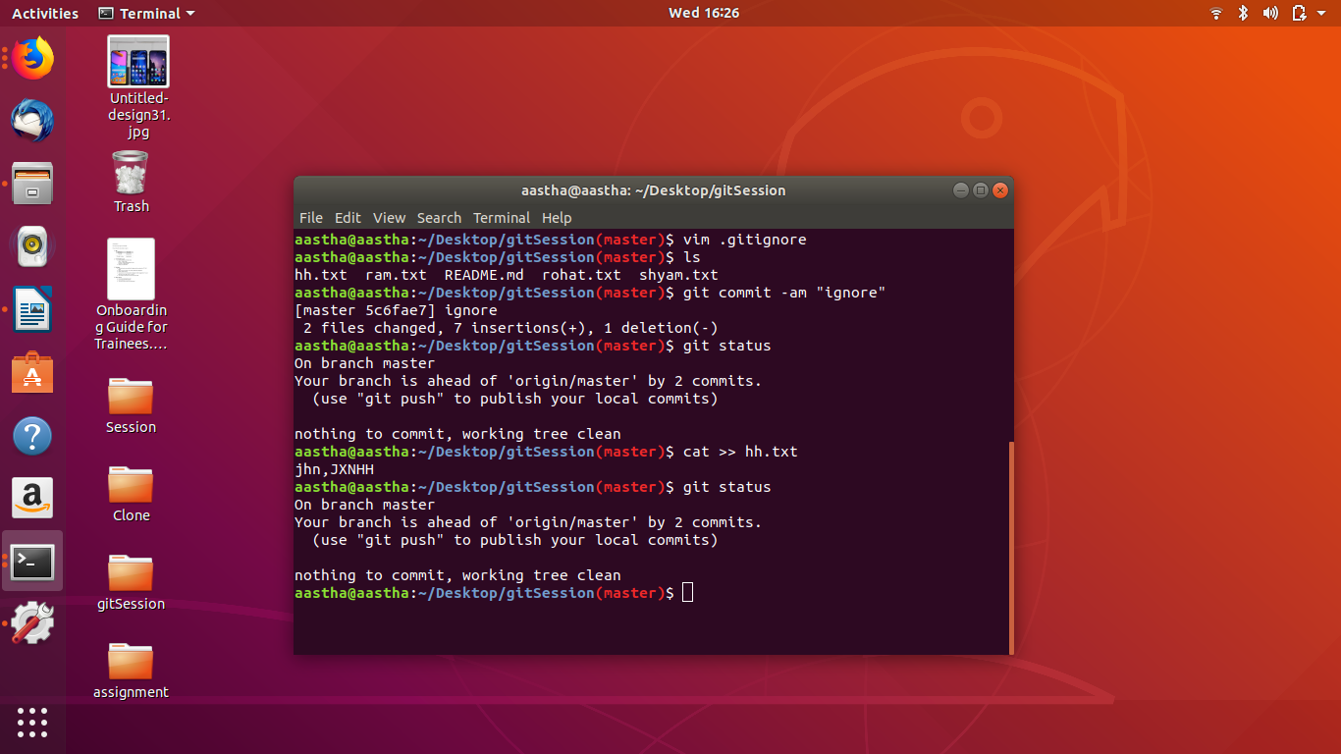
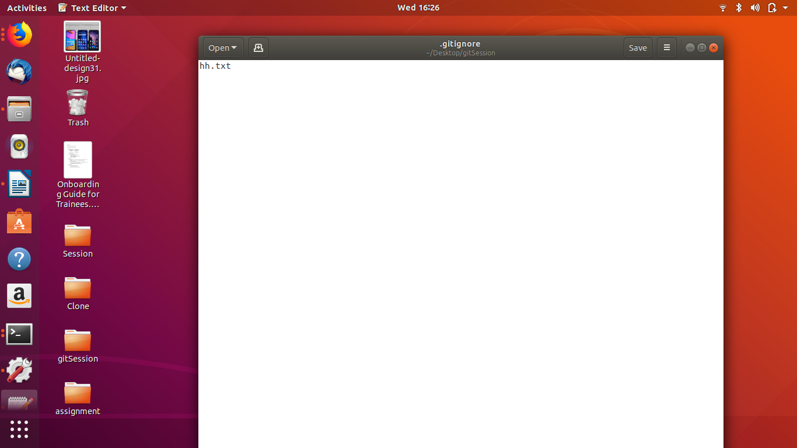

13. git checkout -b test = to make a new branch
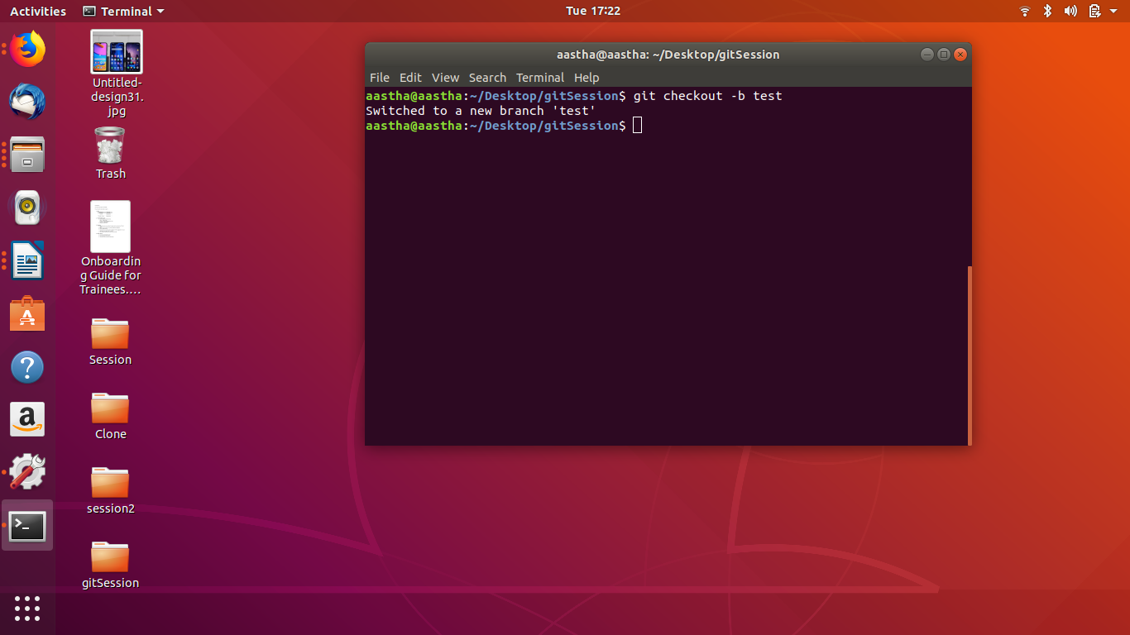

14. git rebase test = diverge branch with commits

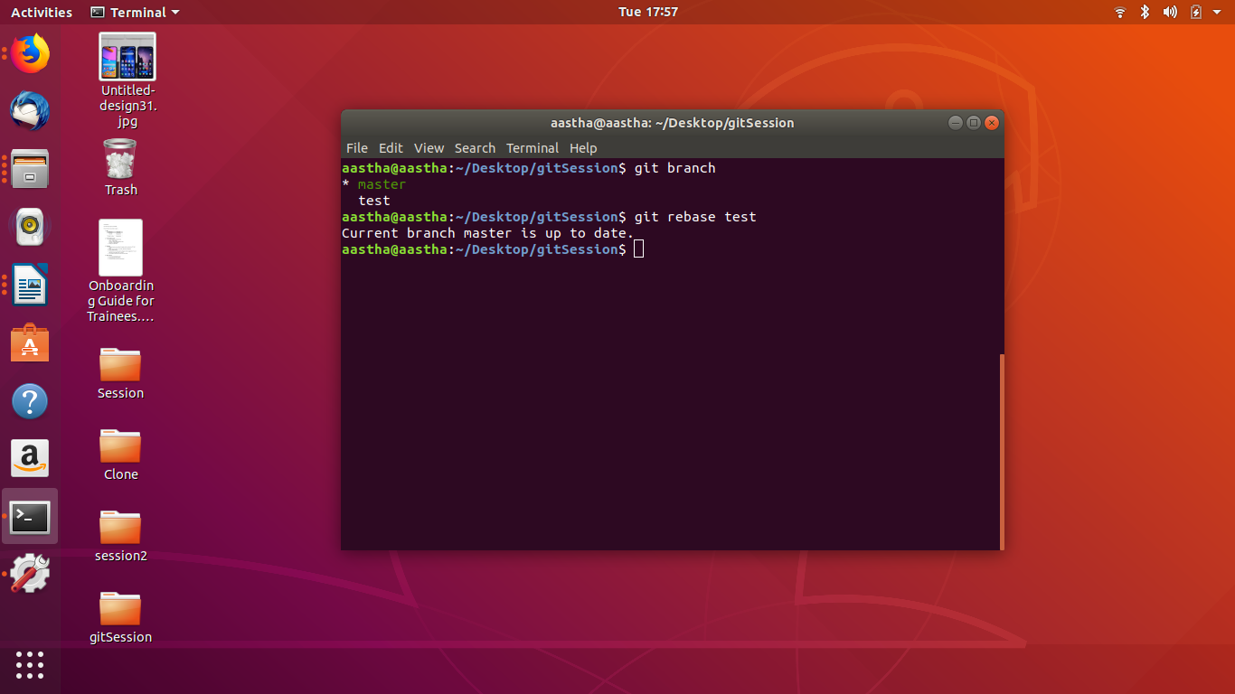

15. git commit -m “for master” = to commit a file after changes
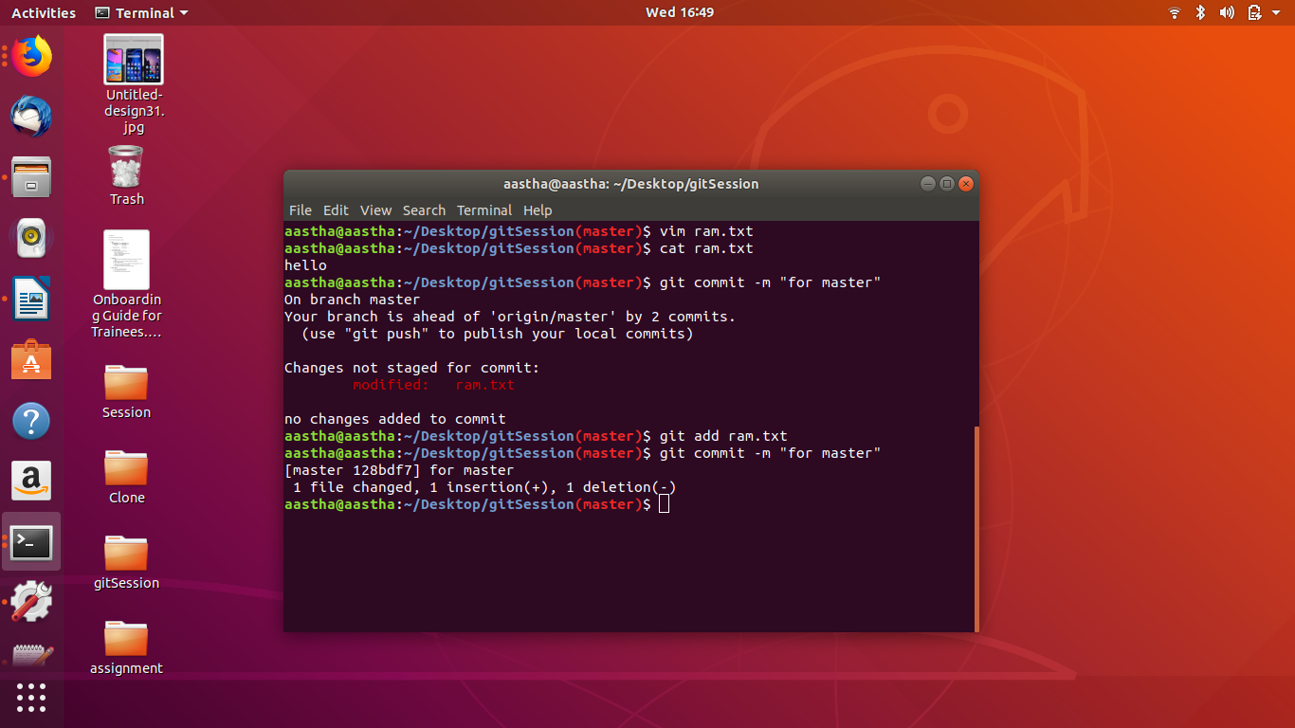
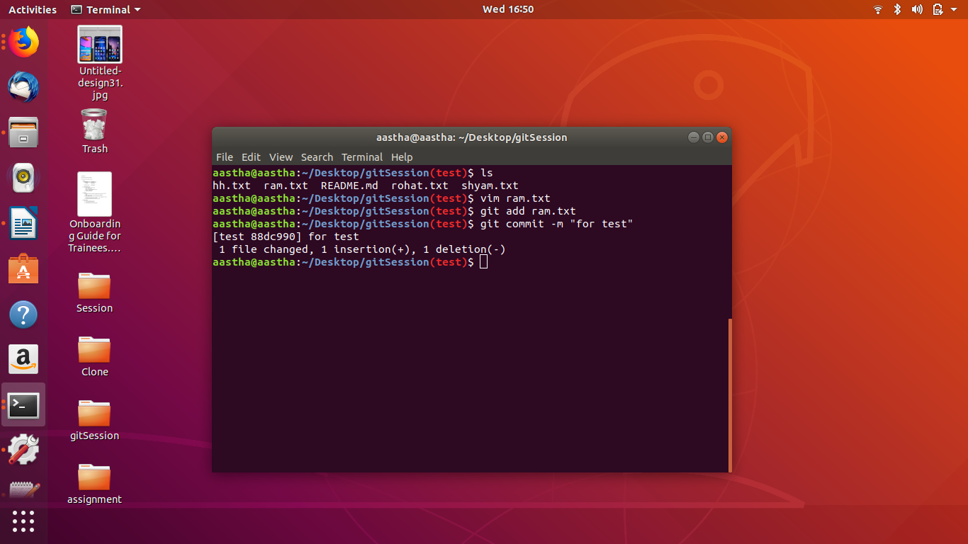
16.
change the content of a file
git add filename = to add file
git commit -m “comment” = to commit
then change the branch to perform the same task
then get back to the initial branch
git merge test = to merge
then change in file to solve merge conflict
git add filename = add file again
git commit -m “comment” = commit the file again to resolve the conflict
then finally merge

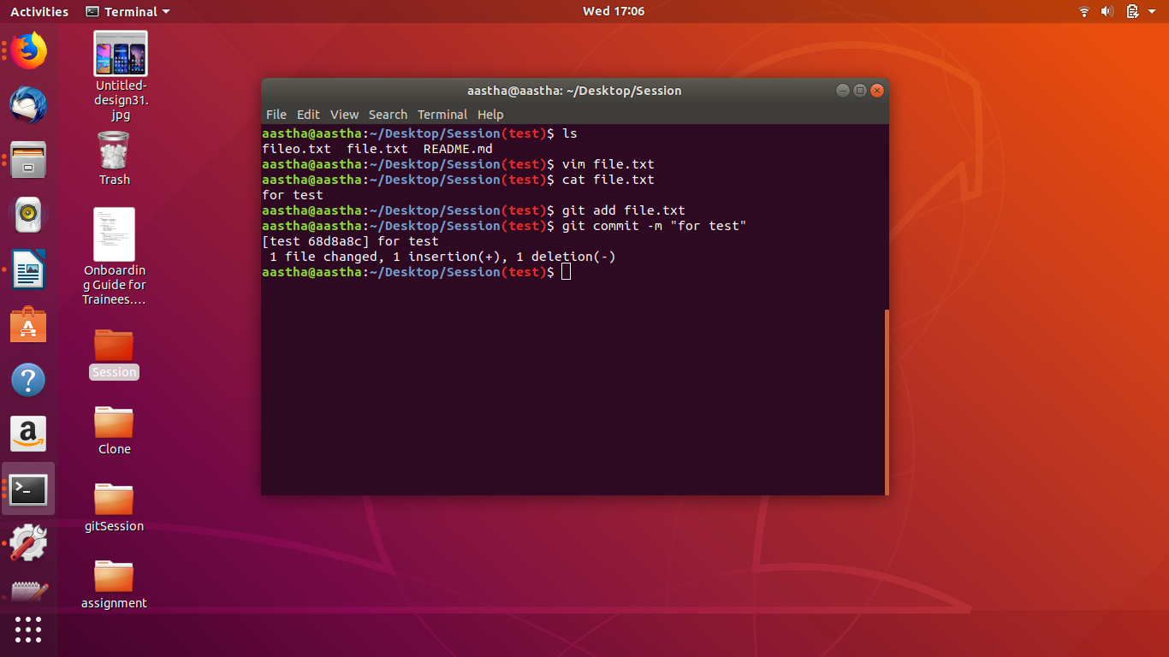
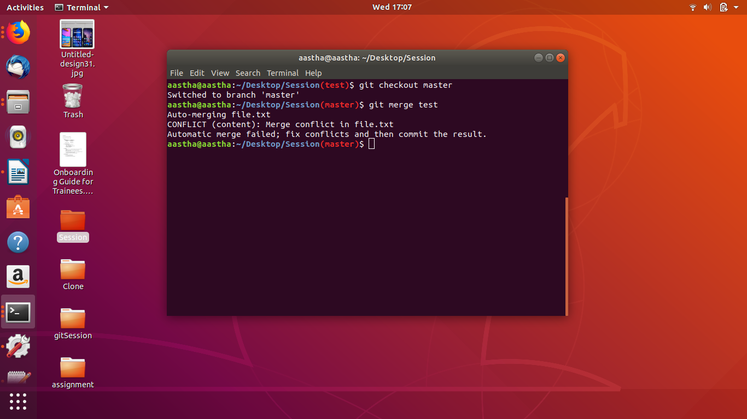
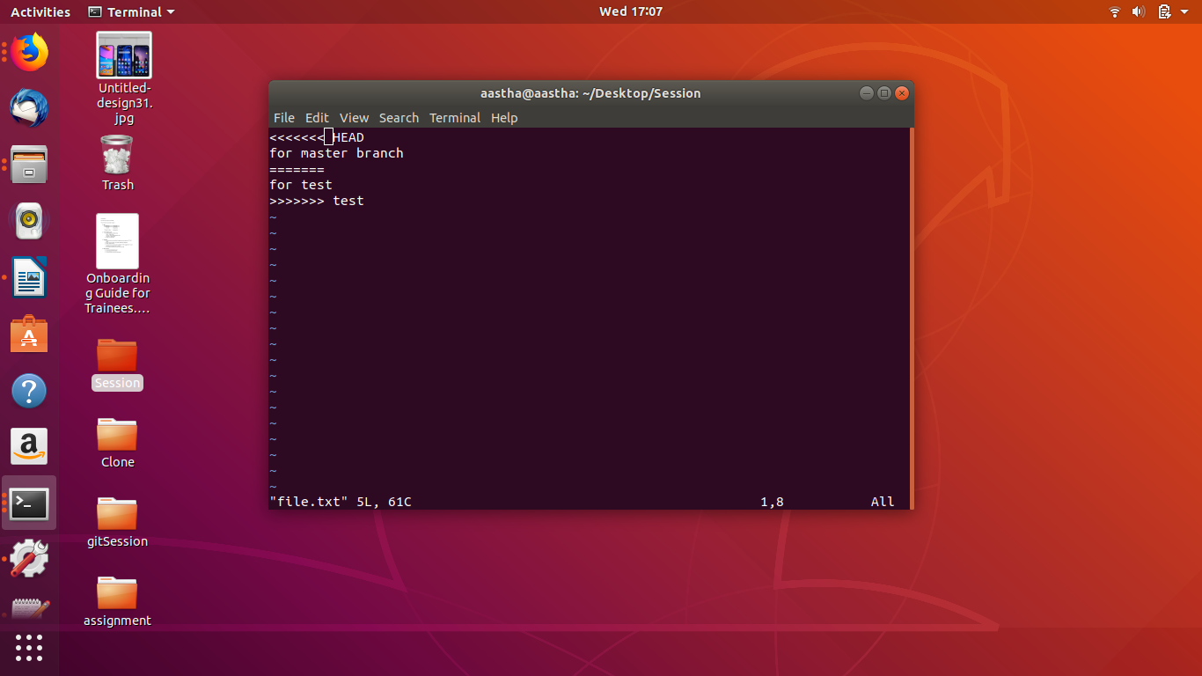
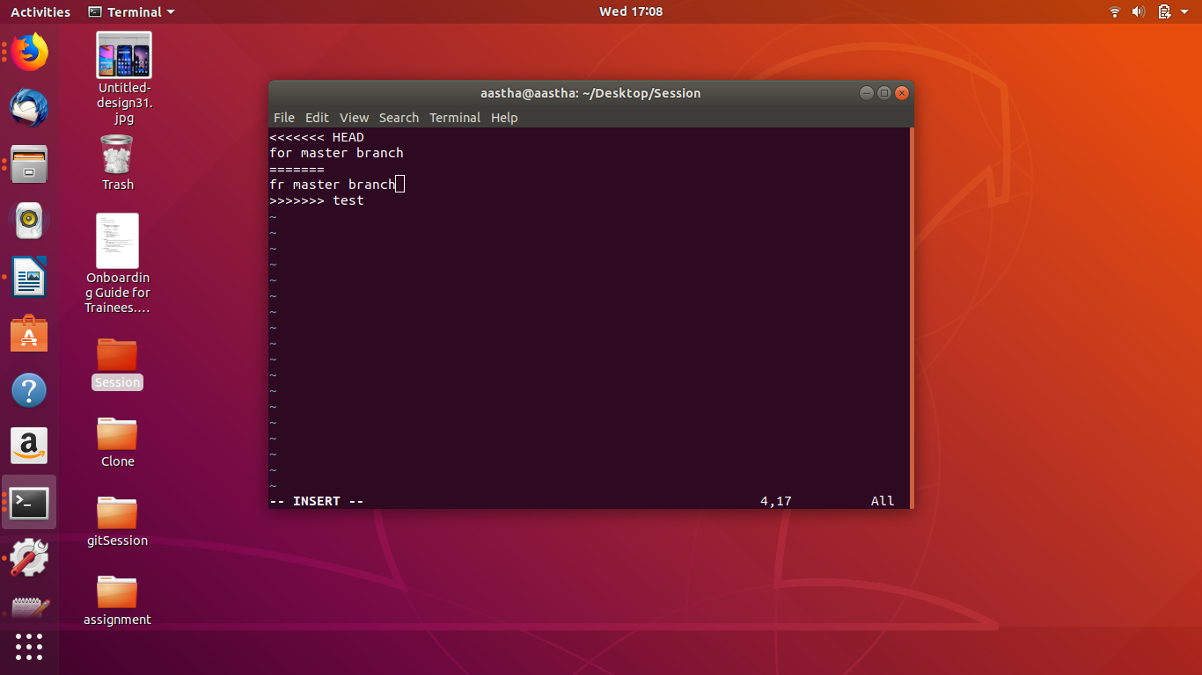
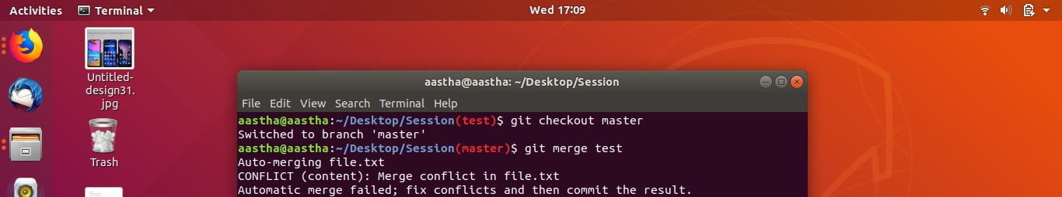
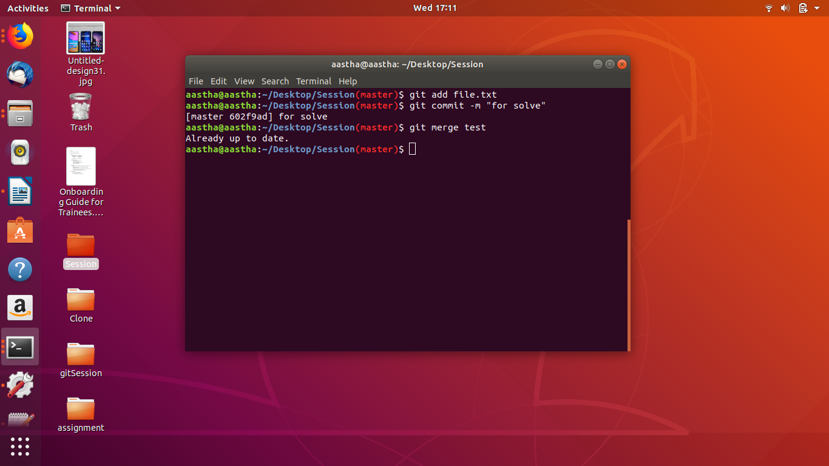

17. git stash = to convert into stash
git stash list = to check the list of files stash

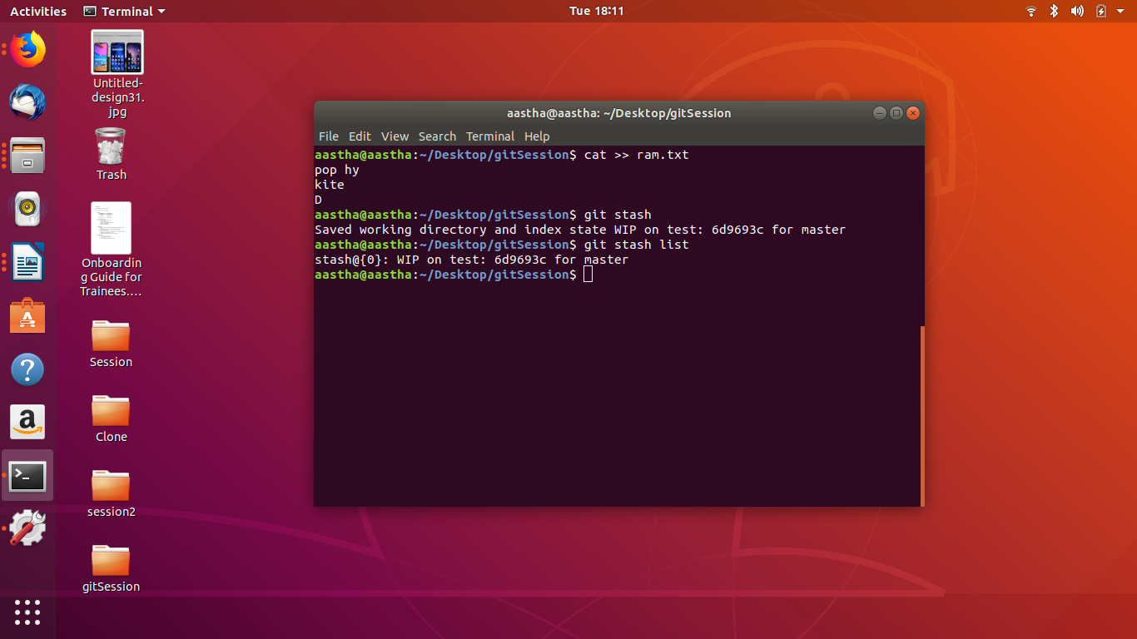
18.
change the script and save in .bashrc file
then open git folder in terminal then it will show with the branch name



